CODEVEDA
TASK 1 – DATA PREPROCESSING
Data Preprocessing using Python and Pandas
Submitted by
Name: ______________________________
Branch: CSE (AI & ML)
Year: III B.Tech
Internship: CodeVeda

1. Introduction
Data preprocessing is an important step in a machine learning workflow. Raw datasets may contain duplicate records, missing values, categorical values, and numerical features with different scales. Preprocessing converts the raw data into a cleaner and more suitable form for further analysis and machine learning.
For this task, the Iris dataset was processed using Python in Google Colab. Pandas was used for data handling, while scikit-learn was used for label encoding, feature scaling, and splitting the dataset into training and testing sets.

2. Objective
- Load the given CSV dataset into a Pandas DataFrame.
- Inspect the structure, columns, and missing values.
- Identify and remove duplicate records.
- Convert the categorical target column into numerical labels.
- Scale numerical features using Min-Max scaling.
- Split the processed data into training and testing sets.
- Save the final processed dataset as a CSV file.

3. Dataset Description
The dataset used for this task is an Iris dataset containing four numerical flower measurements and one target column. The four features are sepal length, sepal width, petal length, and petal width. The target column is species.
Column | Type | Purpose
sepal_length | Numerical | Input feature
sepal_width | Numerical | Input feature
petal_length | Numerical | Input feature
petal_width | Numerical | Input feature
species | Categorical | Target variable

4. Data Loading and Initial Inspection
The dataset was uploaded to the Google Colab environment and read using Pandas. The first five rows were displayed to verify that the file was loaded correctly.
import pandas as pd
df = pd.read_csv("1) iris.csv")
df.head()
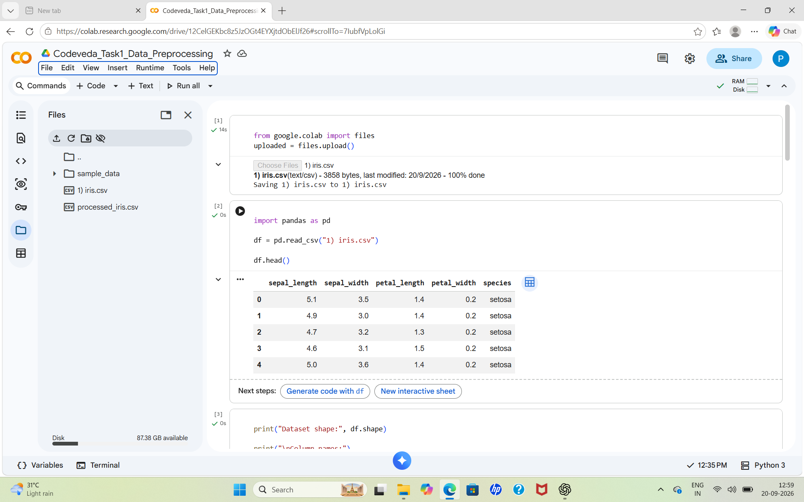
Figure 1. Loading the Iris dataset and displaying the first five records.

5. Dataset Inspection
The dataset initially contained 150 rows and 5 columns. The column names were identified as sepal_length, sepal_width, petal_length, petal_width, and species. The missing-value check showed zero missing values in all five columns.
print("Dataset shape:", df.shape)
print(df.columns)
print(df.isnull().sum())

6. Duplicate Record Detection
Duplicate records were checked before further processing. The notebook identified 3 duplicate rows. These duplicate rows were removed using the Pandas drop_duplicates() function. After removal, the dataset contained 147 rows and 5 columns.

7. Removing Duplicate Records
print("Duplicate rows:", df.duplicated().sum())
df = df.drop_duplicates()
print("Dataset shape after removing duplicates:", df.shape)
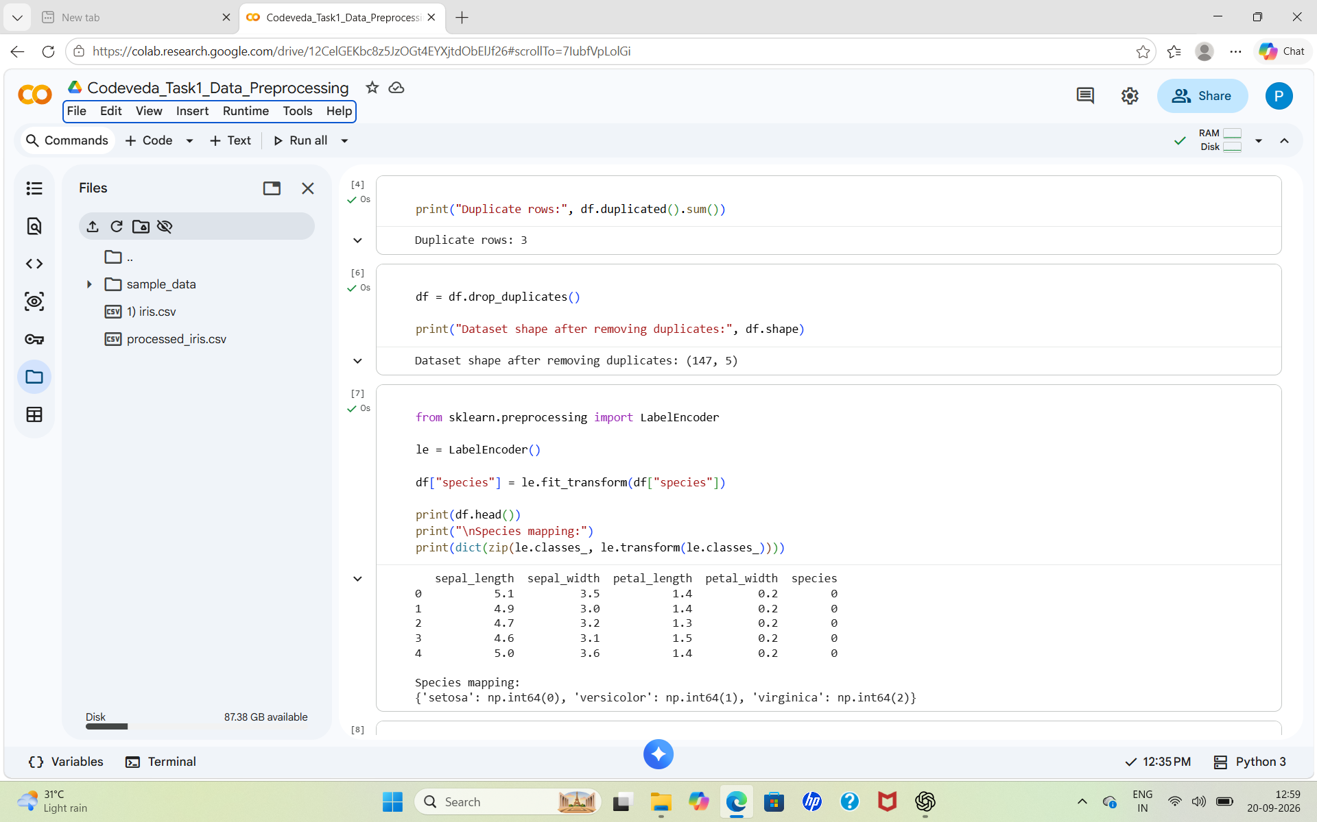
Figure 2. Duplicate detection, duplicate removal, and label encoding.

8. Categorical Data Encoding
The species column contained categorical class names. Since machine learning algorithms generally work with numerical values, LabelEncoder from scikit-learn was used to convert the species names into integer labels.
from sklearn.preprocessing import LabelEncoder
le = LabelEncoder()
df["species"] = le.fit_transform(df["species"])
The resulting class mapping was:
- setosa → 0
- versicolor → 1
- virginica → 2

9. Result After Cleaning and Encoding
After removing duplicates and encoding the target column, the dataset was ready for numerical feature scaling. The target variable was represented by the values 0, 1, and 2.

10. Feature Scaling
Min-Max Scaling was applied to the four numerical features. This transforms the feature values to a common numerical range and reduces the effect of differences in the original measurement scales.
from sklearn.preprocessing import MinMaxScaler
scaler = MinMaxScaler()
features = ["sepal_length", "sepal_width",
"petal_length", "petal_width"]
df[features] = scaler.fit_transform(df[features])
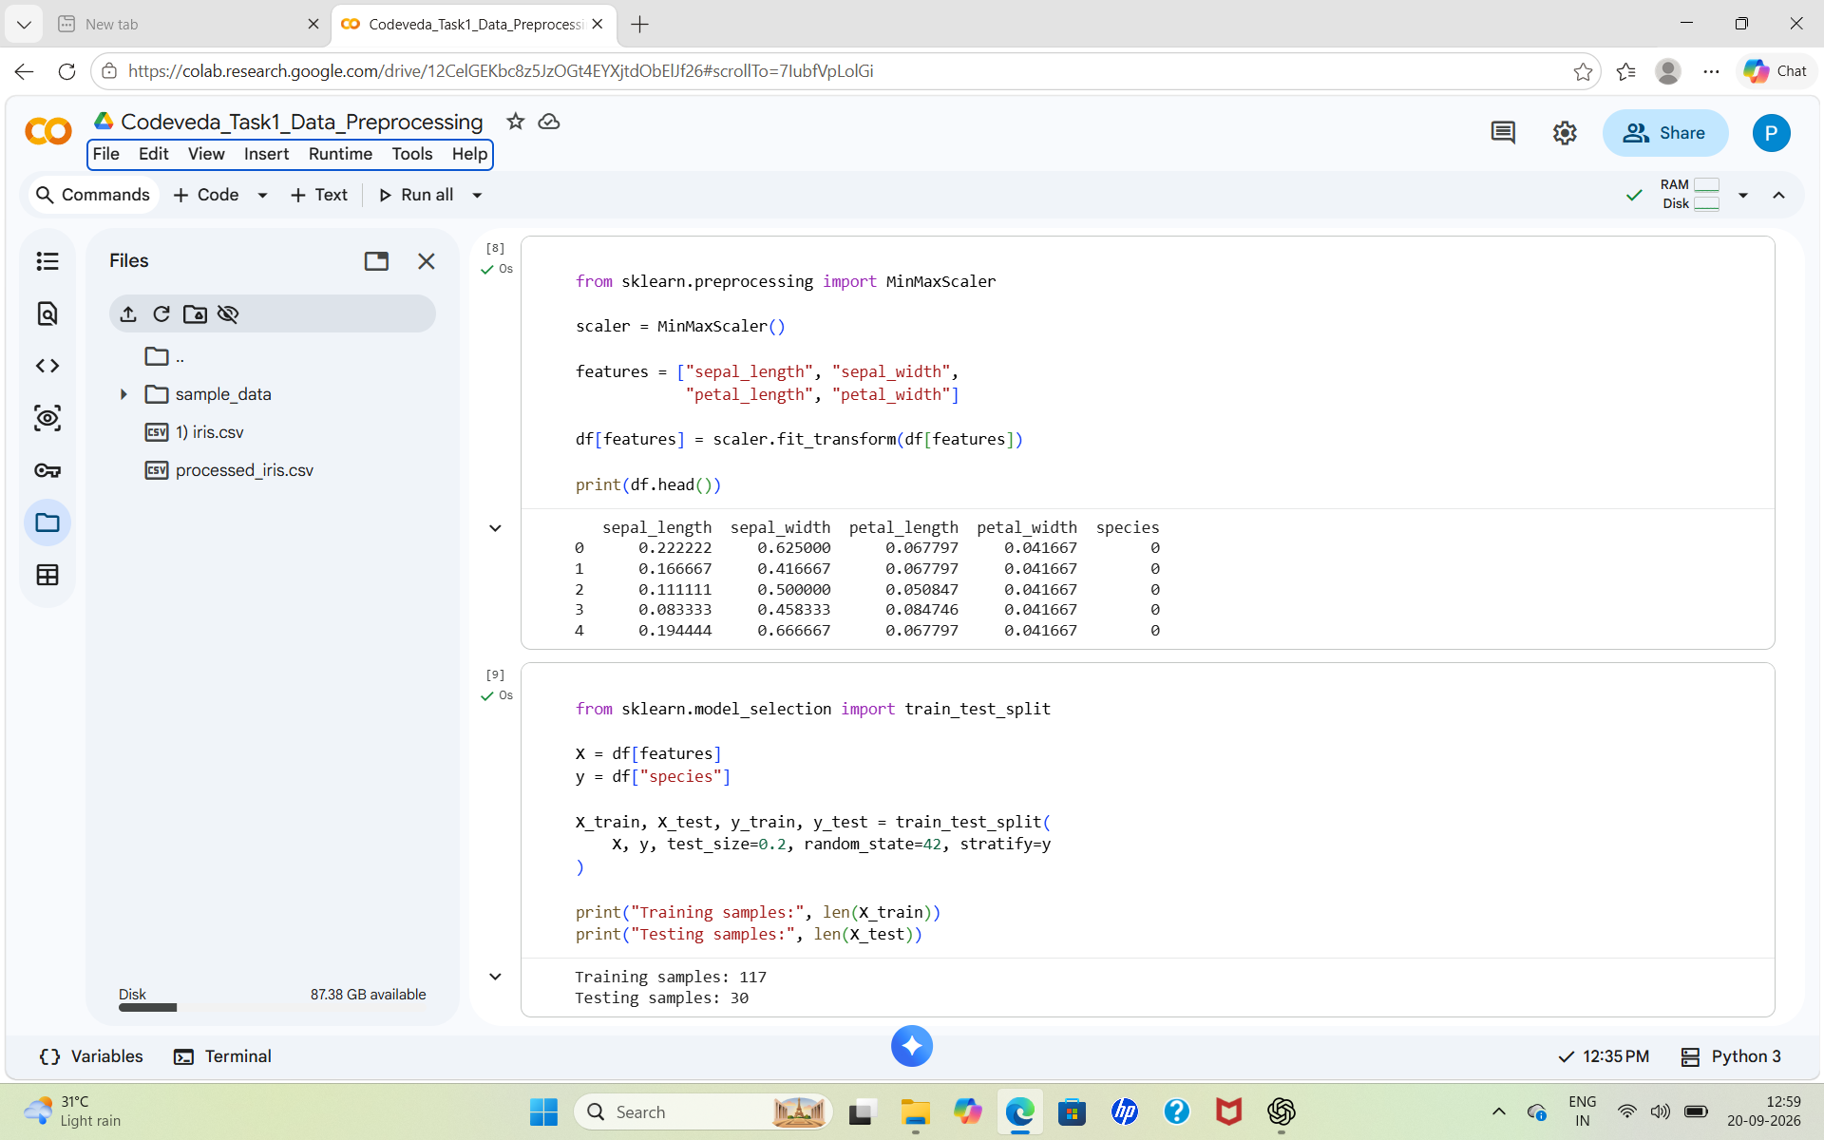
Figure 3. Min-Max scaling of numerical features and train-test split.

11. Train-Test Split
The processed data was divided into training and testing subsets using train_test_split(). A test size of 0.2 was used and stratification was applied to preserve the class distribution.
from sklearn.model_selection import train_test_split
X = df[features]
y = df["species"]
X_train, X_test, y_train, y_test = train_test_split(
X, y, test_size=0.2, random_state=42, stratify=y
)
Dataset | Number of Samples
Training set | 117
Testing set | 30

12. Saving the Processed Dataset
After preprocessing, the training and testing data were combined into a final DataFrame and saved as a CSV file named processed_iris.csv. The index was excluded while saving the file.
processed_df.to_csv("processed_iris.csv", index=False)
print("Processed dataset saved successfully!")
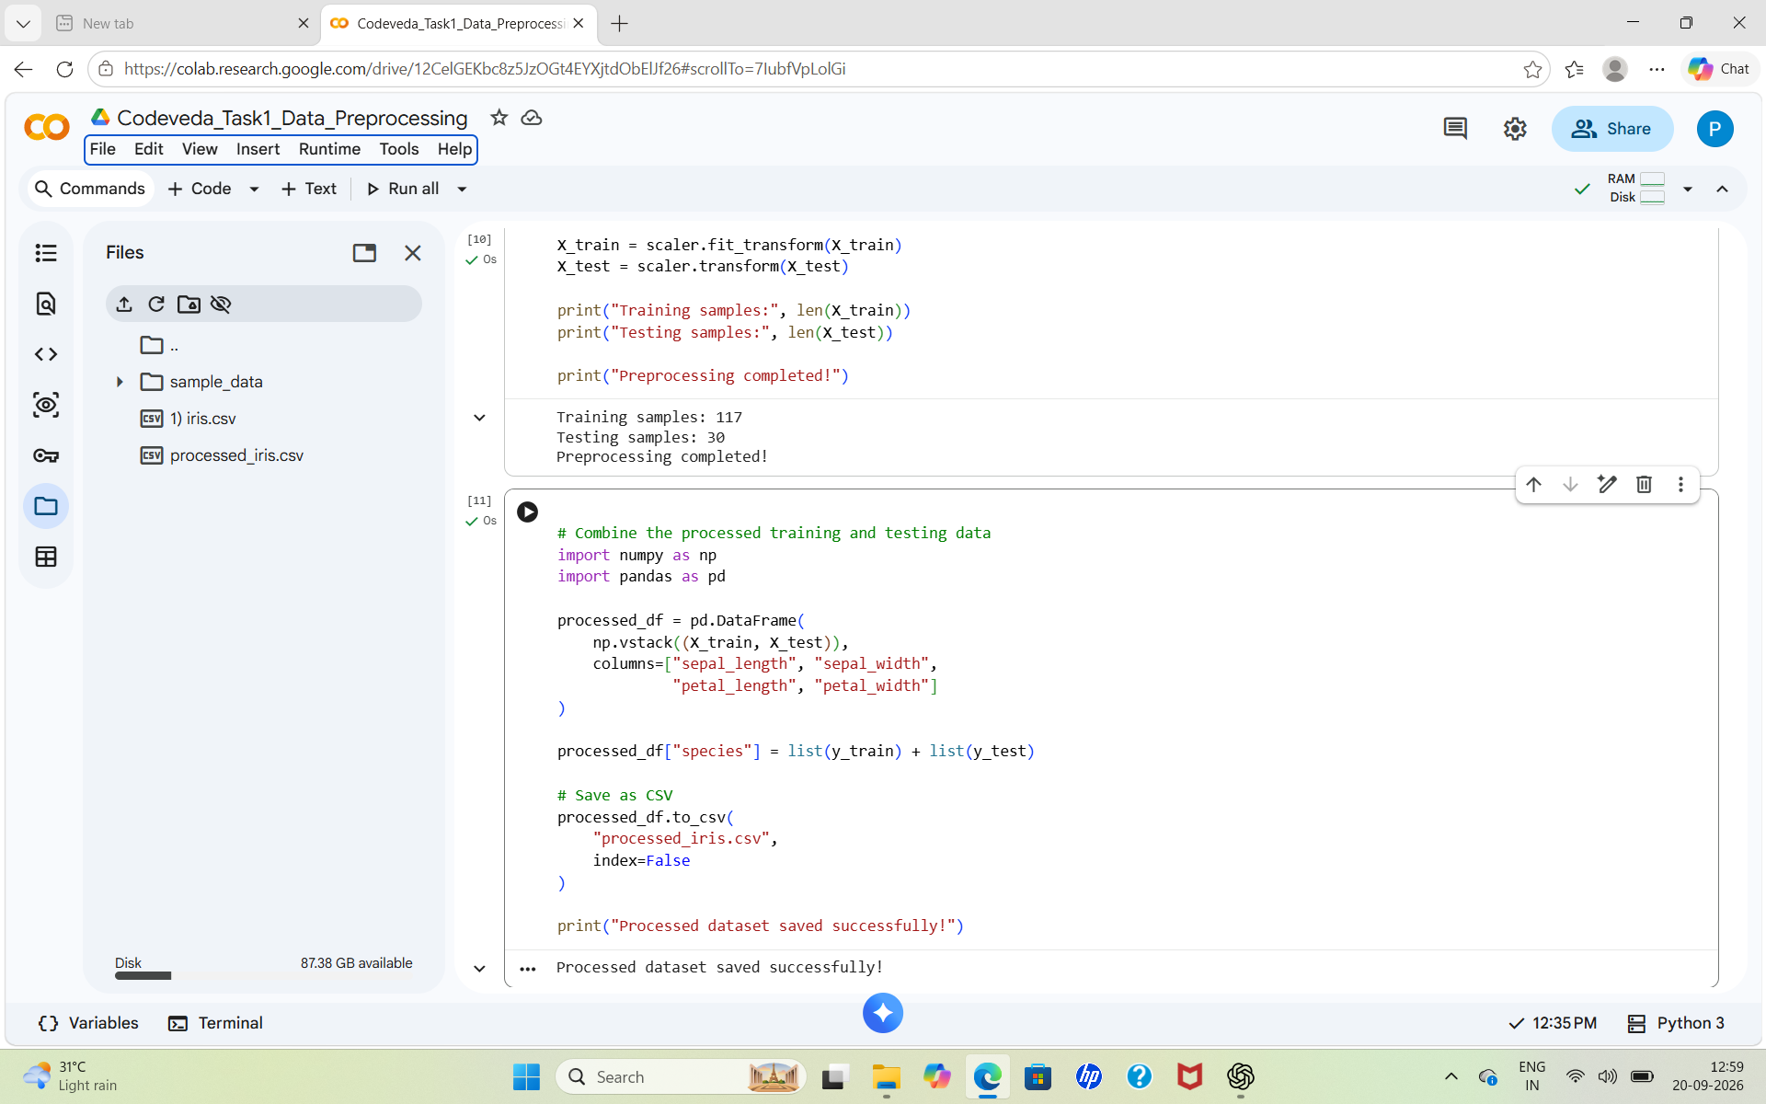
Figure 4. Combining the processed data and saving processed_iris.csv.

13. Final Results
Item | Result
Original dataset | 150 rows × 5 columns
Missing values | 0
Duplicate rows detected | 3
Dataset after duplicate removal | 147 rows × 5 columns
Target encoding | setosa=0, versicolor=1, virginica=2
Training samples | 117
Testing samples | 30
Output file | processed_iris.csv

14. Conclusion
The Iris dataset was successfully preprocessed using Python, Pandas, and scikit-learn. The workflow included dataset loading, inspection, duplicate detection and removal, categorical label encoding, numerical feature scaling, and train-test splitting. The final processed data was saved as processed_iris.csv and is ready to be used for further machine learning analysis or model development.

15. Tools and Technologies Used
- Python
- Google Colab
- Pandas
- NumPy
- Scikit-learn

