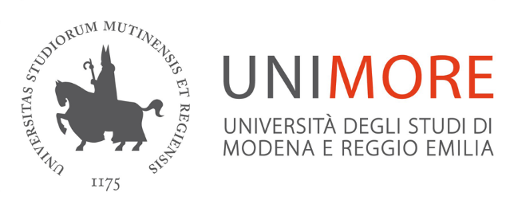
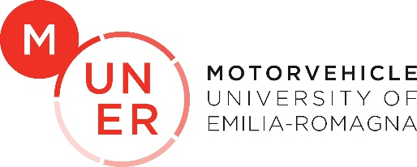
UNIVERSITÁ DEGLI STUDI DI MODENA E REGGIO EMILIA
Dipartimento di Ingegneria “Enzo Ferrari”

Master’s Degree in Advanced Automotive Engineering
Curriculum: High Performance Car Design

MASTER’S THESIS
Development of a full vehicle model for an endurance race car: application from the early stages of design process to the trackside activities.
Advisors
Ch.mo Prof. Matteo Giacopini
Ch.mo Prof. Silvio Sorrentino
Co-Advisor
Stefano Rapisarda
Candidate
Matteo Paganini

Academic Year 2020/2021

