VI-CarRealTime is a virtual modeling and simulation environment targeted to a simplified 4 wheels vehicle model, a reduced degree-of-freedom (DOF) model : it includes only 14 degrees of freedom; model includes 5 rigid parts:
- vehicle chassis (sprung mass) which has 6 DOFs;
- 4 wheel parts (unsprung masses) having 2 DOFs each (motion w.r.t. vehicle body and wheel spin)
The VI-CarRealTime suspension does not have linkages or bushings, and the steering system does not have parts for the steering wheel or rack. Suspension and steering system properties (kinematic, compliance and component data) are described by lookup tables using a conceptual approach. Other vehicle subsystems (brakes and powertrain) are described using differential and algebraic equations, so no extra part is present in the model. (possible to increase DOFs to 20 if body chassis torsional compliance is introduces)
The Vehicle model's intent is to accurately predict overall vehicle behavior for cornering, braking, and acceleration-performance studies for four-wheeled vehicles with independent-front and independent-rear suspensions. The simplified model is described in terms of commands and functions that use an internal development environment working as a symbolic manipulator tailored for deriving multibody equations and a code generator.

The environment based on underlying solver consists of:
- Symbolically derived parameterized equations of motion;
- Pacejka tire model;
- Sophisticated, virtual driver model.
Accessories include: VI-Road (a tool for generating roads and driver paths), VI-Animator (post-processing tool for plots and animations), VI-SuspensionGen (suspension curves generation utility) and VI-TireLimits (a tool for evaluating the force envelope given an input tire property file).

MaxPerformance:
The event uses a specific static solver (VI-SpeedGen) to compute a velocity profile and then it uses the dynamic solver to verify if the computed speed profile is feasible. If the velocity path is unfeasible (maximum path distance exceeded, zero velocity etc.) the solver turns back to the static and computes a new velocity profile, modifying only the portion nearby the unfeasible point. The process is iterated until a feasible velocity profile is found (the vehicle model used for static prediction has no suspensions and inherits all properties from the full VI-CarRealTime model).
The effect of aero forces is considered and the effect of suspension jounce is taken into account by the presence of ride height maps.
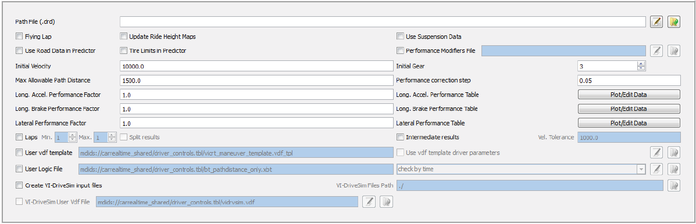

VI-SpeedGen algorithm is used to compute a static speed profile on a given trajectory, it uses a simplified model with respect to the one used in standard dynamic events: it has no suspensions and inherits all the properties from the full VI-CarRealTime model.
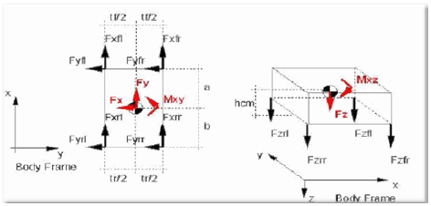

The solver, based on vehicle model and specified lateral and longitudinal grip, computes the limit velocity profile and produces it as output. Solution process consists in 4 steps:
- Speed profile limit on Apex: Starting from the input trajectory, the algorithm recognizes the apex of all the curves and computes the static limit speed for each apex assuming that the vehicle is in pure lateral (the vehicle is assumed to have zero longitudinal acceleration
- Forward Integration: Once the speed in each apex has been computed, the forward integration phase computes the maximum acceleration the vehicle can sustain from each apex forward. Since the apex is the point with minimum speed, after the apex the vehicle must accelerate and the acceleration performance of the vehicle are retrieved from tire and powertrain of the main vehicle, defining speed curve from each apex forward;
- Backward Integration: Computation of the maximum deceleration the vehicle can sustain from each apex backward. Since the apex is the point with minimum speed, before the apex the vehicle must be in deceleration and the deceleration performance of the vehicle are retrieved from tire and brake system of the main vehicle, defining speed profile from each apex backward;
- Final Smoothing: forward and backward generated speed profiles are connected and smoothed in order to define final speed profile;

Last releases of this software have the possibility to exploit the new solver VI-SpeedGenEvo whose working mode is exactly the same as the standard VI-SpeedGen, but the internal vehicle model used as reference to compute the static speed profile is more detailed (it is composed by 5 rigid bodies -1 sprung mass and 4 unsprung masses-, relative movement between sprung mass and unsprung masses is computed by using the suspension kinematic splines of the full VI-CarRealTime model and moreover, a pre-analysis of the full VI-CarRealTime model is performed in order to characterize the vehicle ground stiffness: parallel and opposite travel analysis using the suspension testrig).
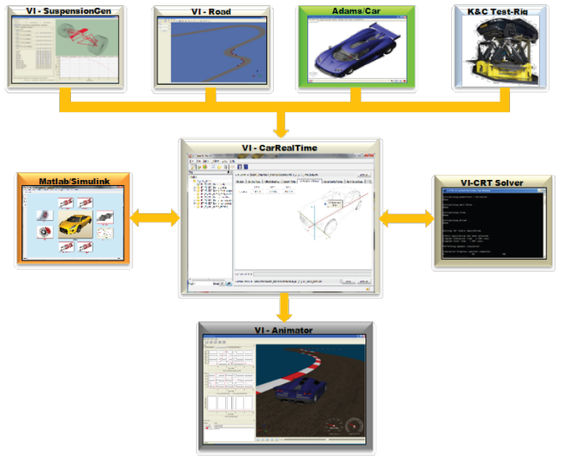

VI-Driver:
VI-Driver is practically speaking a control system designed to drive a vehicle model in a very simple and efficient way, it has been developed with the idea that the "driver" must be:
- robust enough to adapt to a wide range of vehicles characteristics
- simple to tune, and self-adapting whenever possible
- capable of driving on both limit and sub-limit maneuvers
To fulfill those requirements, the simplest vehicle model that captures the dynamical effects of interest has been chosen for the predictive controller: the classical bicycle model.

VI-Driver's lateral controller uses a model base predictive control technique, calculating at each instant in time the required control action; thanks to this technique VI-Driver model is able to calculate with very good approximation the required steering angle, necessary to bring back the vehicle on the target path, when a tracking error occurs, as well a final stage has been implemented, which compensates for the unmodeled lateral dynamics called "yaw rate controller", uses the reference path curvature and the actual vehicle yaw rate, and corrects the steering action with the yaw rate error to bring the vehicle instantaneous curvature as close as possible to the reference path curvature. As for longitudinal dynamics, a model based feedforward/feedback scheme is used to compute the needed torques to accelerate or brake the vehicle, based on the target speed profile coming from the stationary prediction.

CANOPY:

The key step is to transform the simulation problem into an optimisation problem, and simultaneously solve for the controls and the states of the system. Our collocation solver is integral to both our simulations platform and our self-driving solution.

Explorations: enable users to explore the parameter space of the car quickly and easily and in so doing, to find faster lap times. The way that explorations are configured in the Canopy Platform is very flexible, and therefore very powerful, let’s see briefly what practically does this tool and some of the different ways possible to configure them:

Explorations define which parameters of the car and how will be varied in a study.
For example, to run a sweep of fuel mass we would want to run several simulations, each with a different amount of mass added to the mass of the car, increasing from 0kg added at the baseline to 100kg added at the end of the sweep. Thanks to this tool it’s possible to define the afore mentioned sweep by one click and run many different simulations at one time.
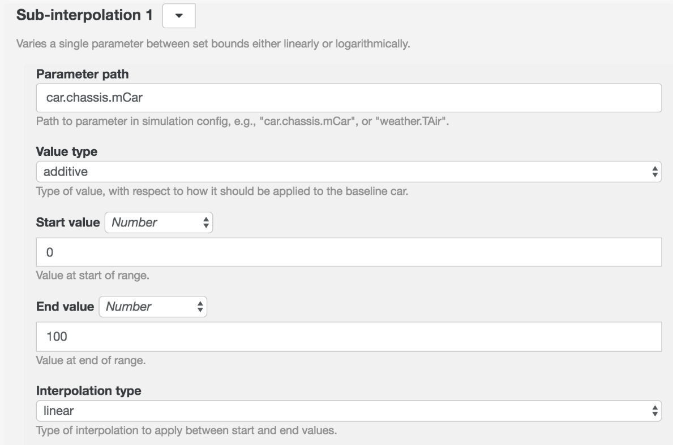
In this particular case, for example would be sufficient to configure an additive sweep pointing at the parameter car.chassis.mCar, in which we would define start and end values delimiting range of variability of that parameter. It’s possible also to make different parameters vary in parallel, increasing the so called “Dimension” of the exploration (if combination of different parameters have to be explored, and we are looking for specific quantities that should vary with different logics and different number of points have to be simulated, it’s also possible to increase the number of ranges).

Different types of explorations:
- Star: the more general case of a single sweep is a Star design exploration, a set of independent sweeps around a common baseline. Each sweep in a star can have a different number of points, and comprise a number of different sub-sweeps. A common example of a star exploration is the Fundamentals Study, whereby various fundamental parameters of the car are varied around a baseline to extract the sensitivities of the car to those parameters.
- Factorial: Whereas a star exploration varies the car along only one dimension at a time, a factorial exploration runs an experiment at every combination of every value in all dimensions. A star design with 3 dimensions, each with 10 points, specifies 30 experiments, a factorial design with the same 3 dimensions of 10 points each will contain 1000 experiments. When a small number of dimensions need to be fully explored, a factorial design can be ideal.
- Monte-Carlo: so called because it relies on randomness, much like the games of chance in Monte-Carlo's casinos, the Monte-Carlo method chooses random points inside the parameter space. The space is defined much as for the star and factorial designs, by specifying a number of dimensions, each comprising one or more sub-ranges. The difference between the dimensions of a Monte-Carlo design and those of a star or factorial is that in the Monte-Carlo case we do not specify a number of points for each dimension, rather we specify a number of points for the exploration as a whole. The dimensions then do not define where exactly the experiments will be carried out in parameter space, rather they define the bounds of a parameter hypercube within which points will be chosen at random as the locations of experiments.

Simulation Types
The Canopy Platform allows users to run several types of simulation. Each simulation type has its own particular uses and limitations; on this page we will explain what each simulation type does and what its uses and limitations are:
- Straight Sim
- Apex Sim
- Limit Sim
- Sub Limit Sim
- Quasi-Static Lap
- Generate Racing Line
- Virtual 4-Post Rig
- Dynamic Lap
- Dynamic Lap (SLS)
- Dynamic Multi-Lap
- Drag Sim
- Channel Inference
- Tyre Replay
- Thermal Replay

Straight Sim
Straight Sim is a straight-line simulation which finds the static equilibrium state (with no acceleration) of the car at a series of speeds from 0 to 100m/s. It is incredibly fast to run and is run by default when any other simulation type is run, and when the 'Validate Car' button is clicked in the car editor page.

Results
Several vector results are returned from Straight Sim, each one giving values for every speed from 0 to 100m/s. Scalar results are also returned for selected speeds, such as 100, 200, and 300kph, and for maximum speed, which itself is a scalar result!

Strengths
Runs incredibly fast and returns very useful setup information such as ride heights at various speeds, aero and mechanical balances across a range of speeds.

Limitations
There's only so much you can learn about your car by looking at straight line, constant speed equilibria.

Apex Sim
Apex Sim is very similar to Straight Sim except that where Straight Sim finds a true equilibrium for the car in a straight line, Apex Sim finds the quasi-static equilibrium of the car at zero throttle (slightly negative gLong) and maximum gLat. In other words it finds the mid-corner condition of the car on the limit of grip for a series of speeds between 10m/s and a few m/s below vMax, which the simulation inherits from Straight Sim.

Results
Exactly as for Straight Sim, but for the mid-corner condition as opposed to straight line.

Strengths
Again, very quick and yields essential setup information such as mid-corner aero and mechanical balances for all corner speeds.

Limitations
It is limited to returning the car state in a single condition.

Limit Sim
Limit Sim shares many characteristics with Apex Sim except that the user can customise the gLat-gLong angle for which quasi-static equilibrium is achieved. The user selects an angle in the g-g plane and focus in gLong from which a ray at that angle emanates. The purpose of providing a gFocus option is so that users can better explore the shape of the envelope at high speed, where the majority of the performance envelope is at negative gLong. angleInGGPlane, as illustrated below is defined with zero being pure gLat direction, pi/2 defining straightline acceleration and -pi/2 defining straightline braking. The simulation will sweep from 10m/s to a few m/s below vMax, which the simulation inherits from Straight Sim. At each point along this sweep we determine the edge-of-envelope position along the ray.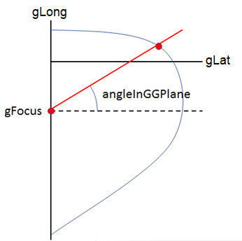

Results
Exactly as for Apex Sim, but for the user defined condition.

Strengths
Again, very quick and yields essential setup information for a specific car condition which might be important in defining the balance of the car.

Limitations
Does not return a lap-time, nor any telemetry from around a lap of the track. When trying to extract edge of envelope car performance from Limit Sim, since the car is balanced on a knife edge there can be relatively large changes in car state for relatively small changes in parameters.

Sub Limit Sim
To compliment Limit Sim, it might be useful to evaluate the car state slightly below the limit of performance. Operating sub limit means there are infinitely many car states that can achieve the desired performance versus just one state at the limit. The user provides a series of vCar-gLat-gLong operating points. The points are evaluated independently and the following equation is used to pick a benign low slip solution from all available options which could achieve the desired operating performance:sum(rSlipTyreXX^2 + aSlipTyreXX^2)sum(rSlipTyreXX​2​​+aSlipTyreXX​2​​)

Results
All the normal channels that can be found in Limit Sim are returned for every user specified operating point.

Strengths
Operating below the limit of performance means that this simulation has the liberty of picking a benign car state, rather than having to chase some awkward operating state for an infinitesimally small gain in performance. This can give more predictable and stable changes in simulation results when modifying car setup.

Limitations
If any of the operating points lie outside of the performance envelope, the simulation will still run, but those points are excluded from the simulation results with a suitable warning provided.

Quasi-Static Lap
This is the traditional workhorse simulation of Formula 1, thousands of Quasi-Static Laps are run daily and used as the cornerstone of F1 car development and design. This simulation finds the quasi-static equilibrium of the car at every point around the track which is consistent with the speed and acceleration of the points surrounding it. The states of the car (other than speed) are not necessarily continuous in the resulting lap simulation, and because the quasi-static equilibrium of the car is found at every point, no transient dynamics appear in the results.

Results
Around 200 channels (a constantly growing number) reported against the distance/time axis for car states and other car outputs around the lap, along with a single scalar result; the lap-time.

Strengths
Taking approximately 1min of execution time to complete an average lap, this is one of the fastest (not to mention most high-fidelity) quasi-static lap simulations in the world. Running large explorations with this simulation will map out the lap-time landscape of whole regions of your car's parameter space. The effect of DRS can be included for defined DRS zones around the lap using Quasi-Static Lap.

Limitations
Due to the quasi-static nature of this simulation, dynamics such as dampers, gear-shift oscillations etc. are not captured. It is also not possible to vary the use of energy by the powertrain with Quasi-Static Lap, instead the available elements of the powertrain (KERS, MGUH, etc.) are fully deployed wherever it is advantageous to do so - no energy limits can be imposed. In almost every respect other than execution time it is better to run Dynamic Lap to get more accurate simulation results, however if you just want to take a quick look-see, then Quasi-Static Lap does a good job.

Generate Racing Line
Another simulation which is powered by the Canopy Collocation Solver, Generate Racing Line does exactly what it says on the tin. Given a car and a track definition containing only the x-y coordinates of the track edges, Generate Racing Line will find the racing line which enables the given car to lap the track in the shortest time in Quasi-Static Lap. The resulting line can be saved as a track itself, to be used in subsequent studies. This is not requried for Dynamic Lap which can automatically generate its own line.

Results
The result returned is a new track definition containing the newly calculated racing line. This can be saved as a user-defined track and used in subsequent studies.

Strengths
The ability to generate a racing line specific to a particular car is valuable in two ways; firstly it allows you to run studies and optimise your car towards circuits that are as-yet unfinished, or which have not been raced at before for which only track edge data exists. Secondly it allows the re-generation of a racing line for changes in setup or regulations which significantly effect the grip/power balance of the car. In our experience the change in racing line precipitated by a change in mechanical grip, or aero regulations for example, is a significant factor in determining the lap-time sensitivity of the car to such a change. Thus the ability to run Generate Racing Line enables you to see second-order effects that your competitors may well miss.

Limitations
Care should be taken when defining the track edges so that an appropriate amount of curb can be taken by the car. The car front wheel centre isn’t allowed to pass over the track edge. Where the car is allowed to cut the corner more you may like to move the track edge out slightly. This simulation has been largely superseded by Dynamic Lap which can automatically generate its own optimal racing line without having to run Generate Racing Line first. If you plan to run a Dynamic Lap, then it is better to let Dynamic Lap automatically pick the racing line, as it will do a better job than Generate Racing Line. The main use for Generate Racing Line is if you want to run a Quasi-Static Lap, as Generate Racing Line has been designed to produce racing lines for this simulation (although Dynamic Lap does a great job of producing racing lines which also work with Quasi-Static Lap).

Virtual 4-Post Rig
Assessing the direct effect of changes to damping and other ride variables on lap-time is fiendishly difficult. Formula 1 teams have spent years trying to reflect ride dynamics in lap-time simulation, all to no avail. The solution which has been arrived at after these years of ride analysis and tool development is to use a Virtual 4-Post Rig simulation. Unlike the simulations above, Virtual 4-Post Rig runs the car fully dynamically. The car is run over a defined road profile by feeding the road heights into the four corners (wheels) of the car in continuous time. The results show the dynamic response of the car to the given road profile, enabling analysis of contact patch load variation and (through the Canopy Platform's infrastructure) exploration of how changes in damping and compliance will affect ride characteristics.

Results
Time series data reflecting the states of the car as they react dynamically to the applied bump profile. In addition, scalar ride metrics are returned allowing for rapid optimisation of ride performance by leveraging the Canopy Platform's huge capacity for running many simulations.

Strengths
Years of R&D by top Formula 1 teams have arrived at this solution as being the best way to tune ride dynamics in offline simulations. Far more accurate and reliable than a forward-marching dynamic lap simulation with a driver model.

Limitations
Whilst the true dynamics of the car are fully modelled in the Canopy Vehicle Model, and thus reflected in Virtual 4-Post Rig, your driver's preferences for curb riding are not. It is expected that the setup arrived at with Virtual 4-Post Rig will require some fine-tuning trackside.

Dynamic Lap
The holy grail of lap simulation. A fully dynamic simulation with no driver model, achieving the maximum performance of the car, including all of its dynamics, without any assumptions about how it is driven. Even the racing line is computed as part and parcel of this simulation. Dynamic Lap solves every state of the car model at every point on the track simultaneously to give a dynamically consistent state trajectory which traverses the lap in minimum time subject to any number of algebraic or integral constraints on it's behaviour. For example, Dynamic Lap can minimise lap time subject to constraints on both energy consumption and tyre usage simultaneously. Dynamic Lap can also solve for minimum time including slow dynamics such as high-rebound damping, banked corners, and bumps such as those which characterise tunnel-turns in NASCAR. As if that weren't enough, Dynamic Lap can also optimise one or more parameters of the car for minimum lap-time whilst it's simulating the lap, examples include stiffness of suspension components, size of battery, ride heights etc. etc...

Results
As for other lap simulations but including transient dynamics and full state-consistency and lap-time sensitivity

Strengths
Fully dynamic simulation of your car; ability to include numerous otherwise neglected dynamic effects such as rebound damping, bumps, battery thermal dynamics, tyre thermal dynamics, aeroelasticity, wake catch-up etc. etc.; automatic re-optimisation of racing line; optimisation of car parameters.

Limitations
Tendency to expose the limitations of your drivers! For the solver to function special care must be taken with the vehicle model. Lookup tables must be nice and smooth (this is one reason why we prefer parametric functions). The car must have dampers in. Dynamic lap may have some difficulties following a racing line generated from telemetry as there may be a mismatch in car dynamics. The order of precedence for racing line use is: i) use track edges and optimise racing line as part of the simulation, ii) if track edges are not available use saved centre line and optimise racing line, iii) if centre line not available used fixed racing line. Dynamic lap can follow sLap and cLap generated from a Dynamic lap run on a similar car if for some reason you wish to restrict all cars in a study to the same racing line. Conversely Quasi-Static Lap will only follow the fixed racing line (run generate racing line first, if only track edges are available).

Dynamic Lap (SLS)
The same as Dynamic Lap except it adds in the computation of additional output channels for Secondary Lap Sensitivities. These local sensitivities help us to evaluate complex engineering trade-offs.

Results
Additional vector outputs are computed for lift & drag coefficients, ride heights, mass, power and grip. As an example, if we want to use the SLS channels to obtain a laptime estimate for an increase in power at a specific point around the lap: Laptime difference = Integral of dTLap_drEnginePowerFactor w.r.t. distance * Increase in rEnginePowerFactor
Cars with electric motors also have the following channels:
dTLap_drElectricPowerFactor: Improvement in laptime for an increase in rElectricPowerFactor for that particular meter around the track (an increase in rElectricalPowerFactor of 1 would mean a doubling in power (increase from 1 to 2)).
dTLap_dPElectricPowerOffset: In a lift zone, changing power factor has no effect since power = 0, so this channel shows the improvement in laptime for a 1 Watt increase in power at that particular meter around the track.
Where the powertrain is energy limited, applying an increase in power violates the energy constraint, so if you're using the above channels to find out how much time you'd gain from extra power at a specific point around the circuit, remember to reduce power elsewhere to balance the energy (or re-run the sim with slightly less energy to find the time lost). Alternatively, you can use the following channels:
dTLap_drElectricPowerFactorWithLapEnergyConstraint: The extra energy required to provide the increase in power is accounted for, so no need to compensate elsewhere, hence why this channel is less than dTLap_drElectricPowerFactor when energy limited.
dTLap_dPElectricPowerOffsetWithLapEnergyConstraint: Again, takes the extra energy into account.

Strengths
When we're deciding whether to fit a component or make a setup change, we typically gain in some places, but lose in others. SLS allows you to identify where these gains/losses originate.

Limitations
The SLS are strictly speaking only valid for infinitesimally small changes, however fortunately they hold up reasonably well for significant changes. This can be tested by running an exploration sweep of a parameter (such as mass) to find the gross laptime sensitivity and comparing it to the integral of the SLS channel (w.r.t. distance).
The SLS output channels take roughly 2 minutes to compute, hence we've made it a separate simulation to Dynamic Lap in order to give users the choice.

Dynamic Multi-Lap
In the same way as Dynamic Lap can optimise for energy over a single lap, Dynamic Multi-Lap can run this optimisation for an entire race stint, while including the thermal dynamics of the powertrain. To enable thermal powertrain, we must enable a cooling loop on the car (see cooling section of wiki).

Results
The initial intention of this simulation is to do a full stint optimisation. When combined with a battery derate map, we can find the quickest deployment strategy for the race taking temperature and thermal constraints into account. We can also add strategy weights for each lap to account for some laps being strategically more important than others. If you have other applications for this simulation, for example tyre energy optimisation, we would be happy to discuss your needs.

Strengths
A much quicker way to work out the optimal deployment than could be achieved by running individual laps.

Limitations
The additional complexity of this simulation requires access to a powerful heavy compute pool which comes at an additional cost. The optimisation problem is much larger than running a single lap, which can have an adverse effect on the reliability of convergence.

Drag Sim
This is a fully dynamic simulation, which accelerates, then brakes as hard as possible for a duration of 30sec.

Results
As per dynamic lap but for straight line braking and acceleration only.

Strengths
Tuning straight line acceleration and braking performance.

Limitations
Same limitations as dynamic lap.

Channel Inference
Working backwards from telemetry data, this simulation uses the vehicle model to estimate the value for channels which were not measured directly. It uses the quasi-static equilibrium of the car and an inverse tyre model (see below) to make these deductions. Channel Inference doesn't have to be run on track data, a laptime simulation output can be staged as telemetry. In this way it is possible to look at the effect of small changes in car setup on balance, for example if two inference sims are run with different rear anti-roll bar rising rates on the same telemetry we could examine delta rLatBalF in the results to see how this might affect car balance at particular points around the circuit. While this is a simplification, because we wouldn't achieve exactly the same vCar-gLat-gLong around the circuit after the setup change, it can be easier to interpret than a lap simulation, because the lap driven doesn't change.

Inverse Tyre Model
In order to attempt to generate realistic tyre loads, while also achieving the accelerations provided in the user telemetry. A challenge with simulations of this type is that if we use a conventional tyre model we will find situations where the combination of gLat and gLong provided by the user is outside the operating envelope of the car. We therefore choose a method where, based on the car attitude, we construct a set of tyre forces which provide the requisite gLat and gLong while splitting Fx and Fy between front and rear axles in a manner which is consistent with the loads on the tyres. We achieve this by applying three fictitious forces to the car:
- Total Fx offset.
- Fy offset at front axle.
- Fy offset at rear axle.
We then split these forces between the tyres as follow:
- Total Fx is split between front and rear in proportion to the static brake balance on braking.
- The front Fx and Fy are split between left and right in proportion to the Fz at each tyre.
- The rear Fx and Fy are split between left and right in proportion to the Fz at each tyre.
In this way we construct a set of forces which are broadly realistic. A variety of more subtle factors, such as µ-degradation are neglected, but the first order effects fulfil our main criteria.
Tyre slips are estimated by feeding the tyre forces and camber angle output into an optimiser wrapped around the tyre model to back calculate slips.

Inputs
Required: timeBase, vCar, gLat, gLong.
Optional: gVertAccelerometer, aTrackCamber, aSteerWheel, aRockerXX or xDamperXX or xDamperPotXX. To simulate DRS: rDRSActivation.
Channel Inference options: Select whether to use rocker angles, damper displacements or damper pot displacements.

Results
Subset of channels that are available from Quasi-Static Lap. These can be used for estimating:
- Aero Loads.
- Suspension Loads.
- Tyre Loads.
- Tyre Slips (see limitations below).

Strengths
Allows a more detailed and insightful analysis of track data; or when run on simulated data makes it easier to deduce what the balance change might be for small setup changes.

Limitations
The effect of car dynamics are not included. The total Fx should be reliable, but the front/rear Fx split is a simplification and does not take the diff or regen into account. Tyre slips may be an under estimate:
- If FxTyreXX and FyTyreXX are outside the range that can be achieved by the tyre model, the tyre model grip is increased to make sure the forces fit within the tyre ellipse.
- There are two solutions to choose between where the tyre slip produces a given force, one before peak µ and the other post peak, the latter is usually the case for the unloaded tyre during limit handling e.g. front locking, or during extreme understeer. The solution returned by Channel Inference is always the low slip solution before peak µ.

Tyre Replay
Enables you to interrogate the tyre model in detail as you make changes to the tyre parameters (Canopy or Pacejka). Tyre forces are returned for each of the tyre input conditions allowing you to fully explore the model. Tyre parameters can be changed as part of an exploration which would make it easy to sweep through and export the data required to make your own tyre tweaker.

Inputs
Required: tRun, FzTyreXX, aSlipTyreXX, rSlipTyreXX, aCamberTyreXX.

Results
Tyre forces & moments: FxTyreXX, FyTyreXX, MxTyreXX, MzTyreXX.

Thermal Replay
Telemetry data is fed through the thermal model with the parameters from the staged car in order to emulate powertrain, tyre or brake temperatures. Large explorations can be run to tune thermal parameters to get correlation to track data, in preparation for running a Dynamic Lap or Dynamic Multi-Lap which will give the optimal stint performance when taking temperature into account.

Inputs
Required: timeBase, vCar and PMotor (electric) or rThrottlePedal (ICE).
Optional: TBattery or TEngine (if you want mean squared delta correlation metrics).
Some notes:
- See notes in cooling section on how to parameterise the powertrain.
- The motor names in the telemetry inputs must correspond to motor names in the powertrain section of your car. In case you run direct-drive motors, you can specify Left and Right side PMotor outputs separately.
  - The option for specifying PMotorMeasurementPosition as either Motor electrical terminals or Motor output shaft is picked up from the staged car.

Results
Electric thermal channels: TBattery, TBatteryDeltaToRef, TBatteryDeltaToRefMeanSquared, TMotor and rStateOfCharge. ICE thermal channels: TEngine, TEngineDeltaToRef, TEngineMeanSquaredDeltaToRef.

