1. Getting Started
To log in, enter tenant slug, email, password then click "Sign In to Clinic".
Sidebar modules: Clinical Care, Laboratory, Pharmacy, Supply & Inventory, Billing, Compliance, Renal Care, System.
Dashboard shows appointments, pending orders, prescriptions, requisitions, billing totals.
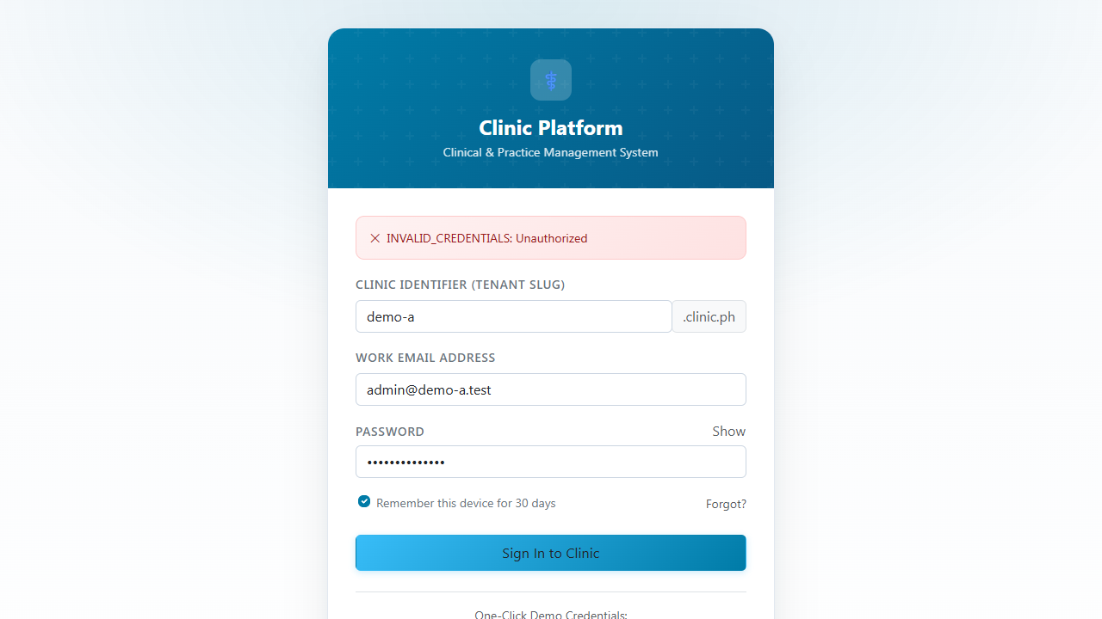

2. Tenant Administration
Users screen lets admins create/update/deactivate accounts.
Roles define access with SoD enforcement; Clinical, Pharmacy, Lab, Supply, Billing, Renal Care (Nephrologist, Dialysis Nurse, Tech), System.
Branches represent facilities with location-specific stock.
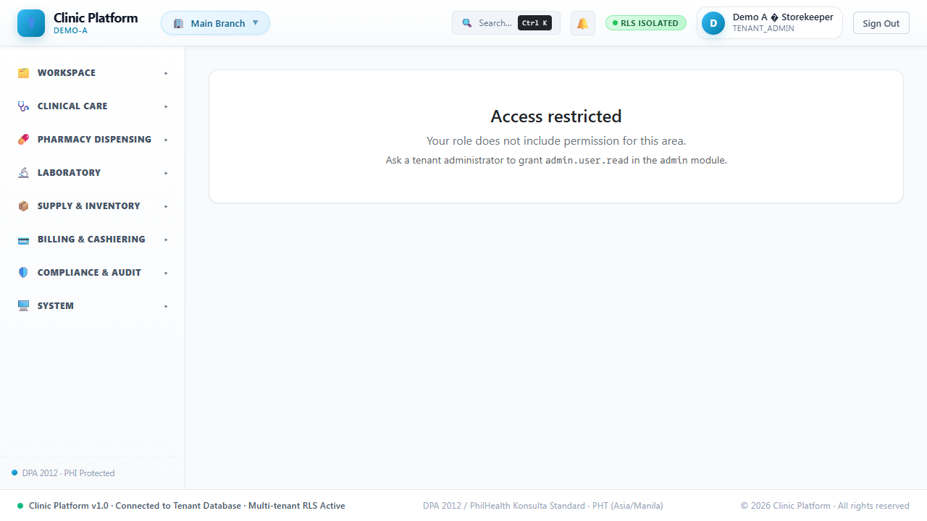

3. Patients
Patients screen is master index (Clinical > Patients).
Create with demographics; MRN auto-generated.
Documents can be uploaded and tagged.
All changes logged in audit trail.
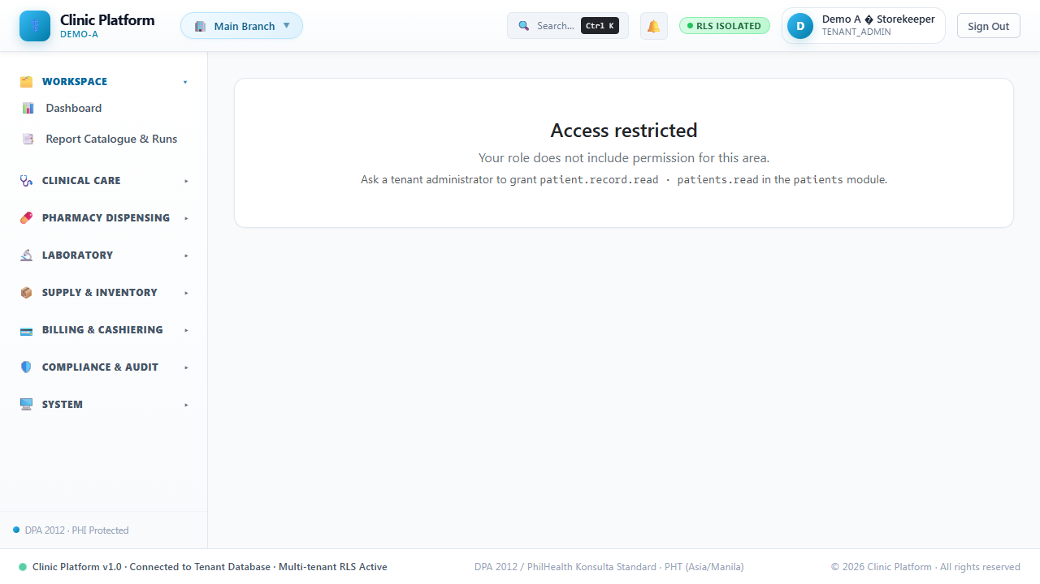

4. Clinical
Appointments screen calendar; book/reschedule/cancel.
Visits capture vitals and SOAP notes; notes locked when signed.
Prescriptions checked for interactions/allergies.
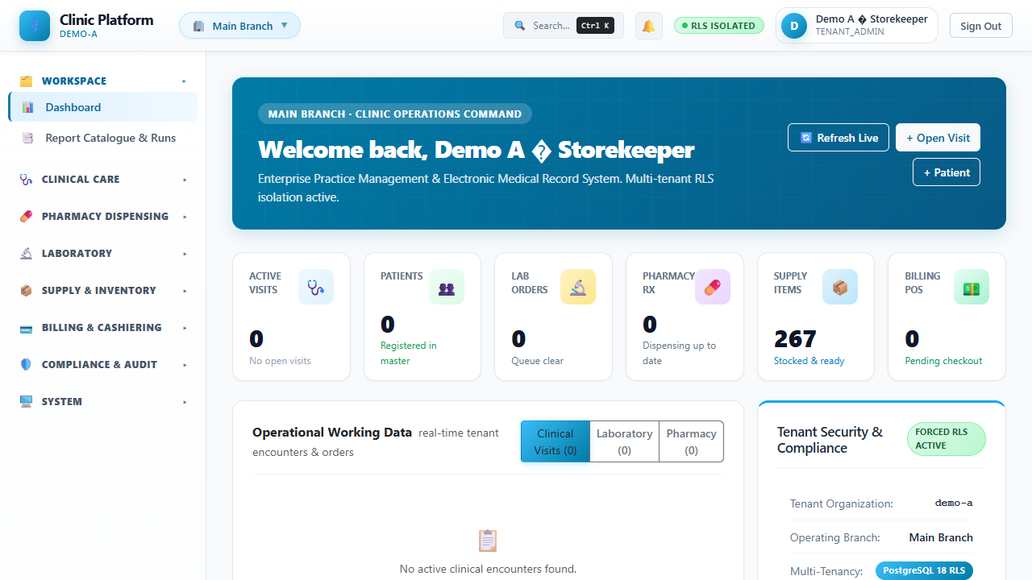

5. Laboratory
Test Catalog defines tests with LOINC, specimen type, reference ranges, price.
Worklist tracks status: ORDERED, COLLECTED, ENTERED, VERIFIED, RELEASED.
Two-person verification (AC-17) enforced; critical values trigger alerts.
Reports downloadable as PDF/CSV.
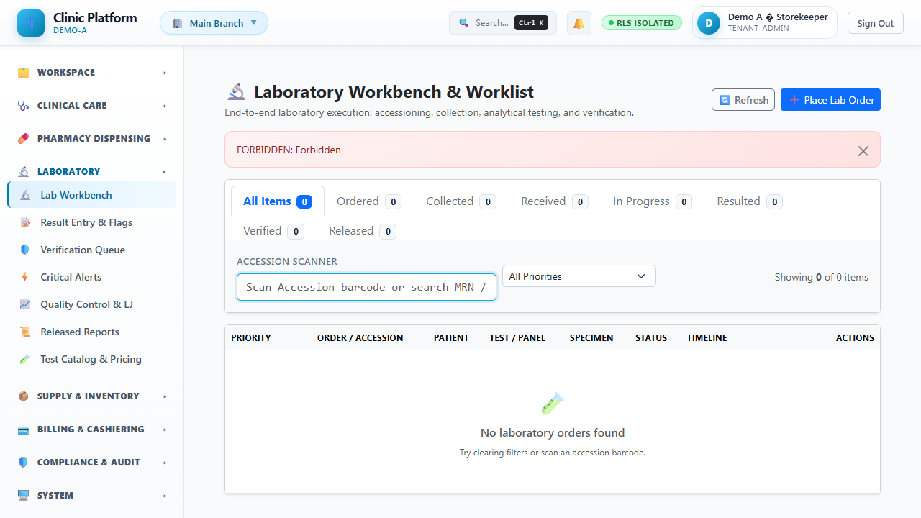

6. Pharmacy
Drug Master catalogs medications with formulary, controlled flag.
Pharmacy Queue for Rx verification.
Dispensing uses FEFO (First-Expired, First-Out).
Controlled drugs logged with witness signatures.
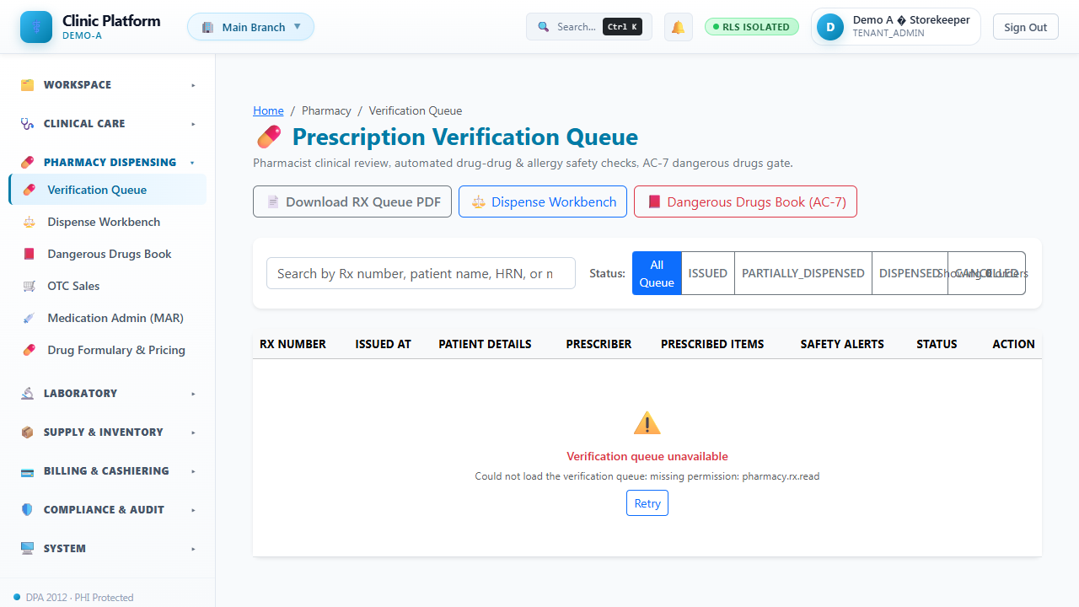

7. Central Supply
Item Master catalogs supplies; Locations define storage hierarchy.
Requisitions internal requests → APPROVAL → PICKED → ISSUED → CLOSED.
Purchase Orders external supplier orders.
GRN matches delivery to PO.
3-way match: PO, GRN, Invoice must agree.
Cycle counts verify stock.
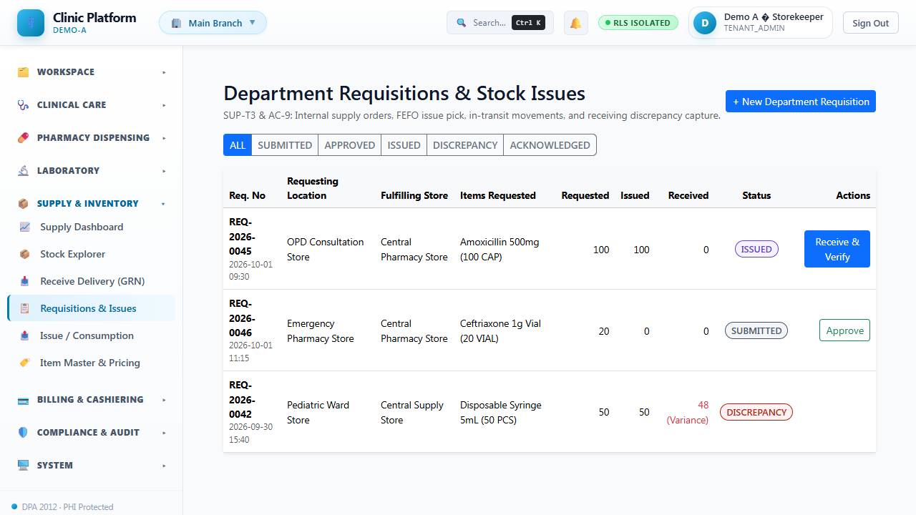

8. Billing & Cashiering
Charges created on service render; POS generates invoices.
Payments via cash, card, insurance; supports split payments.
Cashier shifts track drawer; close counts versus system.
Credit notes for refunds with audit trail.
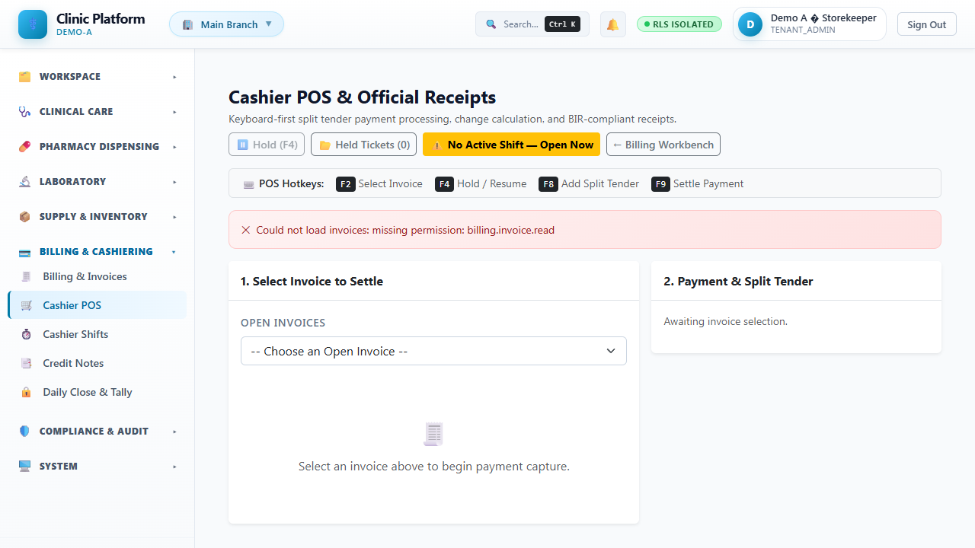

9. Compliance & Audit
Audit Trail logs all actions with user, timestamp, IP.
PHI Access Log tracks health data views per Data Privacy Act.
Consents recorded; DSR workflow: receive → verify → start → complete/reject.

10. Reports & Exports
Dashboard provides CSV/XLSX: Patient Census, Lab TAT, Pharmacy, Stock Ledger, AR Aging, Shift Summary.

11. Renal Care
Stations screen catalogs dialysis chairs/machines with capacity and equipment.
Schedule via appointments; workflow SCHEDULED → CHECKED_IN → IN_PROGRESS → COMPLETED.
Session management records pre/intra/post vitals and flowsheets.
Renal prescriptions by Nephrologist drive scheduling.
Dialyzer management with expiry tracking; system quarantines expired stock.
RO Water Quality monitoring; weekly tests logged.
PhilHealth dialysis claims generated from completed sessions.

12. Frequently Asked Questions
Login — Password reset via admin; Nephrologist/Dialysis Nurse/Dialysis Tech roles required for Renal module access.
Can't schedule dialysis? Patient needs active renal prescription from Nephrologist.
Submit PhilHealth claim? Complete sessions generate EPR file via Renal Care > Claims.
Expired dialyzer? System quarantines it; contact Supply for return/adjustment.
Water quality logged weekly; conductivity, pH, bacterial count tracked.
Vascular access history in patient's Renal tab.

