SITHEMR
Out-Patient Department (OPD)
User Guide & Step-by-Step Workflow

Complete workflow from patient encounter creation
through SOAP documentation, doctor orders (Pharmacy, Lab, CSR, Radiology, Procedure),
and result dispensing.

Table of Contents
1. Introduction
2. Logging In
3. Dashboard Overview
4. OPD Consultations List
5. Creating a New OPD Encounter
5.1 Opening the New Encounter Modal
5.2 Searching for a Patient
5.3 Selecting a Patient
5.4 Filling in Grid Selects (Clinic, Doctor, Type, Visit)
5.5 Reviewing the Form Before Saving
5.6 Saving the Encounter
6. Consultation / Treatment View
6.1 Opening the SOAP Form
6.2 Filling SOAP Notes
7. Placing Doctor Orders
7.1 Order Medications (Pharmacy)
7.2 Order Labs
7.3 Order Supplies (CSR)
7.4 Order Radiology
7.5 Order Procedure
7.6 Viewing Placed Orders
8. Saving the Consultation
9. Lab Results
10. Lab Dispensing
11. Pharmacy Dispensing
12. Quick Reference

1. Introduction
This guide provides a complete, step-by-step walkthrough of the SITHEMR Out-Patient Department (OPD) module. It covers the entire patient visit lifecycle: from creating a new encounter, recording SOAP clinical notes, placing doctor orders across all five order types (Pharmacy, Laboratory, CSR Supplies, Radiology, and Procedures), to viewing lab results and dispensing medications.
The OPD module is the core clinical workspace where doctors and healthcare professionals manage outpatient consultations. Each encounter is assigned a unique consultation code (OPD-XXXXX) and tracks the patient's clinical journey through various statuses: Pending, In Progress, Completed, or Cancelled.

2. Logging In
Access the SITHEMR application at the hospital's designated URL. The login page requires a registered email address and password. Hospital administrators and doctors use their credentials to access the system.
Steps:
1. Navigate to the login page.
2. Enter your registered email address in the Email field.
3. Enter your password in the Password field.
4. Click the Sign In button to access the dashboard.
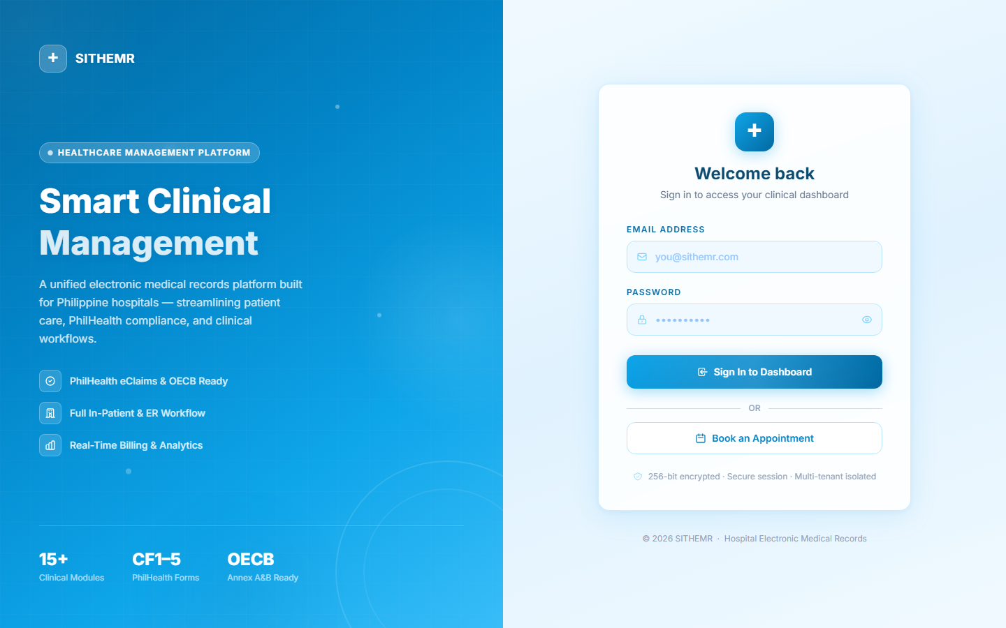
Figure 1: SITHEMR Login Page — enter your credentials to access the system.
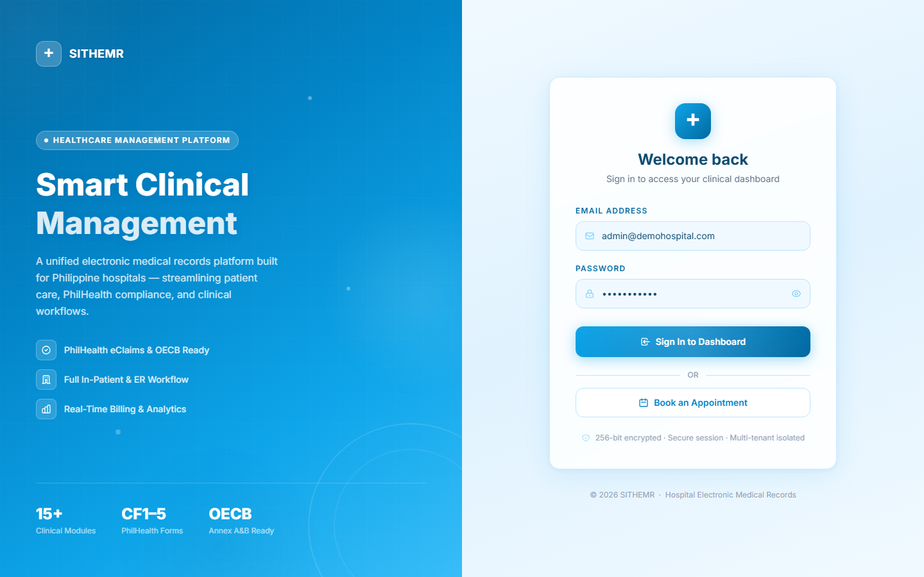
Figure 2: Login Page with Credentials Filled — email and password entered.

3. Dashboard Overview
After successful login, you are directed to the Command Center dashboard. This is the main landing page that provides an at-a-glance overview of hospital operations including patient census, appointment counts, pending tasks, and key performance indicators. The sidebar navigation on the left provides access to all modules in the system.
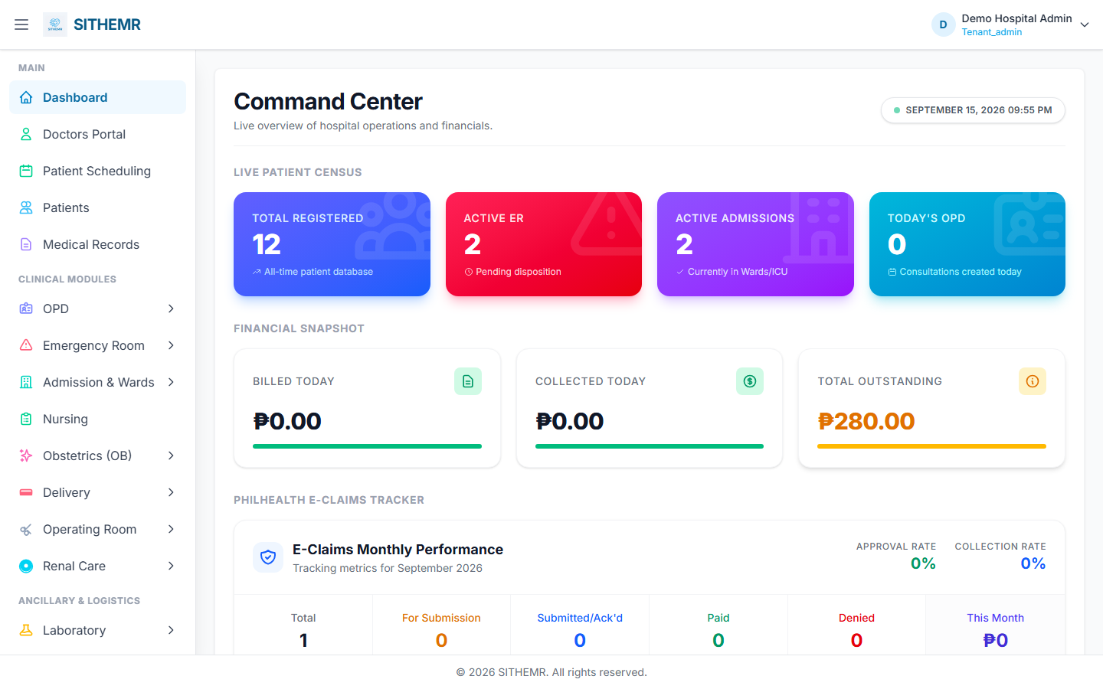
Figure 3: Command Center Dashboard — main landing page after login with sidebar navigation.

4. OPD Consultations List
The OPD Consultations page displays all outpatient encounters in a data table. Each row shows the consultation code, date/time, patient name, clinic, attending physician, status, YAKAP flag, and action buttons. Use the search bar to filter consultations by patient name or code. The page supports pagination and column sorting.
Key features:
- Search: Filter consultations by patient name or consultation code in real-time.
- Pagination: Control how many rows to display per page (10, 25, 50).
- Sorting: Click any column header to sort ascending or descending.
- Actions: Each row has Check-in Vitals and Consult / Treat buttons for clinical workflow.
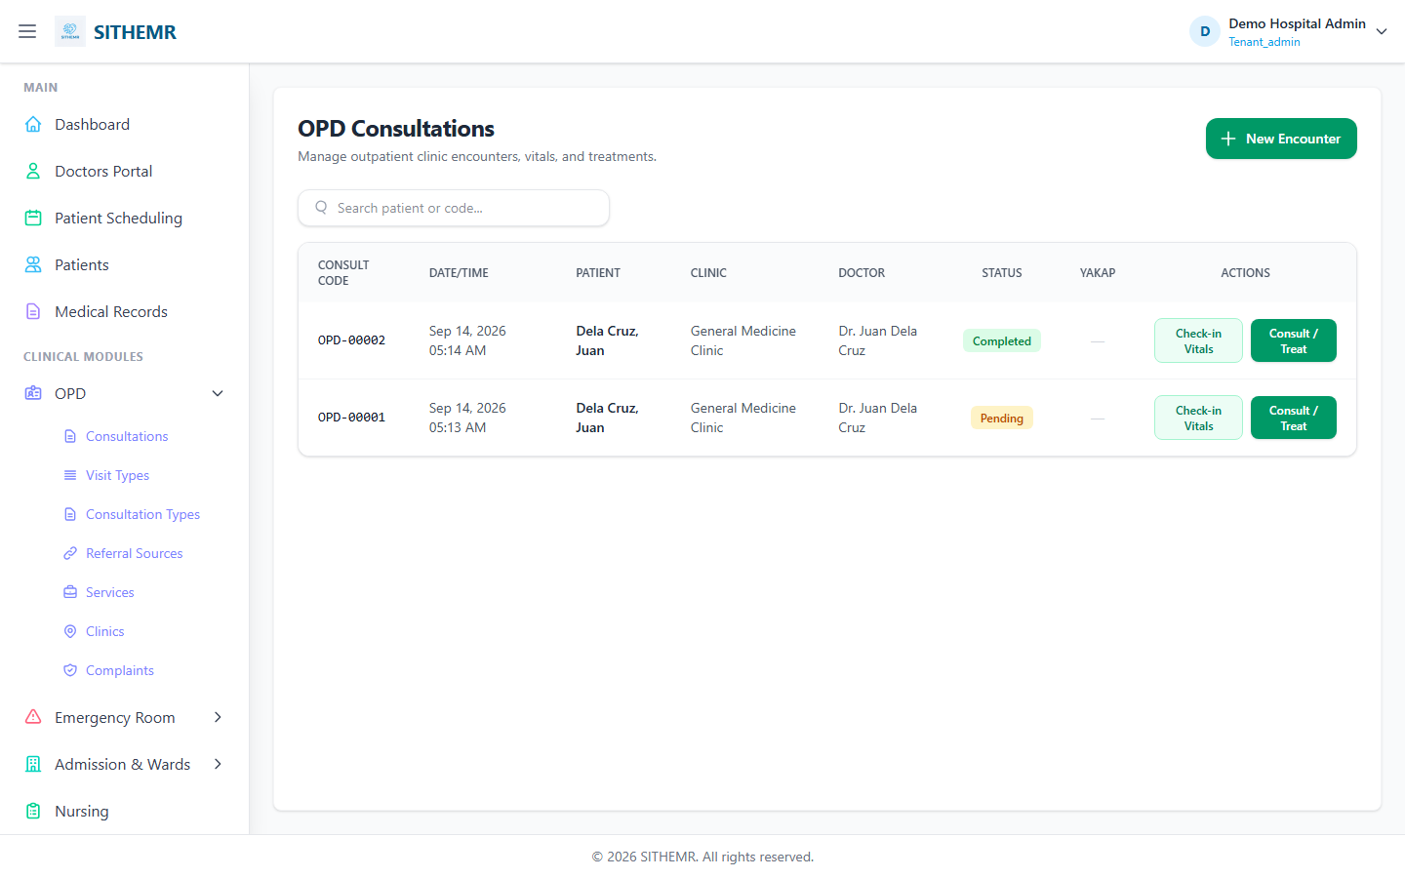
Figure 4: OPD Consultations List — table view of all outpatient encounters with search, pagination, and action buttons.

5. Creating a New OPD Encounter
A new OPD encounter is created when a patient arrives for an outpatient consultation. The encounter record serves as the foundation for all clinical documentation, orders, and billing for that visit.

5.1 Opening the New Encounter Modal
Click the "New Encounter" button located at the top-right of the OPD Consultations page. This opens a modal dialog containing the encounter creation form with mandatory fields for patient selection and encounter classification.
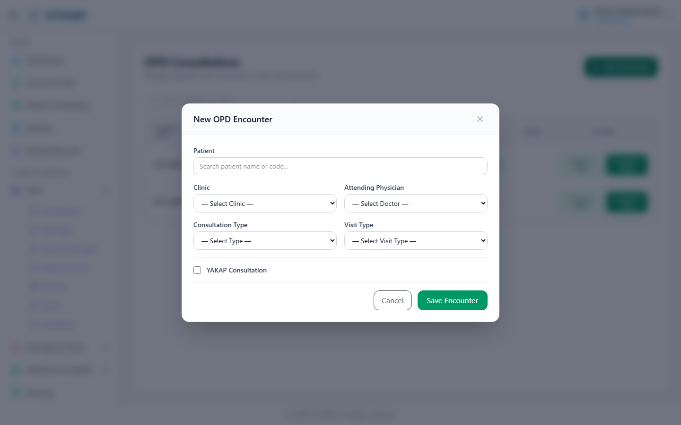
Figure 5: New Encounter Modal — form opened with patient and classification fields.

5.2 Searching for a Patient
In the Patient field, type the patient's name or patient code in the search input. The system performs a live AJAX search and displays matching results. Type at least 2-3 characters to trigger the search. The search is debounced (300ms delay) to avoid excessive queries.
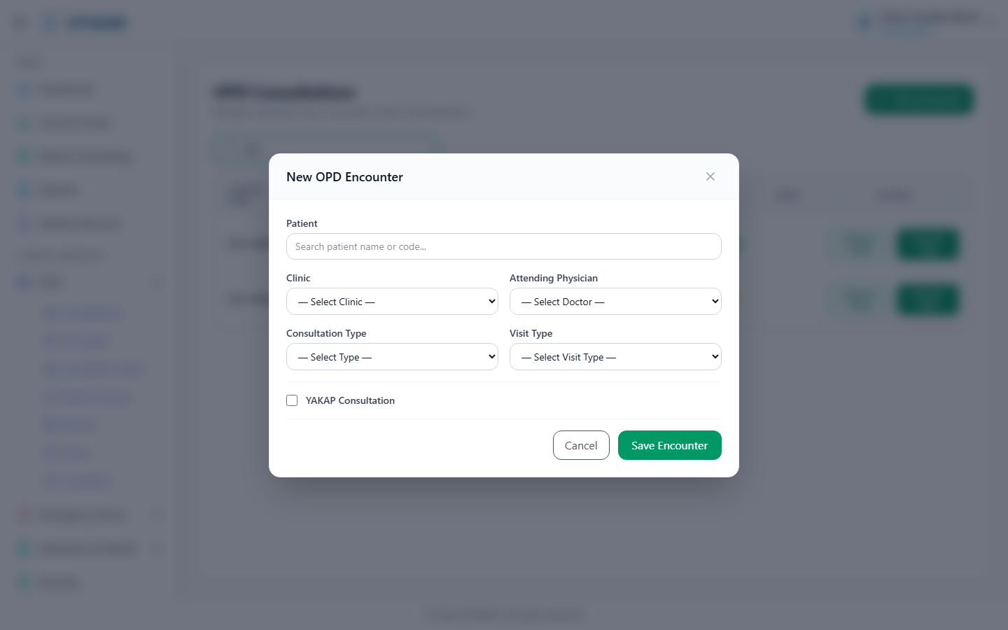
Figure 6: Patient Search — typing "Juan" in the search field triggers AJAX results.

5.3 Selecting a Patient
Click on the correct patient from the search results dropdown. Once selected, the patient's name appears in a green confirmation box within the form, and the search field is cleared. The system stores the patient's ID for the encounter record. To change the selection, click the X button on the green box.
Figure 7: Patient Selected — Juan Dela Cruz confirmed in green selection box.

5.4 Filling in Grid Selects (Clinic, Doctor, Type, Visit)
The encounter form contains four dropdown selectors arranged in a grid layout. Each must be filled before saving:
a) OPD Clinic — Select the clinic/department where the consultation takes place (e.g., General Medicine, Cardiology, Pediatrics). This determines which doctors are available in the next dropdown.
b) Attending Physician — Select the doctor who will conduct the consultation. Only doctors associated with the selected clinic are shown.
c) Consultation Type — Classify the visit: New Patient, Follow-up, Referred, or other types configured in the master data.
d) Visit Type — Specify the nature of the visit: General Consultation, Check-up, Emergency, or other visit classifications.
Additional fields may include Referral Source (where the patient came from) and a YAKAP flag (for community health program patients). The referral source and YAKAP fields are optional depending on your hospital's configuration.
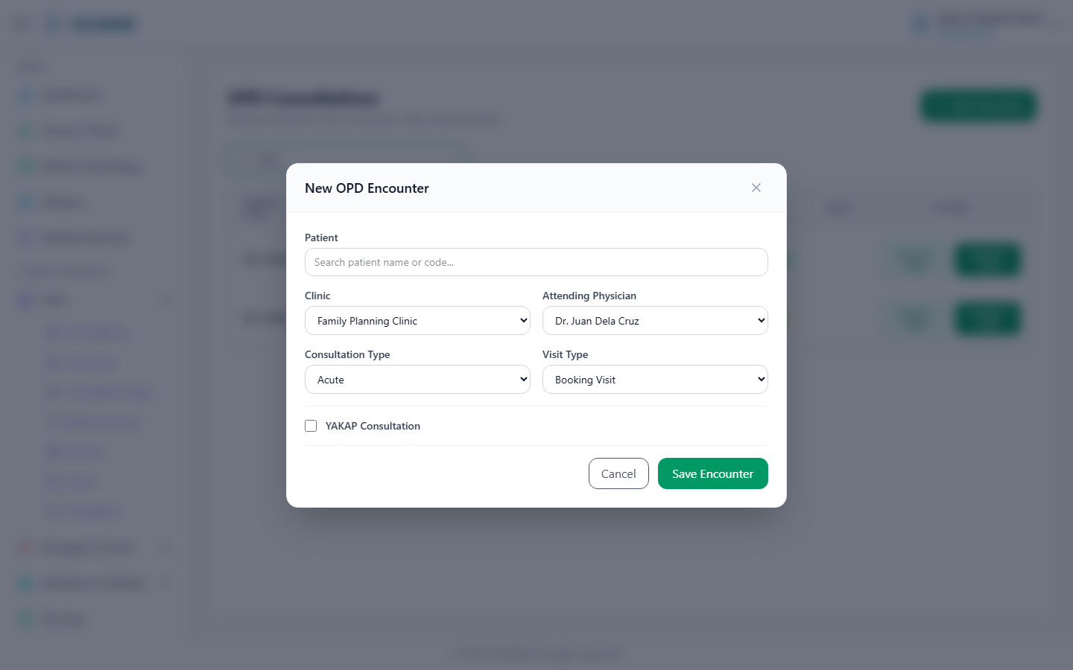
Figure 8: Encounter Form Before Filling — all four grid selects empty, ready for input.

5.5 Reviewing the Form Before Saving
Before saving, review all selected values. Verify that the correct clinic, physician, consultation type, and visit type are selected. The patient name should appear in the green confirmation box. If any field is missing or incorrect, use the dropdown to make corrections. The form cannot be saved with missing required fields — the system will display validation errors for any blank required fields.
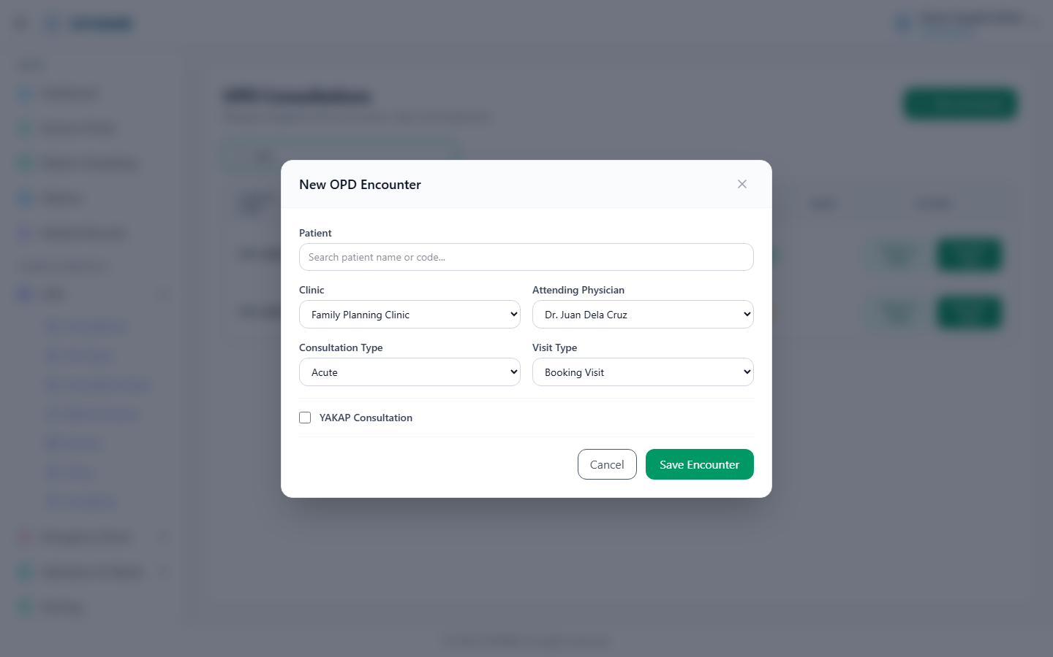
Figure 9: Encounter Form Fields Filled — all grid selects populated with values.

5.6 Saving the Encounter
Click the "Save Encounter" button (or the submit button at the bottom of the modal) to create the encounter. The system generates a unique consultation code (e.g., OPD-00001) and saves the record with status "Pending." A green success toast notification appears confirming the creation. The modal closes and the patient appears in the consultations list.
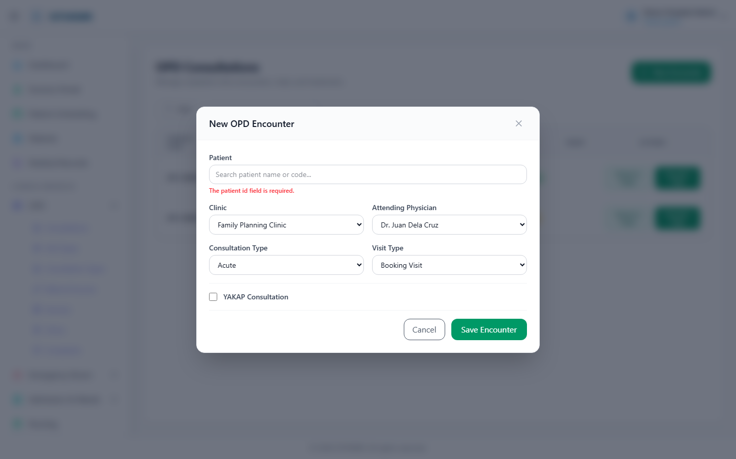
Figure 10: Consultations List After Save — new encounter OPD-00001 appears in the table with Pending status.

6. Consultation / Treatment View
After creating an encounter, click the "Consult / Treat" button on the corresponding row to open the clinical documentation view. This transitions from the list view to the doctor's consultation workspace where SOAP notes are written and orders are placed.

6.1 Opening the SOAP Form
The consultation view is divided into two panels: a left sidebar showing patient summary (name, code, clinic, date, vitals, chief complaint) and a main area with the SOAP form and order buttons. The SOAP form contains four text areas: Subjective (History of Present Illness), Objective (Physical Exam Findings), Assessment (Diagnosis), and Plan (Treatment). Additional fields include Disposition (Discharged/Admitted/Transferred/Follow-up) and Follow-up Date.
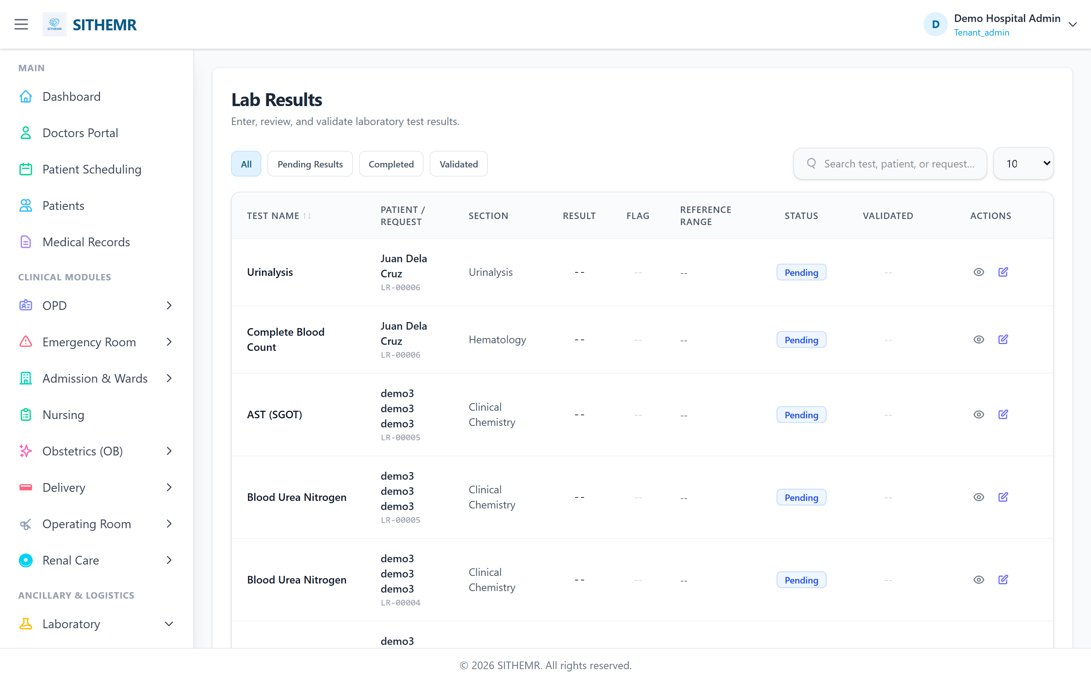
Figure 11: SOAP Form View — clinical documentation panel with Subjective, Objective, Assessment, and Plan fields, plus order buttons.

6.2 Filling SOAP Notes
Complete all four sections of the SOAP note:
Subjective (HPI): Document the patient's own description of symptoms, duration, severity, and relevant history in their own words.
Objective (Physical Exam): Record clinical findings from your examination — vital signs, physical observations, test results, and measurable data.
Assessment (Diagnosis): State your clinical impression or diagnosis. This may include differential diagnoses if the condition is not yet confirmed.
Plan (Treatment): Document the treatment plan including prescribed medications, recommended procedures, lifestyle advice, follow-up schedule, and any referrals.
Select a Disposition to indicate the patient's outcome: Discharged/Sent Home, Admitted, Transferred, or Follow-up Required. If a follow-up is needed, set the Follow-up Date. The disposition field determines whether the encounter status is set to "Completed" (if a disposition is selected) or remains "In Progress."

7. Placing Doctor Orders
From the consultation view, doctors can place orders in five categories. Each order type opens its own modal dialog. Orders are linked to the current consultation and appear in the "Active Orders" section below the SOAP form. Orders drive downstream workflows in Pharmacy, Laboratory, CSR, Radiology, and Procedures modules.

7.1 Order Medications (Pharmacy)
Click "Order Medications" to open the Pharmacy Order modal. This modal displays the full drug formulary with checkboxes next to each drug. Select the medications you want to prescribe by checking the boxes. For each selected drug, specify:
- Quantity: Number of units to dispense (default 1, editable per drug).
- Frequency: Dosage frequency such as BID (twice daily), TID (three times daily), QD (once daily), etc.
- Route: Administration route — PO (Oral), IV (Intravenous), IM (Intramuscular). The default route is pre-filled from the drug master data.
Select a Priority level: Routine, Urgent, or STAT. Add prescription notes/instructions in the Notes field.
Click "Submit Order" to place the pharmacy request. The order is created with status "Pending" and a unique request code (PR-XXXXX).
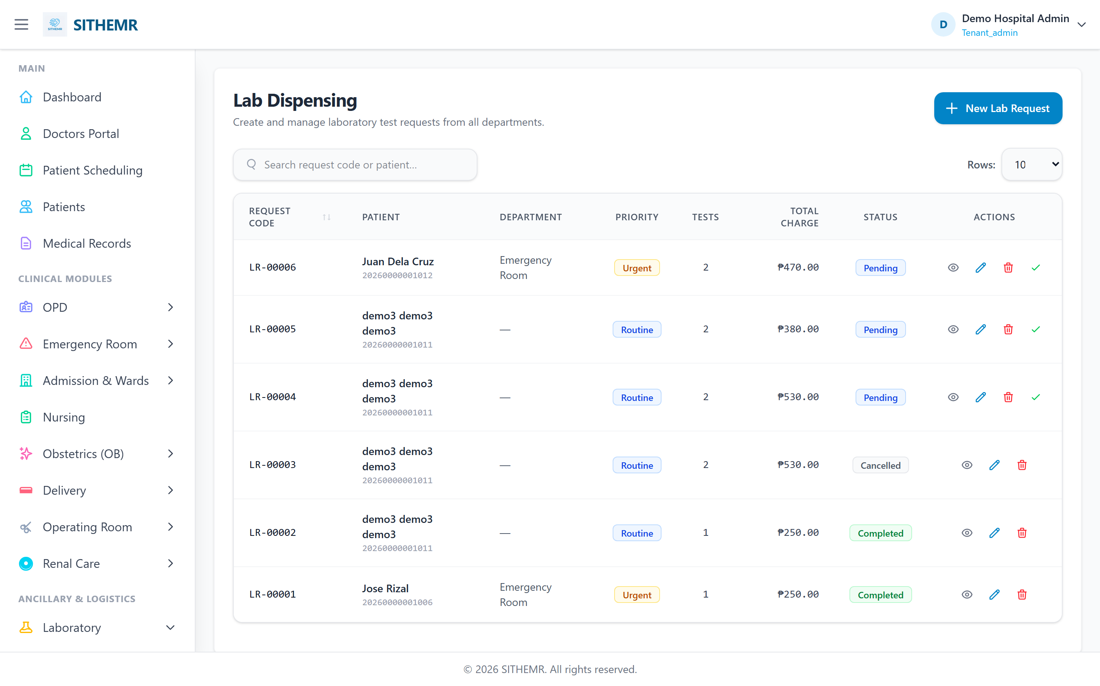
Figure 12: Pharmacy Order Modal — drug list with checkboxes, quantity inputs, frequency, and route selectors.

7.2 Order Labs
Click "Order Labs" to open the Laboratory Order modal. This displays the list of available lab tests with checkboxes. Select the tests you want to order by checking the boxes. The modal includes:
- Test Selection: Checkboxes next to each lab test name. Multiple tests can be selected in a single order.
- Priority: Routine, Urgent, or STAT — determines how quickly the lab processes the request.
Click "Submit Lab Request" to place the order. The system creates a Lab Request (LR-XXXXX) with the selected tests as individual request items. Each item links to its corresponding Lab Test master record.
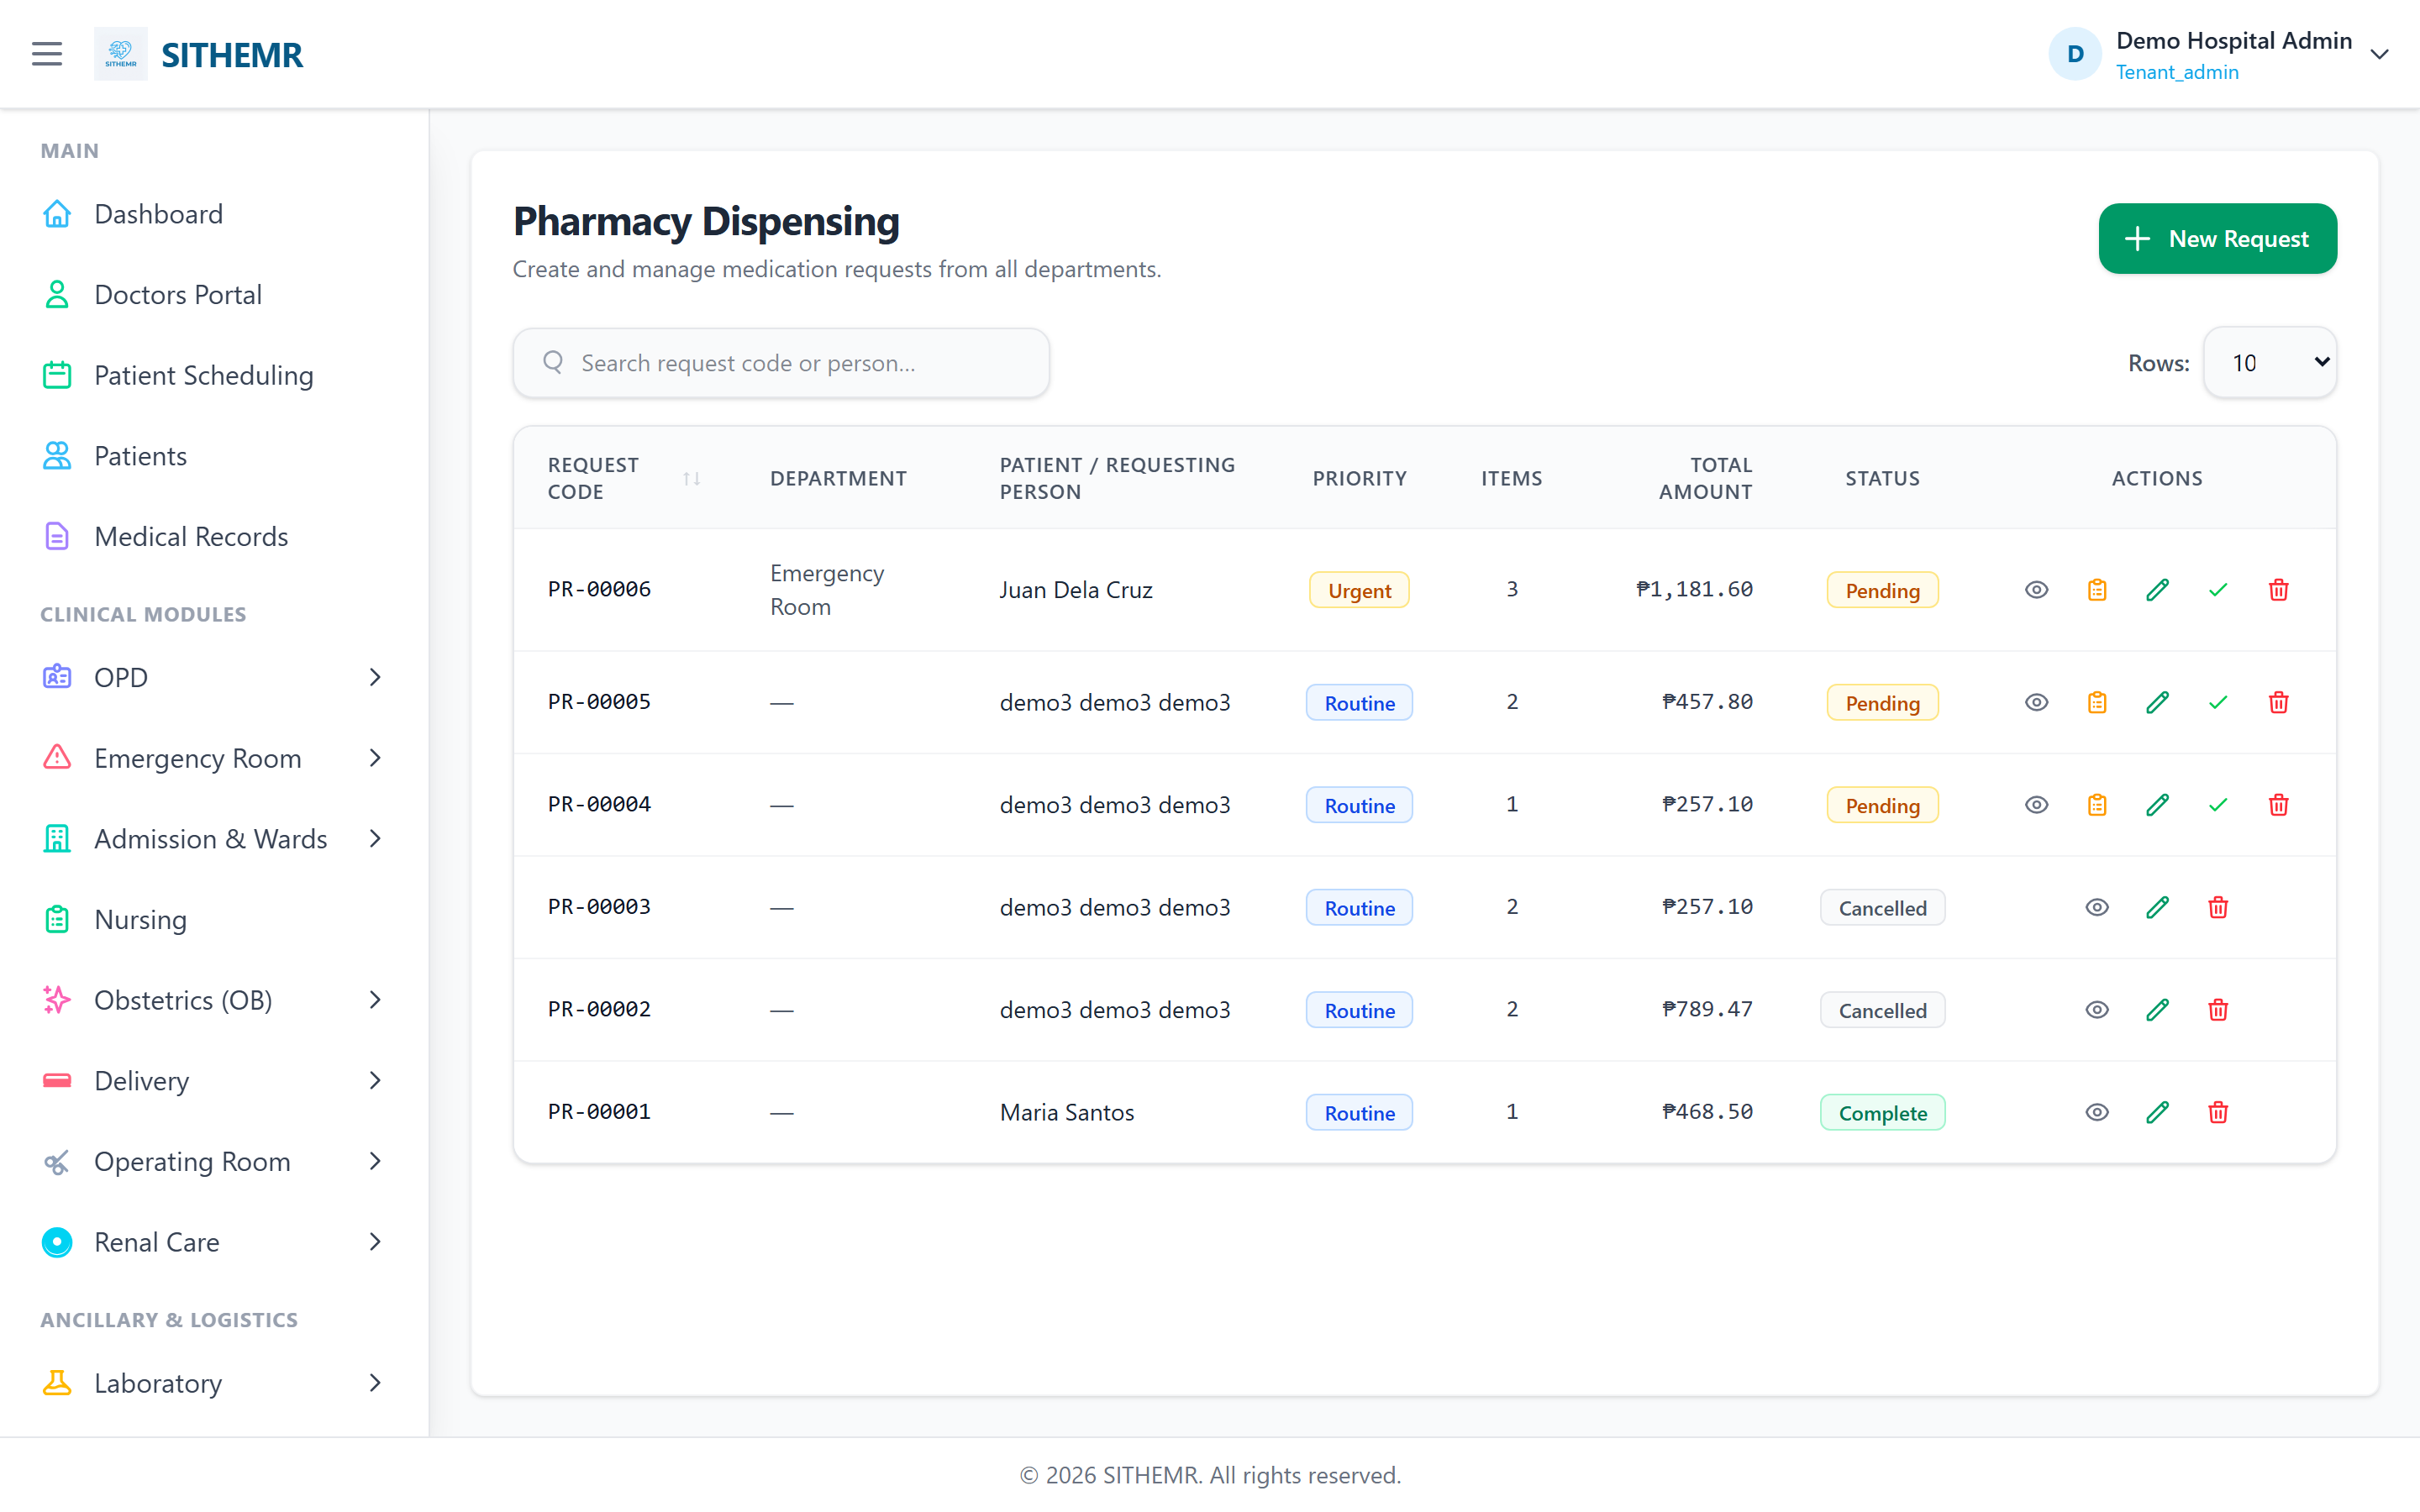
Figure 13: Lab Order Modal — list of available lab tests with checkboxes for selection.

7.3 Order Supplies (CSR)
Click "Order Supplies (CSR)" to open the CSR Supply Order modal. CSR (Customer Service / Supply Chain) orders are used to request medical supplies, consumables, and non-pharmacy items. Select items from the list and specify quantities.
The CSR order creates a CSR Request (CR-XXXXX) linked to the consultation and patient.
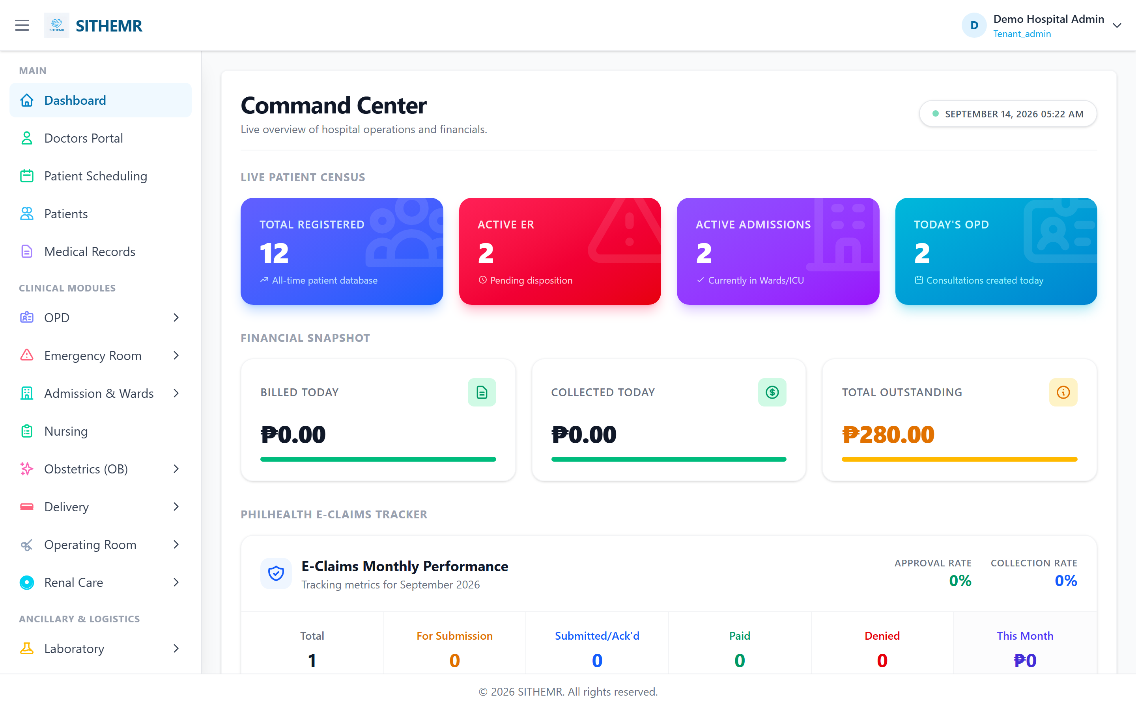
Figure 14: CSR Order Modal — supply items list with quantity inputs.

7.4 Order Radiology
Click "Order Radiology" to open the Radiology Order modal. This displays available radiology exams (X-ray, Ultrasound, CT Scan, MRI, etc.) with checkboxes. Each exam shows its modality in parentheses. Select the exams needed and set priority.
The radiology order creates a Radiology Request (RR-XXXXX) linked to the consultation.
Figure 15: Radiology Order Modal — radiology exams with modalities listed.

7.5 Order Procedure
Click "Order Procedure" to open the Procedure Order modal. This displays available medical procedures (wound suturing, IV insertion, catheterization, etc.) with checkboxes. Select procedures and specify quantities.
The procedure order creates a Procedure Request (PR-XXXXX) linked to the consultation.
Figure 16: Procedure Order Modal — medical procedures list with quantity inputs.

7.6 Viewing Placed Orders
After placing orders, they appear in the "Active Orders" section below the SOAP form. This section is organized by order type with separate tables for Medications, Laboratory Tests, Supplies (CSR), Radiology, and Procedures. Each table shows the item name, quantity (if applicable), request code, and current status. If no orders have been placed, a message indicates "No active orders for this consultation."
Orders remain in "Pending" status until they are processed by the respective department (Pharmacy dispenses, Lab processes results, CSR fulfills supply requests, Radiology schedules/executes exams, Procedures performs the procedure).

8. Saving the Consultation
After completing the SOAP notes and placing any necessary orders, click the "Save Notes" button at the top-right of the SOAP form. This saves all clinical documentation to the consultation record. A green success toast notification confirms the save. The consultation status is automatically updated: if a disposition was selected, the status becomes "Completed"; otherwise it remains "In Progress."
The Save Notes button is located in the SOAP form header, next to the clinical documentation title. After saving, you can continue to modify the notes and save again — each save updates the record with a new timestamp.

9. Lab Results
Lab results are managed in the Laboratory module. When a doctor places a lab order from the OPD consultation, it appears in Laboratory > Lab Requests as a pending request. The laboratory staff collects the specimen, processes the test, and enters the results. Results are viewable from the patient's consultation view under the Laboratory Tests section of Active Orders, and in the patient's full medical record.
Each lab result includes the test name, result value, unit of measurement, reference range, and a flag indicating whether the result is normal or abnormal. Results can be verified by a supervisor before being finalized.
Figure 17: Lab Results — processed lab test results with values, units, and reference ranges.

10. Lab Dispensing
Lab dispensing refers to the process of releasing lab specimens or samples for further analysis, or managing the collection and handling of laboratory specimens from the patient. This module tracks specimen collection, processing status, and ensures proper chain of custody for laboratory samples.
Figure 18: Lab Dispensing — lab specimen collection and processing interface.

11. Pharmacy Dispensing
Pharmacy dispensing is the process where the pharmacy department fulfills prescribed medications from pharmacy orders. When a doctor places a pharmacy order (PR-XXXXX) from the OPD consultation, it appears in Pharmacy > Pharmacy Orders as a pending order. The pharmacist verifies the prescription, checks drug availability and expiry dates, and dispenses the medication to the patient.
The dispensing process includes: selecting the appropriate drug batch (considering expiry date — earliest expiry first), verifying the quantity and dosage, recording the dispensing transaction, and updating the order status to "Dispensed." The patient's medication record is updated with the dispensed items.
Figure 19: Pharmacy Dispensing — pharmacy order fulfillment interface showing drug selection and batch verification.

12. Quick Reference
OPD Workflow Summary:
1. Navigate to OPD > Consultations
2. Click "New Encounter"
3. Search and select patient
4. Fill in: Clinic — Physician — Consultation Type — Visit Type
5. Click Save Encounter → creates OPD-XXXXX (Pending)
6. Click "Consult / Treat" on the new row
7. Fill SOAP notes (Subjective, Objective, Assessment, Plan)
8. Place orders as needed: Pharmacy | Lab | CSR | Radiology | Procedure
9. Set Disposition and Follow-up Date
10. Click "Save Notes" → status becomes Completed

Consultation Status Flow:
- Pending: Encounter created, not yet seen by doctor.
- In Progress: Doctor has opened the consultation, working on SOAP/orders.
- Completed: SOAP notes saved with a disposition selected.
- Cancelled: Encounter cancelled (filtered out by ChecksActiveEncounters).

Order Request Code Prefixes:
- Pharmacy Orders: PR-XXXXX
- Lab Requests: LR-XXXXX
- CSR Requests: CR-XXXXX
- Radiology Requests: RR-XXXXX
- Procedure Requests: PR-XXXXX (Procedure)

Appendix: Figure Index
Figure 1: SITHEMR Login Page (01-login-page.png)
Figure 2: Login Page with Credentials Filled (02-credentials-filled.png)
Figure 3: Command Center Dashboard (03-dashboard.png)
Figure 4: OPD Consultations List (04-opd-consultations-list.png)
Figure 5: New Encounter Modal (05-new-encounter-modal.png)
Figure 6: Patient Search — typing "Juan" (06-patient-search-juan.png)
Figure 7: Patient Selected — Juan Dela Cruz (07-patient-selected.png)
Figure 8: Encounter Form Before Filling (08-form-before-fill.png)
Figure 9: Encounter Form Fields Filled (09-form-fields-filled.png)
Figure 10: Consultations List After Save (10-consultations-list-after-save.png)
Figure 11/15/17: SOAP Form View / Radiology Order / Lab Results (11-lab-results.png)
Figure 12/16/18: Pharmacy Order Modal / Procedure Order / Lab Dispensing (12-lab-dispensing.png)
Figure 13/19: Lab Order Modal / Pharmacy Dispensing (13-pharmacy-dispensing.png)
Figure 14: CSR Order Modal / Final Dashboard (14-final-dashboard.png)

