SITHEHR - Hospital Management & Records System

User Manual

Version: 1.0 | Date: September 2026 | Stack: Laravel 12 + Livewire 4 + Tailwind CSS v4 + DomPDF

Document Control
Field | Value
Application | SITHEHR (Hospital Management & Records System)
Purpose | End-user operational manual for all HMR modules
Audience | Hospital administrators, doctors, nurses, lab/radiology/pharmacy/CSR staff, billing officers, PhilHealth administrators, medical records officers
Platform | Web application - Chrome/Edge/Firefox desktop browser
Backend | Laravel 12, PHP 8.2, Microsoft SQL Server, JWT auth
Frontend | Livewire 4 (reactive components), Tailwind CSS v4, Alpine.js, DomPDF for PDF reports
Database | Microsoft SQL Server (MSSQL) - DB: sithemr, Host: 127.0.0.1:1433
Admin Login | admin@demohospital.com / Admin@12345 (DEMO hospital, tenant ID 1)

Table of Contents
Update fields to populate.

1. System Overview
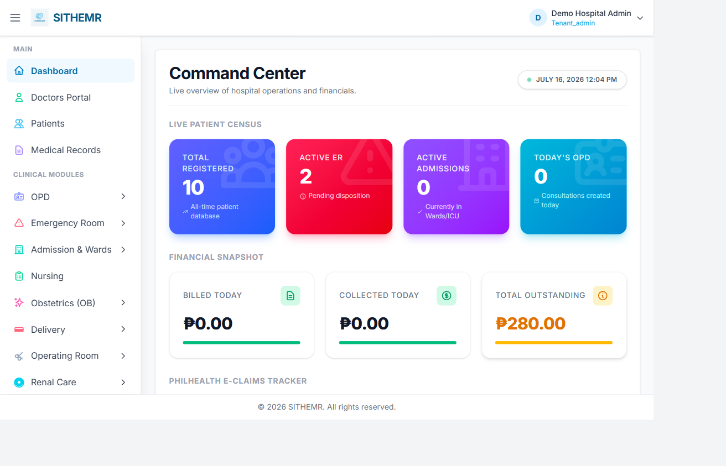
Figure 1: Dashboard — main overview after login

SITHEHR is a comprehensive Hospital Management and Records System (HMR) built for multi-tenant hospital operations. It covers the full patient journey - from public self-service appointment booking, patient registration, outpatient and emergency encounters, inpatient and ICU admission, operating room scheduling, laboratory and radiology services, pharmacy and medical supply dispensing, billing and payments, PhilHealth claims, medical certificate generation, specialty care (OB, delivery, renal/dialysis), primary care (YAKAP), and complete administrative back-office (master data, user/role management, audit logging, and reporting).

Core architectural features: (1) Multi-tenancy - each hospital is a tenant with isolated data scope; (2) Soft deletes - records are deactivated via a history flag (history=1 = active), never physically removed; (3) Audit trail - every create and update logs created_by/created_date and updated_by/updated_date; (4) JWT authentication stored in an HTTP-only cookie; (5) Permission-based route protection - every page requires a specific permission (e.g. permission:lab.manage); (6) PDF reporting via Barryvdh DomPDF for invoices, receipts, statements of account, PhilHealth claim forms, lab/radiology results, ER EECL, and medical certificates; (7) Public appointment booking at /book-appointment - the only route accessible without login.

Technology stack: PHP 8.2.12 on XAMPP, Laravel 12 framework, Livewire 4 for reactive server-side components, Tailwind CSS v4 for styling, Alpine.js for lightweight client interactivity, Barryvdh DomPDF for PDF generation, tymon/jwt-auth for token-based authentication, phpoffice/phpspreadsheet for spreadsheet exports. Frontend assets are built with Vite and published to public/build/ (run npm run build after frontend changes).

2. Getting Started: Login and Dashboard
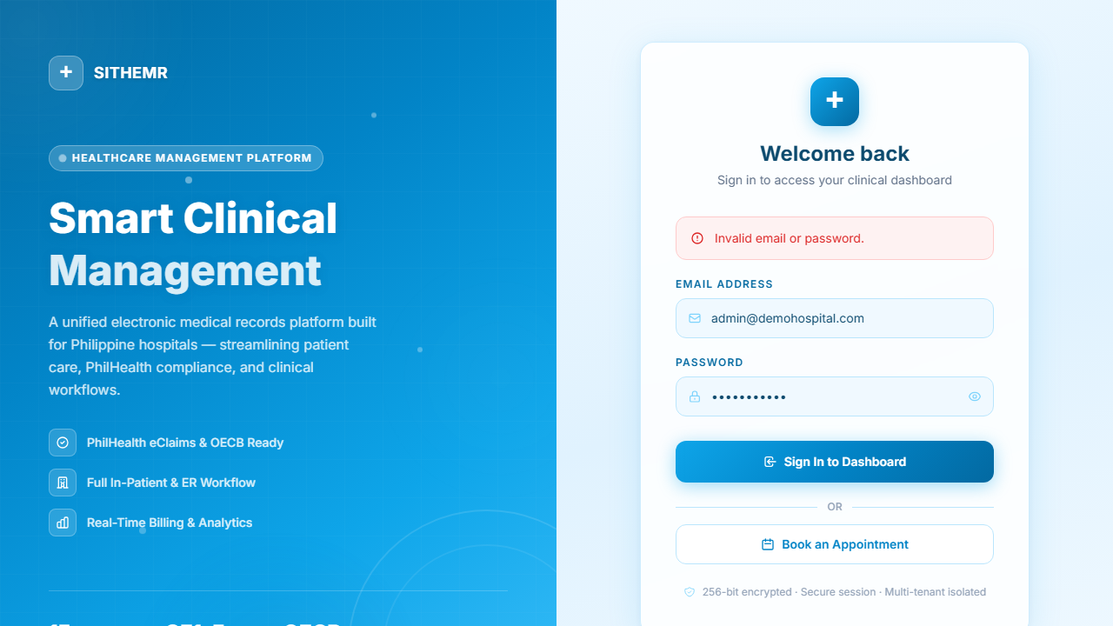
Figure 2: Login page

This section covers the first things every HMR user does: logging in, understanding the dashboard, and navigating the application.

2.1 Logging In
Navigate to http://localhost/login (or /login). The login page is rendered via a guest layout (no auth required). Enter your email address and password. On success, the server issues a JWT token stored as an HTTP-only cookie — you do not see or handle the token directly. You are redirected to /dashboard.
The login route is rate-limited (throttle:10,1 = 10 attempts per 1 minute) to prevent brute-force attacks. After too many failed attempts, wait one minute before trying again.
Default admin credentials for the DEMO hospital: Email: admin@demohospital.com, Password: Admin@12345.

2.2 The Dashboard
After login you land on /dashboard (route: dashboard, permission: dashboard.view). The dashboard is a Livewire-powered summary page showing:
- Today's activity overview — pending OPD consultations, ER admissions, lab/pharmacy/CSR requests awaiting action
- Quick-access cards linking to each major module
- System-wide or tenant-scoped statistics depending on your role
- Recent activity and alerts relevant to your permissions
The dashboard is the central navigation hub. From here you can jump to any module you have permission to access. The sidebar or top navigation (depending on the layout) shows the full menu of accessible pages.

2.3 Navigation Structure
Once logged in, the application organizes its pages into these top-level areas, each gated by permissions:
- Dashboard (/) — home/summary
- Masters (masters/*) — master data management: tenant, department, users, country, region, province, city, barangay, religion, gender, civil status, nationality, occupation, blood type, relationship, hospital, permissions
- Admin (admin/*) — roles, role-permissions, audit log, user permissions
- Patient Registration (/patients) — patient CRUD
- OPD (opd/*) — outpatient: visit types, consultation types, referral sources, services, clinics, complaints, consultations
- ER (er/*) — emergency: triage, acuity levels, mobility statuses, zones, beds, area, admission EECL PDF
- Admission (/admission) — inpatient admissions
- ICU (icu/*) — intensive care: wards, beds
- MICU (micu/*) — medical ICU: patients, assessment parameters
- Ward (ward/*) — ward management: wards, room types, rooms
- OR (or/*) — operating room: rooms, schedule
- Lab (lab/*) — laboratory: sections, units, specimen types, instruments, tests, panels, reference ranges, dispensing, results, result print
- Radiology (radiology/*) — radiology: modalities, body parts, exam types, dispensing, results, result print
- Pharmacy (pharmacy/*) — drugs, drug batches, inventory, purchase orders, stock adjustments, dispensing, patient medication record, reports, request print, encounter print
- Supply/CSR (supply/*) — units, categories, suppliers, stock locations, items, inventory, stock adjustments, dispensing, request print, encounter print
- Procedures (procedures/*) — categories, procedures, dispensing
- OB (ob/*) — visit types, fetal presentations, contraceptive methods, consultations
- Delivery (delivery/*) — types, complications, rooms, schedule
- Renal Care (renal-care/*) — dialysis types, dialysis sessions
- YAKAP (yakap/*) — dashboard, empanelments, FPE records, screenings, capitation
- Billing (billing/*) — billing dashboard, fund sources, insurance providers, invoice print, payment receipt, statement of account
- PhilHealth (philhealth/*) — ICD10 codes, RVS codes, case rates, HC professionals, members, claims, batches, claim PDFs (CF1-CF5, ESOAPDF, EECLPDF), reports
- Konsulta (konsulta/) — primary care consultations
- Medical Records (/medical-records) — certificate generation
- Nursing (/nursing) — nursing dashboard
- Doctors (doctors/*) — dashboard, schedule, patient chart
- Settings (/settings) — system settings
- Reports (/reports) — reports hub
- Transfers (transfers/) — hospital transfers
Pages you do not have permission for are hidden from the menu. Attempting to access a URL directly without the required permission returns a 403 access denied.

2.4 Logout
Click the Logout option in the navigation. The server clears the JWT cookie and you are returned to the login page. Any unsaved form data is lost on logout — save your work before logging out.

3. Master Data Management
Master data forms the foundation of the application. Most modules depend on master records being populated before they can be used. Master data is managed under Masters (/masters) and Admin (/admin).

3.1 Geographic Hierarchy ( cascaded dropdowns )
The application uses a geographic hierarchy that cascades: Country > Region > Province > City/Municipality > Barangay. This is used in patient registration and other modules that need address data. When you select a country, the region dropdown populates; selecting a region populates provinces; and so on down to barangay.
- Masters > Country — country list (e.g. Philippines)
- Masters > Region — Philippine regions (e.g. NCR, CAR, Region I-III, etc.)
- Masters > Province — provinces and highly urbanized cities
- Masters > City — cities and municipalities (Provinces/Cities shared model)
- Masters > Barangay — barangays (village-level districts)

3.2 Demographic Masters
- Masters > Gender — Male, Female, etc.
- Masters > Civil Status — Single, Married, Widowed, Separated, etc.
- Masters > Religion — religious affiliations
- Masters > Nationality — nationalities
- Masters > Occupation — occupation types
- Masters > Blood Type — A, B, AB, O with Rh factor
- Masters > Relationship — relationship types (for emergency contact, etc.)

3.3 Hospital and Department Masters
- Masters > Tenant (Company) — multi-tenant hospital setup. The DEMO hospital is the default tenant (ID 1).
- Masters > Department — clinical departments (e.g. Cardiology, General Surgery, Pediatrics). Departments link to doctors and drive appointment booking.
- Masters > Hospital — hospital/facility records
- Masters > Users — user accounts (see also Admin > Users and Admin > Roles for permission assignment)

3.4 Admin: Roles and Permissions
The application uses a granular permission system. Each route requires a specific permission string. Permissions are assigned to roles, and roles are assigned to users.
- Admin > Roles — create and manage roles (e.g. Superadmin, Tenant Admin, Doctor, Nurse, Pharmacist, Lab Technologist, Billing Officer, etc.)
- Admin > Role Permissions — assign granular permissions to each role. Permissions follow the pattern: <module>.view, <module>.manage, <module>.dispense, <module>.result, etc.
- Admin > Audit Log — view the system-wide audit trail of all create/update/delete operations across all modules
- Admin > User Permissions ({userId}/permissions) — override or fine-tune permissions for an individual user
Key permission patterns:
- <module>.view — can view the module's pages (read access)
- <module>.manage — can create/edit master data for the module
- <module>.dispense — can dispense/issue items (pharmacy, CSR, lab, radiology, procedures)
- <module>.result — can view and/or enter results (lab results, radiology results)
- admin.masters — general master data management
- admin.users — user management
- admin.tenants — tenant/company management
- dashboard.view — access the dashboard
- billing.view — view billing; billing.manage — manage fund sources/insurance providers
- reports.view — access the reports hub

4. Patient Registration
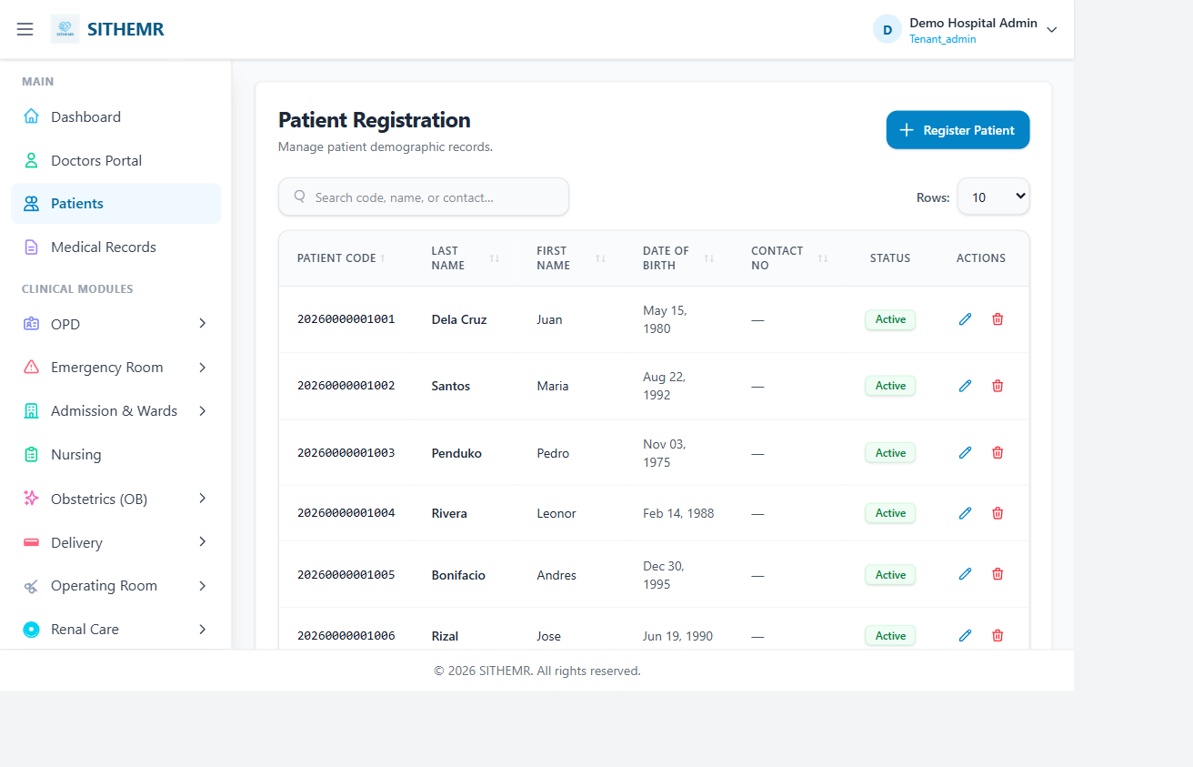
Figure 4: Patient registration list

Patient Registration is accessible at /patients (route: patients, permission: patient.view). It is a Livewire CRUD component (PatientCrud) that handles the full patient demographic record.

4.1 Creating a Patient
Click Create New Patient. The form captures:
Patient identifiers: Patient Code (auto-generated, e.g. 202600000001 — year + zero-padded sequence, unique per tenant; can be overridden), Last Name (required), First Name (required), Middle Name, Suffix.
Demographics: Date of Birth, Gender, Civil Status, Religion, Nationality, Occupation, Blood Type, Is PhilHealth Member (toggle), PhilHealth Member (dropdown when toggle is on), Maiden Name, Place of Birth, Preferred Language, National ID No, Passport No.
Address (cascading): Region > Province > City/Municipality > Barangay, Street Address, Zip Code. Selecting a higher level populates the next dropdown.
Contact: Contact No, Email, Emergency Contact Name, Emergency Contact No, Emergency Relationship.
Family: Father Name, Mother Maiden Name, Spouse Name, Multiple Birth Indicator.
Vital status: Is Deceased (toggle), Date of Death, Primary Care Provider (healthcare professional dropdown).
Active flag: Is Active (default true — uncheck to soft-deactivate).

4.2 Patient Code Generation
When you open the create form, the system auto-generates a patient code in the format YYYYNNNNNNNNN (4-digit year + 10-digit zero-padded sequential number) per tenant. The code is generated by finding the last patient code for the current year and incrementing. You can override it but it must remain unique within the tenant (validated against the unique rule unique:patients,patient_code,NULL,id,tenant_id,{tid},history,1).

4.3 Searching and Filtering Patients
The patient list has a search box. A 3-character search triggers a paginated lookup (15 per page) filtering by name, patient code, PhilHealth number, and contact number. Sort by patient code, last name, or other fields; toggle ascending/descending. Results show patient code, name, gender, age, PhilHealth status, contact, and address summary.

4.4 Editing and Viewing Patient Records
Click Edit on a patient row to open the edit form pre-populated with all current values. Changes are audited. Click View Chart to open the patient chart — a consolidated view of all encounters (OPD, ER, Admission), lab/pharmacy/CSR/radiology/procedure orders, and billing entries for that patient. The patient chart is the central clinical record.

5. Public Appointment Booking (Patient Self-Service)
The /book-appointment page (route: public.book) is publicly accessible — no login required. It lets patients book an appointment with a doctor without creating an account.

5.1 Booking Flow
The booking is a 4-step cascading flow:
- Step 1 - Select Department: Choose from active departments (e.g. Cardiology, General Surgery, Pediatrics). The department list is scoped to the public tenant (configurable via appointment.public_tenant_id, defaults to the first hospital).
- Step 2 - Select Doctor: Doctors (Healthcare Professionals) listing updates based on selected department. Select a doctor. Each doctor shows full name, professional type, and specialization.
- Step 3 - Select Date: Pick an appointment date (must be today or later). After selecting a date, the system loads available time slots.
- Step 4 - Select Time Slot: Available slots are shown in 30-minute increments (configurable via appointment.slot_minutes, default 30) within working hours (configurable via appointment.working_start 08:00 and appointment.working_end 17:00). Slots already booked by other patients are excluded. Past slots on the current day are excluded. Click a slot to select it.

5.2 Patient Information
After selecting a slot, fill in: Patient Name (required, max 150 chars), Patient Phone (optional, max 30), Patient Email (optional, email format, max 150), Reason for Visit (optional, max 5000 chars). Click Book Appointment.

5.3 Booking Confirmation
On successful booking, the system generates an appointment reference code (APT-00001 format — APT- prefix + 5-digit zero-padded sequential number per tenant) and shows a confirmation screen with the appointment details: department, doctor, date, time slot, patient name, and the reference code. The patient can click Book Another Appointment to reset the form and book again.

5.4 How Booking Works Internally
Available slots are computed by: (1) getting all non-cancelled appointments for the selected doctor on the selected date; (2) generating 30-minute slots from working_start to working_end; (3) excluding any slot that overlaps with an existing appointment (overlap check: slot.start < existing.end AND slot.end > existing.start); (4) excluding past slots on today's date.
When booking, the system uses an atomic database transaction with lockForUpdate to prevent double-booking race conditions: it re-checks for conflicts inside the transaction before creating the appointment. If a conflict is detected, the user is prompted to pick another slot and the available slots are refreshed.
Appointment statuses: Scheduled (just booked), In Progress (doctor has started), Completed (done), Cancelled. The public booking creates appointments with status Scheduled.

6. Outpatient Department (OPD)
The OPD module manages outpatient consultations — the most common patient encounter. Route prefix: /opd. All OPD consultation features require permission: opd.view.

6.1 OPD Master Data Setup
Before OPD consultations can be created, set up the master data under OPD in the sidebar:
- OPD > Visit Types — consultation visit types (e.g. New Visit, Follow-up, Referral)
- OPD > Consultation Types — types of consultations (e.g. General Consultation, Specialty Consult, Follow-up Consult)
- OPD > Referral Sources — where the patient came from (e.g. Self, ER, Other Hospital, HMO)
- OPD > Services — clinical services offered
- OPD > Clinics — OPD clinics (e.g. General Clinic, Cardiac Clinic, Pediatric Clinic)
- OPD > Complaints — common chief complaints for quick selection

6.2 Creating an OPD Consultation
Go to OPD > Consultations. Click Create New Consultation. The consultation form captures:
- Patient — search and select an existing patient (search triggers autocomplete-style lookup; selecting a patient fills the name)
- OPD Clinic — from OPD > Clinics master
- Attending Physician — healthcare professional
- Consultation Type — from OPD > Consultation Types
- Visit Type — from OPD > Visit Types
- Referral Source — optional, from OPD > Referral Sources
- Is YAKAP — toggle if this is a YAKAP primary care patient; if on, select an Empanelment from YAKAP > Empanelments
On save, the system: (1) validates all required fields; (2) runs ensureNoActiveEncounter to prevent duplicate active encounters for the same patient; (3) generates a consultation code (OPD-00001 format — OPD- prefix + 5-digit zero-padded sequence per tenant); (4) creates the consultation with status Pending and the current timestamp. The SOAP form then opens for clinical documentation.

6.3 SOAP Documentation
After creating the consultation, the SOAP form captures:
- Chief Complaint — the patient's primary complaint
- History of Present Illness — HPI narrative
- Physical Exam Findings — physical examination notes
- Assessment — diagnosis/assessment
- Treatment Plan — planned treatment
- Orders Summary — summary of orders placed
- Disposition — outcome (e.g. Discharged, Admitted, Referred, Follow-up)
- Next Follow-up Date — scheduled follow-up

6.4 Nursing Vitals Entry
Nursing staff can enter vital signs via the Vitals modal: BP Systolic, BP Diastolic, Heart Rate, Temperature, Respiratory Rate, Weight, Height, O2 Saturation. These are stored on the consultation record.

6.5 Placing Orders from OPD
From the OPD consultation, orders can be placed for:
- Lab Orders — via Order Lab modal: select lab tests, specimen type, priority (Routine/STAT), notes, quantity
- Pharmacy Orders — via Order Pharmacy modal: select drugs, dosage, frequency, route, quantity
- CSR Orders — via Order CSR modal: select supply items, quantity
- Radiology Orders — via Order Radiology modal: select exam type, modality, body part, priority
- Procedure Orders — via Order Procedure modal: select procedure, priority, notes
Each order creates a request (LabRequest, PharmacyRequest, CsrRequest, RadiologyRequest, ProcedureRequest) linked to the OPD consultation via the opd_consultation_id foreign key. These orders feed into billing, results, and dispensing workflows.

6.6 OPD Consultation List and Search
The OPD consultations list shows all consultations with patient name, consultation code, clinic, attending physician, consultation type, visit type, status, and date/time. Search by patient name or consultation code. Sort by date. Paginated.

7. Emergency Room (ER)
The ER module manages emergency admissions, triage, bed management, and emergency billing. Route prefix: /er.

7.1 ER Master Data
- ER > Triage — triage records (created during patient intake)
- ER > Acuity Levels — acuity/severity levels (e.g. Level 1-Critical, Level 2-Emergent, Level 3-Urgent, Level 4-Less Urgent, Level 5-Non-Urgent)
- ER > Mobility Statuses — patient mobility status on arrival
- ER > Zones — ER zones (e.g. Red Zone, Yellow Zone, Green Zone)
- ER > Beds — individual ER beds assigned to a zone
- ER > Area — ER area configuration

7.2 ER Triage and Admission Flow
The ER workflow:
- Triage: ER > Triage creates a triage record — patient, acuity level, mobility status, triage notes. This is the first point of documentation when a patient arrives at the ER.
- Admission: From triage or directly, an ER Admission is created (ER > Admission). The admission links: patient, ER bed (from ER > Beds), attending physician, initial diagnosis, mode of arrival, and disposition. The admission code follows ER#<id>.
- Treatment: The ER admission supports a treatment form with HPI, physical exam findings, assessment, orders summary, and treatment notes. ER admissions can be flagged as OECB (Outpatient Emergency Case Billing) for emergency fee tracking.
- Disposition: After treatment, set the disposition (Discharged, Admitted, Referred, Left Without Being Seen, etc.) via the Disposition modal. This updates the admission status.

7.3 OECB and EECL PDF
OECB (Outpatient Emergency Case Billing) tracks emergency-specific fees. An ER admission can be marked Is OECB, and OECB entries (core presentation + fee schedule items) are recorded against the admission.
The EECL PDF (Extended Encounter Closure / Emergency Summary) is printable from ER > Admission > {admission}/eeclpdf. The PDF includes: patient info, PhilHealth member (if linked), attending physician, OECB entries, triage record with acuity level, and ER bed/zone assignment. Generated via DomPDF, downloaded as eecl-{admission_code}.pdf.

7.4 ER Orders
From the ER admission, orders can be placed just like OPD: Lab, Pharmacy, CSR, Radiology, and Procedures. Each order links to the ER admission via er_admission_id. These orders feed into the respective result/dispensing modules and billing.

8. Inpatient, ICU, Ward, and OR

8.1 Admission (Inpatient)
Admission (/admission, permission: admission.view) manages inpatient admissions. Create an admission: select patient, admitting diagnosis, attending physician, admission type, admission date, and assign a ward room or ICU bed. Admission code: ADM#<id>. The admission is the central record for an inpatient stay — it links to ward/ICU beds, orders, billing, and discharge.

8.2 ICU (Intensive Care Unit)
ICU (/icu, permission: admission.view): ICU > Wards manages ICU ward names; ICU > Beds manages individual ICU beds linked to a ward. ICU beds are assigned to admissions for critical care patients.
MICU (/micu, permission: admission.view): MICU > Patients tracks Medical ICU patient records; MICU > Assessment Parameters captures critical-care assessment data (vitals, scores, monitoring parameters specific to medical ICU).

8.3 Ward Management
Ward (/ward, permission: admission.view): Ward > Wards (ward names like General Ward, Private Ward, Semi-Private), Ward > Room Types (Single, Double, Ward Type categories), Ward > Rooms (individual rooms with room number, floor, bed count, status, linked to a ward and room type). Rooms are assigned to admissions.
Room transfers: when a patient moves rooms, the Admission Room History tracks the move with timestamps for audit purposes.

8.4 Operating Room (OR)
OR (/or, permission: or.view): OR > Rooms manages operating room names/codes and status; OR > Schedule manages OR procedure scheduling. Create an OR schedule: select patient, procedure, surgeon, anaesthetist, OR room, date/time, status. The OR schedule drives operating theatre utilization and integrates with the procedure module and billing.

9. Laboratory Services
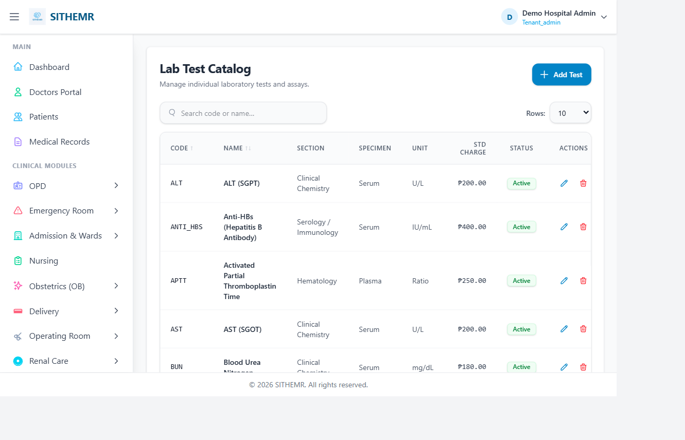
Figure 9: Laboratory module

The Laboratory module (route prefix: /lab) manages lab master data, test ordering, result entry, verification, and lab supply dispensing.

9.1 Lab Master Data
- Lab > Sections — lab sections/departments (e.g. Clinical Chemistry, Hematology, Microbiology, Blood Bank)
- Lab > Units — examination units (e.g. mL, g/dL, cells/mcL, mmol/L)
- Lab > Specimen Types — specimen types (e.g. Whole Blood, Serum, Urine, Stool, Sputum)
- Lab > Instruments — lab instruments/analyzers
- Lab > Tests — individual lab tests with test name, code, section, unit, and reference range linkage
- Lab > Panels — grouped tests (e.g. CBC, BMP, Lipid Panel) that can be ordered together
- Lab > Reference Ranges — normal value ranges per test (used to flag abnormal results)

9.2 Lab Request and Results Workflow
Lab orders are placed from encounters (OPD/ER/Admission) or directly. A Lab Request is created with Lab Request Items — each item links to a Lab Test, specifies specimen type, priority, and requested-by. The request links to the encounter via the appropriate foreign key (opd_consultation_id, er_admission_id, admission_id, etc.).
Results are entered in Lab > Results. Each result links to a Lab Request Item, includes the result value (numeric or text), the reference range for comparison, and a status (Pending/Completed). Results flow through a verification chain: performed by (technologist who ran the test) -> verified by (supervisor) -> validated by (pathologist). Each step is recorded.
Lab > Results shows all lab results with patient name, request code, test name, result value, reference range, status flags, and verification chain. Search and filter by patient, status, date, or test.

9.3 Printing Lab Results
From Lab > Results, click the Print link on a result row (route: lab.result.print). The print view (pages.lab.result-print) loads the Lab Request Item with: patient, lab request, requesting doctor, lab test with unit, performed-by/verified-by/validated-by, result value, reference range, and status. The view is formatted for printing/download.

9.4 Lab Dispensing
Lab > Dispensing (permission: lab.dispense) tracks the issuance of lab materials, reagents, and consumables to patients or departments — similar to pharmacy/CSR dispensing but for laboratory supplies.

10. Radiology Services
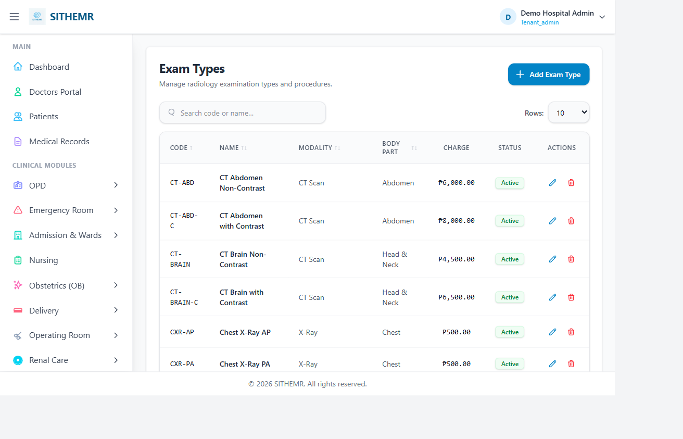
Figure 10: Radiology module

The Radiology module (route prefix: /radiology) manages radiology master data, exam ordering, result reporting, and DICOM/PACS integration.

10.1 Radiology Master Data
- Radiology > Modalities — imaging modalities (X-Ray, CT Scan, MRI, Ultrasound, Mammography, Fluoroscopy, etc.)
- Radiology > Body Parts — anatomical sites (e.g. Chest, Abdomen, Skull, Spine, Extremities)
- Radiology > Exam Types — specific exam names per modality (e.g. Chest X-Ray PA, CT Abdomen with Contrast, MRI Brain)

10.2 Radiology Request and Results
A Radiology Request is created from an encounter or radiology dispensing: select patient, radiologist, modality, body part, exam type, and date. Radiology Request Items link to the exam. The request links to the encounter via the appropriate foreign key.
Results are entered in Radiology > Results (permission: radiology.result). Each result links to a Radiology Request Item with findings, impression, and can attach DICOM images. The result tracks performed-by and radiologist.

10.3 Printing Radiology Results
From Radiology > Results, click the Print link on a result row (route: radiology.result.print). The print view loads the Radiology Request Item with radiologist, performed-by, the full radiology request chain, and loaded images. Formatted for printing.

10.4 DICOM/PACS API Integration
The application exposes a DICOM/PACS API under /api/dicom (permission: radiology.result) for integration with external PACS systems:
- GET /api/dicom/studies — query studies from PACS
- GET /api/dicom/modalities — list modalities
- GET /api/dicom/worklist — radiology worklist
- GET /api/dicom/images/{id} — serve a full image
- GET /api/dicom/images/{id}/thumbnail — serve a thumbnail
- POST /api/dicom/store — store an image to PACS

11. Pharmacy Services
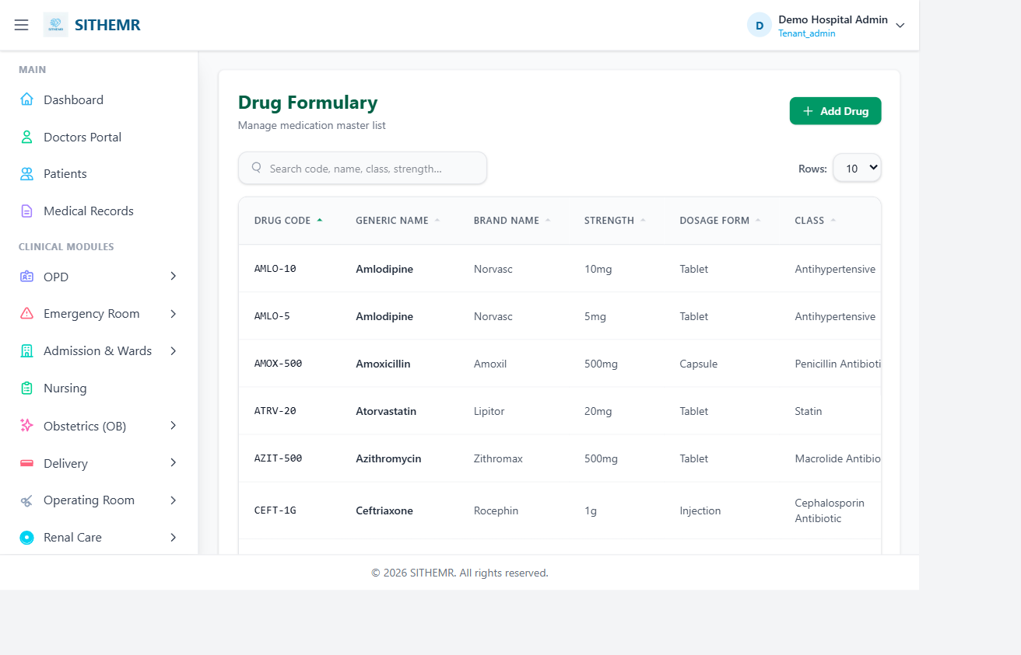
Figure 11: Pharmacy module

The Pharmacy module (route prefix: /pharmacy) manages drug master data, inventory, purchase orders, stock adjustments, dispensing, patient medication records, and pharmacy reports.

11.1 Pharmacy Master Data
- Pharmacy > Drugs — drug master: drug name, generic name, form (tablet, capsule, syrup, etc.), strength, unit, drug category, status
- Pharmacy > Drug Batches — batch numbers per drug: batch number, expiry date, quantity received, status (Active/Expired/Depleted). Batch tracking is essential for drug expiry management and recalls.
- Pharmacy > Inventory — current stock levels per drug and batch, computed from purchase orders received minus dispensing minus stock adjustments
- Pharmacy > Purchase Orders — drug purchase orders from suppliers: order date, supplier, items with quantity and unit cost, received status
- Pharmacy > Stock Adjustments — corrections to inventory: reason (damage, expiration, count adjustment, return), quantity, notes. Stock adjustments adjust the inventory balance.

11.2 Pharmacy Dispensing
Pharmacy > Dispensing (permission: pharmacy.dispense) is where medications are dispensed to patients. The dispensing workflow:
- Select the patient (search by name or select from a patient list)
- Choose drugs from the Pharmacy > Drugs master — the system shows available batches with expiry dates
- Enter quantity, dosage instructions (sig), frequency, route, and duration
- Optionally link to a Pharmacy Request (if the drug was ordered from an OPD/ER/Admission encounter) or leave unlinked for walk-in dispensing
- Save — the dispensing record is created, stock is decremented from the selected batch, and the patient's medication record is updated
Pharmacy dispensing links to the patient and optionally to a Pharmacy Request via pharmacy_request_id, or to an encounter via the encounter foreign keys (opd_consultation_id, er_admission_id, admission_id, etc.).

11.3 Patient Medication Record (PMR)
Pharmacy > Patient Medication Record (permission: pharmacy.view) shows a patient's complete medication history — all dispensing events across all encounters. This is the patient's medication profile, useful for reviewing current and past medications, checking for duplicates, and medication reconciliation.

11.4 Pharmacy Reports
Pharmacy > Reports (permission: reports.view) provides pharmacy analytics: drug usage reports, inventory status, dispensing summaries, expired/near-expiry drug alerts, and stock level reports.

11.5 Printing Pharmacy Requests
Two print options from pharmacy dispensing:
- Request Print (route: pharmacy.request.print) — prints a single pharmacy request with items, drug/batch details, requesting department, requesting doctor, patient, and dispensing status
- Encounter Print (route: pharmacy.request.encounter-print) — groups ALL pharmacy requests for the same encounter (OPD/ER/Admission) into one printout, useful for the patient's medication reconciliation at discharge

12. CSR / Medical Supply
The Supply (CSR) module (route prefix: /supply) manages medical supplies, consumables, and equipment inventory and dispensing. CSR = Clinical Service Request.

12.1 Supply Master Data
- Supply > Units — units of measure for supply items (e.g. pieces, boxes, packs, liters, pairs)
- Supply > Categories — supply item categories (e.g. Syringes & Needles, Gloves, Dressings, IV Supplies, Respiratory, PPE, Equipment)
- Supply > Suppliers — suppliers/vendors for supply items
- Supply > Stock Locations — warehouse/location codes where supplies are stored (e.g. Main Pharmacy, ER Stockroom, Ward 1 Stocks)
- Supply > Items — individual supply items: item code, description, category, unit, shelf life, reorder level, supplier, current stock

12.2 Supply Inventory and Stock Adjustments
Supply > Inventory shows current stock per item and stock location. Supply > Stock Adjustments records inventory movements: incoming (received from supplier), outgoing (issued/dispensed), and adjustments (damage, loss, count correction, return). Each adjustment has a reason code and notes.

12.3 CSR Dispensing
Supply > Dispensing (permission: csr.dispense) issues supply items to patients or departments. The workflow is similar to pharmacy dispensing: select patient, choose items from supply inventory, specify quantity, link to a CSR Request (if ordered from an encounter) or leave unlinked, and save. Stock is decremented, and the patient's supply record is updated.

12.4 Printing CSR Requests
- Request Print (route: supply.request.print) — prints a single CSR request with items, requesting department, patient, and status
- Encounter Print (route: supply.request.encounter-print) — groups all CSR requests for the same encounter into one printout
Difference from Pharmacy: Pharmacy handles medications with batch/expiry tracking and dosage instructions. CSR handles general supplies and consumables without batch tracking (typically). Both share the same dispensing and encounter-print patterns.

13. Billing and Payments
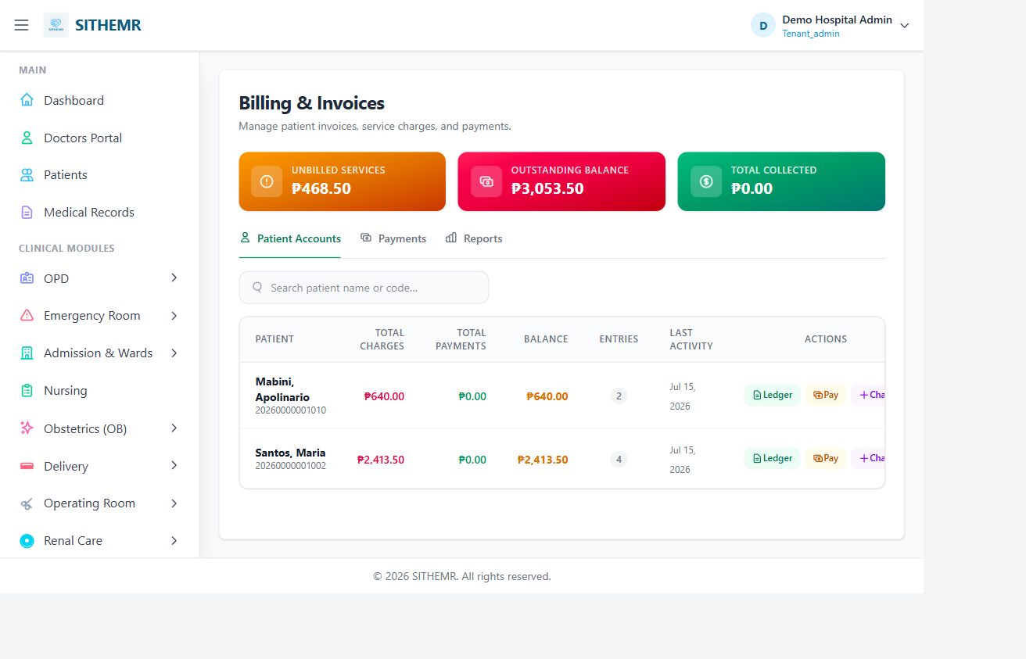
Figure 13: Billing dashboard

The Billing module (route prefix: /billing) manages patient invoices, the patient account ledger, payments, fund sources, insurance providers, and financial reporting. It is the financial core of the application.

13.1 Billing Dashboard Overview
Billing (/billing, permission: billing.view) is a Livewire CRUD (BillingCrud) with three main tabs:
- Tab 1 - Invoice Management: create invoices, view/edit invoice details, apply discounts, add manual charges, print invoices
- Tab 2 - Patient Accounts: view patient balances, access the patient ledger (full charge/payment history), add manual charges directly to a patient account, print statements of account
- Tab 3 - Payments: record payments against invoices, view payment history, print payment receipts

13.2 Creating an Invoice
Click Create Invoice. The invoice creation flow:
- Search for a patient (by name or patient code) and select them
- Select the encounter to bill: Admission, ER Admission, OPD Consultation, or other encounter types. The system links the invoice to the encounter.
- Add service items: the system can pull unbilled items from lab requests, pharmacy requests, CSR requests, radiology requests, and procedure requests associated with the encounter. Select which items to include on the invoice.
- Apply discounts (optional): discount type (percentage or fixed amount), discount value, and computed discount amount
- Add invoice notes (optional)
- Save — the invoice is created with a sequential invoice code, invoice date, line items, subtotal, discount, total, and status

13.3 Patient Account Ledger
Every patient has a running ledger (PatientAccountEntry) that tracks all financial activity. The ledger records:
- Date — when the entry was created
- Entry Type — charge (debit) or payment (credit)
- Source Type — what generated the entry (e.g. BillingInvoice, BillingPayment, ManualCharge, PhilHealthClaim, etc.)
- Source Code — the reference code of the source (invoice code, payment code, etc.)
- Description — human-readable description
- Debit — amount charged (for charge entries)
- Credit — amount paid (for payment entries)
- Balance — running balance after the entry
View the ledger from the Patient Accounts tab: select a patient, open the Ledger modal. The ledger displays chronologically with running balance. You can print a Statement of Account from here (see 13.6).

13.4 Recording Payments
Click Record Payment. The payment flow:
- Select the patient and optionally the invoice to apply the payment to
- Enter payment date, payment amount, payment method (Cash, Card, Check, Insurance, Other), payment reference (check number, transaction ID, etc.), and payment notes
- Optionally link to a Fund Source (from Billing > Fund Sources) or Insurance Provider (from Billing > Insurance Providers)
- Save — the payment is recorded, linked to the invoice, the patient ledger is updated with a credit entry, and the invoice balance is reduced

13.5 Discounts
Discounts can be applied at two levels:
- Invoice-level discount: applied when creating/editing an invoice. Type (percentage or fixed), value, and computed amount. Reduces the invoice total.
- Ledger-level discount: applied to selected ledger entries from the Patient Accounts ledger modal. Useful for adjusting specific charges after the fact (e.g. waiving a fee, applying a markdown).

13.6 Manual Charges
Manual Charges are ad-hoc charges not tied to a specific order — useful for miscellaneous fees (registration fee, bed fee, miscellaneous services). Two places to add manual charges:
- From the Invoice Detail modal: add a manual charge line item to an existing invoice (type, description, quantity, price, notes)
- From the Patient Accounts tab: add a manual charge directly to a patient's account (not tied to any invoice), which creates a debit entry on the ledger

13.7 Printing Billing Documents
- Invoice Print (route: billing.invoice.print) — prints a single invoice: patient info, encounter details, line items with quantities and prices, subtotal, discount, total, payments applied, remaining balance. Generated via DomPDF.
- Payment Receipt (route: billing.payment.receipt) — prints a payment receipt: payment details, invoice it applies to, patient info, amount, payment method, reference.
- Statement of Account (route: billing.statement) — generates a PDF statement of the patient's full ledger. Two modes: Summary (grouped by source type with totals) and Detailed (every ledger entry listed chronologically). The PDF shows total charges, total payments, and current balance. File named Statement_of_Account_{patient_name}_{mode}.pdf. Generated via DomPDF, letter size, portrait.

13.8 Fund Sources and Insurance Providers
Master data for payment tracking:
- Billing > Fund Sources (permission: billing.manage) — government funds, HMO funds, hospital fund accounts, etc. Selected during payment recording to track the source of funds.
- Billing > Insurance Providers (permission: billing.manage) — HMO/insurance company records. Selected during payment recording to track which insurer paid.

14. PhilHealth
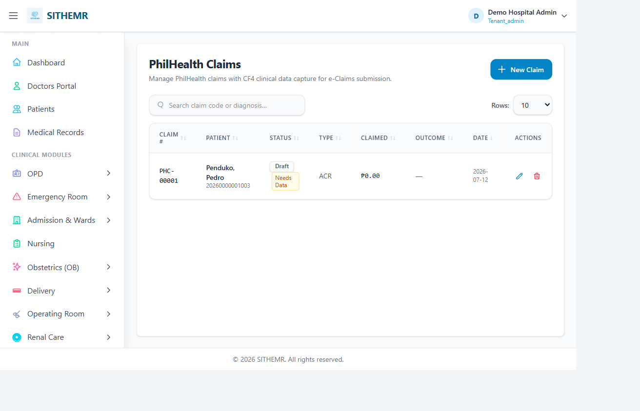
Figure 14: PhilHealth claims

The PhilHealth module (route prefix: /philhealth) manages PhilHealth membership, case rates, healthcare professionals, claims, and claim form generation for PhilHealth reimbursement.

14.1 PhilHealth Master Data
- PhilHealth > ICD10 Codes — diagnosis codes (International Classification of Diseases, 10th Revision). Used on claims to code the principal and secondary diagnoses.
- PhilHealth > RVS Codes — rate/validation schedule codes used in PhilHealth billing
- PhilHealth > Case Rates — per-case reimbursement rates for PhilHealth case-based payment
- PhilHealth > HC Professionals — healthcare professional records for PhilHealth (attending physicians, referring physicians) with their PhilHealth credentials
- PhilHealth > Members — patient PhilHealth membership records: member ID, name, benefit status, enrolment date. Linked to patients via the Is PhilHealth Member toggle and PhilHealth Member dropdown in patient registration.

14.2 PhilHealth Claims
PhilHealth > Claims (permission: philhealth.manage) is where PhilHealth claims are created and managed. The claim creation flow:
- Select the patient — must have a linked PhilHealth Member record
- Attach the encounter being claimed: ER admission, OPD consultation, or inpatient admission
- Add claim items: services and procedures with their case rates. The Clinical Data Pull-Up feature (ClinicalDataPullup Livewire) can auto-populate encounter data (diagnosis, procedures, attending physician) into the claim form to reduce manual entry.
- Link to a PhilHealth Claim Batch (from PhilHealth > Batches) for submission grouping
- Save the claim
Claims are managed in the PhilHealth > Claims list: view claim status, claim amount, batch association, submission status, and linked encounter/patient.

14.3 PhilHealth Claim Form PDFs
The application generates the standard PhilHealth claim form PDFs. Each is downloadable from the claim detail page via dedicated routes, rendered with DomPDF:
Form | Route | Contents
CF1 | philhealth.claims.{claim}.cf1pdf | Claim form 1 — basic claim info, patient, attending physician, principal/secondary/tertiary ICD10, case rate, items
CF2 | philhealth.claims.{claim}.cf2pdf | Claim form 2 — adds referring physician, secondary/tertiary ICD10, case rate, items
CF3 | philhealth.claims.{claim}.cf3pdf | Claim form 3 — for delivery cases: adds delivery type, items
CF4 | philhealth.claims.{claim}.cf4pdf | Claim form 4 — adds referring physician, secondary/tertiary ICD10, case rate, items
CF5 | philhealth.claims.{claim}.cf5pdf | Claim form 5 — shadow billing: adds CF5 shadow billing data
ESOA PDF | philhealth.claims.{claim}.esoapdf | Electronic Summary of Account — patient, PhilHealth member, ICD10, case rate, items, claim batch
EECL PDF | philhealth.claims.{claim}.eeclpdf | Emergency Encounter Closure List — patient, PhilHealth member, attending physician, ICD10, case rate, items, claim batch, ER admission triage record + OECB entries
Each PDF is downloaded with a filename like cf1-{claim_id}.pdf, esoapdf-{claim_id}.pdf, eecl-{claim_id}.pdf.

14.4 PhilHealth Batches and Reports
- PhilHealth > Batches (permission: philhealth.manage) — group claims into batches for submission. Tracks batch status and totals.
- PhilHealth > Reports (permission: reports.view) — PhilHealth claim summaries, batch status reports, and membership reports.

15. Medical Records and Certificates
Medical Records (/medical-records, permission: medical-records.view) handles certificate generation and patient chart access. It uses the MedicalRecordsCrud Livewire component.

15.1 Certificate Generation
The medical-records page provides certificate generation for five certificate types. The route medical-records.certificate accepts four parameters: type (certificate type), encounterType (OPD/ER Treatment/Admission), encounterId, and patientId.
Certificate Type | When to Use | Key Contents
Medical Certificate | Patient needs a general medical certificate for work/school/legal purposes | Patient name, age, diagnosis, statement that patient was under medical care at the institution, issued upon patient request for legal purposes
Certificate of Admission | Patient needs proof of hospital admission | Patient name, age, admission date/time, admitting diagnosis, attending physician, statement of admission
Discharge Summary | Patient needs a summary at discharge | Patient name, date of admission, date of discharge, admitting diagnosis, attending physician, statement that patient was admitted, treated, and discharged in satisfactory condition. For inpatient admissions only — includes Room/Bed
Certificate of Treatment | Patient needs proof of ER treatment | Patient name, age, ER treatment date/time, diagnosis, statement of ER treatment, issued upon patient request
Clinical Abstract | Patient needs a medical summary / clinical abstract | Patient name, encounter code, date, diagnosis, attending physician, horizontal rule, note that complete medical records are available from Medical Records Section

15.2 How Certificates Work
When you request a certificate, the system:
- Loads the patient (with gender) by patient ID
- Loads the encounter based on encounterType: OPD consultation (OpdConsultation), ER admission (ErAdmission), or inpatient admission (Admission). Each is loaded without global scopes and with the attending physician.
- Extracts encounter data: encounter code (e.g. OPD#<id>, ER#<id>, ADM#<id>), date/time formatted, diagnosis (assessment/chief complaint/admitting diagnosis depending on encounter type), attending physician name, status
- For admissions: also extracts room/bed name and discharge date
- For ER admissions: also extracts mode of arrival and disposition
- Pulls linked lab requests and pharmacy requests for the encounter and includes them as orders on the certificate
- Renders the selected certificate template (HTML body with patient name, age, diagnosis, dates, physician) via the certificate-print view (pages.medical-records.certificate-print)
- The certificate is displayed as a printable page — use the browser's print function (Ctrl+P) to print or save as PDF

15.3 Patient Chart Access
The Medical Records page also provides access to the patient chart — a consolidated view of all encounters, orders, and documents for a patient. This is the primary interface for pulling together a patient's complete clinical history for review or audit.

16. Doctors Module
The Doctors module (route prefix: /doctors) gives physicians their own workspace: dashboard, appointment schedule management, and patient chart access.

16.1 Doctors Dashboard
Doctors > Dashboard (route: doctors.dashboard, permission: doctors.dashboard, Livewire DashboardCrud) gives physicians a personalized view: their scheduled appointments, pending consultations, recent patients, and quick-access cards to open patient charts or start new consultations.

16.2 Appointment Schedule Management
Doctors > Schedule (route: doctors.schedule, permission: doctors.schedule, Livewire AppointmentScheduleCrud) is where doctors and admins manage the appointment calendar.
Access control: Admin users (superadmin/tenant_admin) see ALL doctors' appointments and can filter by doctor. Non-admin doctors see ONLY their own appointments (filtered by auth()->user()->health_care_professional_id).
The schedule table shows: appointment code, department, doctor, appointment date, time slot, patient name, status (Scheduled/In Progress/Completed/Cancelled), and notes. Search by patient name or appointment code. Filter by status, date, and (for admins) by doctor. Paginated (10 per page, configurable).

16.3 Managing Appointments
For each appointment, doctors/admins can:
- Edit/Reschedule: Open the edit modal to change the date, time slot, notes, and status. When changing the date, available slots for the new date are loaded. The system checks for scheduling conflicts (overlapping appointments for the same doctor on the same date). If a conflict is found, the user is prompted to pick another slot. On save, the appointment is updated with updated_by and updated_date.
- Mark In Progress: Sets status to In Progress (the doctor is now with the patient). Records updated_by and updated_date.
- Mark Completed: Sets status to Completed (consultation done). Records updated_by and updated_date.
- Cancel: Sets status to Cancelled (cancelled before the appointment). Records updated_by and updated_date.

16.4 Conflict Detection
When editing an appointment's date/time, the system checks for conflicts: it queries all non-cancelled appointments for the same healthcare professional on the same date (excluding the current appointment being edited) and checks if the new slot overlaps (new.start < existing.end AND new.end > existing.start). If a conflict exists, the save is blocked and an error message prompts the user to pick another slot. Available slots are re-loaded to help the user choose a free time.

16.5 Patient Chart (Doctor View)
Doctors > Patient > {type}/{id} (route: doctors.patient, permission: doctors.chart) opens the patient chart. The type parameter indicates the encounter context (e.g. opd, er, admission). The chart shows the patient's demographics, all encounters, clinical notes, orders, and results — the doctor's view of the patient's clinical record.

17. OB, Delivery, and Specialty Care

17.1 OB (Obstetrics) Module
The OB module (route prefix: /ob, permission: ob.view) manages obstetric consultations and related master data.
- OB > Visit Types — OB visit types (e.g. Prenatal Visit, Postnatal Visit, Well-Woman Visit)
- OB > Fetal Presentations — fetal presentation types (e.g. Cephalic, Breech, Transverse, Oblique)
- OB > Contraceptive Methods — contraceptive method codes/names for family planning services
- OB > Consultations (Livewire ObConsultationCrud) — OB consultations, following the same SOAP/order pattern as OPD consultations
OB consultations are created and documented like OPD consultations: create the consultation with patient, visit type, attending physician, contraceptive method (if applicable), fetal presentation (if applicable), then document SOAP notes, place orders (lab, pharmacy, etc.), and set disposition. OB consultations link to the patient and feed into billing and PhilHealth claims.

17.2 Delivery Module
The Delivery module (route prefix: /delivery, permission: delivery.view) manages obstetric delivery services.
- Delivery > Types — delivery types (e.g. Normal Spontaneous Vaginal Delivery, Caesarean Section, Assisted Vaginal Delivery, etc.)
- Delivery > Complications — delivery complications master (e.g. Pre-eclampsia, Hemorrhage, Shoulder Dystocia, etc.)
- Delivery > Rooms — delivery rooms (room name, status, location)
- Delivery > Schedule (Livewire DeliveryScheduleCrud) — delivery scheduling: patient, expected delivery date, delivery type, delivery room, attending physician, status, notes
OB and Delivery integrate: OB consultations track prenatal and postnatal care; Delivery records track the actual delivery event. Together they form the complete obstetric care record for a patient, feeding into the patient chart, billing, and PhilHealth claims (CF3 is the delivery claim form).

17.3 Renal Care (Dialysis) Module
Renal Care (/renal-care, permission: renal.view) manages dialysis services.
- Renal Care > Dialysis Types — dialysis modality types (e.g. Hemodialysis, Peritoneal Dialysis, etc.)
- Renal Care > Dialysis Sessions (Livewire DialysisSessionCrud) — individual dialysis session records: patient, dialysis type, session date, duration, technician/nurse, vital signs, fluid removed, notes, status
Dialysis sessions link to the patient and feed into billing and PhilHealth claims.

18. Nursing, YAKAP, and Konsulta

18.1 Nursing Module
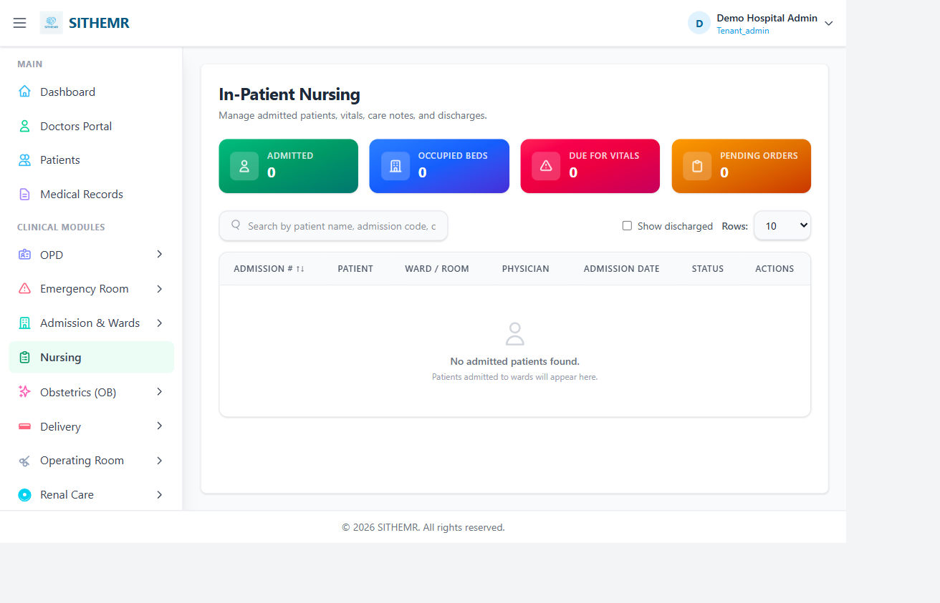
Figure 18: Nursing / YAKAP

Nursing (/nursing, permission: nursing.view, Livewire NursingCrud) provides a nursing workflow dashboard. Nurses use this to view patients needing nursing attention across departments, enter vital signs, and record nursing notes. Vitals can be entered from the OPD/ER/Admission SOAP forms or from the nursing dashboard directly.

18.2 YAKAP (PhilHealth Primary Care) Module
YAKAP (/yakap) is the Primary Care program module for PhilHealth's primary care initiative. All YAKAP routes require permission: yakap.view.
- YAKAP > Dashboard (Livewire DashboardCrud) — YAKAP summary: empanelment counts, FPE records, screenings, capitation overview
- YAKAP > Empanelments (Livewire EmpanelmentCrud, permission: yakap.manage) — patient enrolment records for the YAKAP primary care program: patient, family physician, enrolment date, status, benefit package
- YAKAP > FPE Records (Livewire FpeCrud, permission: yakap.manage) — First Party Encounter / Family Physician Engagement records: the primary care encounter data for YAKAP patients, feeding into PhilHealth primary care reporting
- YAKAP > Screenings (Livewire ScreeningCrud, permission: yakap.manage) — health screening records for YAKAP-enrolled patients
- YAKAP > Capitation (Livewire CapitationCrud, permission: yakap.manage) — capitation payment tracking: per-member-per-month or per-encounter payments against empanelments
YAKAP connects to OPD: when creating an OPD consultation, toggle Is YAKAP and select an empanelment to link the consultation to the YAKAP primary care program. This enables capitation tracking and primary care reporting.

18.3 Konsulta (Primary Care) Module
Konsulta (/konsulta/, permission: konsulta.view, Livewire KonsultaCrud) is the primary care consultation module — a simplified consultation flow for primary care / community health services, separate from OPD.

19. Procedures, Delivery, and Other Modules

19.1 Procedures Module
Procedures (route prefix: /procedures, permission: procedure.manage for master data, procedure.dispense for dispensing) manages clinical procedure master data and procedure ordering.
- Procedures > Categories — procedure categories (e.g. Surgical, Diagnostic, Therapeutic, Ancillary)
- Procedures > Procedures — individual procedure master: procedure code, name, category, description, status
- Procedures > Dispensing (permission: procedure.dispense) — tracks procedure performance/issuance: links to the patient, procedure, performing clinician, date, findings, status
Procedures are ordered from encounters via the Order Procedure modal. A Procedure Request is created with Procedure Request Items. The procedure is then performed and recorded via Procedures > Dispensing.

19.2 Delivery Rooms and Schedule
(Covered in Section 17.2 above — Delivery module handles delivery rooms and delivery scheduling.)

19.3 Transfers
Transfers (/transfers, permission: admission.view, Livewire HospitalTransferCrud) manages patient transfers between hospitals or facilities. Records: patient, from facility, to facility, transfer date, reason, status, and transported-by. Transfer records feed into patient tracking and billing.

19.4 Reports Hub
Reports (/reports, permission: reports.view) is the central reports hub. Individual modules also expose their own report pages (Pharmacy > Reports, PhilHealth > Reports). The reports hub provides cross-module summary reports.

19.5 Settings
Settings (/settings, permission: admin.settings) provides system administration: user profile management, password change, and application-level settings configuration.

20. Frequently Asked Questions
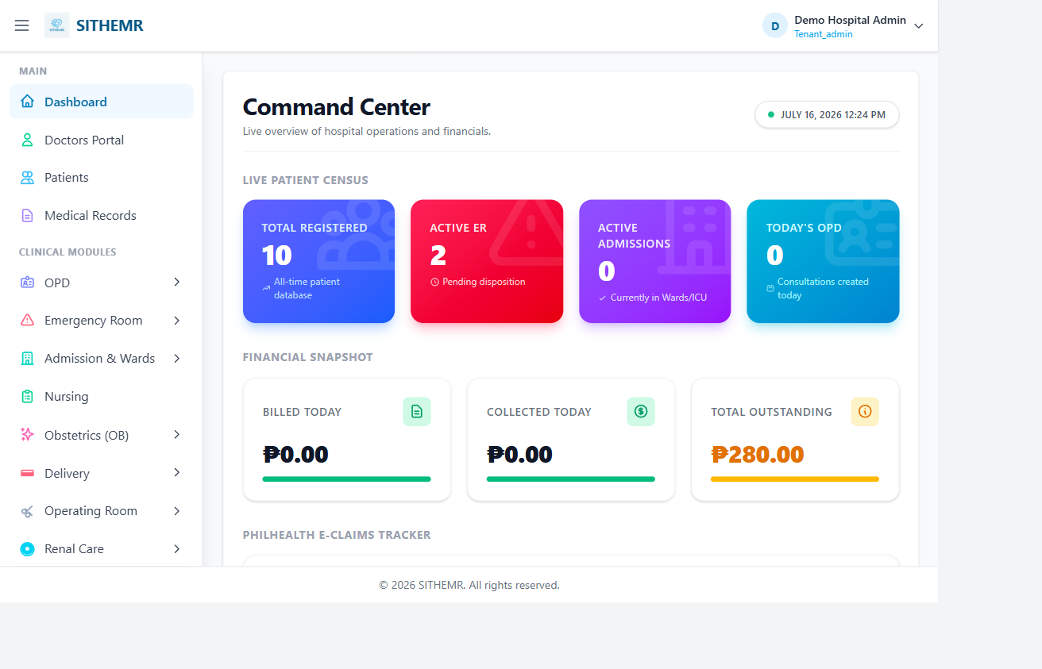
Figure 20: Annotated dashboard reference

This section covers the most common questions from HMR end users across all departments. Each answer references the actual screens, workflows, and configuration in this application.

A. Getting Started and Login
- Q: How do I log in to HMR? A: Go to /login, enter your email and password. A JWT token is issued and stored as an HTTP-only cookie. You are redirected to /dashboard. Admin login: admin@demohospital.com / Admin@12345.
- Q: What do I see on the dashboard? A: /dashboard shows today's activity: pending OPD consultations, ER admissions, lab/pharmacy/CSR requests awaiting action, billing balances, and quick-access cards to each module. Each card links to the relevant module page.
- Q: What if I get access denied (403)? A: Every page requires a specific permission (e.g. permission:lab.manage). If your role lacks the permission, you see access denied. Ask your tenant admin to assign the correct permission under Admin > Roles > Role Permissions, or Admin > User Permissions for your user.
- Q: How do I log out? A: Click Logout in the navigation. The JWT cookie is cleared server-side and you return to /login. Save your work first - unsaved form data is lost on logout.
- Q: My session expired - what happens? A: JWT sessions expire after a configured time. When expired, you are redirected to /login. Unsaved form data may be lost, so save frequently. Just log in again to continue.

B. Patient Registration
- Q: Where do I register a new patient? A: Go to /patients (Patients), click Create New Patient. The form captures demographics, address (Region > Province > City > Barangay cascading), contact info, emergency contact, PhilHealth linkage, and extended EMR fields (maiden name, place of birth, preferred language, national ID, passport, father/mother/spouse names, birth indicator, deceased flag, primary care provider). Patient code is auto-generated as YYYY + 10-digit sequence.
- Q: How do cascading address dropdowns work? A: When you select a Country, the Region dropdown populates. Selecting a Region populates Provinces. Selecting a Province populates Cities/Municipalities. Selecting a City populates Barangays. Each level triggers the next dropdown via Livewire reactive updates.
- Q: How do I search for existing patients? A: Use the search box on the Patients page. A 3-character search triggers a paginated (15 per page) lookup filtering by name, patient code, PhilHealth number, and contact number. Sort by patient code, last name, or other fields.
- Q: What is the PhilHealth Member toggle? A: Checking Is PhilHealth Member reveals a PhilHealth Member dropdown. Select an existing member record (created under PhilHealth > Members) to link the patient to a PhilHealth membership. This enables PhilHealth claims later. The member record must exist before you can link it.
- Q: Can I view a patient's full chart from the patient list? A: Yes. Each patient row has a View Chart link that opens the patient chart - a consolidated view of all encounters (OPD, ER, Admission), lab/pharmacy/CSR/radiology/procedure orders, and billing entries tied to that patient.

C. OPD Consultations
- Q: What is the OPD consultation workflow? A: OPD > Consultations > Create New Consultation. Steps: (1) Search and select a patient; (2) Select OPD Clinic, Attending Physician, Consultation Type, Visit Type, and optionally Referral Source; (3) For YAKAP patients, toggle Is YAKAP and select an Empanelment; (4) Save to create the consultation (status: Pending). The SOAP form then opens for clinical documentation.
- Q: What SOAP fields are captured? A: Chief Complaint, History of Present Illness, Physical Exam Findings, Assessment, Treatment Plan, Orders Summary, Disposition, and Next Follow-up Date. Nursing can enter vitals (BP, HR, temp, RR, weight, height, O2 sat) via the Vitals modal.
- Q: How do I order lab, pharmacy, CSR, radiology, or procedures from OPD? A: Each order type has its own modal on the consultation: Order Lab, Order Pharmacy, Order CSR, Order Radiology, Order Procedure. Select items, set priority (Routine/STAT), notes, quantity, frequency, route. Orders are created and linked to the consultation via opd_consultation_id.
- Q: What master data must I set up first for OPD? A: Visit Types, Consultation Types, Referral Sources, Services, Clinics, and Complaints - all under OPD in the sidebar. These drive the dropdown options in the consultation create form. Doctors (Healthcare Professionals) and Departments must also be set up under Masters.

D. Emergency Room
- Q: How do I admit a patient to the ER? A: Go to ER > Triage first to create a triage record (patient, acuity level from ER > Acuity Levels, mobility status, triage notes). Then create an ER Admission (ER > Admission) linking the patient, ER bed (from ER > Beds), attending physician, initial diagnosis, mode of arrival, and disposition. Admission code: ER#<id>.
- Q: What are zones and beds? A: ER > Zones defines physical zones (e.g. Red, Yellow, Green). ER > Beds assigns individual beds to a zone with a bed number and status (Available/Occupied). Beds are assigned during ER admission.
- Q: What is OECB and the EECL PDF? A: OECB (Outpatient Emergency Case Billing) tracks emergency-specific fees. Flag an ER admission as Is OECB and record OECB entries (core presentation + fee schedule items). The EECL PDF is printable from ER > Admission > {admission}/eeclpdf - it includes patient info, attending physician, OECB entries, triage record with acuity level, and ER bed/zone. Downloaded as eecl-{admission_code}.pdf.
- Q: How do I set the ER disposition? A: After treatment, use the Disposition modal on the ER admission to set the outcome (Discharged, Admitted, Referred, Left Without Being Seen, etc.). This updates the admission status and feeds into billing.

E. Inpatient, ICU, Ward, and OR
- Q: How does inpatient admission work? A: /admission (permission: admission.view). Create an admission: select patient, admitting diagnosis, attending physician, admission type, admission date, and assign a ward room or ICU bed. Admission code: ADM#<id>.
- Q: What is the difference between Ward, ICU, and MICU? A: Ward (/ward) manages general inpatient beds (Wards, Room Types, Rooms). ICU (/icu) manages critical care beds (ICU Wards, ICU Beds). MICU (/micu) manages medical ICU patient records and assessment parameters. An admission can be assigned to a ward room or an ICU bed. MICU is specifically for medical (non-surgical) critical care tracking.
- Q: How do I track bed availability? A: Each room/bed record has a status (Available/Occupied). The admission lists show which beds are occupied and by which patient. When a patient is discharged, the bed is freed. Room transfers are tracked in Admission Room History.
- Q: How do I schedule an OR procedure? A: OR > Schedule. Create an OR schedule entry: patient, procedure, surgeon, anaesthetist, OR room (from OR > Rooms), date/time, status. The OR schedule drives theatre utilization.

F. Laboratory, Radiology, Pharmacy, and CSR
- Q: How do I order a lab test? A: From an encounter (OPD/ER/Admission) or Lab > Results/Dispensing, create a Lab Request. Select patient, requesting doctor/department, add Lab Request Items by choosing tests from Lab > Tests. Each item has specimen type, priority, and requested-by. Master data needed: Lab > Sections, Units, Specimen Types, Instruments, Tests, Panels, Reference Ranges.
- Q: How are lab results verified? A: Results flow through a 3-step chain: Performed By (technologist who ran the test) -> Verified By (supervisor) -> Validated By (pathologist). Each step is recorded on the lab result. The result is not complete until validated.
- Q: How do I print a lab or radiology result? A: From Lab > Results or Radiology > Results, click the Print link on a result row. Lab: route lab.result.print. Radiology: route radiology.result.print. Both load a print-formatted view with patient, requesting doctor, test/exam details, results/findings, and the verification chain.
- Q: How do I dispense medication? A: Pharmacy > Dispensing. Select patient, choose drugs from Pharmacy > Drugs (with batch from Pharmacy > Drug Batches - check expiry), enter quantity, dosage instructions (sig), frequency, route, duration. Optionally link to a Pharmacy Request. Stock is decremented from the selected batch. The patient's medication record (PMR) is updated.
- Q: What is the difference between Pharmacy and CSR? A: Pharmacy handles medications - drugs with batch/expiry tracking, dosage instructions, and the Patient Medication Record (PMR). CSR (Supply) handles general medical supplies and consumables - gloves, syringes, dressings, equipment - without batch tracking. Both share the same dispensing and encounter-print patterns.
- Q: How do I print a pharmacy or CSR request? A: Two options: (1) Request Print (pharmacy.request.print / supply.request.print) - single request with items, requesting department, patient; (2) Encounter Print (pharmacy.request.encounter-print / supply.request.encounter-print) - groups ALL requests for the same encounter into one printout, useful for discharge medication reconciliation.

G. Billing and Payments
- Q: How do I create an invoice? A: Billing > Create Invoice. Search/select patient, select the encounter to bill (admission/ER/OPD), add service items (pulled from unbilled lab/pharmacy/CSR/radiology/procedure orders on the encounter), apply discounts if any, add notes, save. Invoice code is sequential.
- Q: What is the Patient Account Ledger? A: Every patient has a running ledger of all charges (debit) and payments (credit). View it from Billing > Patient Accounts tab or the Ledger modal. Each entry shows date, entry type, source type, source code, description, debit, credit, and running balance. The ledger is the source of truth for patient balances.
- Q: How do I record a payment? A: Billing > Record Payment. Select patient/invoice, enter payment date, amount, method (Cash/Card/Check/Insurance/Other), reference, notes. Optionally link to a Fund Source or Insurance Provider. The payment updates the invoice balance and adds a credit entry to the patient ledger.
- Q: How do I print an invoice, receipt, or statement of account? A: Invoice: billing.invoice.print - full invoice with line items, totals, payments, balance. Receipt: billing.payment.receipt - payment details and linked invoice. Statement of Account: billing.statement/{patientId}/{mode} - full ledger, choose Summary (grouped by source type) or Detailed (every entry). All generated as PDF via DomPDF. Statement file: Statement_of_Account_{patient_name}_{mode}.pdf.
- Q: What are Manual Charges? A: Ad-hoc charges not tied to a specific order - for miscellaneous fees (registration, bed fee, other). Add from the Invoice Detail modal (adds a line item to an invoice) or from the Patient Accounts tab (adds a debit entry directly to the patient ledger, not tied to any invoice).

H. PhilHealth Claims
- Q: How do I create a PhilHealth claim? A: PhilHealth > Claims > Create. Select patient (must have linked PhilHealth Member), attach the encounter (ER/OPD/Admission), add claim items with case rates (use Clinical Data Pull-Up to auto-populate from the encounter), link to a Claim Batch, save.
- Q: What PhilHealth forms can I print? A: Seven forms: CF1, CF2, CF3 (delivery), CF4, CF5 (shadow billing), ESOAPDF (Electronic Summary of Account), and EECLPDF (Emergency Encounter Closure List). Each downloadable from the claim detail page. All rendered with DomPDF and pre-loaded with claim data, patient info, ICD10 codes, case rates, items, and (for EECL) ER triage/OECB data.
- Q: What is the Clinical Data Pull-Up? A: A feature (ClinicalDataPullup Livewire) that auto-populates encounter data - diagnosis, procedures, attending physician - into the PhilHealth claim form, reducing manual entry and transcription errors.

I. Medical Certificates
- Q: How do I print a medical certificate? A: Medical Records (/medical-records). Select certificate type (Medical, Admission, Discharge Summary, Treatment, Clinical Abstract), encounter type (OPD/ER Treatment/Admission), encounter ID, patient ID. The system loads the encounter, extracts diagnosis/physician/dates, pulls linked lab/pharmacy orders, and renders the certificate via the certificate-print view. Print with Ctrl+P or save as PDF.
- Q: Which certificate type should I use? A: Medical Certificate - general purpose (work/school/legal). Certificate of Admission - proof of admission. Discharge Summary - inpatient discharge summary (includes room/bed and discharge date). Certificate of Treatment - ER treatment proof. Clinical Abstract - comprehensive medical summary (notes that full records are available from Medical Records).

J. Doctors and Appointments
- Q: What does the Doctors Dashboard show? A: Doctors > Dashboard shows the physician's scheduled appointments, pending consultations, recent patients, and quick-access cards to open patient charts or start new consultations.
- Q: How do I manage my appointment schedule? A: Doctors > Schedule. Admins see all doctors' appointments (filterable by doctor). Non-admin doctors see only their own. For each appointment: Edit (reschedule date/time, change notes/status), Mark In Progress, Mark Completed, or Cancel. Conflict detection prevents double-booking.
- Q: How does the conflict detection work? A: When editing a date/time, the system checks all non-cancelled appointments for the same doctor on the same date (excluding the current one). If new.start < existing.end AND new.end > existing.start, it is a conflict - save is blocked, error shown, available slots re-loaded.
- Q: How does a patient book an appointment without logging in? A: /book-appointment (public, no login). The patient selects Department > Doctor > Date > Time Slot > enters their name and contact info > Books. They get an APT-XXXXX reference code. The appointment is created with status Scheduled. This is the only public page - everything else requires login.

K. Technical and Troubleshooting
- Q: The page looks broken / unstyled - what do I do? A: The frontend assets (CSS/JS) may be stale. Run npm run build in the project root (E:\sithemr) to rebuild the Vite bundles. Then hard-refresh the browser (Ctrl+Shift+R). The built assets are in public/build/.
- Q: A dropdown is empty - what do I check? A: The dropdown depends on master data. Check that the relevant master records exist (e.g. empty Province dropdown = no provinces created under Masters > Province). Also check you are in the correct tenant - master data is tenant-scoped.
- Q: A patient I know exists does not show up in search? A: Check: (1) You are in the correct tenant (multi-tenancy isolates data per hospital); (2) The patient is active (Is Active flag - soft-deleted patients are hidden); (3) Your search term matches (3-character minimum triggers the search). Try searching by patient code for exact match.
- Q: PDF download does not start - what is wrong? A: PDF generation uses DomPDF server-side. If the PDF route returns an error, check: (1) The record exists and you have permission to view it; (2) Related data is loaded (the PDF route uses loadMissing/with to eager-load relationships); (3) The DomPDF service is available (barryvdh/laravel-dompdf is in composer.json). A 500 error on a PDF route usually means a missing relationship or null reference in the blade template.
- Q: How are records deleted - are they really gone? A: No. The application uses soft deletes via a history flag (history=1 = current/active). When you delete a record, it is deactivated (history set to 0) and hidden from normal views, but retained in the database. This preserves the audit trail and historical data. The Admin > Audit Log shows all changes.
- Q: Can I access the application from another computer? A: Yes - the application is a web app. Access it via the server's URL (configured in .env APP_URL). The default is http://localhost for local development. For network access, configure APP_URL to the server's IP or hostname and ensure the port is accessible. The app uses a JWT cookie - ensure cookies are accepted by the browser.

21. Appendix

A. Role-Based Access Summary
Role / Access Level | Key Permissions | Main Modules Available
Superadmin / Tenant Admin | admin.masters, admin.users, admin.tenants, doctors.schedule, billing.manage, lab.manage, pharmacy.manage, csr.manage, radiology.manage, procedure.manage, er.manage, admission.view, reports.view | All modules — full system access, master data management, user/role administration, audit log
Doctor (non-admin) | doctors.chart, doctors.schedule (own), opd.view, er.view, admission.view, lab.result, pharmacy.view, radiology.view, billing.view, medical-records.view | Doctors Dashboard, own appointment schedule, patient chart, own OPD/ER consultations, view lab/radiology results, view billing, print medical certificates
Nurse | nursing.view, er.triage, opd.view | Nursing dashboard, ER triage, vitals entry, patient monitoring
Lab Technologist / Pathologist | lab.manage, lab.result, lab.dispense | Lab sections, units, tests, panels, reference ranges, results entry, verification, validation, lab dispensing
Pharmacist | pharmacy.manage, pharmacy.dispense, pharmacy.view | Drugs, drug batches, inventory, purchase orders, stock adjustments, dispensing, patient medication record, pharmacy reports
CSR / Supply Officer | csr.manage, csr.dispense | Supply units, categories, suppliers, stock locations, items, inventory, stock adjustments, CSR dispensing, request print
Radiologist / Radiology Tech | radiology.manage, radiology.result, radiology.dispense | Modalities, body parts, exam types, radiology results, image handling, radiology dispensing
Billing Officer | billing.view, billing.manage | Billing dashboard, invoice management, patient accounts ledger, payments, fund sources, insurance providers, invoice/receipt/statement print
PhilHealth Administrator | philhealth.view, philhealth.manage | ICD10 codes, RVS codes, case rates, HC professionals, members, claims, batches, claim form PDFs (CF1-CF5, ESOAPDF, EECLPDF), PhilHealth reports
Medical Records Officer | medical-records.view | Medical Records dashboard, certificate generation (all 5 types), patient chart access
Admission / Ward Staff | admission.view | Admission, ward/room management, ICU, OR rooms, transfer records, patient tracking
YAKAP Administrator | yakap.view, yakap.manage | YAKAP dashboard, empanelments, FPE records, screenings, capitation
Public (unauthenticated) | public.book | Book an Appointment page only — department > doctor > date > slot > patient info > book. Gets APT-XXXXX reference code.

B. Data Flow: Patient Journey End to End
Figure 21: Appendix — system overview

This is the typical flow of data through the system for a complete patient episode:
- Patient registered — Patient record created under /patients with demographics, address, contact, PhilHealth linkage (if any). Patient code assigned (YYYY + sequence).
- Appointment booked (optional) — Patient or staff books via /book-appointment (public) or staff schedules via Doctors > Schedule. Appointment gets APT-XXXXX code, status Scheduled.
- Encounter created — Patient arrives. An encounter is created: OPD Consultation (OPD > Consultations), ER Admission (ER > Admission via triage), or Inpatient Admission (/admission). Each gets a unique code (OPD-/ER#/ADM#) and status Pending.
- Clinical documentation — SOAP notes entered (chief complaint, HPI, physical exam, assessment, treatment plan, disposition, follow-up). Nursing enters vitals. For ER: triage record + acuity level + OECB entries.
- Orders placed — From the encounter, orders are placed: LabRequest, PharmacyRequest, CsrRequest, RadiologyRequest, ProcedureRequest. Each order links to the encounter and contains items (tests, drugs, supply items, exams, procedures) with priority, quantity, and notes.
- Orders processed — Lab results entered and verified (performed > verified > validated). Drugs dispensed from pharmacy (stock decremented, batch tracked). Supplies dispensed from CSR. Radiology results entered with findings/impression. Procedures performed and recorded.
- Billing invoice created — From the encounter + processed orders, a Billing Invoice is created with service items, totals, discounts. The invoice creates charge entries on the patient's ledger.
- Payments recorded — Payments are recorded against the invoice (cash, card, insurance, other). Linked to fund sources/insurance providers. Creates credit entries on the ledger. Reduces invoice balance.
- PhilHealth claim generated (if applicable) — If the patient has PhilHealth membership and the encounter is claimable, a PhilHealth Claim is created with claim items, case rates, ICD10 codes. The claim is linked to a batch. PhilHealth claim form PDFs (CF1-CF5, ESOAPDF, EECLPDF) are generated for submission.
- Medical certificates printed (on request) — If the patient needs a certificate, Medical Records generates the appropriate type (Medical, Admission, Discharge, Treatment, Clinical Abstract) with encounter data and linked orders.
- Encounter closed — Disposition finalized (discharged, admitted, referred, etc.). For inpatients: discharge date recorded, bed freed. The encounter moves to a closed status and the patient's chart reflects the complete episode.

C. Configuration Reference
Setting | File / Location | Default / Example | Description
App URL | .env > APP_URL | http://localhost | Base URL of the application. Use relative URLs in Blade (e.g. href="/book-appointment") — do not rely on route() absolute output.
Database | .env > DB_* | DB_CONNECTION=sqlsrv, DB_HOST=127.0.0.1, DB_PORT=1433, DB_DATABASE=sithemr, DB_USERNAME=root, DB_PASSWORD=P@ssw0rd | Microsoft SQL Server connection for the sithemr database.
Appointment slot minutes | config/appointment.php > slot_minutes | 30 | Duration of each appointment slot in minutes. Used by public booking and doctor schedule.
Appointment working hours | config/appointment.php > working_start / working_end | 08:00 / 17:00 | Start and end of working hours for appointment scheduling. Slots are generated between these times.
Public tenant ID | config/appointment.php > public_tenant_id | (null — defaults to first hospital) | Tenant ID used for public appointment booking. If null, defaults to the first hospital record.
JWT secret | .env > JWT_SECRET | (generated) | Secret key for JWT token signing. Set via php artisan jwt:secret.
Frontend build | package.json > scripts.build | vite build | Command to rebuild Tailwind CSS v4 + Alpine.js + Vite bundles. Run after frontend changes. Output: public/build/.
PDF engine | composer require barryvdh/laravel-dompdf | ^3.1 | DomPDF is the PDF generation engine. Used by all print routes: invoices, receipts, statements of account, PhilHealth claim forms, ER EECL, medical certificates, lab/radiology result prints.
Excel export | composer require phpoffice/phpspreadsheet | ^5.8 | PHPSpreadsheet is available for spreadsheet exports (reports, data exports).
Authentication | composer require tymon/jwt-auth | ^2.3 | JWT authentication. Token stored in HTTP-only cookie. Middleware: JwtMiddleware wraps the web group. Public routes must be added to the skip list in app/Http/Middleware/JwtMiddleware.php.
Livewire | composer require livewire/livewire | ^4.3 | Livewire 4 for reactive server-side components. All CRUD pages and dashboards are Livewire components. Use wire:model.live for cascading UI (selects/date). Never use wire:change (throws DirectCallingLifecycleHooksNotAllowedException).

D. Model and Database Conventions
- Multi-tenancy: tenant_id = hospitals.id. All tenant-scoped models use the ScopedByTenant trait which auto-filters by request()->attributes->get('tenant_id'). DEMO hospital = tenant ID 1.
- History soft delete: history column (1 = current/active, 0 = deactivated). Global scope filters to history=1. When using withoutGlobalScopes(), manually re-add ->where('history', 1) and ->where('tenant_id', $tid).
- Models: $timestamps = false (no created_at/updated_at), $guarded = ['id'] (all other fields mass-assignable). Audit columns: created_by, created_date, updated_by, updated_date — managed explicitly in create/update calls, not by timestamps.
- Appointment model: DoctorAppointment (table: doctor_appointments). Config: config/appointment.php. Reference codes: APT-XXXXX.
- Patient model: Patient. Reference codes: YYYY + 10-digit sequence (e.g. 202600000001).
- OPD Consultation model: OpdConsultation. Reference codes: OPD-XXXXX.
- ER Admission model: ErAdmission (table: er_admissions). Reference codes: ER#<id>.
- Admission model: Admission. Reference codes: ADM#<id>.
- Billing Invoice model: BillingInvoice. Billing Payment model: BillingPayment. Patient Account Entry model: PatientAccountEntry with getLedger() and getPatientBalance() static methods.
- PhilHealth Claim model: PhilhealthClaim. Related: PhilhealthMember, Icd10Code, CaseRate, ClaimBatch, Cf5ShadowBilling.
- Lab: LabRequest, LabRequestItem, LabTest, LabPanel, LabUnit, SpecimenType, Section, ReferenceRange.
- Pharmacy: PharmacyRequest, PharmacyRequestItem, Drug, DrugBatch.
- CSR/Supply: CsrRequest, CsrRequestItem, Item, ItemCategory, Supplier, StockLocation, SupplyUnit.
- Radiology: RadiologyRequest, RadiologyRequestItem, RadiologyExamType, Modality, BodyPart.
- Procedures: ProcedureRequest, ProcedureRequestItem, Procedure, ProcedureCategory.
- All Livewire components use snake_case for public properties (e.g. patient_id, not patientId) — Livewire 4 convention.

E. Development and Deployment Notes
- Development server: php artisan serve — starts on port 8000 by default (http://127.0.0.1:8000).
- Frontend build: npm run build (Vite). Required after any Blade/JS/CSS changes for production. Dev mode: npm run dev (Vite dev server with hot reload). The project uses "type": "module" in package.json — .cjs extensions needed for CommonJS scripts like Playwright tests.
- composersetup: composer install && php artisan key:generate && php artisan migrate --force && npm install && npm run build (see composer.json scripts.setup).
- Full dev stack: npm run dev — runs php artisan serve + queue:listen + laravel/pail (logs) + vite dev concurrently.
- Testing: php artisan test (PHPUnit, configured in phpunit.xml).
- Code style: php artisan pint (Laravel Pint, configured in pint.json).
- Security scan: baspa/larascan and laravel-security/pentest-scanner are in require-dev for static analysis and pentest scanning.
- Playwright E2E: installed locally only (npm install playwright --no-save, NOT in package.json). Browser: npx playwright install chromium. E2E scripts must be .cjs (repo has "type":"module"). Run with node, delete after passing.
- No doctrine/dbal: column changes must use raw DB::statement() — doctrine/dbal is not installed.
- Windows/MSYS: the shell is MSYS bash (git-bash). Use POSIX syntax (ls, grep, |) — PowerShell builtins (Get-ChildItem, $env:FOO) do not work. MSYS-style paths (/c/Users/...) work alongside native Windows paths (C:\Users\...).
- PHP version: PHP 8.2.12 (CLI) on XAMPP. Python toolchain: python3 not found on PATH; use /c/Python313/python.exe for Python tasks (e.g. python-docx for Word document generation).

Document Revision History
Version | Date | Author | Changes
1.0 | September 2026 | SITHEHR Development Team | Initial release — comprehensive user manual covering all HMR modules, workflows, and FAQs. Built from actual application code: routes/web.php, all Livewire components, and Blade views.

