SITHEHR

Hospital Management & Records System

Document Control
Field | Detail
Application | SITHEHR (Hospital Management & Records System)
Purpose | Complete end-user operational reference covering every module, screen, workflow, field, and FAQ
Audience | Hospital administrators, doctors, nurses, lab technologists/pathologists, pharmacists, CSR/supply officers, radiologists, billing officers, PhilHealth administrators, medical records officers, admission/ward staff, YAKAP administrators
Platform | Web application - Chrome/Edge/Firefox desktop browser. Livewire 4 reactive SPA, Tailwind CSS v4, Alpine.js
Backend | Laravel 12 framework, PHP 8.2.12 (XAMPP), Microsoft SQL Server 2019+, JWT authentication (tymon/jwt-auth v2.3)
Frontend | Livewire 4 (reactive server-side components), Tailwind CSS v4 (utility-first), Alpine.js v3.15 (lightweight client interactivity), Vite 7 (bundler)
PDF Engine | Barryvdh DomPDF v3.1 - all print/PDF outputs server-side generated
Spreadsheet | PHPOffice PHPSpreadsheet v5.8 - export to Excel
Database | Microsoft SQL Server (MSSQL) - DB: sithemr, Host: 127.0.0.1, Port: 1433, User: root, Password: P@ssw0rd
Default Tenant | DEMO hospital - tenant_id = 1
Admin Login | Email: admin@demohospital.com / Password: Admin@12345
Public Booking | http://localhost/book-appointment - no login required, patients self-book appointments
Auth Model | JWT token stored in HTTP-only cookie 'jwt_token'. Middleware: JwtMiddleware wraps the entire web group. Public routes must be added to skip list in app/Http/Middleware/JwtMiddleware.php
Multi-tenancy | tenant_id = hospitals.id. All tenant-scoped models use ScopedByTenant trait auto-filtering from request()->attributes. DEMO hospital = id 1
Soft Deletes | history column: 1 = current/active, 0 = deactivated (soft delete). Global scope filters history=1. When using withoutGlobalScopes(), manually re-add ->where('history', 1) and ->where('tenant_id', $tid)
Model Conventions | $timestamps = false (no created_at/updated_at). $guarded = ['id'] (all other fields mass-assignable). Audit columns: created_by, created_date, updated_by, updated_date - managed explicitly in create/update calls
Livewire Convention | Public properties use snake_case (e.g. patient_id, not patientId). wire:model.live for cascading UI (selects/date). NEVER wire:change - throws DirectlyCallingLifecycleHooksNotAllowedException
Frontend Build | npm run build (Vite) - output: public/build/ (CSS + JS bundles). Required after Blade/JS/CSS changes. Dev mode: npm run dev (hot reload). package.json has "type": "module" - E2E scripts must be .cjs

Table of Contents

1. System Architecture & Concepts
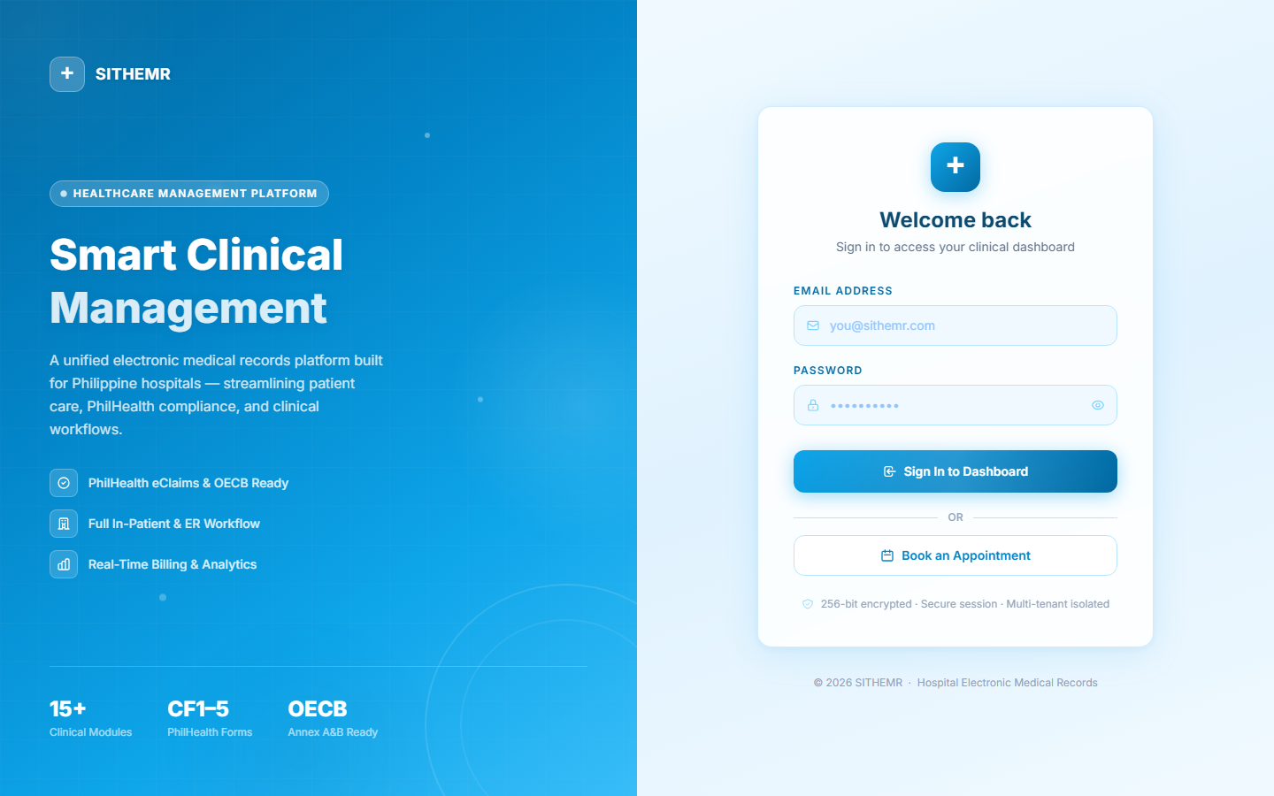
Screenshot: 01-login-page.png

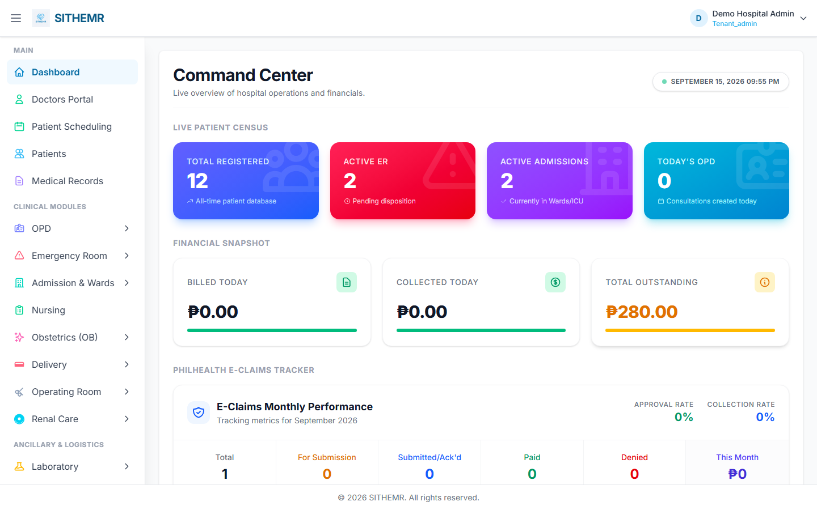
Screenshot: 03-dashboard.png

This chapter explains the foundational concepts that apply across the entire application. Understanding these makes every module easier to use.

1.1 Multi-Tenancy
SITHEHR supports multiple hospitals running on the same installation. Each hospital is a Tenant with a unique tenant_id that matches hospitals.id in the database. The DEMO hospital is tenant_id = 1.
How it works in practice:
- Every tenant-scoped model uses the ScopedByTenant trait. This trait automatically adds a WHERE tenant_id = ? clause to every query, where the tenant_id comes from request()->attributes->get('tenant_id').
- The tenant_id is set on the request when a user logs in - it reflects the hospital the user belongs to.
- Master data (departments, provinces, cities, barangays, genders, etc.) is tenant-scoped. When you create a department, it is created for YOUR hospital only. Other hospitals do not see it.
- To access data across tenants (e.g. in reports or administrative queries), the code explicitly uses withoutGlobalScopes() and re-adds the tenant filter manually.
- When you see a dropdown that appears empty, check: (1) Is the master data created for YOUR tenant? (2) Are you logged in as the correct hospital's user?

1.2 Soft Deletes and History
SITHEHR does not physically delete records. Instead, it uses a soft-delete pattern with a history column:
- history = 1: the record is current/active and visible in normal queries.
- history = 0: the record is deactivated (soft-deleted) and hidden from normal views, but retained in the database.
- The global scope automatically filters to history = 1. This means you never see deactivated records unless you intentionally bypass the scope.
- When you click Delete on a record, the system sets history = 0. The record is preserved for audit/Historical reference.
- When writing custom queries with withoutGlobalScopes(), you MUST manually re-add: ->where('history', 1) and ->where('tenant_id', $tid). Forgetting this causes records from all tenants and all history states to appear.
- The Admin > Audit Log page shows the complete change history across the system - every create, update, and soft-delete is logged with timestamp and user.

1.3 Authentication and Authorization
SITHEHR uses JWT (JSON Web Token) authentication. Here is exactly how it works:
- When you log in at /login, the server validates your email/password and issues a JWT token.
- The JWT token is stored in an HTTP-only cookie named 'jwt_token'. HTTP-only means JavaScript cannot read it - this prevents XSS token theft.
- The JwtMiddleware intercepts every request in the web group. It reads the cookie, validates the token, and attaches the user data to the request.
- If the token is missing or expired, you are redirected to /login. Your session 'expires' - unsaved form data may be lost.
- Every route has a permission requirement. Example: Route::get('/lab/tests', ...)->middleware('permission:lab.manage'). If your role lacks 'lab.manage' permission, you get a 403 Forbidden.
- Permissions are assigned to roles (Admin > Roles > Role Permissions). Roles are assigned to users (Masters > Users or Admin > User Permissions).
- Rate limiting: The /login route is throttled at 10 attempts per 1 minute (throttle:10,1). After too many failed attempts, wait 1 minute before trying again.
- Logout clears the JWT cookie server-side. You return to /login.

1.4 Permission System Reference
Every route requires a specific permission string. Here is the complete permission catalog with what each grants access to:
Permission | Grants Access To
dashboard.view | Main dashboard at /dashboard - home/summary page with today's activity
admin.masters | All Masters menu items - country, region, province, city, barangay, religion, gender, civil-status, nationality, occupation, blood-type, relationship, hospital, permissions
admin.users | Masters > Users - user CRUD, user list
admin.tenants | Masters > Company (Tenant) - multi-tenant hospital setup
admin.masters | General master data management umbrella permission
admin.roles | Admin > Roles - create/edit roles
admin.role-permissions | Admin > Role Permissions - assign permissions to roles
admin.audit-log | Admin > Audit Log - system-wide change history
admin.users.permissions | Admin > Users > {userId}/permissions - override individual user permissions
patient.view | /patients - Patient Registration CRUD (PatientCrud Livewire)
opd.view | All OPD pages: visit-types, consultation-types, referral-sources, services, clinics, complaints, consultations (OpdConsultationCrud)
er.triage | ER > Triage - create triage records
er.manage | ER master data: acuity-levels, mobility-statuses, zones, beds, area + admission EECL PDF
admission.view | Admission (/admission), ICU (/icu), Ward (/ward), OR (/or), Transfers (/transfers) - all inpatient/admission related
lab.manage | Lab master data: sections, units, specimen-types, instruments, tests, panels, reference-ranges
lab.dispense | Lab > Dispensing - issue lab materials/consumables
lab.result | Lab > Results - view and enter lab results, lab.result.print PDF
radiology.manage | Radiology master data: modalities, body-parts, exam-types
radiology.dispense | Radiology > Dispensing
radiology.result | Radiology > Results - view/enter radiology results, result.print PDF
pharmacy.manage | Pharmacy master data: drugs, drug-batches, inventory, purchase-orders, stock-adjustments
pharmacy.dispense | Pharmacy > Dispensing - dispense medications to patients
pharmacy.view | Pharmacy > Patient Medication Record, pharmacy.request.print, pharmacy.request.encounter-print
pharmacy.reports | Pharmacy > Reports
csr.manage | Supply/CSR master data: units, categories, suppliers, stock-locations, items, inventory, stock-adjustments
csr.dispense | Supply > Dispensing + supply.request.print + supply.request.encounter-print
procedure.manage | Procedures > categories, procedures
procedure.dispense | Procedures > dispensing
or.view | OR > rooms, OR > schedule
renal.view | Renal Care > dialysis-types, dialysis-sessions
delivery.view | Delivery > types, complications, rooms, schedule
ob.view | OB > visit-types, fetal-presentations, contraceptive-methods, consultations (ObConsultationCrud)
yakap.view | YAKAP > dashboard
yakap.manage | YAKAP > empanelments, fpe-records, screenings, capitation
konsulta.view | Konsulta > primary care consultations (KonsultaCrud)
billing.view | Billing (/billing) - invoice management, patient accounts, payments, invoice/receipt/statement print
billing.manage | Billing > fund-sources, insurance-providers - master data for payment sources
philhealth.view | PhilHealth > icd10-codes, rvs-codes, case-rates, hc-professionals, members
philhealth.manage | PhilHealth > claims, batches + all claim PDF routes (cf1pdf-cf5pdf, esoapdf, eeclpdf)
philhealth.reports | PhilHealth > reports
medical-records.view | /medical-records - certificate generation, patient chart access
nursing.view | /nursing - nursing dashboard
doctors.dashboard | Doctors > dashboard (DashboardCrud)
doctors.chart | Doctors > patient/{type}/{id} - patient chart view
doctors.schedule | Doctors > schedule - appointment schedule management (AppointmentScheduleCrud)
reports.view | /reports - central reports hub
admin.settings | /settings - system settings, user profile, password change
public.book | /book-appointment - public appointment booking (NO LOGIN REQUIRED) - the only public route

2. Getting Started: Login and Dashboard
Screenshot: 01-login-page.png

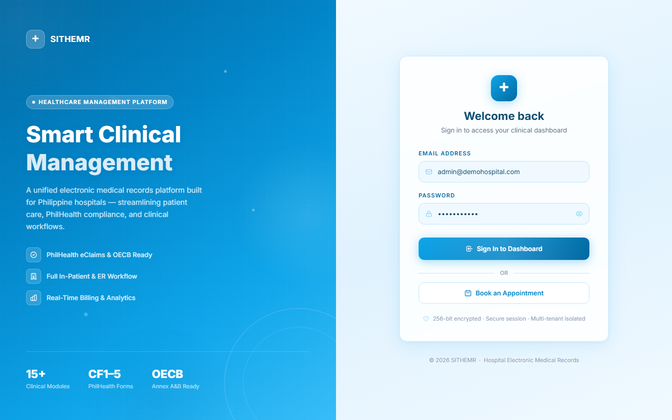
Screenshot: 02-credentials-filled.png

Screenshot: 03-dashboard.png

This chapter covers the first things every user does.

2.1 Logging In
Navigate to http://localhost/login or click Login in the navigation. The login form has two fields:
- Email address - your registered email (e.g. admin@demohospital.com)
- Password - your password (e.g. Admin@12345 for the default admin)
On submit, the AuthLoginController@login (API route: POST api/auth/login) validates credentials and issues a JWT token stored in an HTTP-only cookie. You are redirected to /dashboard.
Default admin credentials for DEMO hospital: admin@demohospital.com / Admin@12345.
Rate limiting: The login route is throttled at 10 attempts per 1 minute. After too many failures, wait 1 minute before trying again.

2.2 The Dashboard
After login you land on /dashboard (route: dashboard, permission: dashboard.view, Livewire component: DashboardCrud). The dashboard shows:
- Today's pending OPD consultations - patients waiting to be seen
- Today's ER admissions - emergency patients currently in the ER
- Pending lab/pharmacy/CSR/radiology/procedure requests awaiting action
- Billing balances - outstanding patient balances
- Quick-access cards linking to each major module
- System-wide or tenant-scoped statistics depending on your role
- Recent activity and alerts relevant to your permissions
The dashboard is the central navigation hub. From here you can jump to any module you have permission to access. The sidebar/top navigation shows the complete menu of accessible pages.

2.3 Navigation Structure
Once logged in, pages are organized into these areas (each gated by permissions):
- Dashboard (/) - home/summary
- Masters (masters/*) - master data: tenant, department, users, country, region, province, city, barangay, religion, gender, civil status, nationality, occupation, blood type, relationship, hospital, permissions. Admin-only sub-pages: country, region, province, city, barangay, religion, gender, civil-status, nationality, occupation, blood-type, relationship, hospital, permissions
- Admin (admin/*) - roles, role-permissions, audit-log, user-permissions ({userId}/permissions)
- Patient Registration (/patients) - patient CRUD (PatientCrud)
- Public Booking (/book-appointment) - public appointment booking (NO LOGIN)
- OPD (opd/*) - visit-types, consultation-types, referral-sources, services, clinics, complaints, consultations (OpdConsultationCrud)
- ER (er/*) - triage, acuity-levels, mobility-statuses, zones, beds, area, admission-eeclpdf
- Admission (/admission) - inpatient admissions
- ICU (icu/*) - wards, beds
- MICU (micu/*) - patients, assessment-parameters
- Ward (ward/*) - wards, room-types, rooms
- OR (or/*) - rooms, schedule
- Laboratory (lab/*) - sections, units, specimen-types, instruments, tests, panels, reference-ranges, dispensing, results, result-print
- Radiology (radiology/*) - modalities, body-parts, exam-types, dispensing, results, result-print
- Pharmacy (pharmacy/*) - drugs, drug-batches, inventory, purchase-orders, stock-adjustments, dispensing, patient-medication-record, reports, request-print, encounter-print
- Supply/CSR (supply/*) - units, categories, suppliers, stock-locations, items, inventory, stock-adjustments, dispensing, request-print, encounter-print
- Procedures (procedures/*) - categories, procedures, dispensing
- OB (ob/*) - visit-types, fetal-presentations, contraceptive-methods, consultations (ObConsultationCrud)
- Delivery (delivery/*) - types, complications, rooms, schedule
- Renal Care (renal-care/*) - dialysis-types, dialysis-sessions
- YAKAP (yakap/*) - dashboard, empanelments, fpe-records, screenings, capitation
- Konsulta (konsulta/) - primary care consultations (KonsultaCrud)
- Billing (billing/*) - billing, fund-sources, insurance-providers, invoice-print, payment-receipt, statement
- PhilHealth (philhealth/*) - icd10-codes, rvs-codes, case-rates, hc-professionals, members, claims, batches, claims-{id}-esoapdf, claims-{id}-cf1pdf, cf2pdf, cf3pdf, cf4pdf, cf5pdf, claims-{id}-eeclpdf, reports
- Medical Records (/medical-records) - certificate generation
- Nursing (/nursing) - nursing dashboard (NursingCrud)
- Doctors (doctors/*) - dashboard (DashboardCrud), schedule (AppointmentScheduleCrud), patient/{type}/{id}
- Settings (/settings) - system settings (permission: admin.settings)
- Reports (/reports) - reports hub (permission: reports.view)
- Transfers (transfers/) - hospital transfers (HospitalTransferCrud, permission: admission.view)
Pages you do not have permission for are hidden from the menu. Direct URL access without the required permission returns 403.

2.4 Logout
Click Logout in the navigation. The JWT cookie is cleared server-side and you return to /login. Save your work first - unsaved form data is lost on logout. If your session expires (JWT timeout), you are redirected to /login automatically.

3. Master Data Management

Screenshot: masters-department-01-list.png

Screenshot: masters-users-01-list.png

Screenshot: masters-province-01-list.png

Screenshot: masters-barangay-01-list.png

Screenshot: masters-city-01-list.png

Screenshot: masters-country-01-list.png

Screenshot: masters-nationality-01-list.png

Screenshot: masters-occupation-01-list.png

Screenshot: masters-permissions-01-list.png

Screenshot: masters-hospital-01-list.png

Screenshot: masters-tenant-01-list.png

Master data forms the foundation of the application. Most modules cannot function without the corresponding master records being populated first. Master data is managed under Masters (/masters) and Admin (/admin). All master data is tenant-scoped - records created for your hospital are not visible to other hospitals.

3.1 Geographic Hierarchy (cascaded dropdowns)
The application uses a strict geographic hierarchy: Country > Region > Province/City > Barangay. This cascades through patient registration and any module needing address data. The cascading logic (from PatientCrud Livewire) works as follows:
- When Country is selected: the regions array is populated from Region::where('country_id', $value)->orderBy('name'). The region_id, province_id, city_id, and barangay_id fields AND their dropdown arrays are ALL reset.
- When Region is selected: the provinces array is populated from ProvinceCity::where('region_id', $value)->where('type', 'province')->orderBy('name'). The province_id, city_id, and barangay_id fields AND their arrays are reset.
- When Province is selected: the cities array is populated from ProvinceCity::where('parent_id', $value)->where('type', 'city')->orderBy('name'). The city_id and barangay_id fields AND arrays are reset.
- When City is selected: the barangays array is populated from Barangay::where('province_city_id', $value)->orderBy('name'). The barangay_id field is reset.
- Each level uses a separate database table: countries, regions (with country_id FK), provinces_cities (shared table with 'type' column = 'province' or 'city', with parent_id FK for cities), and barangays (with province_city_id FK).

3.1.1 Masters > Country
Route: masters.country (permission: admin.masters). Manages the list of countries. The default is the Philippines. Each country has: id, name, code, is_active, tenant_id, created_by, created_date, updated_by, updated_date, history.

3.1.2 Masters > Region
Route: masters.region (permission: admin.masters). Manages Philippine regions (NCR, CAR, Region I through XIII, BARMM). Each region belongs to a country. Fields: id, country_id, name, code, is_active, tenant_id, history, audit columns.

3.1.3 Masters > Province
Route: masters.province (permission: admin.masters). Uses the provinces_cities shared table with type='province'. Each province belongs to a region. Fields: id, region_id, name, code, type (always 'province'), parent_id (null for provinces), is_active, tenant_id, history, audit columns.

3.1.4 Masters > City
Route: masters.city (permission: admin.masters). Uses the same provinces_cities table with type='city'. Each city/municipality belongs to a province (parent_id = province_id). Fields: id, region_id, parent_id (points to province), name, code, type (always 'city'), is_active, tenant_id, history, audit columns.

3.1.5 Masters > Barangay
Route: masters.barangay (permission: admin.masters). The barangay (village/district) level. Each barangay belongs to a city/municipality (province_city_id FK). Fields: id, province_city_id, name, code, is_active, tenant_id, history, audit columns.

3.2 Demographic Masters
- Masters > Gender - gender options (Male, Female, etc.). Fields: id, name, code, is_active, tenant_id, history. Linked to patients via gender_id FK.
- Masters > Civil Status - civil status options (Single, Married, Widowed, Separated, Divorced, etc.). Fields: id, name, code, is_active, tenant_id, history. Linked via civil_status_id FK.
- Masters > Religion - religious affiliations. Fields: id, name, code, is_active, tenant_id, history. Linked via religion_id FK.
- Masters > Nationality - nationalities. Fields: id, name, code, is_active, tenant_id, history. Linked via nationality_id FK.
- Masters > Occupation - occupation types. Fields: id, name, code, is_active, tenant_id, history. Linked via occupation_id FK.
- Masters > Blood Type - blood types (A, B, AB, O with Rh +/−). Fields: id, name, code, is_active, tenant_id, history. Linked via blood_type_id FK.
- Masters > Relationship - relationship types (Self, Spouse, Parent, Sibling, Child, Friend, etc.) used for emergency contacts. Fields: id, name, code, is_active, tenant_id, history. Linked via emergency_relationship.

3.3 Hospital and Department Masters

3.3.1 Masters > Tenant (Company)
Route: masters.tenant (permission: admin.tenants). Manages the multi-tenant hospital setup. Each tenant record represents one hospital. The DEMO hospital is tenant_id = 1. Fields include: id, name, code, address, contact, email, phone, is_active, history, audit columns. This is the hospital profile.

3.3.2 Masters > Department
Route: masters.department (permission: admin.departments). Clinical departments (Cardiology, General Surgery, Pediatrics, Obstetrics, Emergency, Laboratory, Radiology, Pharmacy, etc.). Departments link to doctors and drive appointment booking. Fields: id, dept_name, dept_code, description, is_active, tenant_id, history. The ER department has dept_code='ER' (looked up by ErAdmissionCrud). Department ID is used in patient registration's primary_care_provider and in appointments.

3.3.3 Masters > Hospital
Route: masters.hospital (permission: admin.masters). Additional hospital/facility records (for multi-facility setups). Fields: id, name, code, address, is_active, tenant_id, history.

3.3.4 Masters > Users
Route: masters.users (permission: admin.users). User account CRUD. Fields: id, email, password (hashed), full_name, role (superadmin/tenant_admin/doctor/nurse/etc.), health_care_professional_id (FK to healthcare_professionals for doctor users), department_id, is_active, tenant_id, history, audit columns. User role determines which permissions they get. The health_care_professional_id links a doctor user to their HCP record - this is how the system knows which doctor's appointments to show on the schedule.

3.4 Admin: Roles and Permissions
The permission system is granular and role-based. Every route requires a permission string. The flow: create roles (Admin > Roles) -> assign permissions to roles (Admin > Role Permissions) -> assign roles to users (Masters > Users or Admin > User Permissions).

3.4.1 Admin > Roles
Route: admin.roles (permission: admin.masters). Create and manage roles. A role is a named collection of permissions (e.g. 'Pharmacist', 'Billing Officer', 'Superadmin'). Fields: id, name, description, is_active, created_by, created_date, history.

3.4.2 Admin > Role Permissions
Route: admin.role-permissions (permission: admin.masters). Assign granular permissions to each role. This is where you control exactly what each role can do. The interface shows all available permissions grouped by module, with checkboxes to toggle each permission on/off for the selected role.

3.4.3 Admin > Audit Log
Route: admin.audit-log (permission: admin.masters). Shows the complete system-wide audit trail. Every create, update, and soft-delete across ALL modules is logged here with: the user who made the change (created_by/updated_by), the timestamp (created_date/updated_date), the model/table affected, the record ID, and the old/new values. This is the compliance and troubleshooting reference.

3.4.4 Admin > User Permissions
Route: admin.users.permissions ({userId}, permission: admin.users). Override or fine-tune permissions for an individual user. This lets you give a specific user access to a module that their role doesn't normally grant, or restrict a user below their role's default permissions.

4. Patient Registration
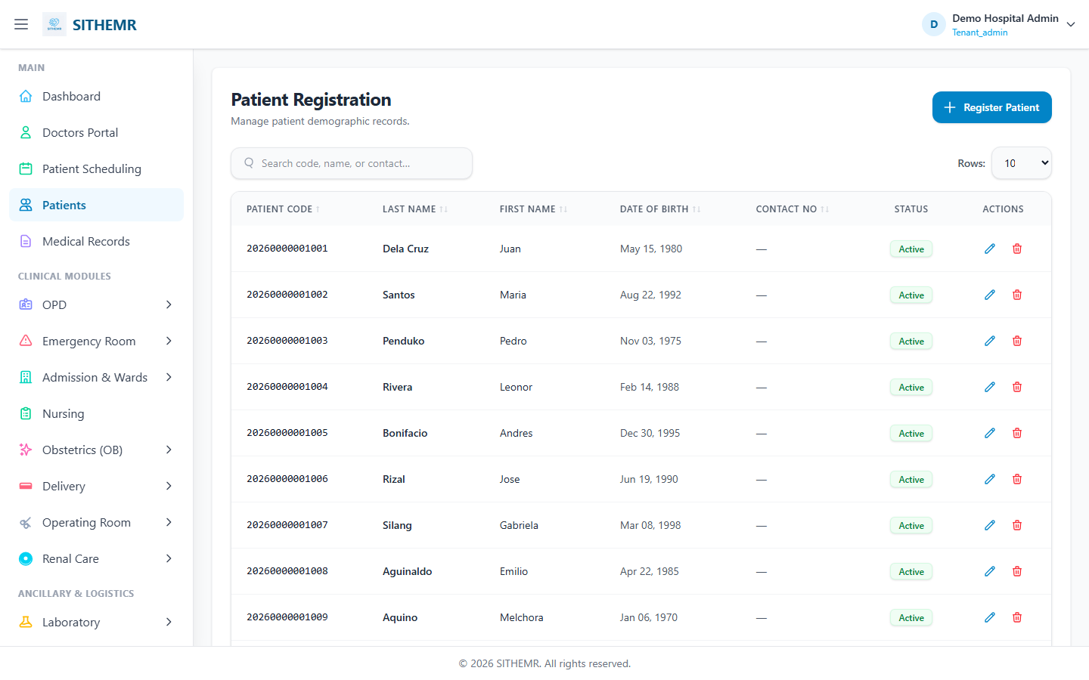
Screenshot: patients-01-list.png

Route: /patients (permission: patient.view, Livewire component: PatientCrud). This is the patient demographic master - the central patient record that all other modules reference. The PatientCrud Livewire handles create, read, update, delete, search, and pagination.

4.1 Patient Model Fields (Complete Reference)
The Patient model has 70+ fields organized into these groups. All fields use snake_case in the code and Livewire components:

4.1.1 Patient Identifiers (5 fields)
- patient_code - Unique patient identifier. Auto-generated as YYYY + 10-digit zero-padded sequence (e.g. 202600000001). Stored as string, max 20 chars. UNIQUE constraint per tenant: unique:patients,patient_code,NULL,id,tenant_id,{tid},history,1. Can be overridden but must remain unique.
- last_name - Required, string, max 60 chars.
- first_name - Required, string, max 60 chars.
- middle_name - Nullable, string, max 60 chars.
- suffix - Nullable, string, max 20 chars (e.g. Jr., Sr., III).

4.1.2 Demographic Fields (10 fields)
- date_of_birth - Nullable, date format. Used to compute age for certificates.
- gender_id - Nullable, FK to genders.id.
- civil_status_id - Nullable, FK to civil_statuses.id.
- religion_id - Nullable, FK to religions.id.
- nationality_id - Nullable, FK to nationalities.id.
- occupation_id - Nullable, FK to occupations.id.
- blood_type_id - Nullable, FK to blood_types.id.
- maiden_name - Nullable, string, max 60 chars. (EMR standard field.)
- place_of_birth - Nullable, string, max 255 chars. (EMR standard field.)
- preferred_language - Nullable, string, max 60 chars. (EMR standard field.)

4.1.3 Identification Fields (2 fields)
- national_id_no - Nullable, string, max 30 chars (PhilHealth ID, SSS, GSIS, PWD ID, etc.). (EMR standard field.)
- passport_no - Nullable, string, max 30 chars. (EMR standard field.)

4.1.4 Family Fields (4 fields)
- father_name - Nullable, string, max 120 chars.
- mother_maiden_name - Nullable, string, max 120 chars.
- spouse_name - Nullable, string, max 120 chars.
- multiple_birth_indicator - Boolean. Indicates if the patient is part of a multiple birth.

4.1.5 Vital Status Fields (3 fields)
- is_deceased - Boolean. Marks the patient as deceased.
- date_of_death - Nullable, date. Only relevant if is_deceased is true.
- primary_care_provider_id - Nullable, FK to health_care_professionals.id. The patient's primary care physician.

4.1.6 PhilHealth Fields (2 fields)
- is_philhealth_member - Boolean toggle. When checked, reveals the philhealth_member_id dropdown.
- philhealth_member_id - Nullable, FK to philhealth_members.id. Links the patient to a PhilHealth membership record. This must exist BEFORE you can link it. Enables PhilHealth claims.

4.1.7 Contact Fields (2 fields)
- contact_no - Nullable, string, max 30 chars.
- email - Nullable, email format, max 100 chars.

4.1.8 Address Fields - Geographic Cascade (9 fields)
- country_id - Nullable, FK to countries.id. When set, triggers region dropdown load.
- region_id - Nullable, FK to regions.id. When set, triggers province dropdown load.
- province_id - Nullable, FK to provinces_cities.id (type='province'). When set, triggers city dropdown load.
- city_id - Nullable, FK to provinces_cities.id (type='city'). When set, triggers barangay dropdown load.
- barangay_id - Nullable, FK to barangays.id.
- address_street - Nullable, string, max 255 chars.
- zip_code - Nullable, string, max 10 chars.

4.1.9 Emergency Contact Fields (3 fields)
- emergency_contact_name - Nullable, string, max 120 chars.
- emergency_contact_no - Nullable, string, max 30 chars.
- emergency_relationship - Nullable, string, max 60 chars. Typically from the relationship master.

4.1.10 System Fields (3 fields)
- is_active - Boolean, default true. Set to false to soft-deactivate the patient (they disappear from normal views but remain in DB).
- created_by / created_date - Audit trail: who created and when.
- updated_by / updated_date - Audit trail: who last modified and when.

4.2 Creating a Patient (Complete Workflow)
Step-by-step from the PatientCrud Livewire source code:
- Navigate to /patients. Click 'Create New Patient' (openCreate method). The form resets, patient_code is auto-generated by generatePatientCode(), isEditing=false, is_philhealth_member=false, showModal=true.
- generatePatientCode(): Gets current year (now()->format('Y')), finds the last patient with patient_code LIKE 'YYYY%' for this tenant (withoutGlobalScope('current')), parses the numeric suffix, increments by 1, pads to 10 digits. Returns e.g. '202600000001'.
- Fill in patient identifiers: patient_code (auto, can override), last_name (required), first_name (required), middle_name, suffix.
- Fill in demographics: date_of_birth, gender_id (dropdown from genders master), civil_status_id, religion_id, nationality_id, occupation_id, blood_type_id, maiden_name, place_of_birth, preferred_language.
- Fill in identification: national_id_no, passport_no.
- Fill in family: father_name, mother_maiden_name, spouse_name, multiple_birth_indicator (checkbox).
- Set vital status: is_deceased (checkbox), date_of_death (if deceased), primary_care_provider_id (dropdown from healthcare_professionals).
- Set PhilHealth: check is_philhealth_member to reveal the philhealth_member_id dropdown. Select an existing PhilHealth member record. If no member record exists, create one first under PhilHealth > Members.
- Fill in contact: contact_no, email.
- Fill in address using the cascading dropdowns: select country -> region dropdown populates -> select region -> province dropdown populates -> select province -> city dropdown populates -> select city -> barangay dropdown populates. Then fill address_street and zip_code.
- Fill in emergency contact: emergency_contact_name, emergency_contact_no, emergency_relationship.
- Set is_active (default true - uncheck only to deactivate).
- Click Save. Validation runs (see 4.3). On success: patient is created with created_by = current user ID, created_date = now(), updated_by = current user ID, updated_date = now(), is_active = true, history = 1. Session flash message: 'Patient created successfully.'
- After save, the patient appears in the list and can be searched, edited, or viewed on the patient chart.

4.3 Validation Rules
The PatientCrud Livewire has validation rules for every field (the complete rules() method returns these):
- patient_code: required, string, max:20, UNIQUE per tenant (unique:patients,patient_code,NULL,id,tenant_id,{tid},history,1). On edit, the rule excludes the current record: unique:patients,patient_code,{editingId},id,tenant_id,{tid},history,1.
- last_name: required, string, max:60.
- first_name: required, string, max:60.
- middle_name: nullable, string, max:60.
- suffix: nullable, string, max:20.
- date_of_birth: nullable, date.
- philhealth_member_id: nullable, integer, exists:philhealth_members,id.
- gender_id: nullable, integer, exists:genders,id.
- civil_status_id: nullable, integer, exists:civil_statuses,id.
- religion_id: nullable, integer, exists:religions,id.
- nationality_id: nullable, integer, exists:nationalities,id.
- occupation_id: nullable, integer, exists:occupations,id.
- blood_type_id: nullable, integer, exists:blood_types,id.
- contact_no: nullable, string, max:30.
- email: nullable, email, max:100.
- address_street: nullable, string, max:255.
- barangay_id: nullable, integer, exists:barangays,id.
- city_id: nullable, integer, exists:provinces_cities,id.
- province_id: nullable, integer, exists:provinces_cities,id.
- region_id: nullable, integer, exists:regions,id.
- country_id: nullable, integer, exists:countries,id.
- zip_code: nullable, string, max:10.
- emergency_contact_name: nullable, string, max:120.
- emergency_contact_no: nullable, string, max:30.
- emergency_relationship: nullable, string, max:60.
- maiden_name: nullable, string, max:60.
- place_of_birth: nullable, string, max:255.
- preferred_language: nullable, string, max:60.
- national_id_no: nullable, string, max:30.
- passport_no: nullable, string, max:30.
- father_name: nullable, string, max:120.
- mother_maiden_name: nullable, string, max:120.
- spouse_name: nullable, string, max:120.
- multiple_birth_indicator: boolean.
- is_deceased: boolean.
- date_of_death: nullable, date.
- primary_care_provider_id: nullable, integer, exists:health_care_professionals,id.
- is_active: boolean.

4.4 Patient List and Search
The patient list (mount() method) shows all active patients for the current tenant with pagination (perPage = 10, configurable). Features:
- Search box: updates on every keystroke (updatingSearch resets page). Filters by patient_code, last_name, first_name, middle_name, contact_no, or philhealth_member_id (PhilHealth number). Uses LIKE '%search%' on each field via a query scope.
- Sort: click column headers to sort by patient_code, last_name, first_name, date_of_birth, created_date. Toggle asc/desc. Default sort: patient_code asc.
- Per-page: 10 per page (configurable up to 50).
- Row actions: View Chart (opens patient chart), Edit (opens edit modal), Delete (soft-deletes - sets history=0).
- The list shows: patient_code, full name (last, first, middle, suffix), gender, age (computed from date_of_birth), PhilHealth status (member or not), contact_no, and address summary.
- Patient codes follow the format: 202600000001 (year + 10-digit zero-padded sequence). The year prefix allows yearly resets.

4.5 Editing a Patient
Click Edit on a patient row (openEdit method). The system:
- Loads the patient with all related masters eager-loaded: gender, civilStatus, religion, nationality, occupation, bloodType, country, region, province, city, barangay.
- Populates every form field from the loaded record, including null-safe fallbacks (?? '') for all 70+ fields.
- Calls loadCascadingForEdit() to populate the cascading dropdown arrays for the patient's current address: regions (where country_id matches), provinces (where region_id matches and type='province'), cities (where parent_id matches and type='city'), barangays (where province_city_id matches).
- Sets editingId, isEditing=true, showModal=true.
- On save: re-runs validation, then updates ALL fields with updated_by = current user, updated_date = now().
- The cascading dropdowns in edit mode work the same as create mode - updating country_id resets region/province/city/barangay fields and their arrays, etc.

4.6 Patient Chart
The View Chart link on each patient row opens the patient chart - a consolidated view of the patient's complete clinical history: all OPD consultations, ER admissions, inpatient admissions, lab requests and results, pharmacy requests and dispensing, CSR requests, radiology requests and results, procedure requests, and billing invoices/payments. The chart is the single source of truth for a patient's clinical record.

5. Public Appointment Booking (Patient Self-Service)
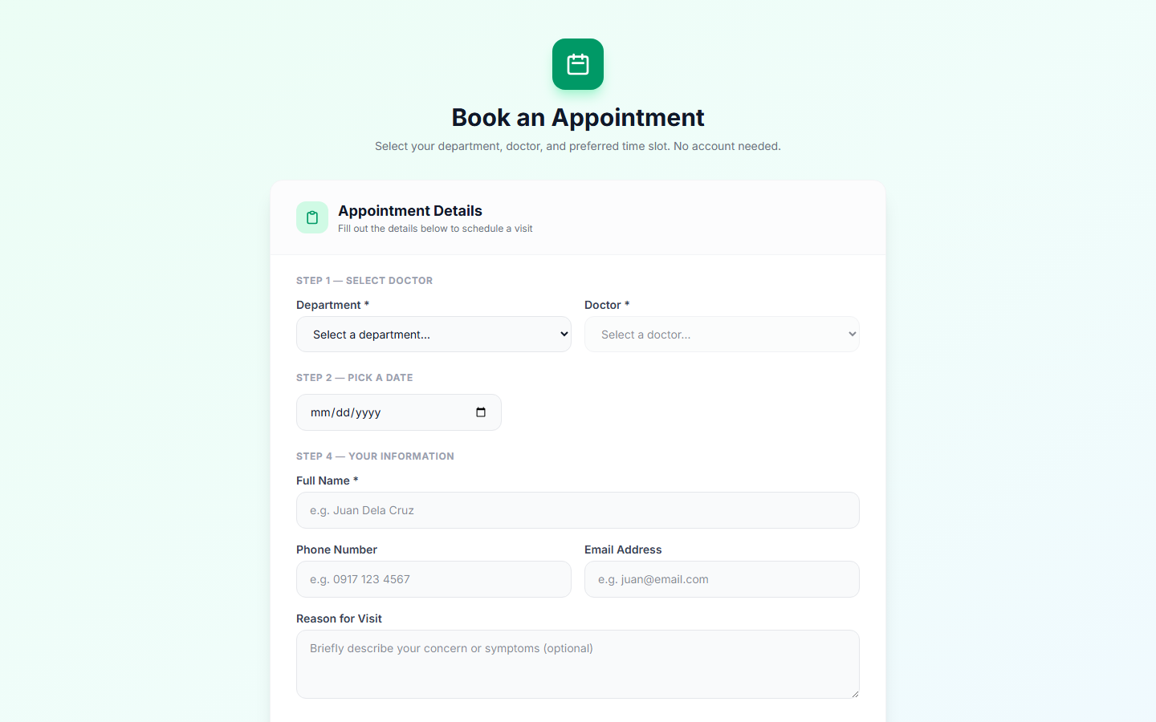
Screenshot: public-booking-01-list.png

Route: /book-appointment (permission: public.book, Livewire component: App\Livewire\Public\AppointmentBooking, layout: layouts.guest). This is the ONLY page in the entire application accessible without login. Patients self-book appointments without creating an account. The booking flow is a 4-step cascading wizard.

5.1 Architecture and Tenant Resolution
The AppointmentBooking component resolves the tenant for public bookings via publicTenantId():
- First checks config('appointment.public_tenant_id') - if set in config/appointment.php, uses that tenant ID explicitly.
- If not configured, falls back to the first hospital in the database: Hospital::withoutGlobalScopes()->orderBy('id')->value('id').
- If no hospital exists, defaults to tenant ID 1.
- All queries in the booking flow use withoutGlobalScopes() and explicitly filter by this tenant_id AND history=1.

5.2 Configuration (config/appointment.php)
Config Key | Default | Description
slot_minutes | 30 | Duration of each appointment slot in minutes. Controls the time increment for available slots.
working_start | 08:00 | Start of working hours. Slots are generated from this time onward.
working_end | 17:00 | End of working hours. No slots are generated after this time.
public_tenant_id | null (auto) | Explicit tenant ID for public bookings. If null, auto-resolves to first hospital or 1.

5.3 Component State Properties
- department_id (string|null) - Selected department ID.
- health_care_professional_id (string|null) - Selected doctor/HC Professional ID.
- appointment_date (string|null) - Selected date (Y-m-d format).
- patient_name (string) - Patient's full name. Required, max 150 chars.
- patient_phone (string|null) - Patient's phone. Optional, max 30 chars.
- patient_email (string|null) - Patient's email. Optional, email format, max 150 chars.
- reason (string|null) - Reason for visit. Optional, max 5000 chars.
- selected_slot (string|null) - The chosen time slot (H:i format, e.g. '09:00').
- booked (bool) - Whether booking was successful.
- booked_code (string|null) - The generated appointment code (APT-XXXXX) on success.
- booked_slots (array) - Available slots loaded for the selected doctor+date.

5.4 Validation Rules
- department_id: required, integer
- health_care_professional_id: required, integer
- appointment_date: required, date, after_or_equal:today (cannot book in the past)
- patient_name: required, string, max:150
- patient_phone: nullable, string, max:30
- patient_email: nullable, email, max:150
- reason: nullable, string, max:5000

5.5 The 4-Step Booking Flow

Step 1: Select Department
The departments list (getDepartmentsProperty) loads active departments for the public tenant:
- Query: Department::withoutGlobalScopes()->where('tenant_id', $tid)->where('is_active', 1)->where('history', 1)->orderBy('dept_name')->get(['id', 'dept_name', 'dept_code'])
- Each option shows dept_name with dept_code in parentheses.
- When department_id changes (updatedDepartmentId): resets health_care_professional_id, appointment_date, selected_slot, and booked_slots to null. This is the cascade reset - selecting a new department clears all downstream selections.

Step 2: Select Doctor (Healthcare Professional)
The doctors list (getDoctorsProperty) loads HCPs for the selected department:
- Returns empty collection if no department_id is selected.
- Query: HealthCareProfessional::withoutGlobalScopes()->where('tenant_id', $tid)->where('department_id', $this->department_id)->where('is_active', 1)->where('history', 1)->orderBy('full_name')->get(['id', 'full_name', 'professional_type', 'specialization'])
- Each option shows full_name with professional_type and specialization as subtitle.
- When health_care_professional_id changes (updatedHealthCareProfessionalId): resets appointment_date, selected_slot, and booked_slots. Clears the date and slots so the user picks a fresh date for the new doctor.

Step 3: Select Date
Patient picks an appointment date using a date picker. The date must be today or later (validated by after_or_equal:today). When appointment_date changes (updatedAppointmentDate): resets selected_slot and calls loadAvailableSlots() to fetch the available time slots for the selected doctor on the selected date.

Step 4: Select Time Slot
loadAvailableSlots() computes available slots as follows:
- Returns empty array if no health_care_professional_id or no appointment_date.
- Parses the appointment_date to a date string.
- Gets slot_minutes from config (default 30), working_start (default 08:00), working_end (default 17:00).
- Queries existing appointments: DoctorAppointment::withoutGlobalScopes()->where('tenant_id', $tid)->where('health_care_professional_id', $this->health_care_professional_id)->where('appointment_date', $date)->where('status', '!=', 'Cancelled')->get(['start_time', 'end_time'])
- Maps existing appointments to ['start' => start_time, 'end' => end_time] pairs.
- Generates slots from working_start to working_end in slot_minutes increments. For each slot: formats start (H:i) and end (H:i), creates a label like '9:00 AM'.
- Overlap check for each slot: $taken->contains(fn ($b) => $st < $b['end'] && $et > $b['start']). If the slot overlaps with any existing appointment, it is excluded.
- Past slot check: if the appointment_date is today AND the slot start is before now(), the slot is excluded (cannot book a slot that has already passed today).
- All non-overlapping, non-past slots are added to booked_slots with keys: start, end, label.
- The UI renders booked_slots as selectable buttons. When patient clicks a slot, selectSlot($slot) sets selected_slot to the H:i string.

5.6 Patient Information Form
After selecting a slot, the patient fills in:
- patient_name (required) - The patient's full name. Max 150 characters.
- patient_phone (optional) - Contact phone number. Max 30 characters.
- patient_email (optional) - Email address for confirmation. Must be valid email format, max 150 characters.
- reason (optional) - Reason for the visit / chief complaint. Max 5000 characters.

5.7 Booking Submission (book() method)
The book() method is the core booking logic. It runs inside a database transaction for atomicity:
- Validates all form fields using the rules above.
- If no selected_slot, adds error 'Please choose an available time slot.' and returns.
- Parses the slot: $slotStart = Carbon::parse($date . ' ' . $this->selected_slot), $slotEnd = $slotStart->copy()->addMinutes($slotMinutes). Formats start_time and end_time as H:i.
- GENERATES APPOINTMENT CODE via generateCode($tid):
- - Queries the last appointment for this tenant: DoctorAppointment::withoutGlobalScopes()->where('tenant_id', $tid)->orderBy('id', 'desc')->first()
- - Parses the numeric portion after 'APT-': (int) substr($last->appointment_code, 4)
- - Increments by 1: $num = $last ? ((int) substr($last->appointment_code, 4)) + 1 : 1
- - Formats: 'APT-' . str_pad($num, 5, '0', STR_PAD_LEFT) — e.g. APT-00001, APT-00002, etc.
- ATOMIC TRANSACTION (DB::transaction):
- - DOUBLE-BOOKING CHECK inside the transaction: Queries for conflicts with lockForUpdate(): DoctorAppointment::withoutGlobalScopes()->where('tenant_id', $tid)->where('health_care_professional_id', $this->health_care_professional_id)->where('appointment_date', $date)->where('status', '!=', 'Cancelled')->where('start_time', '<', $et)->where('end_time', '>', $st)->lockForUpdate()->exists()
- - The lockForUpdate() is critical: it locks the rows so no other request can insert a conflicting appointment between the check and the insert. This prevents race conditions where two patients book the same slot simultaneously.
- - If conflict found: adds error 'Sorry, this slot was just taken. Please pick another time.', calls loadAvailableSlots() to refresh the slot list, and returns (throws exception to rollback transaction).
- - If no conflict: creates the appointment with all fields.
- APPOINTMENT RECORD CREATED:
- - tenant_id: public tenant ID
- - appointment_code: generated APT-XXXXX code
- - department_id: selected department
- - health_care_professional_id: selected doctor
- - appointment_date: selected date (Y-m-d)
- - start_time: slot start (H:i)
- - end_time: slot end (H:i)
- - patient_name: from form
- - patient_phone: from form (nullable)
- - patient_email: from form (nullable)
- - reason: from form (nullable)
- - status: 'Scheduled'
- - is_active: true
- - history: 1
- - created_by: null (public booking has no authenticated user)
- - created_date: now()
- - updated_by: null
- - updated_date: null
- On success: sets booked = true, booked_code = generated code. The UI shows the confirmation screen with all appointment details and the APT-XXXXX reference code.
- If the transaction fails (e.g. conflict), the transaction is rolled back automatically by Laravel.

5.8 Confirmation and Book Another
After successful booking, the confirmation screen shows:
- Appointment Code: APT-XXXXX (the reference number the patient should keep)
- Department name
- Doctor name (full_name)
- Date: formatted appointment date
- Time: formatted start_time - end_time (e.g. '9:00 AM - 9:30 AM')
- Patient name
- Patient phone (if provided)
- Patient email (if provided)
- Reason (if provided)
- Status: Scheduled
The Book Another Appointment button (bookAnother method) resets ALL form fields: department_id, health_care_professional_id, appointment_date, patient_name, patient_phone, patient_email, reason, selected_slot, booked_code, booked. Also calls resetValidation() to clear any validation errors. The form is ready for a new booking.

5.9 Appointment Status Lifecycle
- Scheduled - Initial status when booked via public booking. The appointment is on the doctor's schedule but has not been seen yet.
- In Progress - Doctor has started the consultation. Set via Doctors > Schedule > Mark In Progress.
- Completed - Consultation finished. Set via Doctors > Schedule > Mark Done.
- Cancelled - Appointment cancelled before occurrence. Set via Doctors > Schedule > Cancel. Cancelled appointments are excluded from slot availability checks (where('status', '!=', 'Cancelled')).

6. Outpatient Department (OPD) Consultations
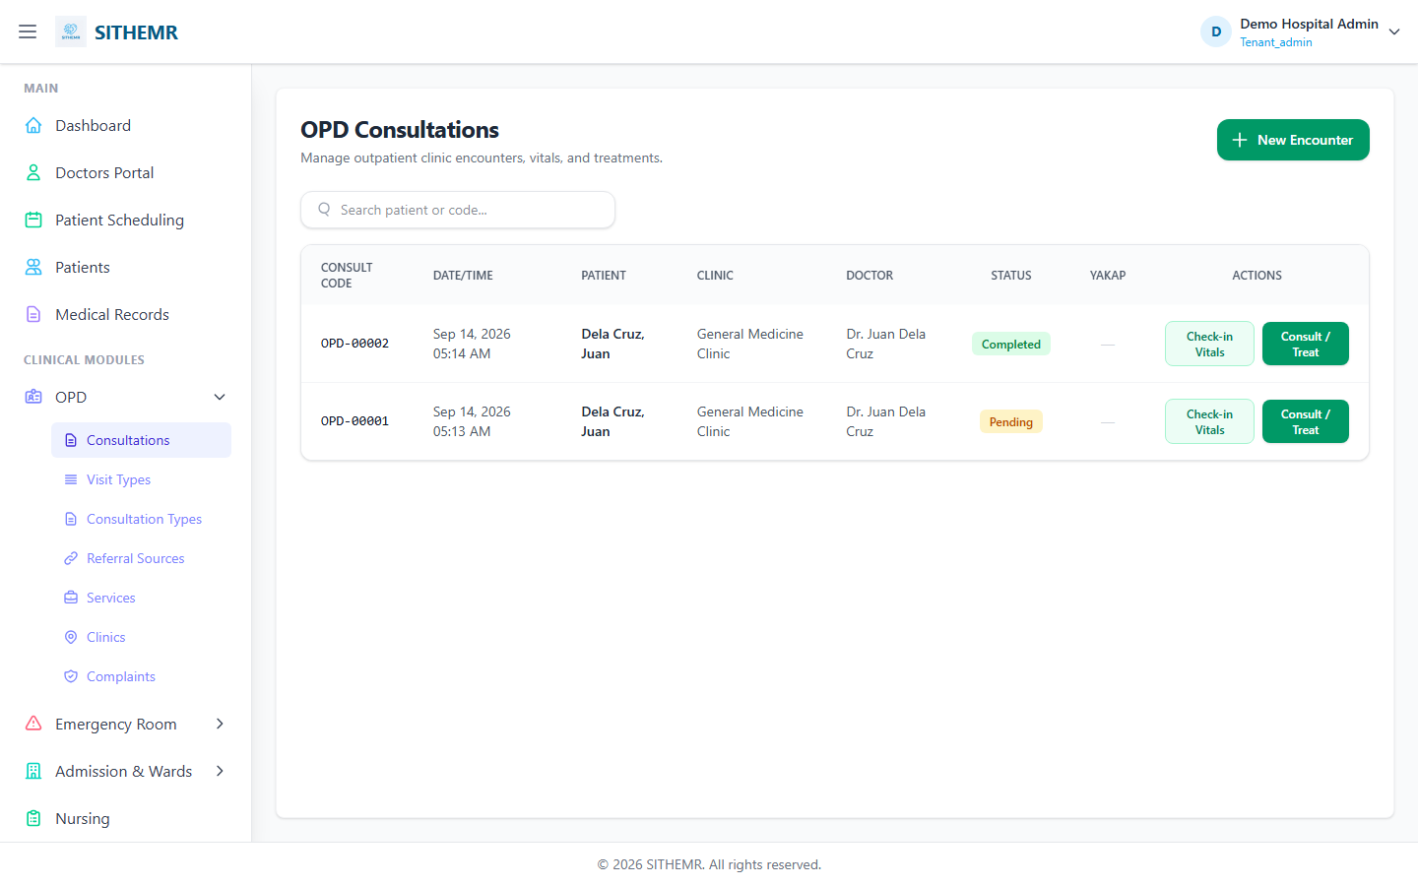
Screenshot: opd-consultations-01-list.png

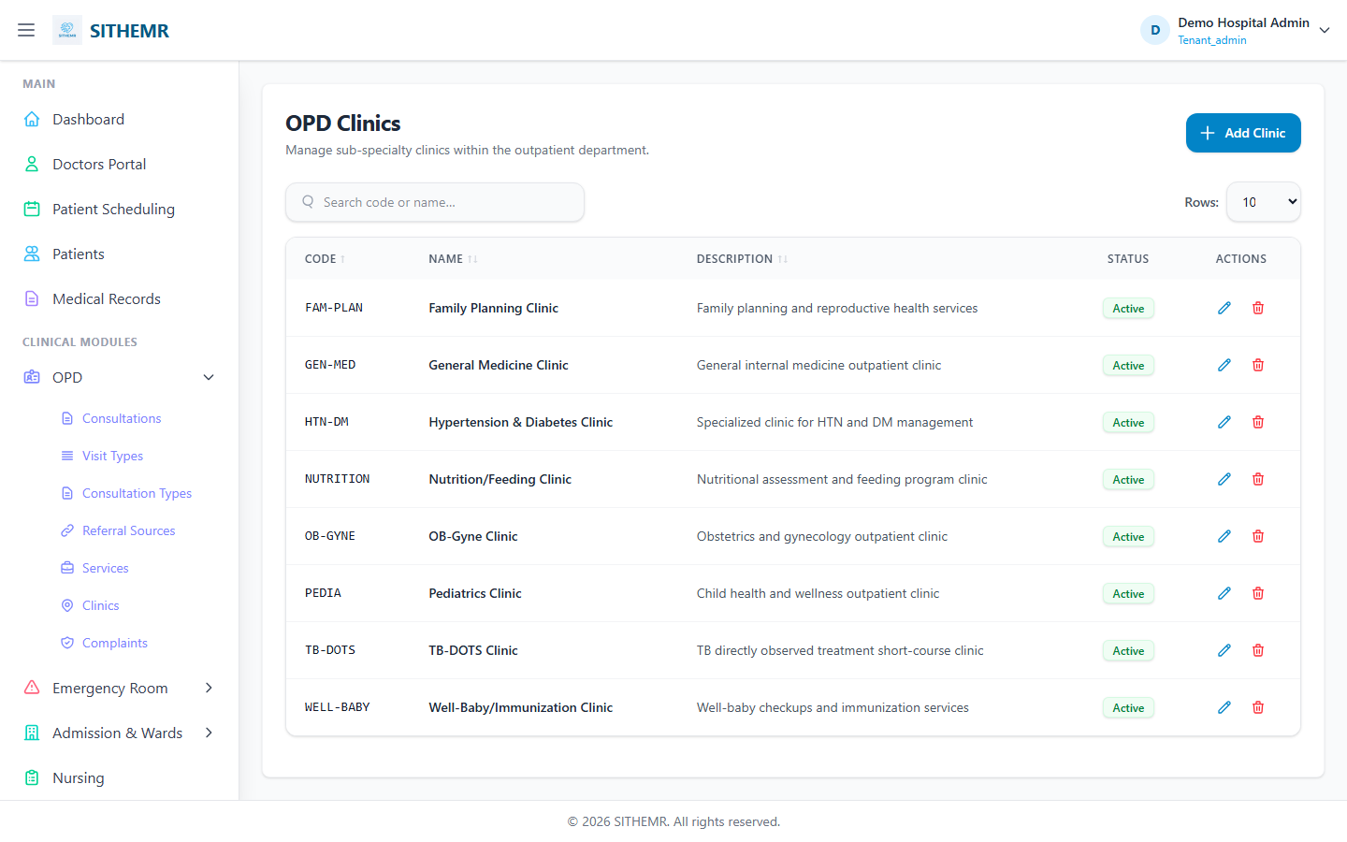
Screenshot: opd-clinics-01-list.png

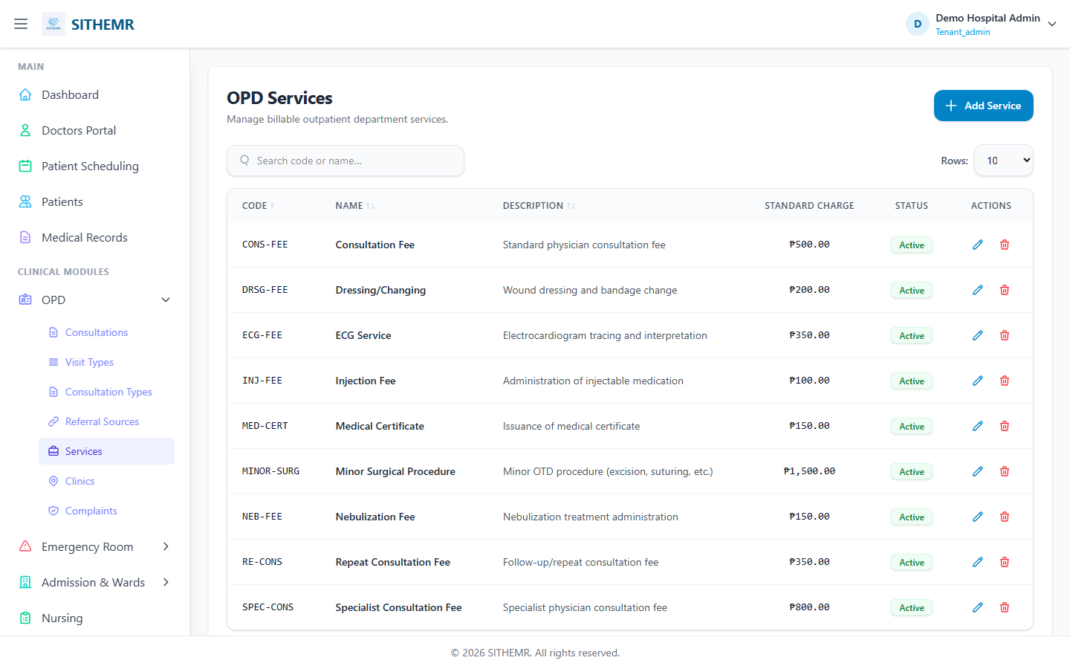
Screenshot: opd-services-01-list.png

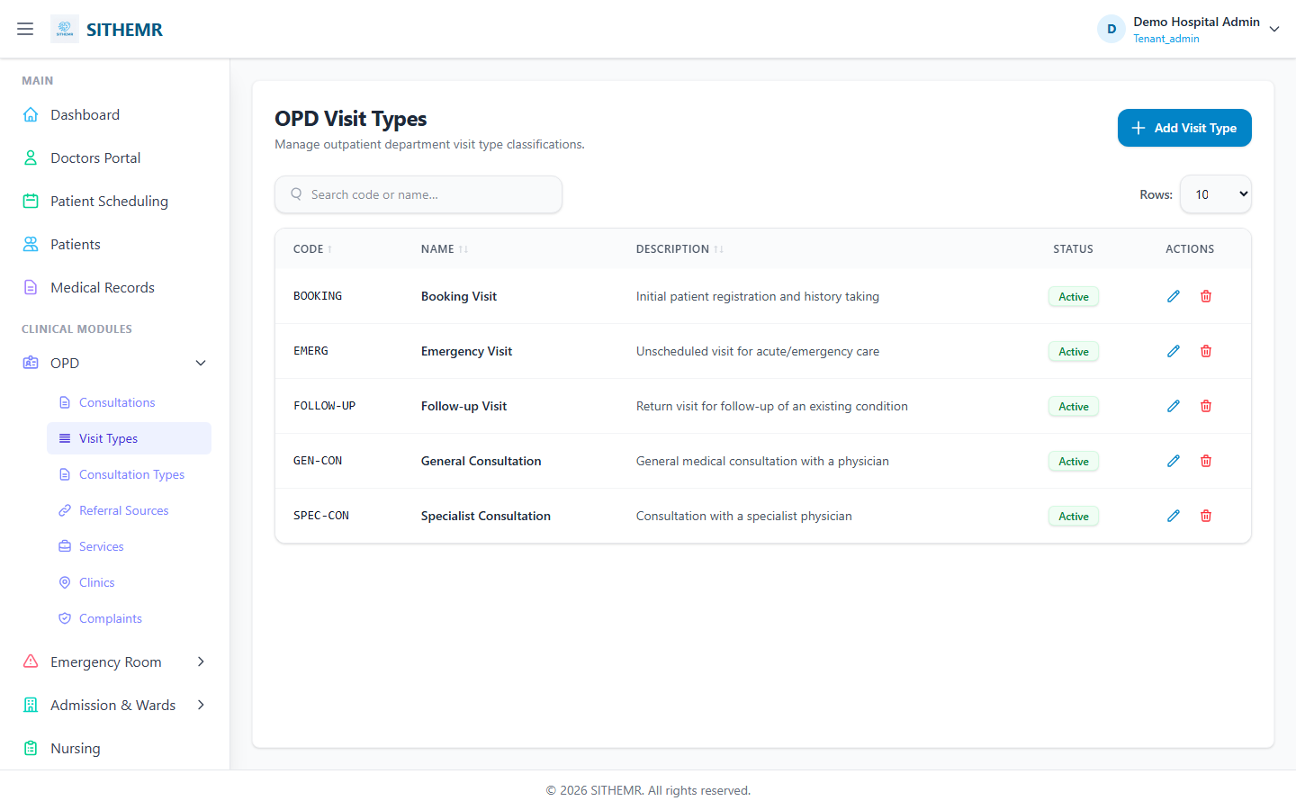
Screenshot: opd-visit-types-01-list.png

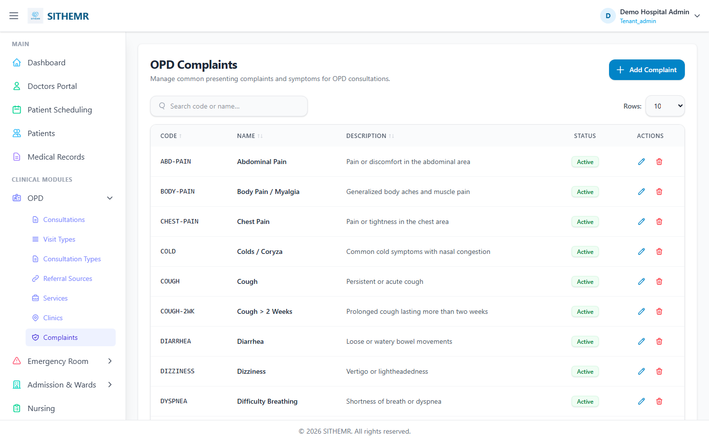
Screenshot: opd-complaints-01-list.png

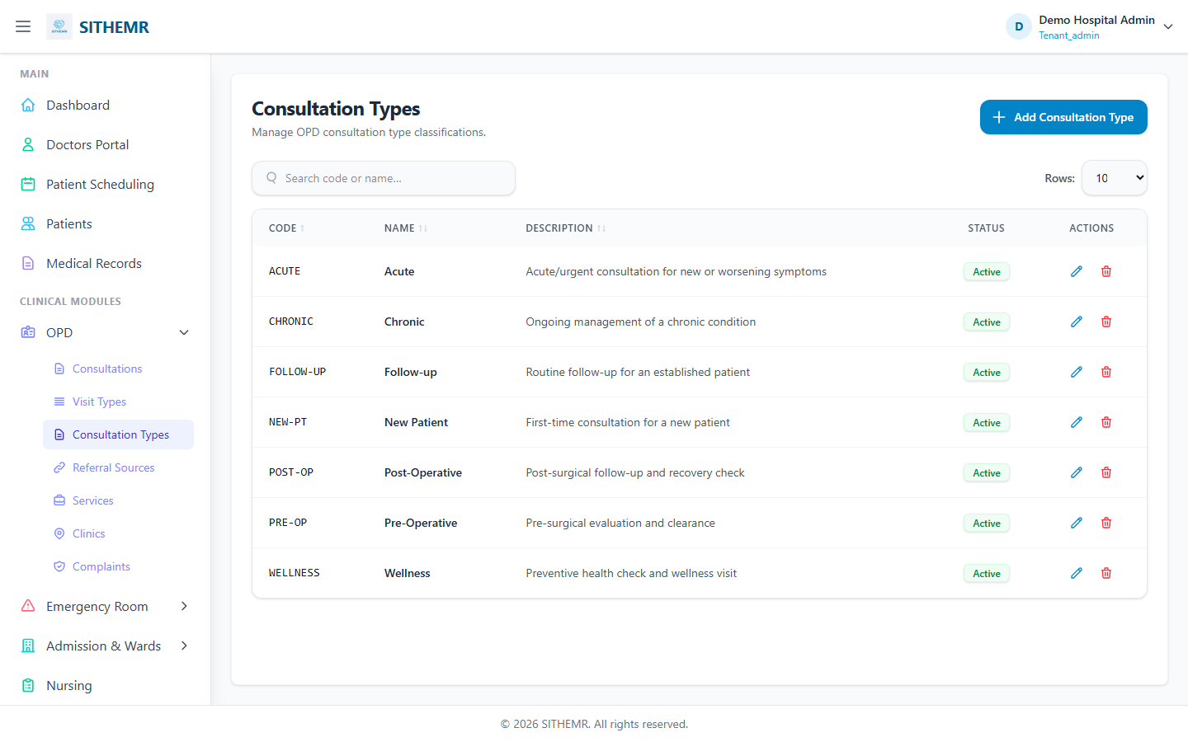
Screenshot: opd-consultation-types-01-list.png

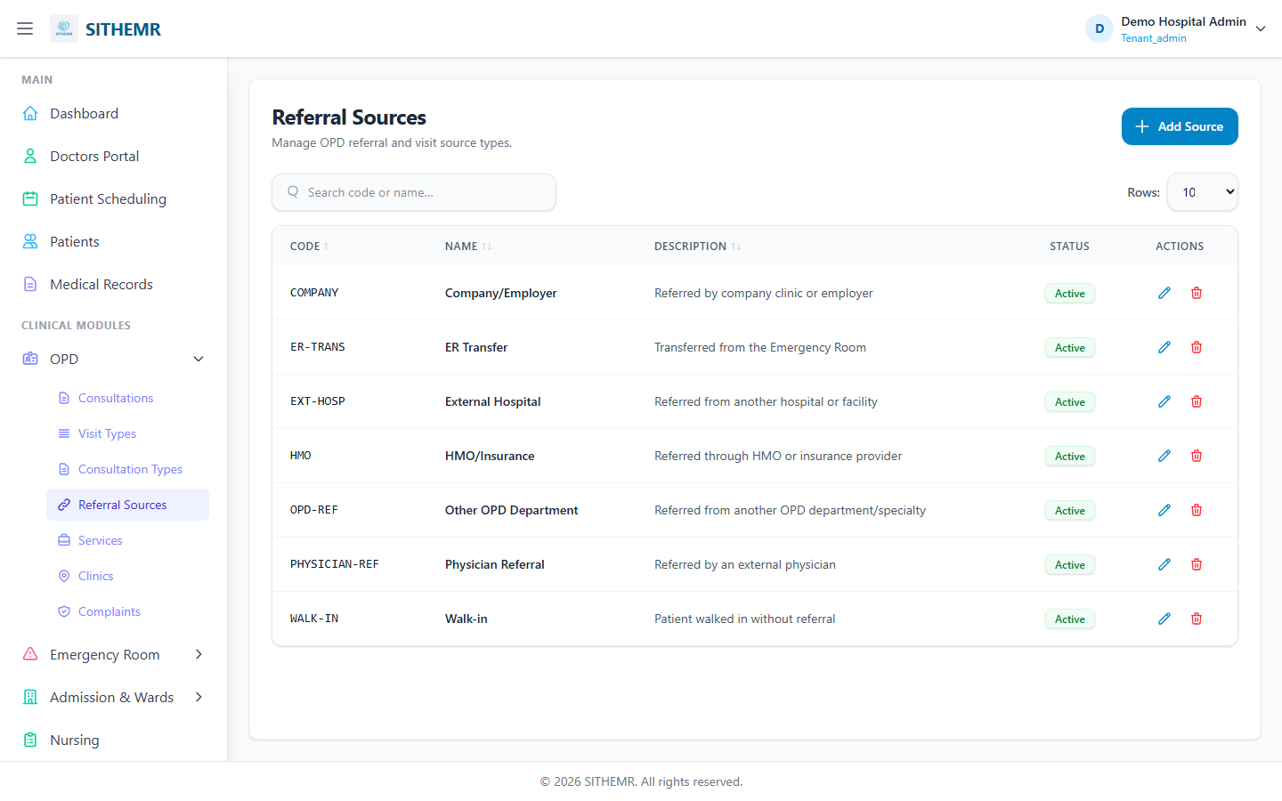
Screenshot: opd-referral-sources-01-list.png

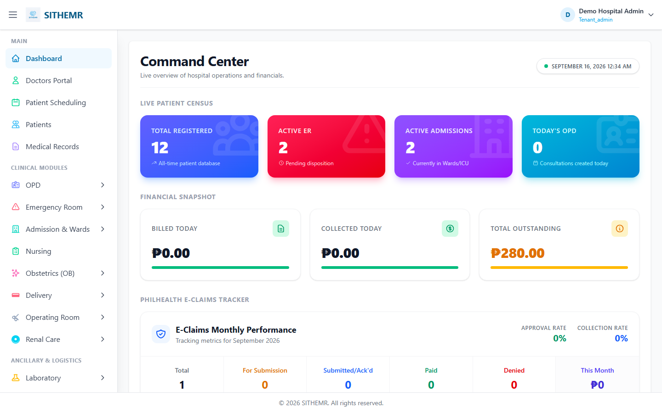
Screenshot: konsulta-01-list.png

Route prefix: /opd. All OPD consultation features require permission: opd.view. The core component is OpdConsultationCrud (Livewire, with WithPagination + ChecksActiveEncounters traits). OPD is the most common patient encounter - it handles walk-in and scheduled outpatient visits.

6.1 OPD Master Data (Complete Reference)

6.1.1 OPD > Visit Types
Route: opd.visit-types (permission: opd.view). Visit types classify the patient's visit: New Visit, Follow-up Visit, Referral Visit, Emergency Follow-up, etc. Fields: id, name, code, description, is_active, tenant_id, history, audit columns. Used in the consultation create form's visit_type_id field.

6.1.2 OPD > Consultation Types
Route: opd.consultation-types (permission: opd.view). Types of consultations: General Consultation, Specialty Consultation, Follow-up Consultation, Urgent Consultation, etc. Fields: id, name, code, description, is_active, tenant_id, history, audit columns. Used in consultation_type_id field.

6.1.3 OPD > Referral Sources
Route: opd.referral-sources (permission: opd.view). Where the patient came from: Self-Referral, ER Referral, Hospital Admission, Other Hospital, HMO Referral, Workplace, School, etc. Fields: id, name, code, description, is_active, tenant_id, history, audit columns. Optional field in consultation create form.

6.1.4 OPD > Services
Route: opd.services (permission: opd.view). Clinical services offered by the OPD. Fields: id, name, code, description, is_active, tenant_id, history, audit columns.

6.1.5 OPD > Clinics
Route: opd.clinics (permission: opd.view). OPD clinics: General Clinic, Cardiac Clinic, Pediatric Clinic, Dermatology Clinic, etc. Each clinic belongs to a department (opdClinic->department_id). Fields: id, department_id, name, code, description, is_active, tenant_id, history, audit columns. Used in opd_clinic_id field. The clinic's department_id is used when creating lab orders (requesting_department_id = consultation->opdClinic->department_id).

6.1.6 OPD > Complaints
Route: opd.complaints (permission: opd.view). Common chief complaints for quick selection: Fever, Cough, Headache, Chest Pain, Abdominal Pain, Dizziness, etc. Fields: id, name, code, category, is_active, tenant_id, history, audit columns.

6.2 OPD Consultation Model (Complete Field Reference)
- id - Primary key.
- tenant_id - Foreign key to hospitals.id (multi-tenancy).
- patient_id - FK to patients.id. The patient being consulted.
- consultation_code - Unique consultation identifier. Auto-generated as 'OPD-' + 5-digit zero-padded sequence (e.g. OPD-00001, OPD-00002). Generated by generateConsultationCode($tid) method: finds last OPD consultation for tenant, parses numeric part after 'OPD-', increments, pads to 5 digits. Falls back to 'OPD-00001' if no existing consultation.
- opd_clinic_id - FK to opd_clinics.id. The clinic where the consultation takes place.
- attending_physician_id - FK to health_care_professionals.id. The doctor conducting the consultation.
- consultation_type_id - FK to opd_consultation_types.id.
- visit_type_id - FK to opd_visit_types.id.
- referral_source_id - FK to opd_referral_sources.id (nullable).
- consultation_datetime - DateTime. Set to now() on creation.
- status - Consultation status: Pending, In Progress, Completed. Default: 'Pending'.
- is_yakap - Boolean. Whether this is a YAKAP primary care consultation.
- empanelment_id - FK to yakap_empanelments.id (nullable). Only set if is_yakap = true.
- history_of_present_illness - Text (max 10000). HPI narrative.
- physical_exam_findings - Text (max 10000). Physical examination findings.
- assessment - Text (max 10000). Diagnosis/assessment.
- treatment_plan - Text (max 10000). Planned treatment.
- orders_summary - Text (max 10000). Summary of orders placed.
- disposition - String. Outcome: Discharged, Admitted, Referred, Follow-up, etc.
- next_follow_up_date - Date. Scheduled follow-up.
- chief_complaint - String. Patient's primary complaint (set by nursing via vitals modal).
- vital_bp_systolic - Integer (nullable). Blood pressure systolic.
- vital_bp_diastolic - Integer (nullable). Blood pressure diastolic.
- vital_heart_rate - Integer (nullable). Heart rate (bpm).
- vital_temperature - Float (nullable). Temperature (Celsius).
- vital_respiratory_rate - Integer (nullable). Respiratory rate (breaths/min).
- vital_weight - Float (nullable). Weight (kg).
- vital_height - Float (nullable). Height (cm).
- vital_o2_saturation - Float (nullable). O2 saturation (%).
- created_by / created_date - Audit columns.
- updated_by / updated_date - Audit columns.
- history - Soft delete flag (1=active).
- is_active - Active flag.

6.3 Creating an OPD Consultation (Complete Workflow)
From OpdConsultationCrud source code, openCreate() + saveEncounter():
- openCreate(): Resets ALL form fields: patient_id, opd_clinic_id, attending_physician_id, consultation_type_id, visit_type_id, referral_source_id, empanelment_id, patient_search, selected_patient_name. Sets is_yakap=false, showCreateModal=true.
- Patient search: The patient_search field triggers an autocomplete. As the user types (minimum 3 characters), the system searches patients by name, patient_code, philhealth number, and contact number. Results appear as a dropdown. When user selects a patient (selectPatient($id, $name)): sets patient_id, selected_patient_name, skipPatientSearchUpdate=true (to prevent unwanted re-firing), clears patient_search.
- Fill in consultation details:
- - opd_clinic_id: Select from OPD > Clinics master. Required.
- - attending_physician_id: Select a healthcare professional (doctor). Required.
- - consultation_type_id: Select from OPD > Consultation Types. Required.
- - visit_type_id: Select from OPD > Visit Types. Required.
- - referral_source_id: Optional. Select from OPD > Referral Sources.
- - is_yakap: Toggle if this is a YAKAP primary care patient. If on, empanelment_id dropdown appears.
- - empanelment_id: If is_yakap, select from YAKAP > Empanelments.
- saveEncounter() validation (ALL required unless noted):
- - patient_id: required|exists:patients,id
- - opd_clinic_id: required|exists:opd_clinics,id
- - attending_physician_id: required|exists:health_care_professionals,id
- - consultation_type_id: required|exists:opd_consultation_types,id
- - visit_type_id: required|exists:opd_visit_types,id
- ensureNoActiveEncounter($this->patient_id): Checks that the patient does not already have an active (non-completed) OPD consultation. Prevents duplicate concurrent encounters.
- Generates consultation_code via generateConsultationCode($tid): 'OPD-' + 5-digit zero-padded sequence.
- Creates OpdConsultation with: tenant_id, patient_id, consultation_code, opd_clinic_id, attending_physician_id, consultation_type_id, visit_type_id, referral_source_id (nullable), consultation_datetime = now(), status = 'Pending', is_yakap, empanelment_id (if yakap), created_by = current user ID, created_date = now(), updated_by = current user ID, updated_date = now(), history = 1, is_active = true.
- Closes create modal, flashes session message 'OPD Encounter created successfully.'
- The SOAP form then opens for clinical documentation (see 6.4).

6.4 SOAP Documentation (Clinical Notes)
After creating the consultation, the SOAP form (treatConsultation + saveConsultation) captures the clinical notes. The treatConsultation($id) method loads the consultation WITH all related orders eager-loaded:
- Loads: patient, opdClinic, attendingPhysician, labRequests.items.labTest, pharmacyRequests.items.drug, csrRequests.items.item, radiologyRequests.items.examType, procedureRequests.items.procedure
- Pre-populates ALL SOAP fields from the existing record (null-safe).

6.4.1 SOAP Fields
- chief_complaint - Patient's primary complaint (also set via Vitals modal by nursing).
- vital_bp_systolic / vital_bp_diastolic - Blood pressure (mmHg).
- vital_heart_rate - Heart rate (bpm).
- vital_temperature - Temperature (Celsius).
- vital_respiratory_rate - Respiratory rate (breaths/min).
- vital_weight - Weight (kg).
- vital_height - Height (cm).
- vital_o2_saturation - O2 saturation (%).
- history_of_present_illness (HPI) - Text, max 10000. Narrative of the present illness.
- physical_exam_findings - Text, max 10000. Physical examination findings.
- assessment - Text, max 10000. Diagnosis/assessment.
- treatment_plan - Text, max 10000. Planned treatment.
- orders_summary - Text, max 10000. Summary of orders placed.
- disposition - String. Outcome: Discharged, Admitted, Referred, Follow-up, etc.
- next_follow_up_date - Date. Follow-up appointment date.

6.4.2 Vitals Modal (Nursing)
The openVitals($id) + saveVitals() methods handle nursing vitals entry. When nursing saves vitals:
- Loads the consultation by ID.
- Pre-populates all vital fields from the existing record.
- On saveVitals(): Updates vital_bp_systolic, vital_bp_diastolic, vital_heart_rate, vital_temperature, vital_respiratory_rate, vital_weight, vital_height, vital_o2_saturation, chief_complaint, AND sets status to 'In Progress' if currently 'Pending'.
- Uses updated_by = current user ID, updated_date = now().
- Flashes 'Vitals saved successfully.'
- This is the Nursing role's primary function in OPD - entering vitals and chief complaint.

6.4.3 Saving SOAP Notes
saveConsultation() updates the SOAP fields:
- Updates: history_of_present_illness, physical_exam_findings, assessment, treatment_plan, orders_summary, disposition, next_follow_up_date.
- Sets status: if disposition is set, status becomes 'Completed'. Otherwise stays 'In Progress'.
- Uses updated_by = current user ID, updated_date = now().
- Flashes 'Consultation notes saved.'
- Then re-loads the consultation (treatConsultation) to refresh the form with updated data and refreshed order lists.

6.5 Placing Orders from OPD
From the OPD consultation, doctors can place 5 types of orders. Each order creates a request record linked to the consultation. All order placement happens inside DB::transaction for atomicity.

6.5.1 Lab Orders (placeLabOrder)
- Generates request code: 'LR-' + 5-digit zero-padded sequence based on count of existing LabRequests for the tenant.
- Finds the 'Laboratory' department for requesting_department_id.
- Creates LabRequest with: tenant_id, opd_consultation_id (current consultation), patient_id (from consultation), request_code, requesting_department_id (lab department), requesting_doctor_id (current user's HCP), priority (orderPriority, default 'Routine'), status = 'Pending', request_notes, created_by, updated_by.
- For each selected test (orderSelection array): Creates LabRequestItem with: lab_request_id, item_type = 'Test', lab_test_id, test_name (from lab test), charge_amount (from test->standard_charge ?? 0), created_by, updated_by. Accumulates total_charge.
- Updates LabRequest total_charge after all items created.
- Closes modal, refreshes consultation view (treatConsultation).

6.5.2 Pharmacy Orders (placePharmacyOrder)
- Generates request code: 'PR-' + 5-digit zero-padded sequence.
- Creates PharmacyRequest with: tenant_id, opd_consultation_id, request_code, requesting_department_id, requesting_person (user's full_name or jwt_user.full_name), requesting_doctor_id, priority, status = 'Pending', notes, created_by, updated_by.
- For each selected drug: Creates PharmacyRequestItem with drug details, quantity (orderQuantities[$drugId] ?? 1), frequency (orderFrequencies[$drugId]), route (orderRoutes[$drugId]), created_by, updated_by.
- Closes modal, refreshes consultation.

6.5.3 CSR Orders (placeCsrOrder)
- Generates request code: 'CR-' + 5-digit zero-padded sequence.
- Creates CsrRequest with: tenant_id, opd_consultation_id, request_code, requesting_department_id, requesting_person, priority, status = 'Pending', notes.
- For each selected CSR item: Creates CsrRequestItem with item details, quantity (orderCsrQuantities[$itemId]), notes.
- Closes modal, refreshes consultation.

6.5.4 Radiology Orders (placeRadiologyOrder)
- Generates request code: 'Rad-' + 5-digit zero-padded sequence.
- Creates RadiologyRequest with: tenant_id, opd_consultation_id, request_code, requesting_department_id, requesting_person, requesting_doctor_id, priority, status = 'Pending', notes.
- For each selected exam: Creates RadiologyRequestItem with exam type, modality, body part, notes.
- Closes modal, refreshes consultation.

6.5.5 Procedure Orders (placeProcedureOrder)
- Generates request code: 'Proc-' + 5-digit zero-padded sequence.
- Creates ProcedureRequest with: tenant_id, opd_consultation_id, request_code, requesting_department_id, requesting_person, priority, status = 'Pending', notes.
- For each selected procedure: Creates ProcedureRequestItem with procedure details, quantity, notes.
- Closes modal, refreshes consultation.

6.6 OPD Consultation List
- Shows all OPD consultations for the current tenant with pagination (perPage=10).
- Search by patient name or consultation code.
- Sort by consultation_datetime (default desc), patient name, status, etc.
- Row actions: View SOAP notes, Enter Vitals (nursing), Place Orders (lab/pharmacy/CSR/radiology/procedure), Edit, Delete.
- Status indicators: Pending (yellow), In Progress (blue), Completed (green).

7. Emergency Room (ER)
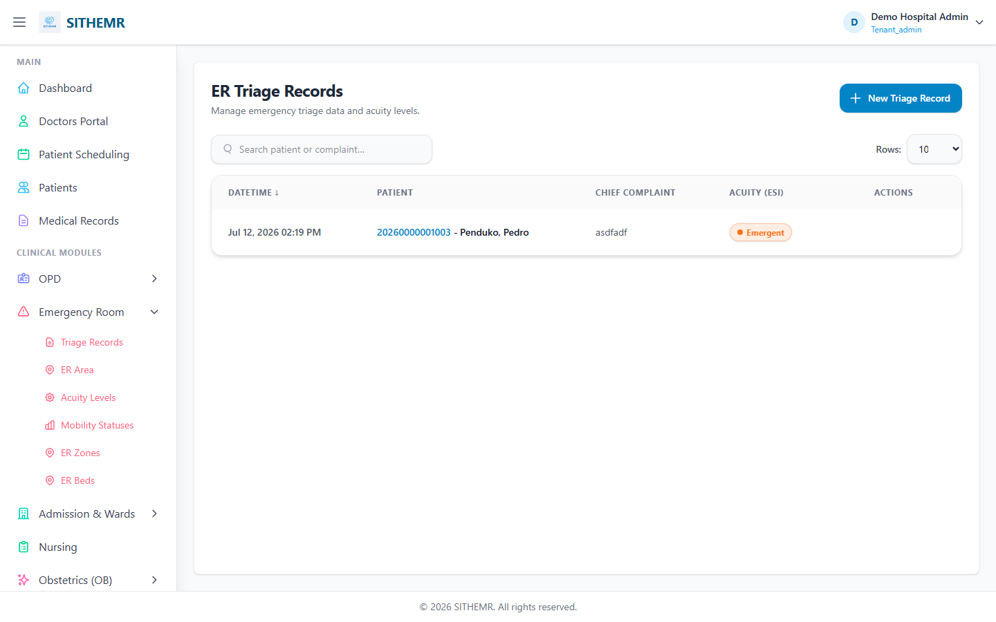
Screenshot: er-triage-01-list.png

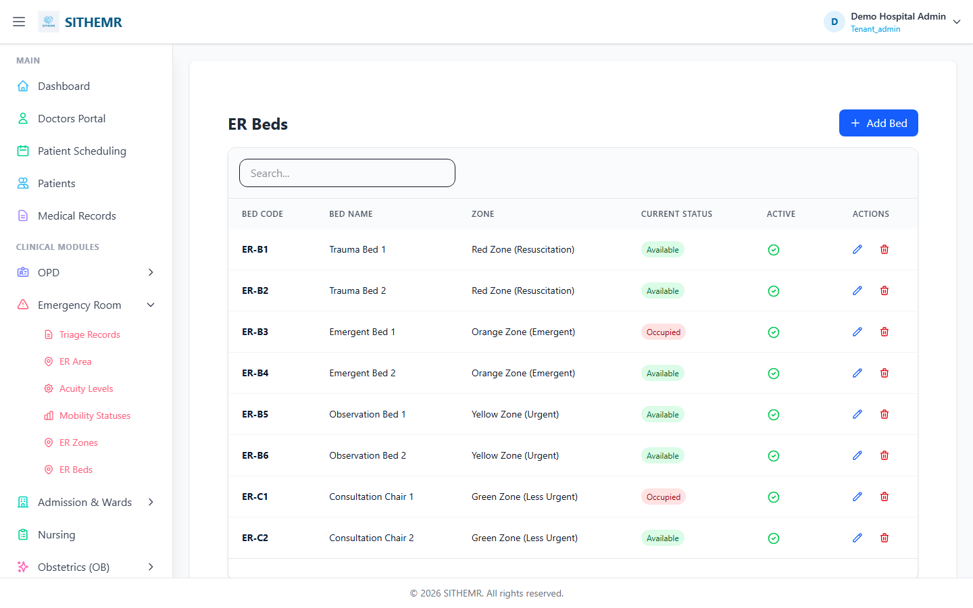
Screenshot: er-beds-01-list.png

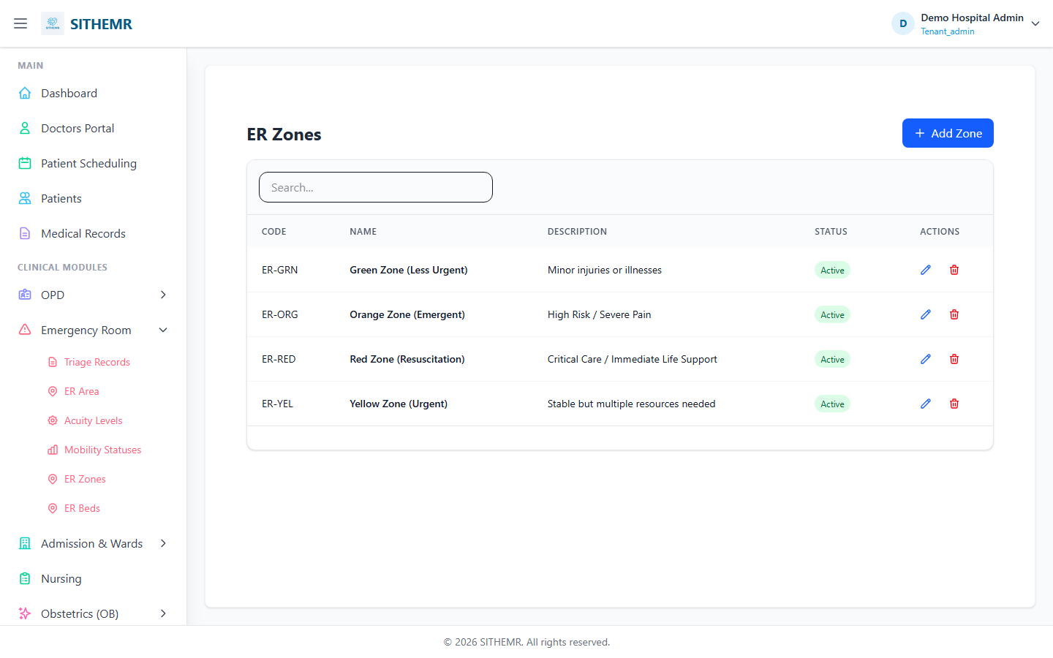
Screenshot: er-zones-01-list.png

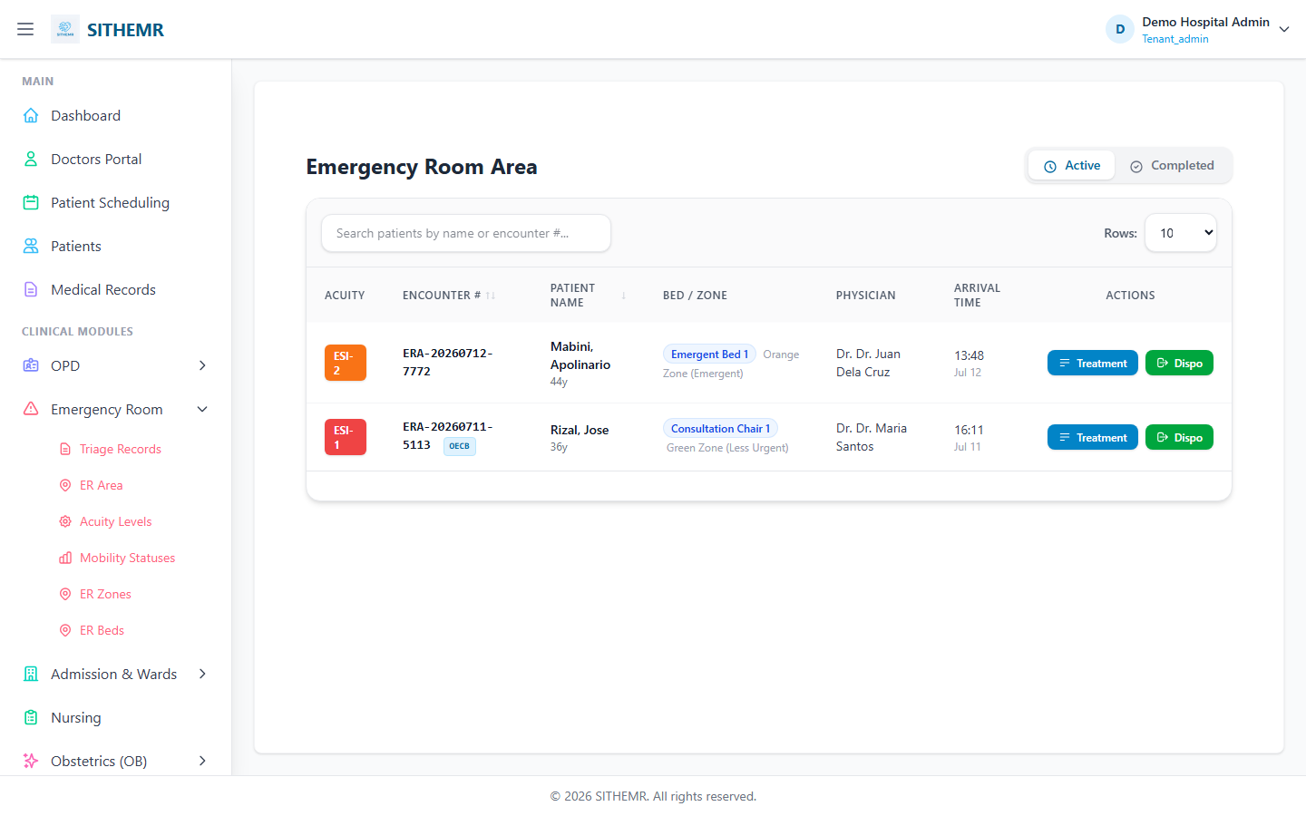
Screenshot: er-area-01-list.png

Screenshot: er-acuity-levels-01-list.png

Screenshot: er-mobility-statuses-01-list.png

Route prefix: /er. Manages emergency patient intake, triage, bed assignment, treatment, OECB billing, and disposition. Core component: ErAdmissionCrud (Livewire, WithPagination).

7.1 ER Master Data (Complete Reference)

7.1.1 ER > Triage
Route: er.triage (permission: er.triage). Triage records capture the initial patient assessment on arrival. Fields: id, tenant_id, patient_id, er_admission_id (FK, nullable - can exist before admission), acuity_level_id (FK to er_acuity_levels), mobility_status_id (FK to er_mobility_statuses), triage_notes (text), triaged_by (FK to users/HCPs), triage_datetime, status, history, audit columns. Triage is typically the FIRST record created when a patient arrives at the ER.

7.1.2 ER > Acuity Levels
Route: er.acuity-levels (permission: er.manage). Emergency severity levels: Level 1 - Immediate/Critical (life-threatening, needs immediate intervention), Level 2 - Emergency (potentially life-threatening, needs immediate evaluation), Level 3 - Urgent (serious but stable, needs prompt evaluation), Level 4 - Less Urgent (needs evaluation but not immediately), Level 5 - Non-Urgent (minor issue, can wait). Fields: id, name, code, description, color (for visual triage tagging), is_active, tenant_id, history, audit columns.

7.1.3 ER > Mobility Statuses
Route: er.mobility-statuses (permission: er.manage). Patient mobility on arrival: Ambulatory (walking), Wheelchair, Stretcher, Bedridden, Unresponsive. Fields: id, name, code, description, is_active, tenant_id, history, audit columns.

7.1.4 ER > Zones
Route: er.zones (permission: er.manage). Physical zones in the ER: Red Zone (critical - resuscitation), Yellow Zone (urgent - monitored), Green Zone (less urgent - waiting), etc. Fields: id, name, code, description, color, is_active, tenant_id, history, audit columns. Zones group beds.

7.1.5 ER > Beds
Route: er.beds (permission: er.manage). Individual ER beds. Each bed belongs to a zone (zone_id FK). Fields: id, zone_id, bed_number, bed_type, status (Available/Occupied/Occupied-Isolation/Maintenance), notes, is_active, tenant_id, history, audit columns. When a bed is assigned to an admission, its status changes to 'Occupied'. When the admission is edited to a different bed or the patient is discharged, the old bed's status is set back to 'Available' (handled in saveEdit method of ErAdmissionCrud).

7.1.6 ER > Area
Route: er.area (permission: er.manage). ER area configuration - broader physical areas that contain zones.

7.2 ER Admission Model (Complete Field Reference)
- id - Primary key.
- tenant_id - FK to hospitals.id.
- patient_id - FK to patients.id.
- admission_code - Code: 'ER#' + id (e.g. ER#1, ER#2). Set as 'ER#' . $id on creation.
- er_bed_id - FK to er_beds.id (nullable). Assigned bed.
- attending_physician_id - FK to health_care_professionals.id.
- initial_diagnosis - String, max 2000. Initial diagnosis on admission.
- history_of_present_illness - Text, max 10000. HPI.
- physical_exam_findings - Text, max 10000. Physical exam.
- assessment - Text, max 10000. Assessment/diagnosis.
- orders_summary - Text, max 10000. Summary of orders.
- treatment_notes - Text, max 10000. Treatment notes.
- is_oecb - Boolean. Whether this admission is billed under OECB (Outpatient Emergency Case Billing).
- oecb_entries - JSON array of OECB entries (see 7.3).
- mode_of_arrival - String. How the patient arrived: Walk-in, Ambulance, Private Vehicle, Motorcycle, Tricycle, Public Transport, etc.
- disposition - String. Outcome: Discharged, Admitted (inpatient), Referred, Left Without Being Seen, Against Medical Advice, Expired, etc.
- discharge_instructions - Text. Instructions given to patient on discharge.
- admission_datetime - DateTime. When the patient was admitted.
- status - Admission status: Pending, In Progress, Discharged, Admitted, Referred, Cancelled, etc.
- created_by / created_date - Audit columns.
- updated_by / updated_date - Audit columns.
- history - Soft delete flag (1=active).
- is_active - Active flag.

7.3 OECB (Outpatient Emergency Case Billing)
OECB is the Philippine emergency billing system. Each ER admission can be flagged as is_oecb=true, and OECB entries are recorded. From the ErAdmissionCrud source code:

7.3.1 OECB Entry Structure
- core_presentation - String, max 200. The core presentation name (e.g. 'Abdominal Pain', 'Chest Pain', 'Trauma'). Selected from OECB core presentation master.
- oecb_package_code - String, max 30. Auto-populated when core_presentation is selected. Looked up from OecbFeeSchedule::whereHas('corePresentation', fn($q) => $q->where('name', $value))->first().
- oecb_fixed_fee - Float (nullable). Auto-populated from the fee schedule when core_presentation is selected. The fixed fee for this OECB package.
- Each OECB entry is stored in the oecb_entries JSON column on the ErAdmission record.

7.3.2 OECB Workflow in the UI
- Toggle is_oecb checkbox on the treatment form to enable OECB entry.
- Click 'Add OECB Entry' to add a new entry row.
- Type the core_presentation name - the system auto-fetches the package_code and fixed_fee from OecbFeeSchedule.
- Multiple OECB entries can be added (e.g. multiple presentations for the same patient).
- Click the X on an entry row to remove it (removeOecbEntry method).
- On saveTreatment(): OECB entries are synced to the admission record via syncOecbEntries(). Existing entries not in the submitted array are deleted. New entries are inserted. Modified entries are updated.
- The EECL PDF (see 7.4) includes all OECB entries with their core presentation, package code, and fixed fee.

7.3.3 OECB Fee Schedule Master
The OecbFeeSchedule model links core presentations to their package codes and fixed fees. Looked up dynamically when core_presentation is selected in the UI. This is the fee reference for emergency billing.

7.4 ER Admission Workflow (Complete)
- TRIAGE (er.triage permission): Create a triage record. Select patient, acuity level, mobility status, triage notes. Triage record created first - this captures the initial severity assessment.
- CREATE ER ADMISSION: From the triage or directly, create an ER admission. Fields: patient_id, er_bed_id (assign a bed from ER > Beds - the bed status changes to 'Occupied'), attending_physician_id, initial_diagnosis, mode_of_arrival, admission_datetime = now(), status = 'Pending'.
- BED MANAGEMENT: When editing an admission's bed (saveEdit method): if the bed is changing, the OLD bed's status is set back to 'Available' and the NEW bed's status is set to 'Occupied'. This keeps bed availability accurate in real-time.
- TREATMENT (openTreatment + saveTreatment): The treatment form captures the full clinical documentation:
- - history_of_present_illness (max 10000)
- - physical_exam_findings (max 10000)
- - assessment (max 10000)
- - orders_summary (max 10000)
- - treatment_notes (max 10000)
- - is_oecb (toggle)
- - oecb_entries (dynamic rows with core_presentation, package_code, fixed_fee)
- - disposition (outcome)
- - discharge_instructions
- On saveTreatment: Updates all fields, syncs OECB entries, uses updated_by/updated_date.
- ORDERS: From the ER admission, orders can be placed just like OPD: Lab (LR-), Pharmacy (PR-), CSR (CR-), Radiology (Rad-), Procedures (Proc-). Each order links to the ER admission via er_admission_id and creates the appropriate request/items.
- DISPOSITION: Set the final outcome via the disposition field on the treatment form. Options: Discharged (patient goes home), Admitted (patient admitted to inpatient ward/ICU - creates an inpatient admission), Referred (sent to another facility), Left Without Being Seen (patient left before treatment), Against Medical Advice, Expired.
- EECL PDF: When is_oecb=true, the EECL PDF becomes available at er.admission.eeclpdf route. See 7.5.

7.5 EECL PDF (Emergency Encounter Closure List)
Route: er.admission.eeclpdf ({admission}, permission: er.manage). Generates a PDF via DomPDF downloaded as eecl-{admission_code}.pdf. The EECL PDF includes:
- Patient information (name, age, sex)
- PhilHealth member details (if patient has linked PhilHealth membership)
- Attending physician name
- OECB entries (all core_presentation, package_code, fixed_fee rows) - ONLY if is_oecb=true
- Triage record: acuity level name, mobility status, triage notes, triage datetime
- ER bed and zone assignment
- Admission datetime
- Initial diagnosis
- Disposition

7.6 ER Orders
ER orders work identically to OPD orders (see 6.5) but link to er_admission_id instead of opd_consultation_id. The ErAdmissionCrud has order modal fields for:
- Lab orders: orderLabSelection, orderLabPriority (default 'Urgent'), orderLabNotes
- CSR orders: orderCsrSelection, orderCsrQuantities, orderCsrNotes
- Radiology orders: orderRadiologySelection, orderRadiologyPriority (default 'Urgent'), orderRadiologyNotes
- Pharmacy orders: orderPharmacySelection, orderPharmacyQuantities, orderPharmacyFrequencies (per-drug CF4 frequency like BID, TID, QID, etc.), orderPharmacyRoutes (per-drug CF4 route like PO, IV, IM, SC, etc.), orderPharmacyPriority (default 'Urgent'), orderPharmacyNotes
- Procedure orders: orderProcedureSelection, orderProcedureQuantities, orderProcedureNotes
- The priority defaults to 'Urgent' for ER (vs 'Routine' for OPD) reflecting the emergency nature.

8. Inpatient Admission, ICU, Ward, and OR
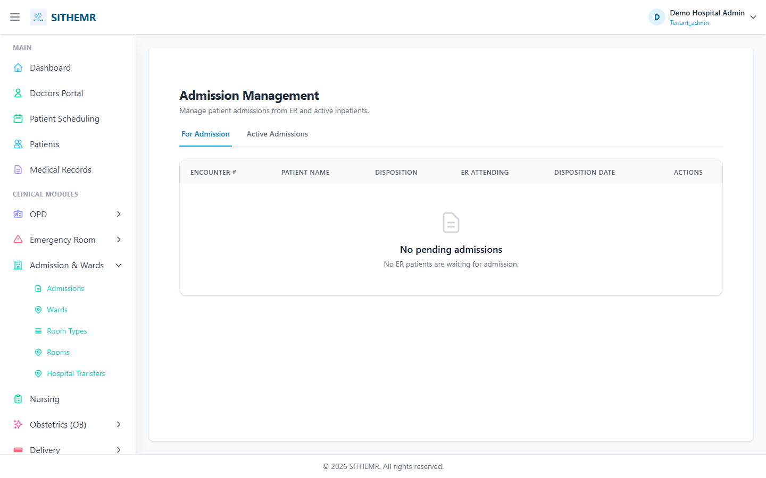
Screenshot: admission-01-list.png

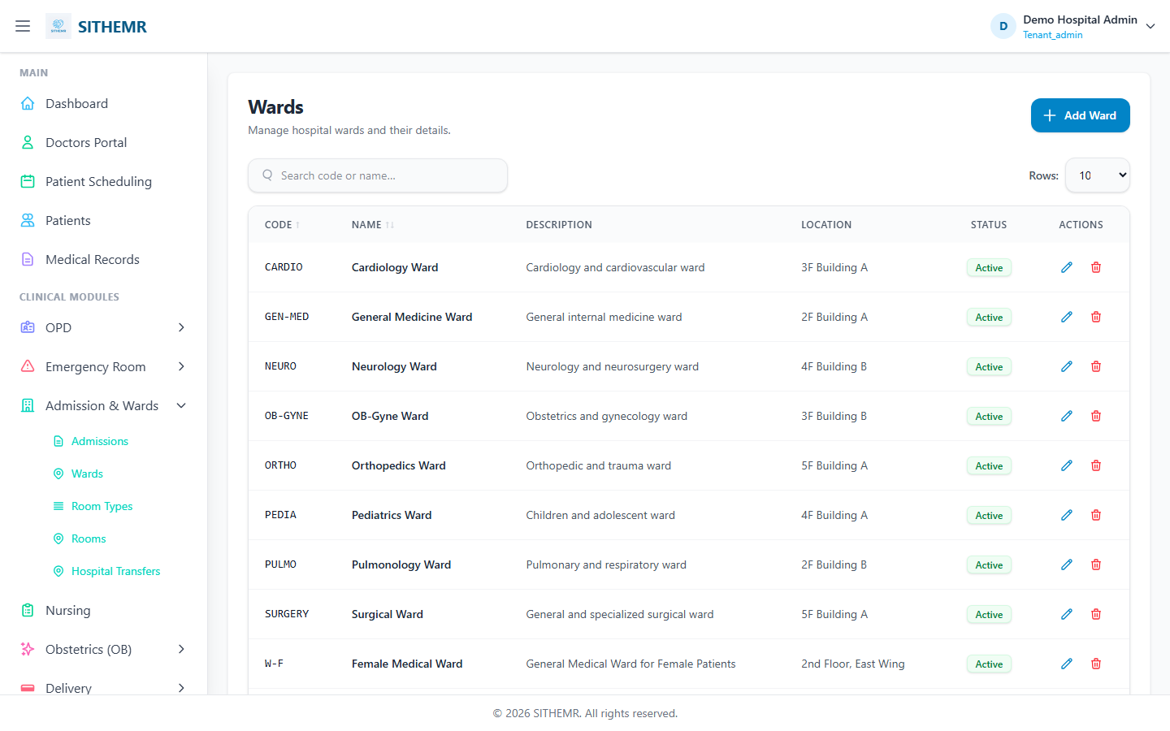
Screenshot: wards-01-list.png

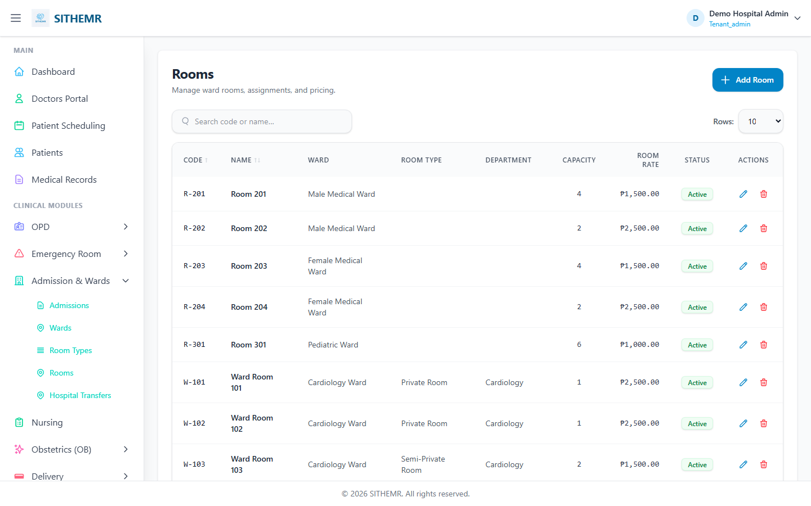
Screenshot: ward-rooms-01-list.png

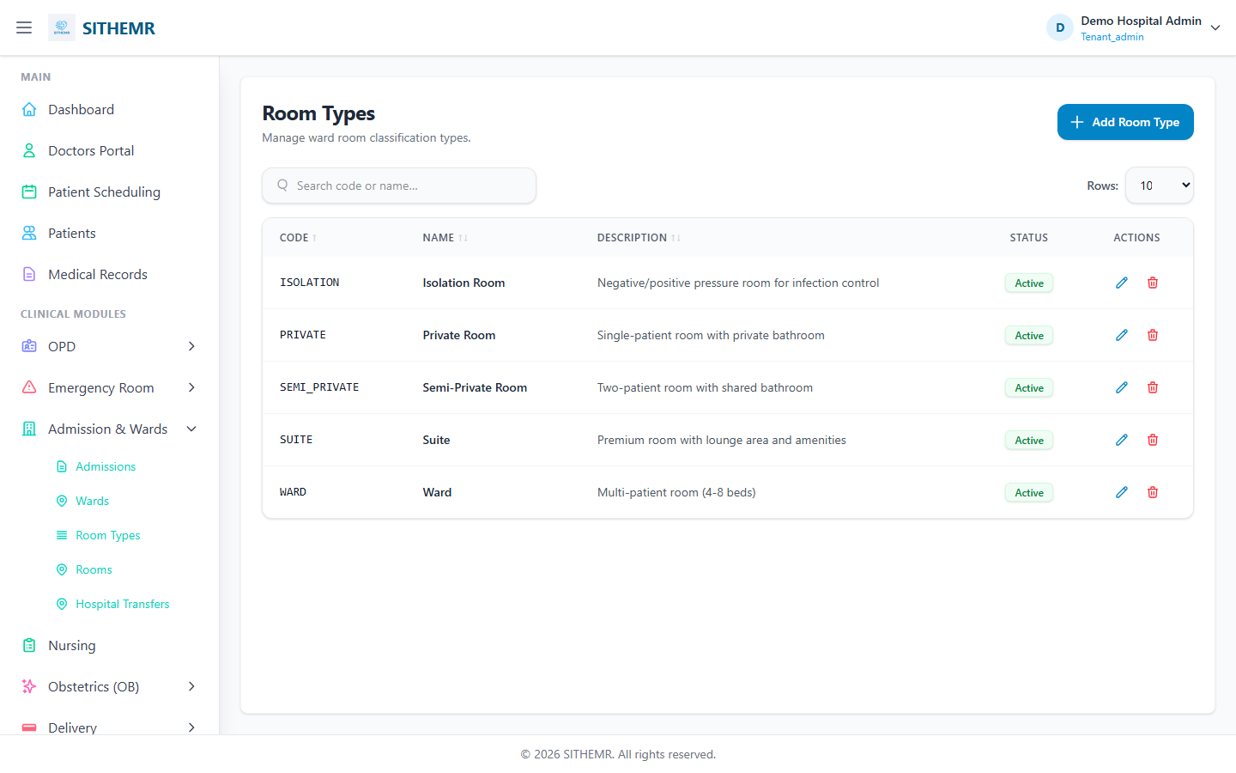
Screenshot: ward-room-types-01-list.png

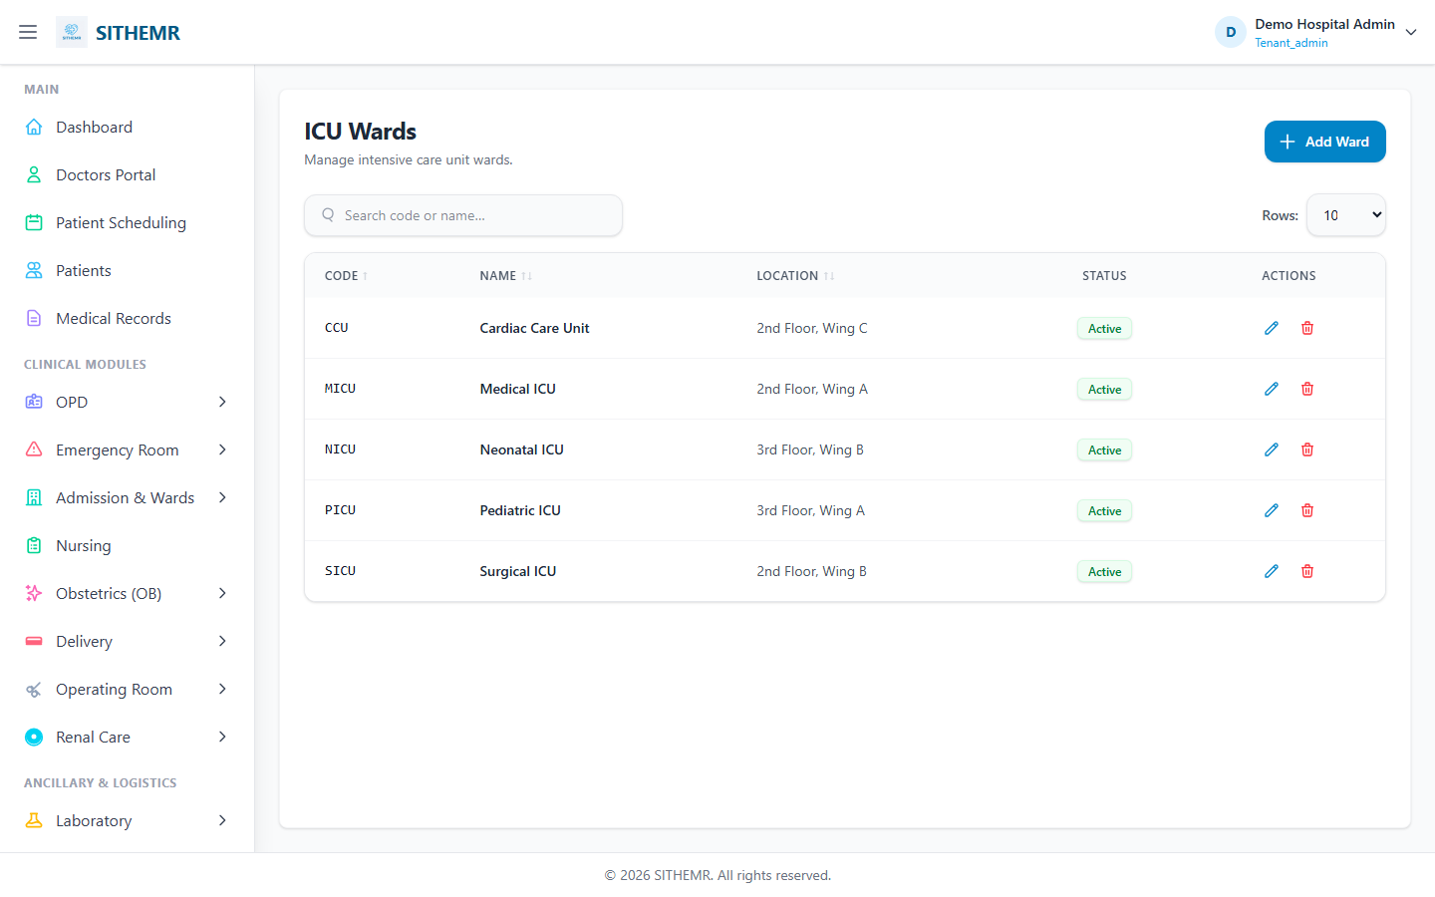
Screenshot: icu-wards-01-list.png

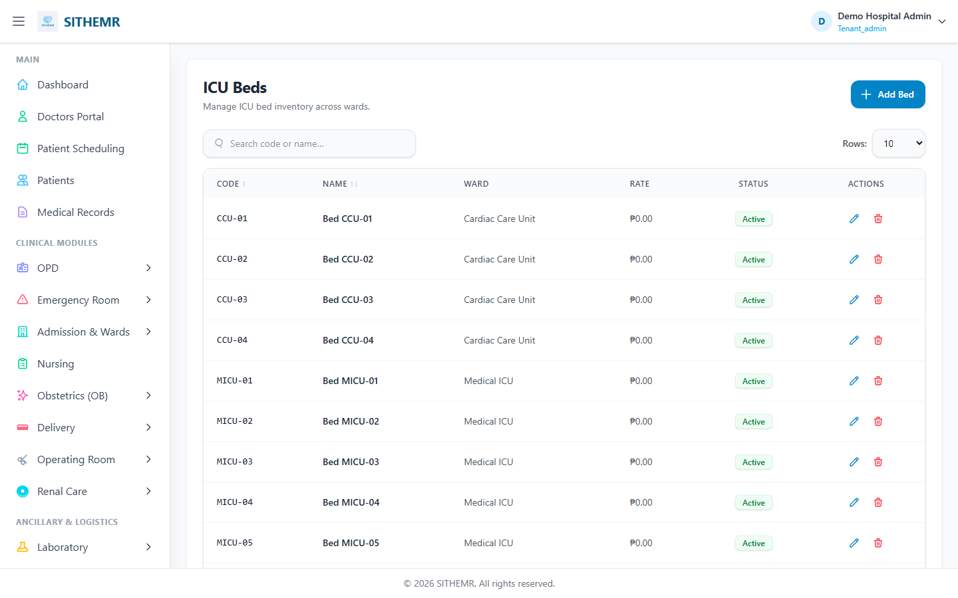
Screenshot: icu-beds-01-list.png

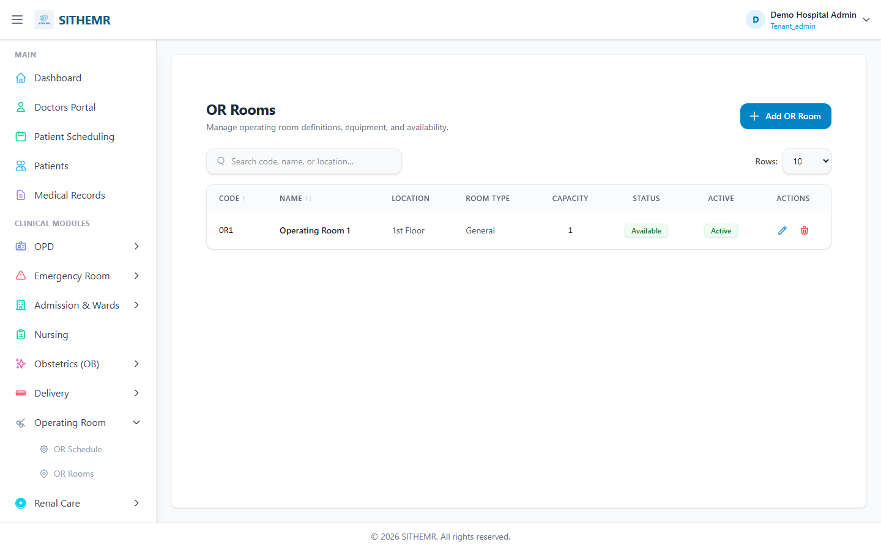
Screenshot: or-rooms-01-list.png

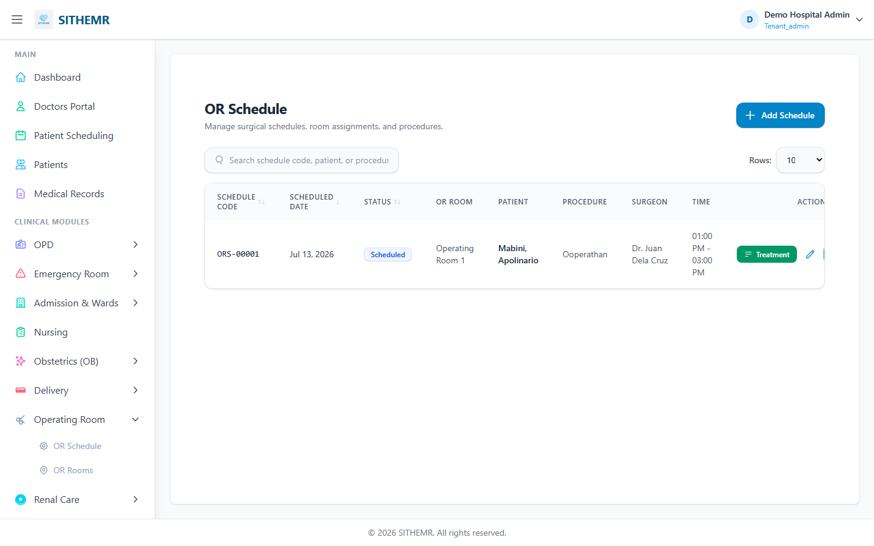
Screenshot: or-schedule-01-list.png

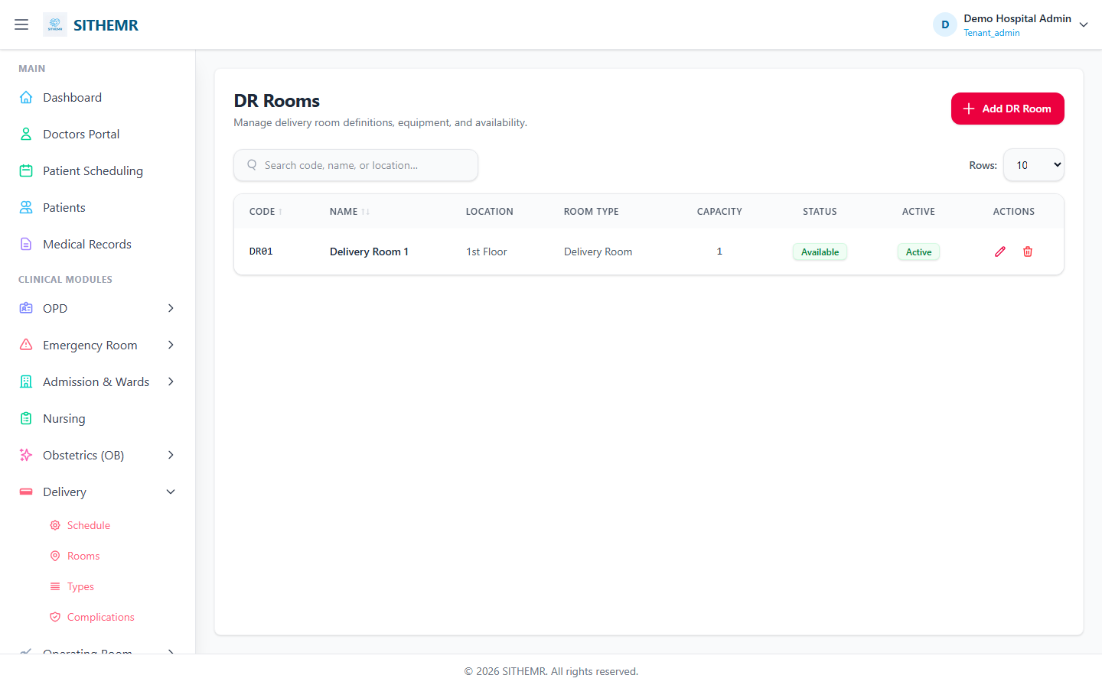
Screenshot: delivery-rooms-01-list.png

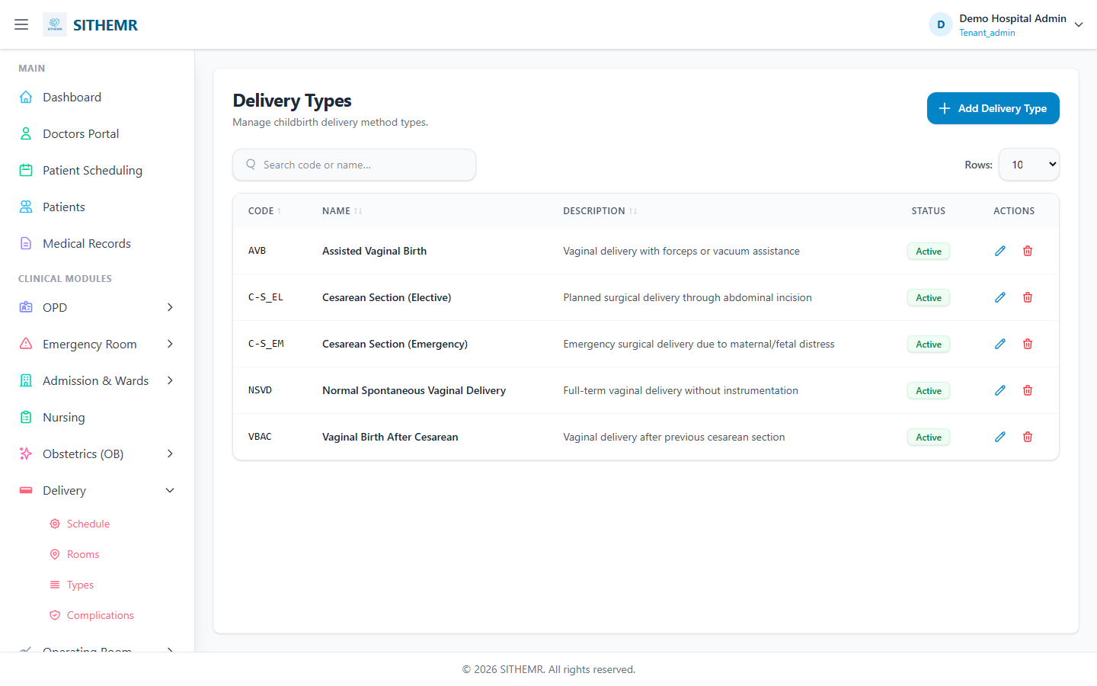
Screenshot: delivery-types-01-list.png

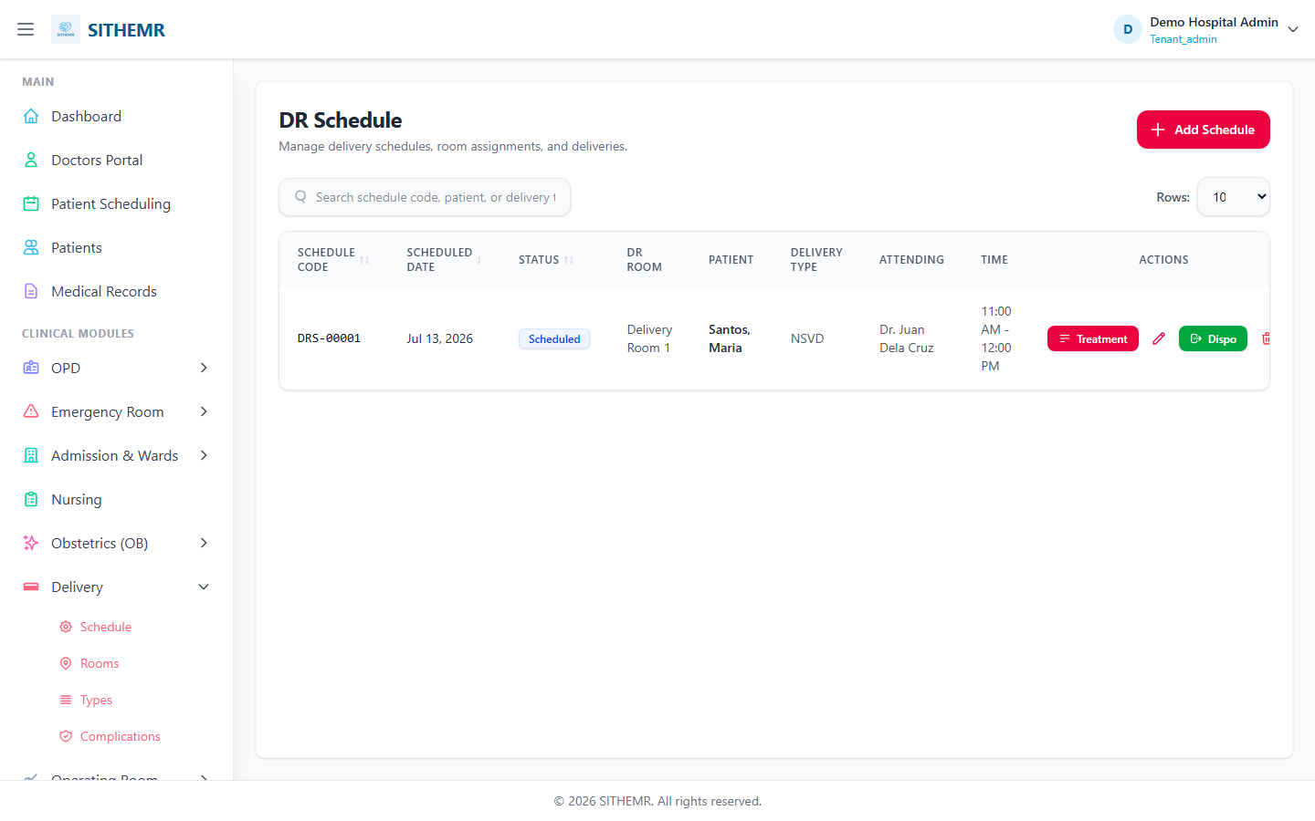
Screenshot: delivery-schedule-01-list.png

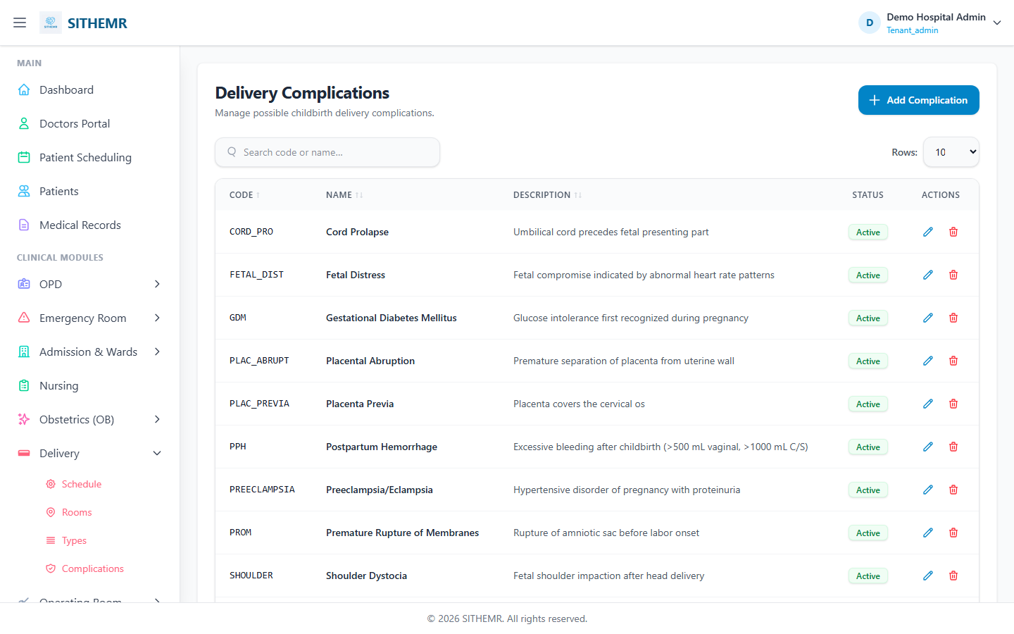
Screenshot: delivery-complications-01-list.png

8.1 Inpatient Admission (/admission)
Route: /admission (permission: admission.view). Manages inpatient admissions. This is where patients who need hospitalization are admitted. The admission record links to a ward room or ICU bed, and serves as the anchor for all inpatient orders, billing, and discharge.
- Admission code: ADM#<id> (e.g. ADM#1, ADM#2).
- Key fields: patient_id, admitting_diagnosis, attending_physician_id, admission_type, admission_date, ward_room_id (FK to ward_rooms) OR icu_bed_id (FK to icu_beds), status (Admitted, Discharged, Transfer, Expired, etc.), discharge_date, discharge_disposition, discharge_instructions.
- The admission is the central record for an inpatient stay. All orders (lab, pharmacy, CSR, radiology, procedure) link to the admission via admission_id.
- When the patient is discharged, the assigned room/bed status is set back to 'Available' and the discharge_date is recorded.
- Admission Room History: When a patient is moved between rooms during their stay, the AdmissionRoomHistory model tracks each move with from_room, to_room, moved_by, moved_date for audit trail.

8.2 ICU (Intensive Care Unit) — /icu
Route prefix: /icu (permission: admission.view). Manages critical care beds.
- ICU > Wards: ICU ward names (e.g. Medical ICU, Surgical ICU, Cardiac ICU). Fields: id, name, code, description, is_active, tenant_id, history.
- ICU > Beds: Individual ICU beds. Each bed belongs to an ICU ward (icu_ward_id FK). Fields: id, icu_ward_id, bed_number, bed_type, status (Available/Occupied), is_active, tenant_id, history.
- ICU beds are assigned to admissions for critical care patients (icu_bed_id on the Admission model).
- When an ICU bed is assigned, its status changes to 'Occupied'. When freed, status returns to 'Available'.

8.3 MICU (Medical Intensive Care Unit) — /micu
Route prefix: /micu (permission: admission.view). Medical (non-surgical) critical care tracking.
- MICU > Patients: MICU-specific patient records. Tracks patients admitted to the Medical ICU with their MICU-specific data. Fields: id, patient_id, icu_bed_id, admission_id, micu_admission_date, micu_discharge_date, primary_diagnosis, micro_organism (if applicable), micu_status, created_by, created_date, history.
- MICU > Assessment Parameters: Critical care assessment data captured for MICU patients. Fields: id, micu_patient_id, assessment_date, vitals (BP, HR, temp, RR, SpO2), laboratory values (ABG, electrolytes, CBC, etc.), severity scores (APACHE II, SOFA, Glasgow Coma Scale), ventilator settings (if applicable), fluid_balance, urine_output, created_by, created_date, history.
- Assessment parameters are captured periodically (e.g. every shift or every 4-6 hours) to track the patient's critical care trajectory.

8.4 Ward Management — /ward
Route prefix: /ward (permission: admission.view). Manages general inpatient wards and rooms.
- Ward > Wards: Ward names (General Ward, Private Ward, Semi-Private, VIP Ward, Pediatric Ward, etc.). Fields: id, name, code, description, bed_capacity, is_active, tenant_id, history.
- Ward > Room Types: Room categories (Single Room, Double Room, Quadruple Room, Ward Bed, Semi-Private Room, etc.). Fields: id, name, code, description, bed_count_per_room, rate_per_day (for billing), is_active, tenant_id, history.
- Ward > Rooms: Individual rooms. Each room belongs to a ward (ward_id FK) and a room type (room_type_id FK). Fields: id, ward_id, room_type_id, room_number, floor, bed_count, status (Available/Occupied/Full/Maintenance), notes, is_active, tenant_id, history.
- Rooms are assigned to admissions (ward_room_id on the Admission model).
- When a room is assigned, bed_count is decremented. When the patient is discharged, the bed is freed and bed_count incremented.
- Room transfers: tracked in AdmissionRoomHistory for audit.

8.5 Operating Room (OR) — /or
Route prefix: /or (permission: or.view). Manages operating theatre scheduling and rooms.
- OR > Rooms: Operating room names/codes (OR 1, OR 2, Main OR, Cardiac OR, Neuro OR, etc.). Fields: id, name, code, description, floor, status (Available/Booked/Maintenance), is_active, tenant_id, history.
- OR > Schedule: OR procedure scheduling. The OR schedule is created from the ErAdmissionCrud's showOrScheduleModal + the OR scheduling form. Fields: id, patient_id, admission_id (nullable), or_room_id (FK to or_rooms), procedure_type, procedure_description, surgeon_id (FK to health_care_professionals), anesthesiologist_id (FK to health_care_professionals), scheduled_date, start_time, end_time, pre_op_notes, intra_op_notes, post_op_notes, status (Scheduled/In Progress/Completed/Cancelled), created_by, created_date, history.
- The OR schedule drives operating theatre utilization. Surgeons and anesthesiologists are both assigned. Pre/intra/post-op notes are captured during the procedure workflow.
- OR schedule integrates with the procedure module (procedures are ordered and linked to OR schedule) and billing (OR use is billed).

9. Laboratory Services
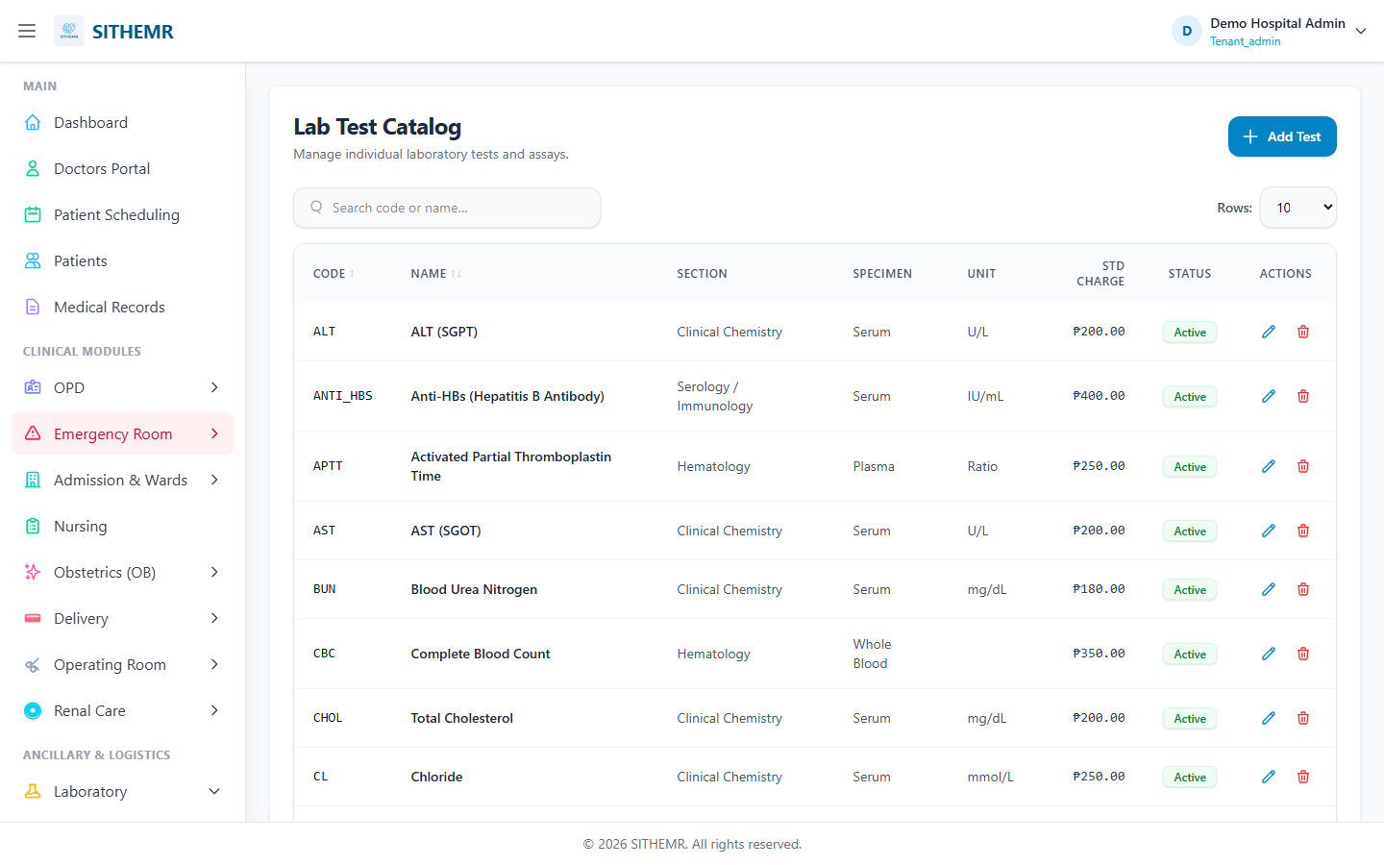
Screenshot: lab-tests-01-list.png

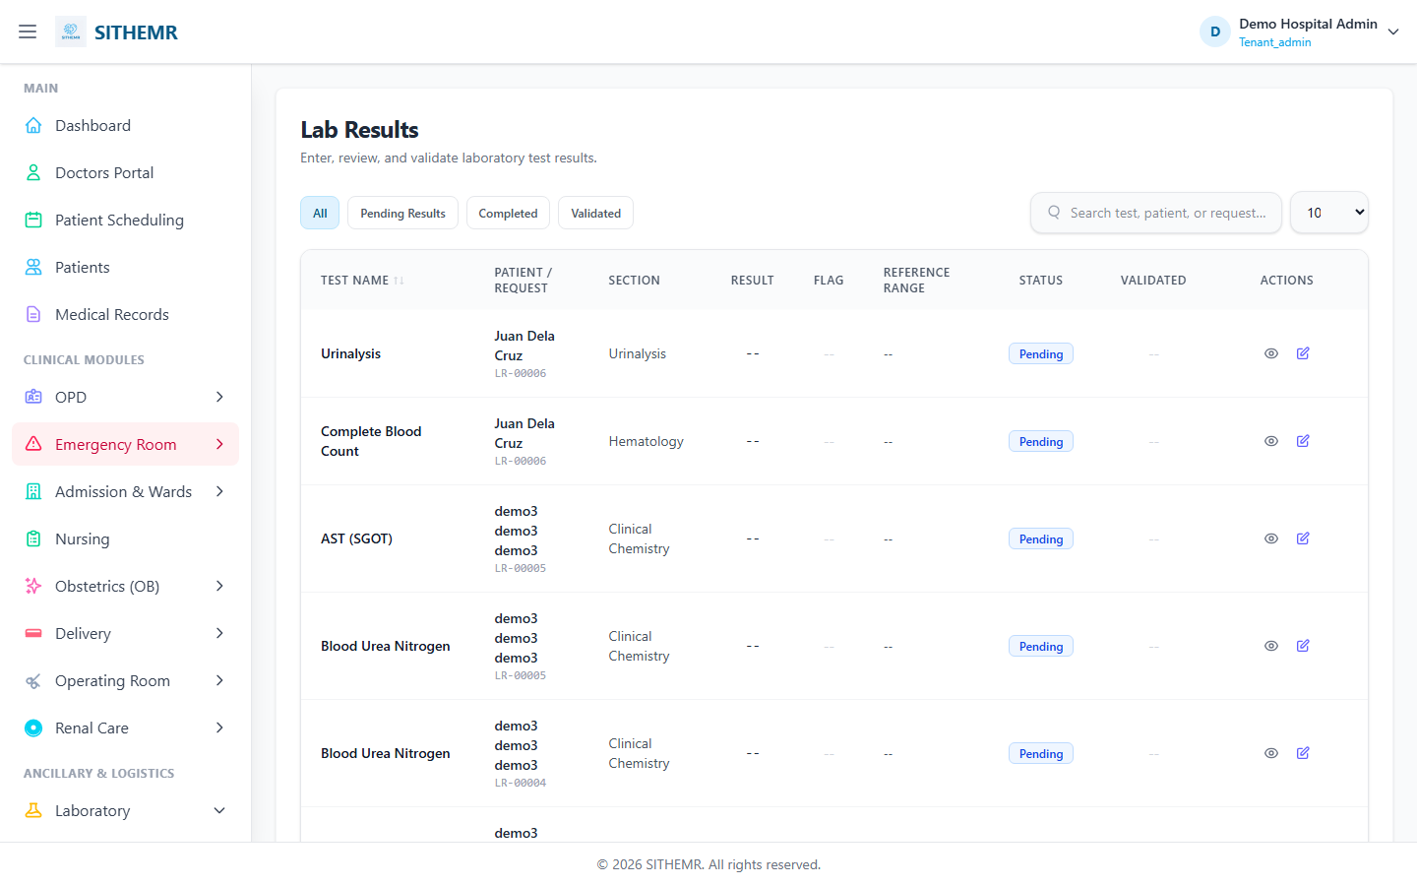
Screenshot: lab-results-01-list.png

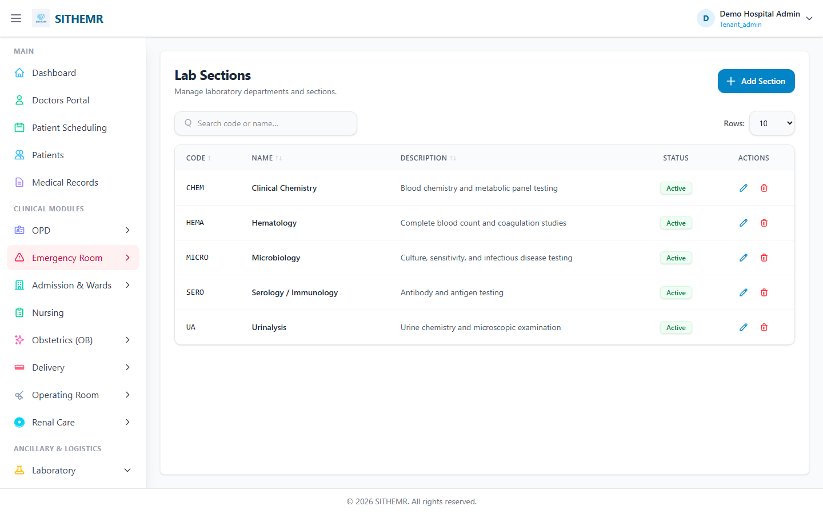
Screenshot: lab-sections-01-list.png

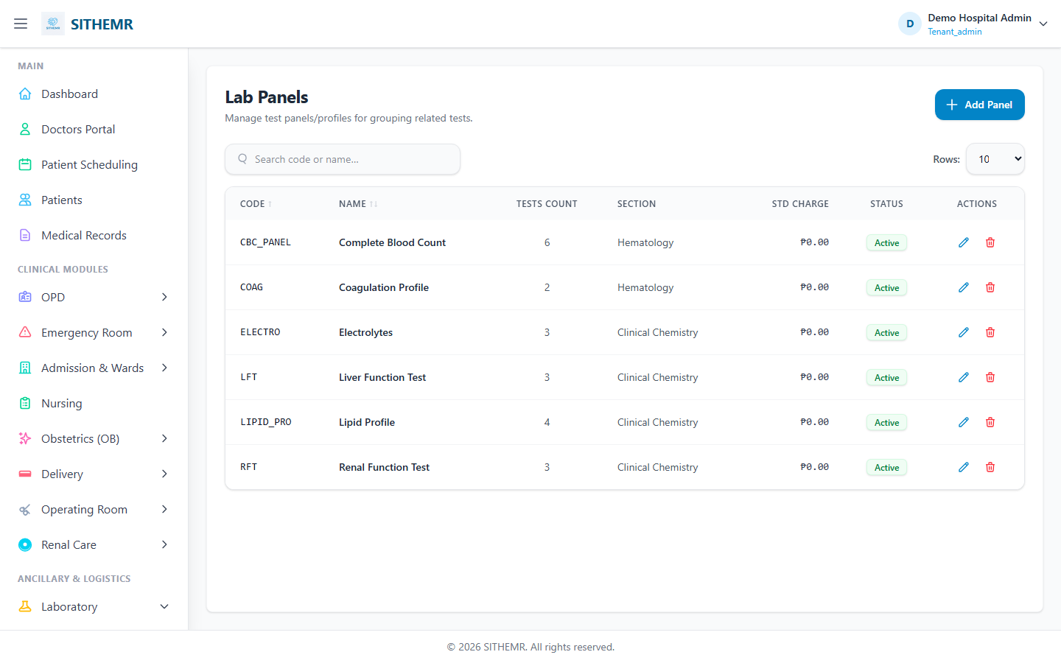
Screenshot: lab-panels-01-list.png

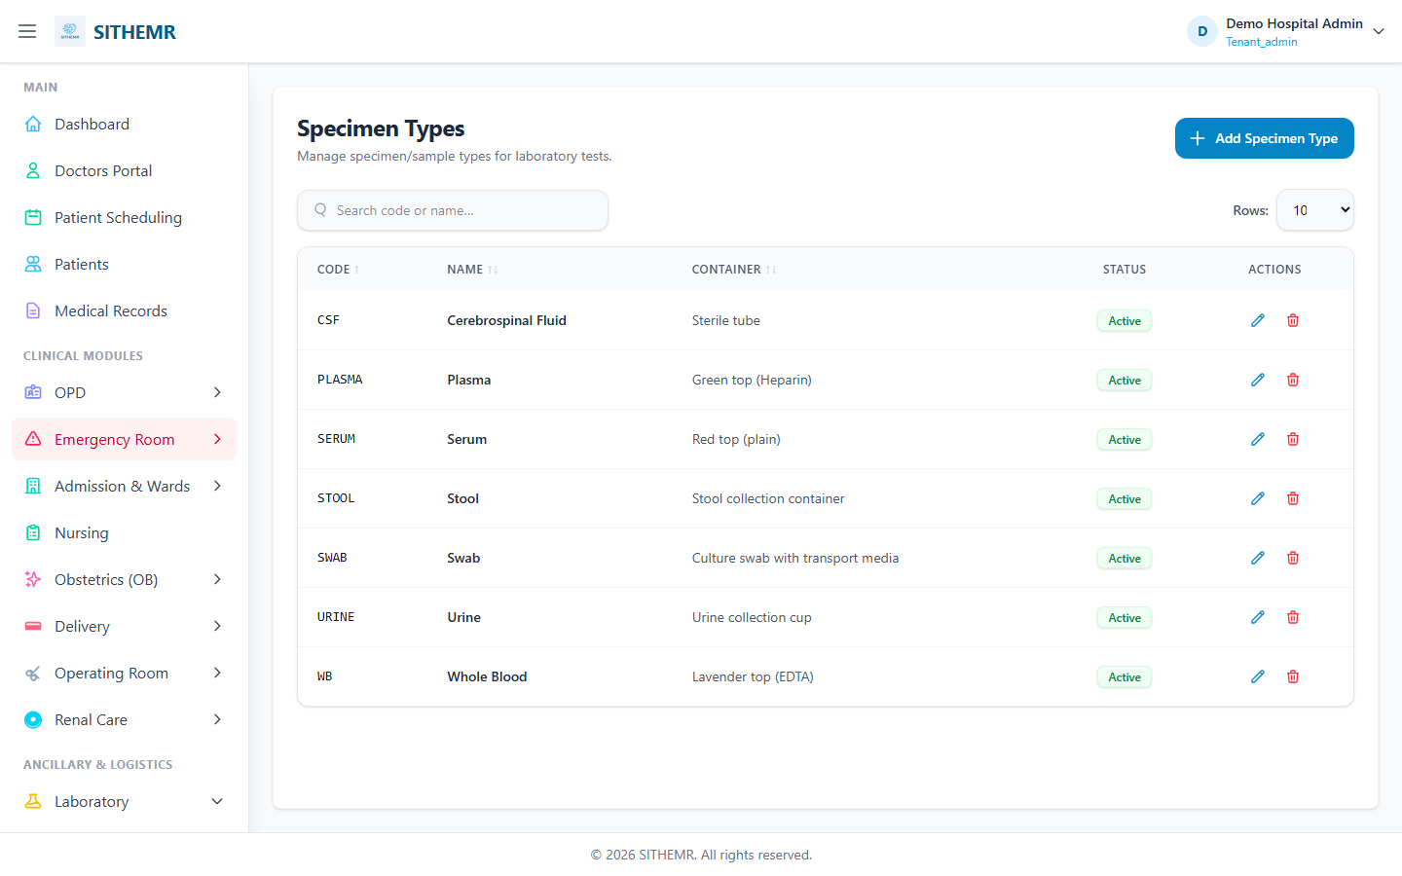
Screenshot: lab-specimen-types-01-list.png

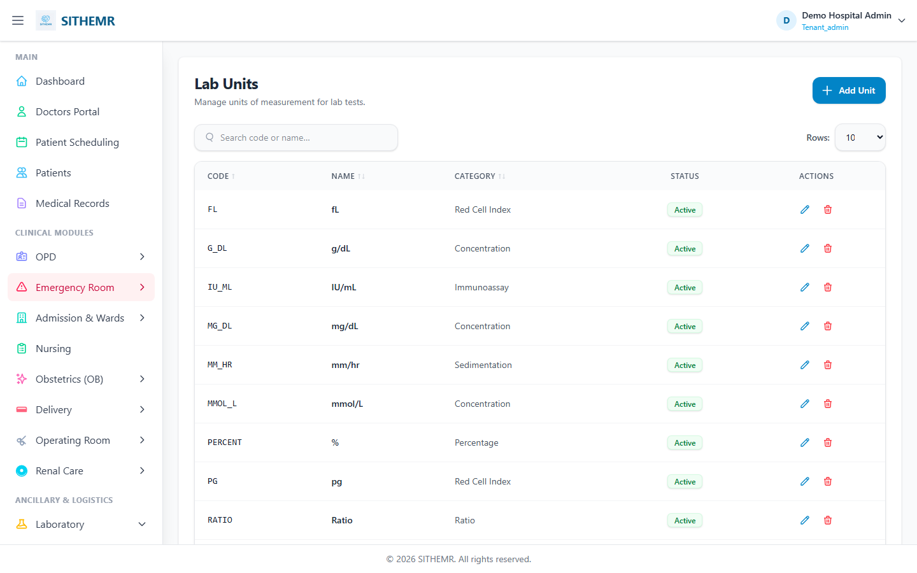
Screenshot: lab-units-01-list.png

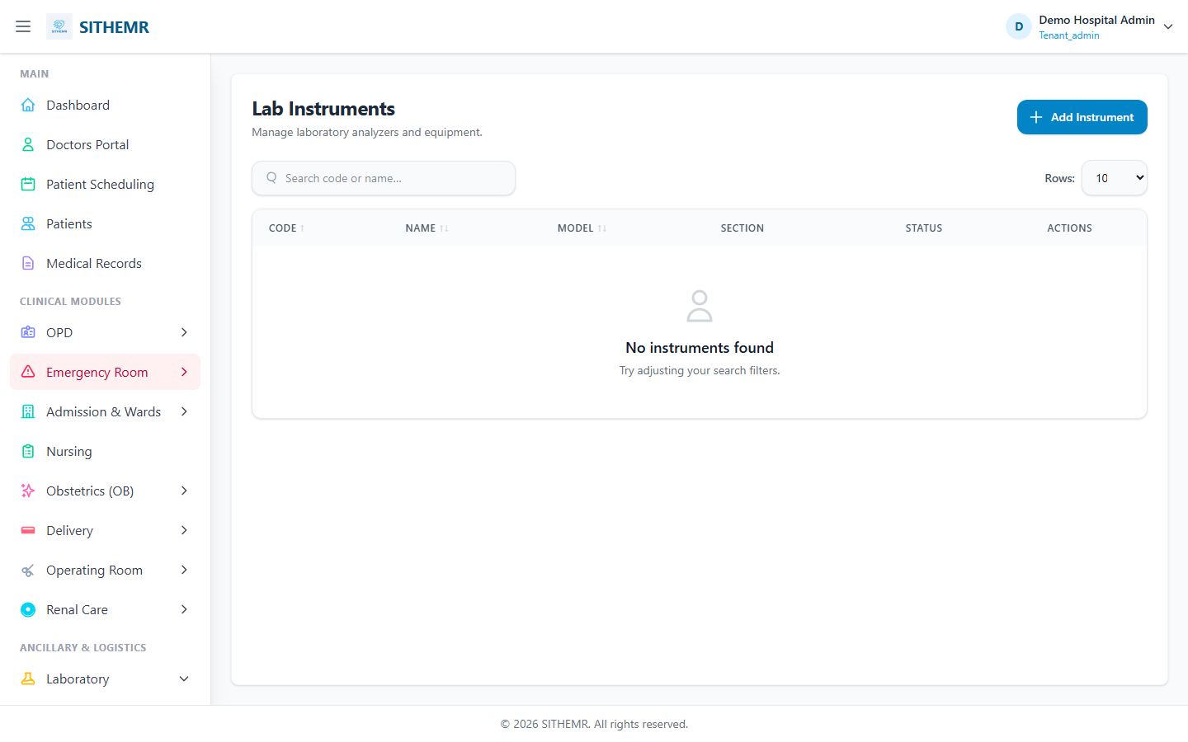
Screenshot: lab-instruments-01-list.png

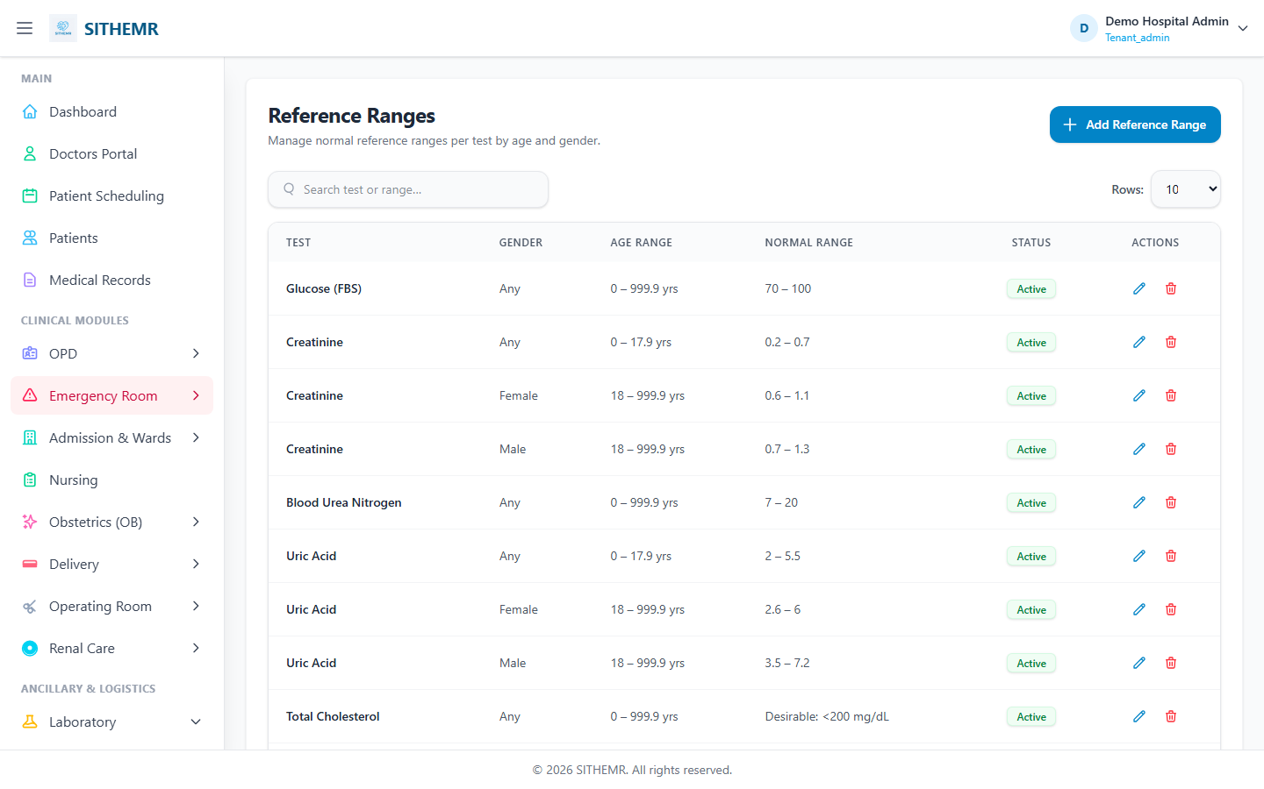
Screenshot: lab-reference-ranges-01-list.png

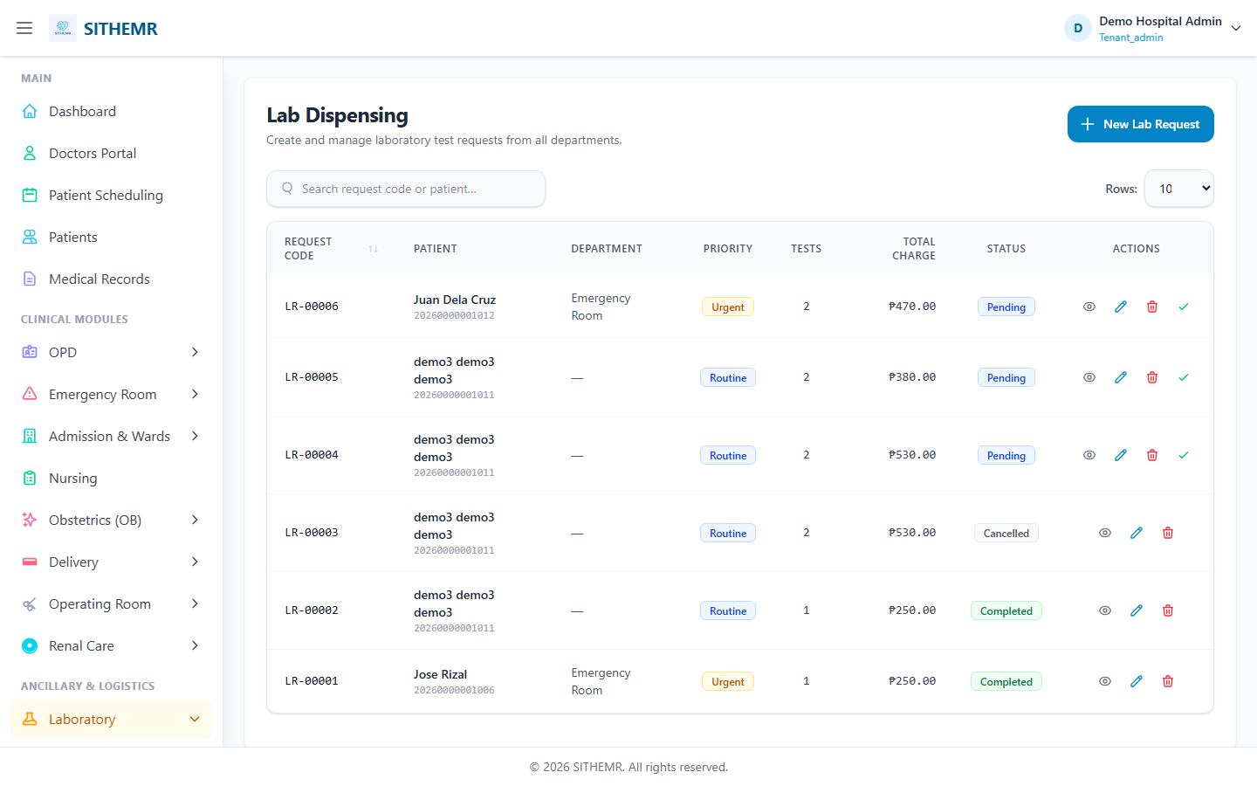
Screenshot: lab-dispensing-01-list.png

Route prefix: /lab. Manages the complete laboratory workflow: master data, test ordering, specimen collection, results entry, and lab material dispensing. Core components: Lab sections, tests, panels, reference ranges, lab requests/items, lab results, and dispensing.

9.1 Lab Master Data (Complete Reference)

9.1.1 Lab > Sections
Route: lab.sections (permission: lab.manage). Laboratory sections/departments: Clinical Chemistry, Hematology, Microbiology, Urinalysis, Immunology/Serology, Coagulation, Blood Banking/Transfusion, Histopathology, Cytology, etc. Fields: id, name, code, description, is_active, tenant_id, history, audit columns. Used as requesting_department_id in lab requests.

9.1.2 Lab > Units
Route: lab.units (permission: lab.manage). Measurement units for lab tests: mmol/L, mg/dL, g/dL, cmm (cells per cubic mm), %, IU/L, U/L, etc. Fields: id, name, abbreviation, system (metric/imperial/none), is_active, tenant_id, history, audit columns. Each lab test references a unit_id.

9.1.3 Lab > Specimen Types
Route: lab.specimen-types (permission: lab.manage). Types of specimens collected: Whole Blood (EDTA), Serum (Red Top), Plasma (Citrate/Blue Top), Urine (Random/Fasting/24hr), Stool, Sputum, Swab (Throat/Nasopharyngeal/Vaginal), Cerebrospinal Fluid (CSF), Synovial Fluid, Ascitic Fluid, Pleural Fluid, Pericardial Fluid, Bronchoalveolar Lavage, Bone Marrow, Tissue/Biopsy, etc. Fields: id, name, code, description, collection_instructions (text), is_active, tenant_id, history, audit columns.

9.1.4 Lab > Instruments
Route: lab.instruments (permission: lab.manage). Laboratory instruments/analyzers: Automated Chemistry Analyzer, Hematology Analyzer, Coagulation Analyzer, Microbiology Incubator, Microscope, Centrifuge, etc. Fields: id, name, code, manufacturer, model, serial_number, installation_date, calibration_date, next_calibration_date, status (Operational/Under Maintenance/Out of Service), is_active, tenant_id, history, audit columns. Instruments can be linked to tests.

9.1.5 Lab > Tests (Complete Reference)
Route: lab.tests (permission: lab.manage). Individual laboratory tests. This is the core test catalog. Each test record defines the test's properties, charges, and result structure. Fields: id, lab_section_id (FK), test_name, test_code, description, specimen_type_id (FK), unit_id (FK), standard_charge (float - used for billing when ordered via OPD/ER/inpatient), normal_range_low (float, nullable), normal_range_high (float, nullable), reference_range_text (string - textual reference range notes), is_coding_required (bool - if true, requires ICD10/ SNOMED coding), is_micro_result_required (bool), is_parametric_result (bool - numeric lab result), parametric_unit_id (FK to lab_units, for numeric results), parametric_decimal_places (int, default 2), is_active, tenant_id, history, audit columns.
- Example tests by section: Hematology - Complete Blood Count (CBC), WBC Differential, Platelet Count, ESR, PT/INR, aPTT; Clinical Chemistry - Fasting Blood Sugar (FBS), Random Blood Sugar (RBS), HbA1c, Creatinine, BUN, ALT, AST, ALP, Total Bilirubin, Direct Bilirubin, Total Protein, Albumin, Globulin, Total Cholesterol, Triglycerides, HDL, LDL, Uric Acid, Sodium, Potassium, Chloride, Bicarbonate; Microbiology - Gram Stain, Culture & Sensitivity (C&S), AFB Smear, Urine Culture; Urinalysis - Urinalysis (Routine), Urine Pregnancy Test; Immunology - ASO Titer, CRP, Rheumatoid Factor, Hepatitis B Panel, Hepatitis C Antibody, HIV Ag-Ab, VDRL/RPR, TSH, T3, T4.
- Each test has: a standard_charge (used for billing when ordered), a unit (mmol/L, %, etc.), optional normal ranges (low/high), and a reference range text.
- parametric_result tests have numeric results with decimal precision. non-parametric tests have text/micro results (e.g. Gram Stain = 'Gram Positive Cocci in Clusters').
- Tests are ordered via OPD/ER/inpatient orders (LabRequest + LabRequestItem), NOT by directly creating lab results.

9.1.6 Lab > Panels
Route: lab.panels (permission: lab.manage). Test panels/batteries: CBC with Differential, Fasting Lipid Profile, Liver Function Test (LFT), Renal Function Test (RFT), Fasting Blood Sugar Panel, Urinalysis Complete, Thyroid Function Test, etc. Panels group multiple tests together for convenient ordering. Fields: id, name, code, description, test_ids (JSON array of lab_tests.id), is_active, tenant_id, history, audit columns.

9.1.7 Lab > Reference Ranges
Route: lab.reference-ranges (permission: lab.manage). Age and sex-specific reference ranges for tests. Fields: id, lab_test_id (FK), age_min (int, nullable), age_max (int, nullable), sex (string - Male/Female/Both), range_low (float), range_high (float), unit_id (FK), notes (string), is_active, tenant_id, history, audit columns. Reference ranges override the test's default normal_range_low/high for specific demographics.

9.2 Laboratory Request and Results Workflow
Flow: Order placed (from OPD/ER/inpatient) -> LabRequest created -> Specimen collected -> Results entered -> Results viewed by requesting doctor.

9.2.1 LabRequest Model
- id - Primary key.
- tenant_id - FK to hospitals.id.
- lab_request_code - Code: 'LR-' + 5-digit sequence (e.g. LR-00001). Generated by placeLabOrder().
- opd_consultation_id - FK to opd_consultations.id (for OPD orders; nullable otherwise).
- er_admission_id - FK to er_admissions.id (for ER orders; nullable otherwise).
- admission_id - FK to admissions.id (for inpatient orders; nullable otherwise).
- patient_id - FK to patients.id. The patient being tested.
- requesting_department_id - FK to departments.id. Typically the 'Laboratory' department or the ordering clinic's department.
- requesting_doctor_id - FK to health_care_professionals.id. The doctor who ordered the tests.
- request_datetime - DateTime. When the order was placed.
- priority - String: Stat, Urgent, Routine, Standby. Default: 'Routine'.
- request_notes - Text (nullable). Clinical notes for the lab technologist.
- specimen_collected_datetime - DateTime (nullable). When the specimen was actually collected.
- specimen_collected_by - String (nullable). Who collected the specimen.
- status - Request status: Pending, Specimen Collected, In Progress, Results Ready, Verified, Cancelled.
- total_charge - Float. Sum of all LabRequestItem charge_amounts.
- created_by / created_date - Audit columns.
- updated_by / updated_date - Audit columns.
- history - Soft delete flag (1=active).
- is_active - Active flag.

9.2.2 LabRequestItem Model
- id - Primary key.
- lab_request_id - FK to lab_requests.id.
- item_type - String: 'Test' (individual lab test). May also include 'Panel' types.
- lab_test_id - FK to lab_tests.id (for item_type='Test').
- test_name - String. Denormalized test name (copied from lab_tests at creation).
- charge_amount - Float. The test's standard_charge at time of order.
- lab_result - Text (nullable, max 4000). The result entered by the lab technologist (text result for non-parametric tests or micro results).
- lab_result_number - Float (nullable). Numeric result for parametric tests.
- result_interpretation - String (nullable). Auto-computed or manually set: 'Within Normal Limits', 'Above Reference Range', 'Below Reference Range', 'Critical - High', 'Critical - Low', 'Not Applicable'.
- is_reviewed - Boolean. Whether the pathologist/lab supervisor has reviewed this result.
- reviewed_by - FK to users/HCPs (nullable).
- reviewed_date - DateTime (nullable).
- created_by / created_date - Audit columns.
- updated_by / updated_date - Audit columns.

9.2.3 Placing a Lab Order
From OPD Consultation (placeLabOrder) or ER Admission. See sections 6.5.1 and 7.6 for the full order placement flow. Summary:
- Doctor selects tests from the lab tests catalog in the order modal.
- For each selected test: a LabRequestItem is created with lab_test_id, test_name, charge_amount (from test->standard_charge).
- LabRequest is created with request_code = 'LR-' + 5-digit sequence, status = 'Pending'.
- The request appears in Lab > Results for the lab technologist to process.

9.2.4 Lab Results Entry
Route: lab.results (permission: lab.result). The lab results page shows all lab requests for the current tenant with their items and results status.
- Filters: by status (All, Pending, Specimen Collected, In Progress, Results Ready, Verified), by priority (Stat, Urgent, Routine), by date range.
- Search by patient name, lab request code, or doctor name.
- For each request: shows patient, request code, ordering doctor, priority, status, date, total charge.
- Clicking into a request shows all LabRequestItems with their test names and current result status.
- Results Entry: For each item, the lab technologist enters:
- - lab_result (text): the result string (e.g. '4.5', 'Gram Positive Cocci in Clusters', 'Negative', '12-15 HPF').
- - lab_result_number (numeric): for parametric tests, the numeric value.
- - result_interpretation: auto-computed by comparing lab_result_number against the test's normal_range_low/high (or the demographic-specific reference range). Options: 'Within Normal Limits', 'Above Reference Range', 'Below Reference Range', 'Critical - High', 'Critical - Low'.
- - is_reviewed: marks whether the result has been reviewed by a supervisor.
- Updating a result: sets updated_by/updated_date. If is_reviewed is checked, sets reviewed_by/reviewed_date.
- When all items have results entered, the request status can advance to 'Results Ready'.
- Verified status: when the pathologist/supervisor verifies the results, status becomes 'Verified' and the requesting doctor can view them.

9.3 Printing Lab Results (result.print)
Route: lab.results.print ({labRequest}, permission: lab.result). Generates a PDF via DomPDF showing the complete lab request with all results.
- PDF includes: Lab request header (request code, patient name, age, sex, status), ordering doctor and department, request date, priority, specimen type, collection date/time and collector.
- Results table: test name, result (numeric + unit), reference range, interpretation, status (Pending/Reviewed/Verified).
- Verified by and verification date (if reviewed).
- The PDF is downloadable and printable for patient records and doctor review.

9.4 Lab Dispensing (lab.dispense)
Route: lab.dispensing (permission: lab.dispense). Dispensing lab materials/consumables to users. Similar to pharmacy dispensing but for lab supplies. Tracks which lab materials are issued to which user/department, with quantities and dates.

10. Radiology Services
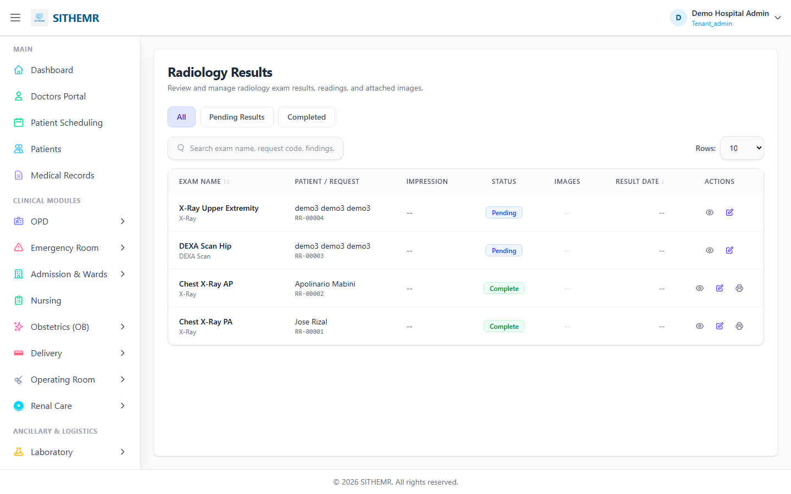
Screenshot: radiology-results-01-list.png

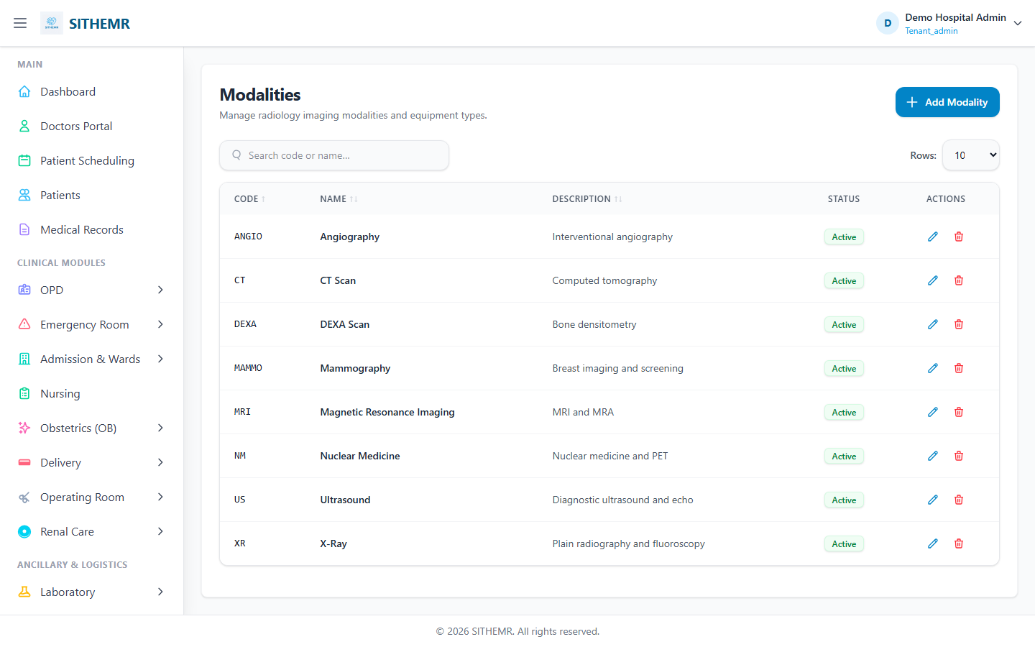
Screenshot: radiology-modalities-01-list.png

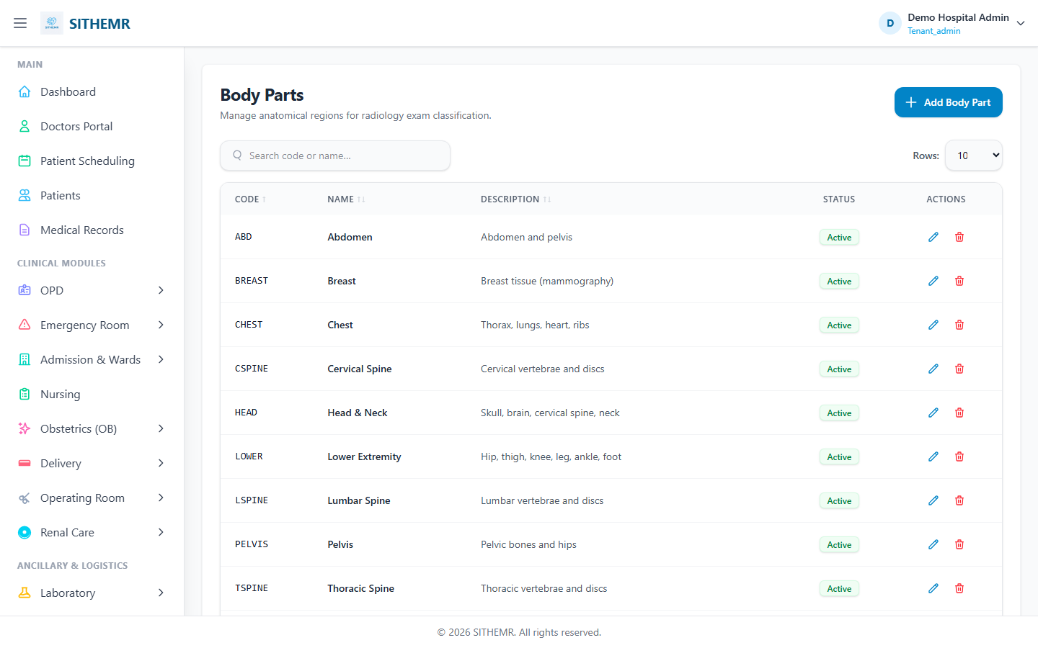
Screenshot: radiology-body-parts-01-list.png

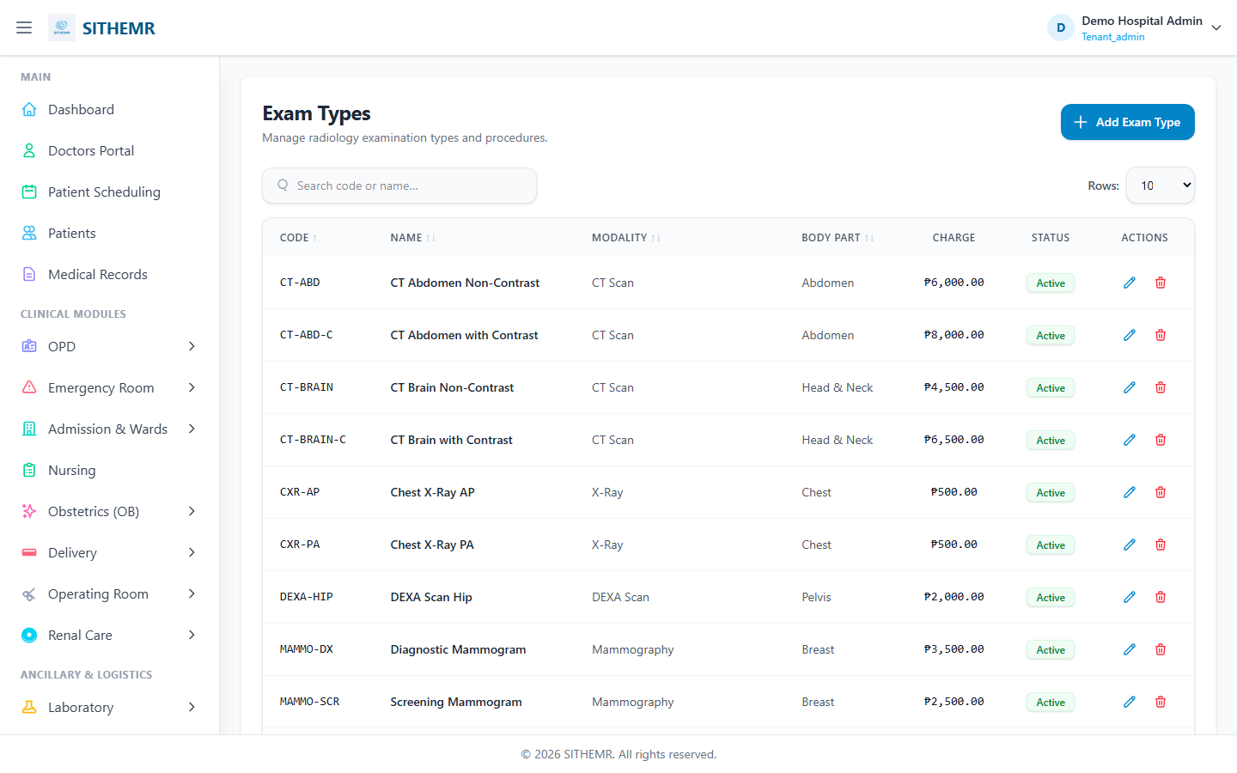
Screenshot: radiology-exam-types-01-list.png

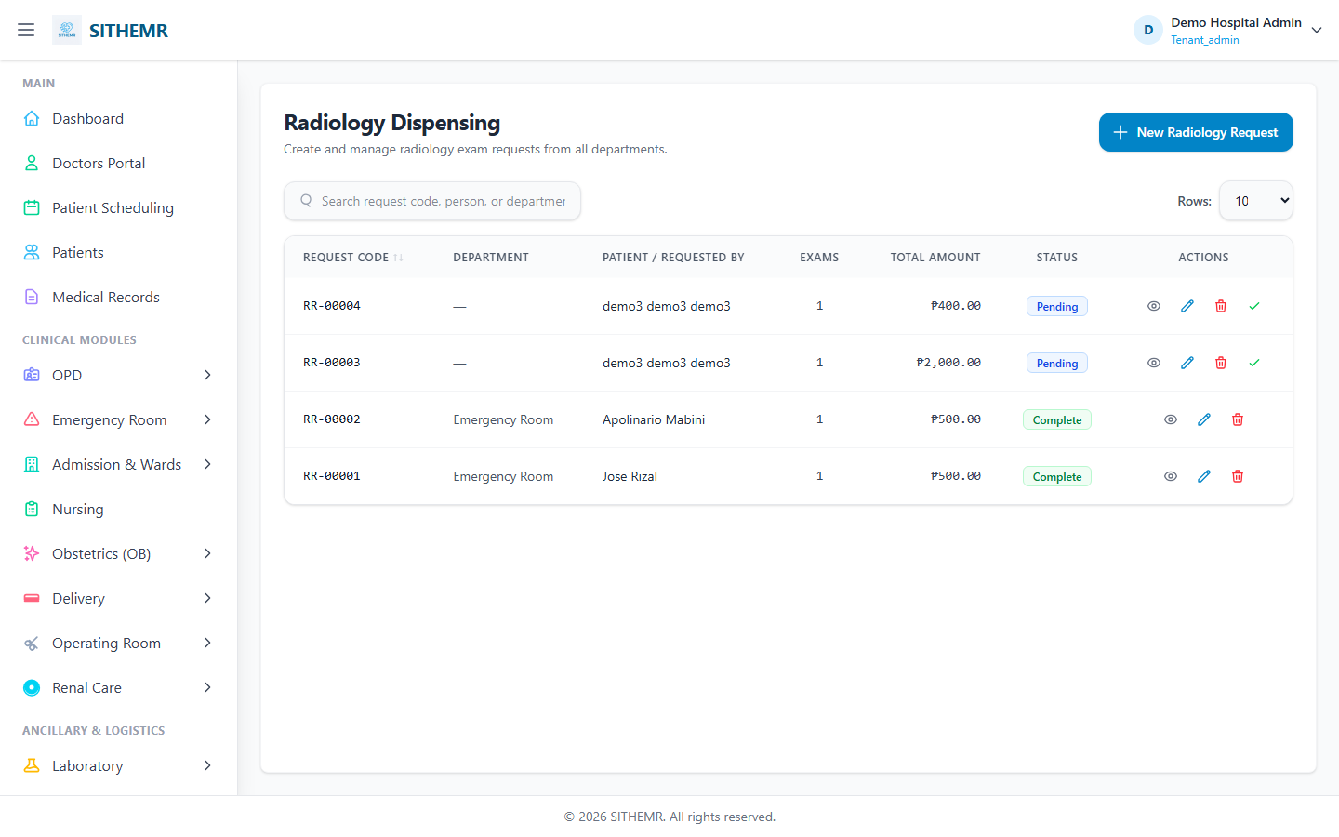
Screenshot: radiology-dispensing-01-list.png

Route prefix: /radiology. Manages radiology imaging: master data, exam ordering, image acquisition, results entry, radiologic technologist workflow, and DICOM/PACS integration. Core components: modalities, body parts, exam types, radiology requests/items, radiology results, and dispensing.

10.1 Radiology Master Data (Complete Reference)

10.1.1 Radiology > Modalities
Route: radiology.modalities (permission: radiology.manage). Imaging modalities: X-Ray, Ultrasound (US), Computed Tomography (CT Scan), Magnetic Resonance Imaging (MRI), Fluoroscopy, Mammography, Nuclear Medicine, PET Scan, Interventional Radiology, etc. Fields: id, name, code, description, room_number (optional), is_active, tenant_id, history, audit columns.

10.1.2 Radiology > Body Parts
Route: radiology.body-parts (permission: radiology.manage). Anatomical body parts/regions examined: Head, Face, Neck, Chest, Abdomen, Pelvis, Spine (Cervical/Thoracic/Lumbar), Upper Extremity (Left/Right), Lower Extremity (Left/Right), etc. Fields: id, name, code, description, parent_body_part_id (for hierarchical parts), is_active, tenant_id, history, audit columns. Body parts are used to categorize exam types.

10.1.3 Radiology > Exam Types
Route: radiology.exam-types (permission: radiology.manage). Radiology exam types. Each exam type belongs to a modality and a body part, and defines the exam's properties and charges. Fields: id, modality_id (FK to radiology_modalities), body_part_id (FK to radiology_body_parts), exam_name, exam_code, description, standard_charge (float), is_coding_required (bool), isoc_clinical_indication_required (bool), premium_service (bool), is_active, tenant_id, history, audit columns.
- Examples: X-Ray Chest PA (Chest X-Ray), X-Ray Abdomen Supine, Ultrasonography Abdomen Complete, CT Brain Plain, CT Chest with Contrast, MRI Brain Plain, MRI Lumbar Spine, Mammography Bilateral.
- Each exam has a standard_charge for billing, modality, body part, and optional clinical indication requirement.
- Exam types are ordered via RadiologyRequest + RadiologyRequestItem from OPD/ER/inpatient.

10.2 Radiology Request and Results Workflow

10.2.1 RadiologyRequest Model
- id - Primary key.
- tenant_id - FK to hospitals.id.
- radiology_request_code - Code: 'Rad-' + 5-digit sequence (e.g. Rad-00001). Generated by placeRadiologyOrder().
- opd_consultation_id - FK to opd_consultations.id (nullable).
- er_admission_id - FK to er_admissions.id (nullable).
- admission_id - FK to admissions.id (nullable).
- patient_id - FK to patients.id.
- requesting_department_id - FK to departments.id.
- requesting_person - String. Name of the person requesting (doctor or staff).
- requesting_doctor_id - FK to health_care_professionals.id.
- clinical_indication - Text (nullable). Clinical reason for the exam (required for ICSC-compliant exams).
- priority - String: Stat, Urgent, Routine. Default 'Routine'.
- status - Request status: Pending, Scheduled, In Progress, Completed, Results Ready, Reported, Cancelled.
- exam_type_id - FK to radiology_exam_types (set when exam is scheduled/completed).
- technologist_id - FK to health_care_professionals.id (nullable). The rad tech who performed the exam.
- radiologist_id - FK to health_care_professionals.id (nullable). The radiologist who interpreted the study.
- exam_datetime - DateTime (nullable). When the exam was performed.
- total_charge - Float. Sum of exam charges.
- created_by / created_date - Audit columns.
- updated_by / updated_date - Audit columns.
- history - Soft delete flag (1=active).
- is_active - Active flag.

10.2.2 RadiologyRequestItem Model
- id - Primary key.
- radiology_request_id - FK to radiology_requests.id.
- exam_type_id - FK to radiology_exam_types.
- exam_name - String. Denormalized exam name.
- modality - String. Denormalized modality name.
- body_part - String. Denormalized body part name.
- charge_amount - Float. Exam's standard_charge at time of order.
- radiologist_findings - Text (nullable, max 10000). The radiologist's interpretation/findings.
- radiology_impression - Text (nullable, max 10000). The radiologist's impression/conclusion.
- is_reviewed - Boolean. Whether the report has been reviewed/finalized.
- reviewed_by - FK (nullable).
- reviewed_date - DateTime (nullable).
- created_by / created_date - Audit columns.
- updated_by / updated_date - Audit columns.

10.2.3 Placing a Radiology Order
From OPD/ER/Inpatient (placeRadiologyOrder). See 6.5.4 and 7.6 for full flow. Summary:
- Doctor selects exam types from the radiology catalog.
- For each selected exam: RadiologyRequestItem created with exam_type_id, exam_name, modality, body_part, charge_amount.
- RadiologyRequest created with request_code = 'Rad-' + 5-digit sequence, status = 'Pending'.
- Clinical indication can be added for ICSC-compliant exams.
- The request appears in Radiology > Results for the rad tech to schedule/perform.

10.2.4 Radiology Results and Reporting
Route: radiology.results (permission: radiology.result). The radiology results page shows all radiology requests.
- Filters: by status, priority, date range, modality.
- Search by patient name, request code, ordering doctor.
- Status flow: Pending -> Scheduled (exam scheduled for a slot) -> In Progress (exam being performed) -> Completed (exam done, images acquired) -> Results Ready (images available, awaiting radiologist) -> Reported (radiologist has finalized report) -> Cancelled.
- Exam Performance: When the rad tech performs the exam, they set technologist_id, exam_datetime, and advance status to 'Completed'.
- Results Entry: The radiologist enters radiologist_findings (the detailed findings narrative) and radiology_impression (the conclusion). Sets is_reviewed=true, reviewed_by, reviewed_date.
- When findings + impression are entered, status advances to 'Reported'.
- For exams requiring a contrast study, the contrast type, dose, and any adverse reactions can be noted in the findings.

10.3 Printing Radiology Results
Route: radiology.results.print ({radiologyRequest}, permission: radiology.result). Generates a PDF via DomPDF.
- PDF includes: Exam header (request code, patient name, age, sex, status), ordering doctor and department, request date, priority, clinical indication, exam type name, modality, body part, exam date/time.
- Radiologist findings (the detailed interpretation narrative).
- Radiology impression (the conclusion).
- Reported by and report date.
- The PDF serves as the official radiology report for the patient's medical record and doctor review.

10.4 DICOM/PACS API Integration
Route: radiology.dicom (permission: radiology.manage). The application supports DICOM/PACS integration for image management.
- DICOM images acquired by the modalities are stored in the PACS and linked to the radiology request/exam.
- The PACS API allows: registering new studies, linking studies to radiology requests, retrieving image lists for a request, downloading DICOM images, and querying studies by patient, exam date, or modality.
- Image access in the UI: from the radiology results page, the PACS link shows the list of DICOM series for the exam. Users can launch the PACS viewer (web-based DICOM viewer) directly to view the images.
- For modalities without DICOM connectivity, image files can be manually uploaded and linked to the exam.
- The DICOM/PACS integration ensures that radiology images are properly archived, linked to the correct patient and exam, and accessible for clinical review and legal medical record purposes.

10.5 Radiology Dispensing (radiology.dispense)
Route: radiology.dispensing (permission: radiology.dispense). Dispensing radiology supplies/contrast media to procedures. Tracks contrast agents, consumables, and supplies issued for imaging exams.

11. Health Sciences: Pharmacy, CSR, and Procedures
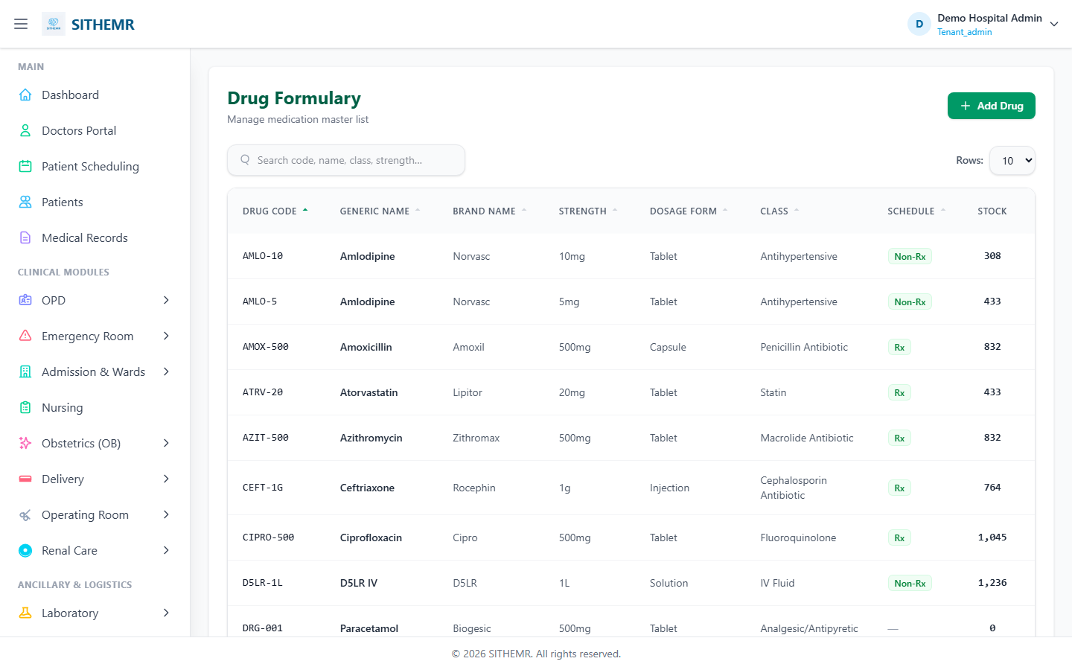
Screenshot: pharmacy-drugs-01-list.png

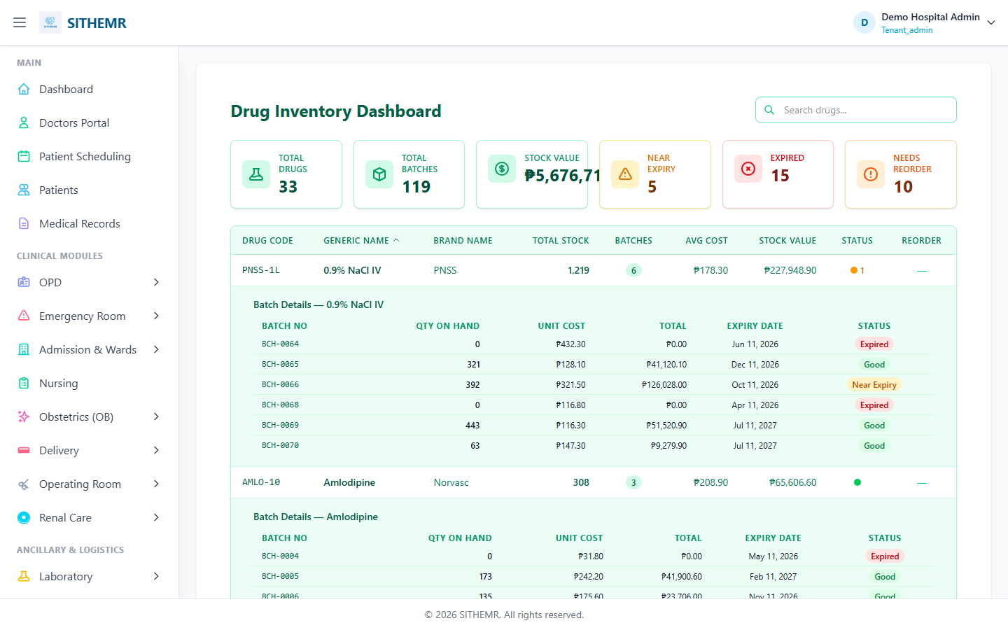
Screenshot: pharmacy-inventory-01-list.png

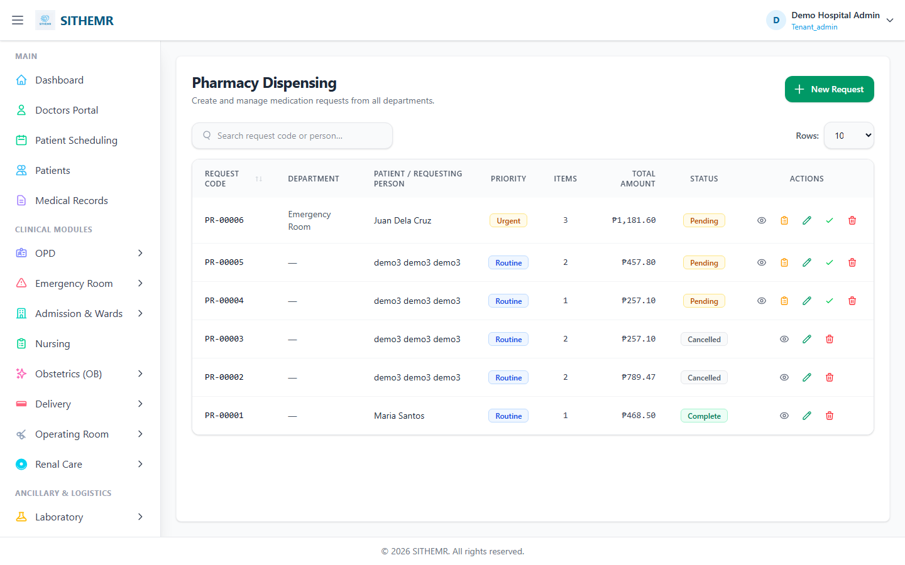
Screenshot: pharmacy-dispensing-01-list.png

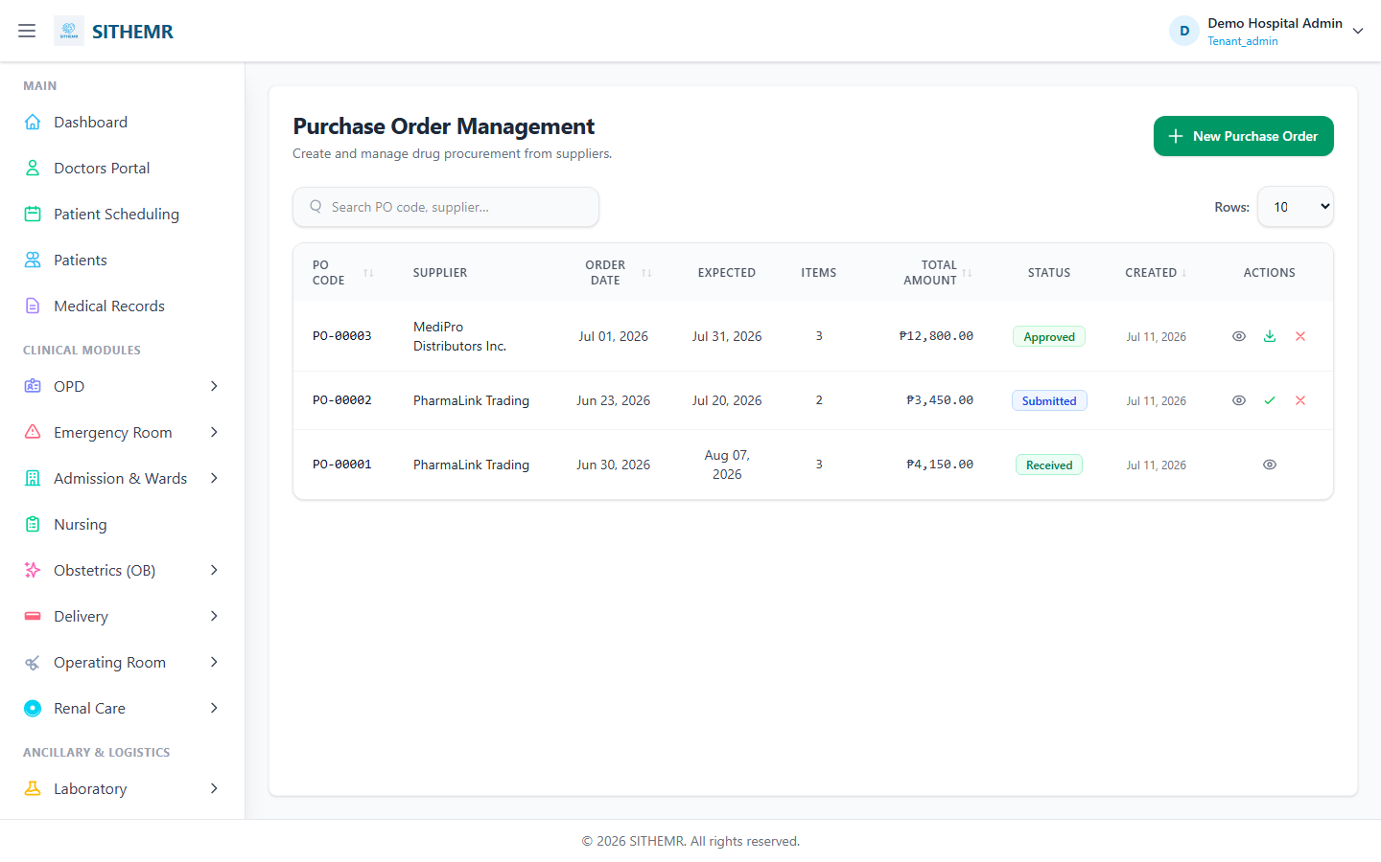
Screenshot: pharmacy-purchase-orders-01-list.png

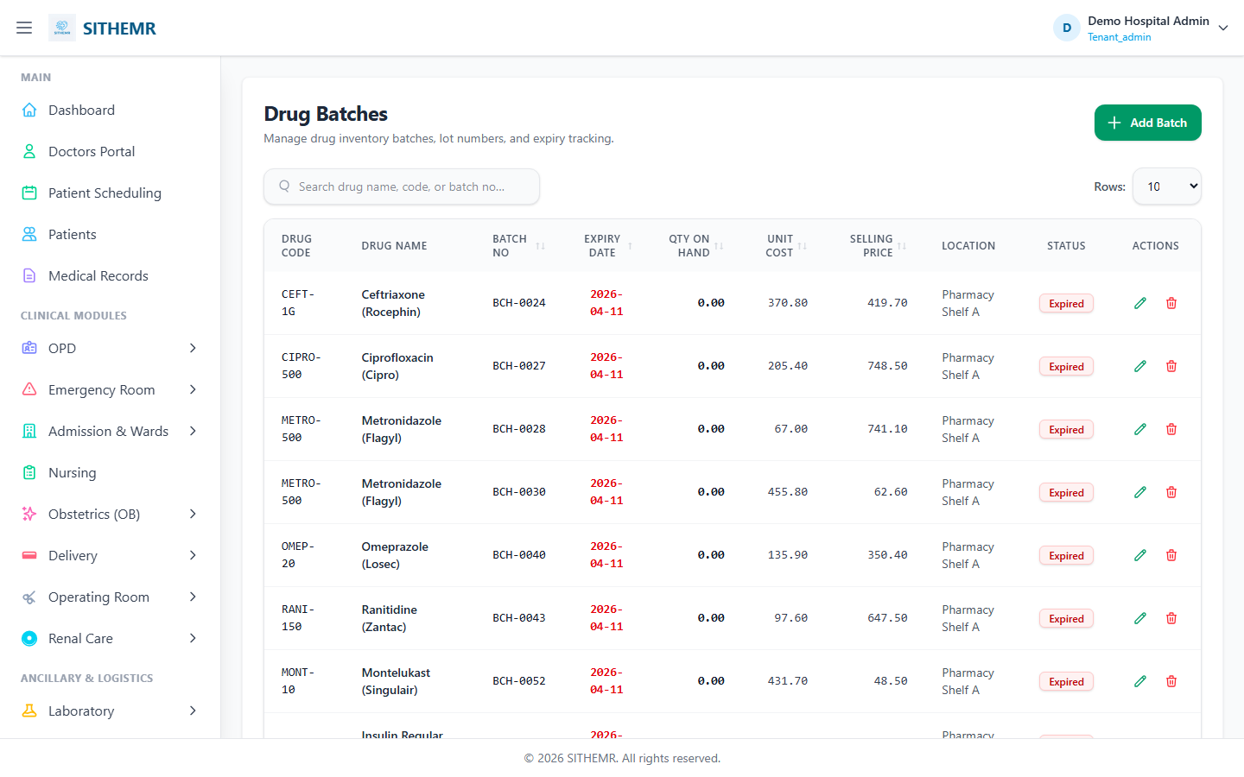
Screenshot: pharmacy-drug-batches-01-list.png

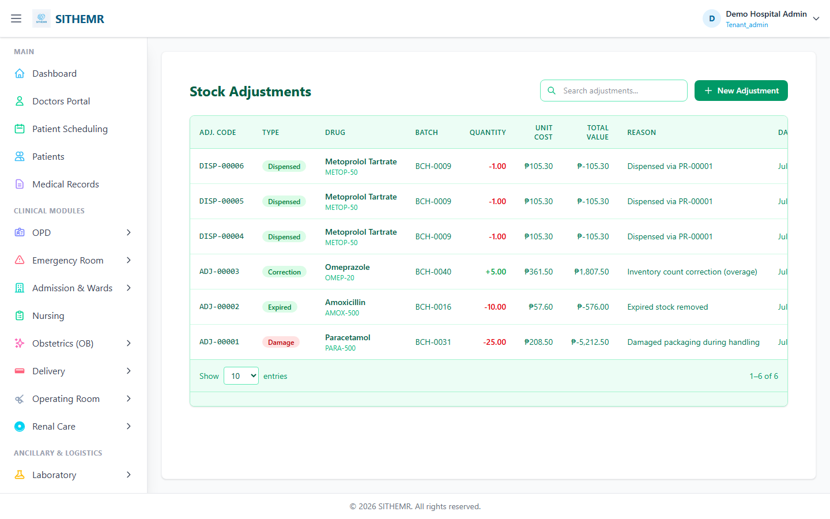
Screenshot: pharmacy-stock-adjustments-01-list.png

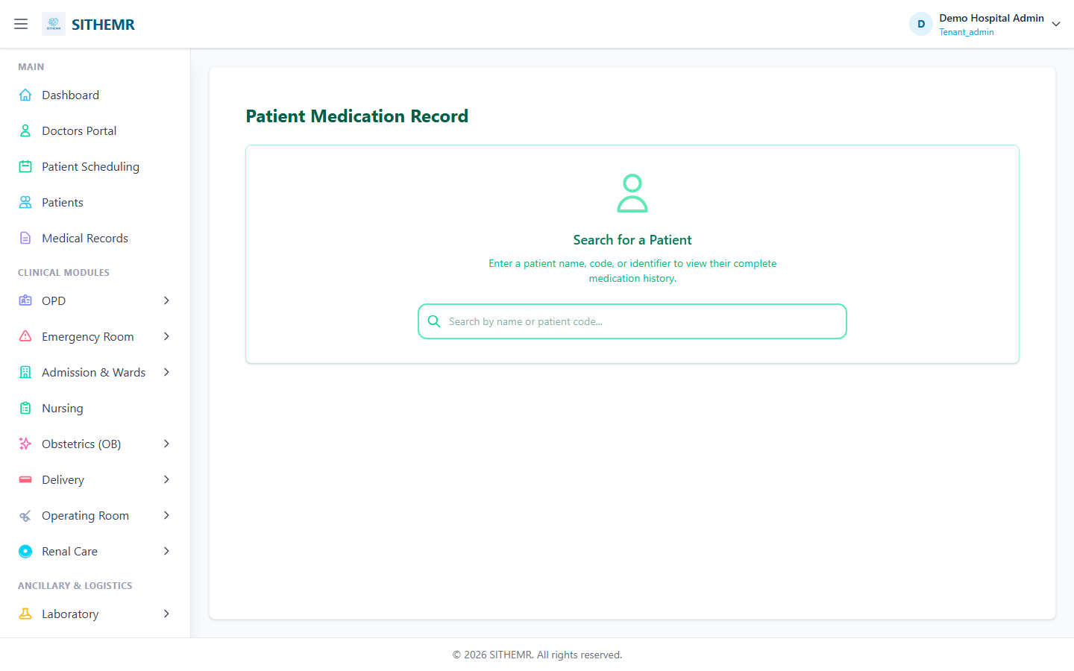
Screenshot: pharmacy-patient-record-01-list.png

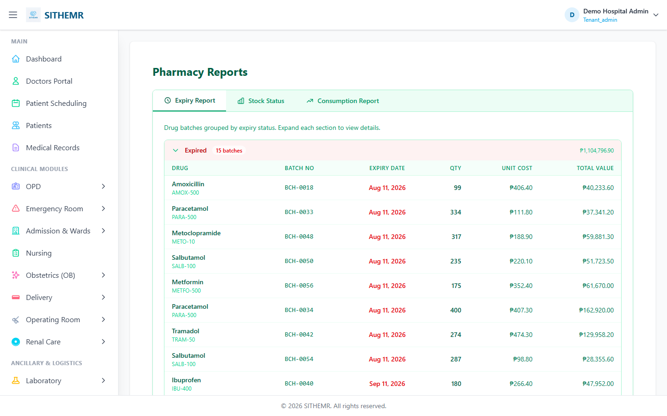
Screenshot: pharmacy-reports-01-list.png

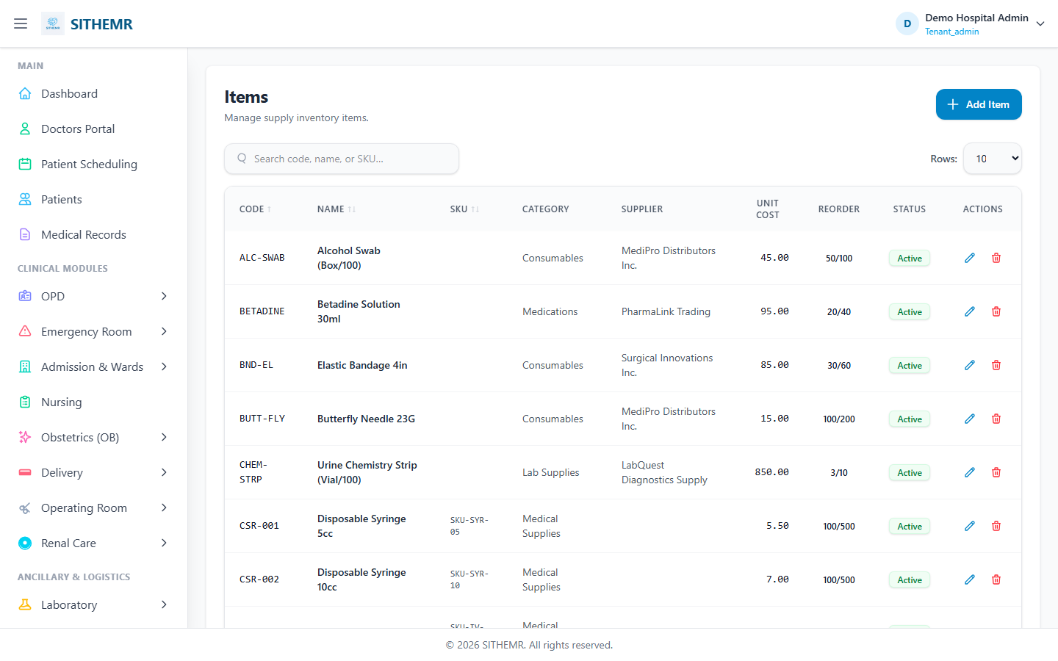
Screenshot: supply-items-01-list.png

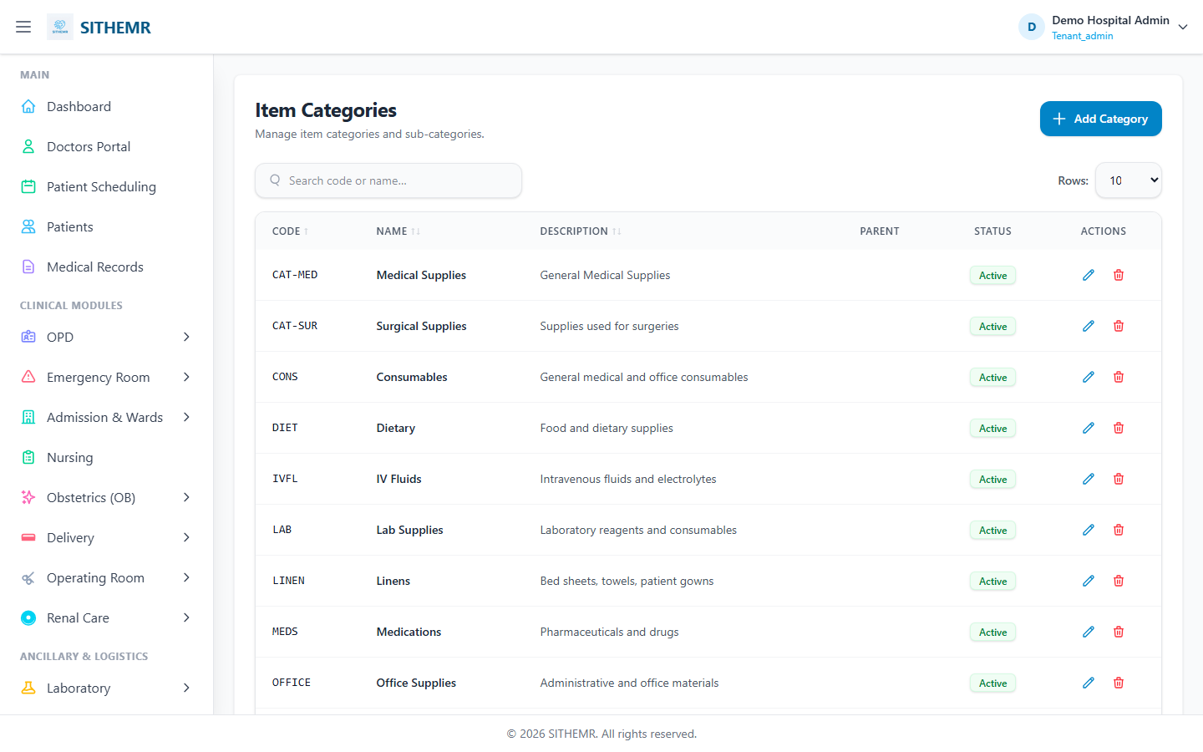
Screenshot: supply-categories-01-list.png

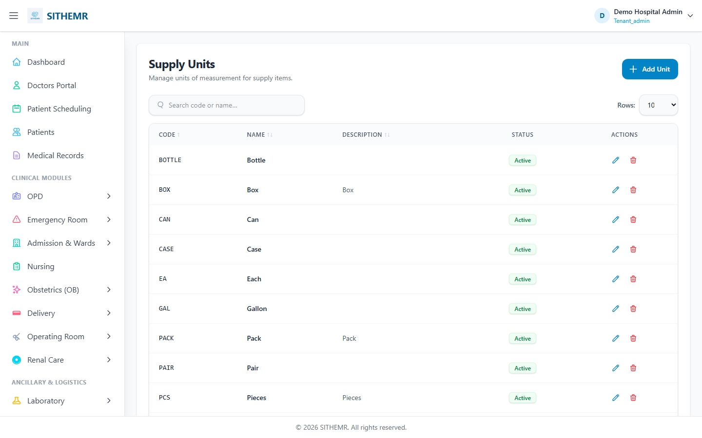
Screenshot: supply-units-01-list.png

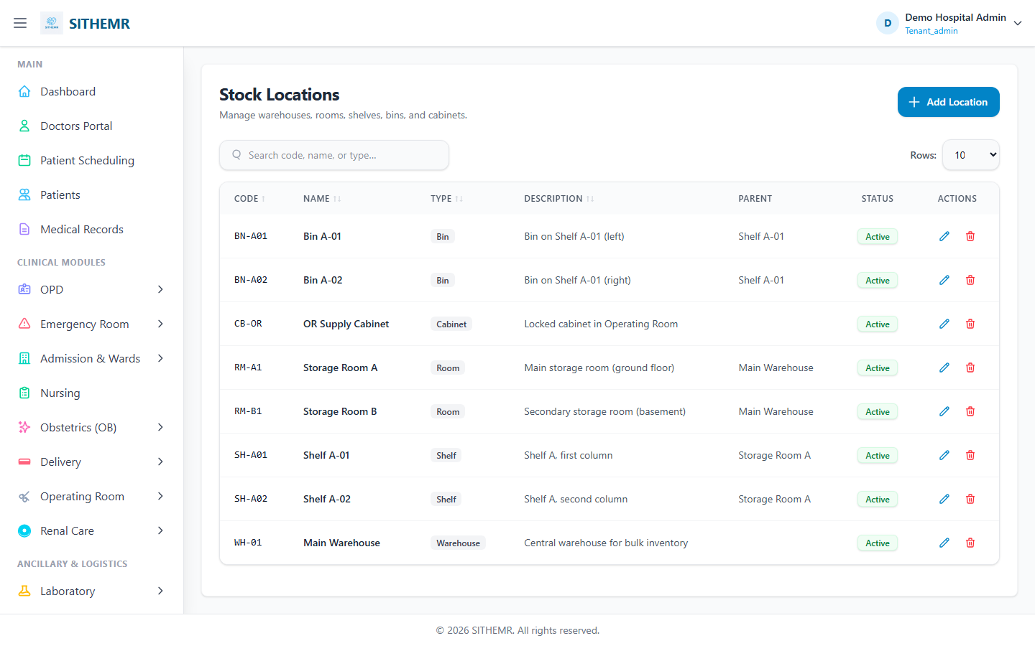
Screenshot: supply-stock-locations-01-list.png

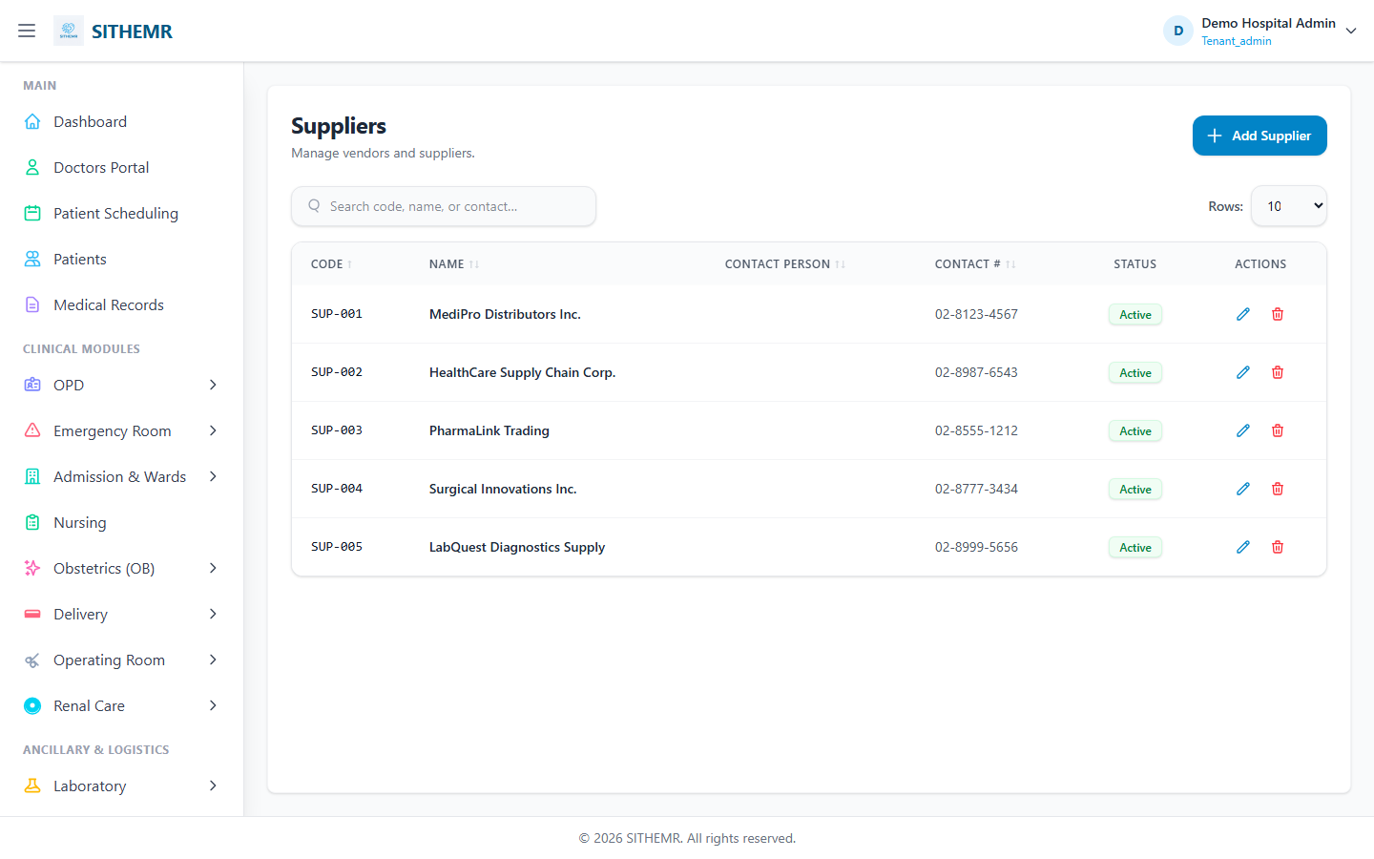
Screenshot: supply-suppliers-01-list.png

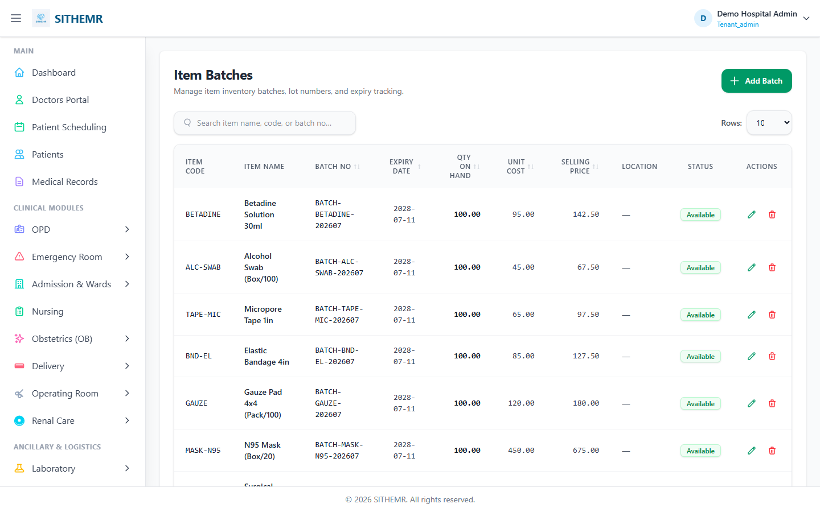
Screenshot: supply-inventory-01-list.png

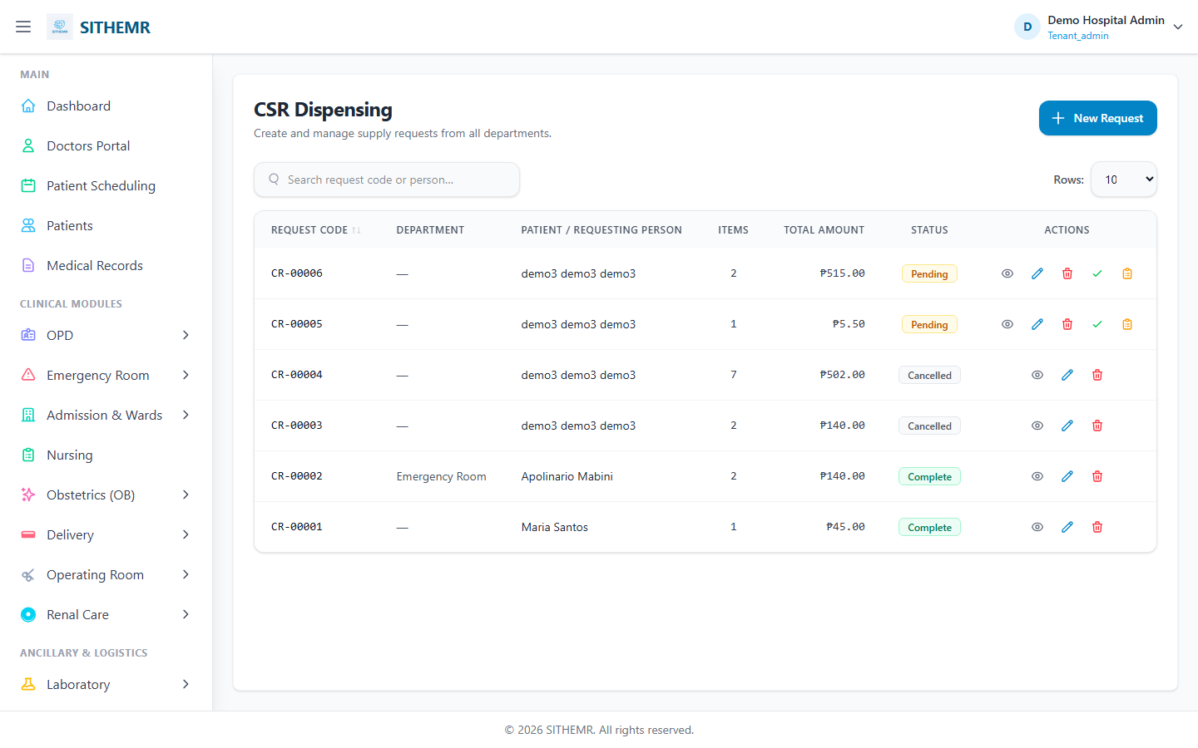
Screenshot: supply-dispensing-01-list.png

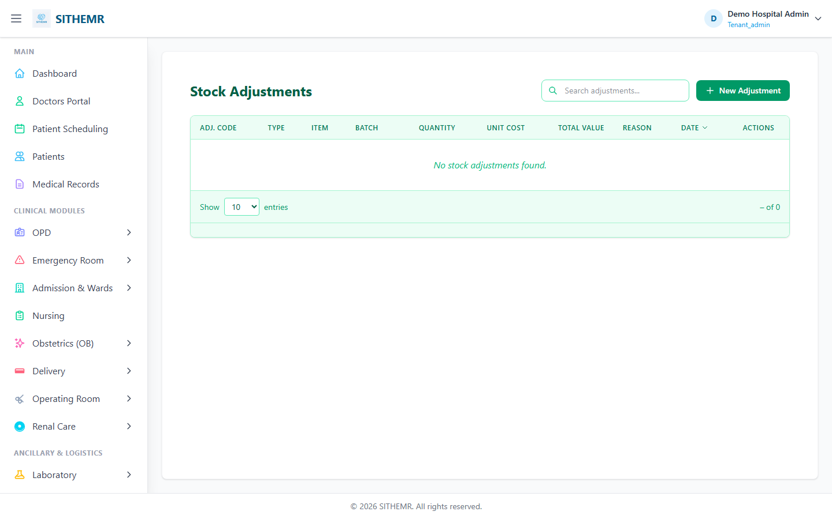
Screenshot: supply-stock-adjustments-01-list.png

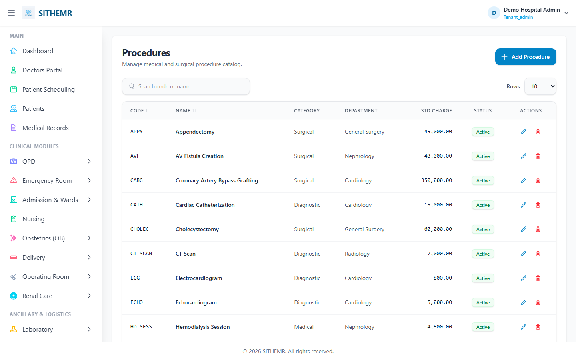
Screenshot: procedure-procedures-01-list.png

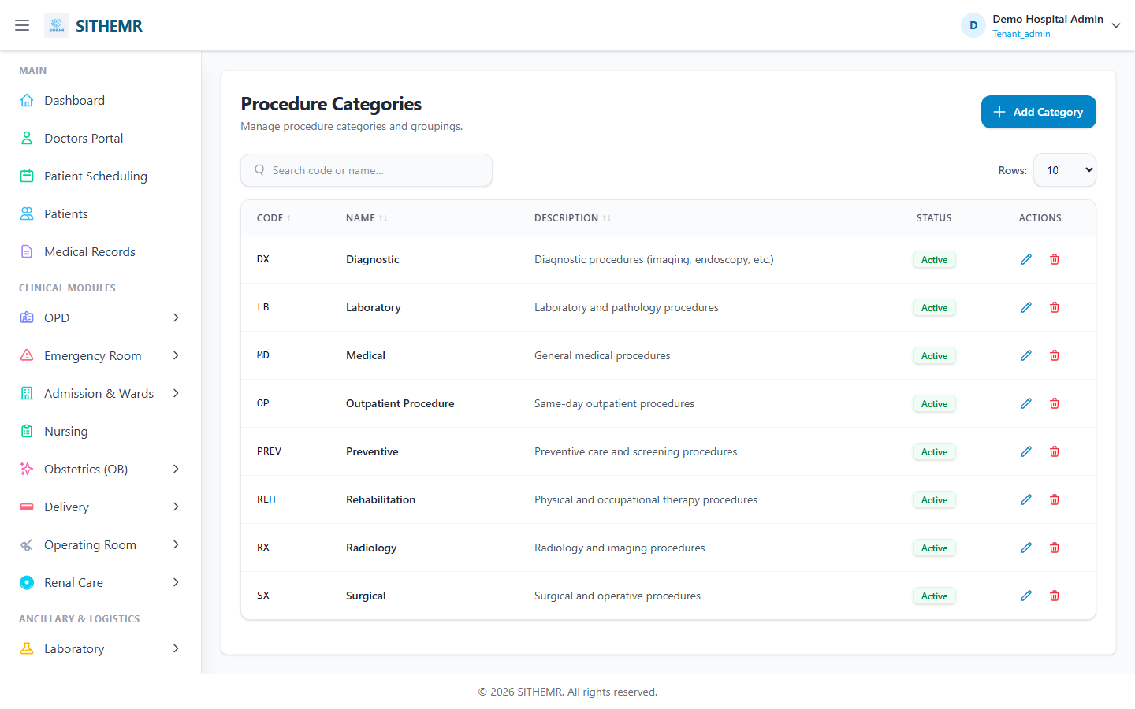
Screenshot: procedure-categories-01-list.png

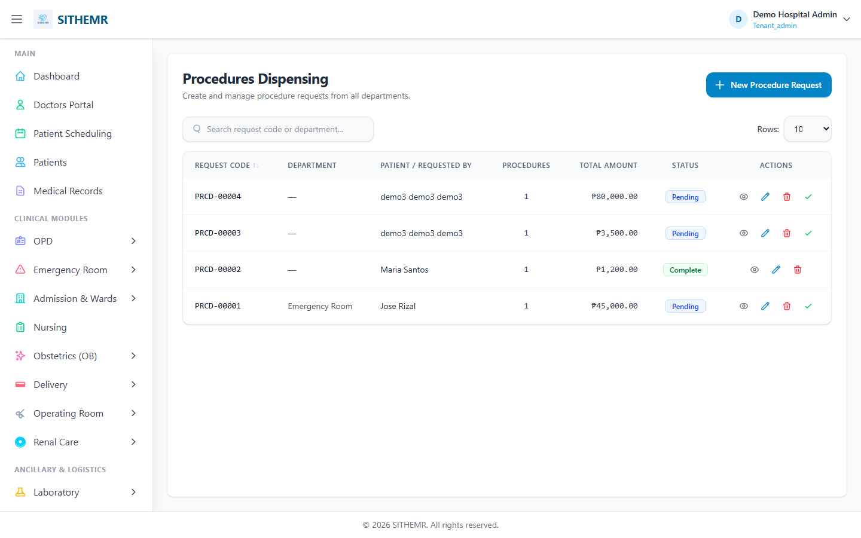
Screenshot: procedure-dispensing-01-list.png

This chapter covers the three health sciences / supply chain modules: Pharmacy (medication management), CSR (Clinical Service Request - medical supplies and equipment), and Procedures (clinical procedures and services). All three share a common order-and-dispense pattern: master data -> order from OPD/ER/inpatient -> items created -> dispensing -> patient medication/supply record -> billing.

11.1 Pharmacy Services (/pharmacy)
Route prefix: /pharmacy. Manages pharmaceutical services: drug master data, drug batch/lot tracking, inventory management, purchase orders, stock adjustments, dispensing to patients, patient medication records (PMR), pharmacy reports, and printing pharmacy requests.

11.1.1 Pharmacy Master Data

11.1.1.1 Pharmacy > Drugs
Route: pharmacy.drugs (permission: pharmacy.manage). Drug/product catalog. Fields: id, drug_name, generic_name, brand_name, drug_category, drug_form (tablet/capsule/syrup/injection/etc.), strength (e.g. 500mg), route (PO/oral, IV, IM, SC, topical, etc.), unit_of_measure (tablet, ml, vial, ampule, box, etc.), standard_charge (float), is_generic (bool), is_controlled (bool - controlled substance requiring extra tracking), supplier_id (FK to supply_suppliers, nullable), is_active, tenant_id, history, audit columns. Drugs are ordered via PharmacyRequest from OPD/ER/inpatient.

11.1.1.2 Pharmacy > Drug Batches
Route: pharmacy.drug-batches (permission: pharmacy.manage). Drug batch/lot tracking for inventory management and expiry control. Critical for drug safety (recalls, expiry dating). Fields: id, drug_id (FK to pharmacy_drugs), batch_number, manufacturer, manufacturing_date, expiry_date (critical for expiry alerts), quantity_received, quantity_dispensed, quantity_on_hand, unit_cost, supplier_id, received_date, received_by, is_active, tenant_id, history, audit columns. When a drug is dispensed, the batch quantity is decremented. Expired or near-expiry batches are flagged.

11.1.1.3 Pharmacy > Inventory
Route: pharmacy.inventory (permission: pharmacy.manage). Current inventory position for each drug. Aggregates/display the on-hand quantity across all batches, or a snapshot table. Fields: id, drug_id (FK), total_quantity_on_hand, total_quantity_dispensed, last_count_date, last_counted_by, reorder_level (min stock alert), is_active, tenant_id, history, audit columns. Inventory shows the drug's current availability for dispensing.

11.1.1.4 Pharmacy > Purchase Orders
Route: pharmacy.purchase-orders (permission: pharmacy.manage). Purchase orders to suppliers for drug procurement. Fields: id, po_number (e.g. PO-00001), supplier_id (FK to supply_suppliers), order_date, expected_delivery_date, status (Pending/Ordered/Partially Received/Received/Cancelled), notes, total_amount, created_by, created_date, updated_by, updated_date, history. Each PO has PO items (PharmacyPurchaseOrderItem): drug_id, batch_number (if specific), quantity_ordered, unit_cost, quantity_received, line_total, is_active, history.

11.1.1.5 Pharmacy > Stock Adjustments
Route: pharmacy.stock-adjustments (permission: pharmacy.manage). Inventory adjustments: corrections, damages, losses, returns, returns-to-vendor, donations, stock counts. Fields: id, adjustment_no, drug_id (FK), batch_id (FK, nullable - can adjust specific batch or aggregate), adjustment_type (Stock In, Stock Out, Damage/Loss, Return to Vendor, Correction, Physical Count Adjustment, Expiration Write-off), quantity_before, quantity_after, quantity_adjusted, reason, adjusted_by, adjustment_date, notes, is_active, tenant_id, history, audit columns.

11.1.2 Pharmacy Dispensing Workflow

11.1.2.1 PharmacyRequest Model (Dispensing Order)
- id - Primary key.
- tenant_id - FK to hospitals.id.
- pharmacy_request_code - Code: 'PR-' + 5-digit sequence (e.g. PR-00001).
- opd_consultation_id / er_admission_id / admission_id - Context FKs (one of these is set depending on where the order originated).
- patient_id - FK to patients.id.
- requesting_department_id - FK to departments.id.
- requesting_person - String. Name of person requesting.
- requesting_doctor_id - FK to health_care_professionals.id.
- priority - String: Stat, Urgent, Routine. Default 'Routine'.
- status - Request status: Pending, In Progress, Dispensed, Partially Dispensed, Cancelled.
- notes - Text (nullable).
- created_by / created_date - Audit columns.
- updated_by / updated_date - Audit columns.
- history - Soft delete flag (1=active).
- is_active - Active flag.

11.1.2.2 PharmacyRequestItem Model
- id - Primary key.
- pharmacy_request_id - FK to pharmacy_requests.id.
- drug_id - FK to pharmacy_drugs.id.
- drug_name - String. Denormalized drug name.
- generic_name - String. Denormalized generic name.
- drug_form - String. Denormalized form.
- strength - String. Denormalized strength.
- route - String. Denormalized route.
- quantity - Float. Quantity ordered (default 1, can be any).
- frequency - String (nullable). Dosage frequency: OD (once daily), BID (twice daily), TID (three times daily), QID (four times daily), q4h, q6h, q8h, q12h, STAT, etc. Set per-drug in the order modal (orderPharmacyFrequencies[$drugId]).
- route_admin - String (nullable). Route of administration: PO, IV, IM, SC, SL, Inhalation, Topical, etc. Set per-drug in the order modal (orderPharmacyRoutes[$drugId]).
- duration - String (nullable). Duration of therapy (e.g. '5 days', '3 weeks').
- dose_instructions - Text (nullable). Special dosing instructions.
- charge_amount - Float. Drug's standard_charge.
- batch_id - FK to pharmacy_drug_batches.id (nullable). The specific batch dispensed from (set during dispensing).
- batch_number - String (nullable). Denormalized batch number.
- expiry_date - Date (nullable). Batch expiry (set during dispensing).
- is_dispensed - Boolean. Whether this item has been dispensed.
- dispensed_quantity - Float (nullable). Quantity actually dispensed (may be less than ordered if stock insufficient).
- dispensed_by - FK to users (nullable).
- dispensed_date - DateTime (nullable).
- created_by / created_date - Audit columns.
- updated_by / updated_date - Audit columns.
- history - Soft delete flag (1=active).
- is_active - Active flag.

11.1.2.3 Placing a Pharmacy Order
From OPD (placePharmacyOrder), ER (see 7.6), or directly. Summary:
- Doctor/nurse selects drugs from the pharmacy catalog.
- For each drug: quantity (default 1), frequency (orderPharmacyFrequencies[$drugId]), route (orderPharmacyRoutes[$drugId]) set per-drug.
- PharmacyRequest created with request_code = 'PR-' + 5-digit sequence, status = 'Pending'.
- PharmacyRequestItems created for each drug with drug details, quantity, frequency, route, charge_amount.
- Founded drugs can optionally be linked to a batch at order time or at dispense time.
- The request appears in Pharmacy > Dispensing for the pharmacist to process.

11.1.2.4 Dispensing (pharmacist workflow)
- Pharmacist reviews the pending PharmacyRequest and its items.
- For each item: selects the batch to dispense from (batch_id), verifies expiry date, enters dispensed_quantity (may be less than ordered if stock unavailable - partial dispense).
- When all items are dispensed: status becomes 'Dispensed'. If only some items dispensed: 'Partially Dispensed'.
- dispensed_by and dispensed_date are set for each item.
- Batch quantities are decremented (quantity_dispensed incremented, quantity_on_hand decremented).
- The patient's medication record (PMR) is updated (see 11.1.3).

11.1.3 Patient Medication Record (PMR)
Route: pharmacy.pmr (permission: pharmacy.view). The PMR shows ALL medications a patient has been prescribed and dispensed across all encounters (OPD, ER, inpatient). This is the patient's medication history.
- View by patient: select patient, see all medication orders (pharmacy requests) with their items, frequencies, routes, dates, and dispensing status.
- Each medication entry shows: drug name, generic name, form, strength, route, frequency, quantity, duration, start date, end date (computed from frequency x duration), dispensing status, prescribing doctor.
- The PMR is used for medication reconciliation (checking for drug interactions, allergies, duplicate therapy).
- PMR is the pharmacy counterpart to the patient chart's medication history.

11.1.4 Pharmacy Reports
Route: pharmacy.reports (permission: pharmacy.reports). Pharmacy reports: drug dispensing report (by drug, by period), inventory status report, expiry report (drugs expiring within X days), purchase order status report, top selling drugs, stock adjustment report.

11.1.5 Printing Pharmacy Requests
- pharmacy.request.print ({pharmacyRequest}) - Prints the pharmacy request/form with all items, quantities, frequencies, routes, charges. Used by pharmacist as dispensing worksheet.
- pharmacy.request.encounter-print ({opdConsultationId}) - Prints all pharmacy requests for a given OPD encounter on one page. Consolidated dispensing list for the encounter.

11.2 CSR / Medical Supply (Clinical Service Request)
Route prefix: /supply. The CSR module manages medical supplies, equipment, and non-pharmaceutical consumables. 'CSR' stands for Clinical Service Request - the supply chain module that handles issuance of medical supplies to patients/departments. Pattern identical to pharmacy: master data -> order -> dispense -> record -> print.

11.2.1 CSR Master Data
- Supply > Units (supply.units) - Units of measure: pcs, box, pack, set, roll, sheet, pair, each, etc.
- Supply > Categories (supply.categories) - Supply categories: Surgical Supplies, Dressing & Wound Care, IV Therapy Supplies, Syringes & Needles, PPE (Gloves, Masks, Gowns, Goggles), Respiratory Supplies, Patient Care Supplies, Linen & Textiles, Office/Non-Medical, etc.
- Supply > Suppliers (supply.suppliers) - Supplier/vendor details: name, contact, address, email, phone, tax_id, is_active.
- Supply > Stock Locations (supply.stock-locations) - Physical storage locations: Pharmacy Store, ER Supply Room, Ward 1 Supply, Central Supply, ICU Supply, OR Supply, etc. Fields: id, name, code, description, floor, is_active.
- Supply > Items (supply.items) - Supply item catalog: item_name, generic_name, category_id, unit_id, standard_charge, stock_location_id, reorder_level, is_active. Fields: id, item_name, generic_name, category_id (FK), unit_id (FK), standard_charge (float), stock_location_id (FK to supply_stock_locations), reorder_level (int), is_active, tenant_id, history.
- Supply > Inventory (supply.inventory) - Current stock per item per location: item_id, stock_location_id, quantity_on_hand, quantity_dispensed, last_count_date, last_counted_by, is_active.
- Supply > Stock Adjustments (supply.stock-adjustments) - Same pattern as pharmacy: item_id, stock_location_id, adjustment_type, quantity, reason, adjusted_by, adjustment_date, notes. For stock corrections, damages, expirations, returns.

11.2.2 CSR Order and Dispense Workflow

11.2.2.1 CsrRequest / CsrRequestItem
- CsrRequest: Code 'CR-' + 5-digit sequence. Same context pattern: opd_consultation_id, er_admission_id, admission_id, patient_id, requesting_department_id, requesting_person, priority (default 'Routine'), status (Pending/In Progress/Dispensed/Partially Dispensed/Cancelled), notes, audit columns.
- CsrRequestItem: csr_request_id, item_id (FK to supply_items), item_name, category, unit, quantity (orderCsrQuantities[$itemId]), notes, charge_amount, is_dispensed, dispensed_quantity, dispensed_by, dispensed_date, batch/lot info (if applicable).
- Order flow (placeCsrOrder): doctor/nurse selects items, quantities set per-item, request + items created with 'CR-' code, status 'Pending'.
- Dispense flow: CSR/warehouse officer reviews request, dispenses quantities from stock location inventory, decrements inventory, marks items as dispensed, advances status to 'Dispensed' or 'Partially Dispensed'.
- CSR items don't have frequency/route (unlike pharmacy) - they are consumable supplies.

11.2.3 Printing CSR Requests
- supply.request.print ({csrRequest}) - Prints CSR request/form with items, quantities, charges.
- supply.request.encounter-print ({opdConsultationId}) - Consolidated CSR requests for an encounter.

11.3 Procedures Module
Route prefix: /procedures. Manages clinical procedures/services: procedure categories and procedures catalog, ordering, and dispensing of procedural services.

11.3.1 Procedure Master Data
- Procedures > Categories (procedures.categories) - Procedure categories: Surgical, Medical, Diagnostic, Therapeutic, Obstetric, Anesthesia, Endoscopy, Cardiac Catheterization, Hemodialysis, etc. Fields: id, name, code, description, is_active, tenant_id, history, audit columns.
- Procedures > Procedures (procedures.procedures) - Procedure catalog. Each procedure: name, code, category_id (FK), description, standard_charge (float), is_active, tenant_id, history, audit columns. Examples: Incision & Drainage, Suture Removal, Wound Debridement, Cast Application, ECG (12-lead), Nebulization, IV Cannulation, Urinary Catheterization, Foley Catheterization, Blood Transfusion (Packed RBC), Oxygen Therapy, Nebulization with Salbutamol, etc.
- Procedures are ordered via ProcedureRequest from OPD/ER/inpatient and dispensed when performed.

11.3.2 Procedure Request/Dispense Workflow
- ProcedureRequest: Code 'Proc-' + 5-digit sequence. Same context pattern (opd_consultation_id, er_admission_id, admission_id, patient_id, requesting_department_id, requesting_person, priority, status).
- ProcedureRequestItem: procedure_request_id, procedure_id (FK to procedures_procedures), procedure_name, category, standard_charge, quantity (orderProcedureQuantities[$procedureId] - usually 1 for procedures), notes, is_dispensed (performed), dispensed_by, dispensed_date, duration (minutes, if applicable).
- Order flow (placeProcedureOrder): doctor selects procedures, quantities set per-procedure, request + items created with 'Proc-' code, status 'Pending'.
- Dispense flow: procedure is performed (nurse/therapist/technician performs it), items marked as dispensed (is_dispensed=true), dispensed_by/dispensed_date set, status advances.
- Procedure orders integrate with billing (charge_amount flows to billing) and OR scheduling (for surgical procedures - can link to OR schedule).
- There is no procedures.print route shown in the current page listing (only procedures categories and procedures CRUD + dispensing).

12. Billing and Payments
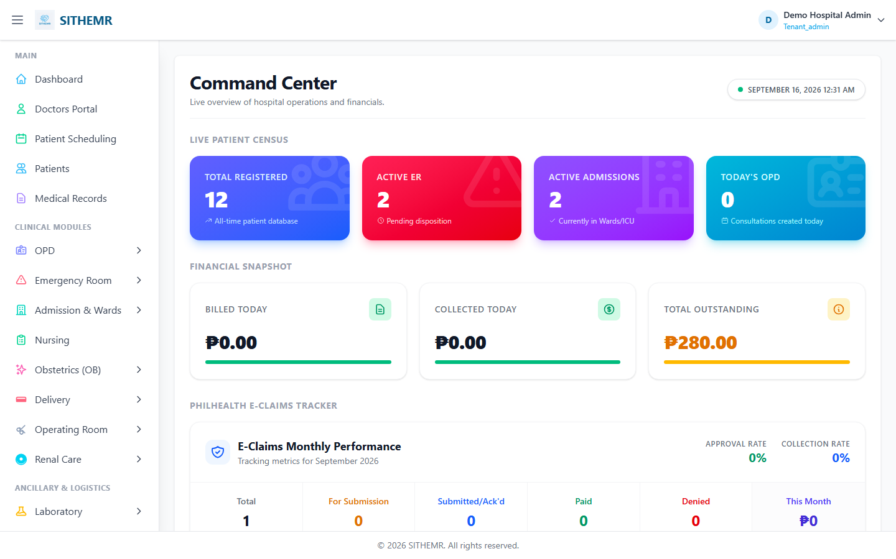
Screenshot: billing-01-list.png

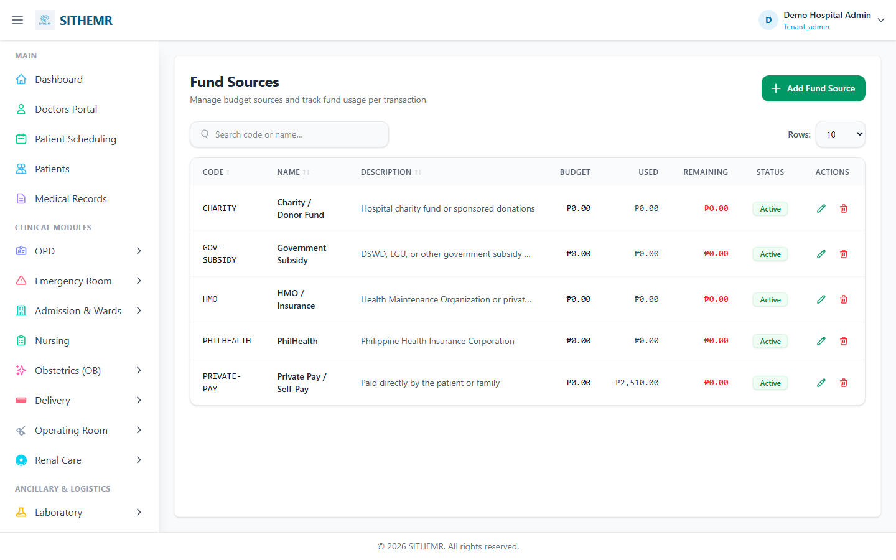
Screenshot: billing-fund-sources-01-list.png

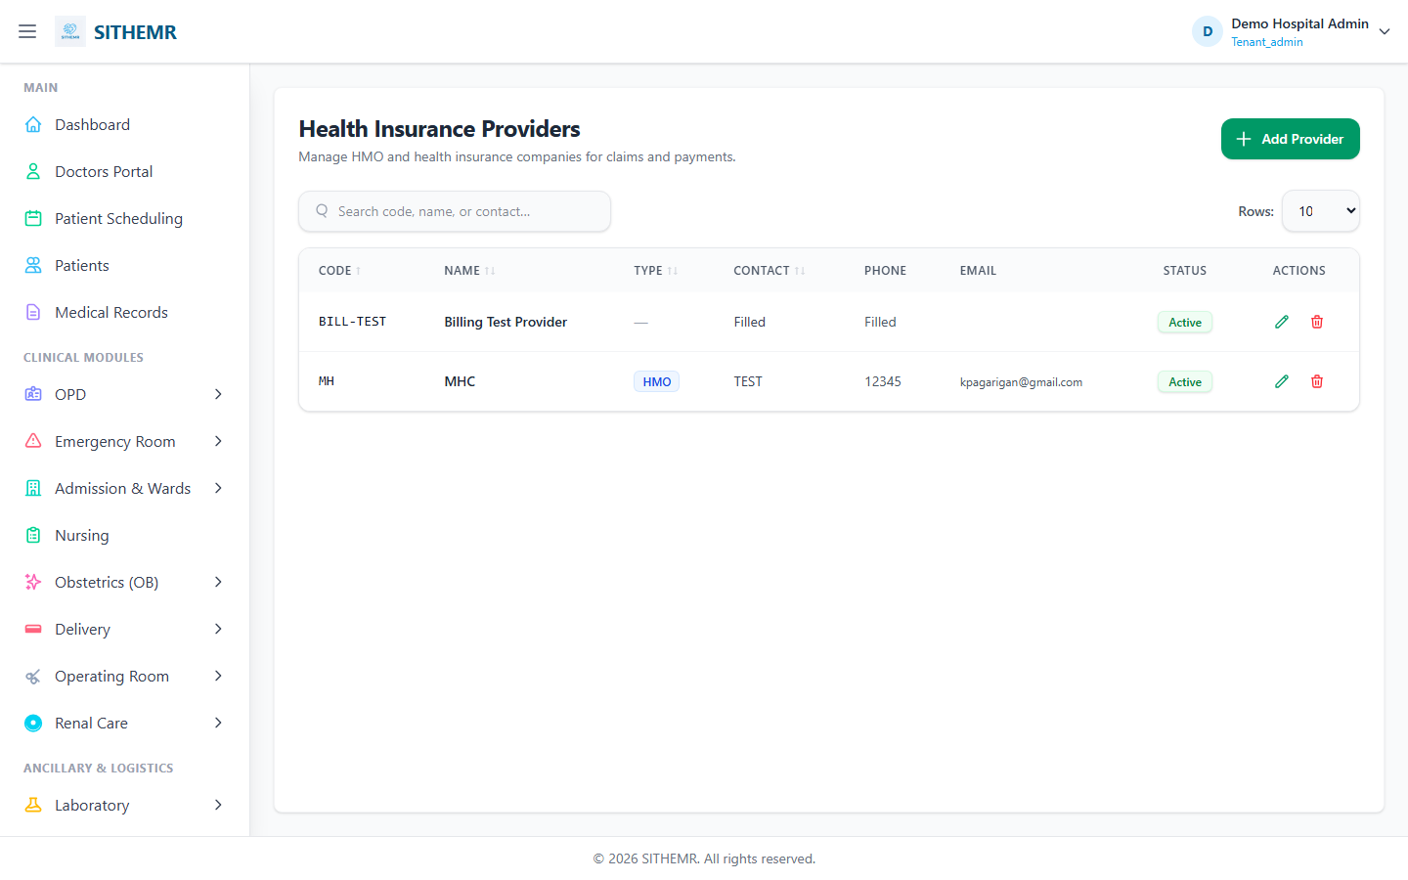
Screenshot: billing-insurance-providers-01-list.png

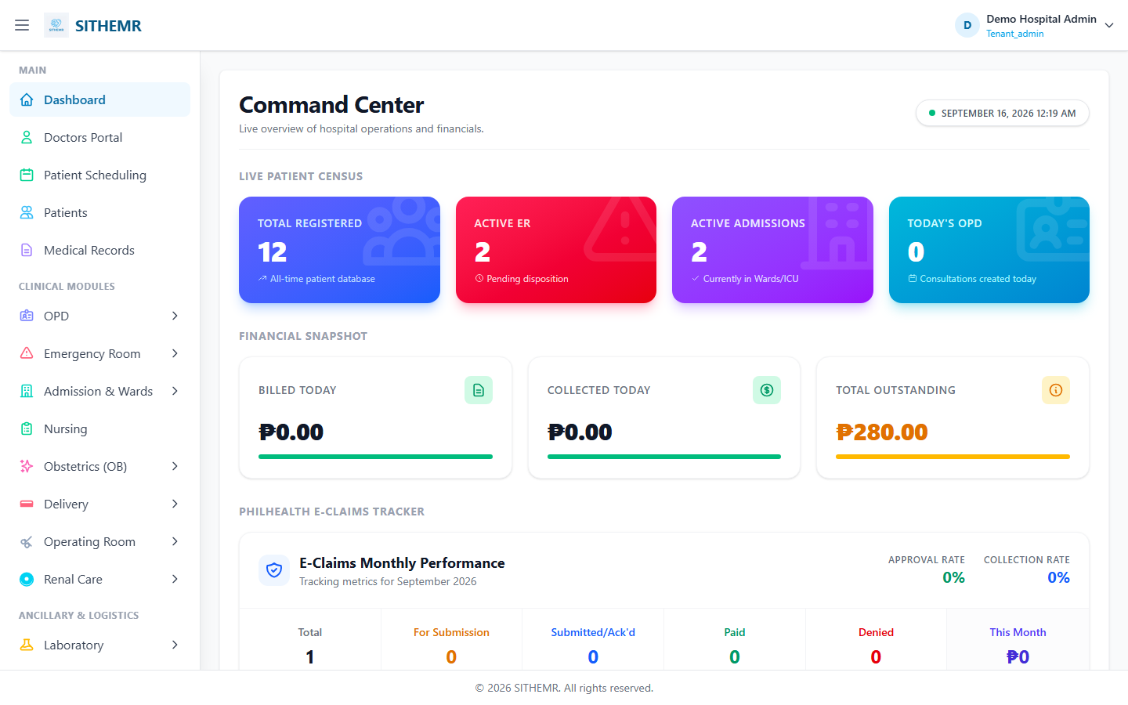
Screenshot: dashboard-01-list.png

Route prefix: /billing. Manages patient financial accounts: invoices, billing line items, payments, discounts, fund sources, insurance providers, and document printing (invoice, payment receipt, statement of account). Core component: BillingCrud (Livewire, massive with 2109 lines of code).

12.1 Billing Model (Complete Reference)

12.1.1 BillingInvoice Model
- id - Primary key.
- tenant_id - FK to hospitals.id.
- invoice_code - Code: 'INV-' + 5-digit sequence (e.g. INV-00001). Generated by generateInvoiceCode($tid): finds last BillingInvoice for tenant, parses numeric after 'INV-', increments, pads to 5 digits. 'INV-00001' if no existing invoice.
- patient_id - FK to patients.id. The patient being billed.
- bill_date - Date. Invoice date. Defaults to today (Y-m-d).
- due_date - Date. Payment due date.
- subtotal_services - Float. Sum of service charges (lab + pharmacy + CSR + radiology + procedure + manual charges).
- discount_type - String: 'percentage' or 'fixed' (nullable).
- discount_value - Float (nullable). The discount percentage or fixed amount.
- discount_amount - Float. Computed discount amount.
- total_amount - Float. Subtotal - discount + any other adjustments.
- paid_amount - Float. Total payments received against this invoice.
- balance - Float. Total - paid_amount. If <=0, status = 'Paid'.
- status - Invoice status: Unpaid, Partial, Paid, Overpaid, Cancelled, Write-Off, Doubtful, Provision, Suspense.
- payment_terms - String (nullable). e.g. 'Cash', 'Installment', 'PhilHealth', 'HMO', 'Insurance'.
- remarks - Text (nullable).
- created_by / created_date - Audit columns.
- updated_by / updated_date - Audit columns.
- history - Soft delete flag (1=active).
- is_active - Active flag.

12.1.2 BillingLineItem Model
- id - Primary key.
- tenant_id - FK to hospitals.id.
- billing_invoice_id - FK to billing_invoices.id.
- patient_id - FK to patients.id.
- line_item_code - Line item code (e.g. LI-00001).
- line_type - String: 'Service' (lab/pharmacy/CSR/radiology/procedure order charges), 'Manual Charge' (manual charge entries), 'Fund Source Disbursement' (fund source payment allocations).
- description - String. Description of the charge.
- quantity - Float (default 1).
- unit_price - Float. Price per unit.
- total_amount - Float. Quantity x unit_price (or just unit_price for services).
- source_type - String (nullable). The source of this line item: 'LabRequest', 'PharmacyRequest', 'CsrRequest', 'RadiologyRequest', 'ProcedureRequest', 'ManualCharge', 'FundSource'.
- source_id - FK (nullable). ID of the source record (e.g. lab_request_id, pharmacy_request_id, etc.).
- is_billed - Boolean. Whether this line item has been billed to an invoice.
- billed_invoice_id - FK (nullable). The invoice this line item was billed to.
- created_by / created_date - Audit columns.
- updated_by / updated_date - Audit columns.
- history - Soft delete flag (1=active).
- is_active - Active flag.

12.1.3 BillingPayment Model
- id - Primary key.
- tenant_id - FK to hospitals.id.
- payment_code - Code: 'PAY-' + 5-digit sequence.
- patient_id - FK to patients.id.
- invoice_id - FK to billing_invoices.id (nullable - can be a direct payment not linked to a specific invoice).
- payment_date - Date. Date payment was received.
- payment_amount - Float.
- payment_method - String: Cash, Check, Credit Card, Debit Card, PhilHealth, HMO/Insurance, Bank Transfer, etc.
- reference_no - String (nullable). Check number, transaction reference, etc.
- payment_by - String. Name of person who paid (patient, guarantor, HMO, etc.).
- receipt_no - String (nullable). Generated receipt number.
- payment_notes - Text (nullable).
- received_by - FK to users/HCPs (nullable).
- created_by / created_date - Audit columns.
- updated_by / updated_date - Audit columns.
- history - Soft delete flag (1=active).
- is_active - Active flag.

12.2 Billing Dashboard (BillingCrud UI)
The BillingCrud Livewire is a large component (2109 lines) that serves as the billing dashboard, invoice creation interface, patient account ledger, and payment recording interface - all in one view with tabs.

12.2.1 Dashboard / Summary Tab
- Shows billing summary: total outstanding balance, total paid this period, total new invoices this period, aging analysis (current, 1-30 days, 31-60 days, 61-90 days, >90 days).
- Can be filtered by date range, payment status, patient.
- Quick summary cards for at-a-glance financial position.

12.2.2 Patient Search and Selection
- Patient search: autocomplete search by name, patient_code, PhilHealth number.
- Select patient to load their account.
- When patient selected: unbilled_services loads (requests with status that can be billed), staging_manual_charges loads (pending manual charges for this patient).
- The unbilled_services are the line items available to bill: LabRequest items with charge_amount, PharmacyRequest items, CSRRequest items, RadiologyRequest items, ProcedureRequest items, plus any manual charges.

12.2.3 Creating an Invoice (saveInvoice)
- Select patient from search.
- Select which unbilled services to include (selectedServiceItems array - multiple selection from unbilled_services).
- Optionally add manual charges (see 12.6) - these appear in staging_manual_charges.
- Set invoice date (bill_date, default today), due date.
- Set payment terms if applicable.
- Discount: see 12.5 for discount logic.
- Click Save Invoice.
- saveInvoice() creates the BillingInvoice with generated invoice_code, computes subtotal_services (sum of selected line items total_amount + manual charges), applies any entered discount (though on save, the discount is applied via saveInvoiceDiscount separately), sets status based on paid_amount (initially 0, so status = 'Unpaid').
- Creates BillingLineItems for each billed service/charge with line_type, description, quantity, unit_price, total_amount, source_type/source_id linking back to the original request/charge.
- Marks source items as is_billed=true (prevents double-billing).
- The invoice is now created and appears in the invoices list.

12.3 Patient Account Ledger (viewAccount)
When viewing a patient's account (viewAccount), the BillingCrud shows:
- All invoices for the patient (billed and unbilled charges).
- All payments made by the patient.
- Running balance: total charges - total payments.
- Current status: whether the patient has outstanding balance.
- Invoice list with: invoice_code, bill_date, due_date, subtotal, discount, total, paid, balance, status.
- Payment list with: payment_code, payment_date, amount, method, reference_no, receipt_no.
- The ledger is the patient's complete financial history.

12.4 Recording Payments (savePayment)
- Select patient.
- Select invoice(s) to apply payment to (can be multiple invoices - payment allocated across invoices).
- Enter payment amount.
- Select payment method: Cash, Check, Credit Card, Debit Card, PhilHealth, HMO/Insurance, Bank Transfer.
- Enter reference number (check number, transaction ref, etc.) if applicable.
- Enter payment_by name.
- Click Save Payment.
- savePayment() creates BillingPayment with generated payment_code, payment_date, payment_amount, payment_method, reference_no, payment_by, and links to invoice(s) (billing_invoice_id).
- Updates the invoice(s) paid_amount and balance. Recomputes status (Unpaid/Partial/Paid/Overpaid).
- If payment exceeds the invoice balance, the overpaid amount remains as credit on the patient account for future invoices.
- A payment receipt PDF (see 12.7) can be generated.

12.5 Discounts

12.5.1 Invoice-Level Discount (saveInvoiceDiscount)
Applied to a specific invoice after creation. From BillingCrud source code:
- detail_discount_type: 'percentage' or 'fixed'.
- detail_discount_value: percentage (0-100) or fixed amount.
- computeDetailDiscount(): Computes discount_amount = round(total_amount * discount_value / 100, 2) for percentage, OR min(discount_value, total_amount) for fixed.
- saveInvoiceDiscount(): Updates the invoice with discount_type, discount_value, discount_amount, recomputes balance = total_amount - discount_amount - paid_amount, recomputes status (Paid if balance <=0, Partial if paid_amount > 0, else Unpaid). If balance < 0, sets to 0 (overpayment handled by patient account credit logic).
- Flashes 'Discount saved.'

12.5.2 Line-Item / Service Discount (computeDiscount)
Applied during invoice creation to the selected services:
- discount_type: 'percentage' or 'fixed'.
- discount_value: percentage or fixed amount.
- computeDiscount(): Computes on the selected services total (serviceTotal = sum of selectedServiceItems total_amount). For percentage: discount_amount = round(serviceTotal * discount_value / 100, 2). For fixed: discount_amount = min(discount_value, serviceTotal).
- This discount is applied at invoice creation time when saveInvoice is called.
- manualTotal: sum of staging manual charges (total_price). Combined serviceTotal + manualTotal = total for discount computation.

12.5.3 Discount Types
- Percentage discount: % off the total. Example: 10% discount on a 5000 invoice = 500 discount, total becomes 4500.
- Fixed discount: flat amount off. Example: 500 fixed discount on a 5000 invoice = 500 off, total becomes 4500. Capped at the total (cannot discount below zero).
- PhilHealth discount: handled through PhilHealth claims (separate module), not this discount field.
- HMO/Insurance discount: handled through the insurance provider and fund source mechanisms.

12.6 Manual Charges
Manual charges are ad-hoc charges added by billing staff that don't come from a lab/pharmacy/CSR/radiology/procedure request. From BillingCrud staging mechanism:
- Manual charges are staged (temporary, not yet saved to DB) in stagingManualCharges() - a session-managed collection keyed by patient_id.
- Add manual charge: description, quantity, unit_price, total_amount (computed).
- Manual charges appear in staging_manual_charges and are visible in the invoice creation UI alongside unbilled services.
- When creating an invoice, manual charges can be included (selected) along with service charges.
- On saveInvoice: manual charges become BillingLineItems with line_type='Manual Charge', source_type='ManualCharge', and are cleared from staging.
- Manual charges can also be made persistent via the billing manual-charges management interface (if the module exists) - standing charges that can be re-used.

12.7 Printing Billing Documents
- billing.invoice.print ({invoice}) - Prints the invoice PDF. Shows: invoice header (invoice_code, patient name, address, bill_date, due_date, status), billing line items table (description, quantity, unit_price, total_amount, source reference), subtotal services, discount (type, value, amount), total amount, paid amount, balance, payment terms, remarks. The official invoice document.
- billing.payment-receipt ({payment}) - Prints payment receipt PDF. Shows: receipt header (receipt_no, patient name, payment_date, payment amount, payment method, reference_no), payment allocation (which invoices/payments it was applied to), remaining balance, received by, payment notes.
- billing.statement ({patientId}) - Prints patient statement of account PDF. Shows: patient name and address, statement period, all invoices (invoice_code, bill_date, due_date, total, paid, balance), all payments (payment_code, date, amount, method), running balance. The patient's account statement - used for billing statements, reminders, and collection.

12.8 Fund Sources and Insurance Providers

12.8.1 Billing > Fund Sources (fund-sources)
Route: billing.fund-sources (permission: billing.manage). Fund sources for payment: Cash, PhilHealth, HMO/Insurance, Government Assistance (IAC-CTB, RA 11223 PhilHealth Konsulta, TUPAD, etc.), Charity/Donor Fund, Discounts. Each fund source has: id, name, code, description, account_number (for insurance/HMO reference), is_active, tenant_id, history, audit columns. Fund sources are used to categorize payments and allocate them to patient accounts.

12.8.2 Billing > Insurance Providers (insurance-providers)
Route: billing.insurance-providers (permission: billing.manage). Insurance/HMO providers: Maxicare, Intellicare, Carillion, Medicare, Avega, etc. Fields: id, provider_name, provider_code, contact_person, contact_phone, contact_email, address, effective_date, status (Active/Inactive/Expired), is_hmo (boolean - HMO vs regular insurance), is_active, tenant_id, history, audit columns. Insurance providers are linked to patient accounts (patient insurance coverage) and used for insurance claims processing.

12.8.3 Patient Insurance Coverage
Patients can have insurance coverage recorded: insurance_provider_id (FK), policy_number, coverage_type, coverage_amount, coverage_start_date, coverage_end_date, is_active. Used when billing insurance claims - the patient's coverage determines what can be claimed and the reimbursement process.

13. PhilHealth Module
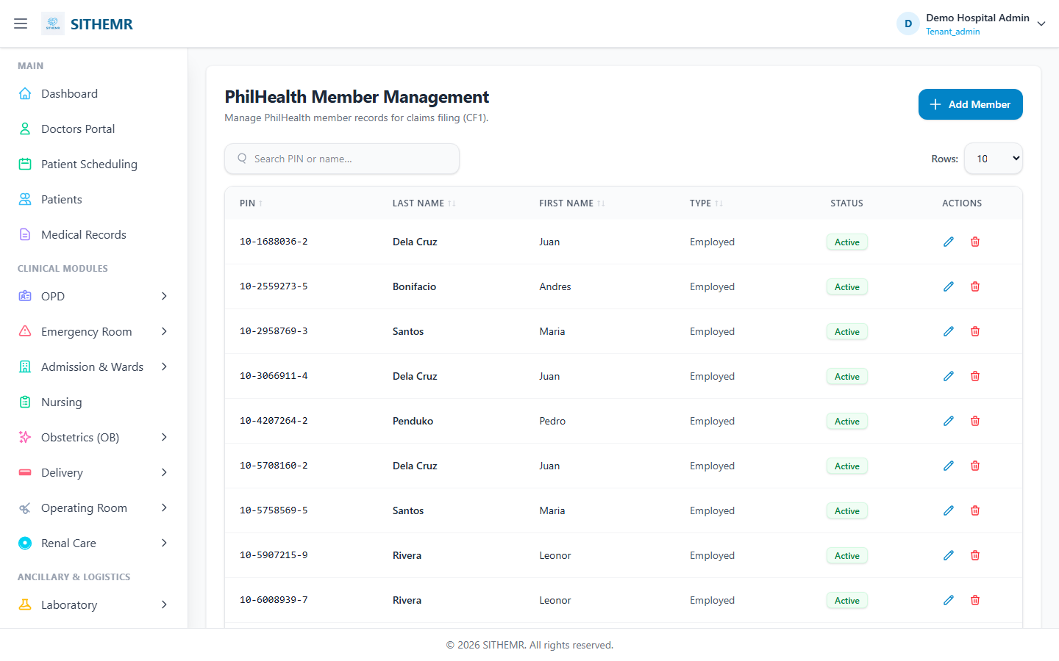
Screenshot: philhealth-members-01-list.png

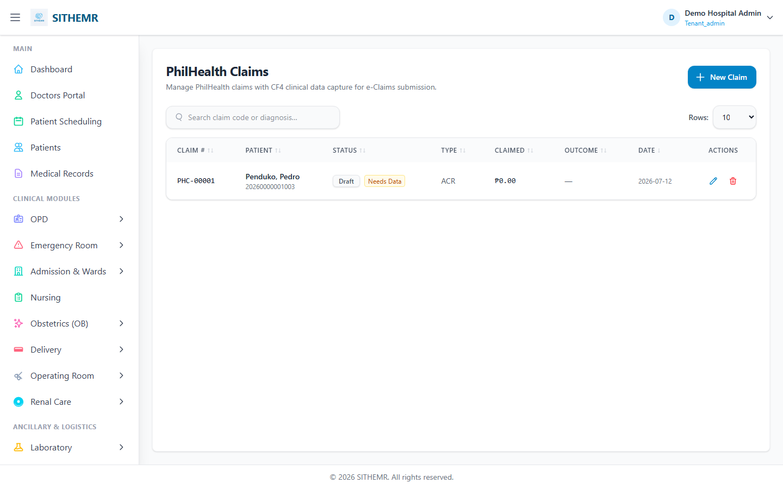
Screenshot: philhealth-claims-01-list.png

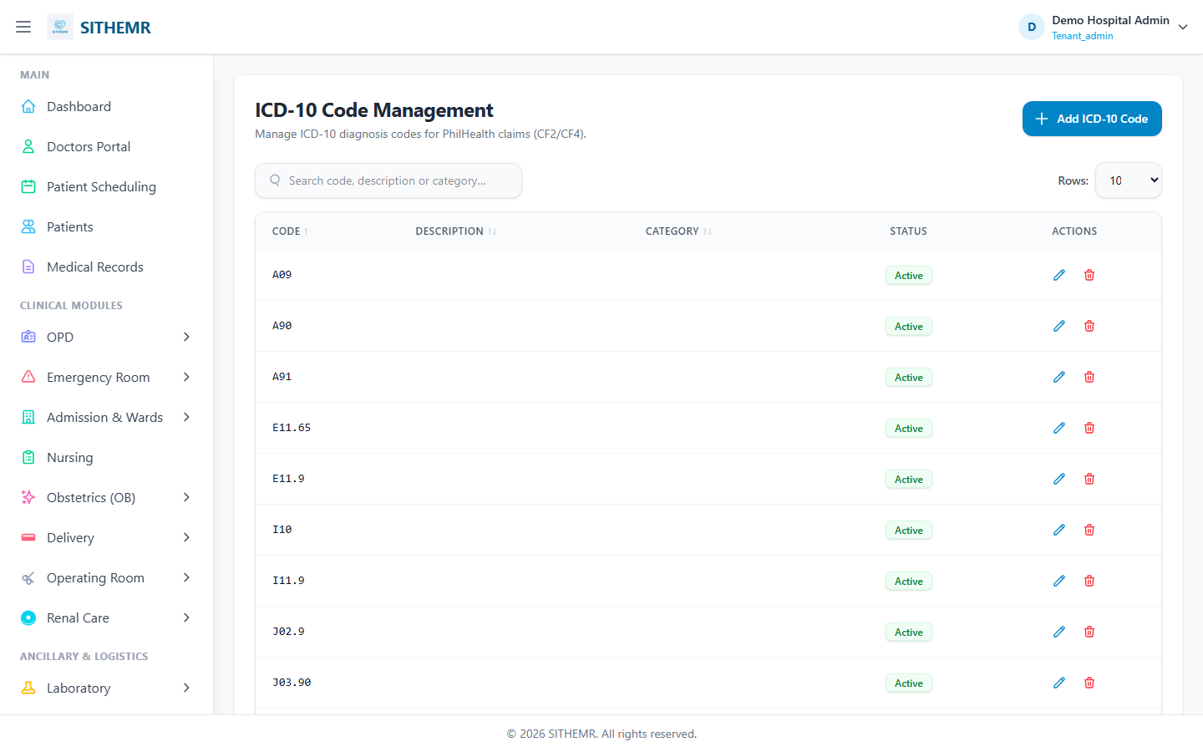
Screenshot: philhealth-icd10-01-list.png

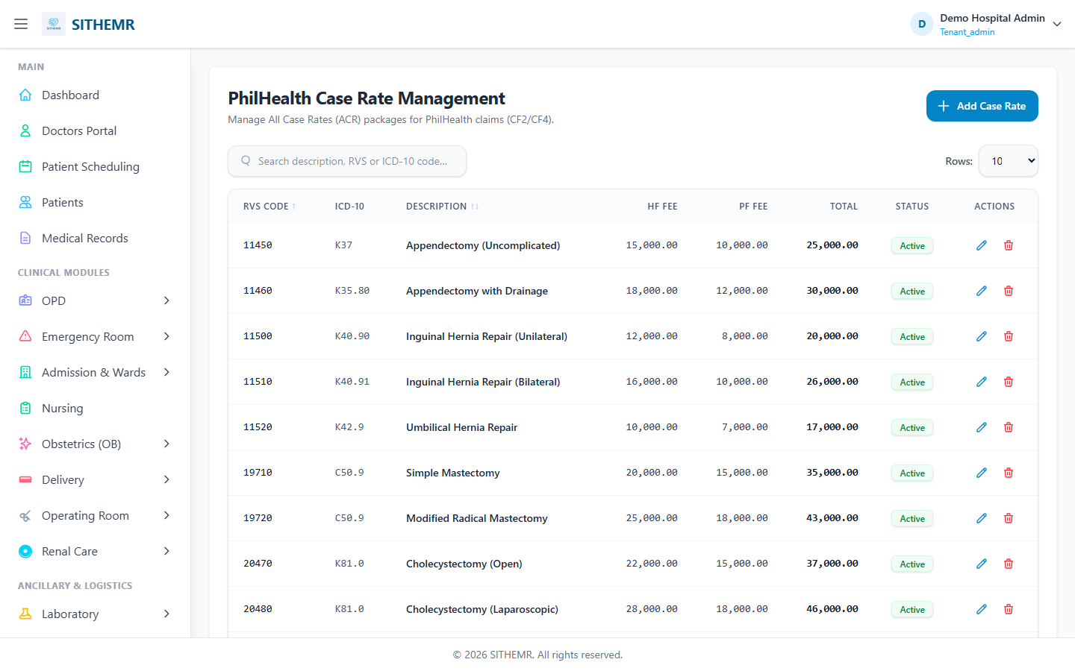
Screenshot: philhealth-case-rates-01-list.png

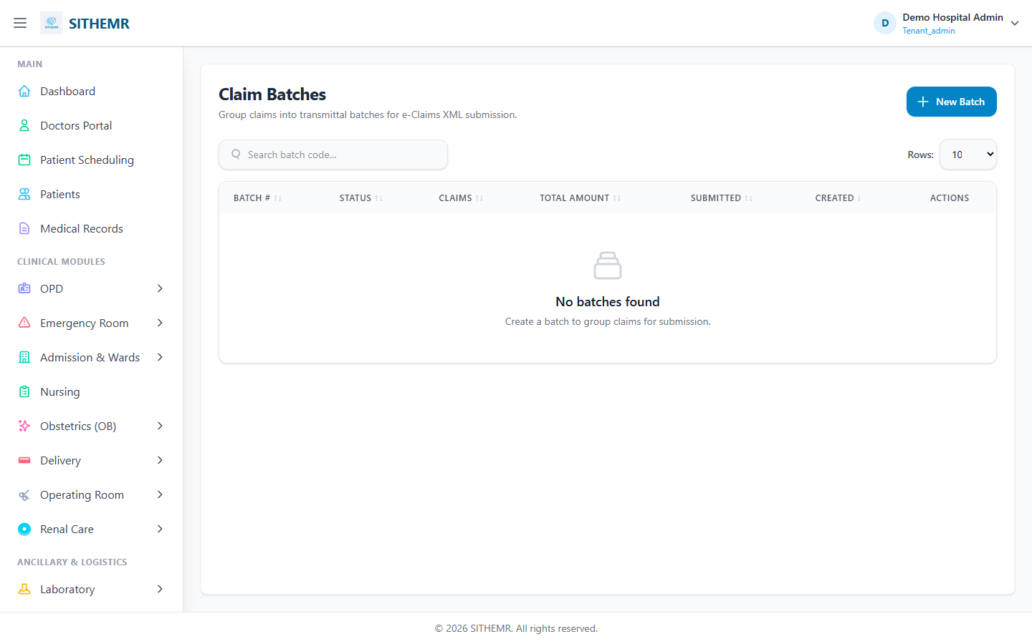
Screenshot: philhealth-batches-01-list.png

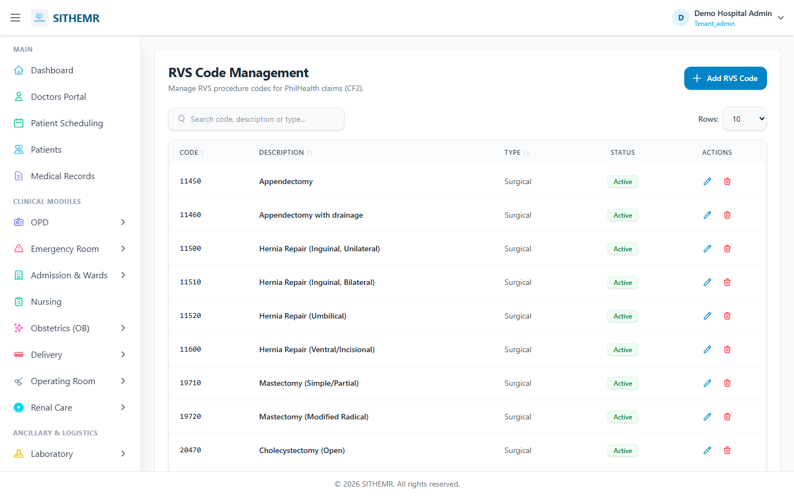
Screenshot: philhealth-rvs-01-list.png

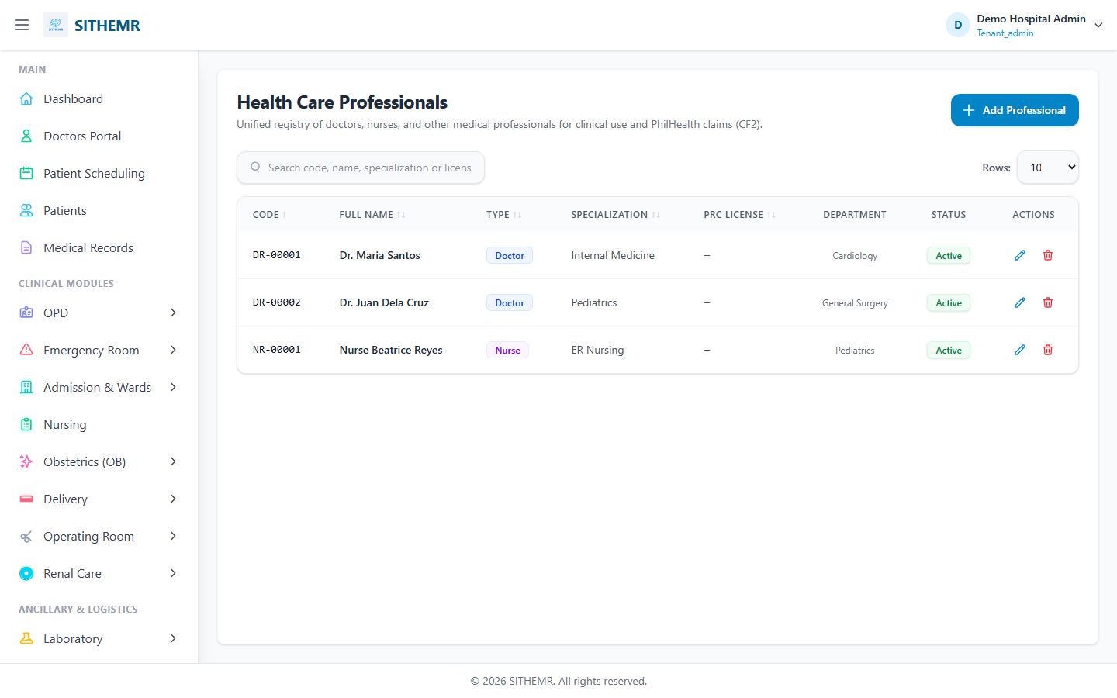
Screenshot: philhealth-hc-professionals-01-list.png

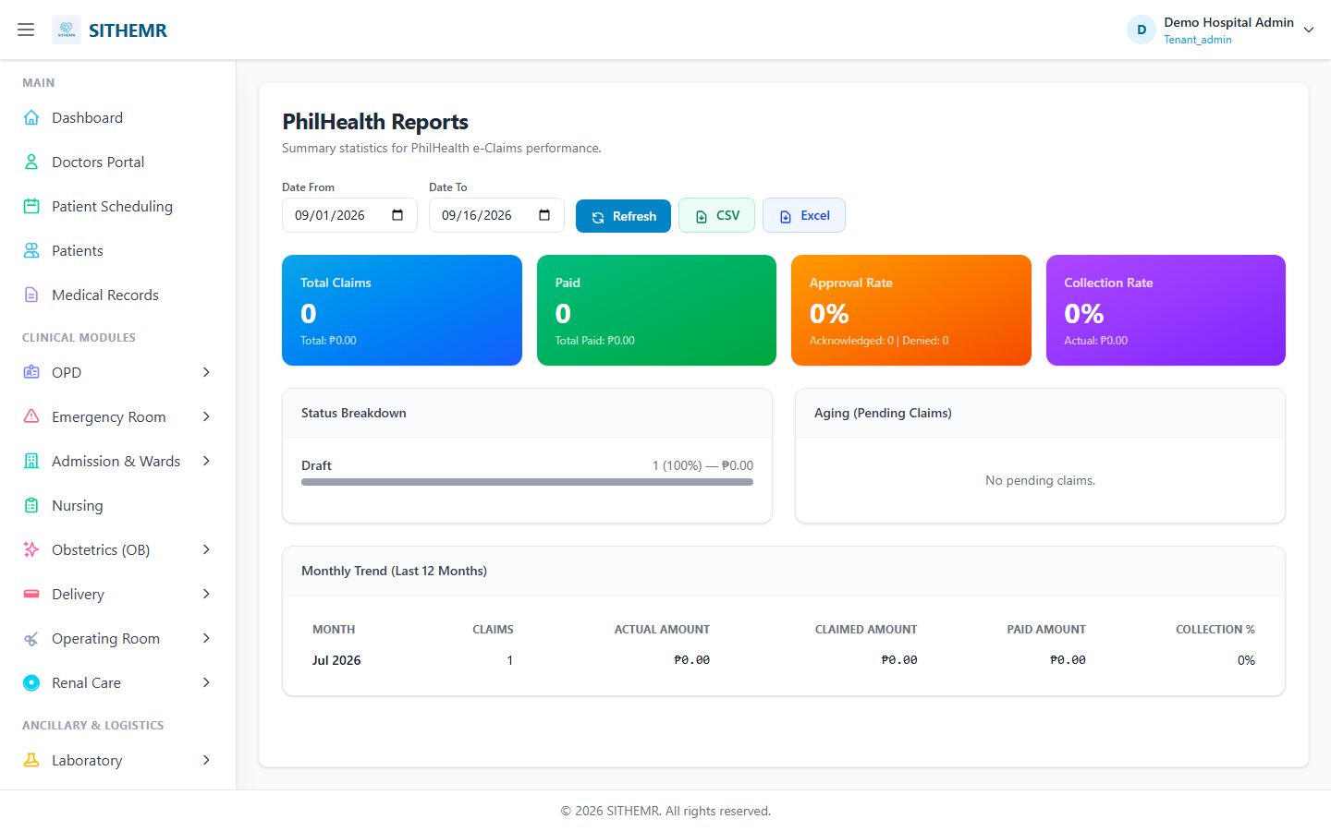
Screenshot: philhealth-reports-01-list.png

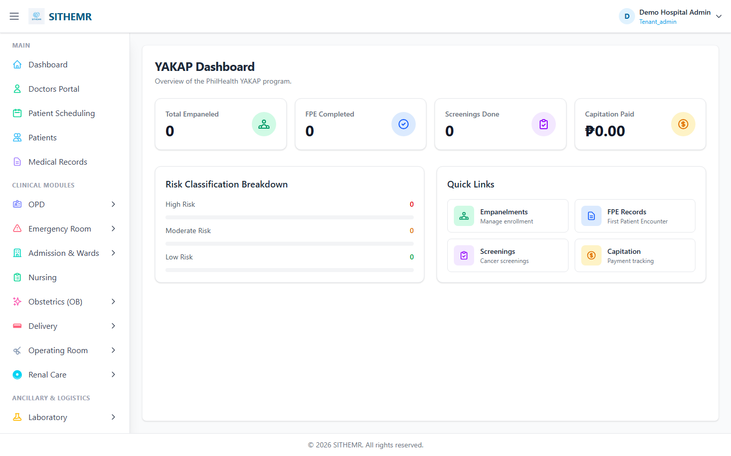
Screenshot: yakap-dashboard-01-list.png

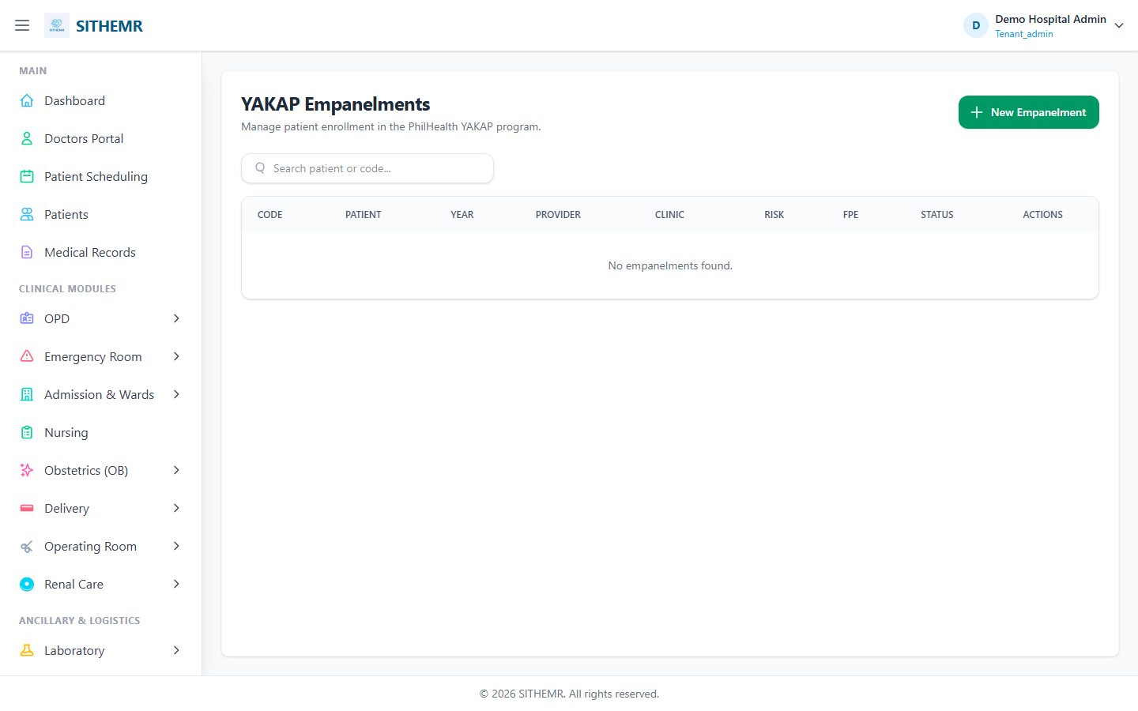
Screenshot: yakap-empanelments-01-list.png

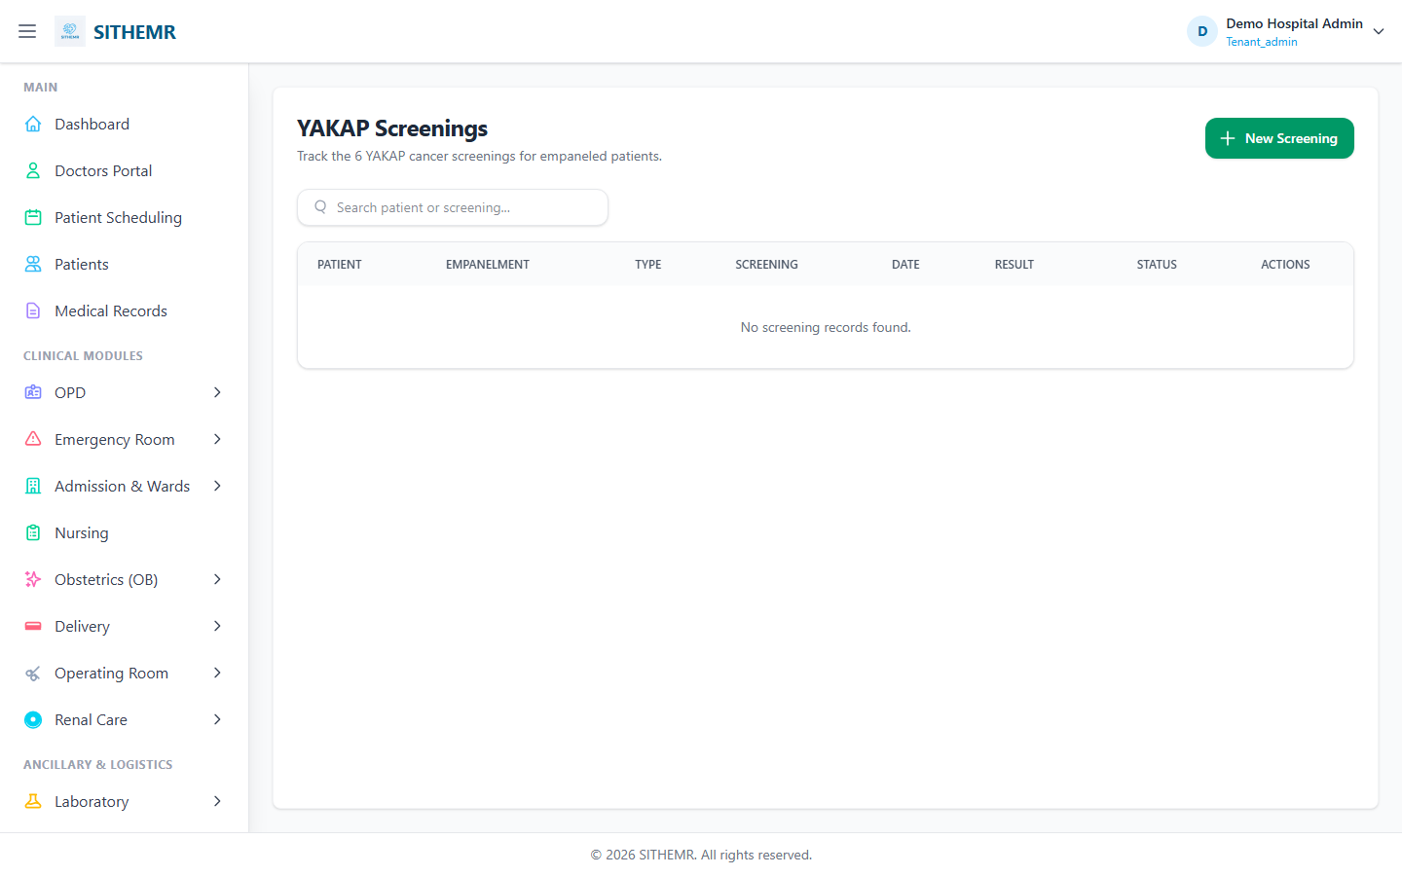
Screenshot: yakap-screenings-01-list.png

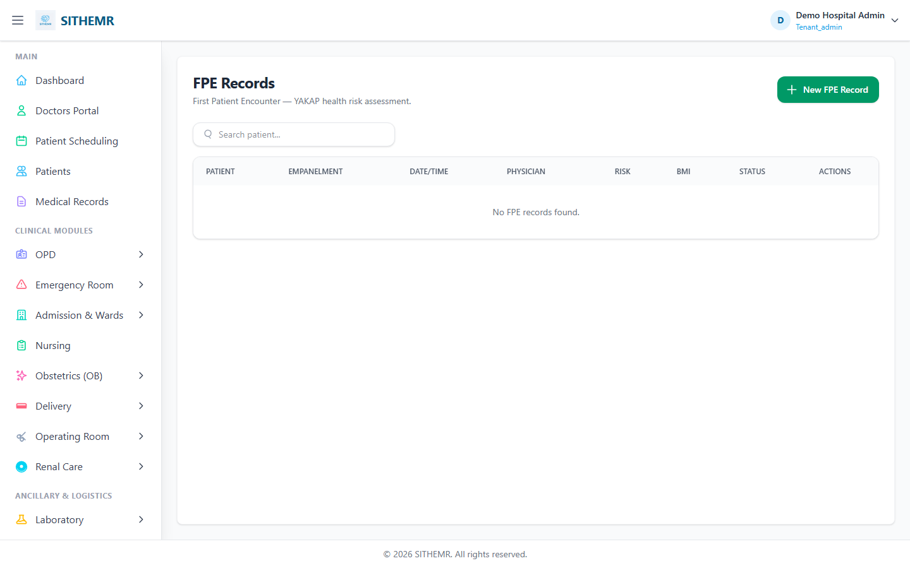
Screenshot: yakap-fpe-01-list.png

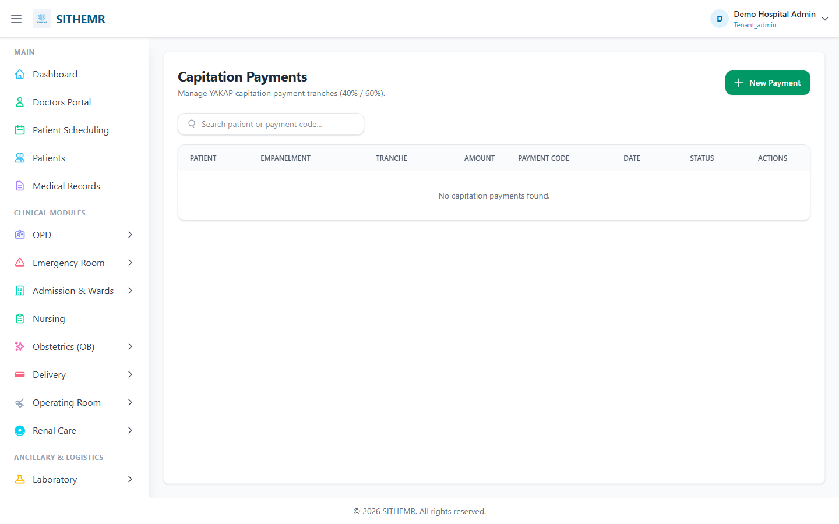
Screenshot: yakap-capitation-01-list.png

Route prefix: /philhealth. Manages PhilHealth - the Philippine Health Insurance Corporation - membership, claims, form generation, batch processing, and reporting. All PhilHealth operations require permission: philhealth.view (basic) or philhealth.manage (claims/batches/pdfs).

13.1 PhilHealth Master Data

13.1.1 PhilHealth > ICD10 Codes
Route: philhealth.icd10-codes (permission: philhealth.view). ICD-10 diagnosis codes catalog. The WHO International Classification of Diseases, 10th Revision. Used in PhilHealth claims for diagnosis coding. Fields: id, icd10_code (e.g. 'A00', 'J06.9', 'I10', 'K35'), icd10_description (e.g. 'Cholera', 'Acute upper respiratory infection, unspecified', 'Essential (primary) hypertension', 'Acute appendicitis'), chapter (e.g. 'I - Certain infectious and parasitic diseases'), block, is_active, tenant_id, history, audit columns. ICD10 codes are linked to diagnoses in EMR encounters and used in claim forms (CF1-CF5) for primary and secondary diagnoses.

13.1.2 PhilHealth > RVS Codes (Relative Value Scale)
Route: philhealth.rvs-codes (permission: philhealth.view). PhilHealth RVS codes - the standardized fee schedule codes for medical services. Each RVS code maps a service to its PhilHealth-recognised fee. Fields: id, rvs_code, service_description, service_category (e.g. 'Physician Service', 'Laboratory', 'Radiology', 'Drug/Pharma', 'Surgical Package', 'Professional Fee'), rvs_point_value (or fee amount), is_active, tenant_id, history, audit columns. RVS codes are used in PhilHealth claim forms to itemize services for reimbursement.

13.1.3 PhilHealth > Case Rates
Route: philhealth.case-rates (permission: philhealth.view). PhilHealth case rate schedules - fixed-rate packages for specific clinical conditions/procedures. Fields: id, case_rate_code, case_description, package_type (e.g. 'Normal Delivery', 'Cesarean Section', 'Hemorrhage', 'Pneumonia - Pneumococcal', 'Stroke', 'CABG', 'Hip Replacement', 'Kidney Transplant'), case_rate_amount (fixed fee), coverage_duration_days (e.g. 3 days, 5 days, etc.), is_active, tenant_id, history, audit columns. Case rates are used for cashless/emergency admissions under PhilHealth's Z-benefit / Case Rate program.

13.1.4 PhilHealth > HC Professionals
Route: philhealth.hc-professionals (permission: philhealth.view). Healthcare professional registry for PhilHealth purposes. Fields: id, hc_professional_id (FK to health_care_professionals.id), philhealth_prc_no (PRC license number), philhealth_id (PhilHealth provider ID), profession (Physician, Dentist, Nurse, Medical Technologist, Radiologic Technologist, Pharmacist, etc.), specialization, is_active, tenant_id, history, audit columns. HC professionals used as service providers in PhilHealth claims must be registered here.

13.1.5 PhilHealth > Members
Route: philhealth.members (permission: philhealth.view). PhilHealth membership records. This is what links a patient to their PhilHealth membership for claims eligibility. Fields: id, philhealth_member_id (the PhilHealth membership number - this is what the patient. philhealth_member_id FK points to), last_name, first_name, middle_name, suffix, date_of_birth, sex, address_street, barangay_id, city_id, province_id, region_id, membership_type (Individual Payor, Employer-Employed, Employer-Voluntary, Overseas Filipino Worker (OFW), Indigent/Sponsored, Lifetime Member, etc.), membership_status (Active, Inactive, Cancelled, Expired, Pending), enrollment_date, benefit_rating, is_active, tenant_id, history, audit columns.
- The Patient model has a philhealth_member_id FK that points to this table. When filling out patient registration, if is_philhealth_member is checked, the user selects an existing PhilHealth member record.
- If the patient's PhilHealth membership does not exist yet, create it here first under PhilHealth > Members.
- PhilHealth membership status must be 'Active' for the patient to be eligible for PhilHealth claims.

13.2 PhilHealth Claims
Route: philhealth.claims (permission: philhealth.manage). PhilHealth claim management - the core claims workflow. Claims are requests for PhilHealth reimbursement for medical services rendered to accredited members.

13.2.1 PhilHealthClaim Model
- id - Primary key.
- tenant_id - FK to hospitals.id.
- claim_code - Code: 'PH-' + 5-digit sequence (e.g. PH-00001, PH-00002).
- philhealth_member_id - FK to philhealth_members.id. The patient's PhilHealth membership.
- patient_id - FK to patients.id. (Redundant but useful for easy lookup.)
- claim_type - String: 'Outpatient', 'Inpatient', 'Emergency', 'Maternity', 'Z-Benefit/Case Rate', 'Konsulta', 'HMO Referral', etc.
- admission_id - FK to admissions.id (for inpatient claims; nullable for outpatient).
- opd_consultation_id - FK to opd_consultations.id (for outpatient/diagnostic claims; nullable).
- service_date - Date. Date the service was rendered.
- facility_id - String. PhilHealth-accredited facility code (the hospital's PhilHealth accreditation number).
- diagnosis_primary_id - FK to icd10_codes.id. Primary diagnosis (ICD10 code).
- diagnosis_secondary_id - FK to icd10_codes.id (nullable). Secondary diagnosis.
- diagnosis_tertiary_id - FK to icd10_codes.id (nullable). Tertiary diagnosis.
- total_claim_amount - Float. Total amount claimed for PhilHealth reimbursement.
- philhealth_reimbursement - Float. Amount PhilHealth approved/reimbursed (set after claim is processed by PhilHealth).
- patient_share - Float. Patient's share/co-pay (if any).
- hospital_share - Float. Hospital's share (total - reimbursement - patient_share).
- status - Claim status: Draft, Submitted, Pending Review, Approved, Disapproved/Rejected, Paid, Adjusted, Closed.
- submission_date - Date (nullable). When the claim was submitted to PhilHealth.
- philhealth_ref_no - String (nullable). PhilHealth's reference number for the claim.
- remarks - Text (nullable).
- created_by / created_date - Audit columns.
- updated_by / updated_date - Audit columns.
- history - Soft delete flag (1=active).
- is_active - Active flag.

13.2.2 PhilHealthClaimService Model (Claim Line Items)
- id - Primary key.
- philhealth_claim_id - FK to philhealth_claims.id.
- service_type - String: 'Physician Service', 'Laboratory', 'Radiology', 'Drug/Pharmaceutical', 'Surgical Package', 'Professional Fee', 'Nursing Service', 'Blood Transfusion', 'Isolation Room', 'Intensive Care', 'Burn Care', etc.
- service_description - String. Description of the service/item.
- quantity - Float. Quantity of service (e.g. 1 for physician professional fee, number of lab tests, number of drug days, etc.).
- rvs_code - FK to philhealth_rvs_codes.id (nullable). The PhilHealth RVS code for this service (if applicable).
- case_rate_code - FK to philhealth_case_rates.id (nullable). The case rate package (if claim is a case rate / Z-benefit).
- unit_rate - Float. Rate per unit of service.
- total_amount - Float. Quantity x unit_rate. The claimed amount for this line item.
- philhealth_allowed - Float (nullable). Amount PhilHealth allows/covered for this service (after deduction).
- patient_share_amount - Float (nullable). Patient's co-pay for this item.
- sequence - Int. Sequence number for the line item in the claim form.
- is_active - Active flag.
- history - Soft delete flag.

13.2.3 Claim Workflow
- From the PhilHealth claims page, create a new claim.
- Select PhilHealth member (or search patient - links to existing membership).
- Set claim_type: Outpatient, Inpatient, Emergency, Maternity, Z-Benefit/Case Rate, Konsulta, HMO Referral.
- Link to the encounter: for inpatient, link to admission_id. For outpatient, link to opd_consultation_id.
- Set service_date.
- Enter primary diagnosis (ICD10 code from philhealth.icd10-codes master).
- Optionally enter secondary and tertiary diagnoses.
- Add claim services/line items: each line item has service_type, description, quantity, rvs_code (if applicable), unit_rate, total_amount.
- For case rate claims: select the case_rate_code, and the system populates the case_rate_amount and coverage duration.
- System computes total_claim_amount (sum of all line items).
- Review the claim, then submit. Status becomes 'Submitted' (or 'Pending Review' if internal review required before submission).
- When PhilHealth processes and approves: update status to 'Approved', enter philhealth_ref_no, philhealth_reimbursement amount, patient_share, hospital_share.
- When paid: status becomes 'Paid'.
- If rejected/disapproved: status becomes 'Disapproved/Rejected' with reason in remarks.
- The claim lifecycle: Draft -> Submitted -> Pending Review -> Approved/Paid OR Disapproved.

13.2.4 PhilHealth Batches and Reports
- philhealth.batches - Group claims into batches for submission. A batch is a collection of claims submitted together to PhilHealth. Useful for organizing claims by submission period (weekly/monthly). Fields: id, batch_code (e.g. 'BATCH-2026-09'), description, total_claims, total_amount, submitted_date, philhealth_batch_ref, status.
- philhealth.reports - PhilHealth reports: claims summary by claim type, claims by diagnosis (ICD10), claims by facility, claims aging, reimbursement summary, batch listing, claim line item report.

13.3 PhilHealth Claim Form PDFs
These routes generate official PhilHealth claim forms as downloadable PDFs via DomPDF. Each form is a standardized PhilHealth document:
- philhealth.claims.esoapdf ({claim}) - PhilHealth E-SOAP (Electronic Summary of Accounts and Payments) PDF. Shows the complete claim with all services, amounts, and the computed E-SOAP. The digital equivalent of the traditional PhilHealth claim form.
- philhealth.claims.cf1pdf ({claim}) - PhilHealth CF1 (Claim Form 1) PDF. The CF1 form lists the patient's demographic and insurance information, the admitting facility, the primary/secondary/tertiary diagnoses (ICD10), the attending physician details, and the hospitalization summary.
- philhealth.claims.cf2pdf ({claim}) - PhilHealth CF2 (Claim Form 2) PDF. The CF2 form itemizes all services rendered with their RVS codes (if applicable), quantities, unit rates, total amounts, PhilHealth allowed amounts, and patient shares. This is the detailed service breakdown.
- philhealth.claims.cf3pdf ({claim}) - PhilHealth CF3 (Claim Form 3) PDF. The CF3 form lists the medications/pharmaceuticals administered during the admission, with drug names, dosages, quantities, and charges.
- philhealth.claims.cf4pdf ({claim}) - PhilHealth CF4 (Claim Form 4) PDF. The CF4 form lists laboratory tests performed, with test names, results (if relevant), RVS codes, charges, and amounts.
- philhealth.claims.cf5pdf ({claim}) - PhilHealth CF5 (Claim Form 5) PDF. The CF5 form lists radiology/imaging procedures performed, with exam types, modalities, findings summary, RVS codes, charges, and amounts.
- philhealth.claims.eeclpdf ({claim}) - PhilHealth EECL (Emergency Encounter Closure List) PDF. For emergency admissions, the EECL form documents the emergency encounter with triage level, OECB package (if applicable), diagnosis, and disposition. This is the emergency equivalent of the inpatient claim summary.
These PDFs are the official PhilHealth submission documents. Hospitals submit these forms (electronically or physically) to PhilHealth for reimbursement.

14. Medical Records and Certificates
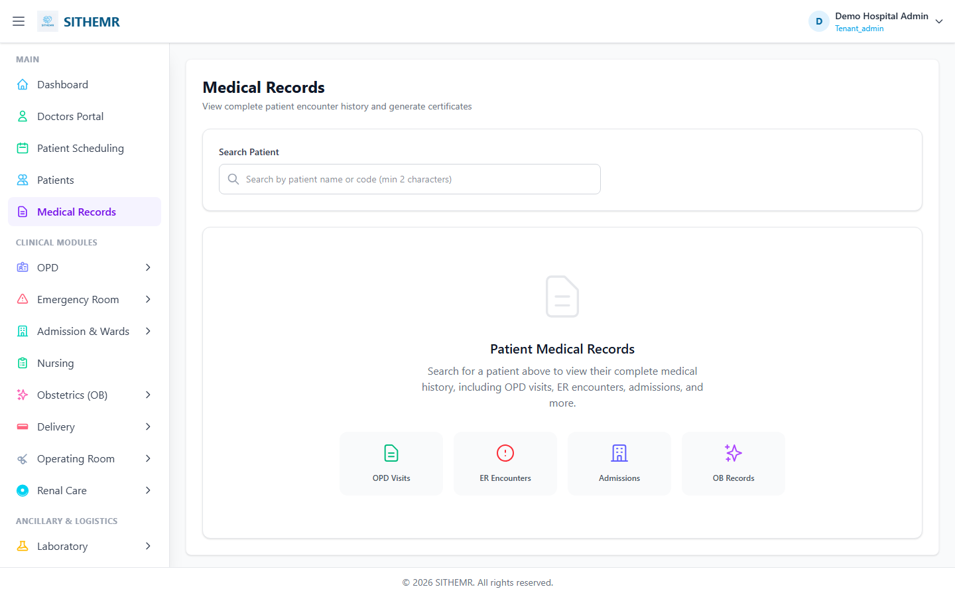
Screenshot: medical-records-01-list.png

Route: /medical-records (permission: medical-records.view). Manages medical certificate generation and patient chart access. This is the official records module - the legal medical documentation output.

14.1 Certificate Generation
The medical records module generates various medical certificates as PDFs via DomPDF. These are official medical documents used for employment, schooling, legal purposes, insurance, and government requirements.
- Medical Certificate (MC) - General medical certificate stating the patient's condition, date of examination, fitness status (fit to work, unfit for work, fit with restrictions), recommended rest period, and physician signature block. Generated from patient encounters.
- Certificate of Employment (COE) - Certificate verifying the patient's employment status (if employer provided), used for employment verification.
- Certificate of Disability (COD) - Certificate documenting the patient's disability status, disability type, degree of disability, and recommendations. Used for PWD ID application, government benefits, and accommodations.
- Nil per os (NPO) Order / Special Orders - Hospital orders: NPO (nothing by mouth), activity orders (bed rest, ambulate as tolerated, etc.), diet orders, positioning orders, monitoring orders.
- Letter of Request / Referral Letter - Letter from the attending physician to another facility/specialist requesting referral, consultation, or transfer.
- Fit to Work / Fit to Fly / Fit to Travel Certificate - Certificate clearing the patient for specific activities.
- Encashment / Reimbursement Certificate - For HMO/insurance claims documentation.
- Birth Certificate / Delivery Note - For delivery patients: details of delivery, mother and baby information, attending physicians, delivery type, complications, Apgar score (if newborn), etc.
- Death Certificate - For expired patients: patient details, cause of death (primary and underlying), time of death, attending physician certification.

14.2 Certificate PDF Generation (DomPDF)
- All certificates are generated server-side via Barryvdh DomPDF.
- Templates use Blade templates rendered to HTML, then converted to PDF.
- Certificate data is pulled from the patient record and associated encounters (OPD consultations, ER admissions, admissions, delivery records, etc.).
- The patient's demographic data (name, age, sex, address) comes from the Patient model.
- The clinical information (diagnosis, findings, treatment) comes from the encounter records.
- The physician's name and signature block come from the attending physician (health_care_professionals) and the user who generated the certificate.
- Generated PDFs are downloadable and printable.
- The certificate generation interface shows available certificate types, lets the user select the patient and encounter, fills in certificate-specific fields, and generates the PDF.

14.3 Patient Chart Access
The patient chart (see also 4.6) is accessible from medical records. It shows the patient's complete medical record across all encounters and modules. From medical-records.view permission, the chart shows: demographics, all OPD consultations with SOAP notes and orders, all ER admissions with triage and treatment, all inpatient admissions with ward/ICU/OR course, all lab requests and results, all radiology requests and reports, all pharmacy requests and dispensing history (PMR), all CSR requests and dispensing, all procedure orders, all billing invoices and payments, PhilHealth membership and claims, and all certificates generated. The patient chart is the single comprehensive view of the patient's health record.

15. Doctors Module
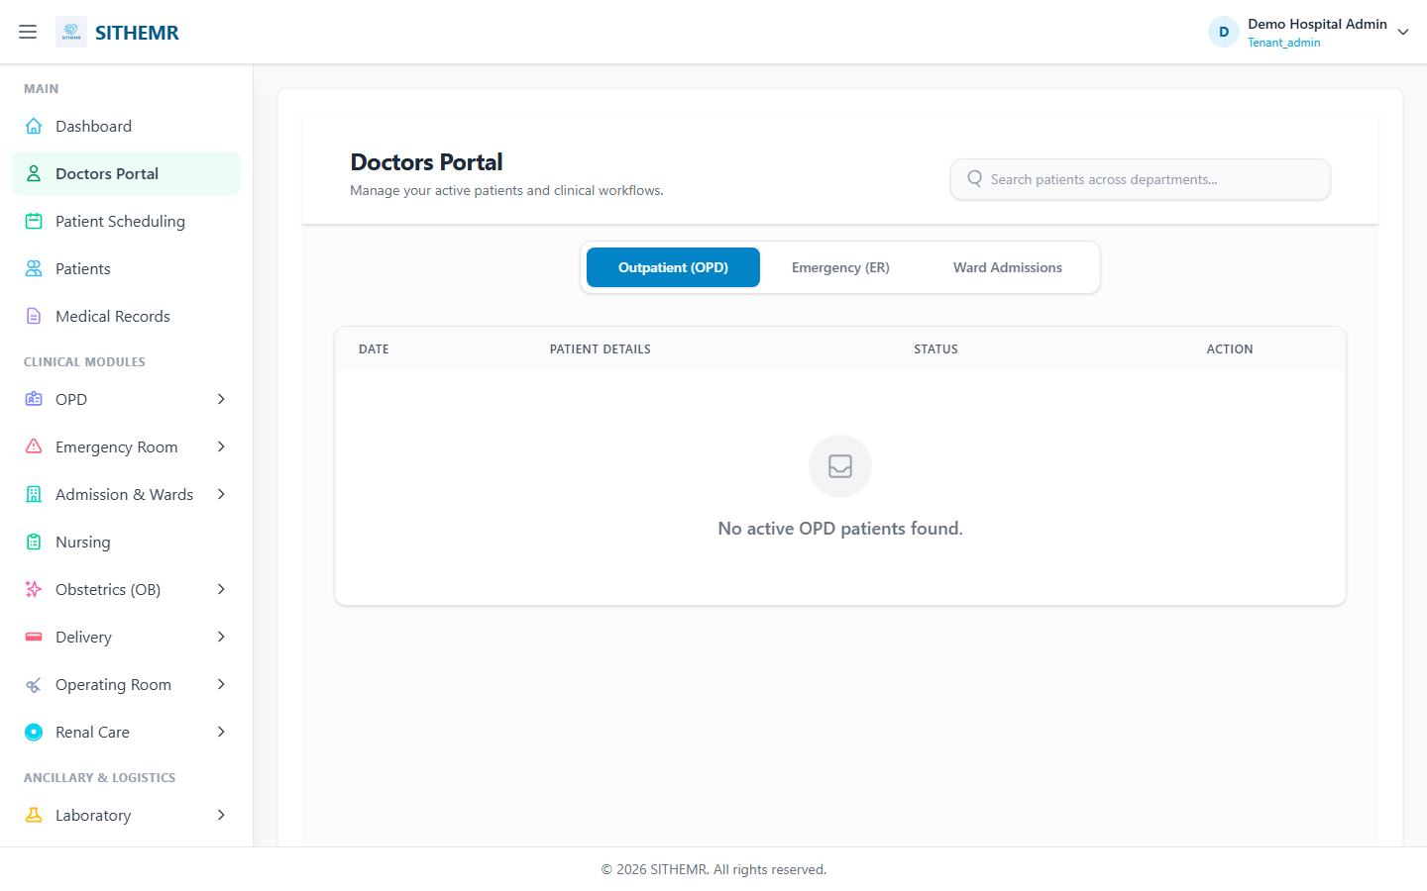
Screenshot: doctors-dashboard-01-list.png

Screenshot: billing-01-list.png

Route prefix: /doctors. The doctors module gives healthcare professionals (HCPs) a personalized view of their schedule, appointments, and patient charts. It has 3 distinct components sharing the doctors layout (x-layouts.doctors): doctors dashboard, doctors schedule management, and doctor patient chart view.

15.1 Doctors Dashboard
Route: doctors.dashboard (permission: doctors.dashboard, Livewire component: App\Livewire\Doctors\DashboardCrud, layout: x-layouts.doctors). The doctor's home screen showing today's workload and quick actions.
- Today's scheduled appointments: list of the doctor's own appointments for today (filtered to the doctor's health_care_professional_id). Shows patient name, appointment time, status (Scheduled/In Progress/Completed/Cancelled).
- Pending consultations: OPD consultations assigned to this doctor that are pending or in progress and need attention.
- Pending orders to review: lab/pharmacy/CSR/radiology/procedure orders requested by this doctor that are awaiting action or results.
- Today's admissions: ER admissions and inpatient admissions assigned to this doctor.
- Quick stats: total appointments today, pending reviews, pending orders.
- Quick navigation: links to patient chart, schedule, admission list.

15.2 Appointment Schedule Management
Route: doctors.schedule (permission: doctors.schedule, Livewire component: App\Livewire\Doctors\AppointmentScheduleCrud, layout: x-layouts.doctors). This is the doctor's schedule management interface - where they view, edit, reschedule, mark in-progress, mark done, and cancel appointments. SEE ALSO public appointment booking (section 5) - that's the patient-facing booking page; this is the doctor-facing management page.

15.2.1 AppointmentScheduleCrud Component (Full Code Reference)
- search (string) - Search appointments by patient name or appointment code.
- statusFilter (string) - Filter by status: empty = all, 'Scheduled', 'In Progress', 'Completed', 'Cancelled'.
- dateFilter (string) - Filter by specific date (Y-m-d). Empty = current/today context.
- doctorFilter (?string) - Filter by specific doctor (HCP ID). For non-admin doctors, this is implicitly locked to their own ID.
- perPage (int = 10) - Appointments per page.
- showModal (bool) - Whether the edit modal is open.
- editingId (?int) - The appointment ID being edited.
- edit_date (?string) - The new date (Y-m-d) for rescheduling.
- edit_start_time (?string) - The new start time (H:i) for rescheduling.
- edit_notes (string) - Updated appointment notes.
- edit_status (string = 'Scheduled') - Updated status (Scheduled, In Progress, Completed, Cancelled).
- availableSlots (array) - Computed available slots for the selected doctor+date (populated by loadAvailableSlots()).

15.2.2 Current Tenant and User Helpers
- currentTenantId(): request()->attributes->get('tenant_id') ?? 1.
- currentUserId(): request()->attributes->get('jwt_user')?->id ?? 1.
- isAdmin(): in_array(auth()->user()?->role, ['superadmin', 'tenant_admin']). Used to determine if the doctor can see ALL doctors' appointments (admin) or only their own (non-admin).

15.2.3 Data Loading (mount/query properties)
- mount(): Sets initial values. If no dateFilter, defaults to today. Loads appointments based on filters.
- query filter logic (applied per-page with pagination): If doctorFilter is set, include appointments for that doctor. If dateFilter is set, include appointments for that date. If statusFilter is set, include appointments with that status. Otherwise show all by default.
- Appointment model: DoctorAppointment::with(['department', 'doctor']) - eager loads department and doctor (HealthCareProfessional) relations.
- Doctor relation: health_care_professional - the HealthCareProfessional model representing the doctor. Links to the doctor's full_name, professional_type, specialization.
- Department relation: department - the Department model. Links to dept_name.

15.2.4 Appointment Model (DoctorAppointment) - Complete Fields
- id - Primary key.
- tenant_id - FK to hospitals.id.
- appointment_code - Code: 'APT-' + 5-digit sequence (e.g. APT-00001, APT-00002). Generated by AppointmentBooking::book() via generateCode($tid). Format: 'APT-' . str_pad($num, 5, '0', STR_PAD_LEFT). The patient-facing reference code.
- department_id - FK to departments.id. The department where the appointment belongs.
- health_care_professional_id - FK to health_care_professionals.id. The doctor assigned to this appointment.
- appointment_date - Date (Y-m-d). The appointment date.
- start_time - String (H:i). Appointment start time.
- end_time - String (H:i). Appointment end time. Computed from start_time + slot_minutes (30 min default from config).
- patient_name - String. Patient's full name (from public booking form). Max 150 chars.
- patient_phone - String (nullable). Patient's phone. Max 30 chars.
- patient_email - String (nullable). Patient's email. Max 150 chars.
- reason - String (nullable). Reason for visit / chief complaint. Max 5000 chars.
- status - String: 'Scheduled', 'In Progress', 'Completed', 'Cancelled'. Default: 'Scheduled'.
- notes - Text (nullable). Doctor's notes on the appointment.
- is_active - Boolean, default true.
- history - Soft delete flag (1=active).
- created_by - Nullable (null for public bookings - no authenticated user).
- created_date - DateTime. When the appointment was created.
- updated_by - Nullable.
- updated_date - DateTime (nullable).
- Uniqueness constraint: unique:doctor_appointments,health_care_professional_id,appointment_date,start_time,NULL,id,tenant_id,{tid},history,1. The combination of doctor+date+start_time must be unique (prevents double-booking the same slot for the same doctor).
- Config: slot_minutes (default 30), working_start (08:00), working_end (17:00) from config/appointment.php.

15.2.5 Loading Available Slots (loadAvailableSlots)
Used when editing/rescheduling an appointment. Computes which time slots are still available for the selected doctor on the selected date:
- Resets availableSlots to empty array.
- Returns if no editingId or no edit_date.
- Loads the appointment being edited.
- Parses edit_date to date string.
- Gets slot_minutes, working_start, working_end from config.
- Queries EXISTING appointments for the same doctor on the same date: DoctorAppointment::withoutGlobalScopes()->where('tenant_id', $tid)->where('health_care_professional_id', $doctor->id)->where('appointment_date', $date)->where('history', 1)->get(['start_time', 'end_time']). Note: history=1 filter is manually added.
- Maps existing appointments to ['start' => start_time, 'end' => end_time] pairs (as Carbon instances).
- Iterates from working_start to working_end in slot_minutes increments:
- - Creates Carbon slot start and end (addMinutes).
- - Checks overlap: for each existing appointment, if slot_start < existing_end AND slot_end > existing_start, the slot overlaps and is skipped.
- - Checks past: if the appointment_date is today AND slot_start < now(), skip (past slot).
- - If no overlap and not past: add slot to availableSlots with start (H:i), end (H:i), and label (formatted time with AM/PM).
- The available slots are rendered as clickable time buttons in the edit modal.

15.2.6 Edit Modal and Actions

5.2.6.1 openEdit (load appointment for editing)
- Loads the appointment with department and doctor relations.
- Populates edit_date (from appointment_date), edit_start_time (from start_time), edit_notes (from notes), edit_status (from status).
- Sets editingId, showModal=true.
- Calls loadAvailableSlots() to populate available time slots for rescheduling.

5.2.6.2 updatedEditDate - cascade reset
- When edit_date changes: resets edit_start_time to null (clears the old time), calls loadAvailableSlots() to fetch fresh slots for the new date.
- This is the cascade: changing the date clears the time and reloads available slots.

5.2.6.3 selectSlot - pick a time
- Sets edit_start_time to the selected slot string (H:i format).
- The user clicks a time button in the modal, and this sets the new start time.

5.2.6.4 Save / Update Actions
- Save changes (reschedule + notes): Updates the appointment with edit_date (new appointment_date), edit_start_time (new start_time), edit_notes (new notes), and computed end_time (Carbon::parse(edit_date . ' ' . edit_start_time)->addMinutes(slotMinutes)->format('H:i')). Uses updated_by = currentUserId(), updated_date = now().
- Mark In Progress: sets status = 'In Progress', updated_by/updated_date.
- Mark Done (Completed): sets status = 'Completed', updated_by/updated_date.
- Cancel: sets status = 'Cancelled', updated_by/updated_date. Cancelled appointments are excluded from public booking slot availability (where('status', '!=', 'Cancelled') in AppointmentBooking::loadAvailableSlots()).
- On any status change: closes modal, flashes success message, refreshes the page data (contact() dispatch or reload).
- Validation: required checks on edit_date (if rescheduling), valid date format, valid time slot selected.

15.3 Managing Appointments (Doctor Actions)
- View appointment: see patient name, department, doctor, date, time, reason, notes, status.
- Edit/Reschedule: change the date and/or time. The available slots are computed in real-time. The doctor can only pick from currently-available slots (not double-book).
- Edit notes: add/update doctor notes on the appointment (e.g. special instructions, patient condition notes).
- Mark In Progress: when the doctor starts seeing the patient.
- Mark Completed: when the consultation is finished.
- Cancel: cancel the appointment (patient won't be seen). The public booking slot becomes available again.
- Non-admin doctors (non-admin role): see only their own appointments (filtered by their health_care_professional_id). Cannot see or edit other doctors' appointments.
- Admin doctors (superadmin/tenant_admin): see ALL doctors' appointments, can edit any doctor's schedule.

15.4 Conflict Detection
- Database-level uniqueness constraint: unique:doctor_appointments, health_care_professional_id, appointment_date, start_time for the active tenant. This prevents inserting a duplicate slot at the DB level.
- Application-level check (AppointmentBooking::book()): before inserting, queries for overlapping appointments with lockForUpdate() (pessimistic locking). This prevents race conditions between two simultaneous booking requests.
- Public booking conflict: if a conflict is detected, the booking fails with error 'Sorry, this slot was just taken. Please pick another time.' and the available slots are refreshed.
- Schedule management conflict: when editing an appointment's date/time, loadAvailableSlots() shows only non-overlapping slots. The doctor cannot pick a time that's already taken by another appointment for the same doctor.

15.5 Patient Chart (Doctor View)
Route: doctors.patient ({type}, {id}, permission: doctors.chart). The doctor's view of a specific patient's chart. Shows the complete clinical history for the patient from the doctor's perspective: demographics, all OPD consultations with SOAP notes, all ER admissions, all inpatient admissions, all lab results, all radiology reports, all pharmacy dispensing history, all CSR issued items, all procedure records, all billing invoices, PhilHealth membership and claims, and the current encounter summary. The 'type' parameter may indicate the encounter type to highlight (e.g. opd, er, admission).

16. OB, Delivery, and Specialty Care
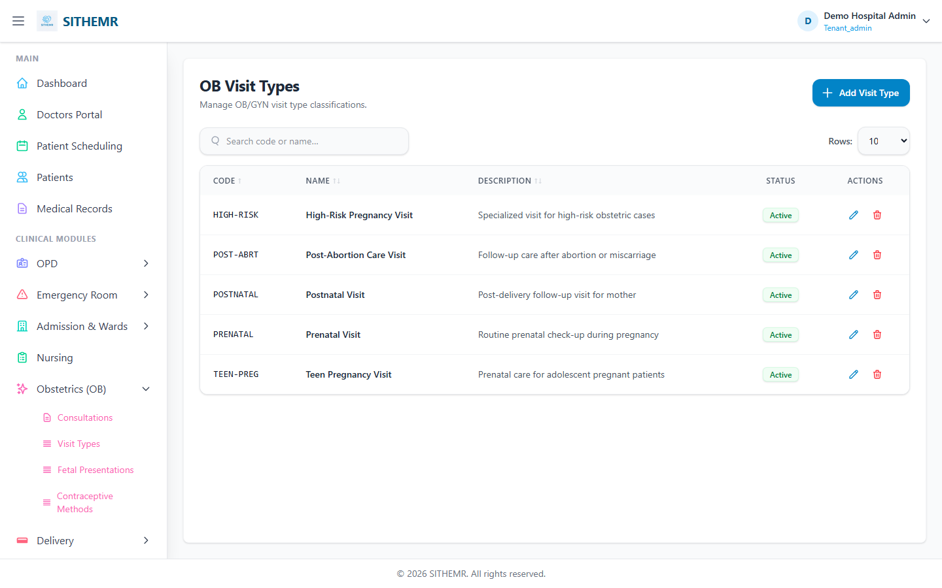
Screenshot: ob-visit-types-01-list.png

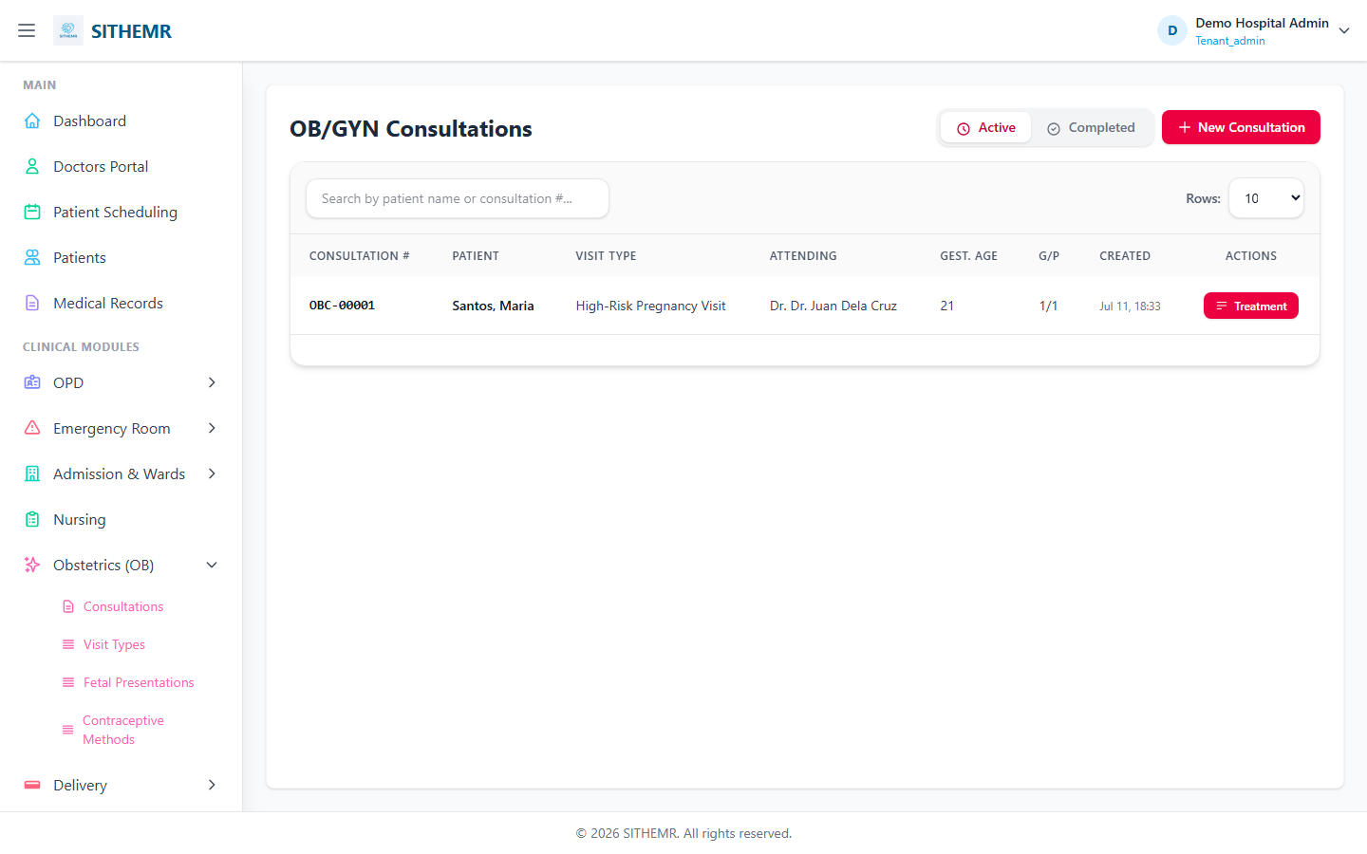
Screenshot: ob-consultations-01-list.png

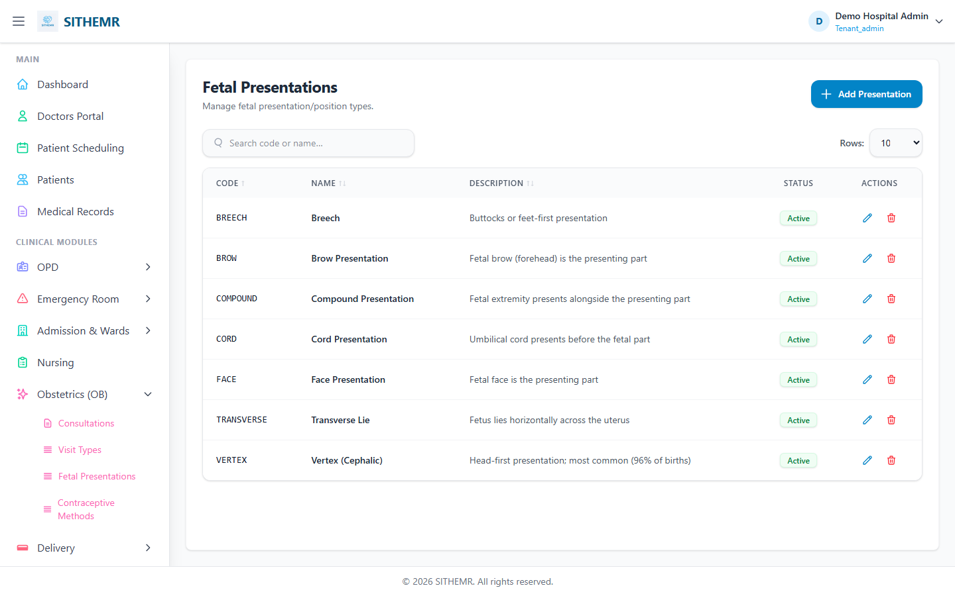
Screenshot: ob-fetal-presentations-01-list.png

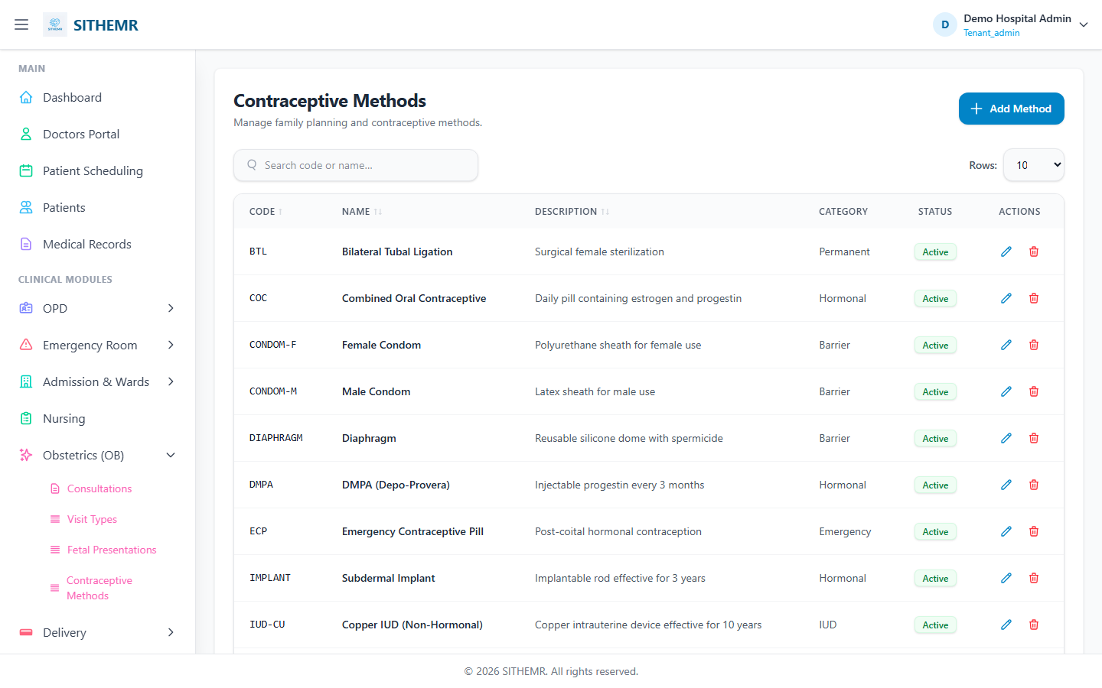
Screenshot: ob-contraceptive-methods-01-list.png

16.1 OB (Obstetrics) Module
Route prefix: /ob. Manages obstetric services: visit types, fetal presentations, contraceptive methods, and OB consultations (ObConsultationCrud Livewire).

16.1.1 OB Master Data
- OB > Visit Types (ob.visit-types) - OB visit classifications: First Prenatal Visit, Prenatal Follow-up, Postpartum Visit, Postnatal Check, Newborn Check, etc. Fields: id, name, code, description, is_active, tenant_id, history, audit columns.
- OB > Fetal Presentations (ob.fetal-presentations) - Fetal presentation types: Cephalic (Vertex), Breech (Frank, Complete, Footling), transverse/oblique, etc. Used in OB consultations. Fields: id, name, code, description, is_active, tenant_id.
- OB > Contraceptive Methods (ob.contraceptive-methods) - Contraceptive methods: Condoms, Oral Contraceptives (Combined, Progestin-only), IUD (Copper, Hormonal), Injectables (Depo-Provera), Implants (Implanon/Nexplanon), Diaphragm, Fertility Awareness Methods, Permanent (Tubal Ligation, Vasectomy), etc. Fields: id, name, code, description, is_active, tenant_id.

16.1.2 OB Consultations (ObConsultationCrud)
Route: ob.consultations (permission: ob.view, Livewire: ObConsultationCrud). OB consultation records for prenatal, postnatal, and gynecological visits. Similar pattern to OPD consultations but OB-specific fields. The consultation includes OB assessment: gestational age (weeks), estimated due date (EDD), fetal presentation, fetal heart rate, fundic height, blood pressure, weight, urine protein/ glucose, fetal movement, obstetric history, and plan. The OB consultation links to a patient and can generate orders (lab, pharmacy, etc.).

16.2 Delivery Module
Route prefix: /delivery. Manages delivery/obstetric delivery services: delivery types, complications, rooms, and schedule.

16.2.1 Delivery Master Data
- Delivery > Types (delivery.types) - Delivery types: Normal Vaginal Delivery (NVD), Cesarean Section (CS), Assisted Vaginal Delivery (Forceps / Vacuum Extraction), VBAC (Vaginal Birth After Cesarean), etc. Fields: id, name, code, description, is_active, tenant_id, history, audit columns.
- Delivery > Complications (delivery.complications) - Delivery complications: Postpartum Hemorrhage (PPH), Retained Placenta, Cervical/Laceration, Perineal Laceration (1st/2nd/3rd/4th degree), Amniotic Fluid Embolism, Shoulder Dystocia, Preterm Labor, Preeclampsia/Eclampsia, Uterine Rupture, etc. Fields: id, name, code, description, is_active, tenant_id.
- Delivery > Rooms (delivery.rooms) - Delivery rooms/labor rooms. Fields: id, room_number, floor, status (Available/Occupied/Booked), is_active, tenant_id.
- Delivery > Schedule (delivery.schedule) - Delivery schedule: planned/emergency deliveries with patient, attending obstetrician, anesthesiologist, delivery type, scheduled date/time, status, notes.

16.2.2 Delivery Records
Delivery records (linked to admissions/patients) capture the full delivery event: delivery type, complications (multiple), attending physician (obstetrician), anesthesiologist, anesthesia type, delivery date/time, Apgar scores (if newborn), estimated blood loss, placenta delivery (complete/incomplete/retained), perineal status, lacerations/repairs, newborn details (sex, weight, length, APGAR), mother's post-delivery condition, and plan. Delivery records can link to the admission record for inpatient postpartum care.

16.3 Renal Care (Dialysis) Module
Route prefix: /renal-care (permission: renal.view). Manages renal/dialysis care services for patients with kidney failure requiring hemodialysis or other renal therapies.

16.3.1 Renal Care Master Data
- Renal Care > Dialysis Types (renal-care.dialysis-types) - Dialysis modalities: Hemodialysis (HD), Peritoneal Dialysis (PD) - Continuous Ambulatory Peritoneal Dialysis (CAPD), Automated Peritoneal Dialysis (APD), Continuous Cycling Peritoneal Dialysis (CCPD), etc. Fields: id, name, code, description, is_active.
- Renal Care > Dialysis Sessions (renal-care.dialysis-sessions) - Individual dialysis treatment sessions. Links patient to the dialysis type, session date/time, duration, dialyzer used, dialysate composition, blood flow rate, dialysate flow rate, ultrafiltration volume, pre-dialysis and post-dialysis vitals (weight, BP, HR), complications during session, medications administered during session (e.g. heparin, erythropoietin), and session notes. Each session is a record of one dialysis treatment.

16.3.2 Dialysis Session Workflow
- Patient with renal failure is registered in the system with their diagnosis and dialysis prescription.
- A dialysis session is scheduled/created: link patient, select dialysis type (Hemodialysis, CAPD, etc.), set session date/time, duration.
- Pre-dialysis assessment: weight, blood pressure, heart rate, pre-dialysis laboratory values (if available: BUN, Creatinine, electrolytes, hemoglobin, etc.), access site assessment (AV fistula, catheter, graft).
- During session: dialyzer type, dialysate composition (Na, K, Ca, HCO3, glucose), blood flow rate (Qb), dialysate flow rate (Qd), ultrafiltration goal/volume removed, heparin dose, vital signs monitoring (periodic BP, HR).
- Post-dialysis: post-weight, post-BP, total ultrafiltration achieved, complications (hypotension, cramping, nausea, etc.), session notes.
- Dialysis sessions can be linked to billing (dialysis service charge) and PhilHealth claims (renal care case rate / Z-benefit if applicable).
- Dialysis schedule is managed to track recurring sessions (e.g. patient on HD 3x/week). The schedule shows upcoming and past sessions.

17. Nursing, YAKAP, and Konsulta
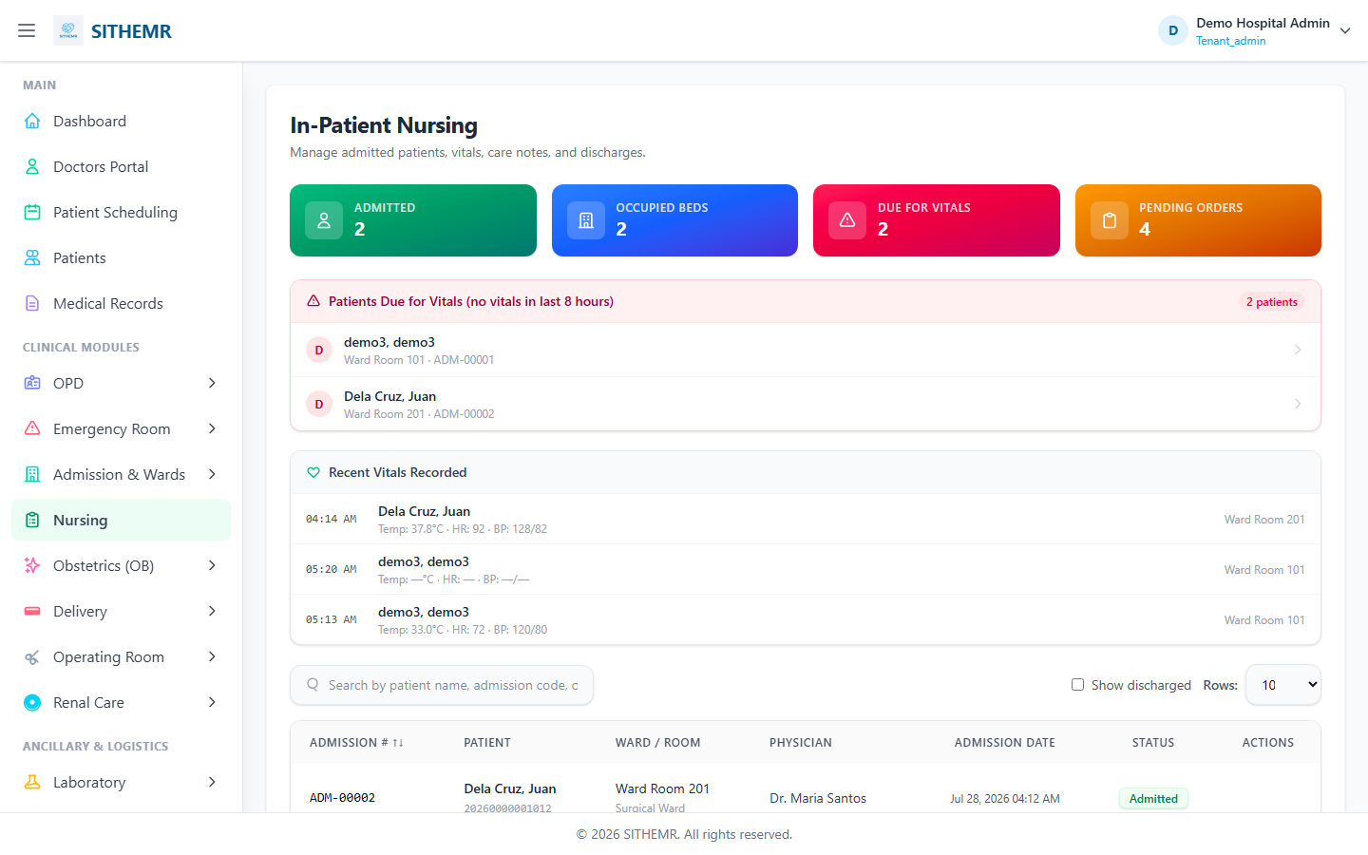
Screenshot: nursing-01-list.png

17.1 Nursing Module
Route: /nursing (permission: nursing.view, Livewire component: NursingCrud). The nursing dashboard provides a nursing workflow view - accessible to nurses to manage their nursing tasks, patient observations, vitals, and nursing notes. The NursingCrud Livewire (source: app/Livewire/Nursing/NursingCrud.php) serves as the nursing workflow interface.
- Nursing dashboard: overview of patients needing nursing attention, pending vitals to enter, scheduled medications, nursing tasks, and ward/ICU patient summaries.
- Nursing notes: nurses can document nursing assessments, observations, and care activities.
- Vitals entry: nurses enter patient vitals (BP, HR, temp, RR, weight, height, O2 sat) - this is the same vitals entry from OPD consultations (openVitals/saveVitals in OpdConsultationCrud) accessible through the nursing workflow.
- The nursing module integrates with OPD, ER, and inpatient workflows - nurses document care across all patient settings.
- Nursing view is role-based: nurses see patients in their assigned units/wards.

17.2 YAKAP (PhilHealth Primary Care) Module
Route prefix: /yakap (permission: yakap.view or yakap.manage). YAKAP is the PhilHealth Primary Care program module. It manages primary care empanelment and services for PhilHealth Konsulta beneficiaries. The YAKAP module has 4 main sub-pages: dashboard, empanelments, FPE records, screenings, and capitation.

17.2.1 YAKAP Dashboard (yakap.dashboard)
Route: yakap.dashboard (permission: yakap.view, Livewire: YakapDashboard). The YAKAP dashboard shows the primary care program overview: total enrolled/empaneled patients, services delivered this period, capitation summary, active empanelments, and upcoming screenings.

17.2.2 YAKAP Empanelments (yakap.empanelments)
Route: yakap.empanelments (permission: yakap.manage, Livewire: YakapEmpanelmentsCrud). Manages YAKAP patient empanelment - registering patients into the PhilHealth Konsulta/primary care program. Empanelment is the enrollment of a patient into the primary care program, linking them to a primary care provider (health_care_professional) and their primary care clinic.
- Empanelment fields: id, tenant_id, patient_id (FK to patients.id), empanelment_no (e.g. 'YAP-00001'), philhealth_member_id (FK to philhealth_members.id - the patient must have active PhilHealth membership), primary_care_provider_id (FK to health_care_professionals.id - the assigned primary care doctor/nurse), primary_care_clinic_id (FK - the clinic providing primary care), empanelment_date, status (Active, Inactive, Expired, Suspended), remarks, created_by, created_date, updated_by, updated_date, history.
- Empanelment process: patient must have an active PhilHealth membership, be assigned to a primary care provider, and be registered at a primary care clinic.
- The empanelment record is what enables the patient to access YAKAP/PhilHealth Konsulta primary care services and capitation payments to the provider.

17.2.3 YAKAP FPE Records (fpe-records)
Route: yakap.fpe-records (permission: yakap.manage, Livewire: YakapFpeCrud). FPE = Family Planning Education/Enumeration records. Tracks family planning education and services provided to YAKAP empaneled patients. Records: patient, date of FPE session, family planning method discussed/provided (links to OB contraceptive methods master), method adopted (if applicable), provider, and notes. FPE is part of the comprehensive primary care package under PhilHealth Konsulta.

17.2.4 YAKAP Screenings (screenings)
Route: yakap.screenings (permission: yakap.manage, Livewire: YakapScreeningsCrud). YAKAP health screenings - primary care health screening records for empaneled patients. Screenings include: blood pressure screening, blood sugar screening (FBS/random), BMI screening, visual acuity screening, hearing screening, etc. Each screening record has: patient, screening type, screening date, result (numeric or categorical), reference range/interpretation, provider, and follow-up recommendation if needed. Screenings are part of the preventive primary care services under YAKAP.

17.2.5 YAKAP Capitation (capitation)
Route: yakap.capitation (permission: yakap.manage, Livewire: YakapCapitationCrud). Manages capitation payments - the fixed per-patient per-period payment to primary care providers under PhilHealth Konsulta. Capitation tracks: empaneled patient count, period (monthly/quarterly), capitation rate per patient, total capitation amount, payments made, and outstanding capitation. Used for the financial reconciliation of the YAKAP/PhilHealth Konsulta program - providers are paid a fixed amount per empaneled patient regardless of services consumed (with service limits).

17.3 Konsulta (Primary Care) Module
Route: konsulta/ (permission: konsulta.view, Livewire component: App\Livewire\Konsulta\KonsultaCrud). The Konsulta module manages PhilHealth Konsulta primary care consultations. Konsulta is the PhilHealth program for primary care access - consultations, screenings, and basic services at accredited primary care facilities.
- KonsultaCrud Livewire: manages primary care consultation records. Similar pattern to OPD/OB consultations but for primary care/Konsulta context.
- Consultation includes: patient, attending primary care provider (HCP), consultation date, consultation type (general primary care, follow-up, screening, etc.), chief complaint, assessment, plan, and linked services (lab screening tests, FPE, etc.).
- Konsulta consultations link to the patient's YAKAP empanelment record (if the patient is empaneled).
- Services delivered under Konsulta are billable to PhilHealth under the Konsulta benefit package.
- Konsulta integrates with the PhilHealth module for claims generation under the Konsulta claim type.

18. Procedures, Delivery, and Other Modules
Screenshot: procedure-procedures-01-list.png

Screenshot: procedure-categories-01-list.png

Screenshot: procedure-dispensing-01-list.png

Screenshot: delivery-types-01-list.png

Screenshot: delivery-rooms-01-list.png

18.1 Procedures Module (detail)
Route prefix: /procedures (see also section 11.3 for the health sciences view). The procedures module has 2 sub-pages: categories and procedures CRUD, plus a procedures dispensing page.
- procedures.categories (permission: procedure.manage) - Master data: procedure categories (Surgical, Medical, Diagnostic, Therapeutic, Obstetric, Anesthesia, Endoscopy, Cardiac Catheterization, Hemodialysis, etc.). CRUD list view.
- procedures.procedures (permission: procedure.manage) - Procedure catalog CRUD: name, code, category_id, description, standard_charge. List view with search and pagination.
- procedures.dispensing (permission: procedure.dispense) - Procedures dispensing: the list of procedure requests that have been ordered and are awaiting performance/dispensing. The pharmacist/nurse/technician performs the procedure and marks it as dispensed (is_dispensed=true).

18.2 Delivery Rooms and Schedule (detail)
- delivery.rooms (permission: delivery.view) - Delivery rooms: room_number, floor, status (Available/Occupied/Booked). Room management for delivery/labor rooms.
- delivery.schedule (permission: delivery.view) - Delivery schedule: planned and emergency deliveries with patient, attending physicians, delivery type, date/time, status, notes. The OR-like schedule for deliveries.

18.3 Transfers (transfers/)
Route: transfers/ (permission: admission.view, Livewire: HospitalTransferCrud). Manages hospital transfers - patients transferred between facilities or within the hospital (e.g. ER to inpatient ward, ward to ICU, hospital to another hospital).
- Transfer record: patient, from_location (ward/room/ICU/ER), to_location, transfer_date, transfer_type (inter-facility, intra-facility), transferring_physician, receiving_physician (if inter-facility), transfer_mode (ambulance, wheelchair, stretcher, walking), transfer_notes, is_active, history.
- Transfers track patient movement for continuity of care and bed management.
- When a patient is transferred, the old location's bed/room status is updated and the new location's bed/room status is set to occupied.

18.4 Reports Hub (/reports)
Route: /reports (permission: reports.view). Central reports hub providing access to all system reports. Reports are generated via DomPDF and/or PHPSpreadsheet (Excel). Report categories include: patient reports (demographics, active patients), clinical reports (OPD volume, ER volume, admission reports, consultation types), laboratory reports (test volume, results summary), radiology reports (exam volume, modality usage), pharmacy reports (drug dispensing, inventory), billing reports (invoices, payments, aging, revenue), PhilHealth reports (claims, reimbursement), and operational reports (bed occupancy, utilization).

18.5 Settings (/settings)
Route: /settings (permission: admin.settings). System settings and user profile management. The settings page includes: user profile (view/edit own profile), password change (current password + new password + confirm), system configuration options (if any), and possibly tenant-level settings. Only accessible by users with admin.settings permission (typically admin/superadmin).

19. Frequently Asked Questions (FAQ)
This section covers the most frequently encountered situations and questions from HMR end users. Each question references the actual screens and workflows in the application. The answers are written for the end user - practical, step-by-step guidance.

A. Getting Started and Login
- Q: How do I log in to the system? - Go to /login (or click Login). Enter your email address and password. The default admin for DEMO hospital is admin@demohospital.com / Admin@12345. After successful login, you are redirected to /dashboard. If you get 'too many attempts', wait 1 minute (login is rate-limited to 10 attempts per minute).
- Q: I forgot my password. What do I do? - Contact your hospital administrator or IT helpdesk. The system does not have a self-service password reset in this version. The admin can reset your password or create a new user account for you.
- Q: What browsers does the system support? - Chrome, Edge, and Firefox on desktop. The system uses Tailwind CSS v4 and Livewire 4, which work best in modern browsers. Use the latest version of your browser.
- Q: The system redirected me back to login. Why? - Your JWT session expired or you were logged out. The JWT token is stored in an HTTP-only cookie. Log back in to resume. Any unsaved form data may be lost - save your work frequently.
- Q: I see a '403 Forbidden' error when accessing a page. What does it mean? - You do not have the required permission for that page. Permissions are assigned to your role by the admin. Contact your administrator to request access to the specific module. See section 3.4 for the full permission list.
- Q: How do I log out? - Click 'Logout' in the navigation menu. Your session is cleared and you return to the login page.

B. Patient Registration
- Q: How do I register a new patient? - Go to Patients (/patients). Click 'Create New Patient'. Fill in the patient's information. The patient_code is auto-generated (e.g. 202600000001). At minimum, you need last_name and first_name. The address uses a cascading dropdown: Country -> Region -> Province -> City -> Barangay. If the dropdowns are empty, the master data for that geographic level has not been created yet by the admin.
- Q: What is a patient_code and how is it generated? - It is a unique patient identifier in the format YYYY + 10-digit number (e.g. 202600000001). It is auto-generated when you create a patient. The year prefix resets each calendar year. The number increments sequentially. You can override it during creation if needed, but it must be unique.
- Q: I selected a Country but the Region dropdown is empty. Why? - The Region master data has not been created for your hospital (tenant). The admin needs to create the regions (and provinces, cities, barangays) under Masters. The system cascades the dropdowns based on what master data exists.
- Q: How do I link a patient to PhilHealth? - In the patient registration form, check the 'Is PhilHealth Member' box. This reveals the PhilHealth Member dropdown. Select the patient's existing PhilHealth membership record. If the membership does not exist yet, create it first under PhilHealth > Members.
- Q: Can I edit a patient's record after creation? - Yes. Go to Patients, find the patient, click Edit. All fields are editable (except patient_code which is generally not changed). Changes are logged in the audit trail with your user ID and timestamp.
- Q: How do I search for a patient? - On the Patients page, use the search box. It searches by patient_code, last_name, first_name, middle_name, contact_no, and PhilHealth member ID. Results are paginated (10 per page by default). You can also sort by clicking column headers.
- Q: What happens when I delete a patient? - The patient is soft-deleted (history = 0). They are hidden from normal views. The record is retained in the database. The patient's clinical history (consultations, admissions, orders) is also retained. To permanently remove data is not possible - the system never physically deletes records.

C. OPD Consultations
- Q: How do I start an OPD consultation? - Go to OPD > Consultations. Click 'Create New OPD Consultation'. Search for the patient (by name, patient code, PhilHealth number) - minimum 3 characters to trigger the search. Select the patient. Fill in: OPD Clinic, Attending Physician, Consultation Type, Visit Type (and optionally Referral Source). Click Save. The consultation is created with status 'Pending'. Then the SOAP form opens for clinical documentation.
- Q: What are the OPD master data items I need to set up first? - Before OPD consultations can be created, you need: OPD Clinics (which clinic the patient visits), Consultation Types (type of consultation), Visit Types (new/follow-up/referral), Referral Sources (where the patient came from), Services (clinical services offered), and Complaints (common chief complaints for quick selection). All are under OPD in the Masters side menu. Create these first, then consultations can be created.
- Q: What is SOAP and how do I document it? - SOAP = Subjective (history of present illness + chief complaint), Objective (physical exam findings, vitals), Assessment (diagnosis), Plan (treatment plan). After creating the consultation, fill in: chief_complaint, vitals (BP systolic/diastolic, HR, temp, RR, weight, height, O2 saturation), history_of_present_illness, physical_exam_findings, assessment, treatment_plan, orders_summary, disposition, next_follow_up_date. The SOAP documentation can be done in stages - you don't need to complete it all at once. Save as you go.
- Q: How do I enter vitals? - From the OPD consultations list, click 'Enter Vitals' on a consultation. The vitals modal opens. Enter: BP systolic, BP diastolic, heart rate, temperature, respiratory rate, weight, height, O2 saturation, and chief_complaint. Click Save. The vitals are saved and the consultation status advances to 'In Progress' (if it was 'Pending'). This is typically done by nursing staff.
- Q: How do I place an order (lab, pharmacy, CSR, radiology, procedure) from an OPD consultation? - From the OPD consultation, click 'Place Order' and select the order type (Lab, Pharmacy, CSR, Radiology, Procedure). In the order modal, select the items (tests, drugs, supplies, exam types, procedures). For pharmacy orders, you can set per-drug frequency (BID, TID, etc.) and route (PO, IV, IM, etc.). Set priority (Routine, Urgent, Stat) and add notes. Click Save. The order is created with a request code (LR- for lab, PR- for pharmacy, CR- for CSR, Rad- for radiology, Proc- for procedure) and appears in the respective module for processing.
- Q: What request codes are generated and what do they mean? - Lab requests: LR-00001 format (Lab Request). Pharmacy requests: PR-00001 format (Pharmacy Request). CSR/Supply requests: CR-00001 format (Clinical Service Request). Radiology requests: Rad-00001 format (Radiology Request). Procedure requests: Proc-00001 format (Procedure Request). OPD consultations: OPD-00001 format. ER admissions: ER#<id> format. These codes are generated automatically when the record is created.
- Q: Can I place multiple orders for the same consultation? - Yes. You can place separate lab, pharmacy, CSR, radiology, and procedure orders from the same consultation. Each order is a separate request with its own request code. The consultation's orders_summary field can be used to summarize all orders placed.
- Q: How do I close/complet an OPD consultation? - In the SOAP form, set the disposition (Discharged, Admitted, Referred, Follow-up, etc.) and optionally the next_follow_up_date. Click Save. Setting the disposition changes the status to 'Completed'. The consultation is now closed.

D. Emergency Room
- Q: How do I admit a patient to the ER? - Go to ER > Triage. Create a triage record: select patient, acuity level (severity), mobility status, triage notes. Then go to ER > Admission (or create directly from triage) to create the ER admission. Assign an ER bed (the bed status changes to 'Occupied'), set attending physician, initial diagnosis, mode of arrival, and other fields. The admission_code is ER#<id> (e.g. ER#1).
- Q: What is triage and why is it important? - Triage is the initial assessment of a patient's severity when they arrive at the ER. The triage record captures: acuity level (Level 1-5, from most to least severe), mobility status (ambulatory, wheelchair, stretcher, etc.), and triage notes. Triage helps prioritize patient care. The triage record is created first, then the ER admission is created.
- Q: How does ER bed management work? - ER beds are managed under ER > Beds. Each bed has a status: Available, Occupied, Occupied-Isolation, Maintenance. When you assign a bed to an ER admission, the bed status changes to 'Occupied'. When you edit the admission and change the bed (or discharge the patient), the old bed's status is automatically set back to 'Available'. This keeps bed status accurate in real-time.
- Q: What is OECB and how do I use it? - OECB (Outpatient Emergency Case Billing) is the Philippine emergency billing system. To use it: on the ER admission treatment form, toggle 'Is OECB' to enable OECB billing. Click 'Add OECB Entry' to add a core presentation (e.g. 'Abdominal Pain'). When you type the core presentation name, the system auto-fetches the OECB package code and fixed fee from the OECB Fee Schedule master. You can add multiple OECB entries. On save, the OECB entries are stored with the admission. The EECL PDF (see below) includes all OECB entries.
- Q: What is the EECL PDF and how do I generate it? - The EECL (Emergency Encounter Closure List) is an official emergency encounter document. When the ER admission has is_oecb=true, you can generate the EECL PDF from: ER > Admission > select admission > EECL PDF button (route: er.admission.eeclpdf). The PDF includes: patient info, PhilHealth member details (if linked), attending physician, OECB entries (core presentation, package code, fixed fee), triage record, ER bed/zone, admission datetime, initial diagnosis, disposition. Download and print for PhilHealth/emergency billing.
- Q: How do I discharge an ER patient? - On the ER admission treatment form, set the disposition to 'Discharged'. Add discharge instructions. Click Save. The admission status changes to 'Discharged'. If the patient was assigned an ER bed, the bed status is automatically set back to 'Available'. The patient can then be billed (billing module) and/or have PhilHealth claims filed.

E. Inpatient, ICU, Ward, and OR
- Q: How do I admit a patient as an inpatient? - Go to Admission (/admission). Click 'Create New Admission'. Select patient, admitting diagnosis, attending physician, admission type, and assign a ward room or ICU bed (the room/bed status changes to occupied). Set admission date. The admission_code is ADM#<id>. The patient is now an inpatient.
- Q: How does the ward room assignment work? - Ward rooms are under Ward > Rooms. Each room belongs to a ward and a room type (which determines the bed count and rate). When you assign a room to an admission, the available bed count decreases. When the patient is discharged, the bed is freed and the count increases. Room transfers (moving a patient to a different room) are tracked in the AdmissionRoomHistory for audit.
- Q: How does ICU bed management work? - ICU beds are under ICU > Beds. Each ICU bed belongs to an ICU ward (Medical ICU, Surgical ICU, Cardiac ICU, etc.). ICU beds are assigned to critical care patients. When assigned, the bed status becomes 'Occupied'. When freed (discharge/transfer), status returns to 'Available'.
- Q: What is MICU and how is it different from ICU? - MICU (Medical Intensive Care Unit) is the non-surgical critical care unit. MICU tracks patients admitted to medical critical care with specific assessment parameters: vitals, laboratory values (ABG, electrolytes, CBC), severity scores (APACHE II, SOFA, Glasgow Coma Scale), ventilator settings (if applicable), fluid balance, urine output. MICU assessment parameters are captured periodically (every shift or every 4-6 hours). ICU is the broader intensive care unit including surgical ICU. MICU is for medical (non-surgical) critical care specifically.
- Q: How do I schedule an OR procedure? - Go to OR > Schedule. Create an OR schedule entry: select patient, OR room, procedure type and description, surgeon (attending physician), anesthesiologist, scheduled date/time, pre-op notes. The OR schedule manages operating theatre utilization. During the procedure, intra-op notes and post-op notes are captured. The OR schedule links to the admission record and can be linked to procedure orders.

F. Laboratory, Radiology, Pharmacy, and CSR
- Q: How do I view lab results for a patient? - Go to Lab > Results. Find the lab request by patient name, request code (LR-XXXXX), or doctor. Click into the request to see all lab items with their results. Results can be: not yet entered (Pending), entered (In Progress/Results Ready), or verified (Verified). The lab technologist enters results on each item.
- Q: How do I enter a lab result? - In Lab > Results, open a lab request. For each lab item: enter the lab_result (text - e.g. '4.5', 'Negative', 'Gram Positive Cocci in Clusters'), and if parametric, the lab_result_number (numeric value). The result_interpretation is auto-computed based on the test's normal ranges (Within Normal Limits, Above Reference Range, Below Reference Range, Critical-High, Critical-Low). Check 'is_reviewed' if a supervisor has reviewed it. When all items have results, advance status to 'Results Ready'. When verified by pathologist, status becomes 'Verified'.
- Q: How do I print a lab result report? - From Lab > Results, open the lab request. Click 'Print Results' (route: lab.results.print). A PDF is generated showing the request header (patient, request code, ordering doctor, priority, date, specimen info), and the results table (test name, result, reference range, interpretation, reviewed status). Download and print.
- Q: How do I order a radiology exam? - From an OPD/ER/inpatient encounter, place a radiology order (see C.6 above). The order creates a RadiologyRequest with code Rad-XXXXX. In Radiology > Results, the rad tech sees the pending request. They schedule/perform the exam (set technologist_id, exam_datetime, advance status to 'Completed'). The radiologist then enters findings and impression, marks is_reviewed=true, and the report is finalized (status 'Reported').
- Q: How do I print a radiology report? - From Radiology > Results, open the radiology request. Click 'Print Results' (route: radiology.results.print). The PDF shows the exam header (request code, patient, clinical indication, exam type, modality, body part, exam date), the radiologist's findings narrative, the impression/conclusion, and the reporting details (reported by, date).
- Q: How do I dispense medication from the pharmacy? - Go to Pharmacy > Dispensing. Find the pending PharmacyRequest (PR-XXXXX). For each item: select the batch to dispense from (batch_id), verify expiry date, enter the dispensed_quantity (may be less than ordered for partial dispense). When all items are dispensed, status becomes 'Dispensed'. If only some items, status becomes 'Partially Dispensed'. The batch quantities are decremented. The patient's PMR is updated.
- Q: What is the PMR and how do I view it? - PMR (Patient Medication Record) is the patient's complete medication history across all encounters. Go to Pharmacy > Patient Medication Record. Select the patient. The PMR shows all medications prescribed and dispensed: drug name, generic name, form, strength, route, frequency, quantity, duration, start/end dates, prescribing doctor, dispensing status. Use it for medication reconciliation.
- Q: How do I adjust pharmacy inventory? - Go to Pharmacy > Stock Adjustments. Click 'Create New Adjustment'. Select the drug and batch (or aggregate), select adjustment type (Stock In, Stock Out, Damage/Loss, Return to Vendor, Correction, Physical Count Adjustment, Expiration Write-off), enter quantities before/after, reason, notes. Click Save. The inventory is updated.
- Q: How do I issue medical supplies (CSR dispensing)? - Go to Supply > Dispensing. Find the pending CsrRequest (CR-XXXXX). For each item: select quantity to dispense from the stock location, enter notes. When all items dispensed, status becomes 'Dispensed'. The stock location inventory is decremented. Print the CSR request form if needed.

G. Billing and Payments
- Q: How do I create an invoice for a patient? - Go to Billing (/billing). The BillingCrud shows tabs for Dashboard, Create Invoice, Patient Account, Payments. To create an invoice: select the patient (search by name/code/PhilHealth). The system shows unbilled services (lab/pharmacy/CSR/radiology/procedure orders with charges, plus any staged manual charges). Select which services to include. Optionally add manual charges. Set invoice date, due date, payment terms. Apply discount if needed (percentage or fixed). Click 'Save Invoice'. The invoice is created with code INV-XXXXX. Line items are created for each billed service.
- Q: How does the discount work? - Discounts can be applied at two levels: (1) At invoice creation (service-level discount): percentage or fixed discount on the selected services total. (2) After invoice creation (invoice-level discount): percentage or fixed discount on the entire invoice total. For percentage: discount_amount = round(total * percentage / 100, 2). For fixed: discount_amount = min(fixed_amount, total) - cannot exceed the total. The discount reduces the total_amount. The balance is total - paid_amount. If balance <= 0, status becomes 'Paid'.
- Q: How do I record a payment? - In Billing, go to the Payments tab. Select patient. Select which invoice(s) to apply payment to (can be multiple). Enter payment amount, payment method (Cash, Check, Credit Card, PhilHealth, HMO/Insurance, Bank Transfer), reference number (check number, transaction ref), payment_by name. Click 'Save Payment'. A BillingPayment is created with code PAY-XXXXX. The invoice(s) paid_amount and balance are updated. If payment exceeds invoice balance, the overpaid amount remains as credit on the patient account. A payment receipt PDF can be generated.
- Q: How do I print an invoice? - From Billing, find the invoice (INV-XXXXX). Click 'Print Invoice' (route: billing.invoice.print). The PDF shows: invoice header (code, patient, bill_date, due_date, status), billing line items (description, qty, unit_price, total, source reference), subtotal services, discount (type, value, amount), total amount, paid amount, balance, payment terms, remarks. Download and print.
- Q: How do I print a payment receipt? - From Billing, find the payment (PAY-XXXXX). Click 'Print Receipt' (route: billing.payment-receipt). The PDF shows: receipt header (receipt_no, patient, payment_date, amount, method, reference_no), payment allocation (which invoices), remaining balance, received by, payment notes.
- Q: How do I print a patient statement of account? - From Billing, select the patient. Click 'Print Statement' (route: billing.statement). The PDF shows: patient name/address, statement period, all invoices (code, bill_date, due_date, total, paid, balance), all payments (code, date, amount, method), running balance. This is the patient's complete account statement.

H. PhilHealth Claims
- Q: What PhilHealth master data do I need to set up? - Before filing PhilHealth claims, set up: ICD10 Codes (diagnosis codes - WHO classification), RVS Codes (Relative Value Scale - PhilHealth fee schedule codes for services), Case Rates (fixed-rate packages for specific conditions), HC Professionals (healthcare professional registry for PhilHealth - PRC license number, PhilHealth provider ID), PhilHealth Members (membership records linking patients to PhilHealth). All under PhilHealth in the Masters/Admin menu.
- Q: How do I link a patient to PhilHealth? - Two steps: (1) Create the PhilHealth Member record under PhilHealth > Members (if not already created). Enter the patient's PhilHealth membership details: membership number, name, DOB, sex, address, membership type, status. (2) In Patient Registration, check 'Is PhilHealth Member' and select the PhilHealth member record from the dropdown. The patient's philhealth_member_id FK is now linked to the membership record.
- Q: How do I file a PhilHealth claim? - Go to PhilHealth > Claims. Click 'Create New Claim'. Select PhilHealth member (or search patient to link membership). Set claim_type (Outpatient, Inpatient, Emergency, Maternity, Case Rate/Z-Benefit, Konsulta, HMO Referral). Link to the encounter (admission_id for inpatient, opd_consultation_id for outpatient). Set service_date. Enter primary diagnosis (ICD10 code). Add claim services/line items (service_type, description, quantity, RVS code if applicable, unit_rate, total_amount). For case rate claims, select the case_rate_code. Review, then submit. Status becomes 'Submitted'.
- Q: What are the PhilHealth claim forms and how do I print them? - The PhilHealth module generates 6 official claim form PDFs: (1) E-SOAP PDF - the electronic summary of accounts and payments (complete claim summary). (2) CF1 PDF - Claim Form 1 (patient demographics, facility, diagnoses, admitting physician). (3) CF2 PDF - Claim Form 2 (service line items with RVS codes, quantities, rates, amounts, PhilHealth allowed, patient share). (4) CF3 PDF - Claim Form 3 (medications/pharmaceuticals administered). (5) CF4 PDF - Claim Form 4 (laboratory tests performed). (6) CF5 PDF - Claim Form 5 (radiology/imaging procedures). (7) EECL PDF - Emergency Encounter Closure List (for emergency admissions). Generate each from the claim page. These are the official PhilHealth submission documents.
- Q: What is a PhilHealth batch and how do I use it? - A batch groups multiple claims together for submission. From PhilHealth > Batches, create a batch, add claims to it. The batch has a batch_code (e.g. BATCH-2026-09), description, total claims count, total amount, submission date, and PhilHealth batch reference. Batches are useful for organizing claims by submission period (weekly/monthly). Submit the batch to PhilHealth.

I. Medical Certificates
- Q: How do I generate a medical certificate? - Go to Medical Records (/medical-records). Select the certificate type (MC, Certificate of Disability, Fit to Work, Death Certificate, Birth Certificate/Delivery Note, etc.). Select the patient and the relevant encounter (OPD consultation, ER admission, admission, delivery record). Fill in certificate-specific fields. Click Generate. The PDF is created via DomPDF and downloaded. The certificate includes: patient demographics, clinical information from the encounter (diagnosis, findings), certificate-specific statements, physician signature block, date.
- Q: What certificates are available? - Medical Certificate (MC - fitness status), Certificate of Employment (COE), Certificate of Disability (COD - for PWD ID, government benefits), Nil per os/Special Orders (NPO, activity, diet, positioning orders), Letter of Request/Referral Letter, Fit to Work/Fit to Fly/Fit to Travel Certificate, Encashment/Reimbursement Certificate (HMO/insurance), Birth Certificate/Delivery Note (for delivery patients), Death Certificate (for expired patients).

J. Doctors and Appointments
- Q: How do I view my schedule as a doctor? - Go to Doctors > Dashboard (doctors.dashboard). The dashboard shows today's scheduled appointments (filtered to your health_care_professional_id), pending consultations, pending orders to review, today's admissions, and quick stats. The dashboard is your home screen.
- Q: How do I manage my appointments? - Go to Doctors > Schedule (doctors.schedule). The schedule shows your appointments with filters: search by patient name/appointment code, filter by status (Scheduled/In Progress/Completed/Cancelled), filter by date. For each appointment: click Edit to reschedule (change date/time - available slots are computed in real-time), edit notes, Mark In Progress (when you start seeing the patient), Mark Completed (when done), Cancel (if cancelled). Non-admin doctors see only their own appointments. Admin doctors see all.
- Q: What happens if I try to reschedule to a time that's already taken? - The system computes available slots in real-time when you edit the date (loadAvailableSlots). Only non-overlapping, future slots are shown as clickable buttons. You cannot select a time that's already booked by another appointment for the same doctor. The database also has a uniqueness constraint (doctor + date + start_time) that prevents double-booking at the DB level.
- Q: How do I view a patient's chart? - Click 'View Chart' on a patient (from Patients list, or from an appointment). The patient chart shows the patient's complete clinical history: demographics, all OPD consultations with SOAP notes, ER admissions, inpatient admissions, lab results, radiology reports, pharmacy dispensing history, CSR items, procedure records, billing invoices/payments, PhilHealth membership/claims, and all certificates. The chart is the single comprehensive view of the patient's medical record.

K. Technical and Troubleshooting
- Q: The server is not responding. What do I do? - The application runs on PHP 8.2.12 with XAMPP. Make sure XAMPP Apache and SQL Server services are running. The database is at 127.0.0.1:1433 (DB: sithemr, User: root, Pass: P@ssw0rd). If the server process died, restart it with 'php artisan serve --port=8000' from the project directory (E:\sithemr). The application URL is http://localhost:8000.
- Q: I see a 'page expired' or 'csrf token mismatch' error. What does it mean? - This happens when your session expired or the page was open for too long. Refresh the page and try again. If you were in the middle of a form, unsaved data is lost. Save frequently.
- Q: A dropdown is empty or has no options. What should I check? - Cascading dropdowns (country->region->province->city->barangay, or patient->philhealth member) depend on master data being created. If the dropdown is empty, the master data for that level has not been created yet. For example: if Region dropdown is empty, no regions have been created under Masters > Region. The admin needs to create the master data first. Also check that you are logged in as the correct hospital's user (multi-tenancy - data is per hospital).
- Q: I don't see a menu item I expect. Why? - Menu items are hidden based on your permissions. If you don't have the required permission for a page, it is not shown in the menu. Contact your admin to have the permission added to your role (Admin > Roles > Role Permissions).
- Q: How do I report a bug or issue? - Document: the page URL, what you were trying to do, what happened (error message, wrong behavior), your user/role, and the date/time. Submit to the IT helpdesk or the development team. For urgent issues affecting patient care, use the hospital's emergency IT contact.

20. Appendix

A. Role-Based Access Summary
Role | Key Permissions | Main Modules Accessible
Superadmin | All permissions | Everything - all modules, admin, all master data, all reports, all print functions
Tenant Admin (Hospital Admin) | admin.masters, admin.roles, admin.role-permissions, admin.audit-log, admin.users, admin.users.permissions, admin.tenants, admin.settings | All master data (country, region, province, city, barangay, religion, gender, civil status, nationality, occupation, blood type, relationship, hospital, departments, permissions), all user/role management, audit log, settings. Plus all clinical module permissions typically granted to hospital admin.
Doctor (Attending Physician) | opd.view, er.triage, admission.view, lab.view, radiology.view, pharmacy.view, procedure.view, billing.view, philhealth.view, medical-records.view, doctors.dashboard, doctors.chart, doctors.schedule, patient.view | OPD consultations (create, edit, SOAP, orders), ER triage, ER admission and treatment, lab results viewing, radiology results viewing, pharmacy requests viewing, procedures viewing, billing invoices/payments viewing, PhilHealth claims viewing, medical records/certificates, doctors dashboard and schedule, patient registration (view/search only typically).
Nurse | opd.view, er.triage, nursing.view, admission.view, lab.view, pharmacy.view, procedure.view | OPD (vitals entry, create encounter support), ER triage, nursing dashboard, admission support, lab/pharmacy/procedure order entry support. Vitals entry is the nurse's primary function in OPD (openVitals/saveVitals in OpdConsultationCrud).
Pharmacist | pharmacy.manage, pharmacy.dispense, pharmacy.view, pharmacy.reports, pharmacy.request.print, pharmacy.request.encounter-print | Pharmacy master data (drugs, drug batches, inventory, PO, stock adjustments), dispensing, PMR viewing, pharmacy reports, printing pharmacy requests.
Laboratory Technologist | lab.manage, lab.result, lab.dispense, lab.result.print | Lab master data (sections, units, specimen types, instruments, tests, panels, reference ranges), lab results entry (lab_result, lab_result_number, result_interpretation), lab material dispensing, printing lab results.
Radiologic Technologist | radiology.manage, radiology.result, radiology.dispense | Radiology master data (modalities, body parts, exam types), radiology results entry (findings, impression), radiology supply dispensing, printing radiology reports.
Pathologist / Lab Supervisor | lab.manage, lab.result (with review), lab.result.print | All lab technologist permissions PLUS result review (is_reviewed, reviewed_by, reviewed_date) and verifying results (Verified status).
Radiologist | radiology.manage, radiology.result (with report), radiology.result.print, radiology.dicom | All rad tech permissions PLUS radiologist report finalization (radiologist_findings, radiology_impression, is_reviewed, reviewed_by).
Billing Officer | billing.view, billing.manage | Billing dashboard, invoices (create, edit, discount), payments (record), patient account ledger, manual charges, printing (invoice, receipt, statement), fund sources and insurance providers management.
PhilHealth Administrator | philhealth.view, philhealth.manage, philhealth.reports | PhilHealth master data (ICD10, RVS, case rates, HC professionals, members), PhilHealth claims (create, submit, manage line items, batches), all PhilHealth claim form PDFs (E-SOAP, CF1-CF5, EECL), PhilHealth reports.
Medical Records Officer | medical-records.view | Medical certificate generation (all certificate types), patient chart access.
CSR / Supply Officer | csr.manage, csr.dispense, supply.request.print, supply.request.encounter-print | Supply master data (units, categories, suppliers, stock locations, items, inventory, stock adjustments), CSR dispensing, printing CSR requests.
YAKAP / Primary Care Admin | yakap.view, yakap.manage, konsulta.view | YAKAP dashboard, empanelments (CRUD), FPE records, screenings, capitation, Konsulta consultations.
OB / Gynecology Specialist | ob.view, delivery.view | OB visit types, fetal presentations, contraceptive methods, OB consultations, delivery types, complications, rooms, schedule, delivery records.
Renal / Dialysis Specialist | renal.view | Renal care dialysis types, dialysis sessions CRUD.
OR / Surgical Team | or.view | OR rooms, OR schedule (create, edit, reschedule, perform, post-op notes).
Ward / Bed Manager | admission.view | Admission CRUD, ICU wards/beds, MICU patients/assessments, ward wards/room types/rooms, room transfers, transfers.
HMO / Insurance Coordinator | billing.view, billing.manage, philhealth.view | Billing (insurance payments, HMO payments), PhilHealth (insurance-related claims).
Supervisor / Head Nurse | nursing.view, opd.view, er.triage, admission.view, plus review permissions | Nursing dashboard, all nursing functions plus review/verification capabilities for orders and results.
Auditor / Compliance Officer | admin.audit-log | Read-only access to audit log for compliance review.
Receptionist / Front Desk | patient.view, opd.view (limited), public.book (if applicable) | Patient registration (create, search), may assist with OPD encounter creation, public appointment booking (if access granted).

B. User Interface Conventions
- All forms use Livewire 4 reactive components. When you change a field, the form reacts immediately on the server (no full page reload).
- Cascading dropdowns (country->region->province->city->barangay, patient->philhealth member) use wire:model.live for real-time updates. Plain wire:model is deferred and would not re-render the dependent dropdown.
- Never use wire:change - this throws DirectlyCallingLifecycleHooksNotAllowedException in Livewire 4. Use wire:model.live instead for cascading UI.
- Pagination is standard across all list views. Use the page navigation controls at the bottom of lists.
- Search boxes auto-filter on input (Livewire updatingX methods reset the page when the search term changes).
- Modal dialogs are used for create/edit forms and detail views. Close modals with the X button or the Close button inside.
- Flash messages (success/error) appear at the top of the page after actions. They auto-dismiss after a few seconds.
- Table views show data in a grid with column headers. Click column headers to sort (ascending/descending toggle).
- Print/PDF buttons generate documents server-side via DomPDF. The browser downloads the PDF file. Open it with your PDF viewer and print from there.
- The sidebar/top navigation shows all accessible pages based on your permissions. Pages you cannot access are hidden.
- The dashboard is the landing page after login. It shows today's activity and quick-access cards to major modules.

C. Data Flow: Patient Journey End to End
This section traces a typical patient's complete journey through the system, from registration to discharge, showing which modules and records are created at each step.

C.1 Outpatient Journey (walk-in OPD consultation)
- Patient arrives at hospital.
- Step 1: Patient Registration - If new patient, register at Patients (/patients). Create patient record with demographics, address, contact, PhilHealth membership (if applicable). Patient code generated (e.g. 202600000001). If existing patient, skip to step 2.
- Step 2: OPD Consultation Creation - At OPD, create OPD consultation (OPD > Consultations > Create New). Search/select patient. Fill: OPD Clinic, Attending Physician, Consultation Type, Visit Type, Referral Source. Save. Consultation code generated (OPD-00001). Status: Pending.
- Step 3: Nursing Vitals Entry - Nurse enters vitals (BP, HR, temp, RR, weight, height, O2 sat, chief complaint) via Enter Vitals button. Status advances to In Progress.
- Step 4: Doctor SOAP Documentation - Doctor fills SOAP: HPI, physical exam, assessment, treatment plan, orders summary, disposition, follow-up date. Status becomes Completed (if disposition set).
- Step 5: Orders (if needed) - Doctor places orders: Lab (LR-XXXXX), Pharmacy (PR-XXXXX), CSR (CR-XXXXX), Radiology (Rad-XXXXX), Procedure (Proc-XXXXX). Each order created with request code and items.
- Step 6: Order Fulfillment - Lab tech enters results (Lab > Results). Pharmacist dispenses (Pharmacy > Dispensing). CSR officer dispenses supplies (Supply > Dispensing). Rad tech performs exam, radiologist reports (Radiology > Results). Procedures performed (Procedures > Dispensing). Each updates the request status.
- Step 7: Billing - Billing officer creates invoice (INV-XXXXX) from unbilled services (lab charges, pharmacy charges, CSR charges, radiology charges, procedure charges, manual charges). Applies discount if needed. Records patient payment (PAY-XXXXX). Prints invoice and receipt as needed.
- Step 8: PhilHealth Claim (if eligible) - If patient has active PhilHealth membership and the visit qualifies, file PhilHealth claim (PhilHealth > Claims). Link to OPD consultation. Add services with RVS codes. Submit claim. Generate CF1-CF5 forms for submission.
- Step 9: Certificate (if needed) - If patient needs a medical certificate, generate from Medical Records (/medical-records). Select certificate type, patient, encounter. Generate PDF.
- Step 10: Follow-up - If follow-up needed, next_follow_up_date is set on the consultation. Patient returns for follow-up visit, new OPD consultation created.

C.2 Emergency Journey (ER admission to discharge)
- Step 1: Triage - Patient arrives at ER. Create triage record (ER > Triage): patient, acuity level (1-5), mobility status, triage notes. Triage captures severity.
- Step 2: ER Admission - Create ER admission (ER > Admission): patient, ER bed (status -> Occupied), attending physician, initial diagnosis, mode of arrival. Admission code: ER#<id>.
- Step 3: Treatment - Doctor fills treatment form: HPI, physical exam, assessment, orders summary, treatment notes, OECB (if applicable - add OECB entries with core presentation, auto-fetches package code and fixed fee), disposition, discharge instructions.
- Step 4: Orders - Doctor places orders from ER: Lab (LR-), Pharmacy (PR-), CSR (CR-), Radiology (Rad-), Procedure (Proc-). Priority defaults to 'Urgent' for ER.
- Step 5: Order Fulfillment - Same as OPD (lab results, pharmacy dispensing, CSR dispensing, radiology exam+report, procedure performance).
- Step 6: EECL PDF (if OECB) - If is_oecb=true, generate EECL PDF (route: er.admission.eeclpdf). PDF includes all OECB entries, triage, bed/zone, diagnosis, disposition. For emergency billing/PhilHealth.
- Step 7: Disposition - Set final disposition: Discharged (goes home), Admitted (transferred to inpatient ward/ICU), Referred (to another facility), Left Without Being Seen, Against Medical Advice, Expired. Bed status updated (occupied bed -> Available if discharged).
- Step 8: Billing - Billing officer creates invoice (INV-XXXXX) from ER charges. Records payment. If PhilHealth member, file PhilHealth claim (Emergency type). Generate EECL claim form PDF.
- Step 9: Inpatient Admission (if admitted) - If disposition = Admitted, create inpatient admission (Admission /admission): patient, admitting diagnosis, attending physician, admission type, ward room or ICU bed (status -> Occupied). Admission code: ADM#<id>. The ER admission links to the inpatient admission.

C.3 Inpatient Journey (admission to discharge)
- Step 1: Inpatient Admission - Create admission (Admission /admission): patient, admitting diagnosis, attending physician, admission type, ward room or ICU bed (status -> Occupied), admission date. Admission code: ADM#<id>.
- Step 2: Ward/ICU Care - Throughout stay: vitals, nursing notes, physician rounds, orders (lab, pharmacy, CSR, radiology, procedure daily), medications dispensed, procedures performed. All linked to the admission record. Bed/room status managed. MICU patients get periodic assessment parameters.
- Step 3: OR Procedure (if needed) - Schedule OR procedure (OR > Schedule): patient, OR room, procedure type/description, surgeon, anesthesiologist, date/time. Perform procedure: intra-op notes, post-op notes. OR schedule updates.
- Step 4: Discharge - On discharge: set discharge date, discharge diagnosis, discharge disposition, discharge instructions. Bed/room status freed (Occupied -> Available). Admission status becomes 'Discharged'.
- Step 5: Billing - Billing officer creates invoice (INV-XXXXX) from all inpatient charges (cumulative lab, pharmacy, CSR, radiology, procedure charges, room/bed charges, OR charges, etc.). Records payment. If PhilHealth, file inpatient claim (Inpatient type). Generate CF1-CF5 forms.
- Step 6: Certificate - If needed, generate discharge summary/medical certificate from Medical Records.
- Step 7: Follow-up - If follow-up needed, patient returns to OPD. New OPD consultation created, linked to admission if needed.

D. Model and Database Conventions
- All models use $timestamps = false - there are no automatic created_at/updated_at columns. Instead, audit columns created_by, created_date, updated_by, updated_date are managed explicitly in every create() and update() call.
- All models use $guarded = ['id'] - all other fields are mass-assignable.
- Soft deletes use a history column: 1 = current/active, 0 = deactivated. The global scope filters to history = 1. To query across all history states or across tenants, use withoutGlobalScopes() and re-add ->where('history', 1) and ->where('tenant_id', $tid) manually.
- Tenant scoping: all tenant-scoped models use the ScopedByTenant trait. This trait automatically adds ->where('tenant_id', request()->attributes->get('tenant_id')) to every query. The tenant_id is set on the request when a user logs in.
- Foreign keys follow Laravel conventions: {relation}_id (e.g. patient_id, department_id, health_care_professional_id).
- Audit columns: created_by (int - user ID), created_date (datetime), updated_by (int - user ID), updated_date (datetime). Set explicitly on every create/update. For public booking (no authenticated user), created_by/updated_by can be null.
- Multi-tenancy: tenant_id = hospitals.id. DEMO hospital = id 1. All tenant-scoped records have tenant_id field. When running raw queries or withoutGlobalScopes, always filter by tenant_id.
- Unique constraints often include tenant_id and history in the rule (e.g. unique:patients,patient_code,NULL,id,tenant_id,{tid},history,1). This ensures uniqueness per tenant per active record.
- MS SQL Server quirks: SUBSTRING takes 3 arguments (expression, start, length). Unlike MySQL, there is no 2-argument form. When writing raw SQL with DB::statement(), use SUBSTRING correctly.
- Relationships: Eloquent relationships (belongsTo, hasMany, belongsToMany) are standard. Some models use belongsToThrough for indirect relationships (e.g. PayoutTransaction -> SC via PayoutCutoff).

E. Development and Deployment Notes
- Stack: Laravel 12, PHP 8.2.12, XAMPP on Windows, Microsoft SQL Server (MSSQL) database. Frontend: Livewire 4, Tailwind CSS v4, Alpine.js v3.15, Vite 7.
- Environment: .env file contains APP_URL, DB_CONNECTION=sqlsrv, DB_HOST=127.0.0.1, DB_PORT=1433, DB_DATABASE=sithemr, DB_USERNAME=root, DB_PASSWORD=P@ssw0rd.
- Do NOT install doctrine/dbal - use raw DB::statement() for column changes (schema modifications). The project explicitly avoids doctrine/dbal.
- Frontend build: npm run build - compiles Vite assets (CSS + JS) to public/build/. Run this after any Blade/Vue/Tailwind changes. npm run dev runs hot-reload dev server. package.json has "type": "module" - E2E test scripts must be .cjs files.
- JWT Auth: tymon/jwt-auth v2.3. JWT token stored in HTTP-only cookie 'jwt_token'. JwtMiddleware wraps the entire web group. Public routes must be explicitly added to the skip list in app/Http/Middleware/JwtMiddleware.php.
- Livewire 4: use wire:model.live for cascading UI. NEVER wire:change. snake_case for public component properties.
- PDF Engine: Barryvdh DomPDF v3.1. All PDF generation is server-side. PDF templates are Blade templates rendered to HTML then converted to PDF. PDFs are downloaded by the browser.
- Spreadsheet: PHPOffice PHPSpreadsheet v5.8. Used for Excel export in reports.
- E2E Testing: Playwright installed locally only (not in package.json - run npm install playwright --no-save). Browser downloaded (npx playwright install chromium). Test scripts must be .cjs (because package.json has "type": "module"). Run with node. Delete after passing.
- Admin login: admin@demohospital.com / Admin@12345 (DEMO hospital, tenant ID 1).
- Public booking: /book-appointment is the only route accessible without login. Patients self-book appointments. The booking generates appointment_code (APT-XXXXX format).
- Rate limiting: /login throttled to 10 attempts per 1 minute.
- Multi-tenancy: tenant_id = hospitals.id. ScopedByTenant trait auto-filters. DEMO hospital = id 1.
- History soft delete: history column (1=current). Global scope filters history=1. When using withoutGlobalScopes(), add ->where('history', 1) and ->where('tenant_id', $tid) manually.
- Debugging tips: (1) If a dropdown is empty, check if master data exists for your tenant. (2) If you get 403, check your role's permissions. (3) If a page expired, refresh and log in again. (4) For raw SQL on MSSQL, remember SUBSTRING needs 3 args. (5) For queries across tenants, use withoutGlobalScopes() + manual tenant/history filters.

F. Revision History
Version | Date | Author | Changes
1.0 | September 2026 | HMR Team | Initial user manual release. Covered system overview, login/dashboard, master data, patient registration, public appointment booking, OPD, ER, inpatient/ICU/ward/OR, laboratory, radiology, pharmacy, CSR, procedures, billing, PhilHealth, medical records, doctors module, OB, delivery, renal care, nursing, YAKAP, Konsulta, procedures, transfers, reports, settings, renal care, FAQ with 11 categories and 50+ questions, and appendix with role-based access summary, UI conventions, patient journey flows, model conventions, and development notes.
2.0 (Enhanced) | September 2026 | HMR Team | Enhanced version with significantly deeper detail: complete field-level references for all major models (Patient with 70+ fields, OpdConsultation, ErAdmission, DoctorAppointment, BillingInvoice/BillingLineItem/BillingPayment, PhilHealthClaim/ClaimService, LabRequest/LabRequestItem, RadiologyRequest/RadiologyRequestItem, PharmacyRequest/PharmacyRequestItem, CsrRequest/CsrRequestItem, ProcedureRequest/ProcedureRequestItem, YAKAP empanelments/FPE/screenings/capitation), exact request code formats (LR-/PR-/CR-/Rad-/Proc-/OPD-/APT-/INV-/PAY-/PH-/YAP-), complete validation rules for patient registration, full order placement workflows for all 5 order types (lab/pharmacy/CSR/radiology/procedure) from OPD and ER with transaction details, OECB structure and workflow, complete PhilHealth claim form PDF descriptions (E-SOAP/CF1-CF5/EECL), complete doctor schedule management workflow from source code, cascading dropdown logic for geographic hierarchy and patient-philhealth, ER bed management real-time status updates, MICU assessment parameters detail, complete payment/discount logic (two-level discount, overpayment handling), billing line item types, PhilHealth claim lifecycle, patient journey end-to-end flows (OPD/ER/Inpatient), complete role-based access table (18+ roles), UI conventions, model/database conventions, and development/deployment notes.

