SITHEMR
Module Testing Report

Comprehensive System-Wide Functional Testing
with Screenshots and Test Results

Tested: September 2026
Modules Tested: 109
Screenshots Captured: 286
Records Created: 54
Hospital: DEMO Hospital (Tenant ID: 1)

Executive Summary
This report documents the results of a comprehensive functional test of all 109 modules in the SITHEMR hospital electronic medical records system. Each module was navigated to via the sidebar menu, screenshots were captured, and where applicable, CRUD (Create/Read/Update/Delete) operations were performed to verify functionality.

Test Results at a Glance
Metric | Count | Percentage
Total Modules Tested | 109 | 100%
Modules Passed | 101 | 92.7%
Modules Passed with Manual Verification Needed | 6 | 5.5%
Modules Skipped (no create button) | 2 | 1.8%
Modules with Errors | 0 | 0.0%
Test Records Created | 54 | —
Screenshots Captured | 286 | —

Module Categories
Category | Count | Description
CRUD-Tested Modules | 61 | Modules where records were created and verified
List-Only Modules | 46 | Modules viewed but not modified (results listings, dashboards)
Navigation-Only Modules | 2 | Modules accessed for navigation verification only
Master Data Modules | 17 | Reference data: countries, regions, genders, etc.
Clinical Modules | 57 | Patient care modules: OPD, ER, OB, Pharmacy, Lab, etc.
Administrative Modules | 25 | Admin, billing, PhilHealth, supply chain, procedures
Doctor Portal Modules | 2 | Doctor dashboard and scheduling

Detailed Test Results
Below is the complete list of all 109 modules tested, organized by functional area. Each entry includes the module name, route, test type, status, and screenshots.

Dashboard
Dashboard
Route: / | Type: nav-only | Status: PASS
[PASS]
Page loaded — Command Center Live overview of hospital operations and financials. SEPTEMBER
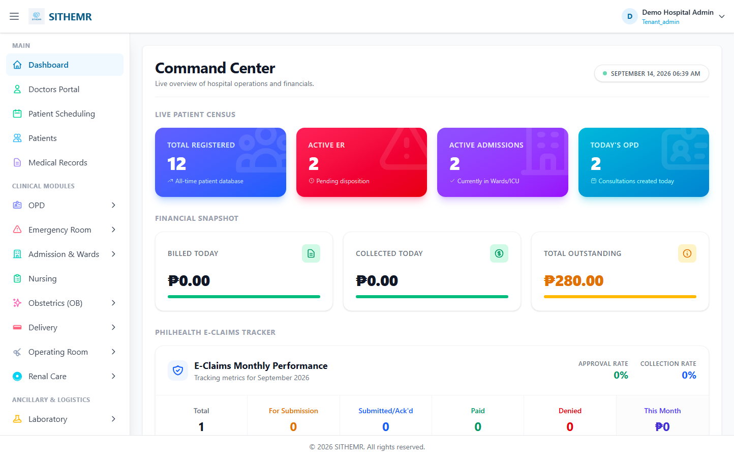
(177 KB)

Master Data
Tenant (Hospital)
Route: /masters/company | Type: crud | Status: PASS
[PASS]
Record created (1 fields filled)
✓ Test record created successfully
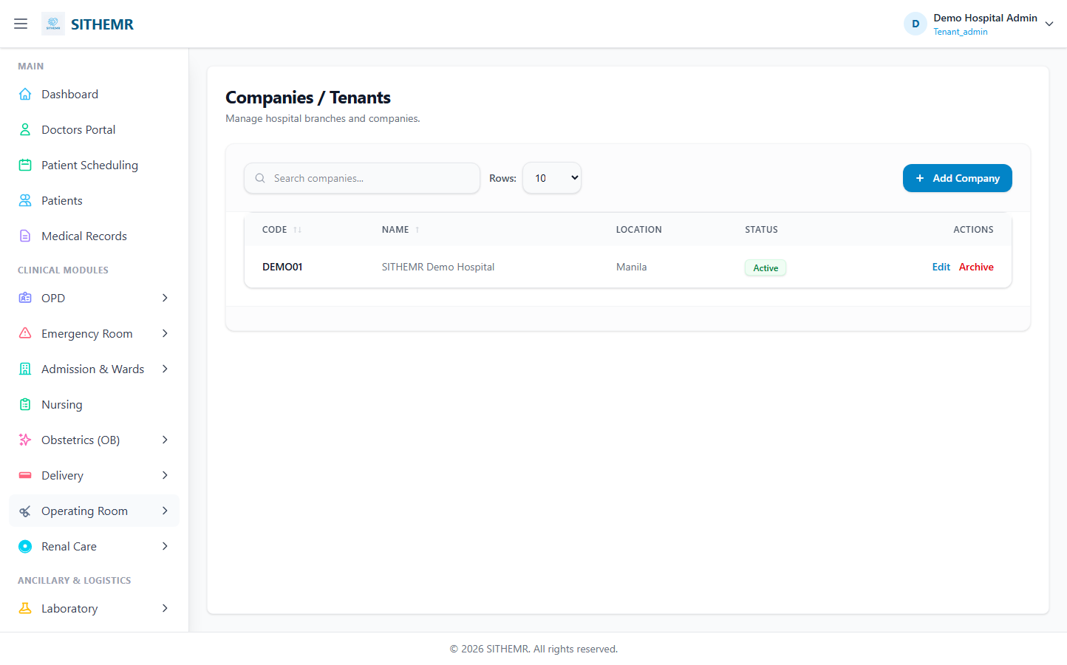
(63 KB)
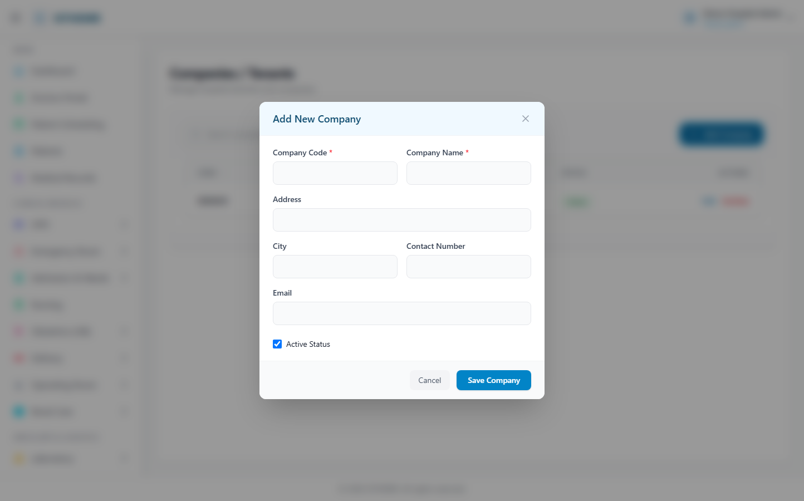
(127 KB)
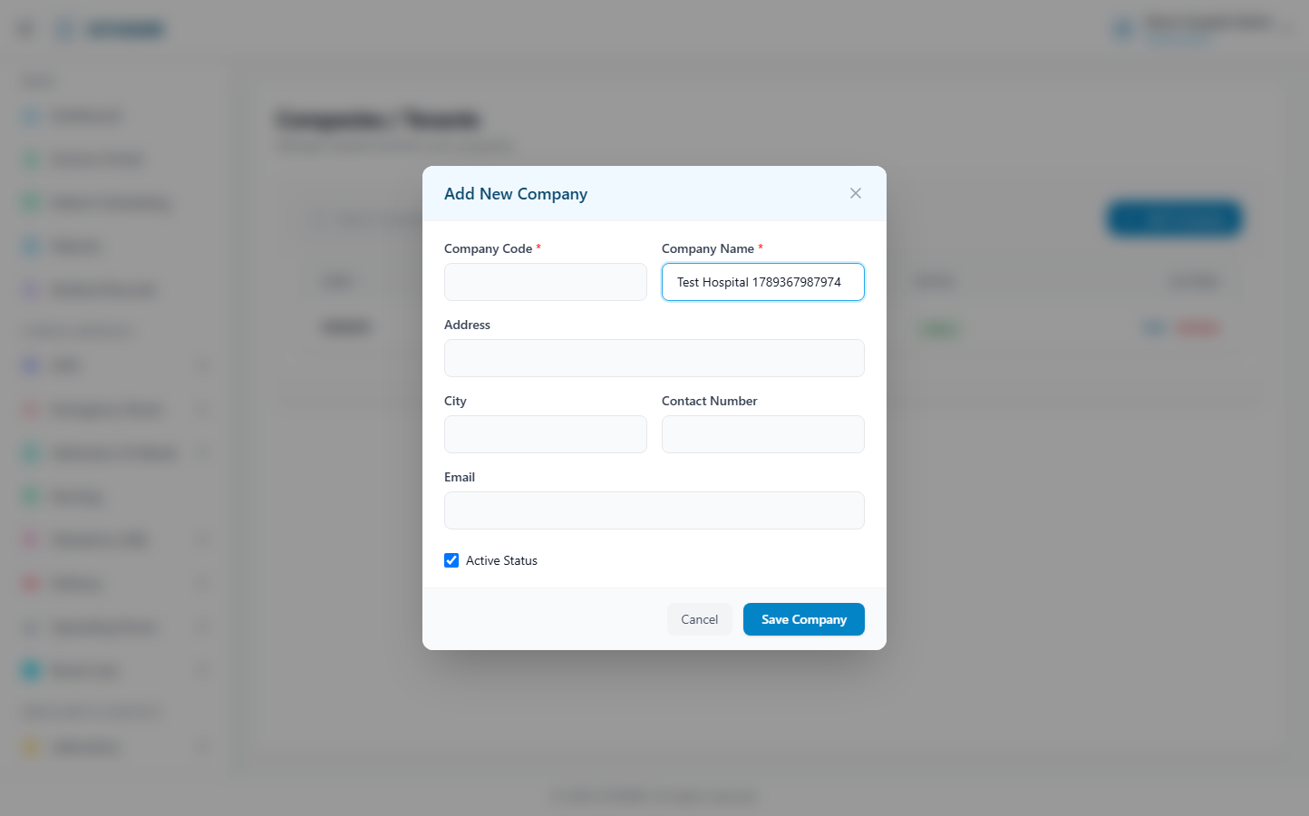
(129 KB)
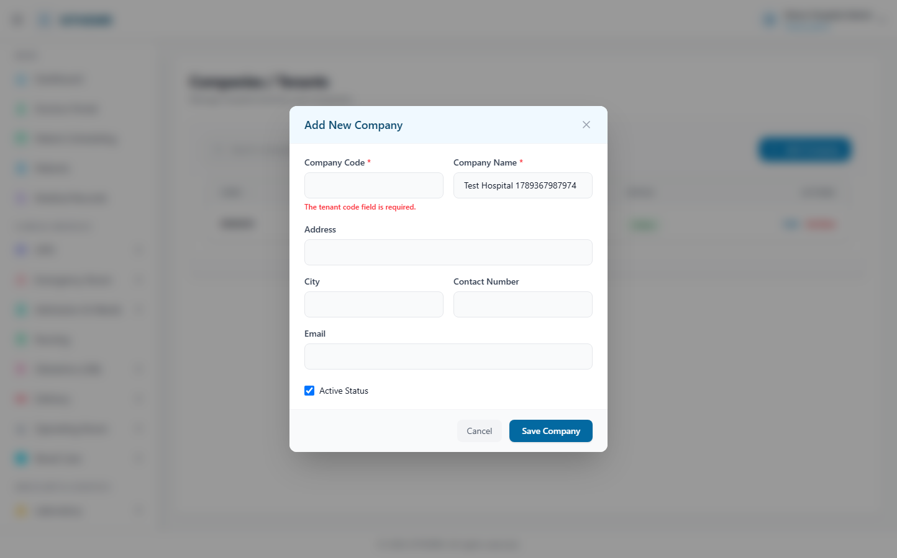
(130 KB)
Department
Route: /masters/department | Type: crud | Status: PASS
[PASS]
Record created (1 fields filled)
✓ Test record created successfully
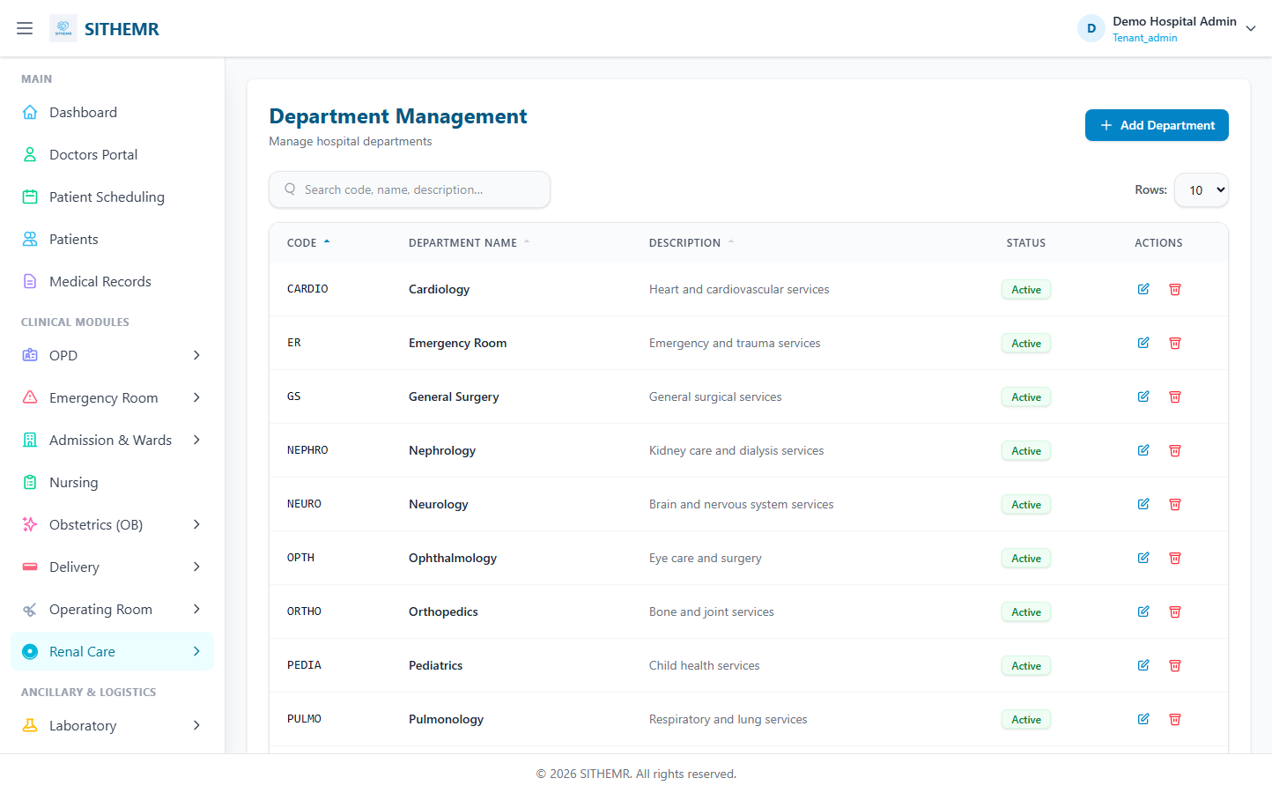
(104 KB)
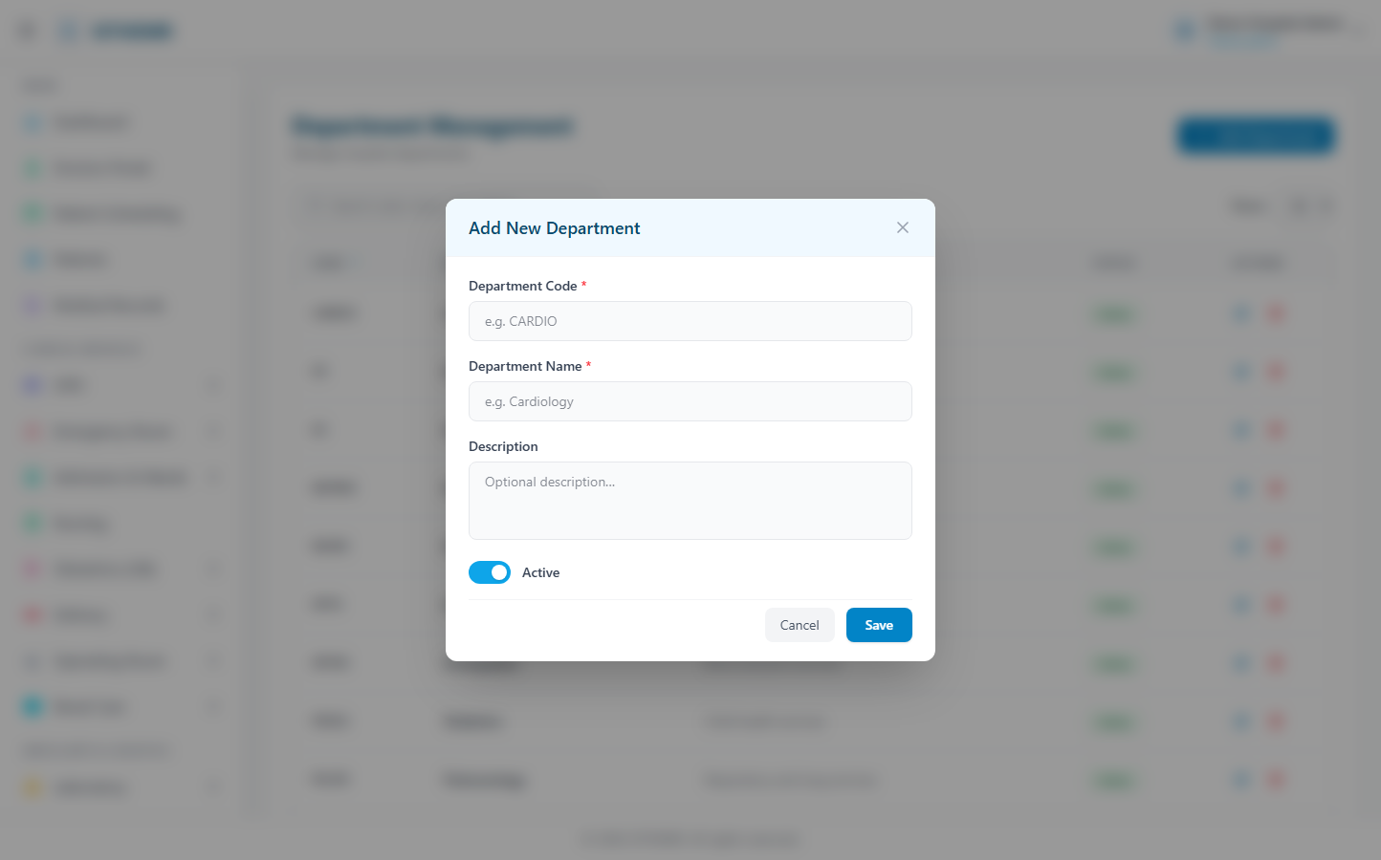
(183 KB)
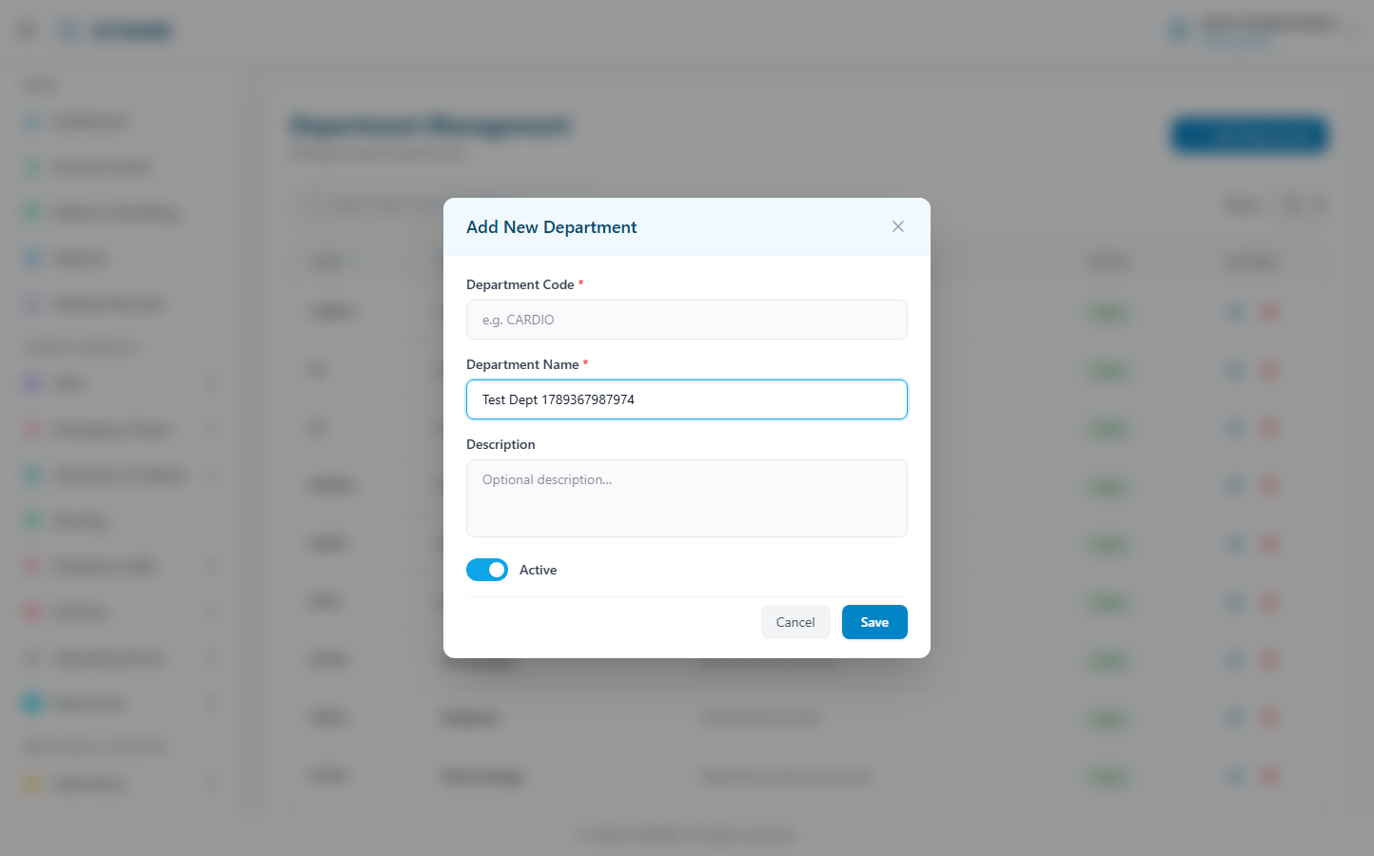
(184 KB)
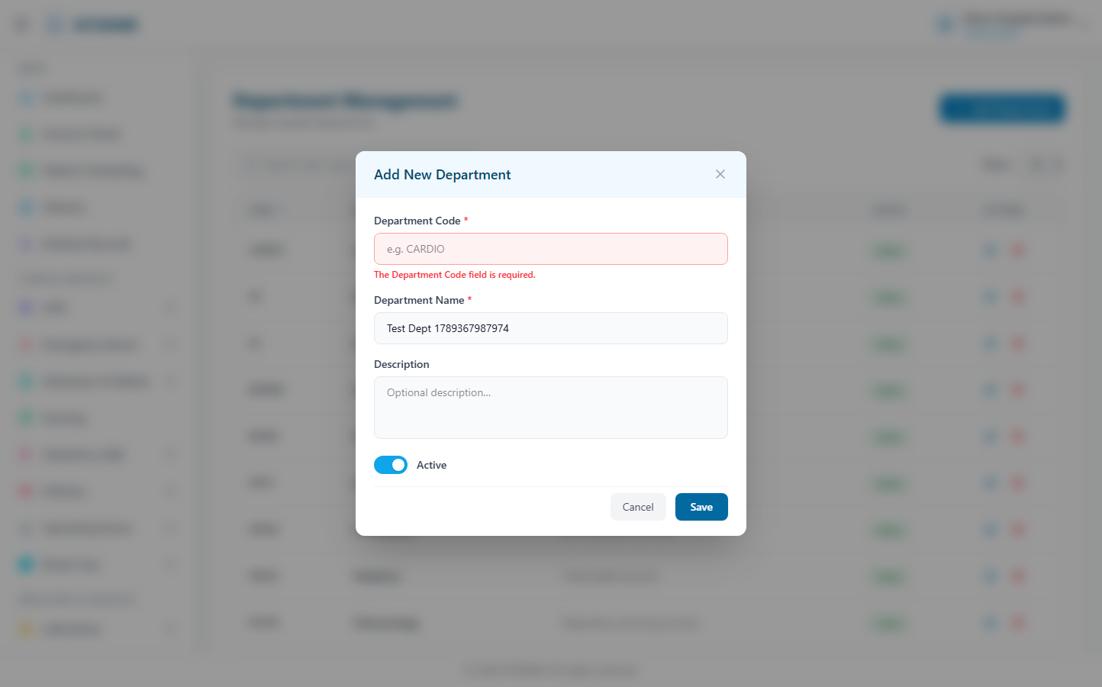
(184 KB)
Users
Route: /masters/users | Type: list-only | Status: PASS
[PASS]
Page loaded — User Management Manage system access and roles. Add User Rows: 10 25 50 USERNA
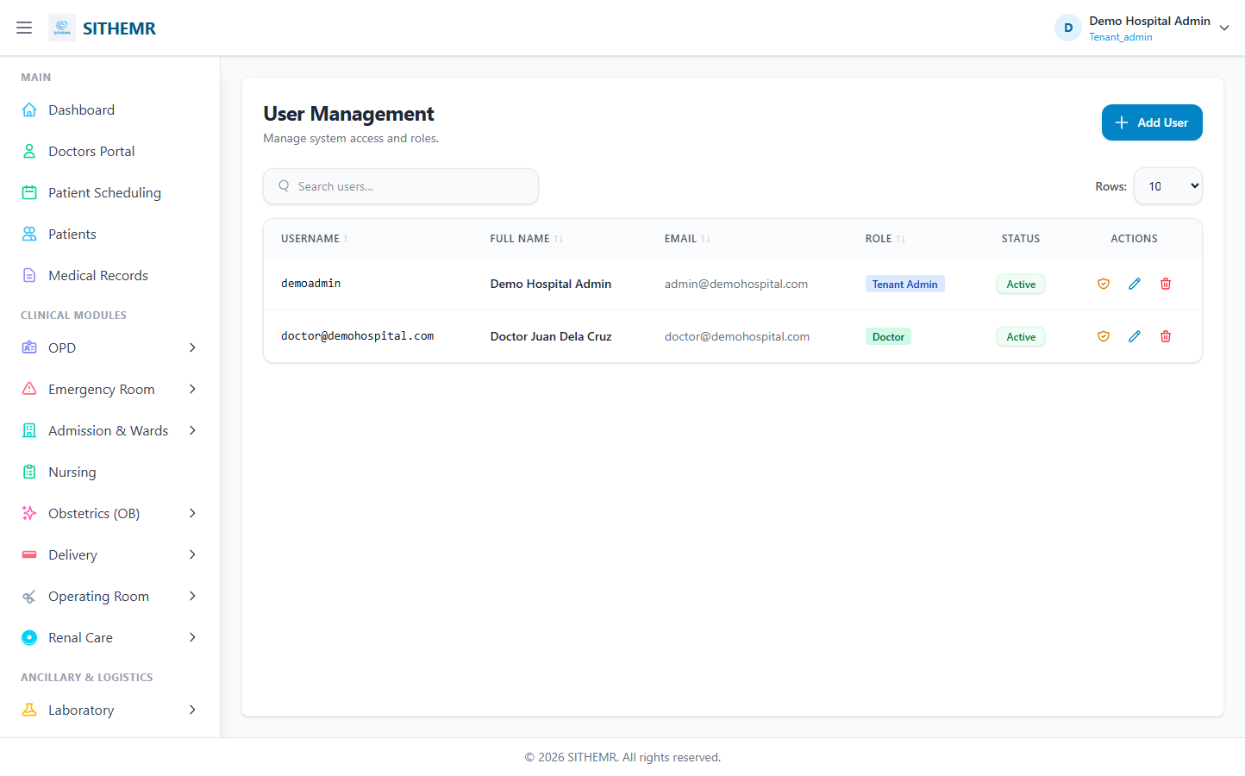
(71 KB)
Hospital
Route: /masters/hospital | Type: crud | Status: CHECK
[CHECK]
Created but no success toast — verify manually
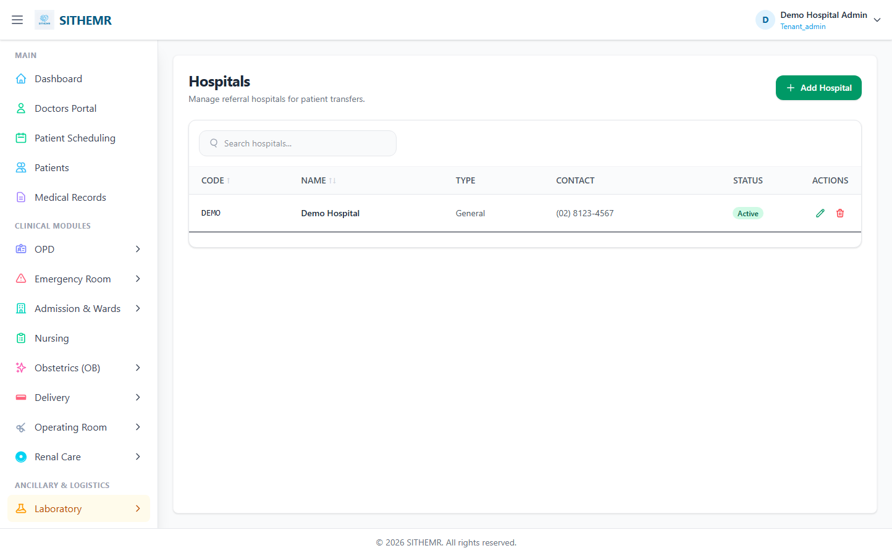
(59 KB)
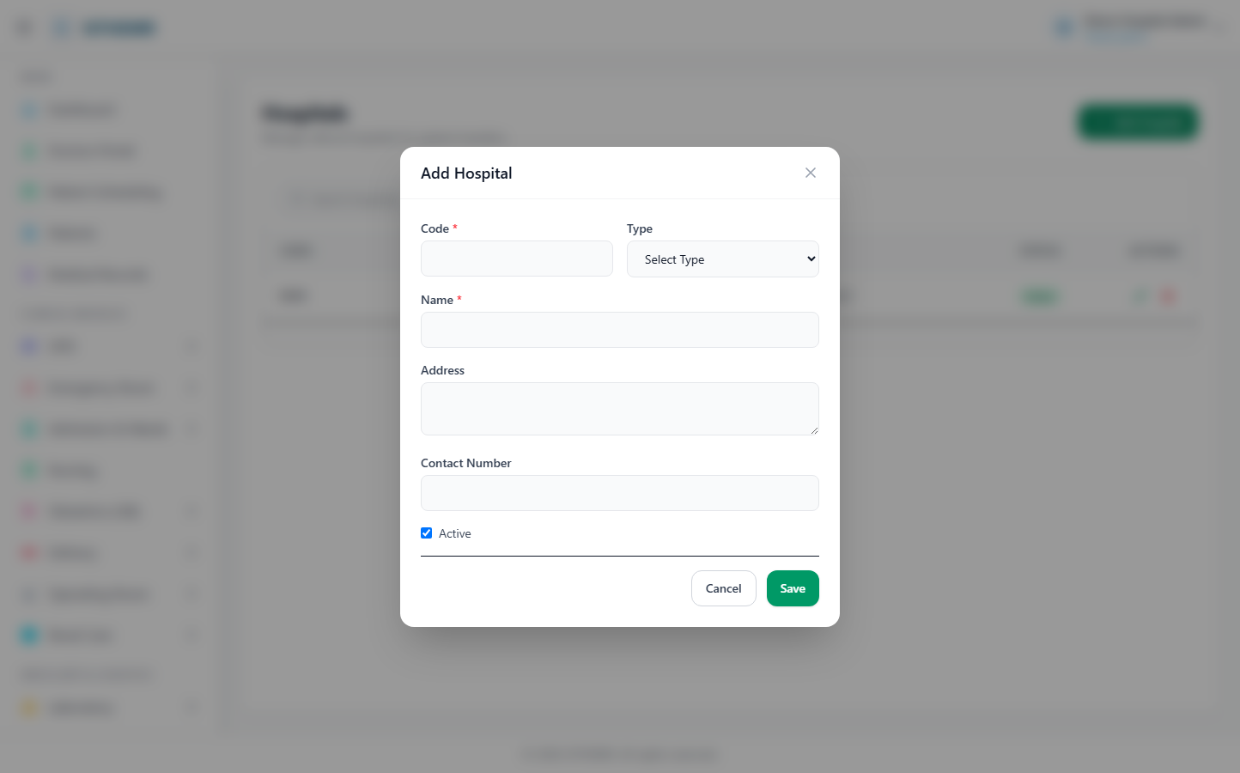
(123 KB)
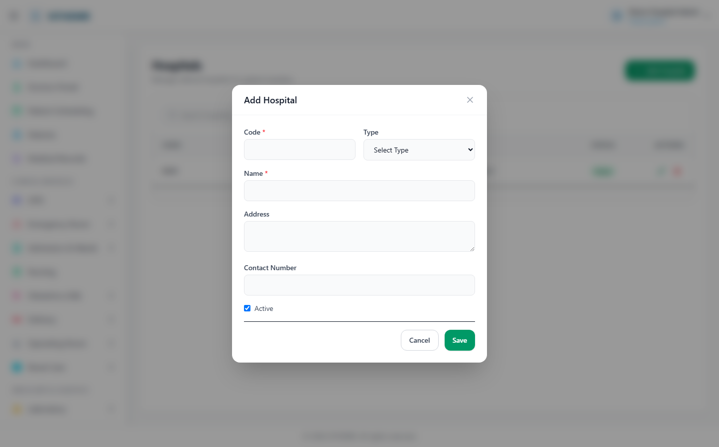
(123 KB)
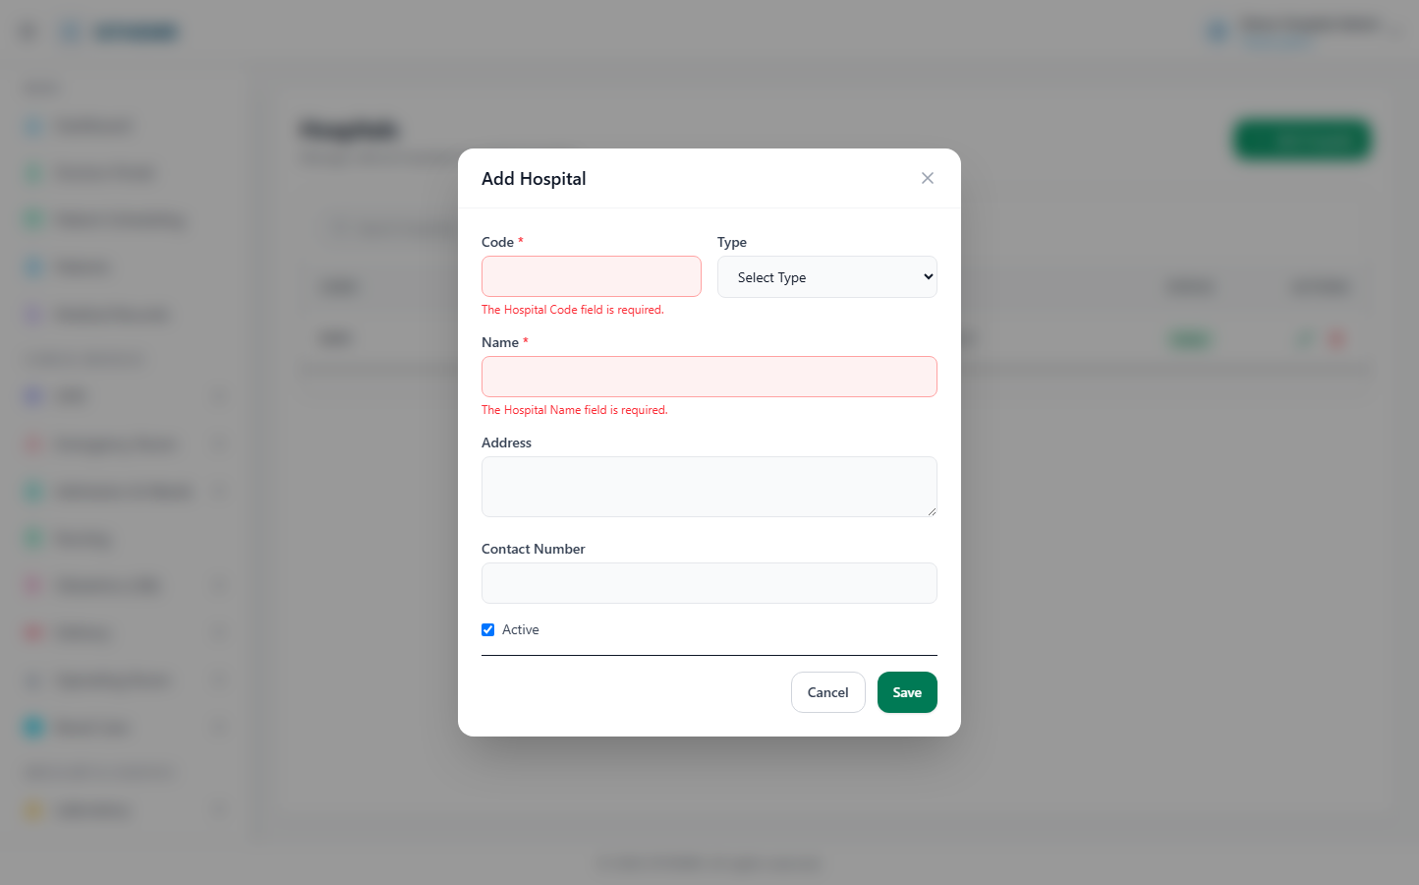
(125 KB)
Permissions
Route: /masters/permissions | Type: list-only | Status: PASS
[PASS]
Page loaded — Permission Management Manage system permissions Add Permission Rows: 10 25 50
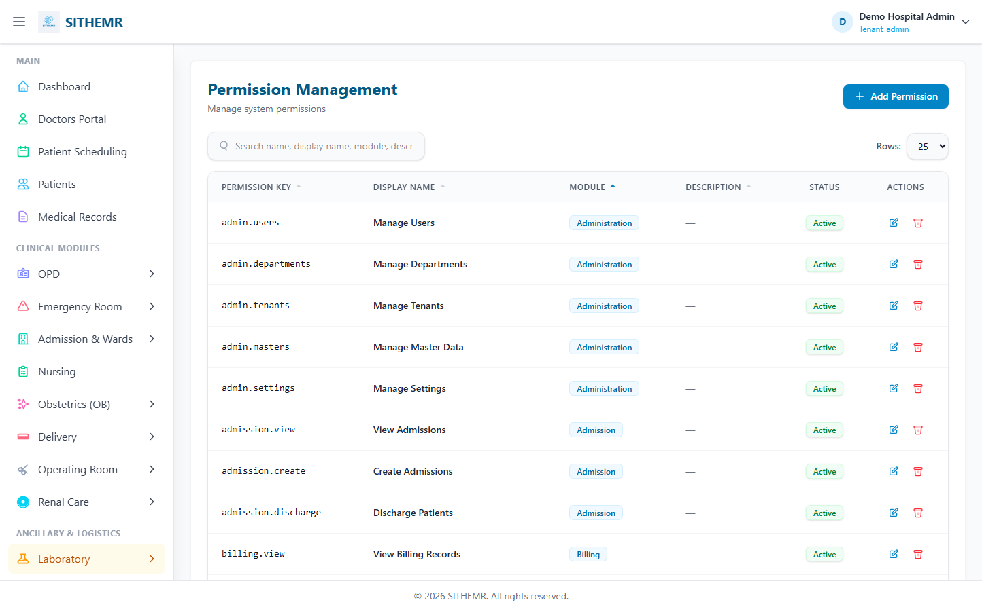
(111 KB)
Country
Route: /masters/country | Type: crud | Status: PASS
[PASS]
Record created (1 fields filled)
✓ Test record created successfully
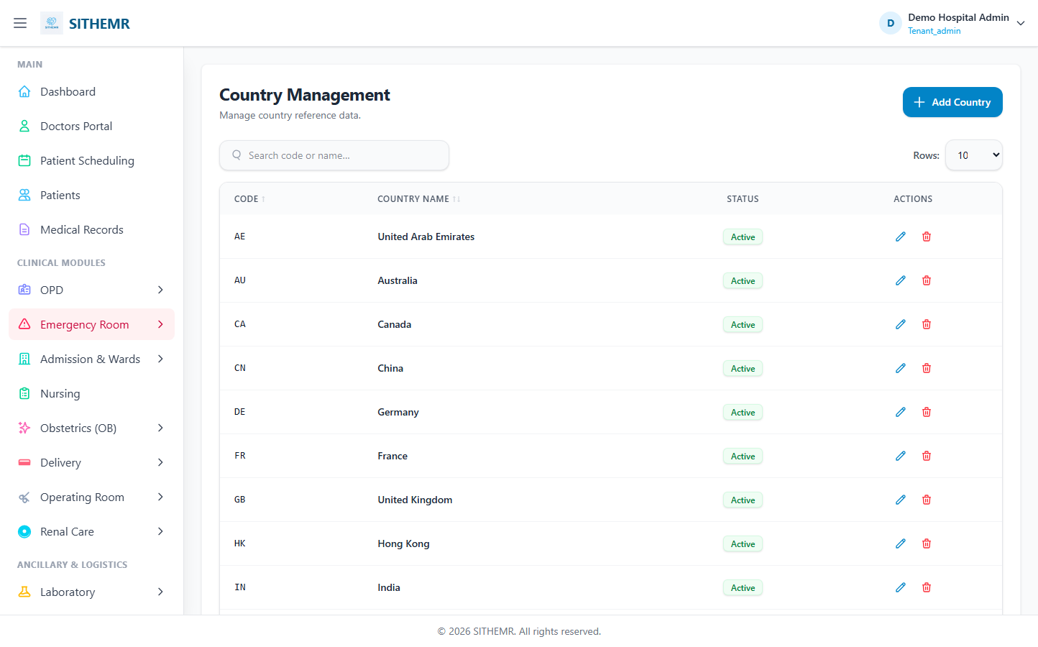
(85 KB)
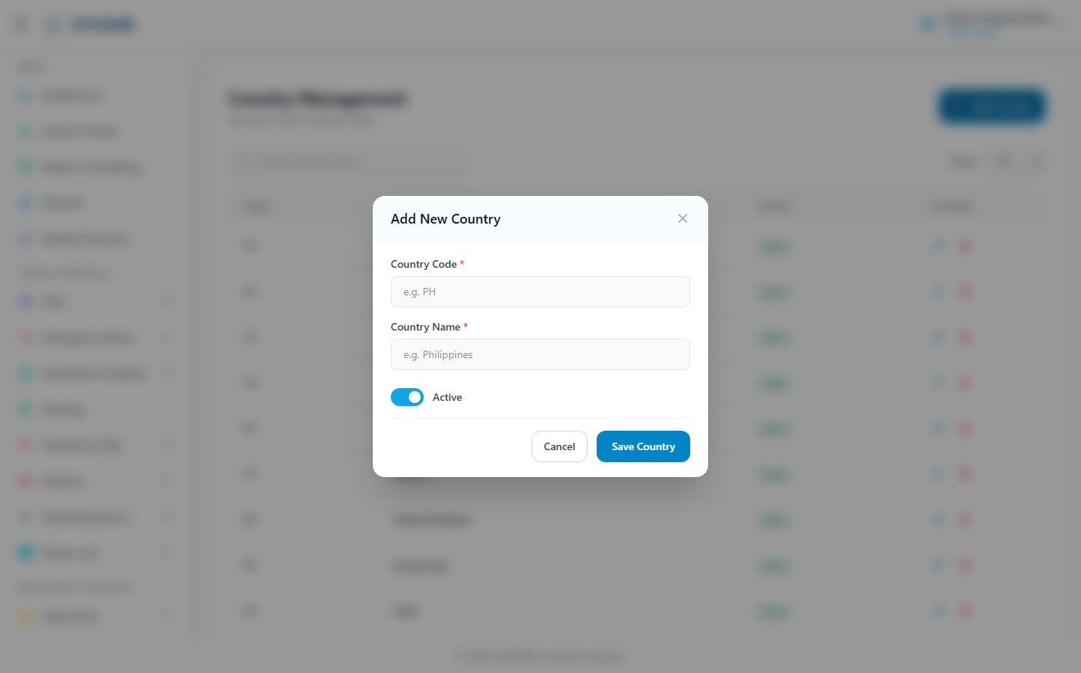
(169 KB)
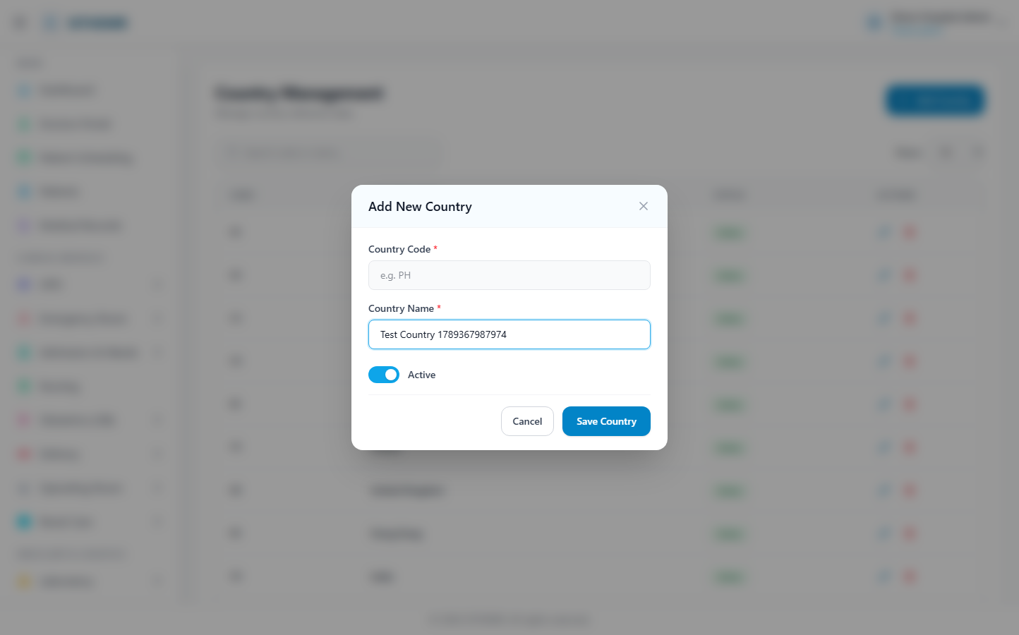
(170 KB)
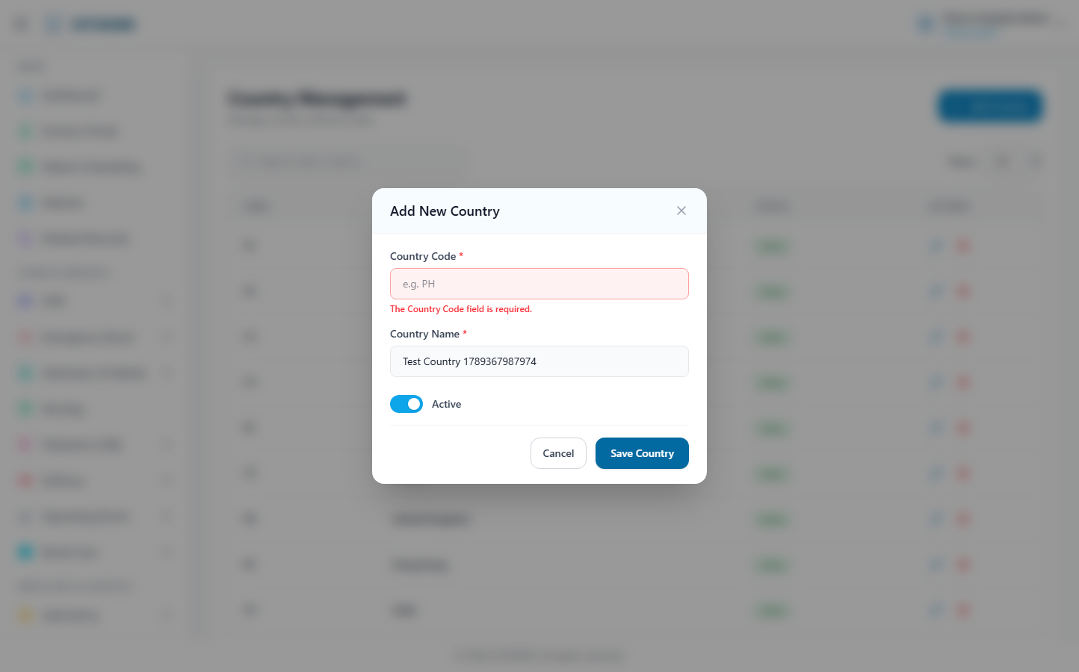
(171 KB)
Region
Route: /masters/region | Type: crud | Status: PASS
[PASS]
Record created (1 fields filled)
✓ Test record created successfully
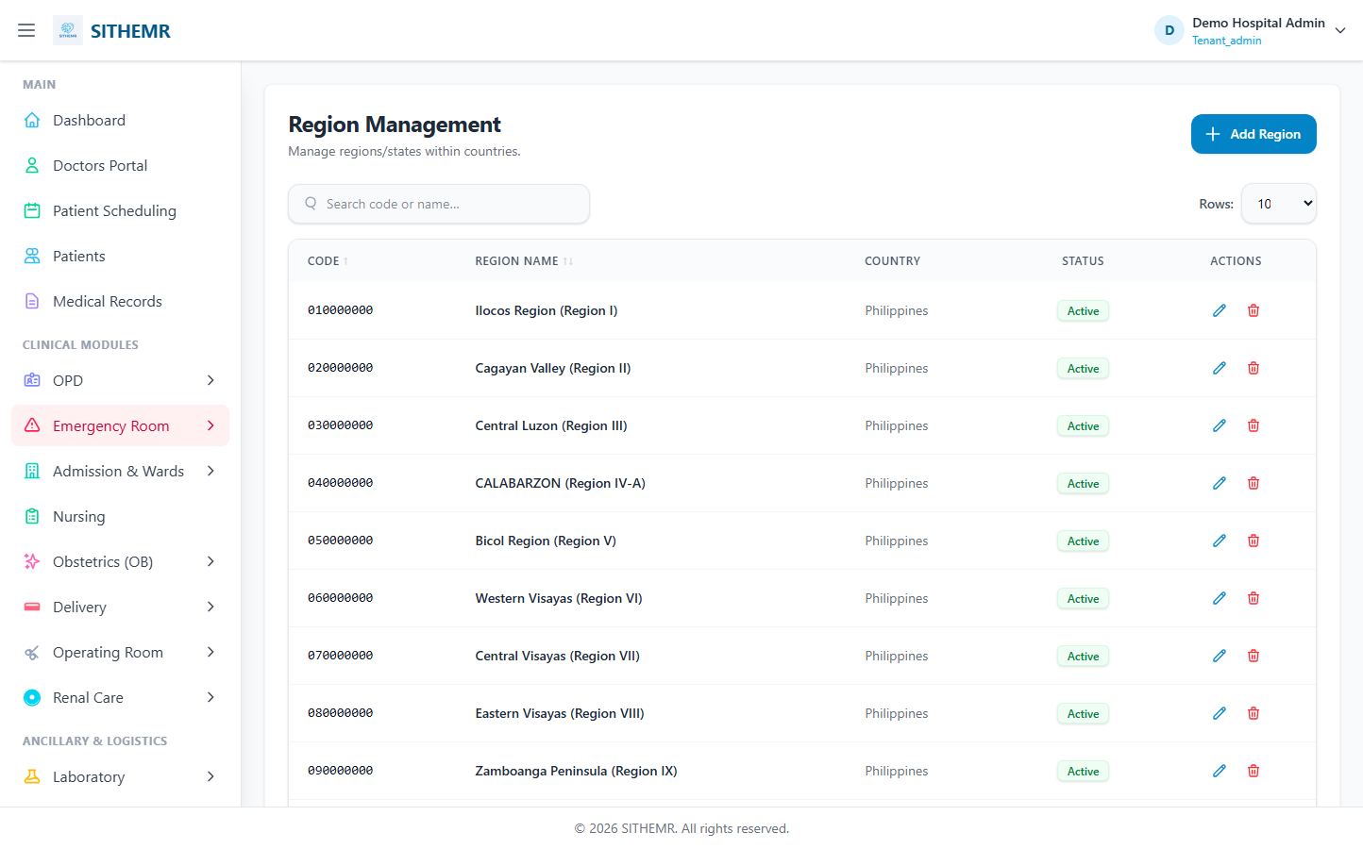
(109 KB)
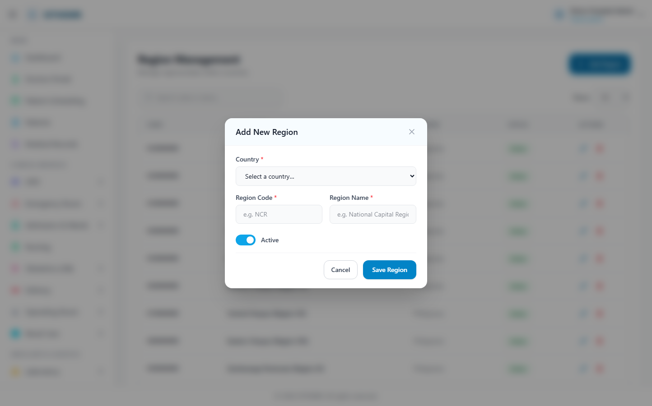
(196 KB)
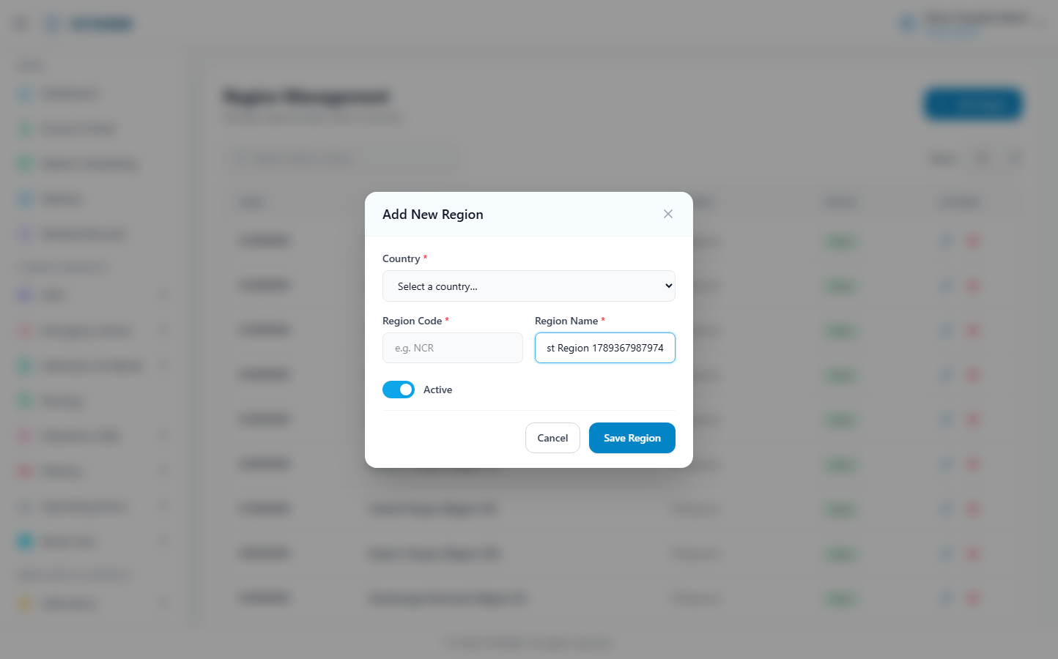
(197 KB)
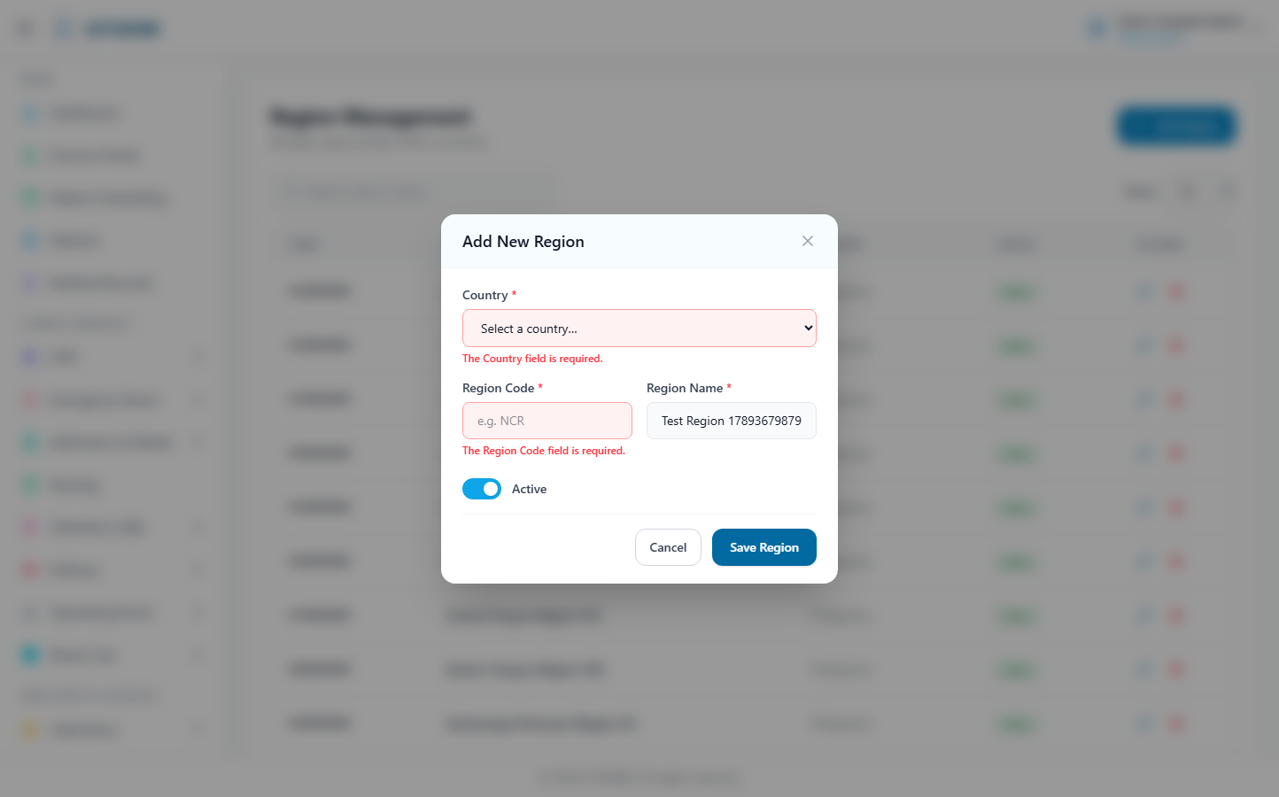
(199 KB)
Province/State
Route: /masters/province | Type: crud | Status: PASS
[PASS]
Record created (1 fields filled)
✓ Test record created successfully
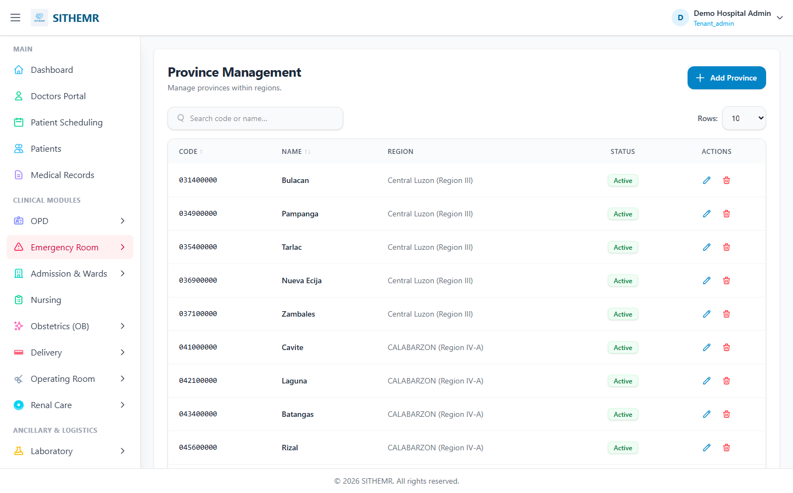
(103 KB)
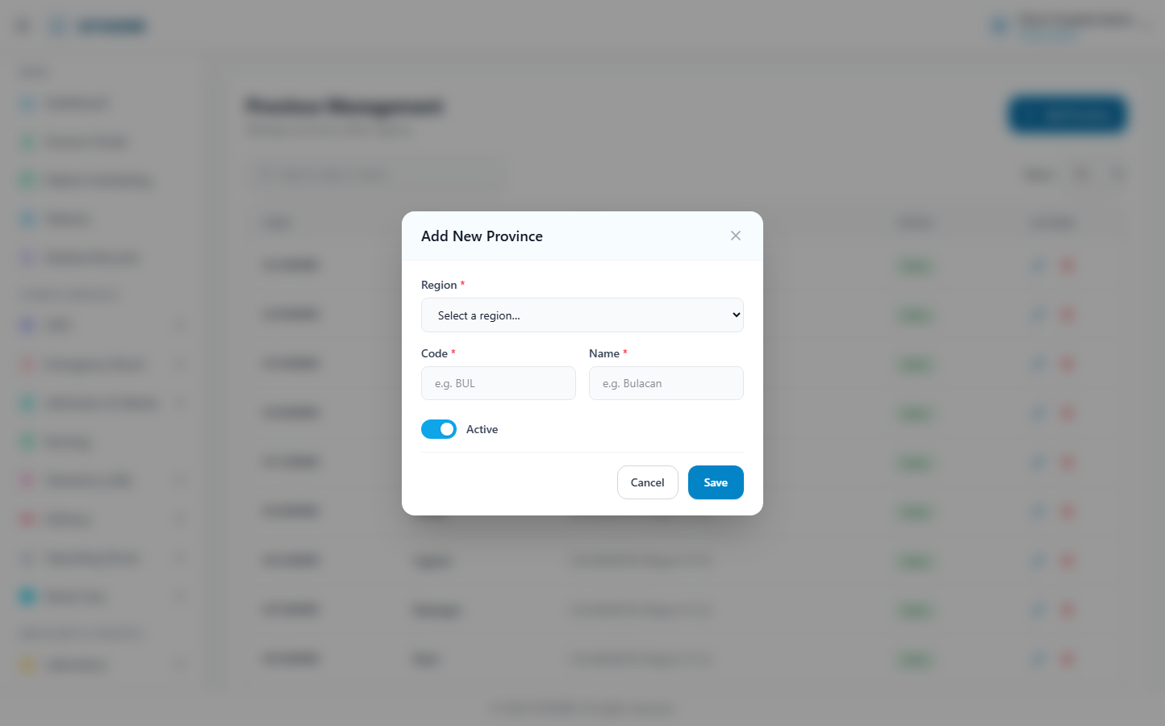
(184 KB)
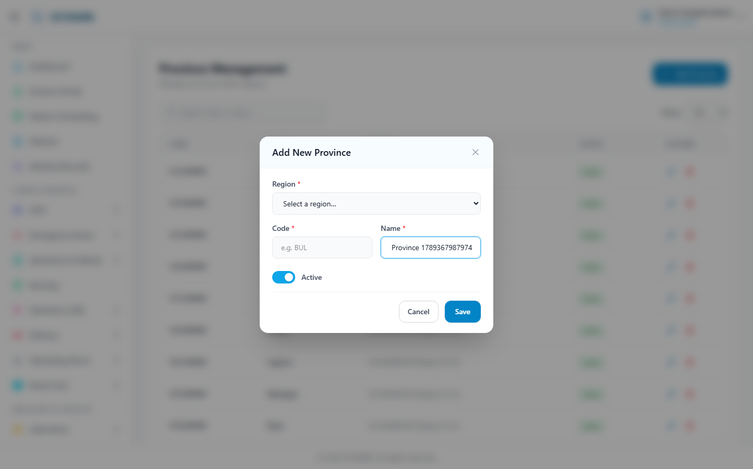
(186 KB)
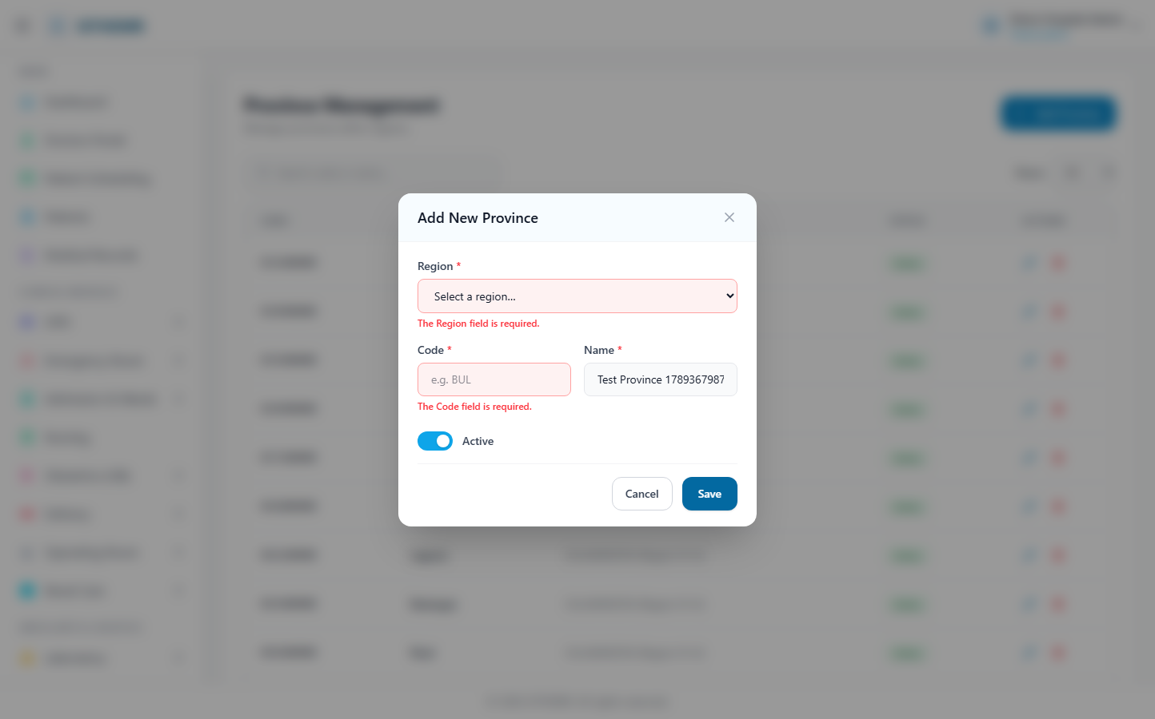
(187 KB)
City/Municipality
Route: /masters/city | Type: crud | Status: PASS
[PASS]
Record created (1 fields filled)
✓ Test record created successfully
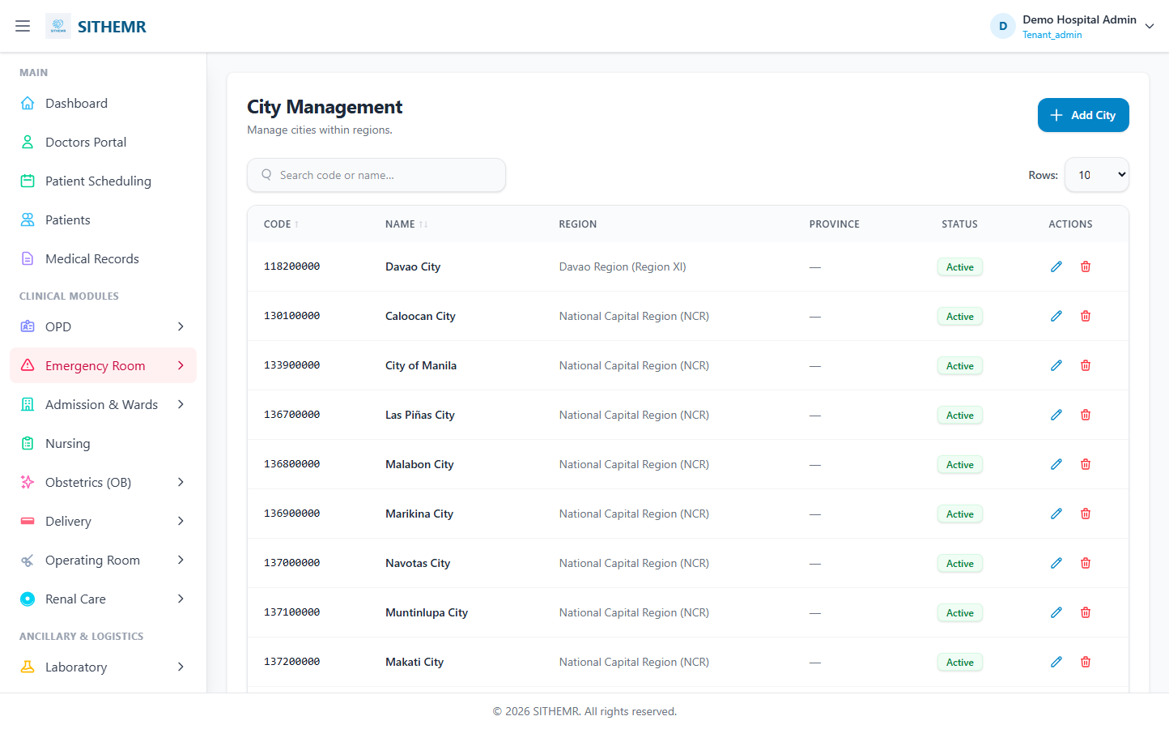
(109 KB)
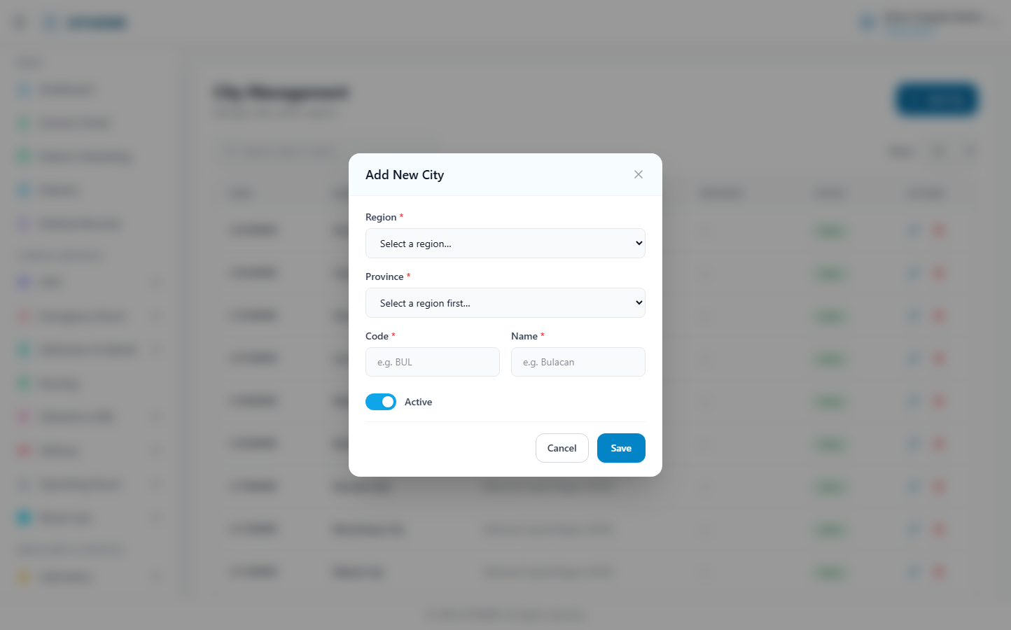
(198 KB)
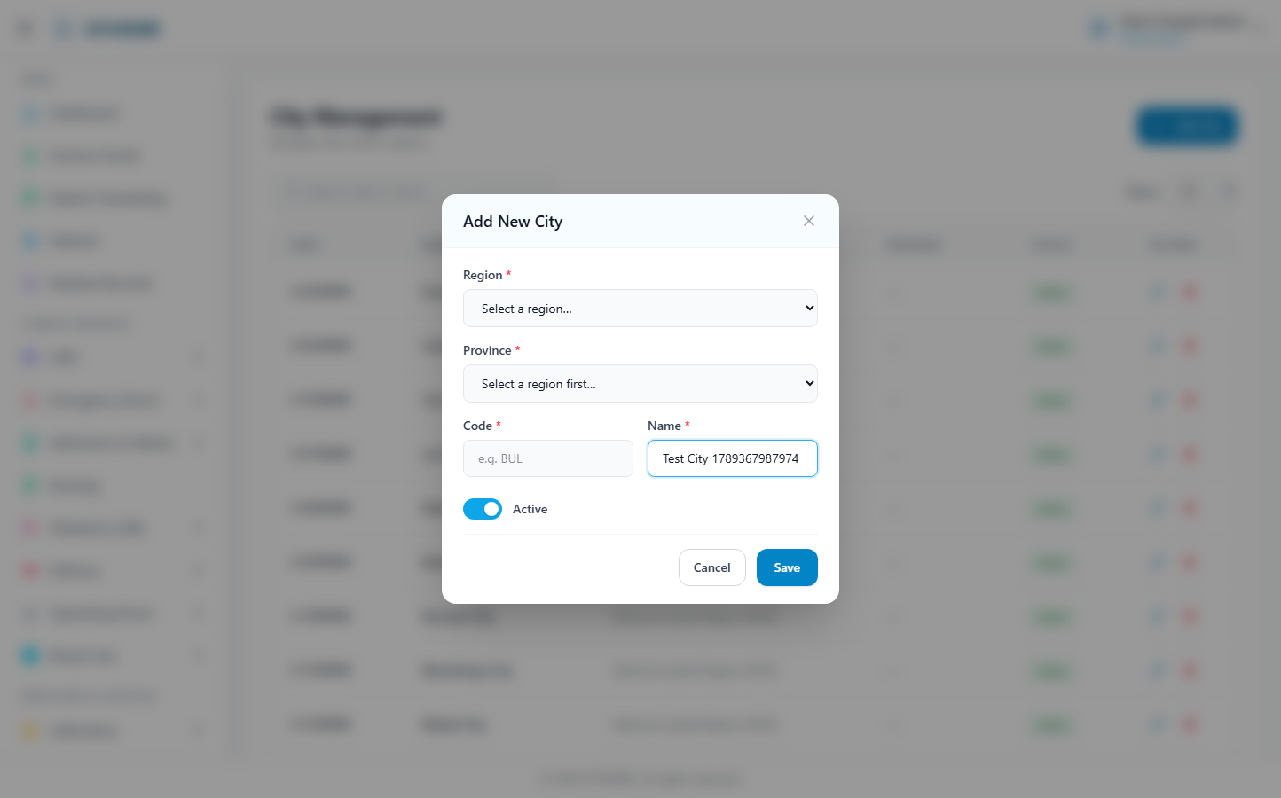
(199 KB)
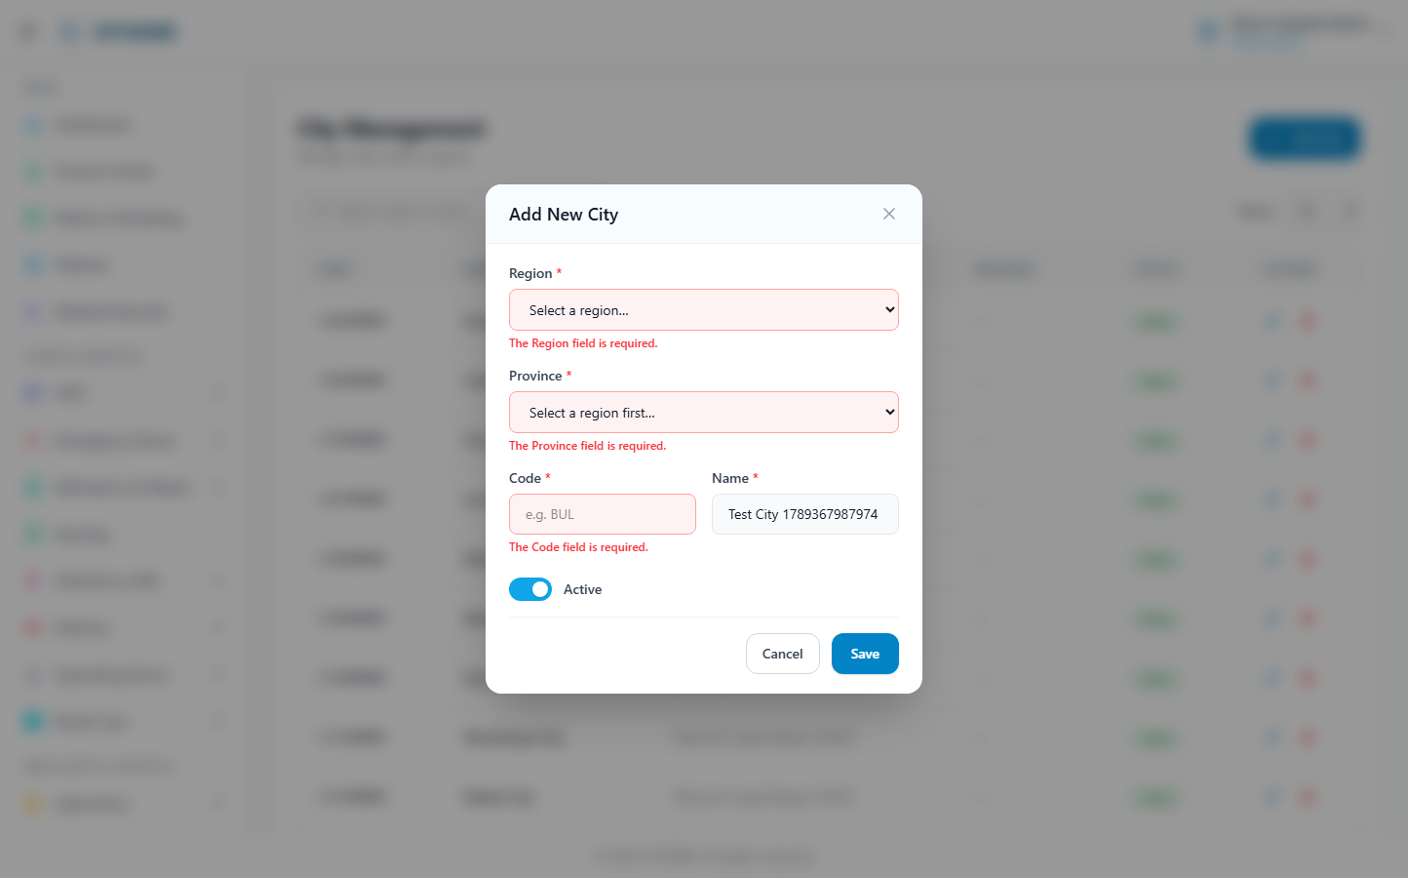
(201 KB)
Barangay
Route: /masters/barangay | Type: crud | Status: PASS
[PASS]
Record created (1 fields filled)
✓ Test record created successfully
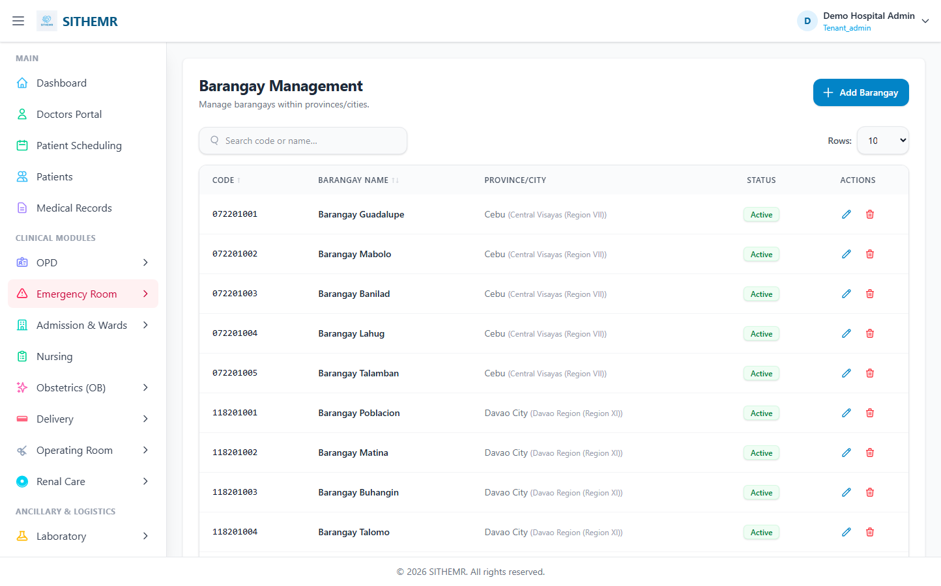
(117 KB)
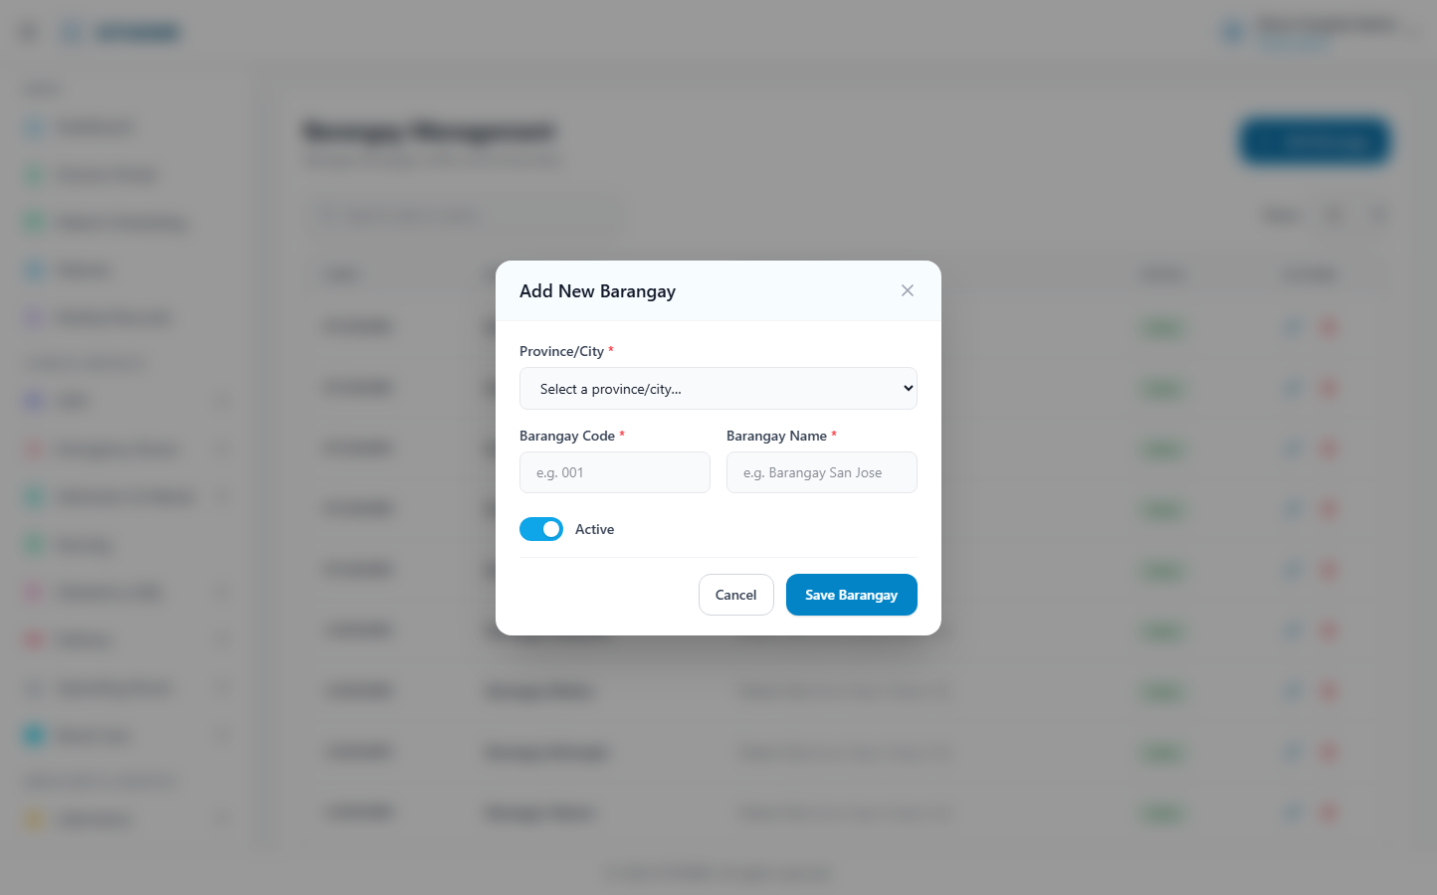
(198 KB)
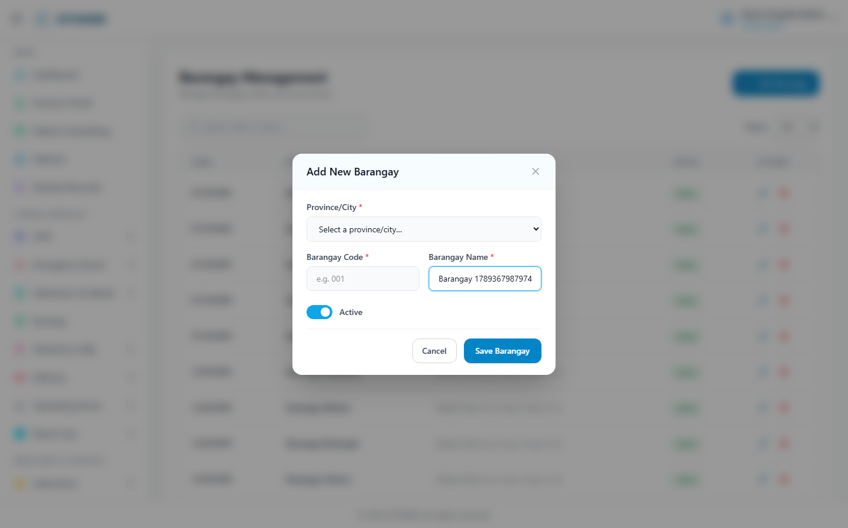
(199 KB)
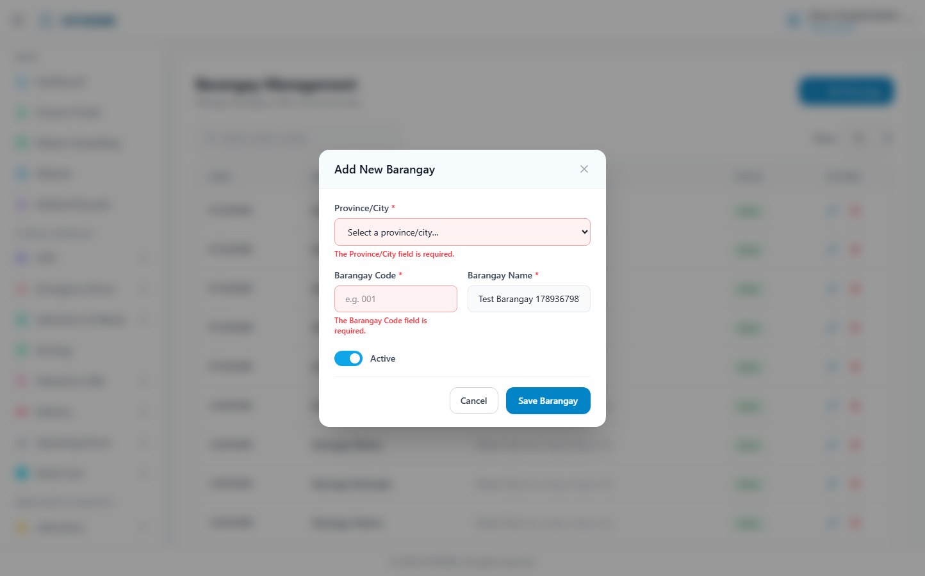
(202 KB)
Religion
Route: /masters/religion | Type: crud | Status: PASS
[PASS]
Record created (1 fields filled)
✓ Test record created successfully
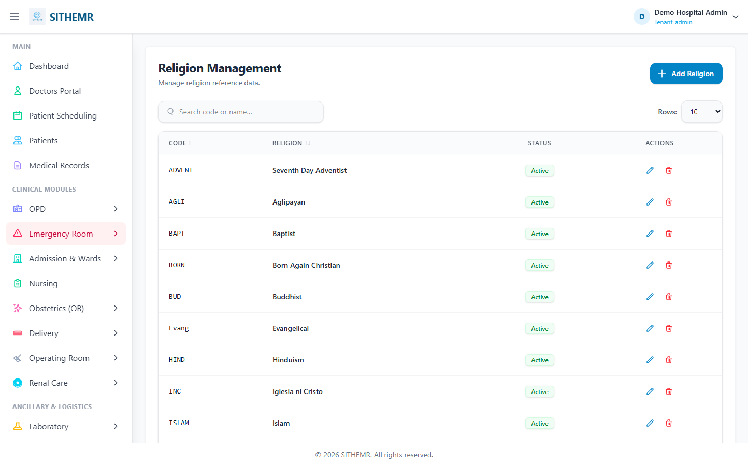
(88 KB)
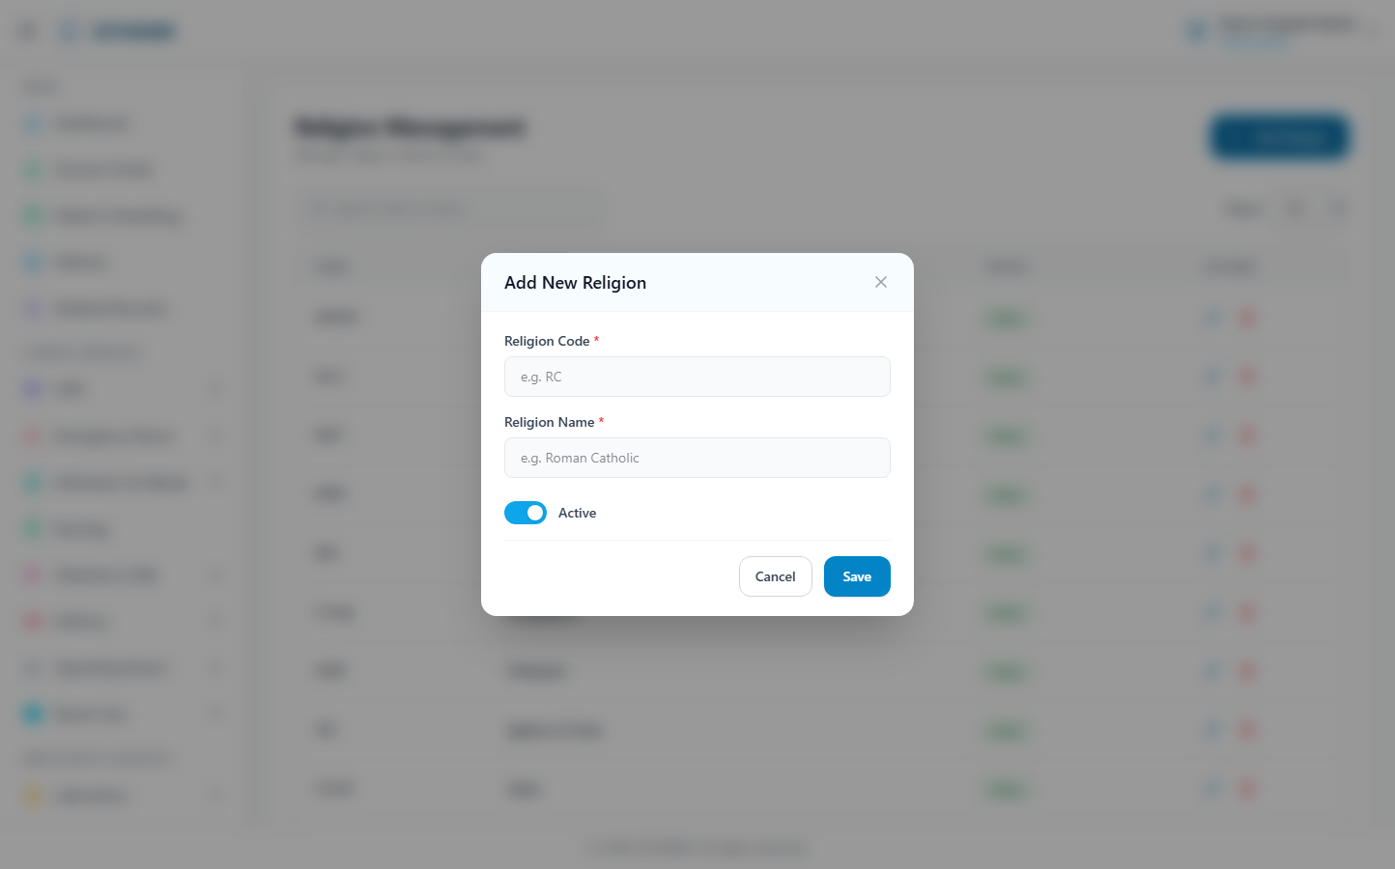
(173 KB)
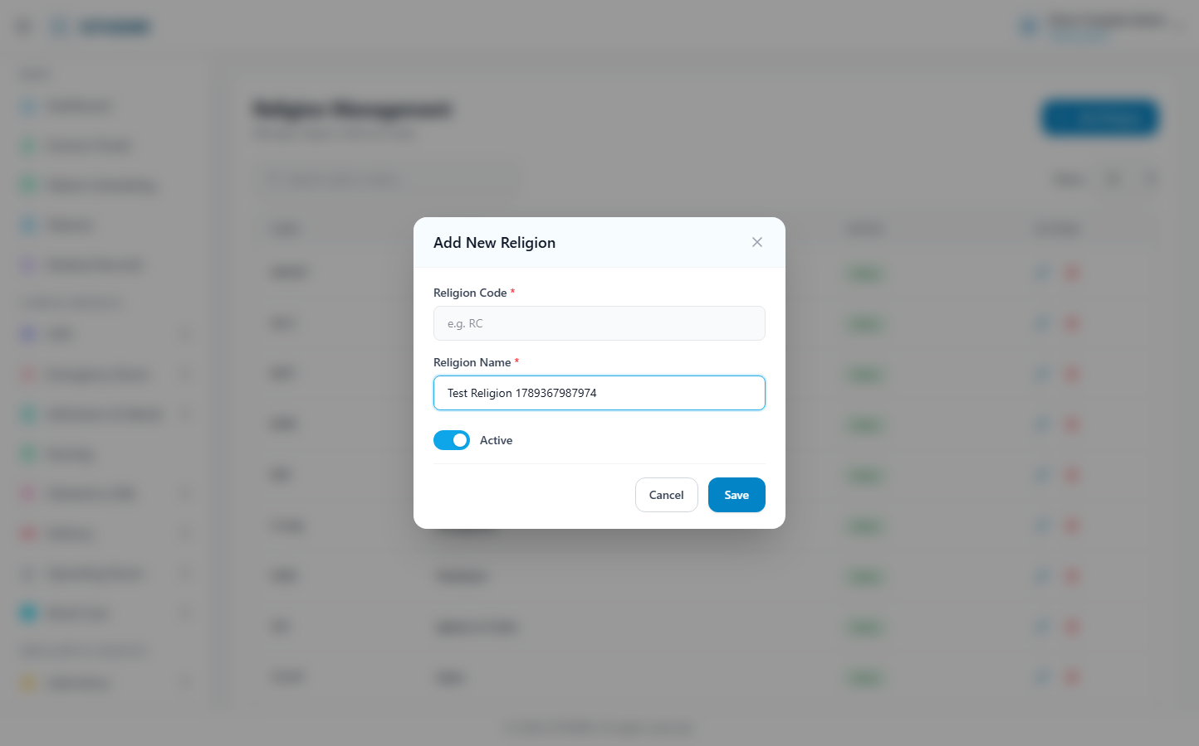
(173 KB)
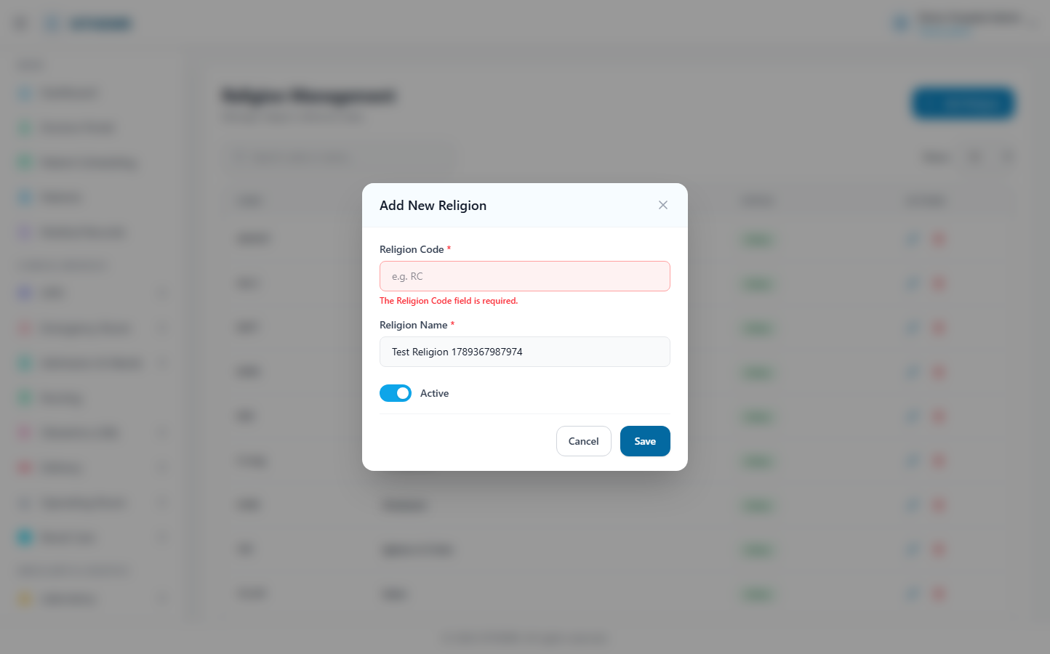
(174 KB)
Gender
Route: /masters/gender | Type: crud | Status: PASS
[PASS]
Record created (1 fields filled)
✓ Test record created successfully
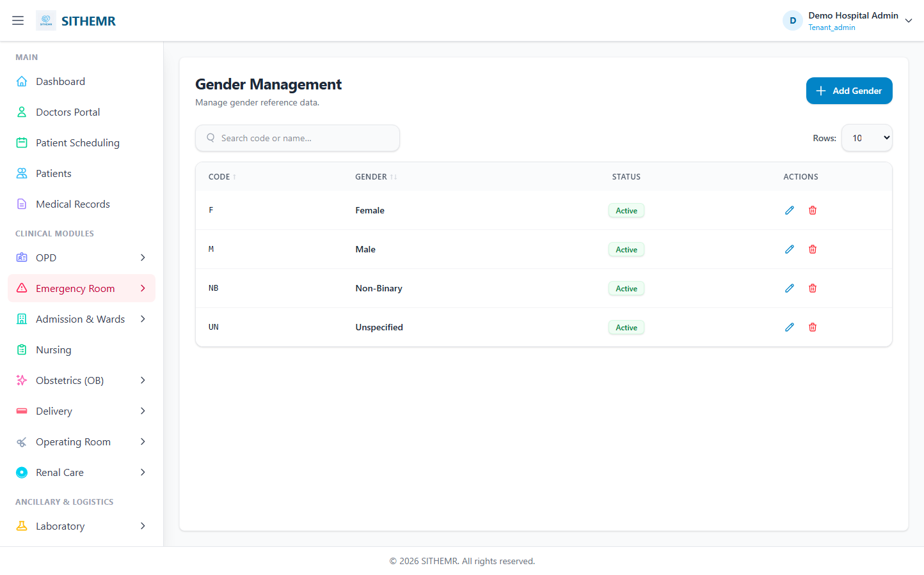
(67 KB)
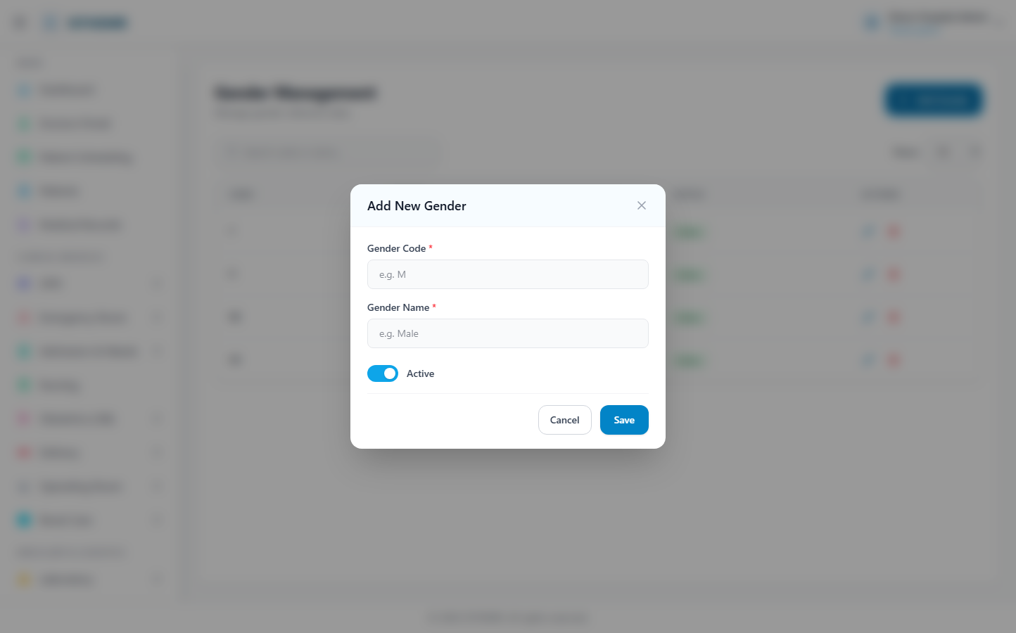
(138 KB)
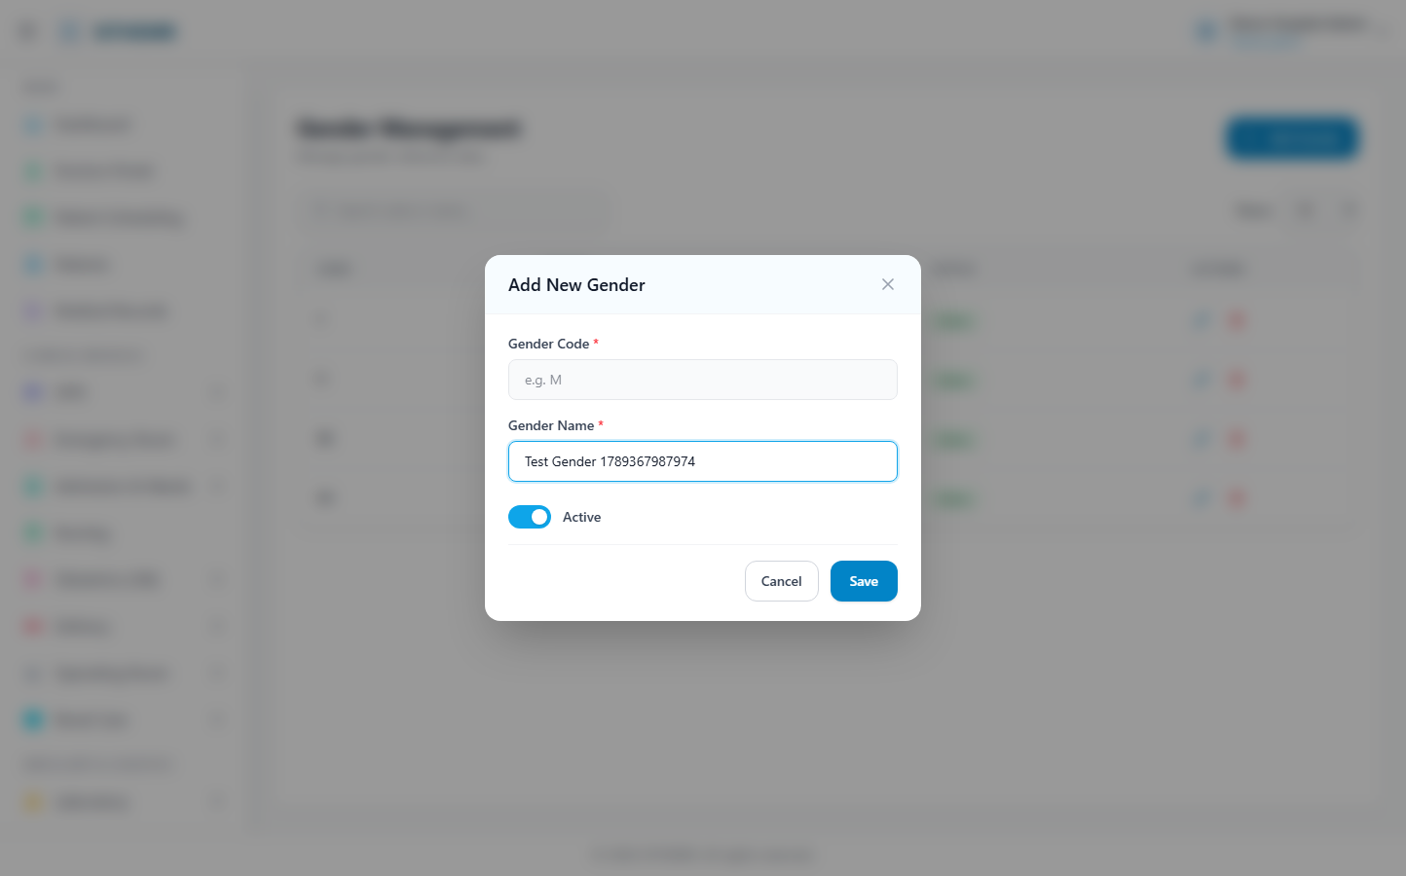
(139 KB)
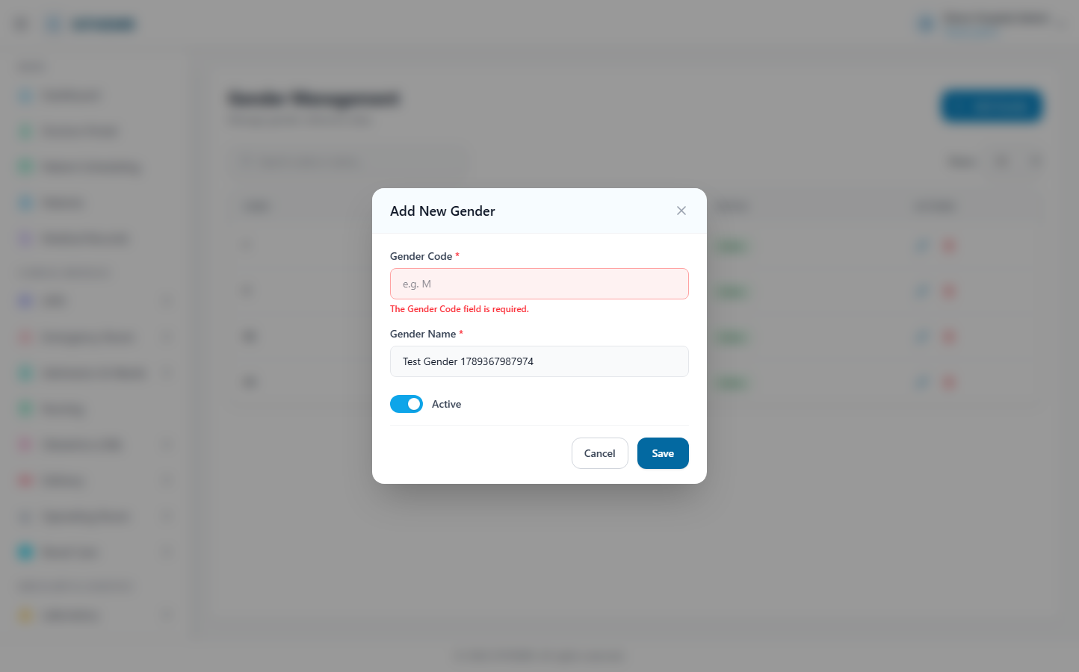
(140 KB)
Civil Status
Route: /masters/civil-status | Type: crud | Status: PASS
[PASS]
Record created (1 fields filled)
✓ Test record created successfully
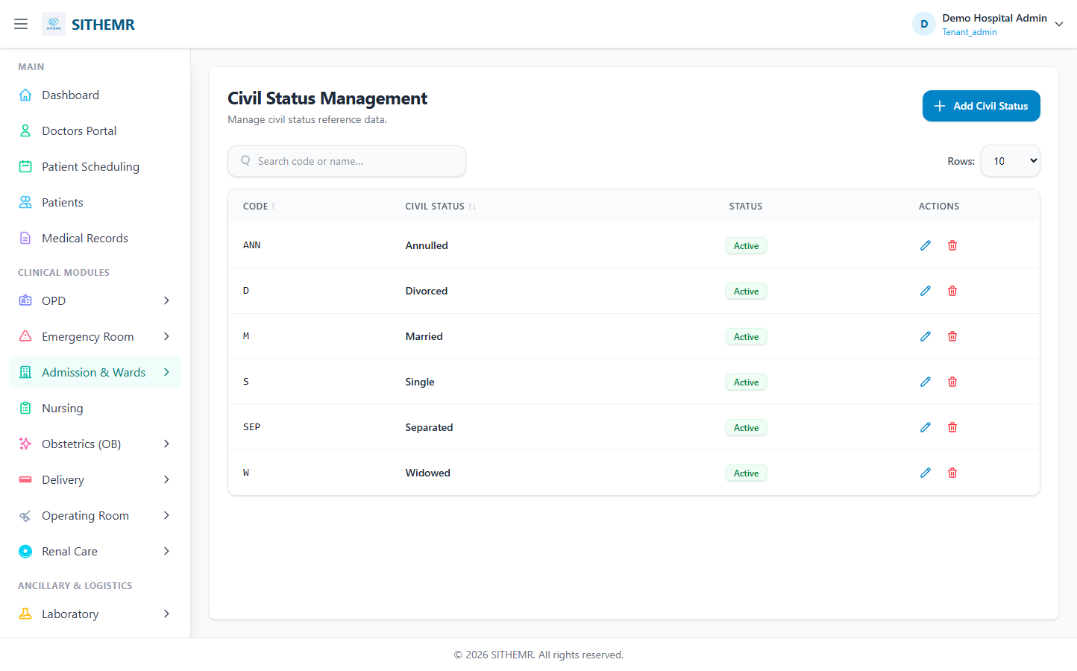
(75 KB)
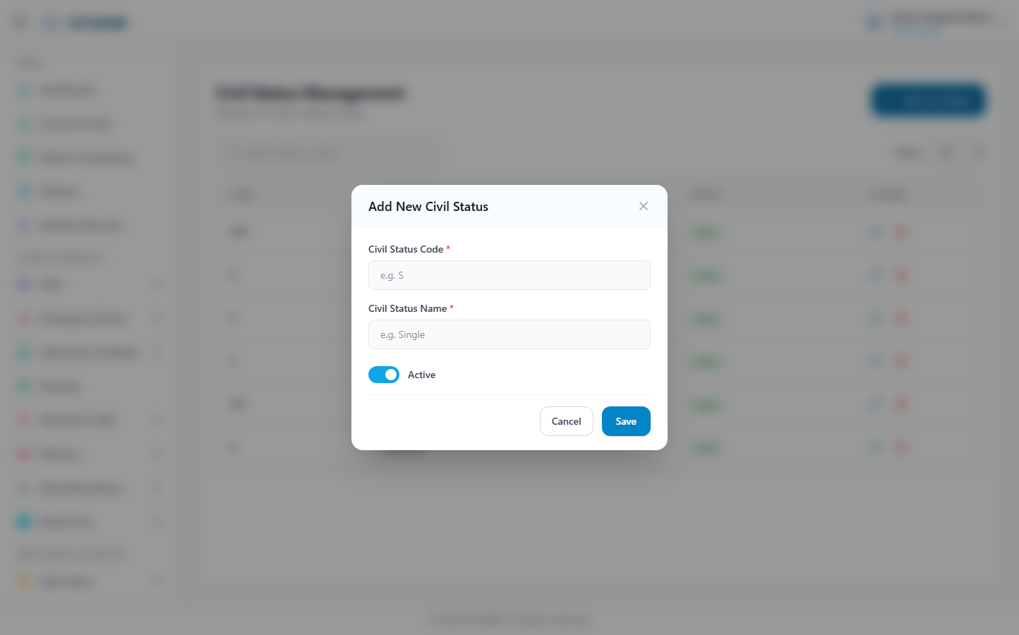
(151 KB)
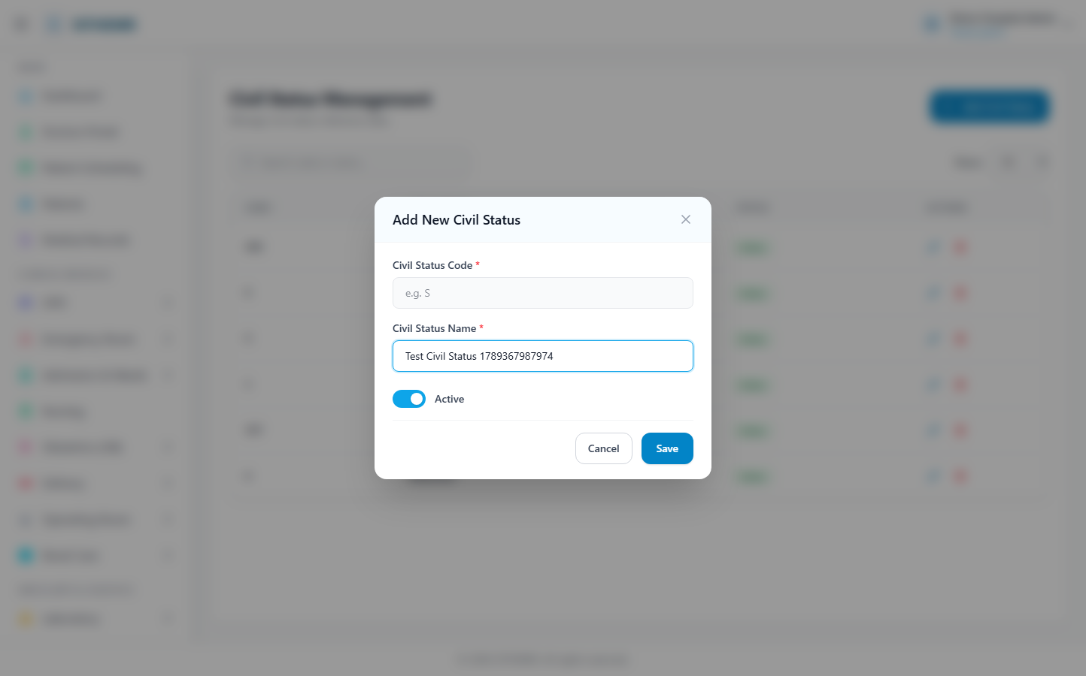
(152 KB)
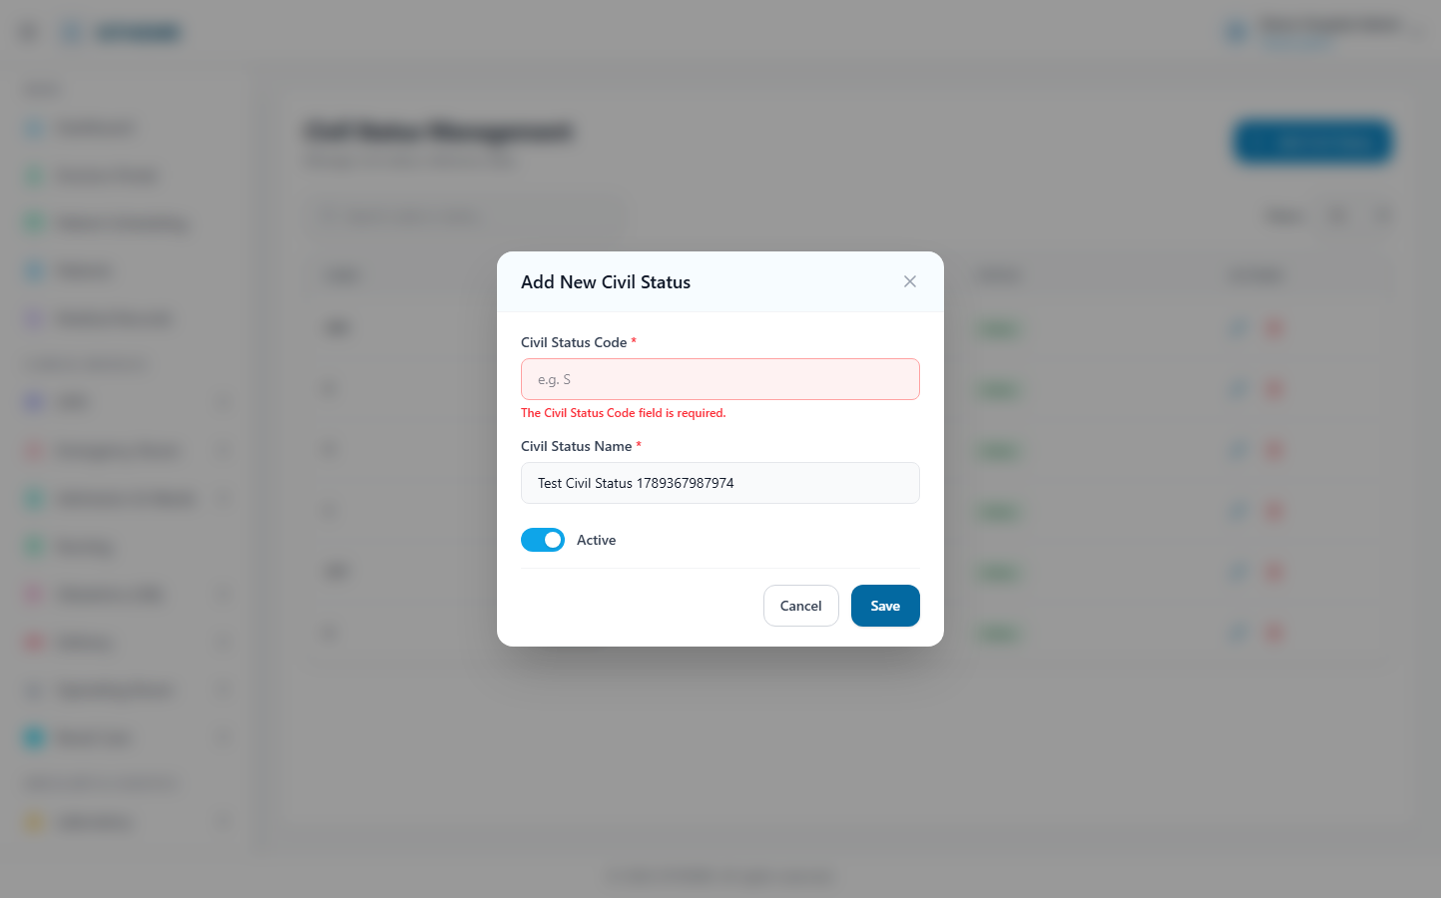
(153 KB)
Nationality
Route: /masters/nationality | Type: crud | Status: PASS
[PASS]
Record created (1 fields filled)
✓ Test record created successfully
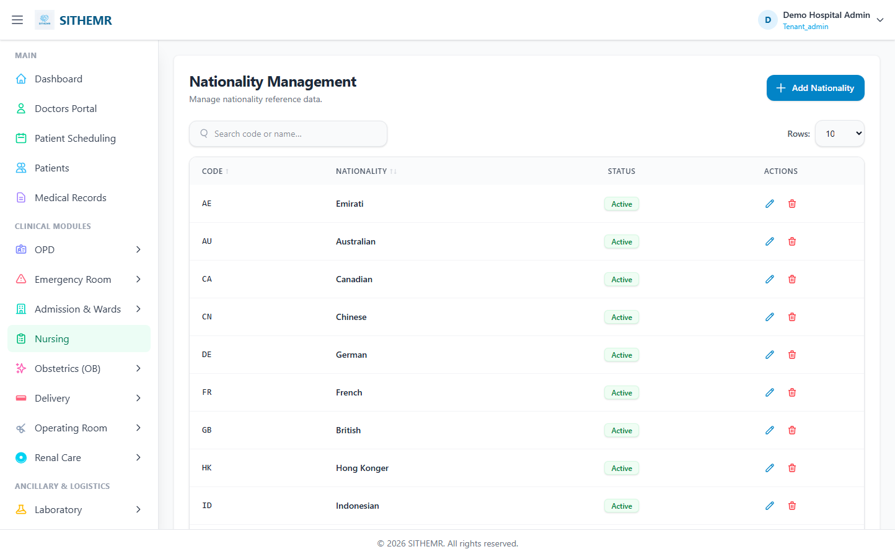
(84 KB)
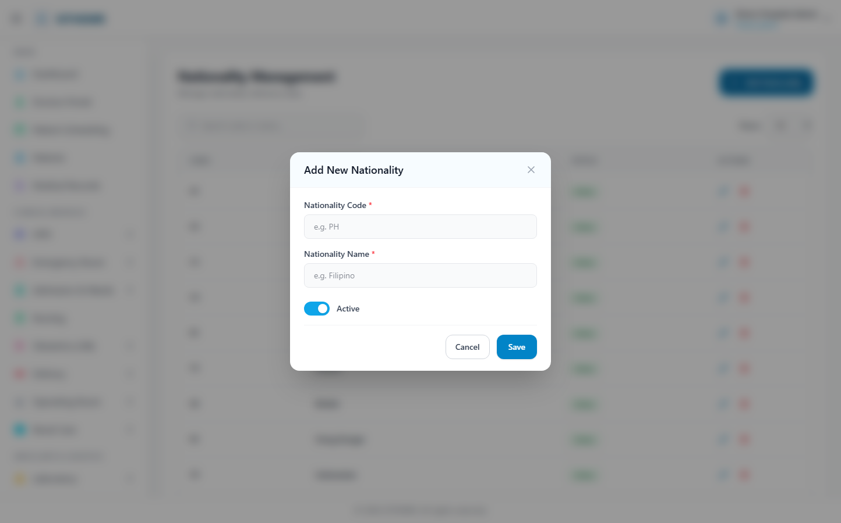
(170 KB)
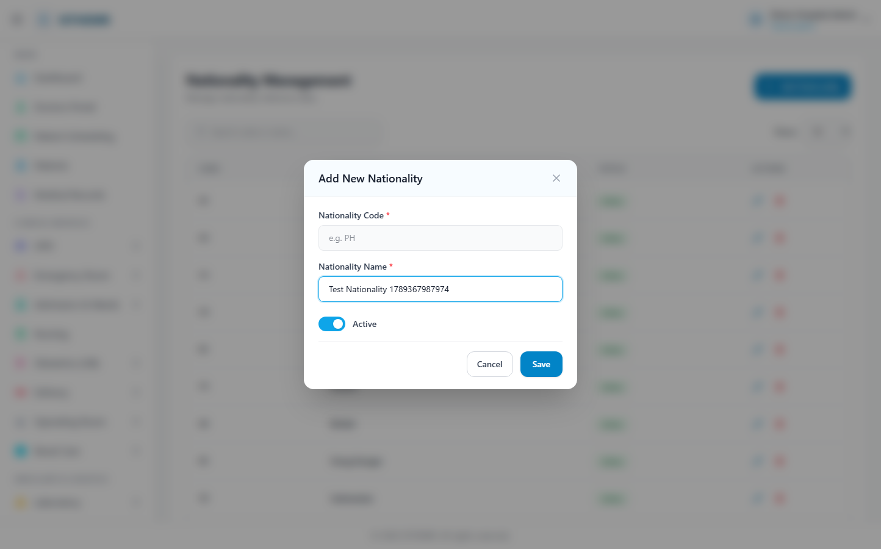
(171 KB)
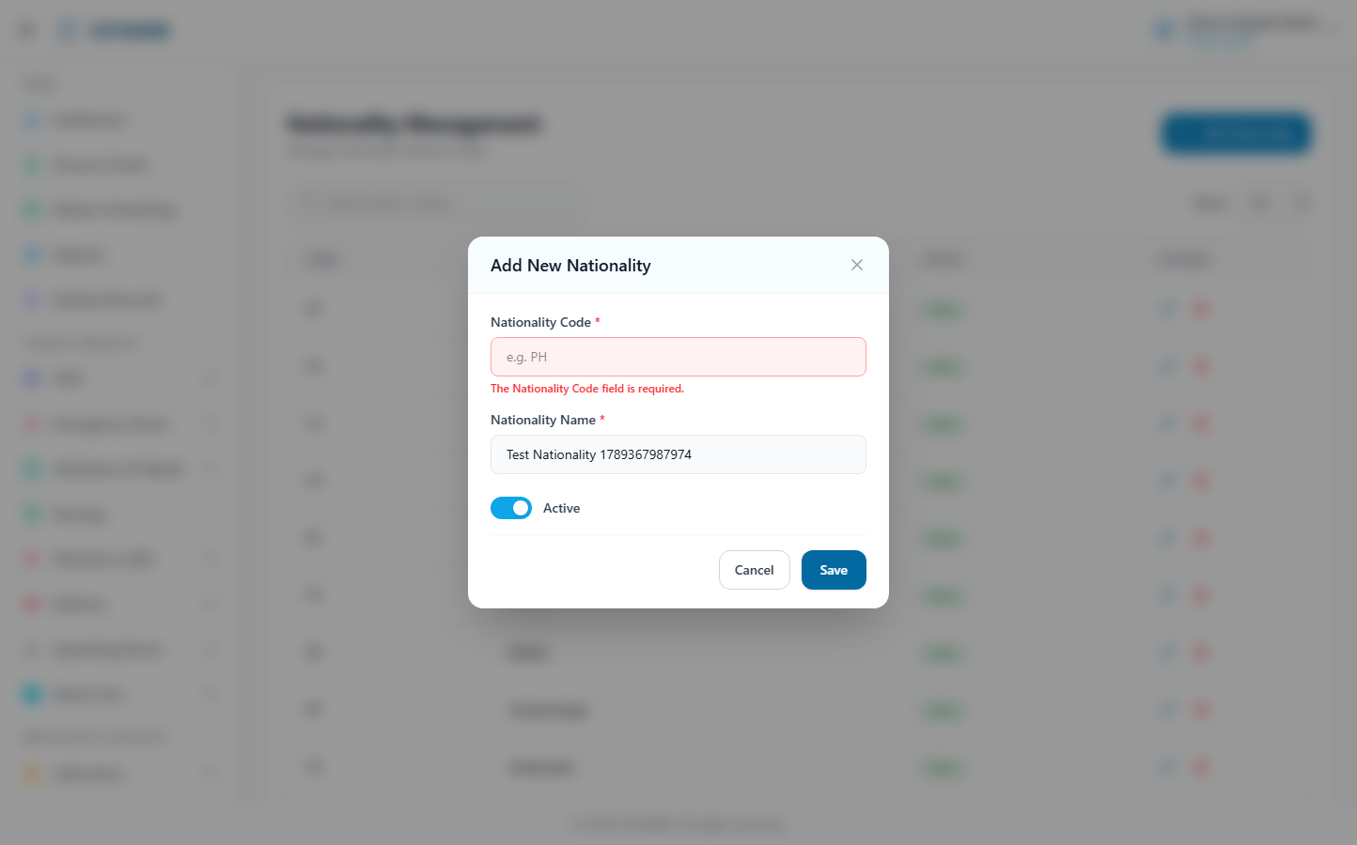
(172 KB)
Occupation
Route: /masters/occupation | Type: crud | Status: PASS
[PASS]
Record created (1 fields filled)
✓ Test record created successfully
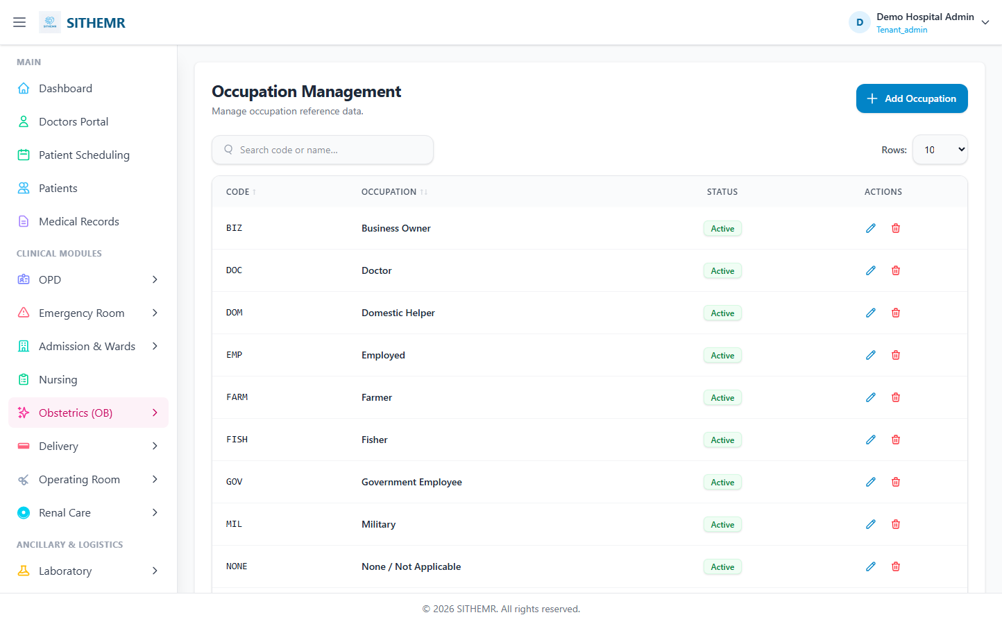
(88 KB)
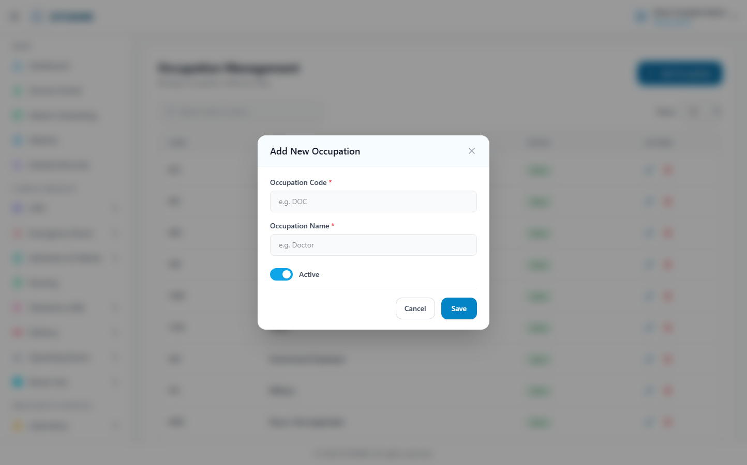
(175 KB)
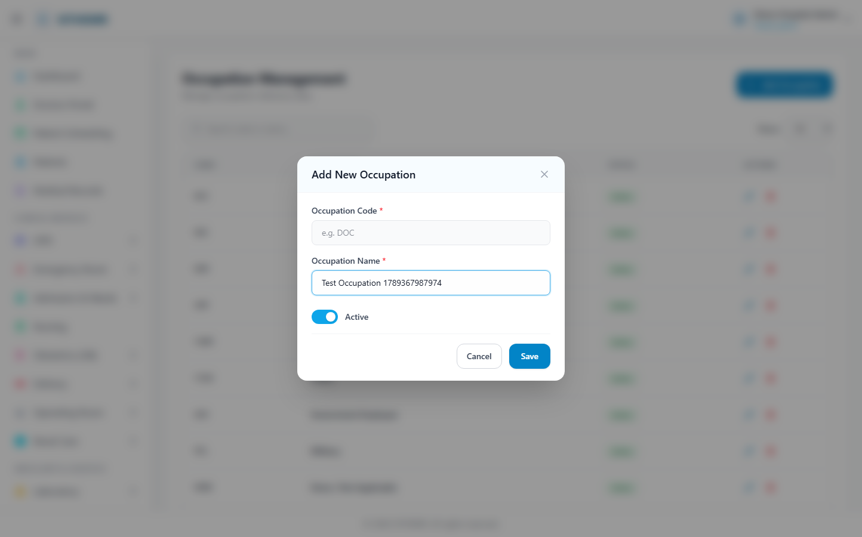
(176 KB)
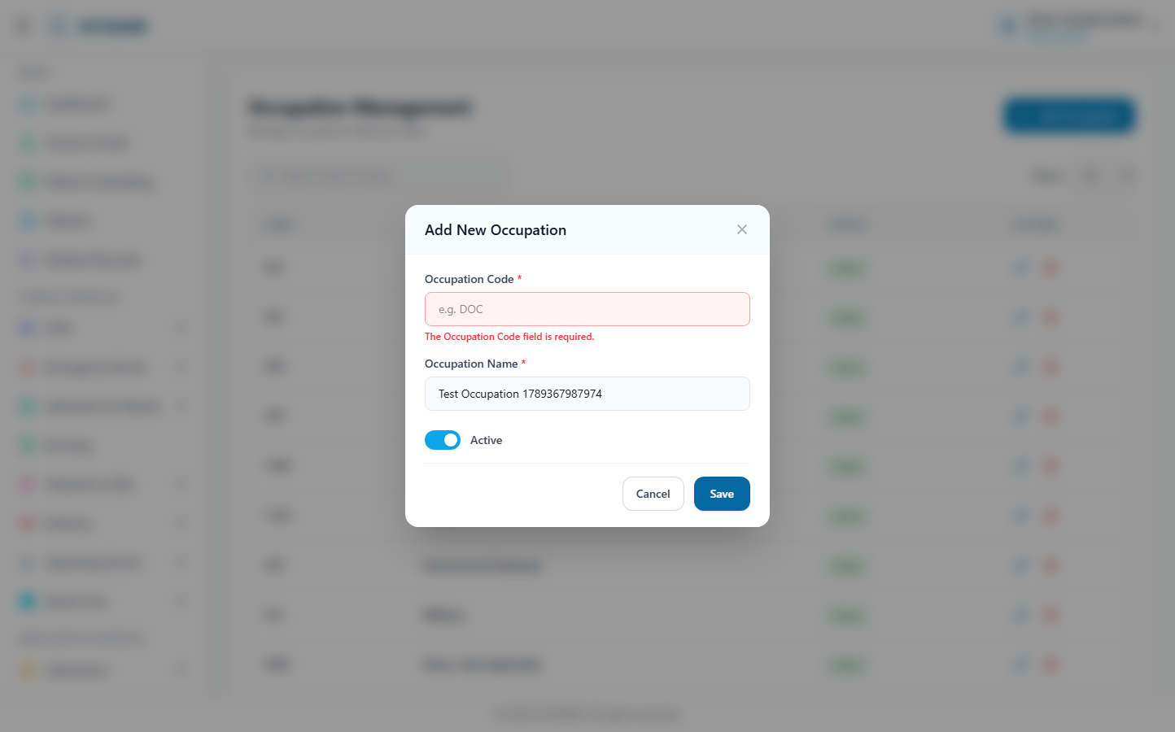
(178 KB)
Blood Type
Route: /masters/blood-type | Type: crud | Status: PASS
[PASS]
Record created (1 fields filled)
✓ Test record created successfully
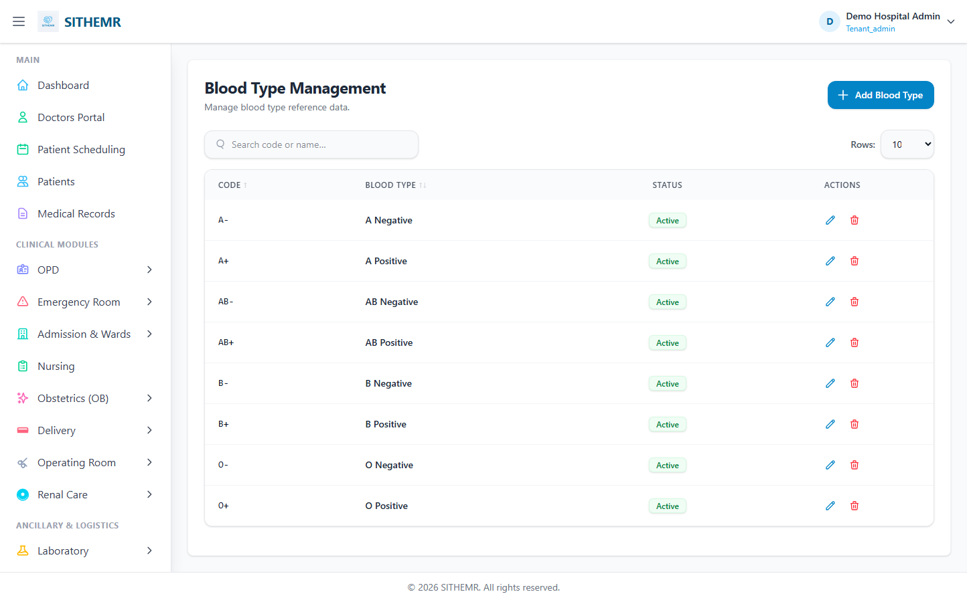
(83 KB)
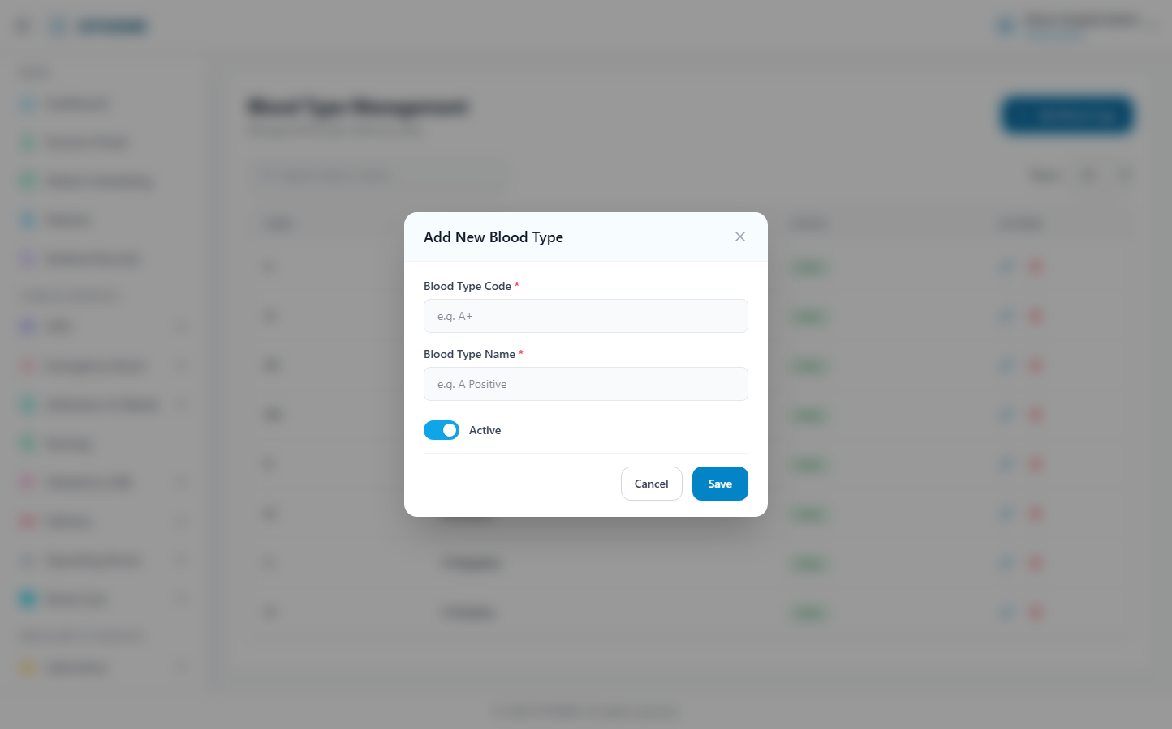
(165 KB)
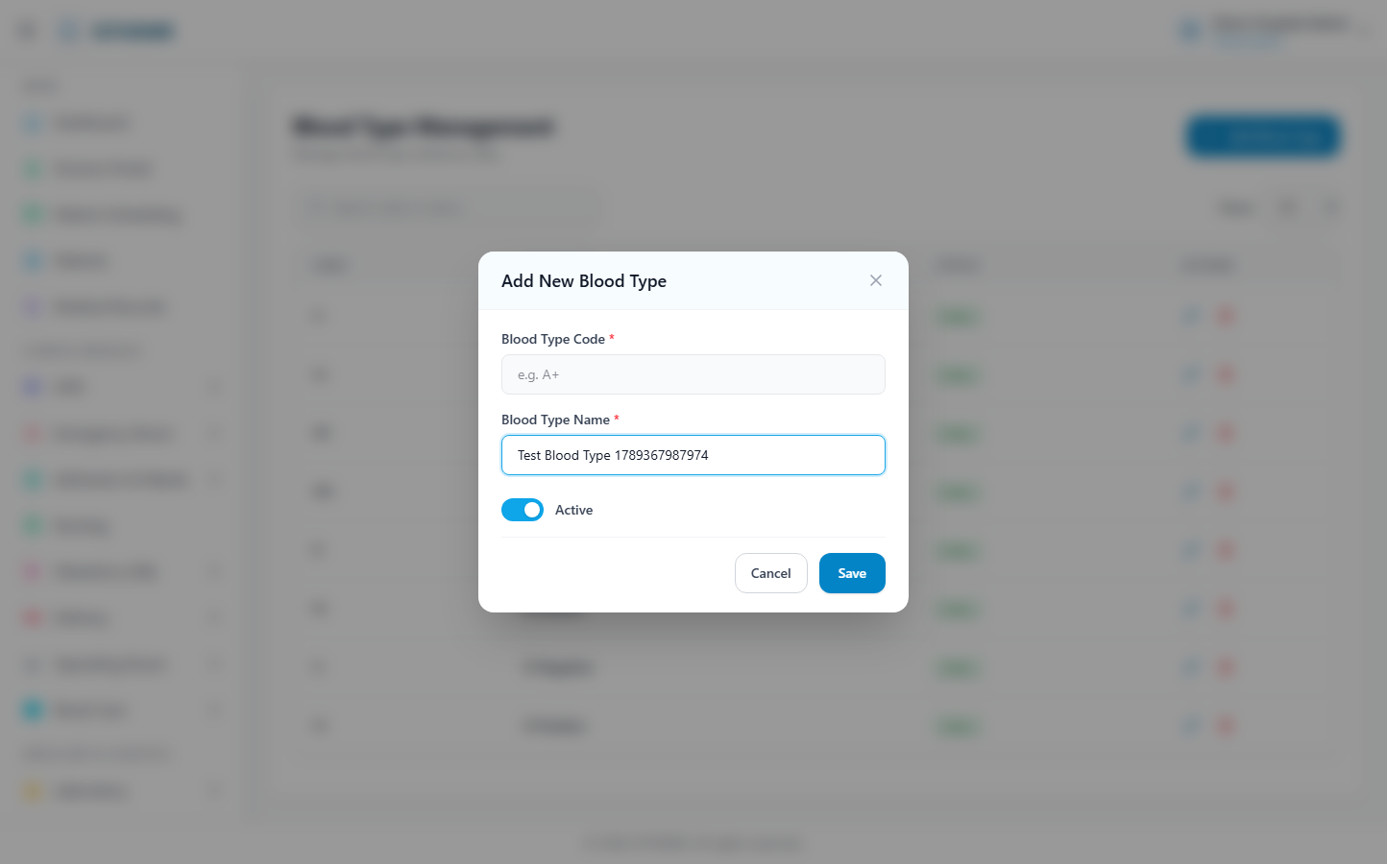
(166 KB)
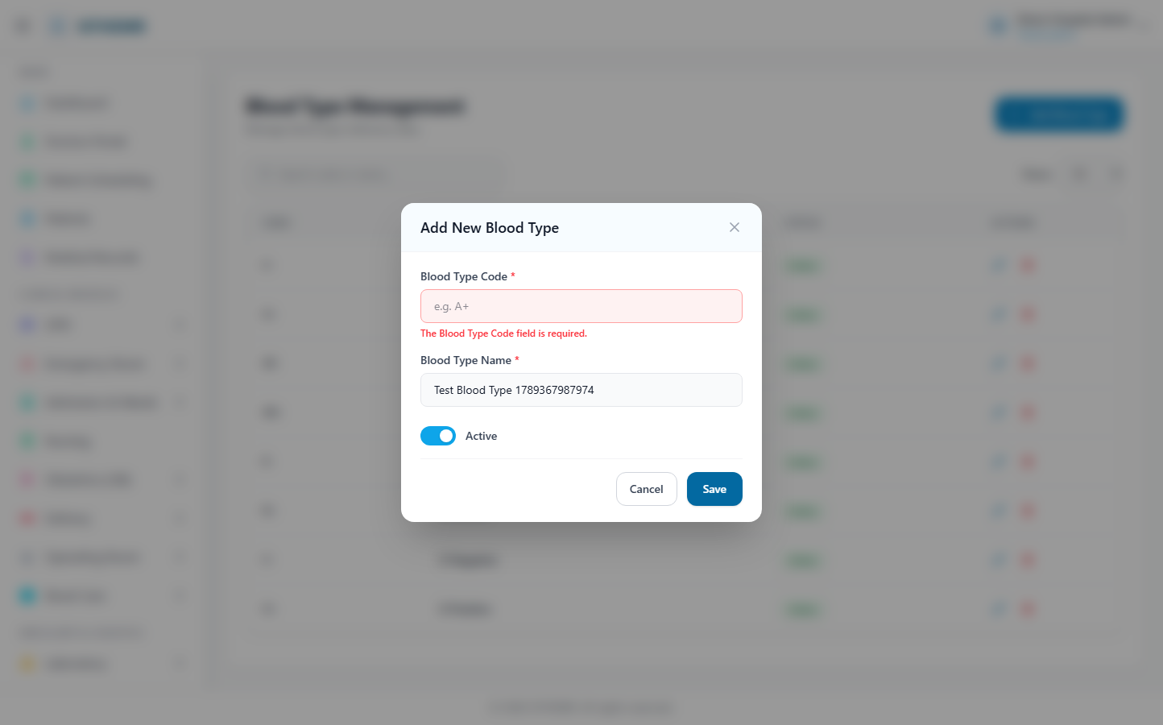
(167 KB)
Relationship
Route: /masters/relationship | Type: crud | Status: PASS
[PASS]
Record created (1 fields filled)
✓ Test record created successfully
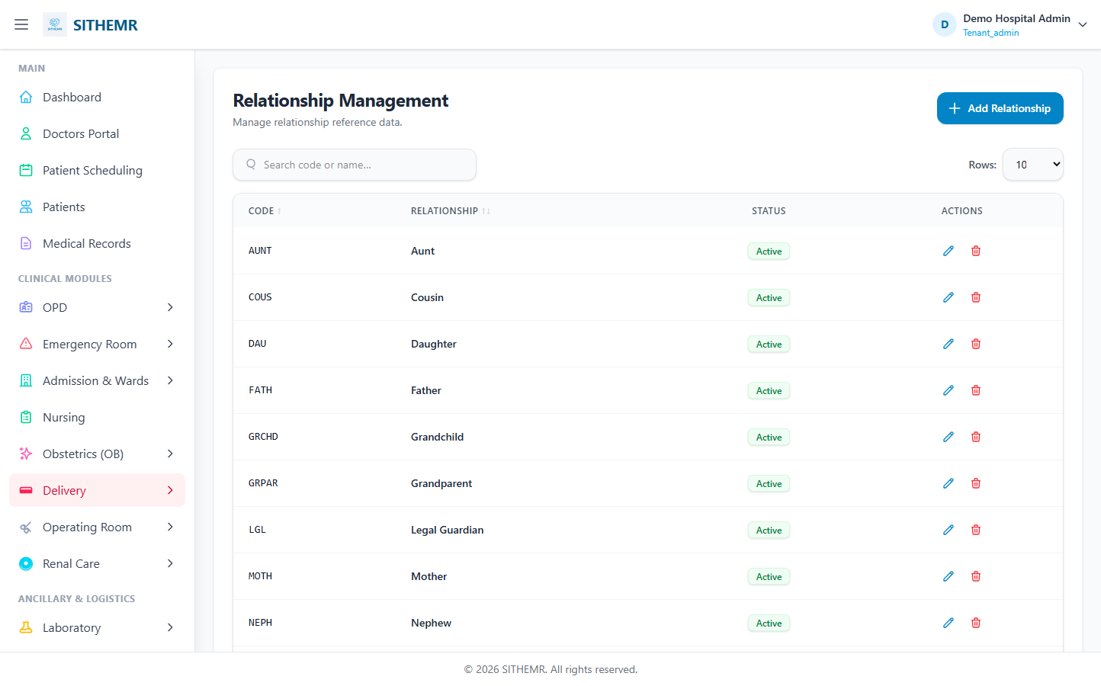
(86 KB)
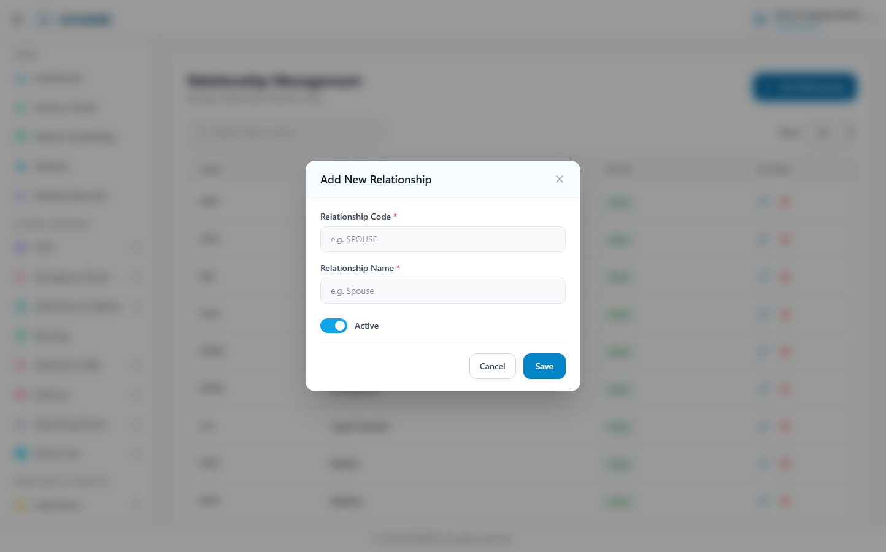
(175 KB)
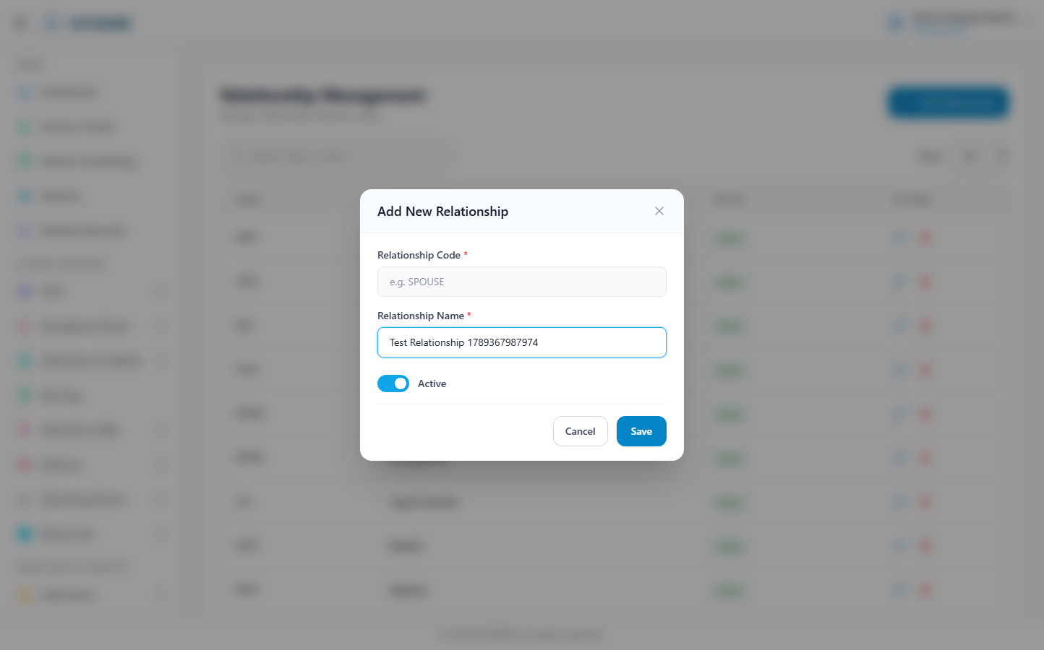
(176 KB)
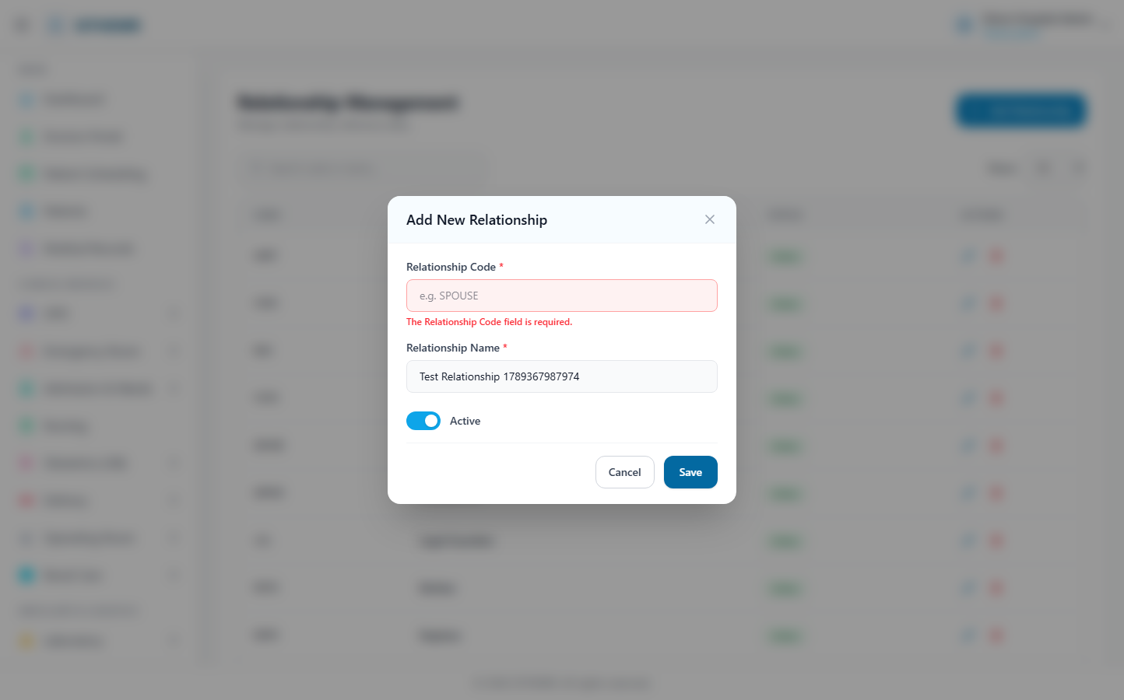
(177 KB)

Administration
Roles
Route: /admin/roles | Type: crud | Status: PASS
[PASS]
Record created (1 fields filled)
✓ Test record created successfully
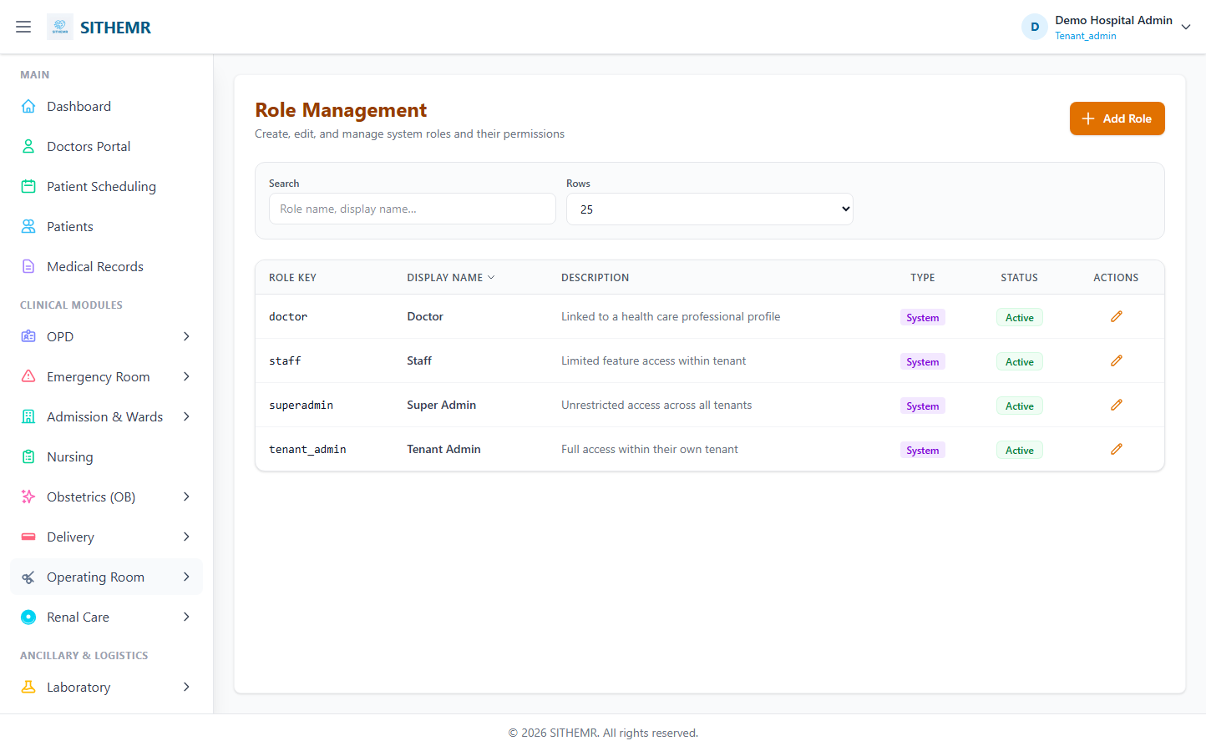
(78 KB)
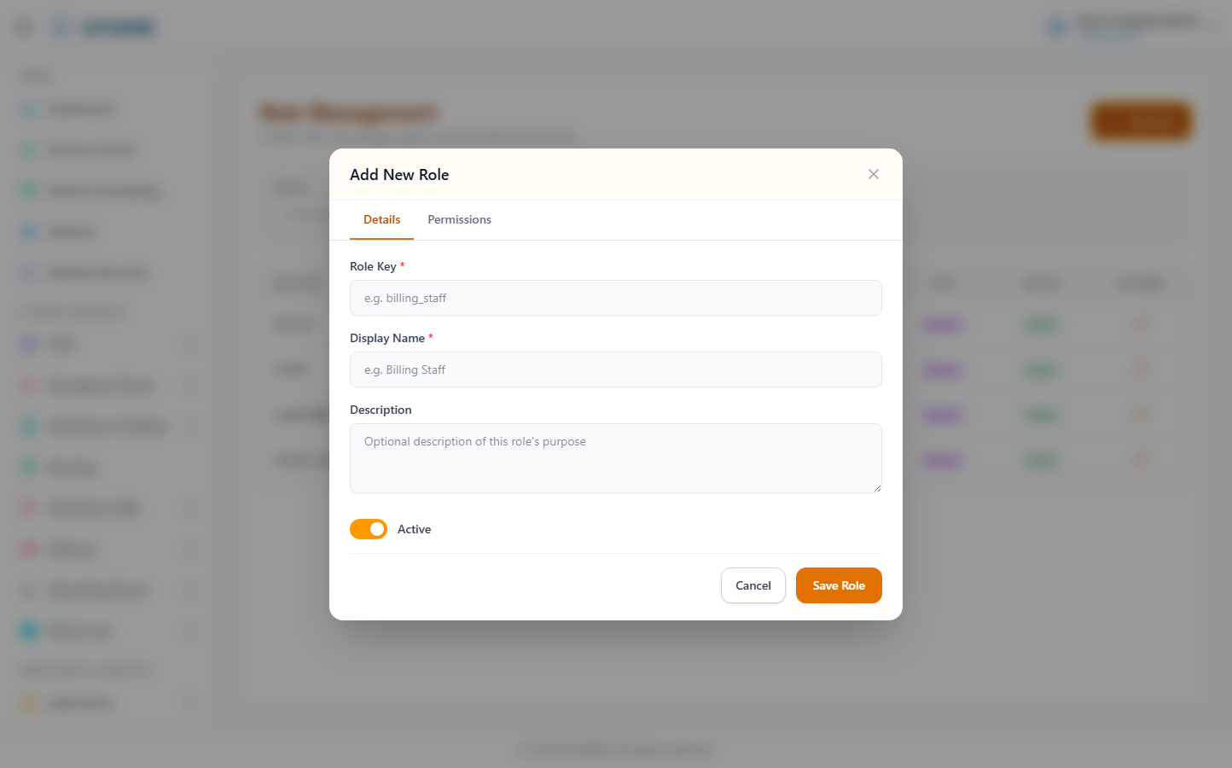
(149 KB)
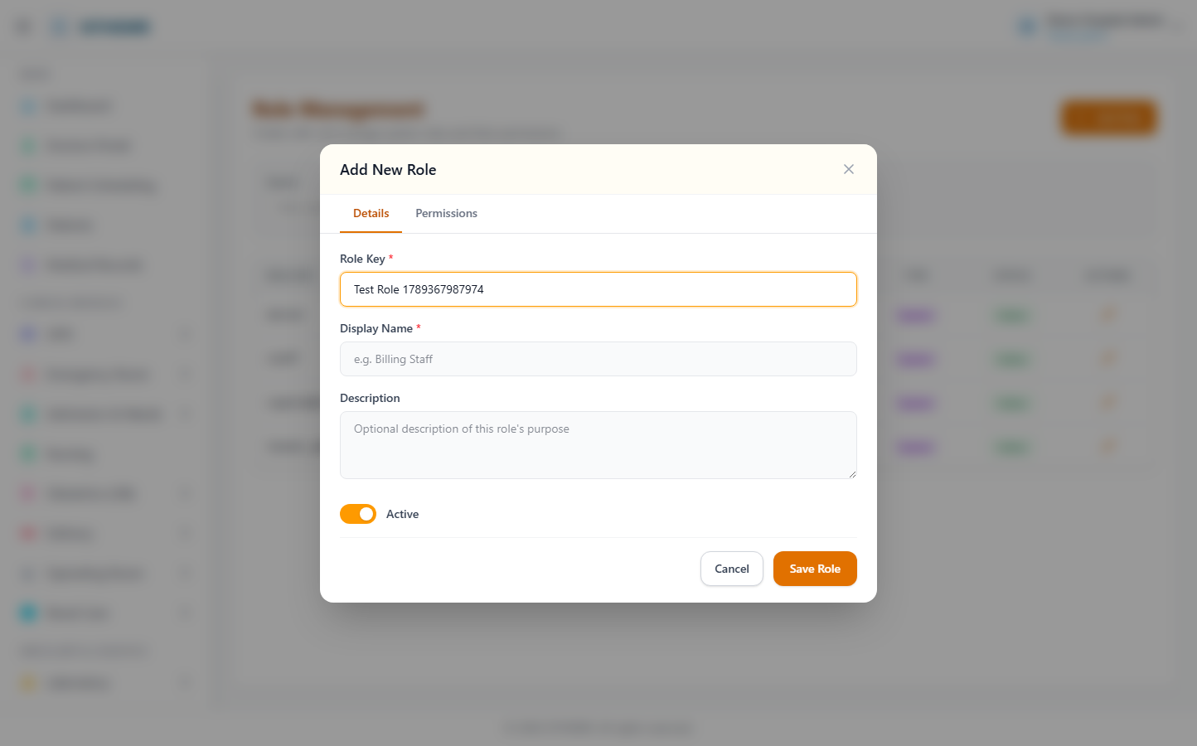
(150 KB)
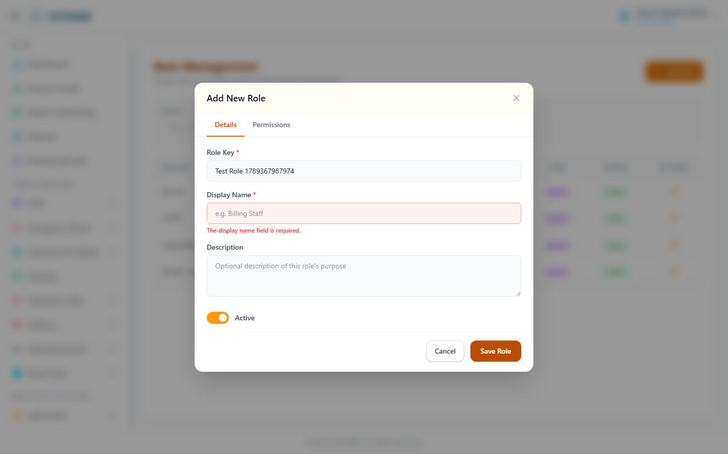
(150 KB)
Role Permissions
Route: /admin/role-permissions | Type: list-only | Status: PASS
[PASS]
Page loaded — Role Permissions Assign permissions to system roles Select Role Doctor Staff S
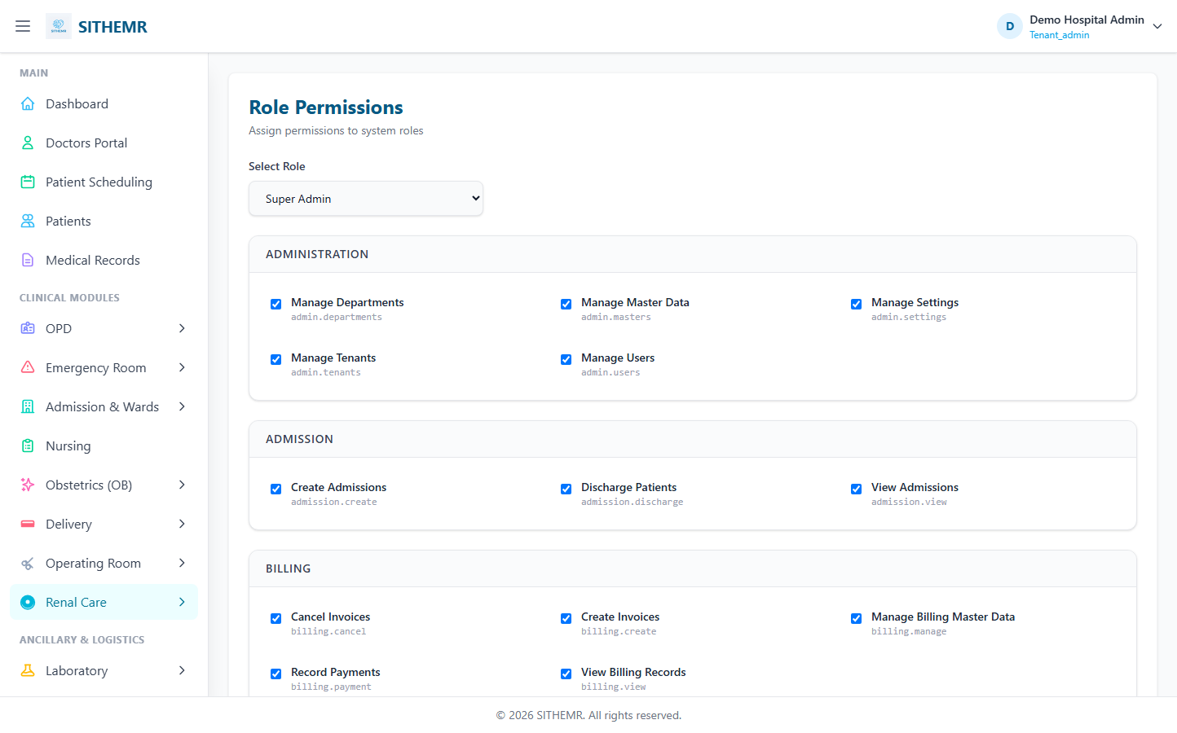
(80 KB)
Audit Trail
Route: /admin/audit-log | Type: list-only | Status: PASS
[PASS]
Page loaded — Permission Audit Trail View all permission changes across the system Search Ac
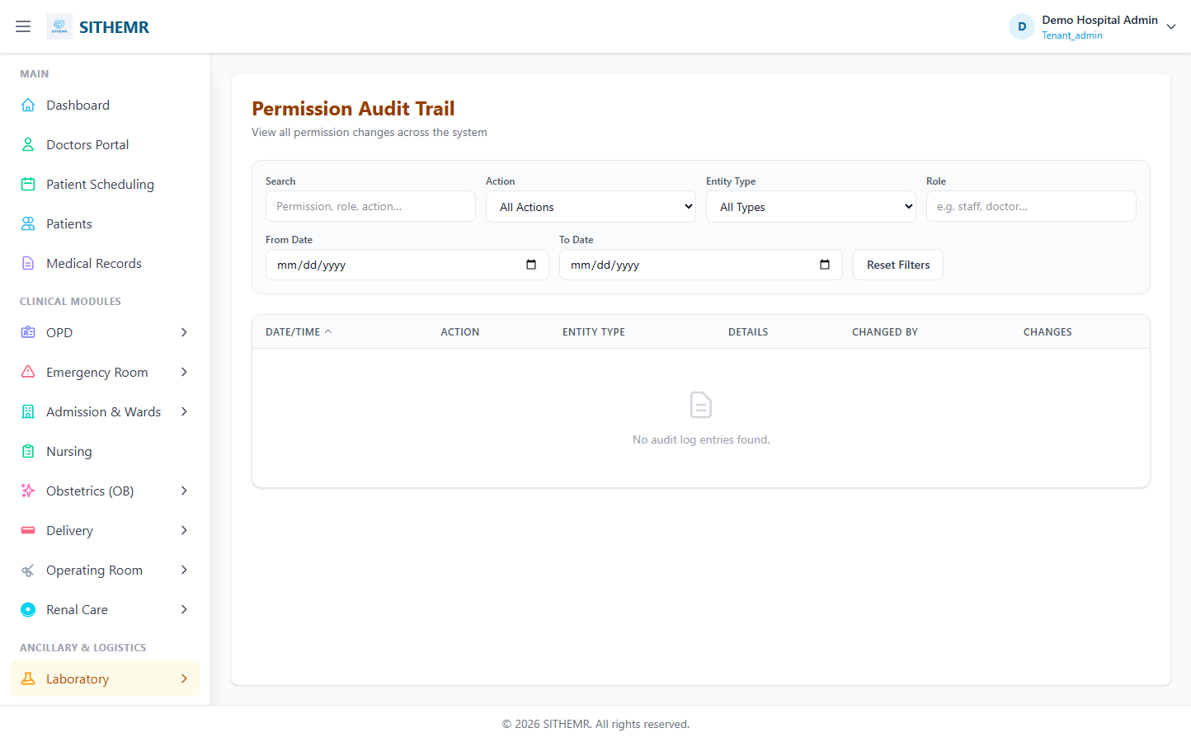
(65 KB)

Patient Management
Patient Registration
Route: /patients | Type: crud | Status: SKIP
[SKIP]
No Create/New/Add button found
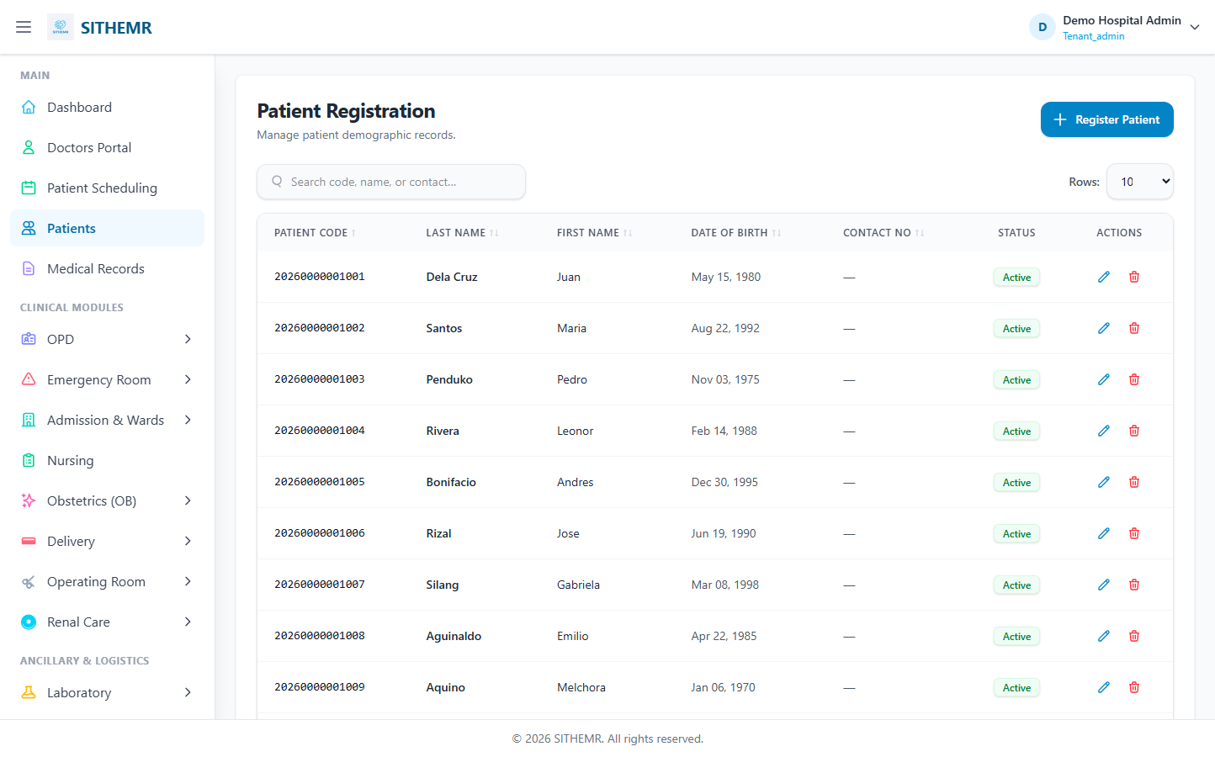
(106 KB)

Out-Patient Department (OPD)
OPD Consultations
Route: /opd/consultations | Type: list-only | Status: PASS
[PASS]
Page loaded — OPD Consultations Manage outpatient clinic encounters, vitals, and treatments.
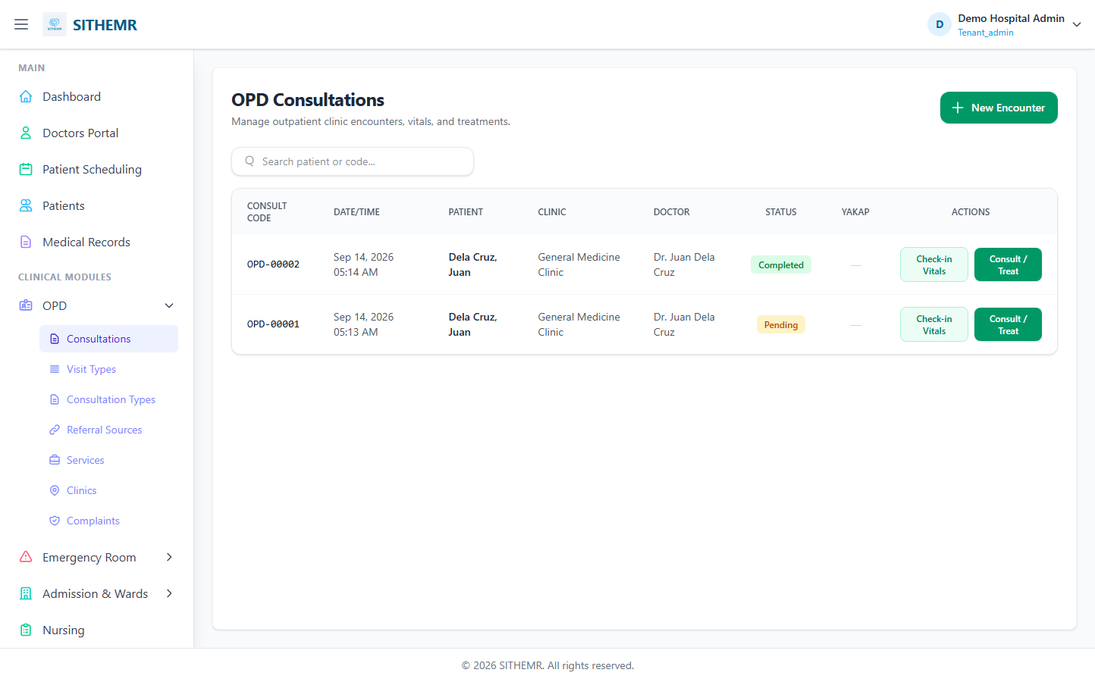
(76 KB)
OPD Clinics
Route: /opd/clinics | Type: crud | Status: PASS
[PASS]
Record created (1 fields filled)
✓ Test record created successfully
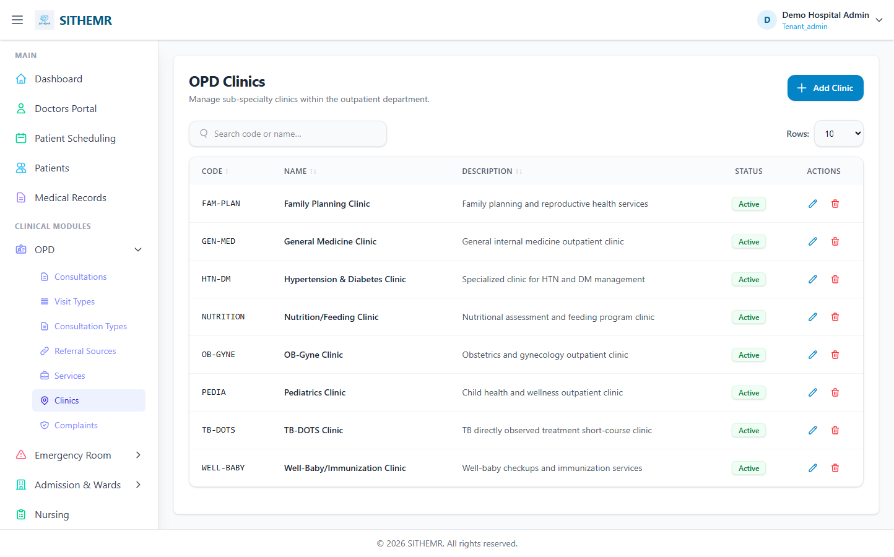
(103 KB)
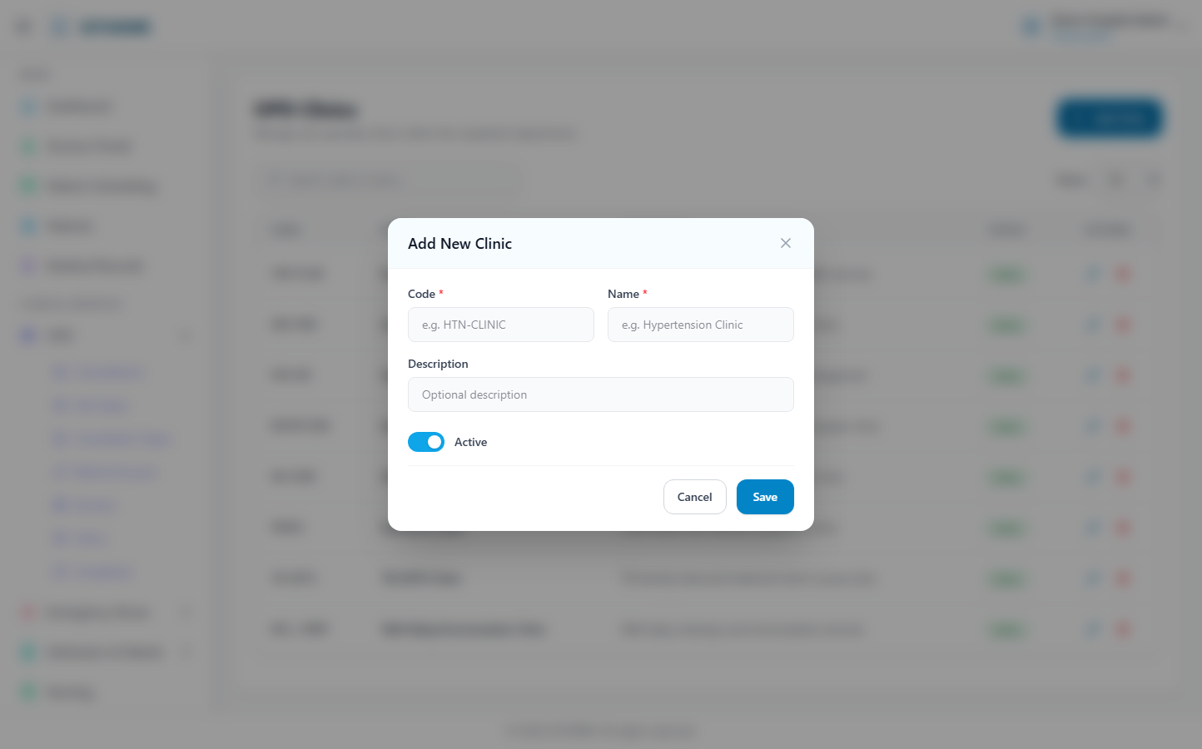
(182 KB)
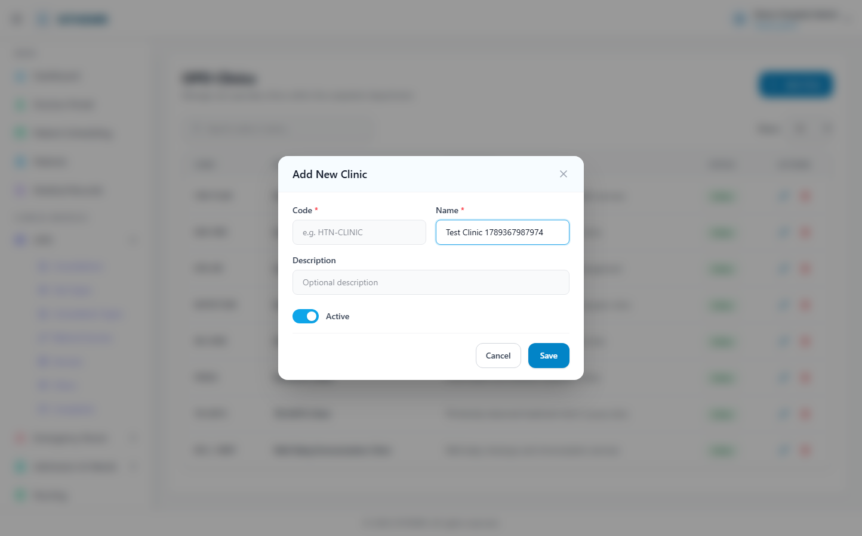
(182 KB)
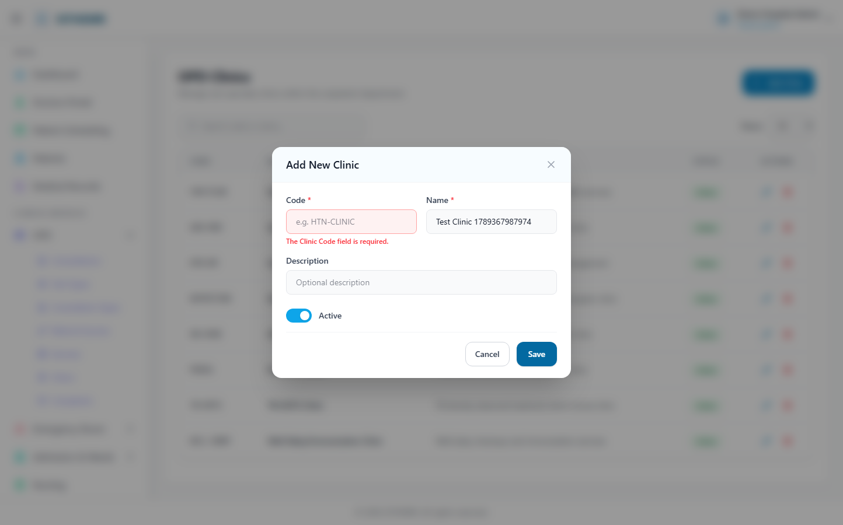
(183 KB)
Consultation Types
Route: /opd/consultation-types | Type: crud | Status: PASS
[PASS]
Record created (1 fields filled)
✓ Test record created successfully
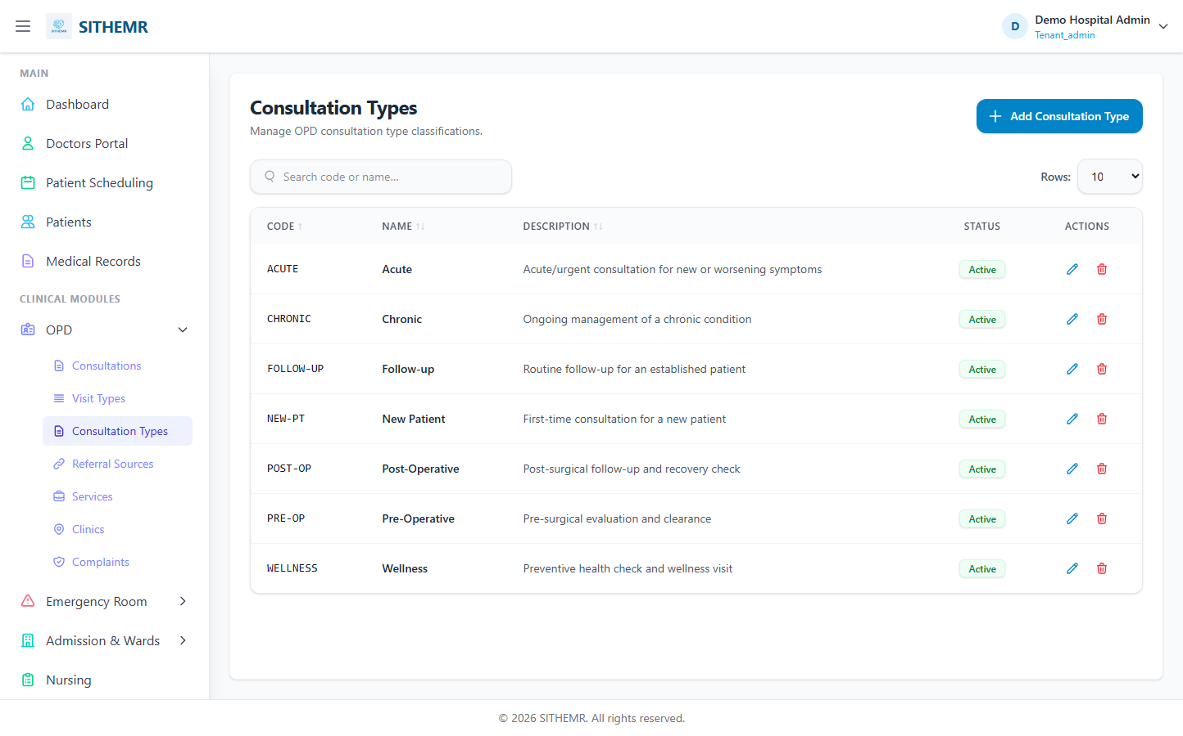
(92 KB)
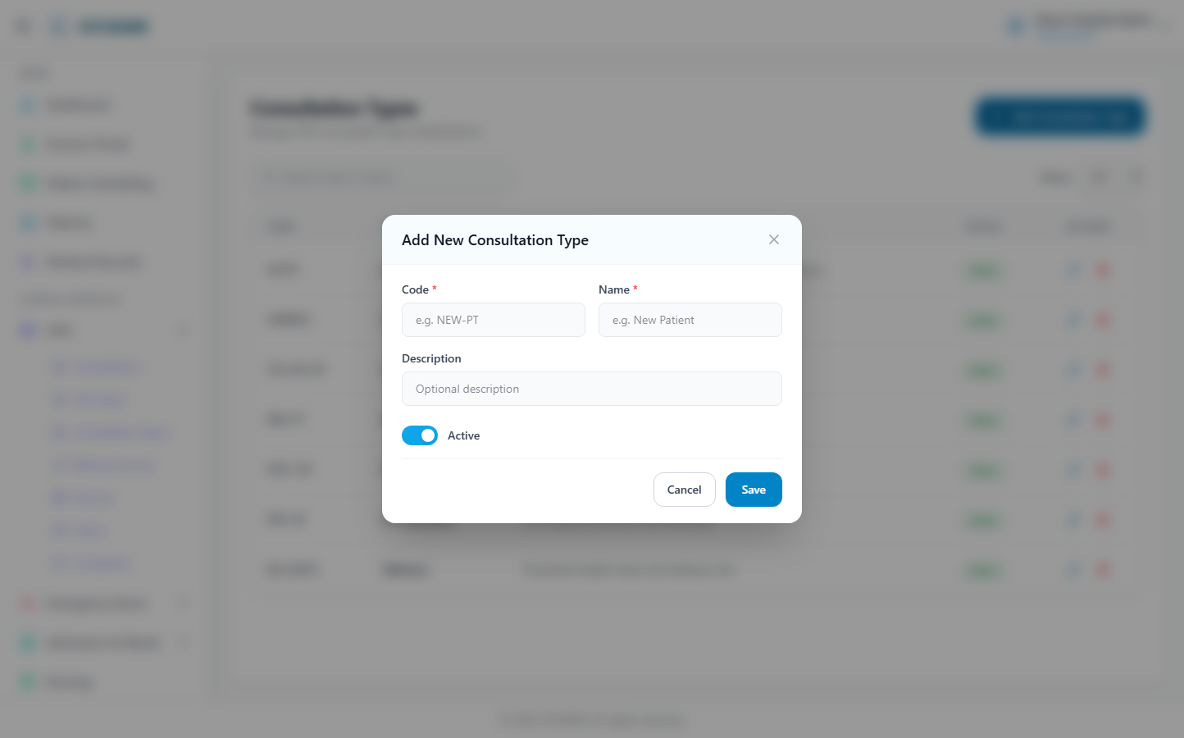
(163 KB)
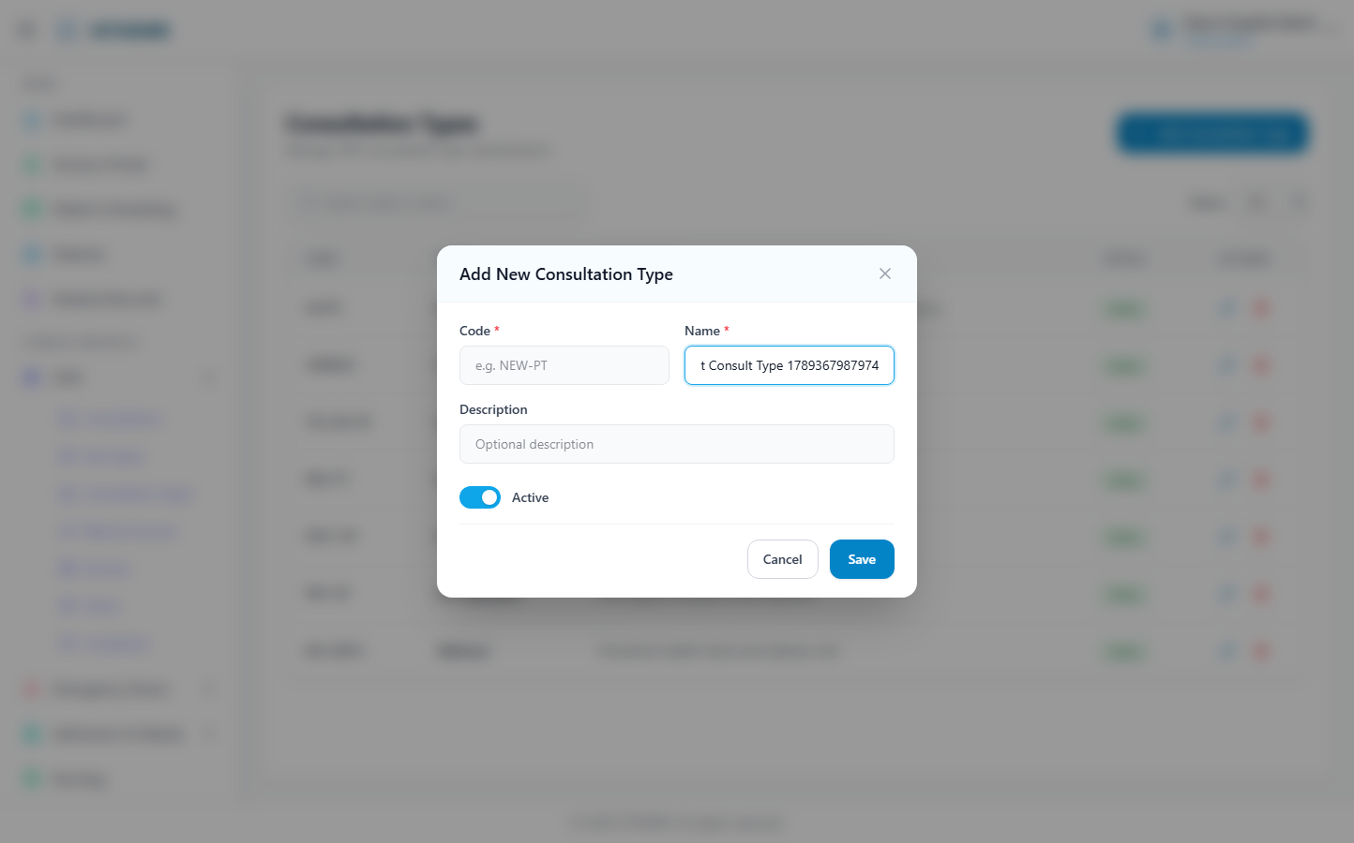
(164 KB)
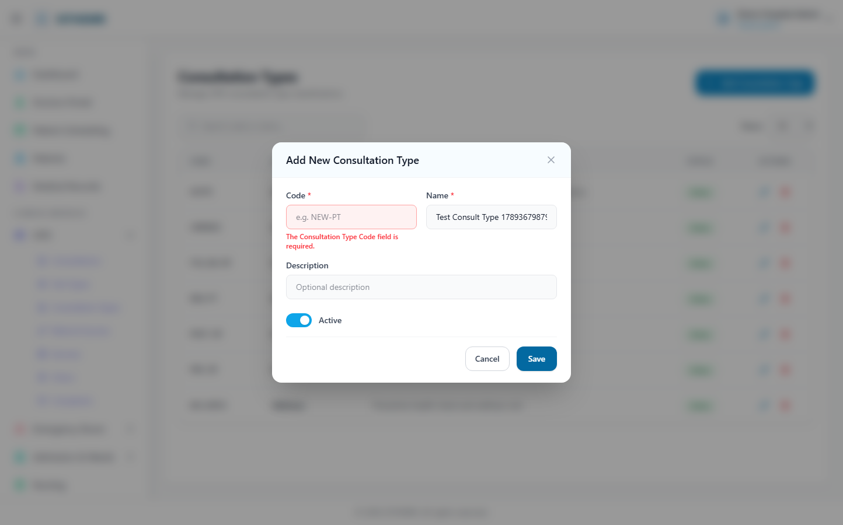
(164 KB)
Visit Types
Route: /opd/visit-types | Type: crud | Status: PASS
[PASS]
Record created (1 fields filled)
✓ Test record created successfully
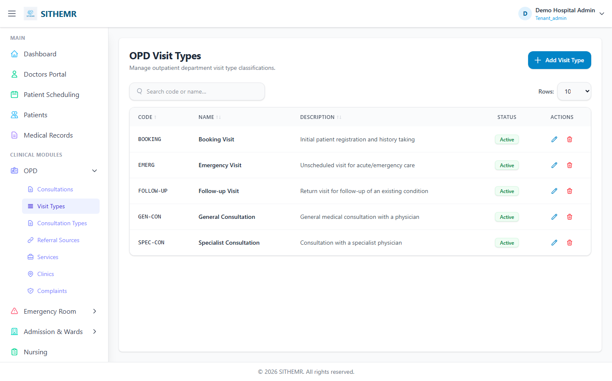
(85 KB)
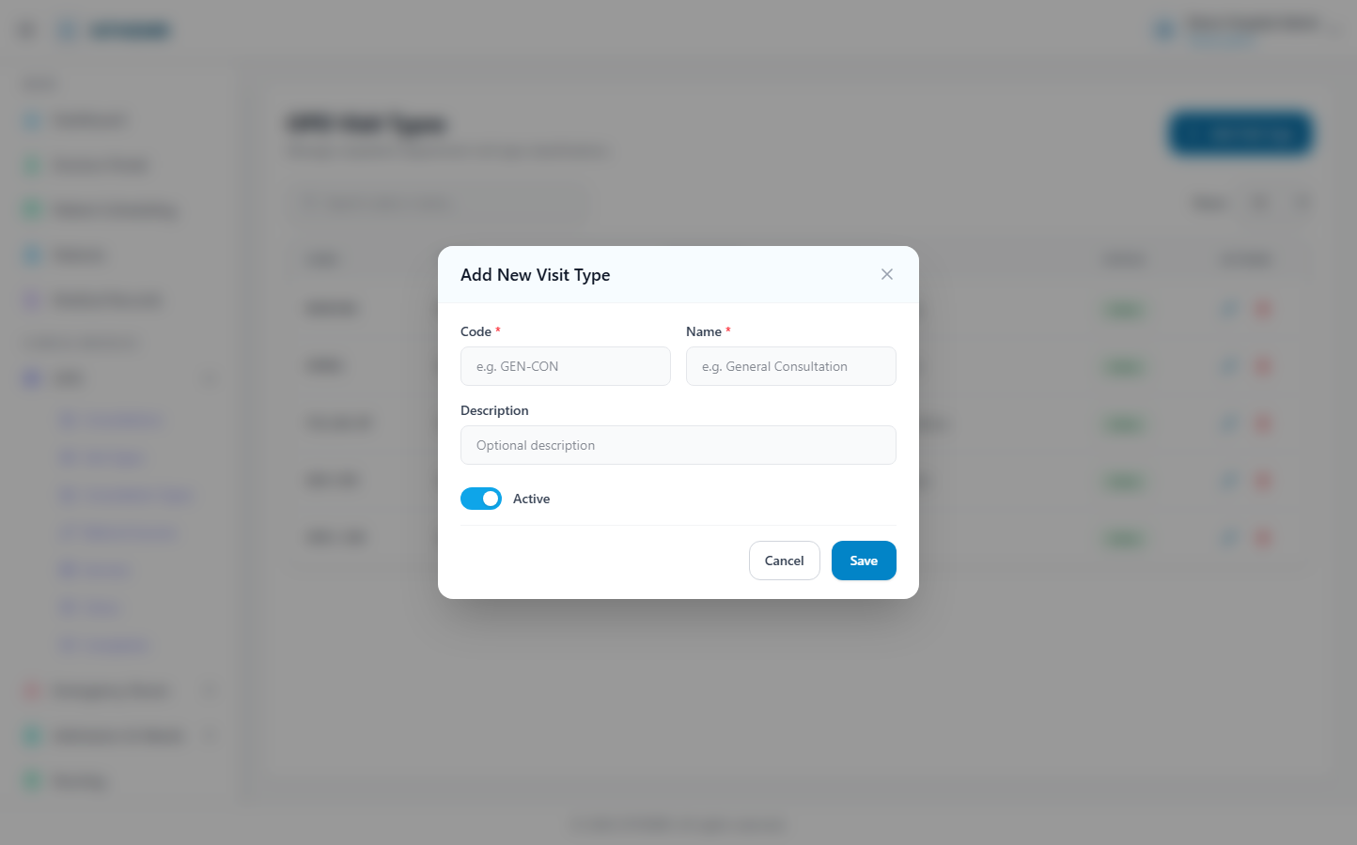
(145 KB)
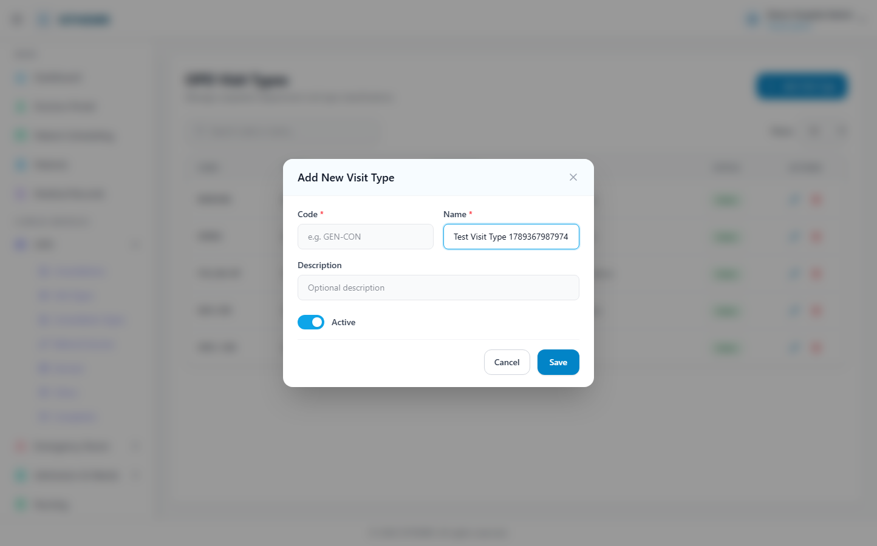
(146 KB)
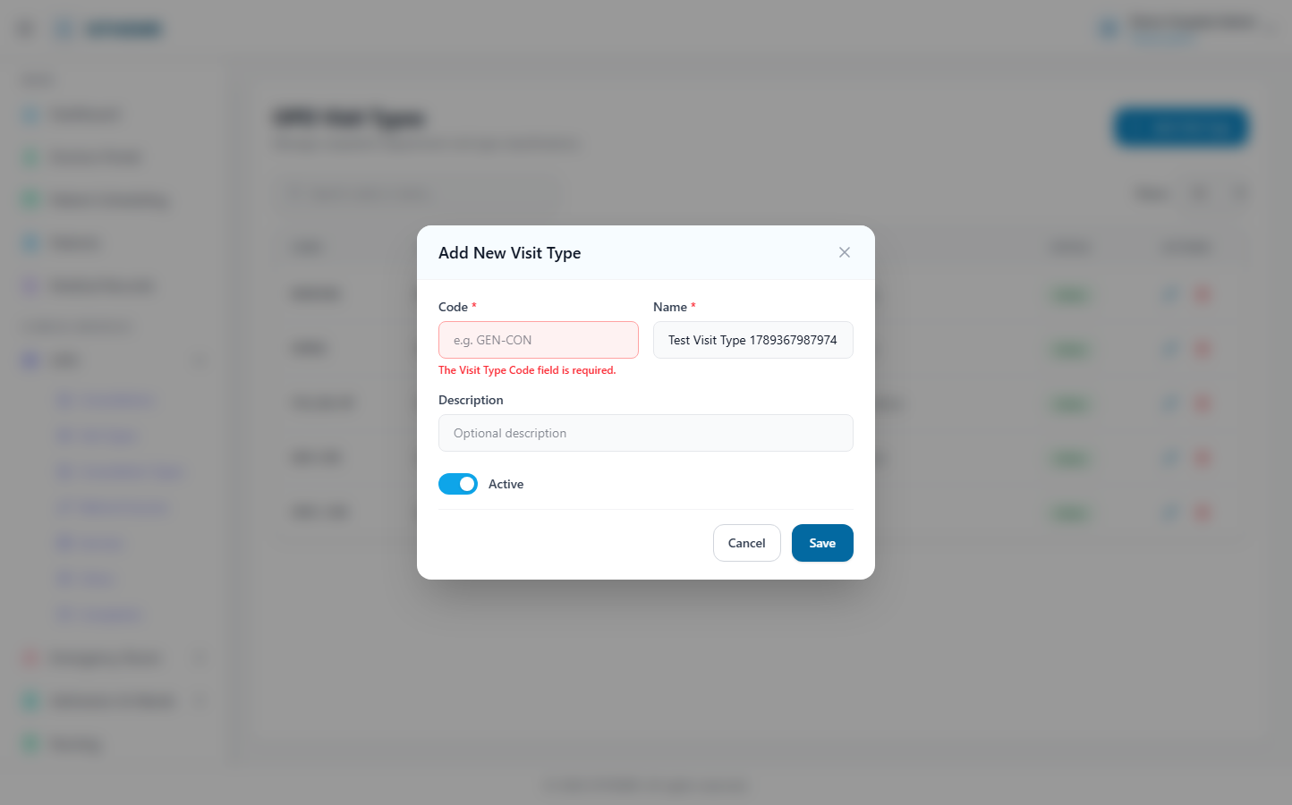
(148 KB)
Services
Route: /opd/services | Type: crud | Status: PASS
[PASS]
Record created (1 fields filled)
✓ Test record created successfully
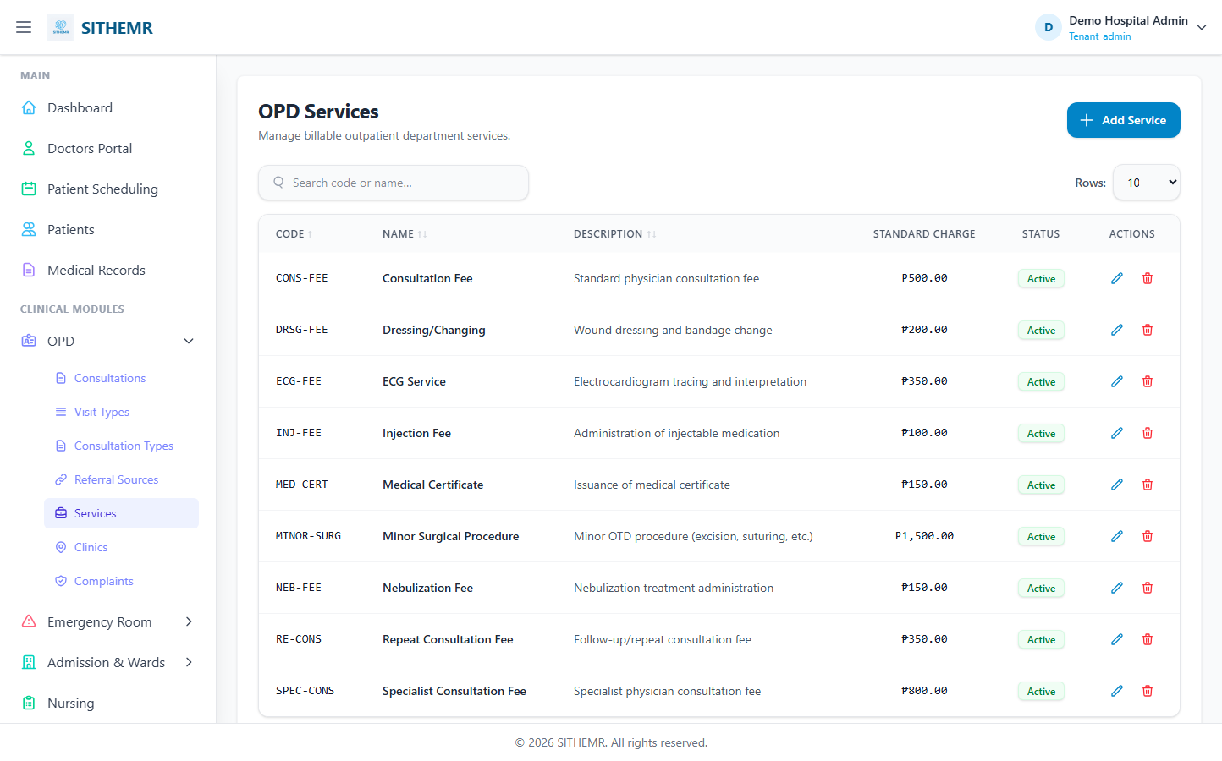
(115 KB)
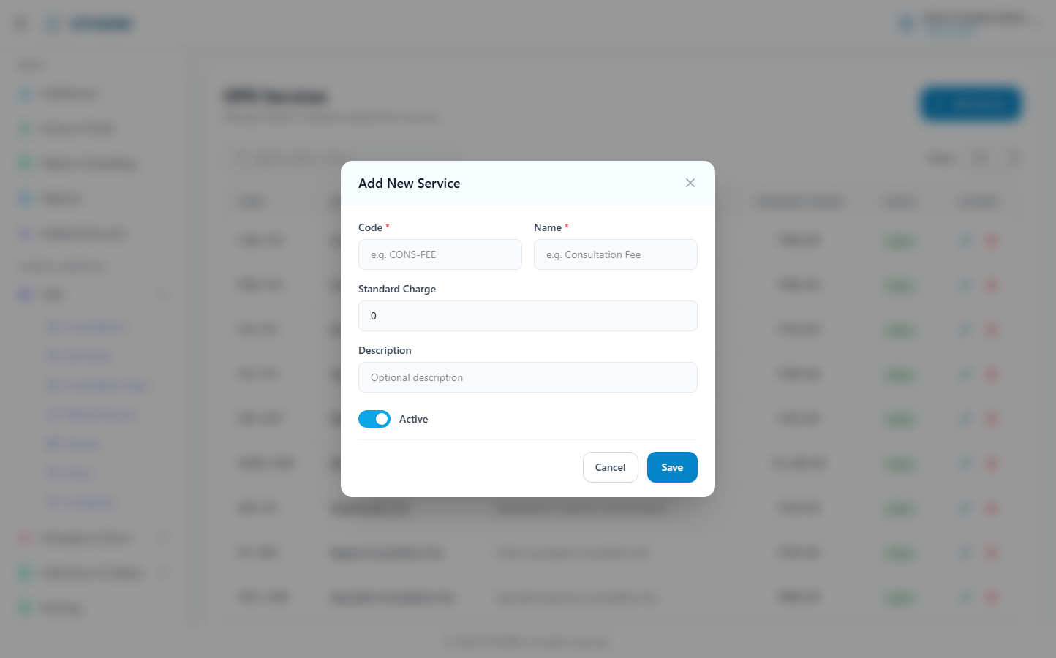
(204 KB)
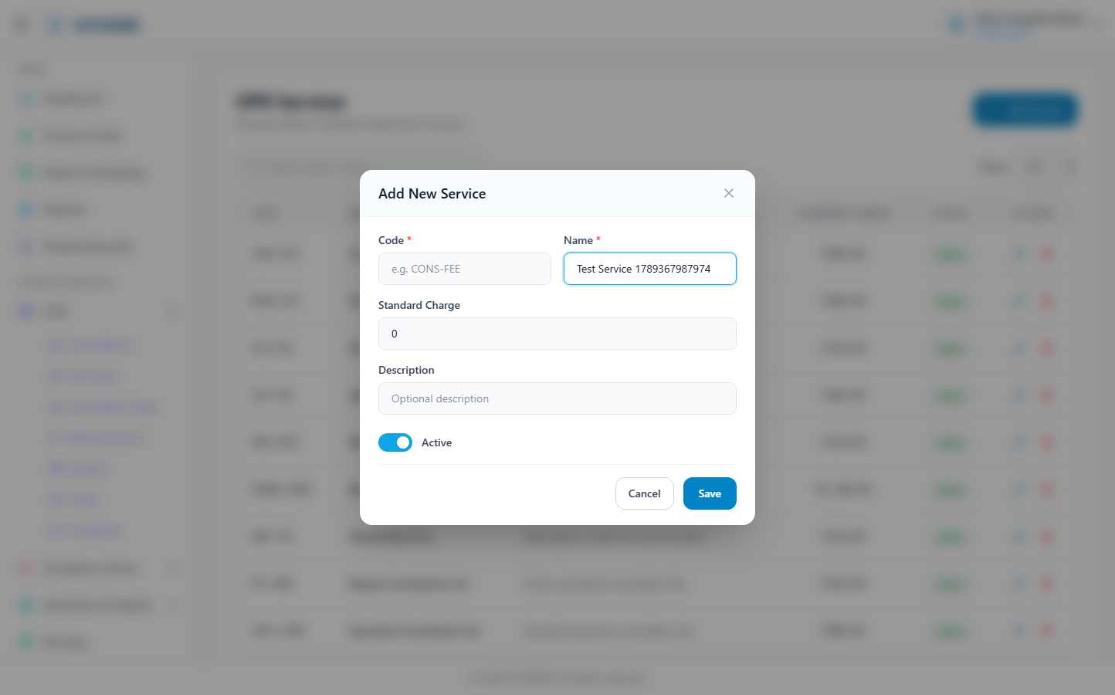
(205 KB)
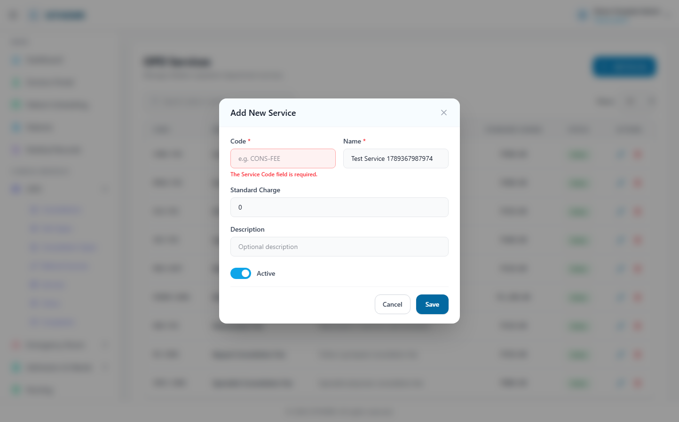
(206 KB)
Complaints
Route: /opd/complaints | Type: crud | Status: PASS
[PASS]
Record created (1 fields filled)
✓ Test record created successfully
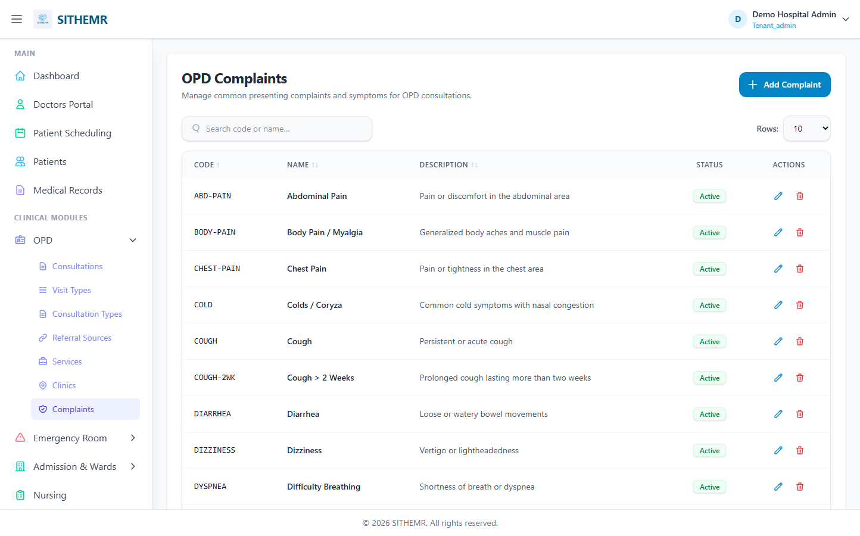
(105 KB)
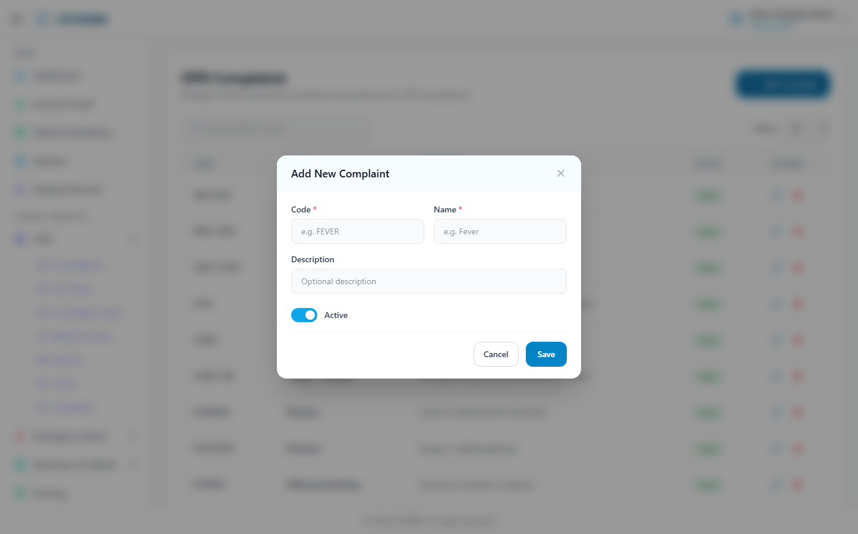
(182 KB)
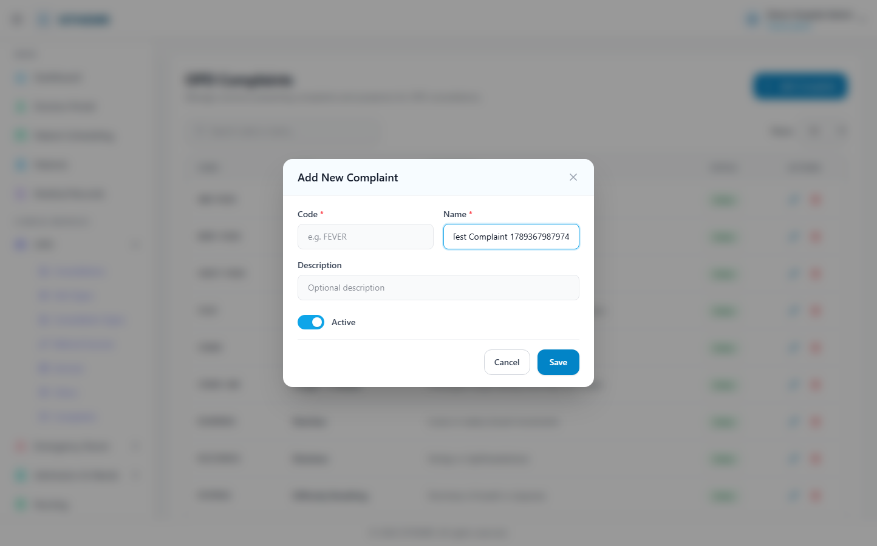
(184 KB)
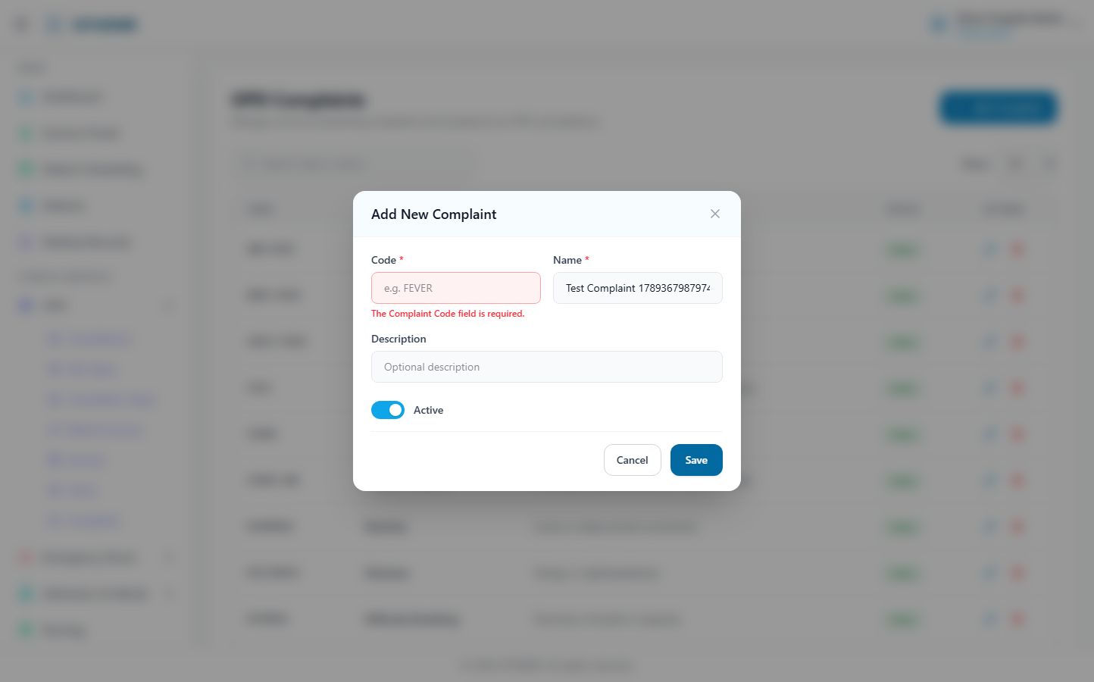
(184 KB)
Referral Sources
Route: /opd/referral-sources | Type: crud | Status: PASS
[PASS]
Record created (1 fields filled)
✓ Test record created successfully
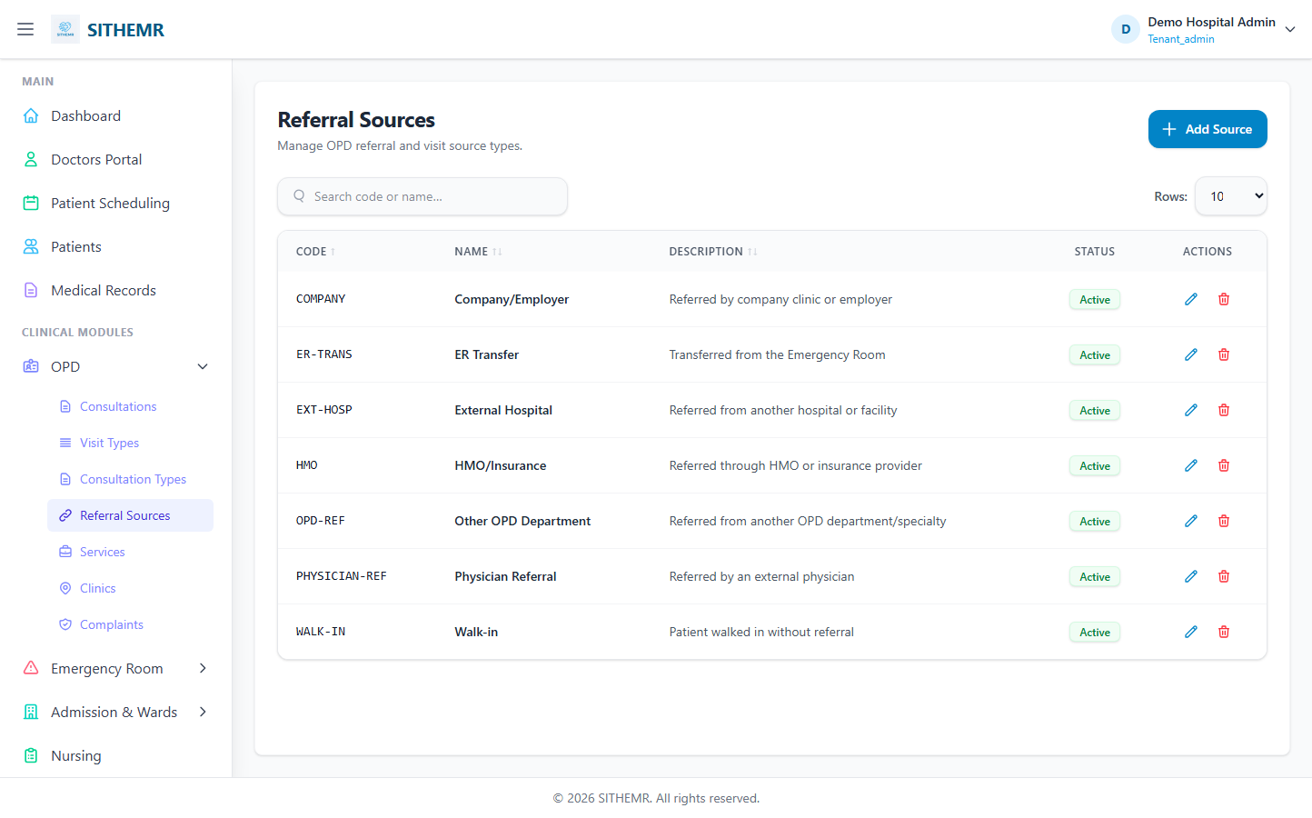
(94 KB)
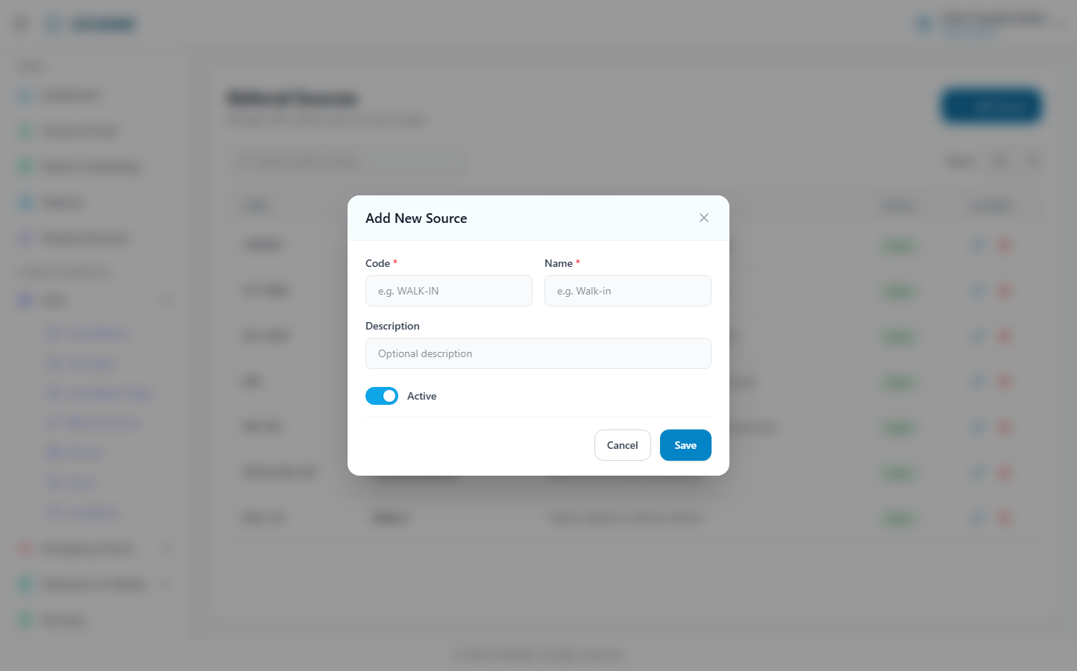
(160 KB)
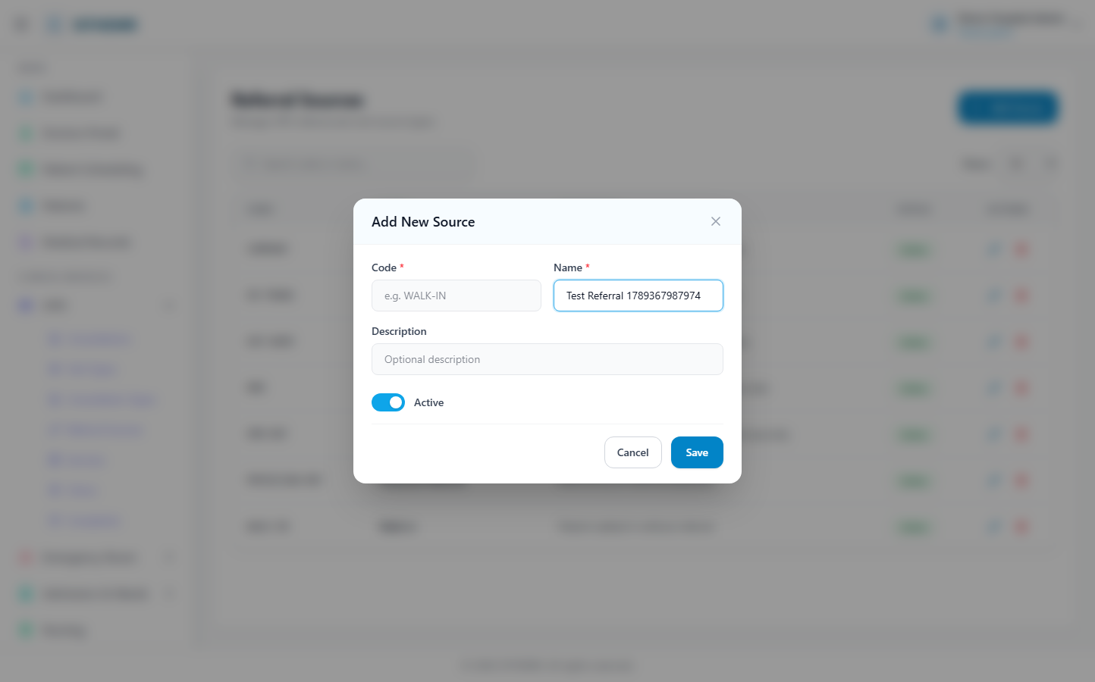
(162 KB)
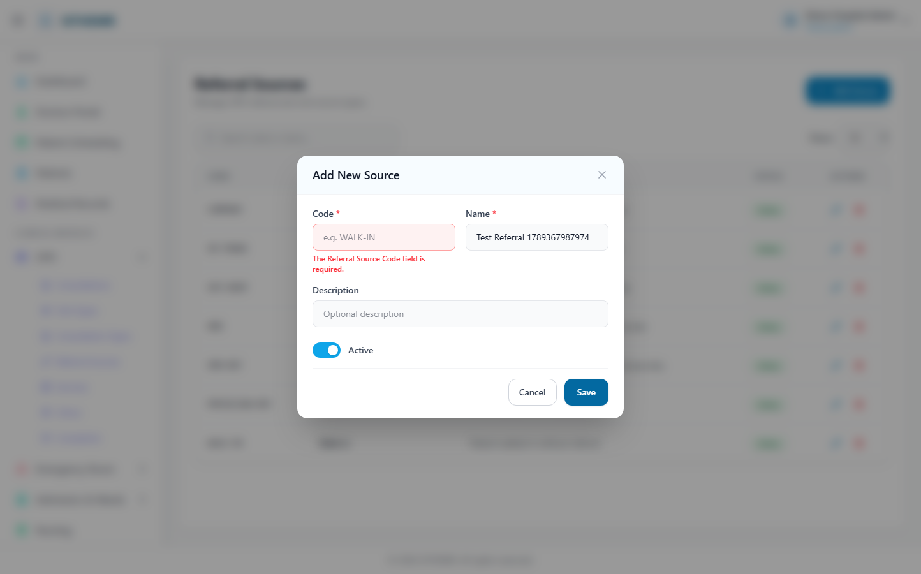
(162 KB)

Emergency Room (ER)
Triage Records
Route: /er/triage | Type: list-only | Status: PASS
[PASS]
Page loaded — ER Triage Records Manage emergency triage data and acuity levels. New Triage R
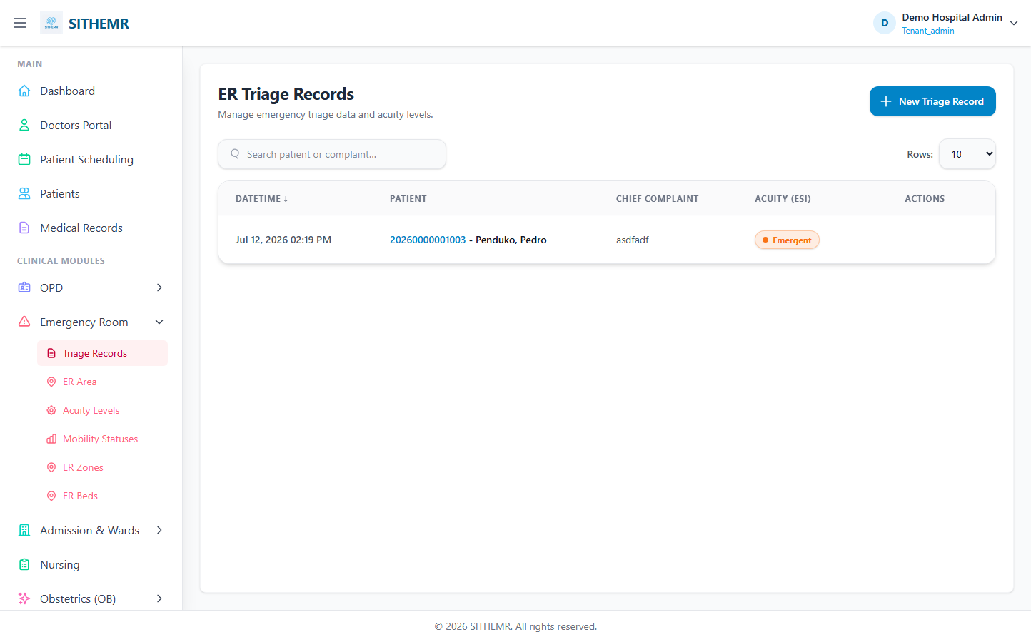
(62 KB)
ER Area/Admissions
Route: /er/area | Type: list-only | Status: PASS
[PASS]
Page loaded — Emergency Room Area Active Completed Rows: 10 25 50 ACUITY ENCOUNTER # ↑↓ PAT
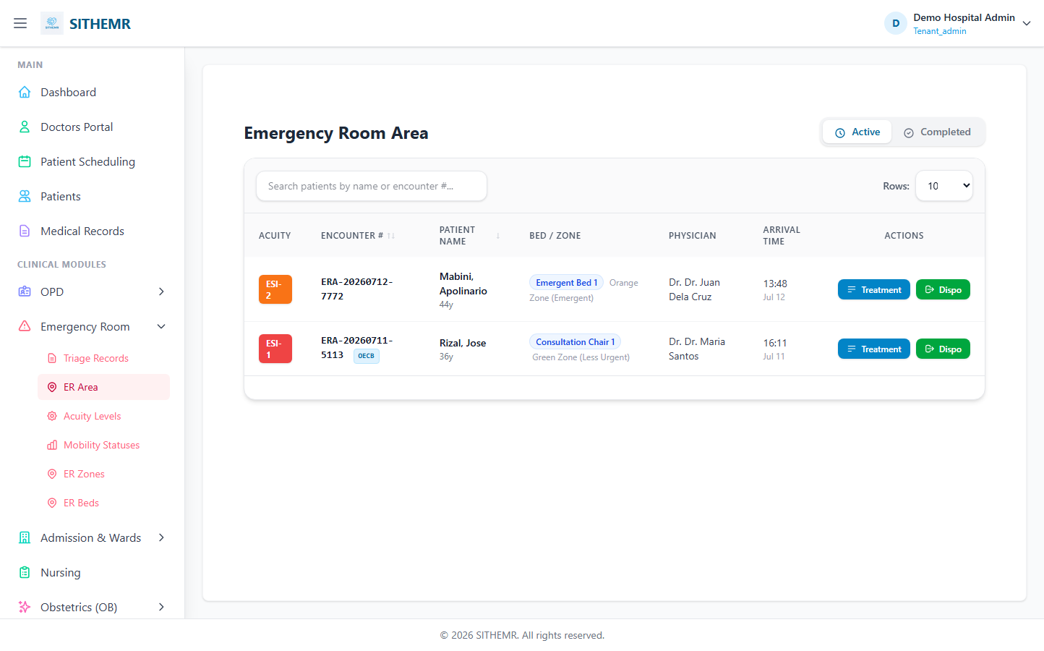
(84 KB)
Acuity Levels
Route: /er/acuity-levels | Type: crud | Status: PASS
[PASS]
Record created (1 fields filled)
✓ Test record created successfully
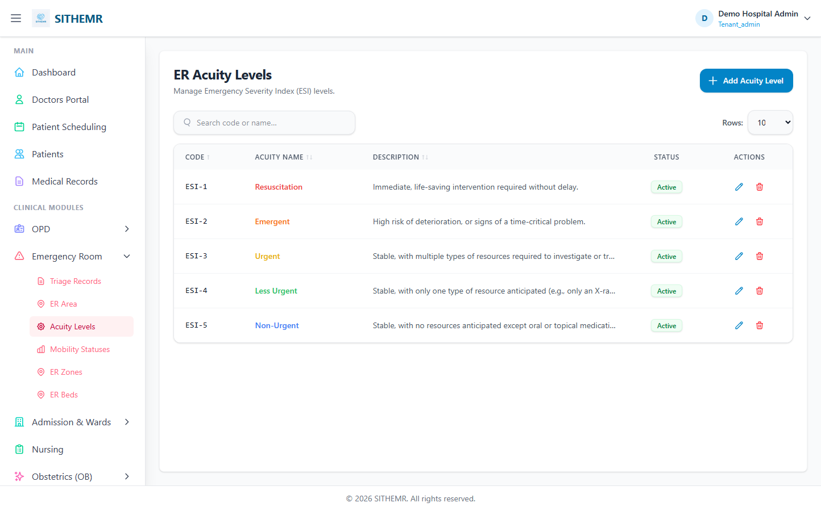
(85 KB)
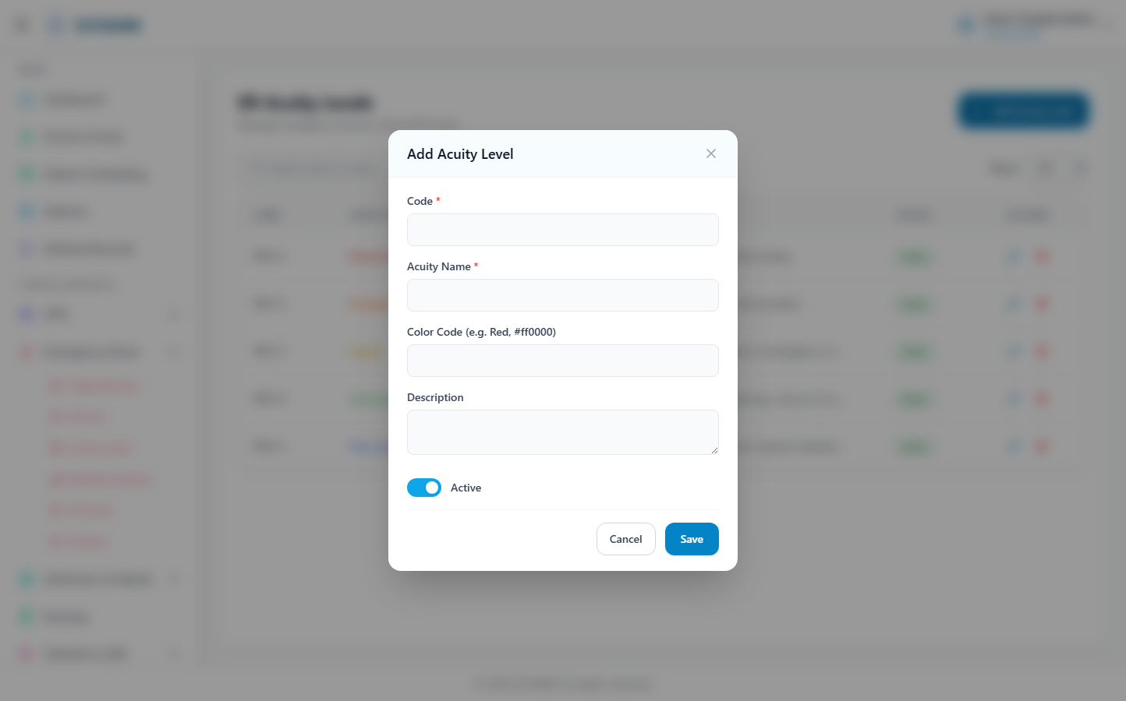
(161 KB)
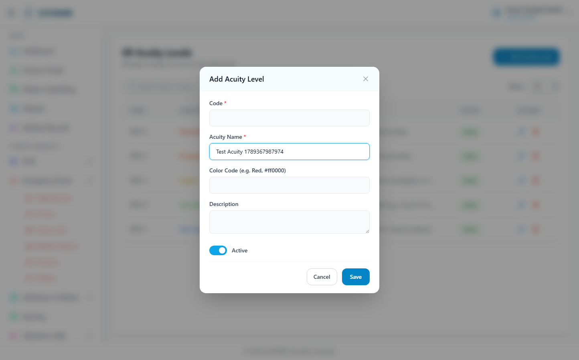
(162 KB)
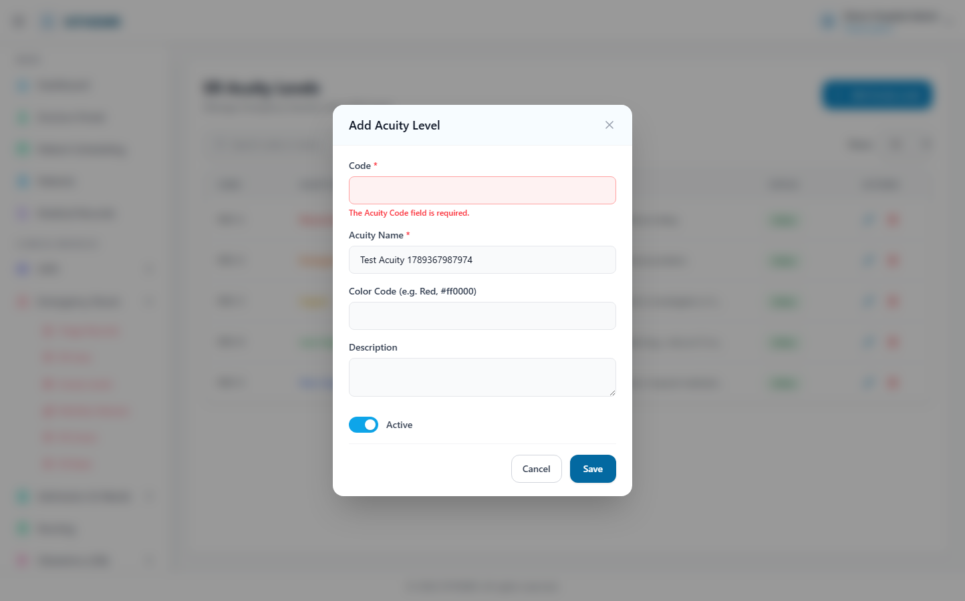
(163 KB)
Mobility Statuses
Route: /er/mobility-statuses | Type: crud | Status: PASS
[PASS]
Record created (1 fields filled)
✓ Test record created successfully
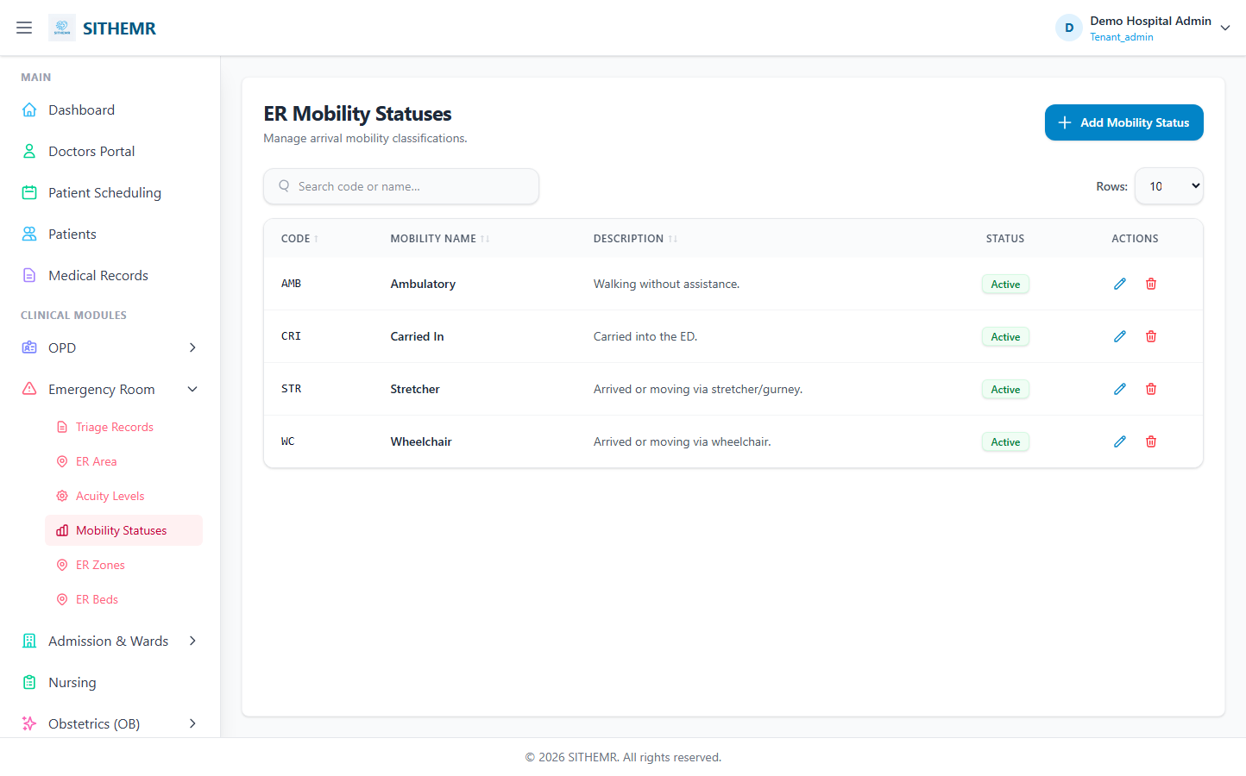
(75 KB)
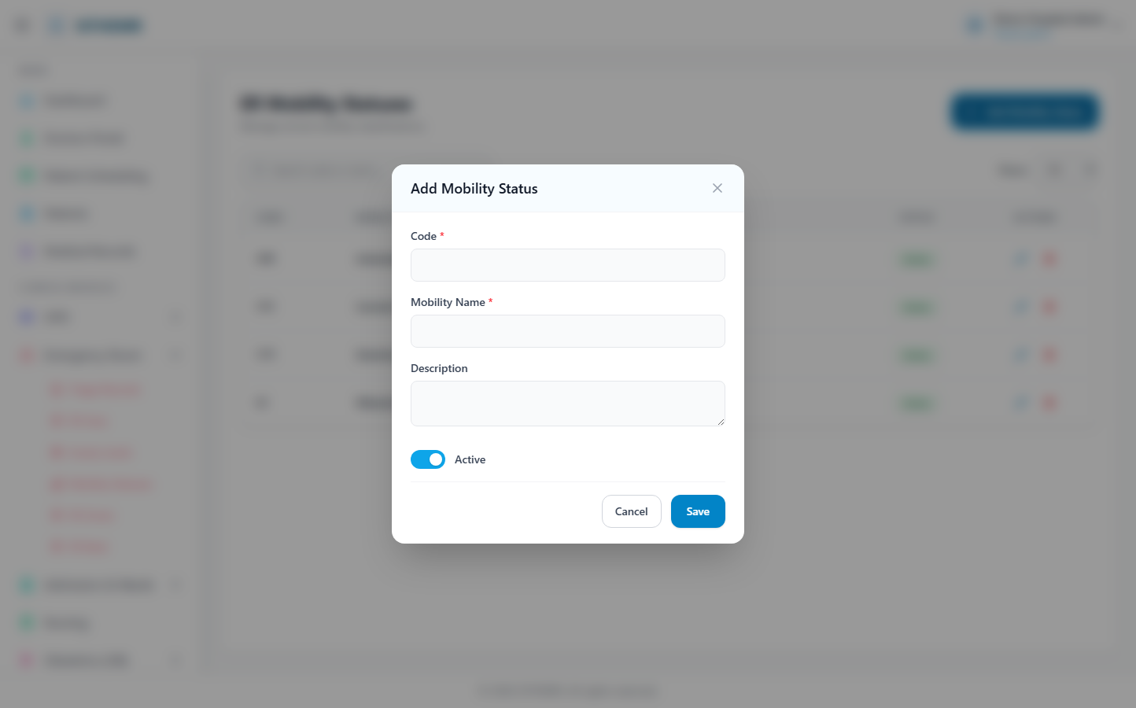
(141 KB)
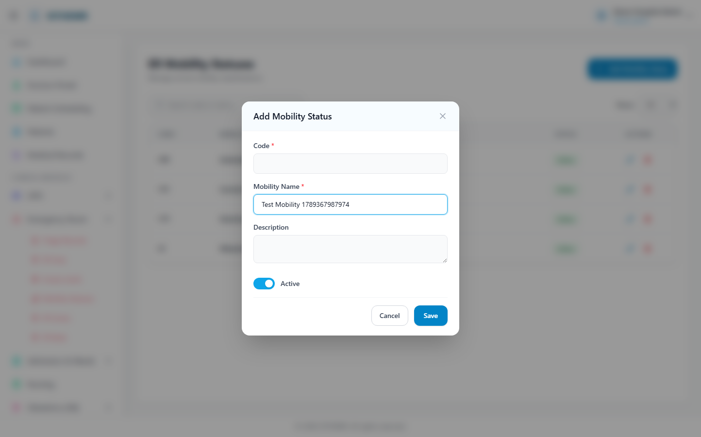
(143 KB)
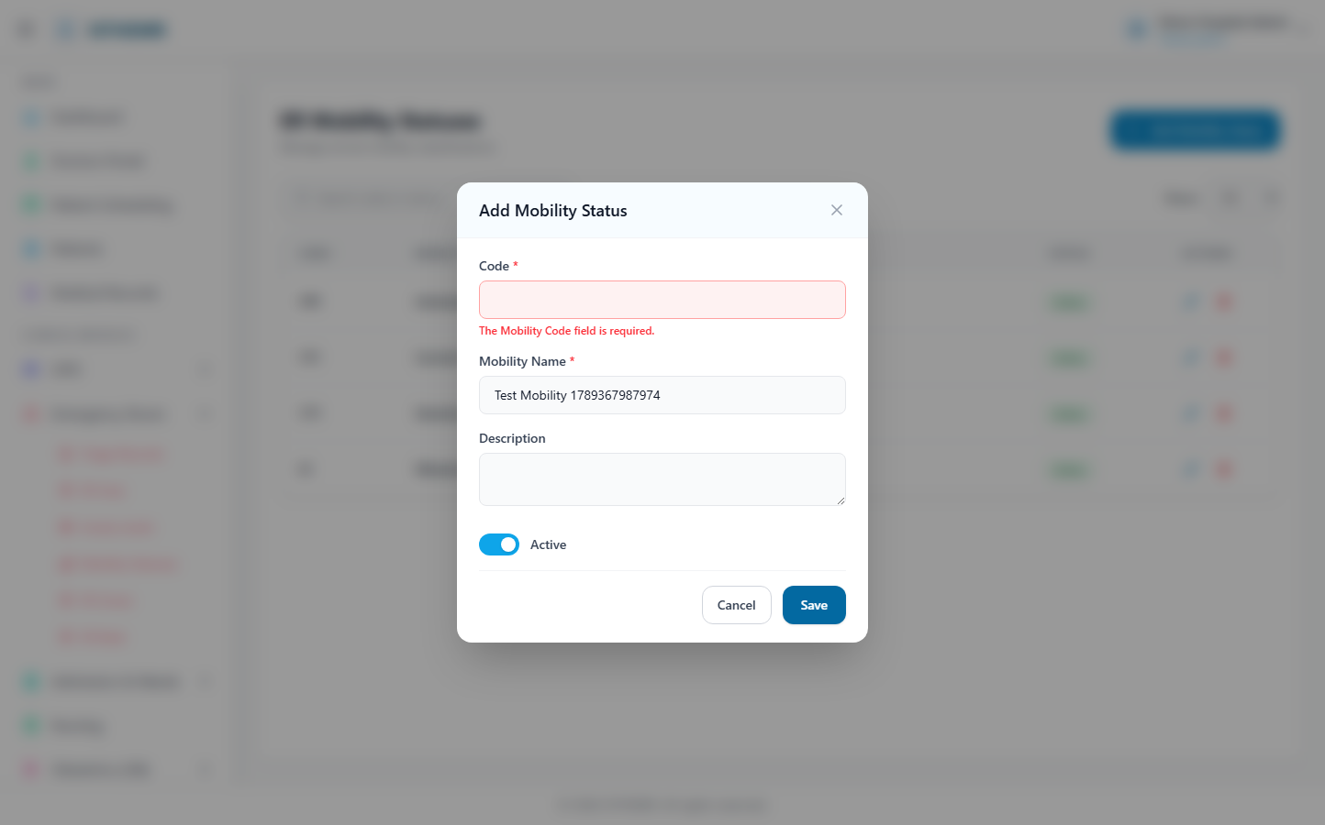
(144 KB)
ER Zones
Route: /er/zones | Type: crud | Status: CHECK
[CHECK]
Created but no success toast — verify manually
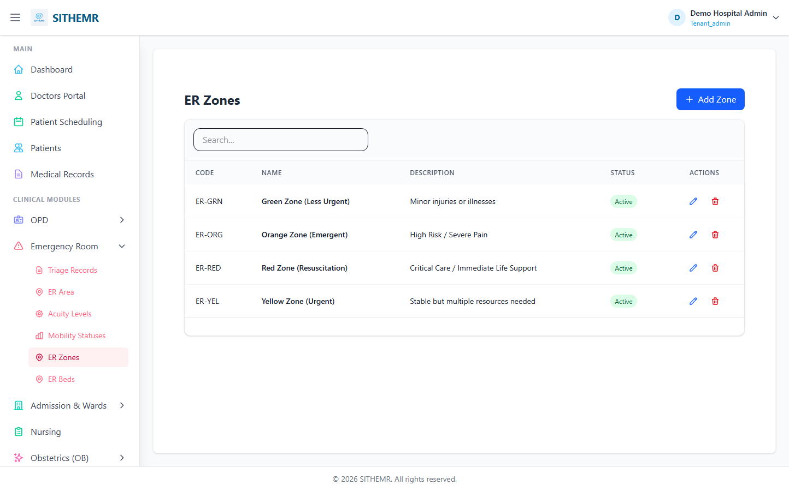
(70 KB)
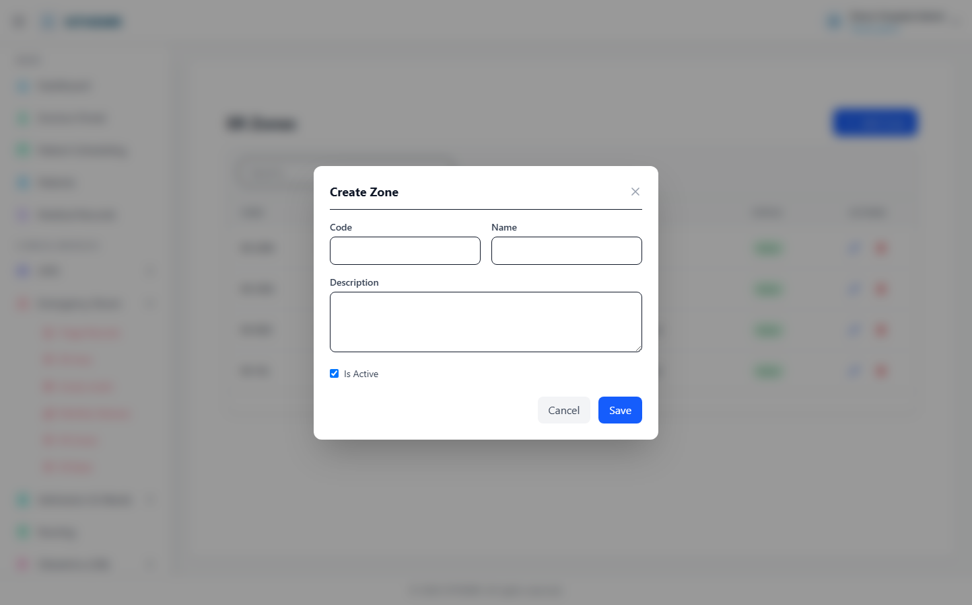
(121 KB)
(121 KB)
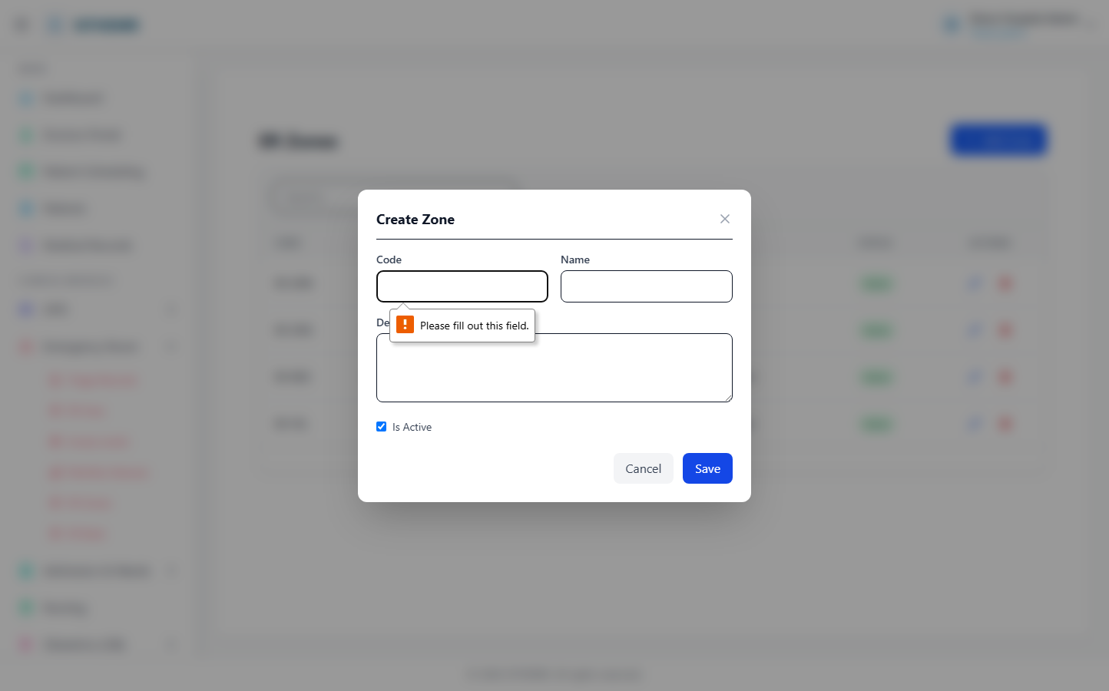
(123 KB)
ER Beds
Route: /er/beds | Type: crud | Status: CHECK
[CHECK]
Created but no success toast — verify manually
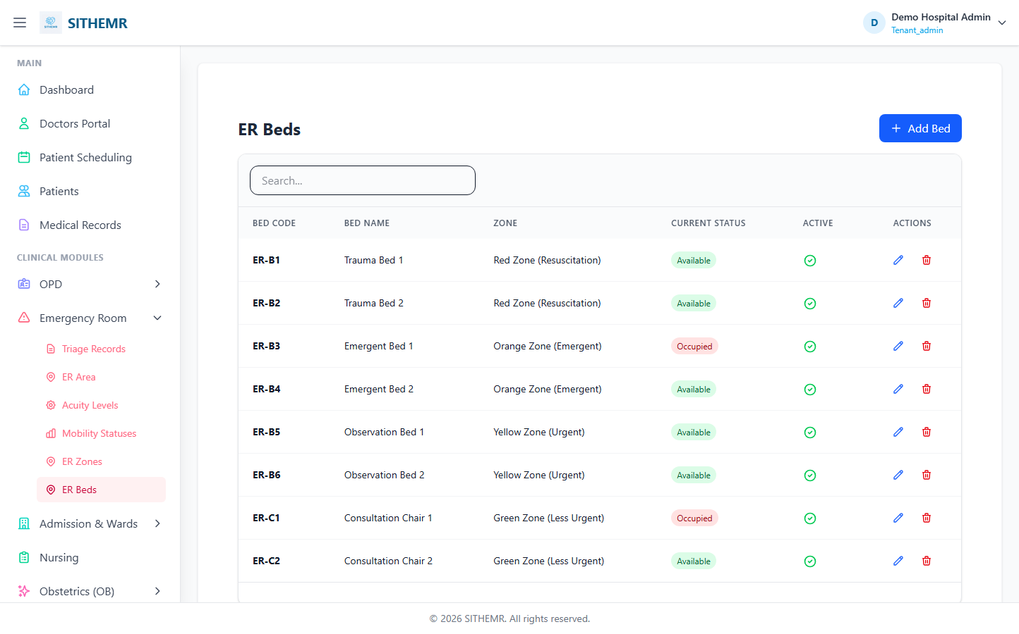
(86 KB)
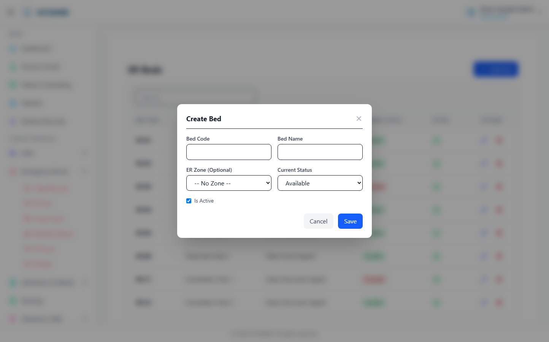
(174 KB)
(174 KB)
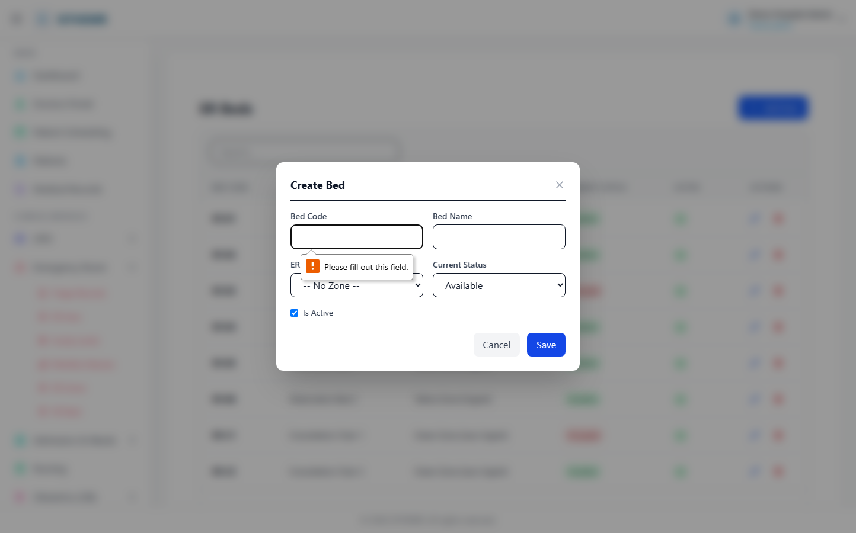
(175 KB)

Admission & Wards
Admissions
Route: /admission | Type: list-only | Status: PASS
[PASS]
Page loaded — Admission Management Manage patient admissions from ER and active inpatients.
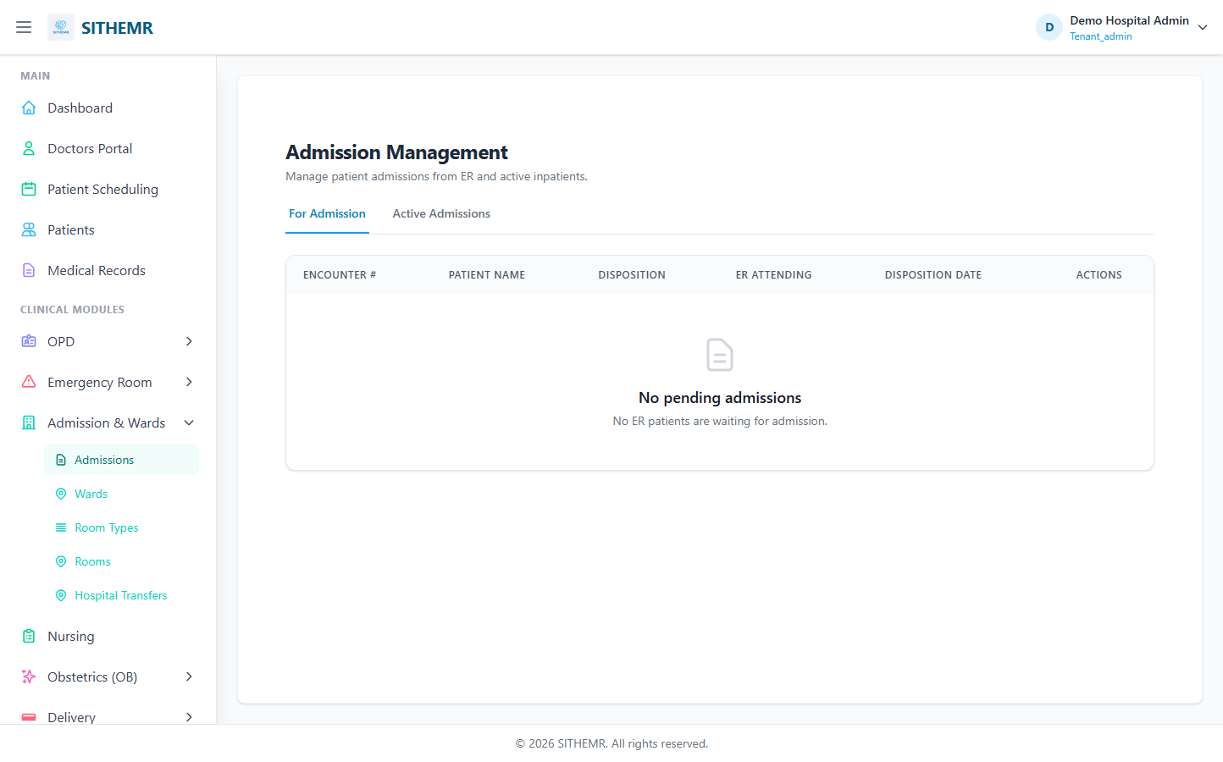
(61 KB)
Wards
Route: /ward/wards | Type: crud | Status: PASS
[PASS]
Record created (1 fields filled)
✓ Test record created successfully
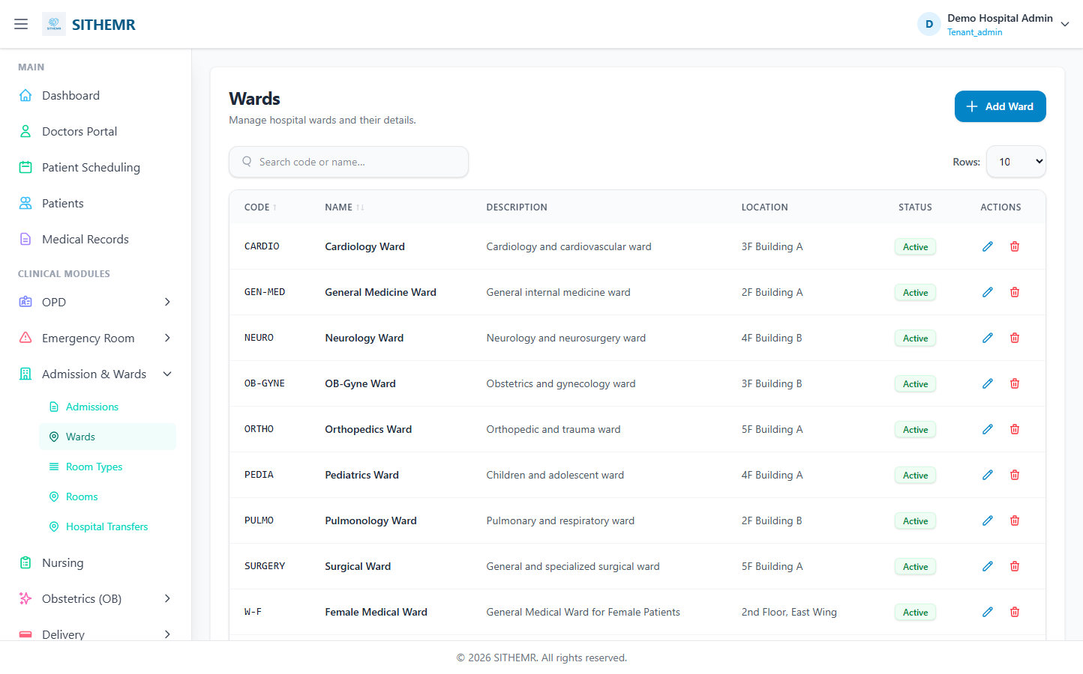
(112 KB)
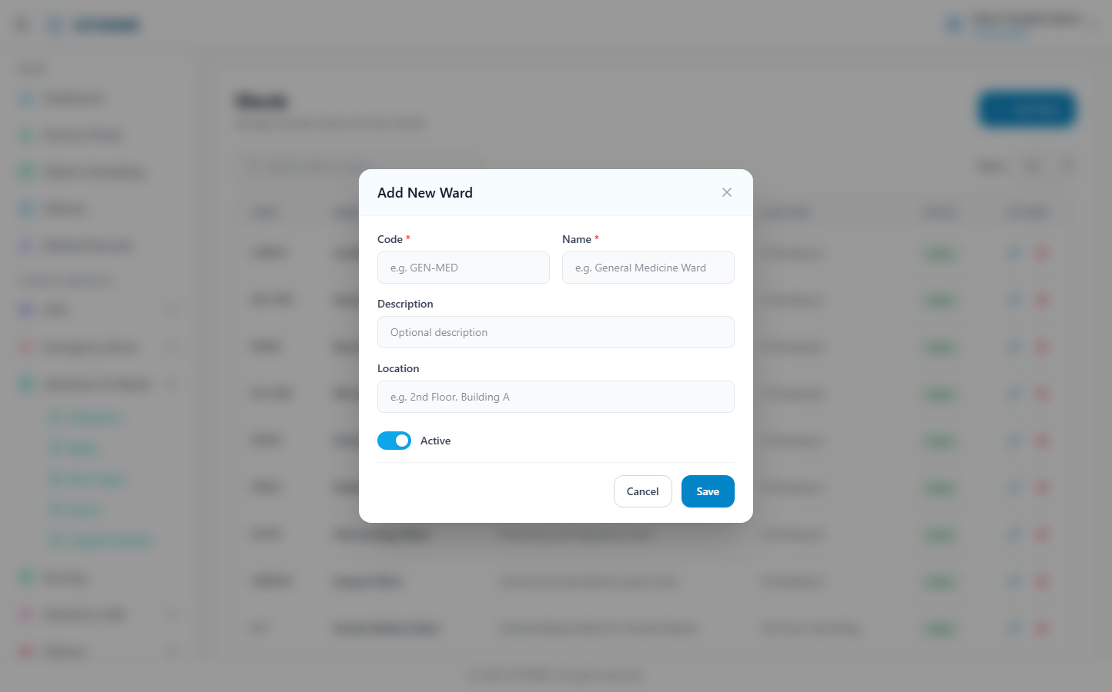
(207 KB)
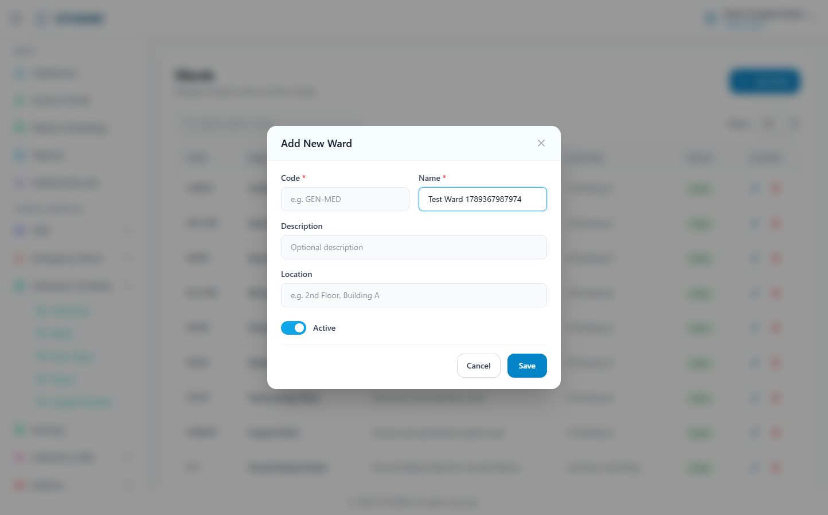
(208 KB)
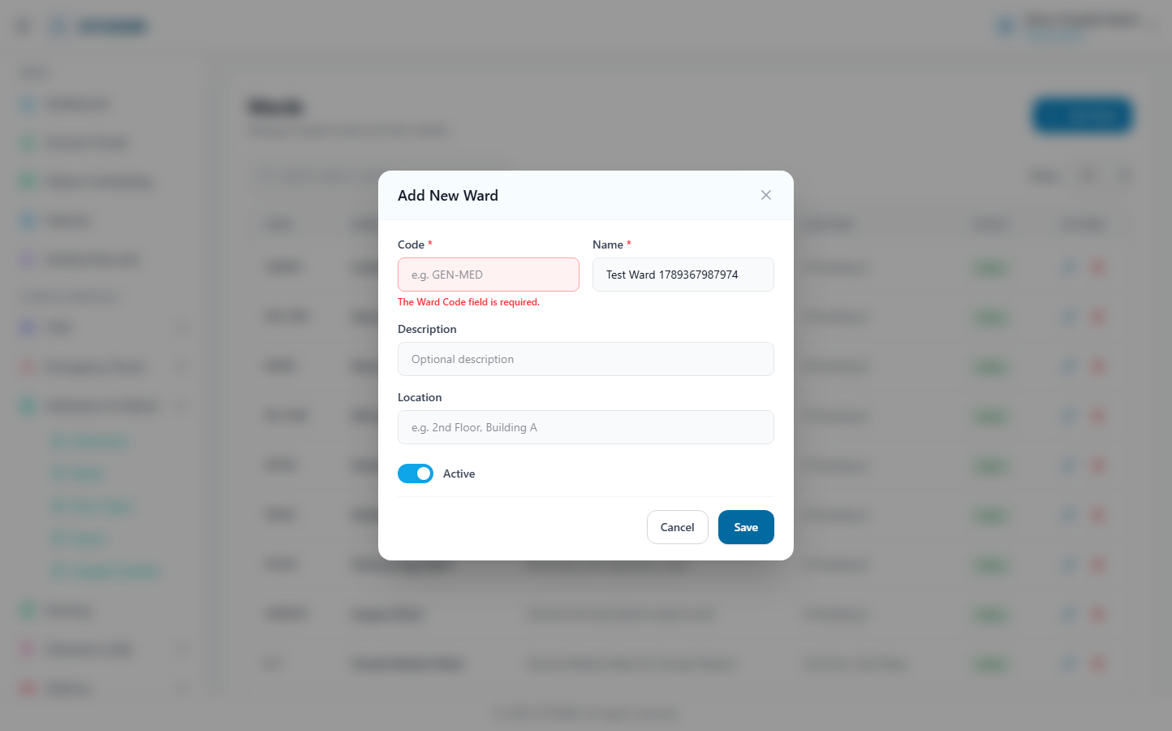
(209 KB)
Rooms
Route: /ward/rooms | Type: crud | Status: PASS
[PASS]
Record created (1 fields filled)
✓ Test record created successfully
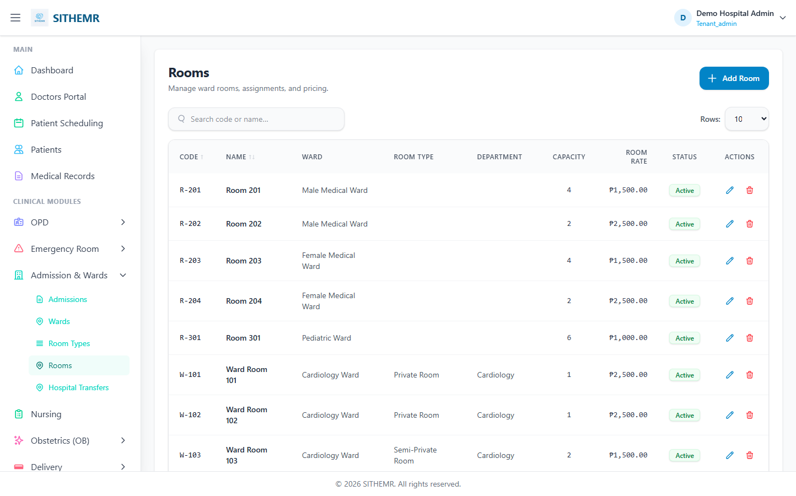
(108 KB)
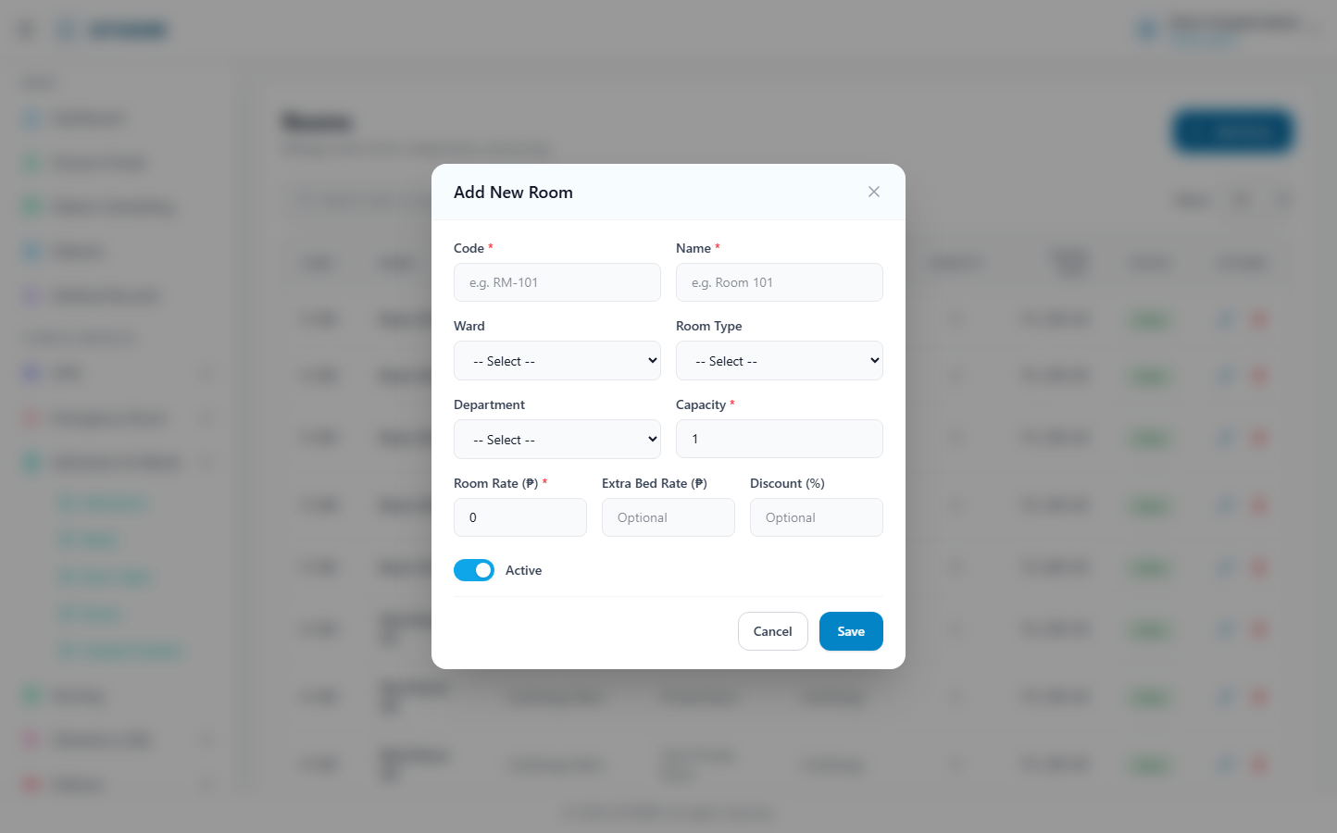
(215 KB)
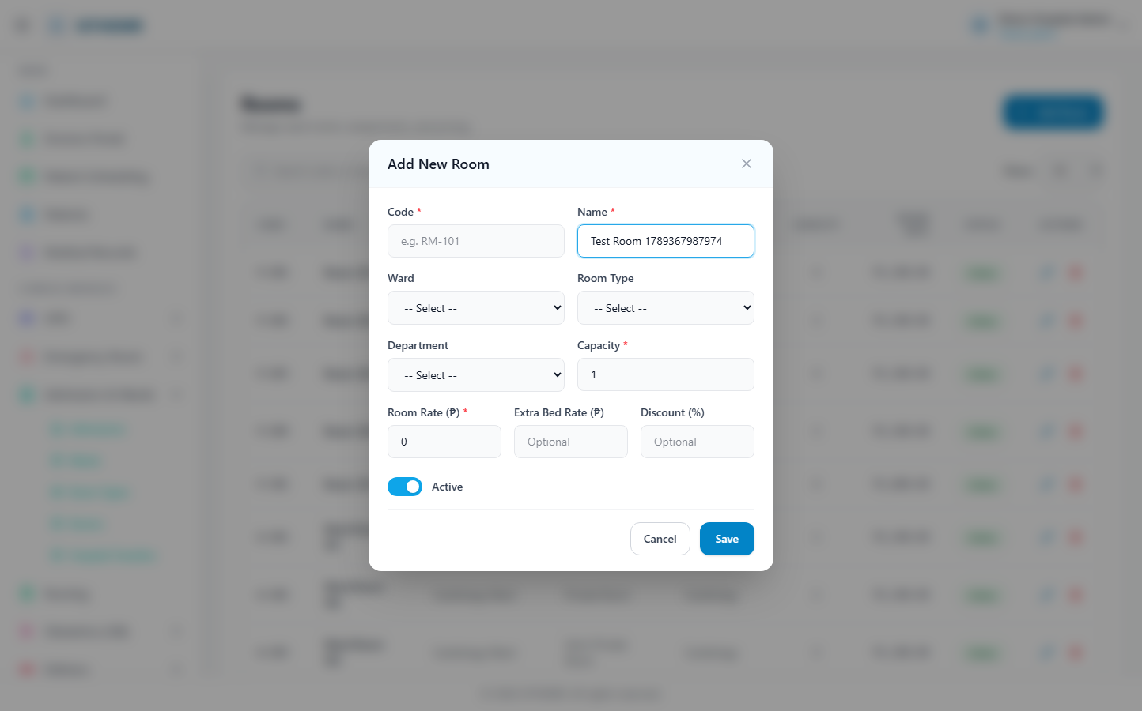
(216 KB)
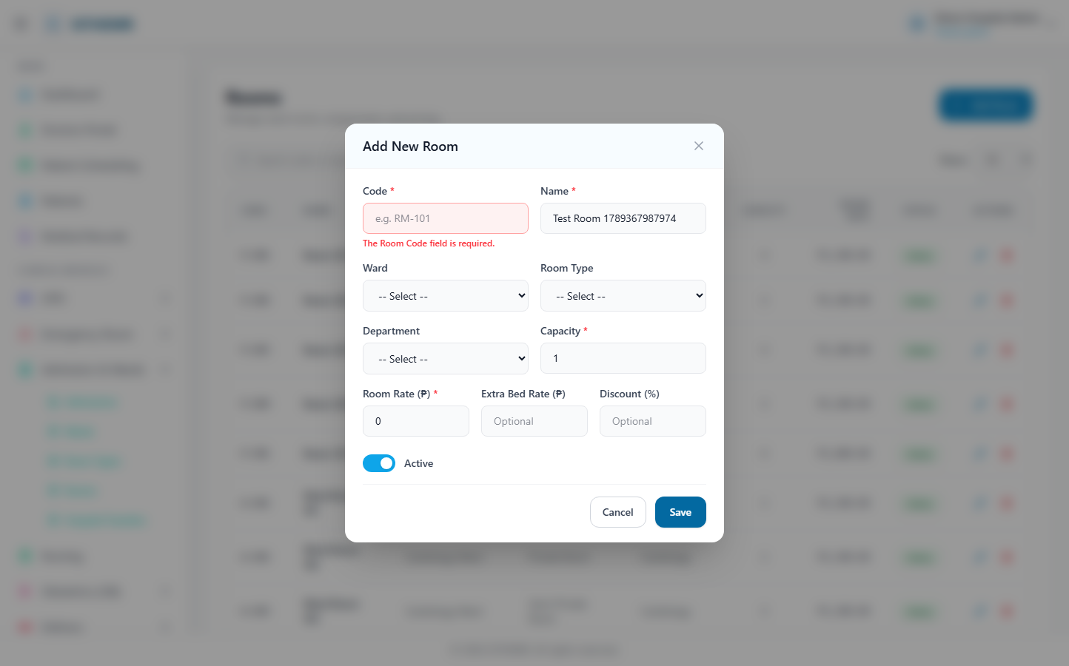
(217 KB)
Room Types
Route: /ward/room-types | Type: crud | Status: PASS
[PASS]
Record created (1 fields filled)
✓ Test record created successfully
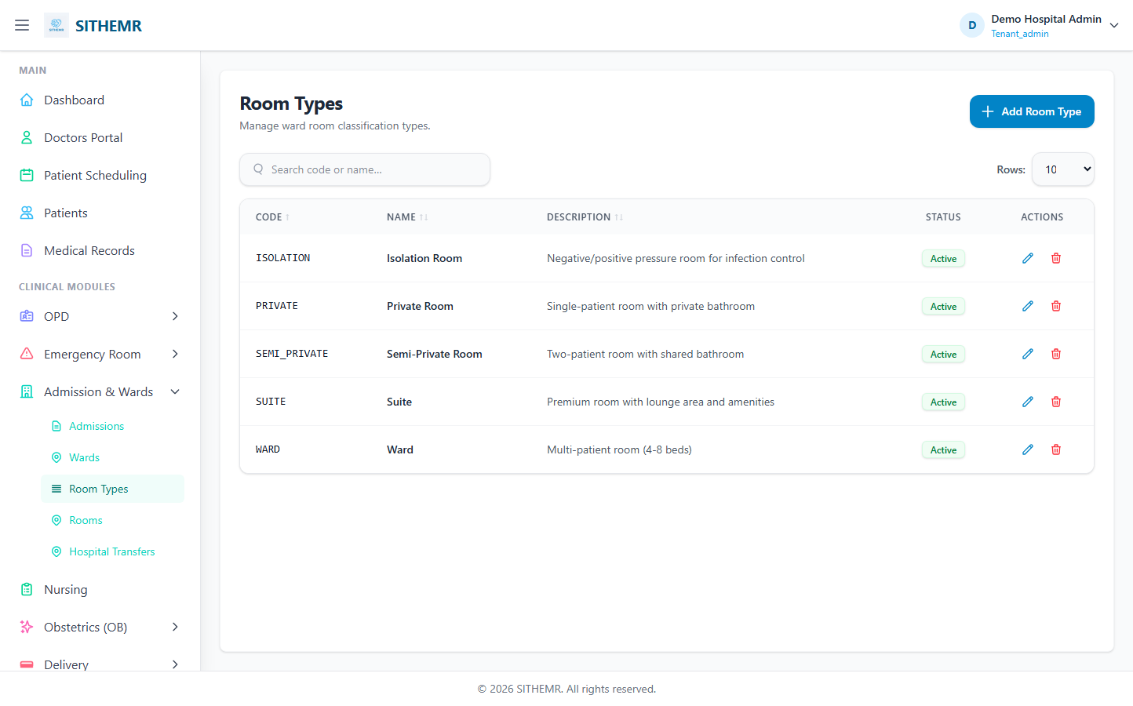
(83 KB)
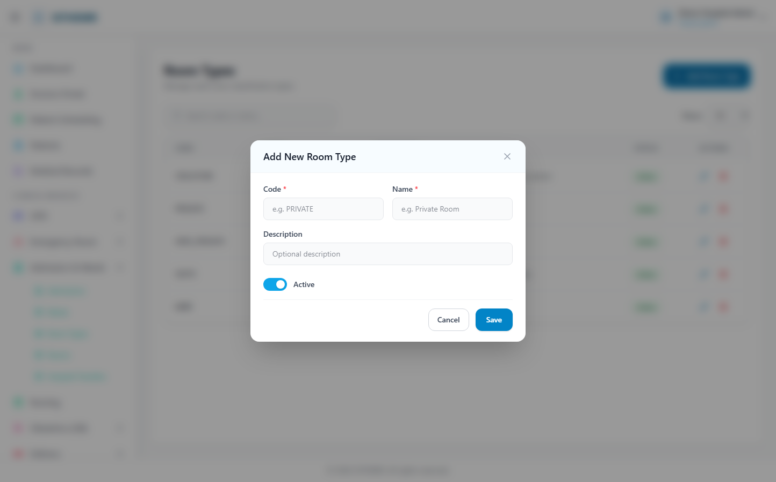
(146 KB)
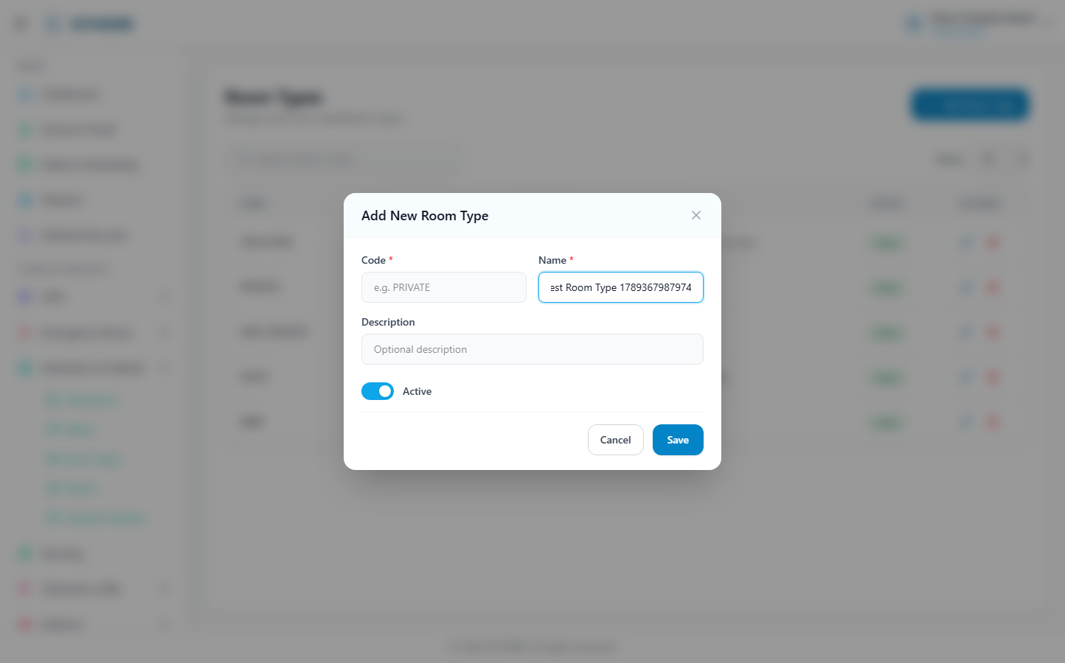
(148 KB)
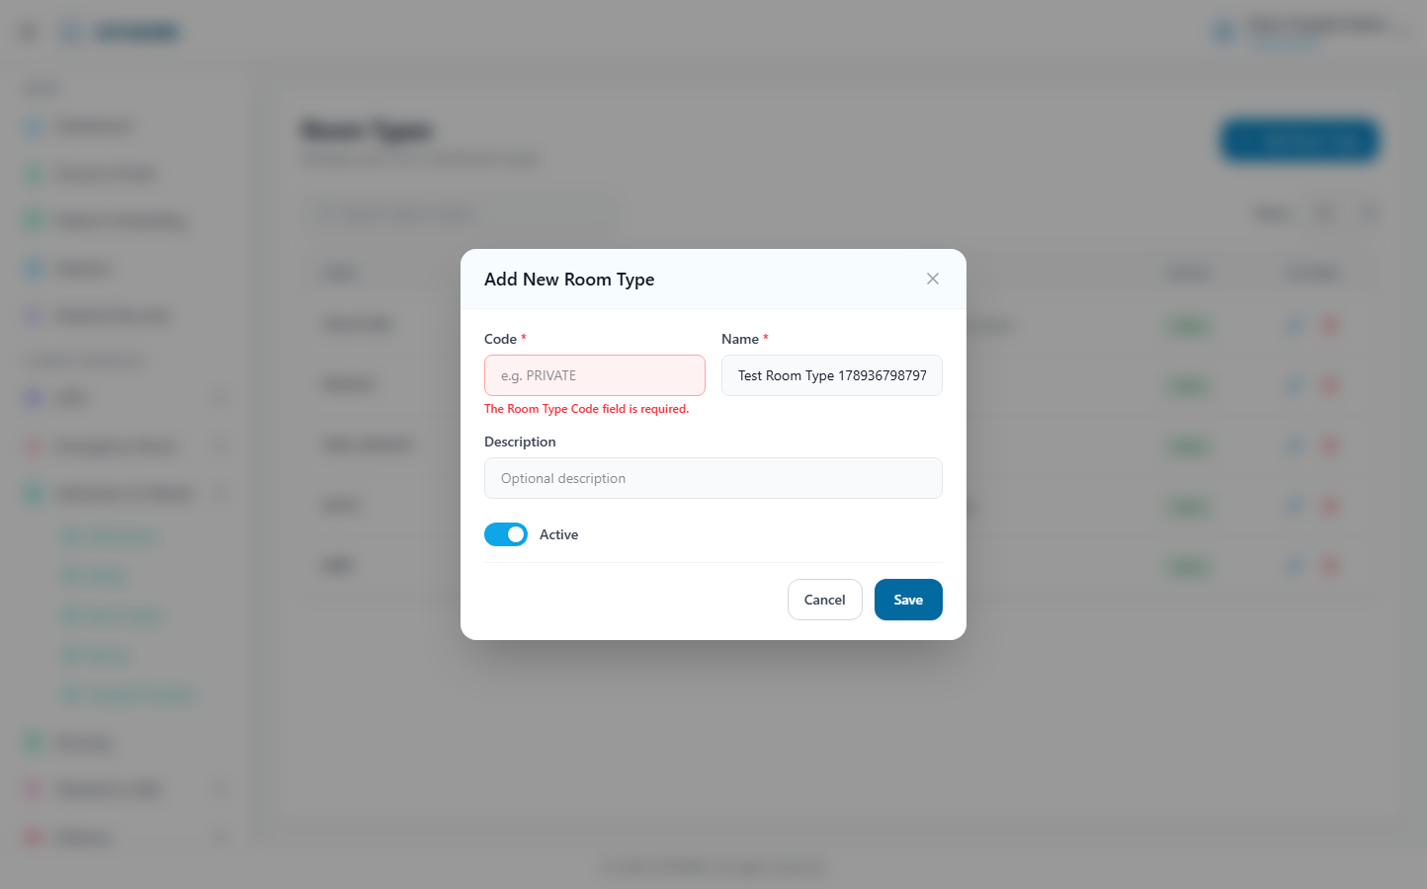
(149 KB)
ICU Wards
Route: /icu/wards | Type: list-only | Status: PASS
[PASS]
Page loaded — ICU Wards Manage intensive care unit wards. Add Ward Rows: 10 25 50 CODE ↑ NA
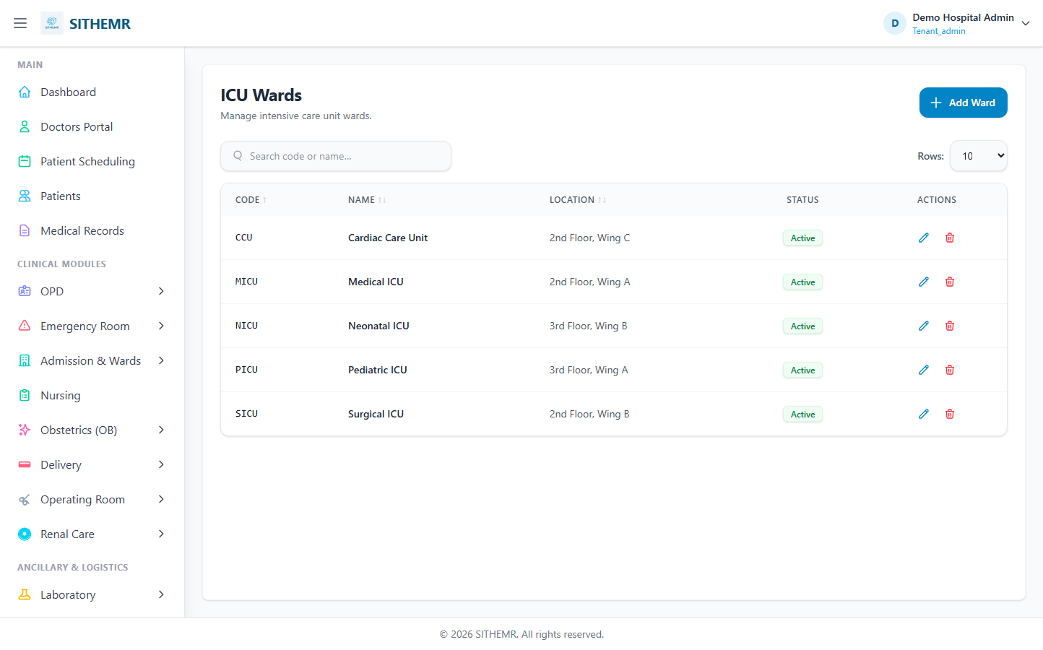
(77 KB)
ICU Beds
Route: /icu/beds | Type: list-only | Status: PASS
[PASS]
Page loaded — ICU Beds Manage ICU bed inventory across wards. Add Bed Rows: 10 25 50 CODE ↑
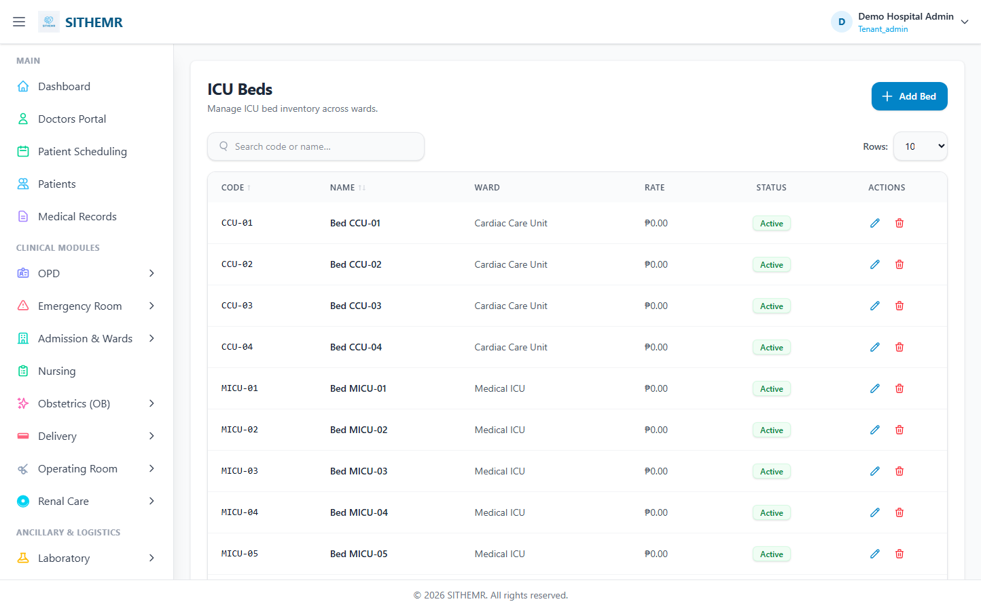
(100 KB)
Hospital Transfers
Route: /transfers | Type: list-only | Status: PASS
[PASS]
Page loaded — Hospital Transfers Track patient transfers to other healthcare facilities. New
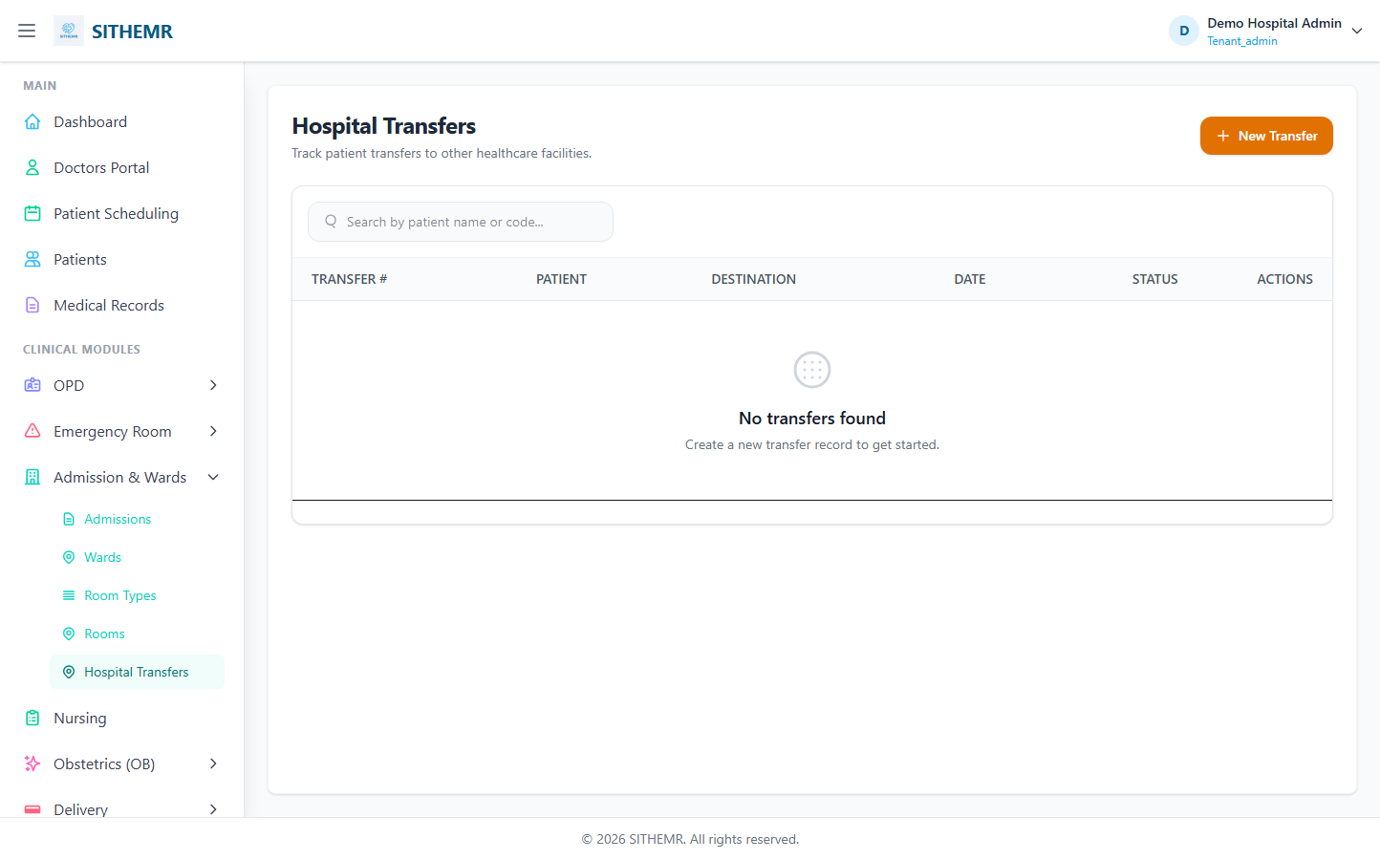
(60 KB)

Nursing
Nursing
Route: /nursing | Type: list-only | Status: PASS
[PASS]
Page loaded — In-Patient Nursing Manage admitted patients, vitals, care notes, and discharges
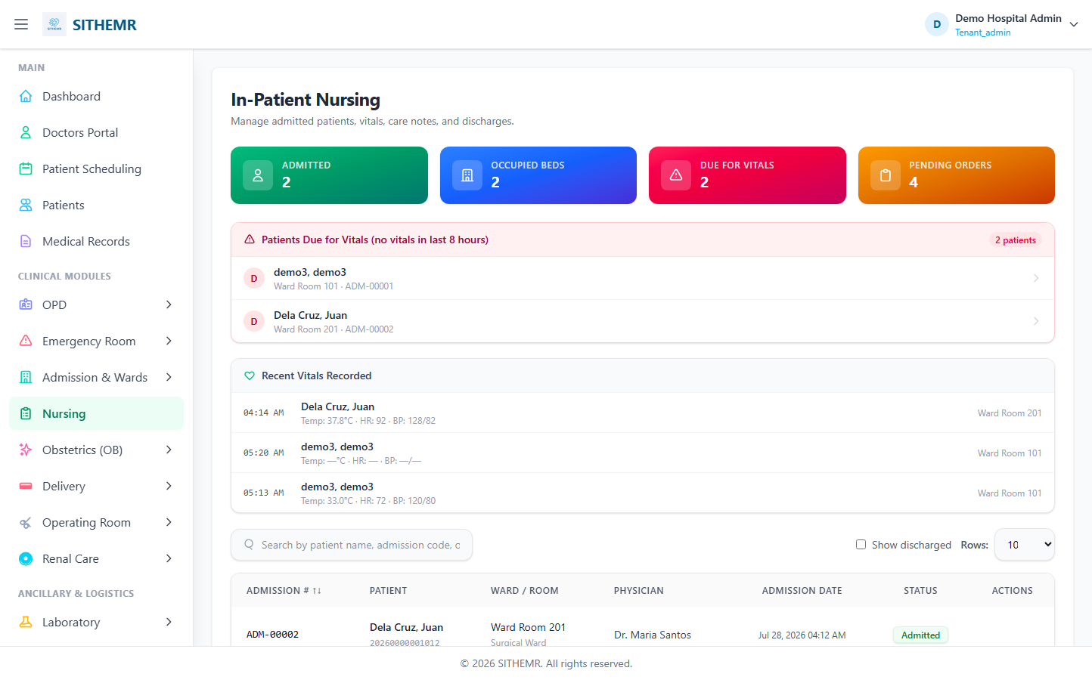
(140 KB)

Laboratory
Lab Sections
Route: /lab/sections | Type: crud | Status: PASS
[PASS]
Record created (1 fields filled)
✓ Test record created successfully
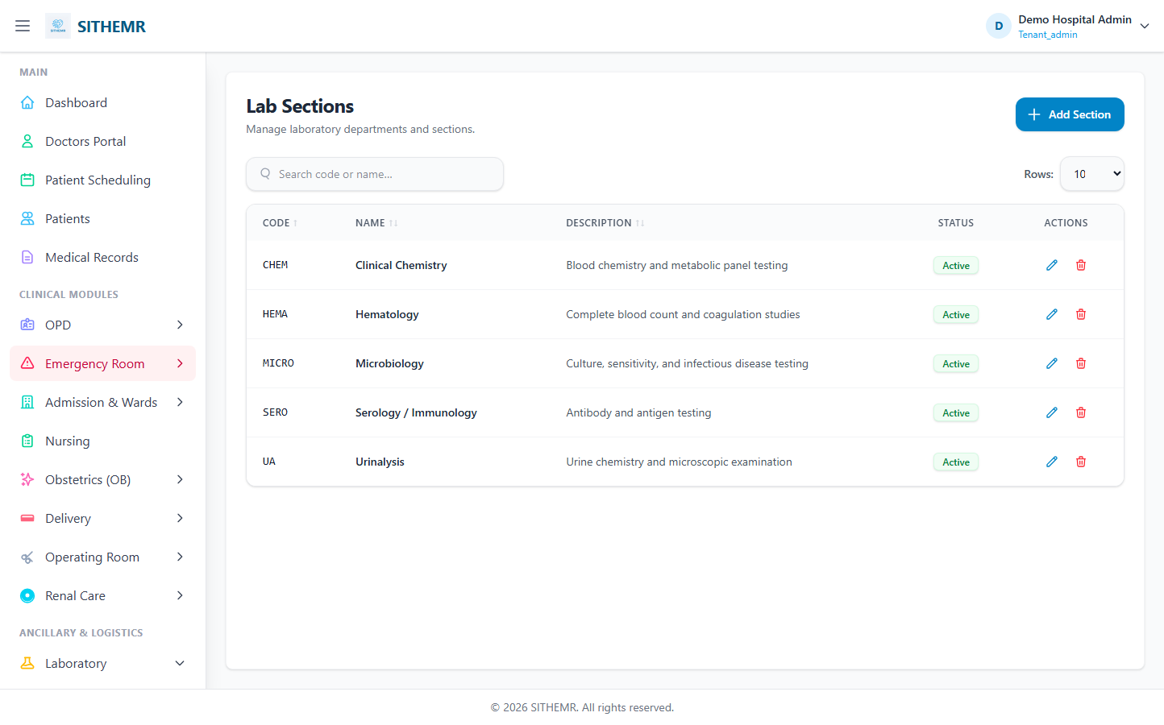
(84 KB)
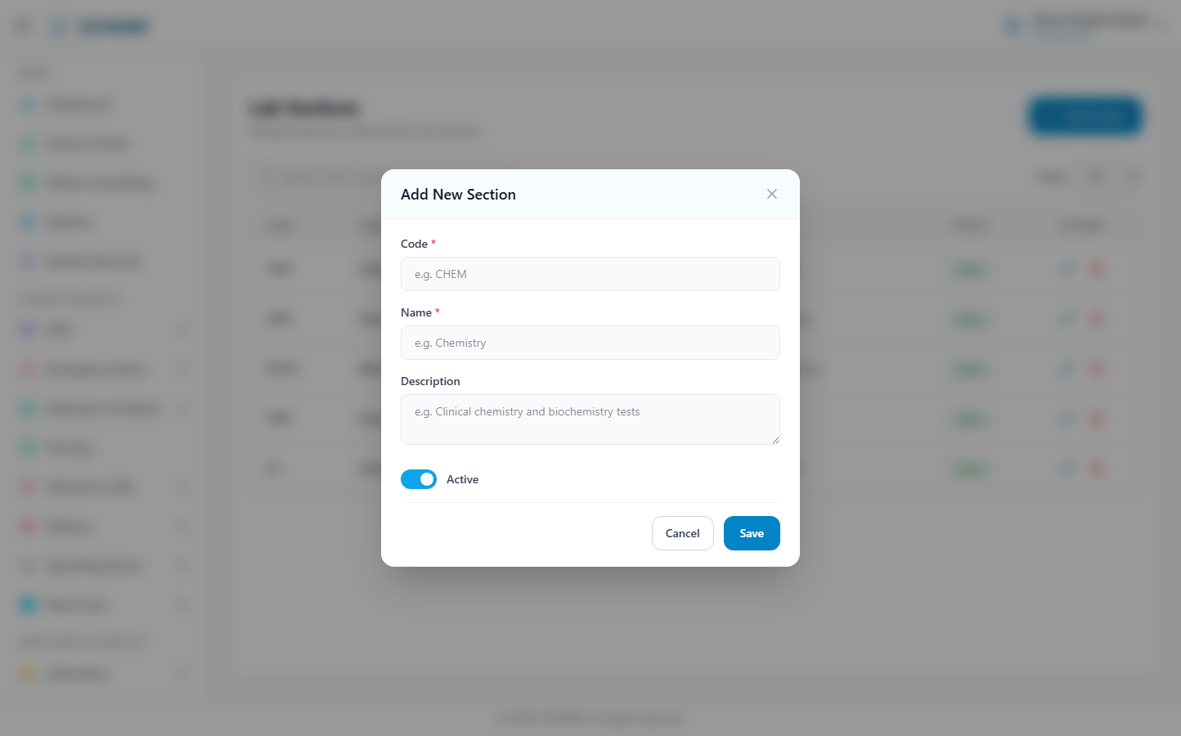
(155 KB)
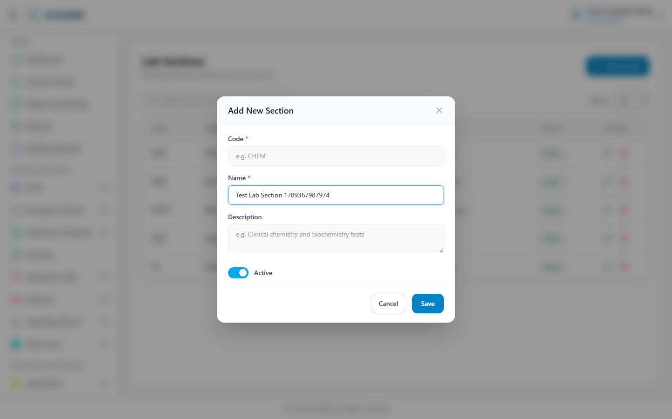
(156 KB)
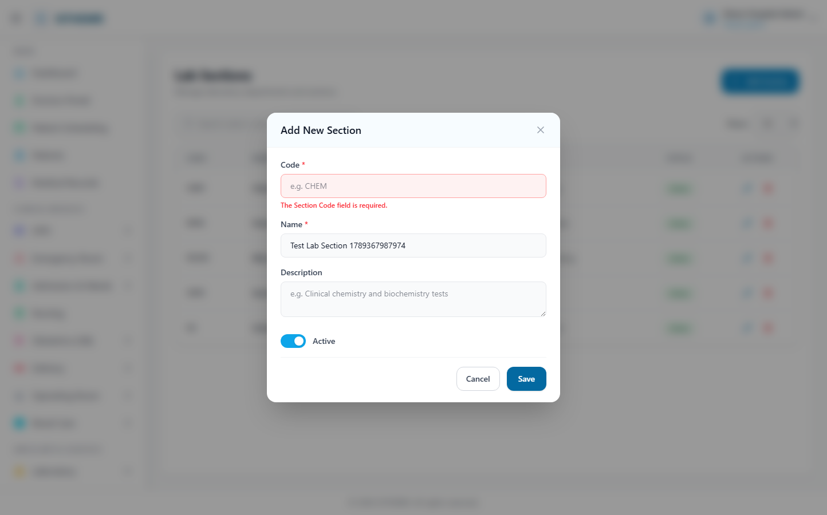
(157 KB)
Lab Units
Route: /lab/units | Type: crud | Status: PASS
[PASS]
Record created (1 fields filled)
✓ Test record created successfully
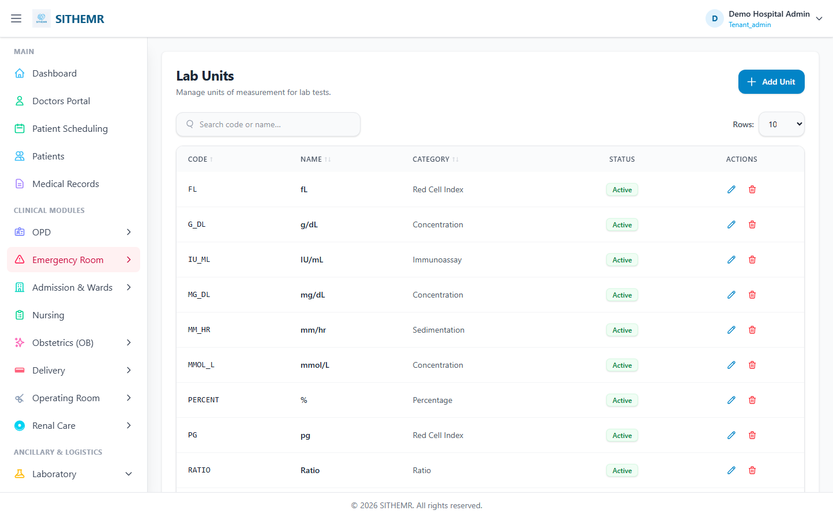
(87 KB)
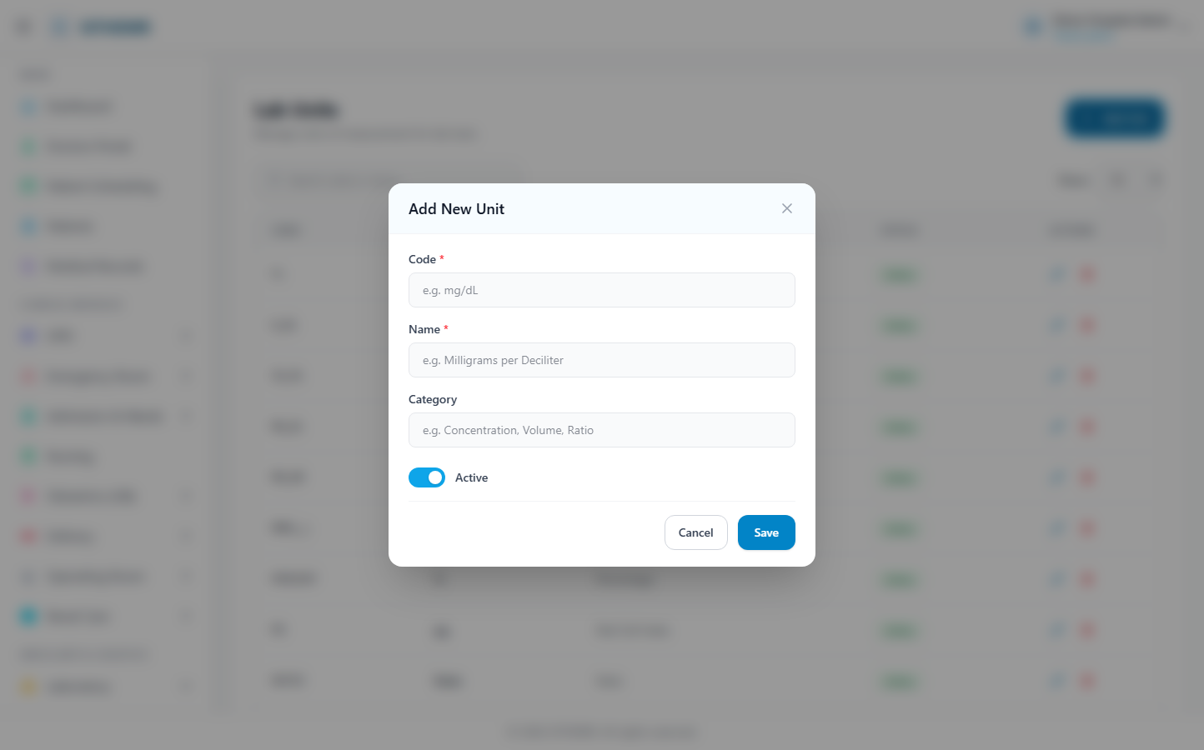
(172 KB)
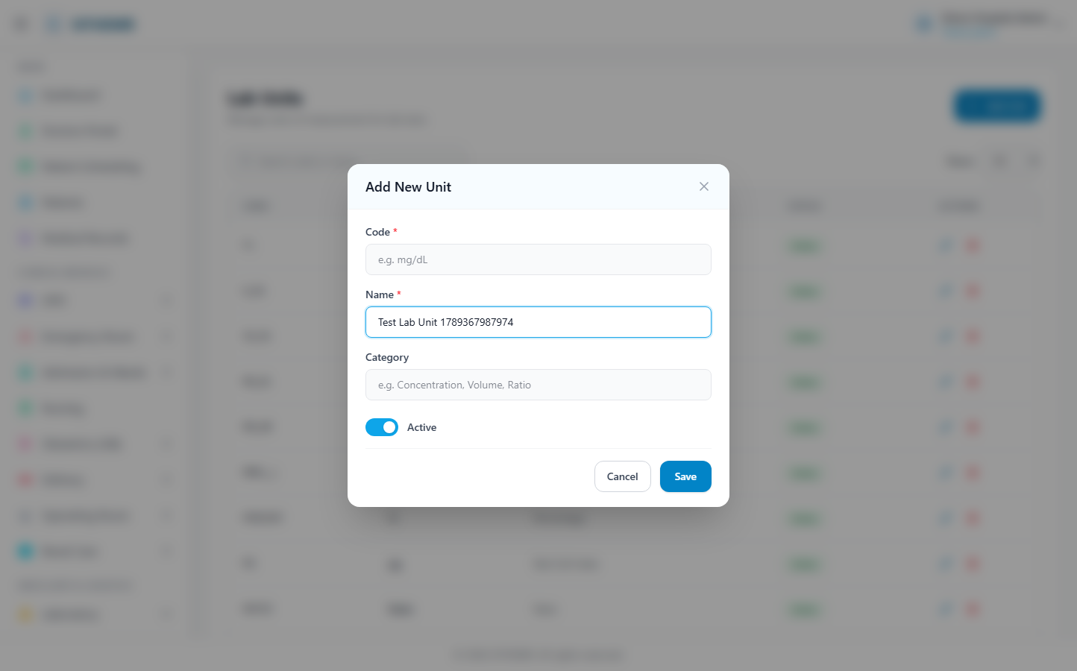
(172 KB)
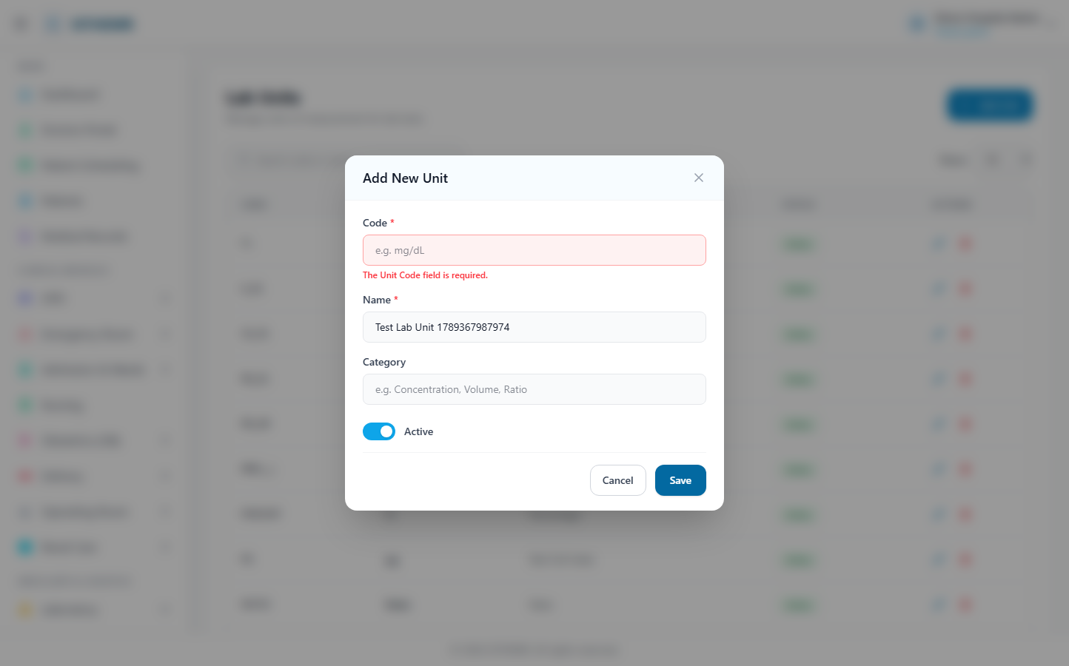
(173 KB)
Specimen Types
Route: /lab/specimen-types | Type: crud | Status: PASS
[PASS]
Record created (1 fields filled)
✓ Test record created successfully
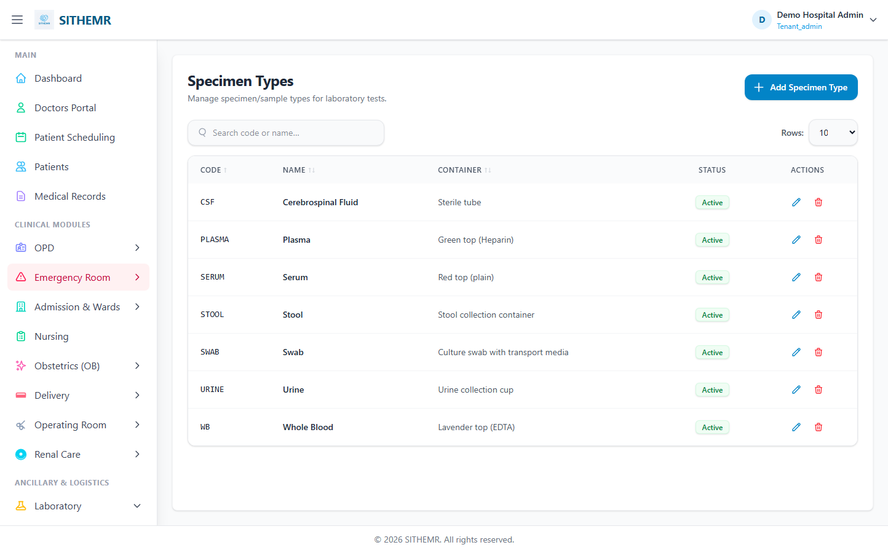
(86 KB)
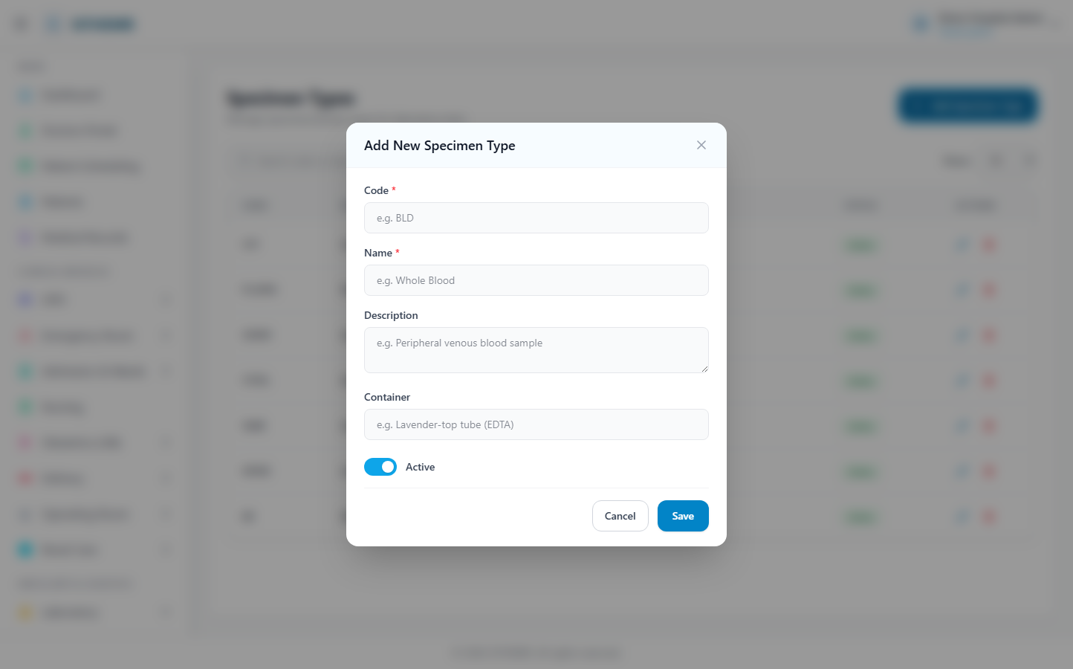
(167 KB)
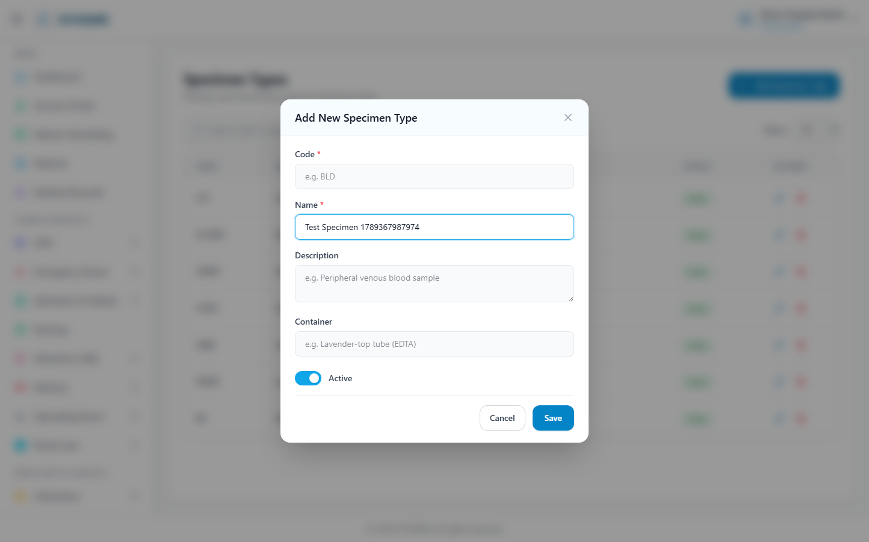
(168 KB)
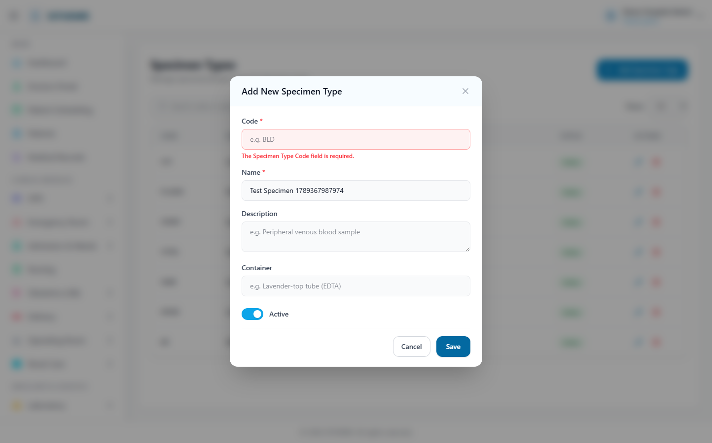
(169 KB)
Instruments
Route: /lab/instruments | Type: crud | Status: CHECK
[CHECK]
Created but no success toast — verify manually
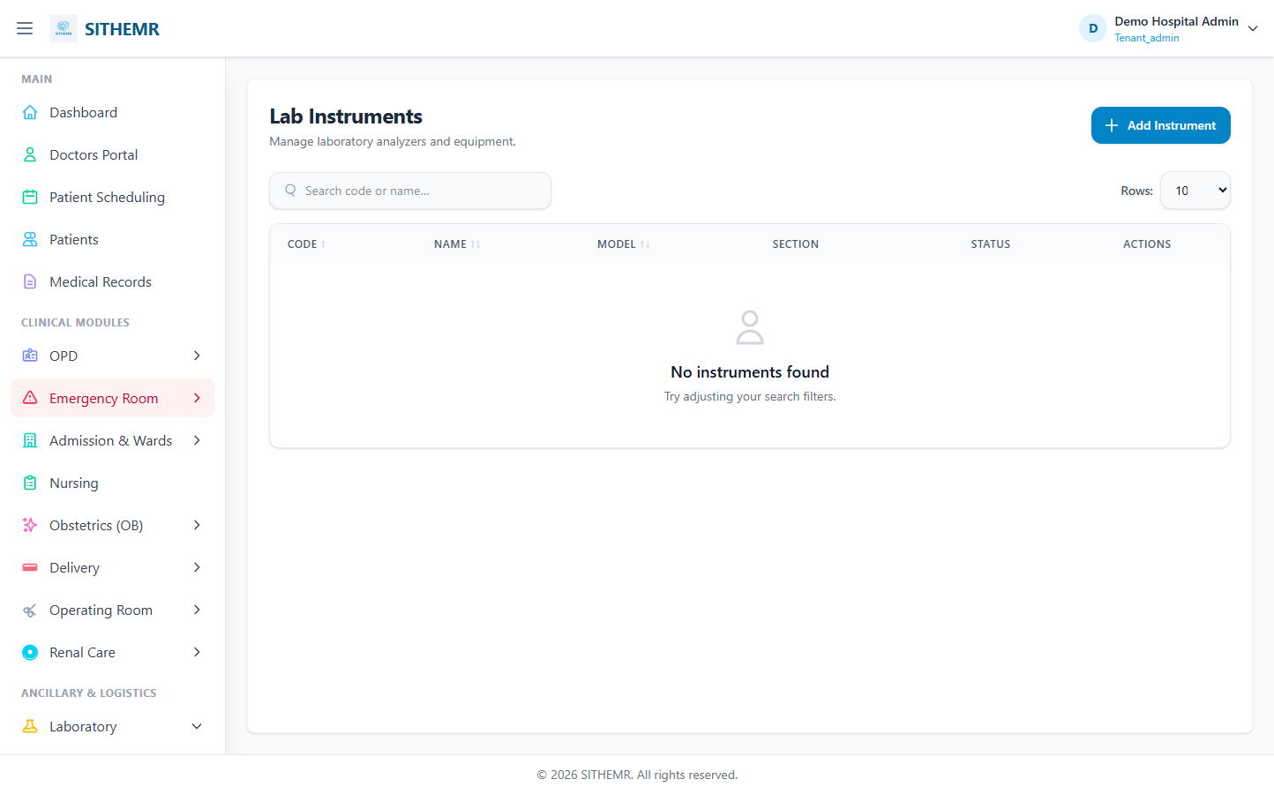
(60 KB)
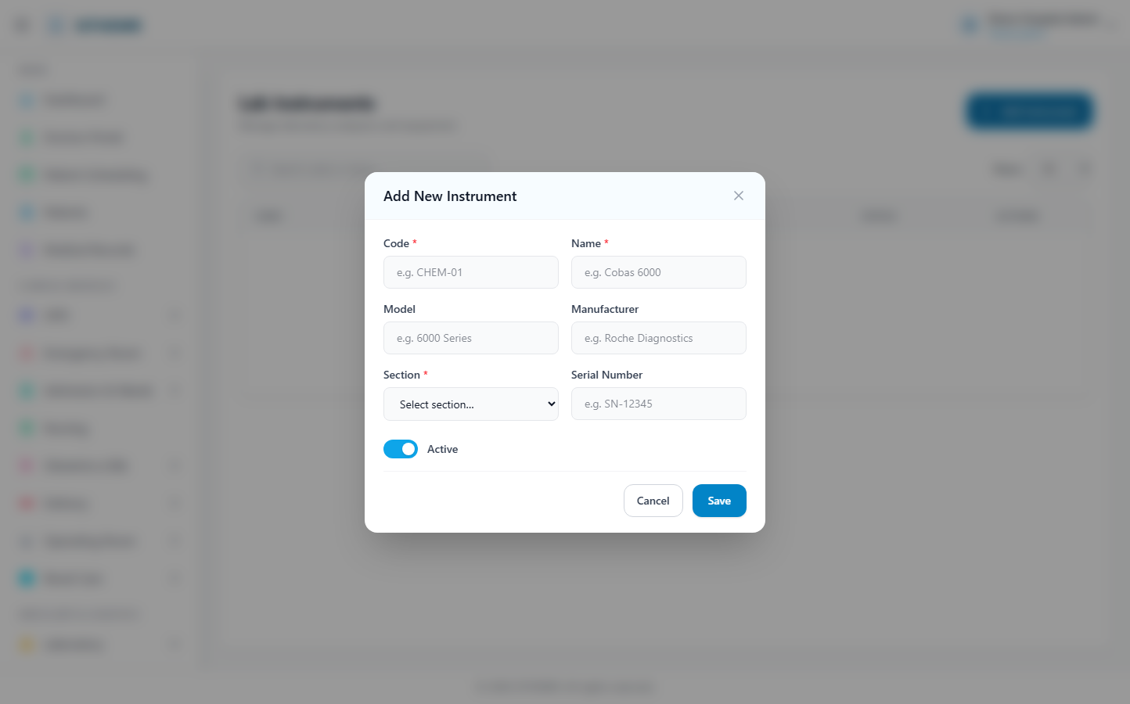
(128 KB)
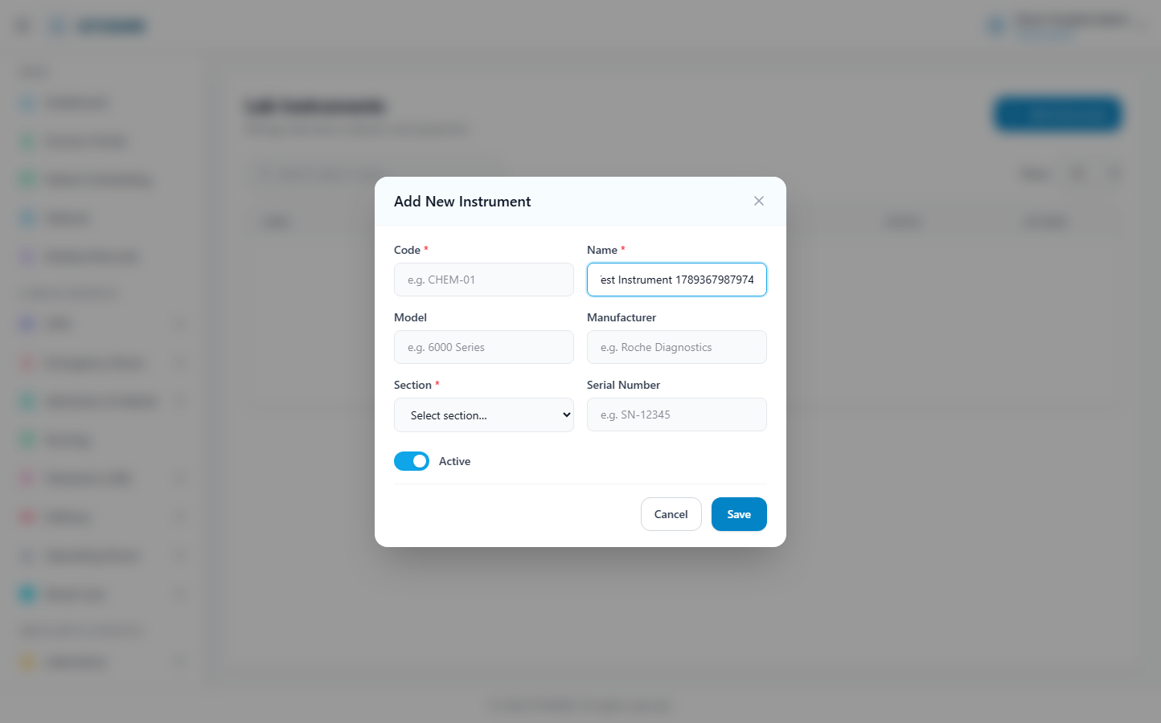
(129 KB)
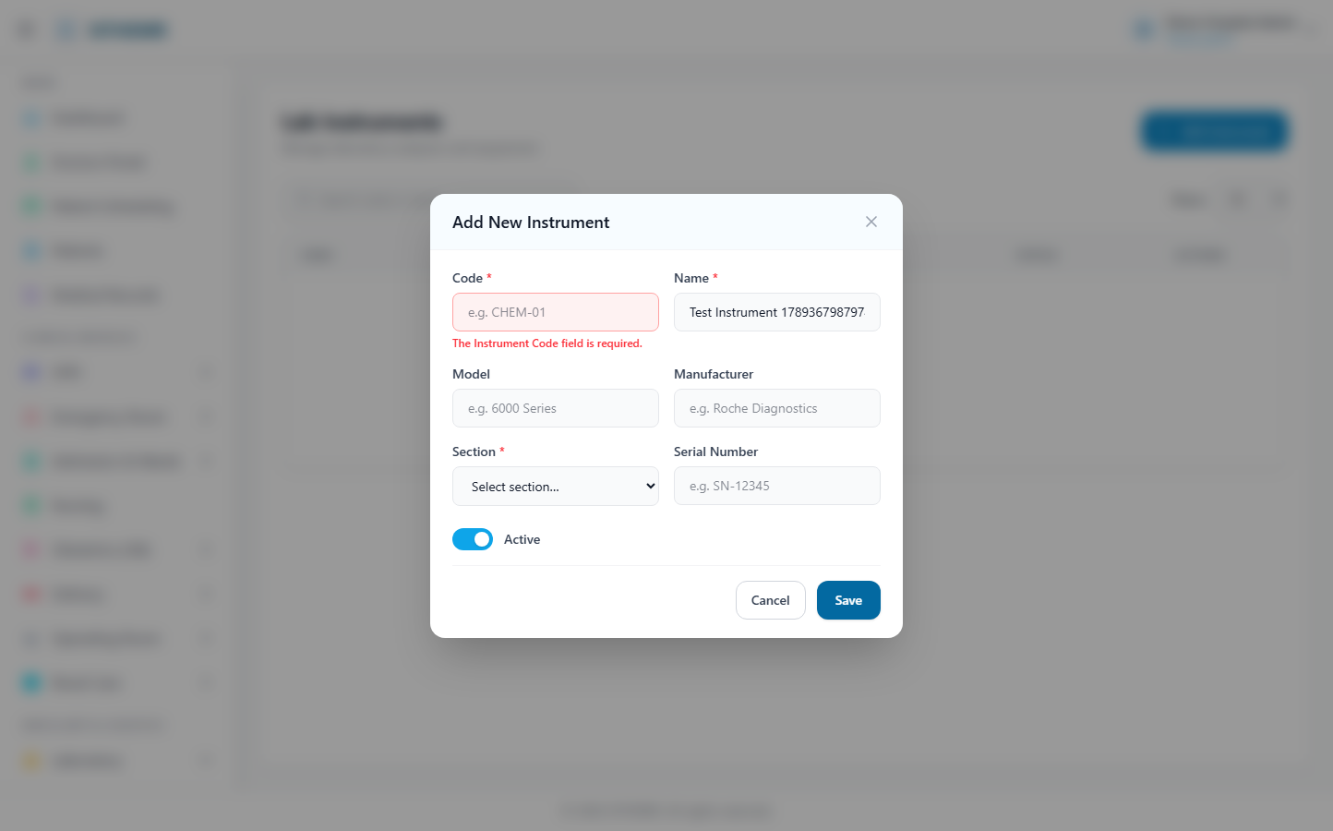
(131 KB)
Test Catalog
Route: /lab/tests | Type: crud | Status: PASS
[PASS]
Record created (1 fields filled)
✓ Test record created successfully
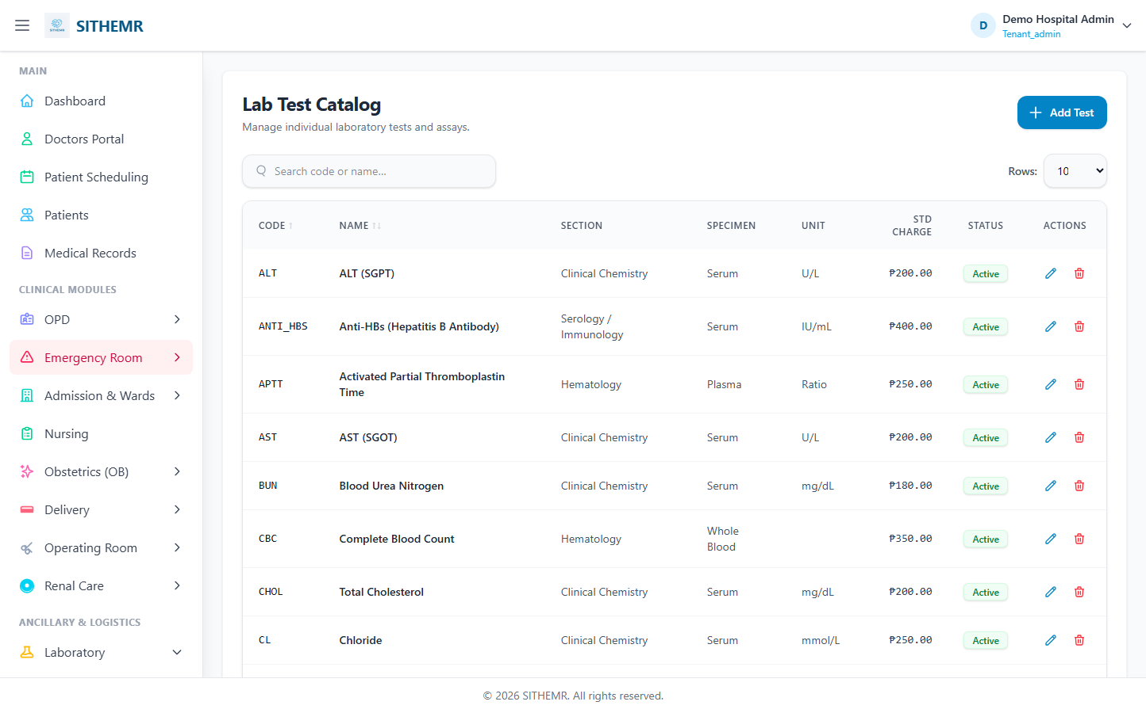
(110 KB)
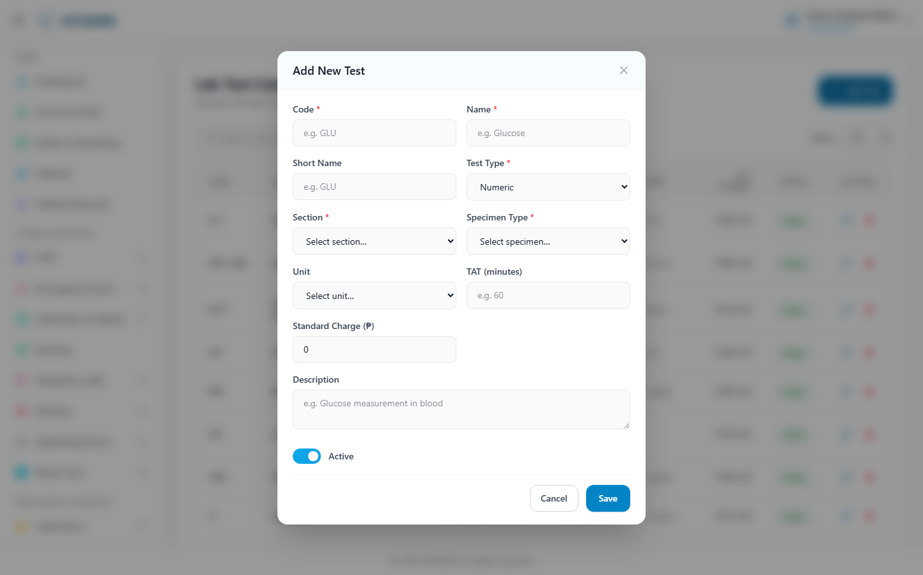
(202 KB)
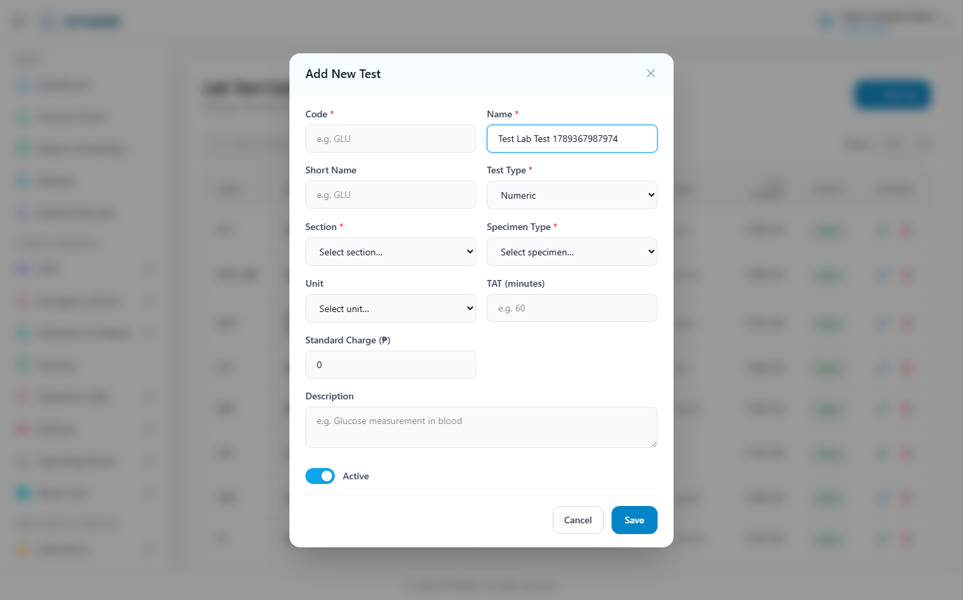
(204 KB)
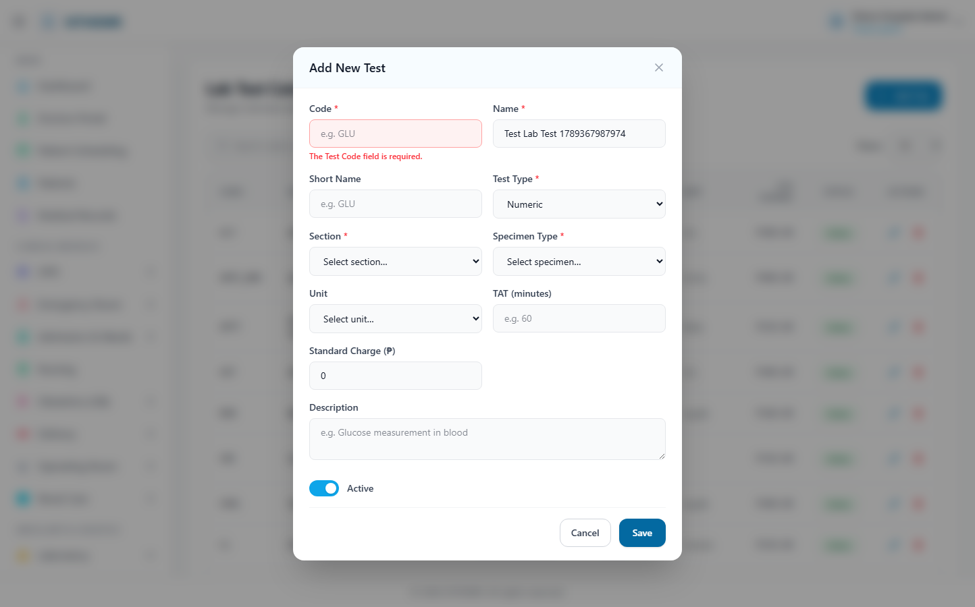
(205 KB)
Panels
Route: /lab/panels | Type: crud | Status: PASS
[PASS]
Record created (1 fields filled)
✓ Test record created successfully
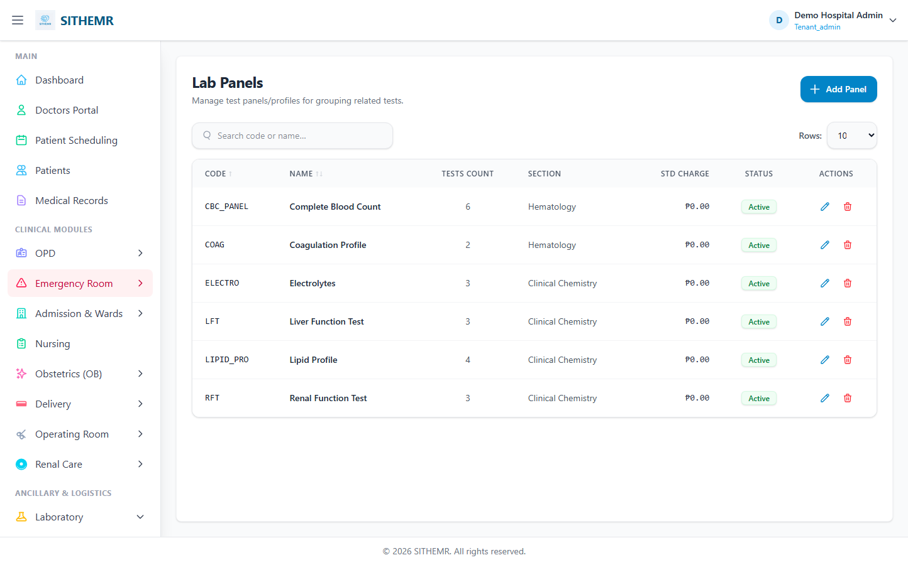
(88 KB)
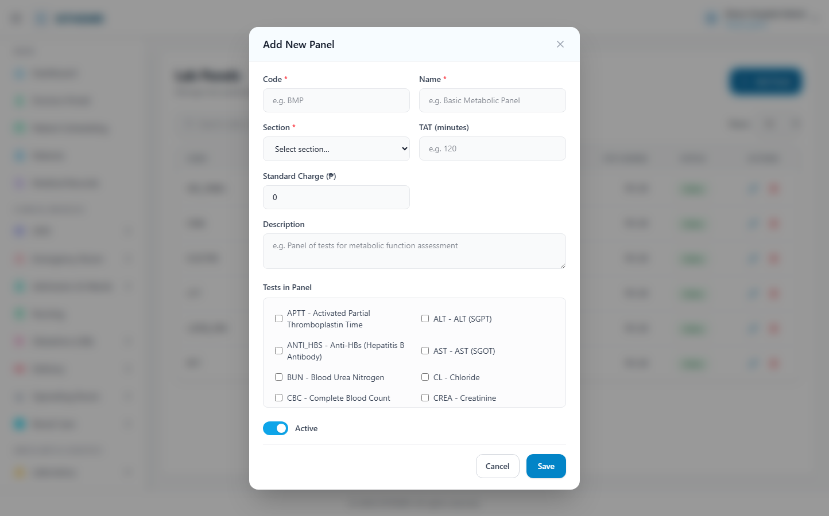
(182 KB)
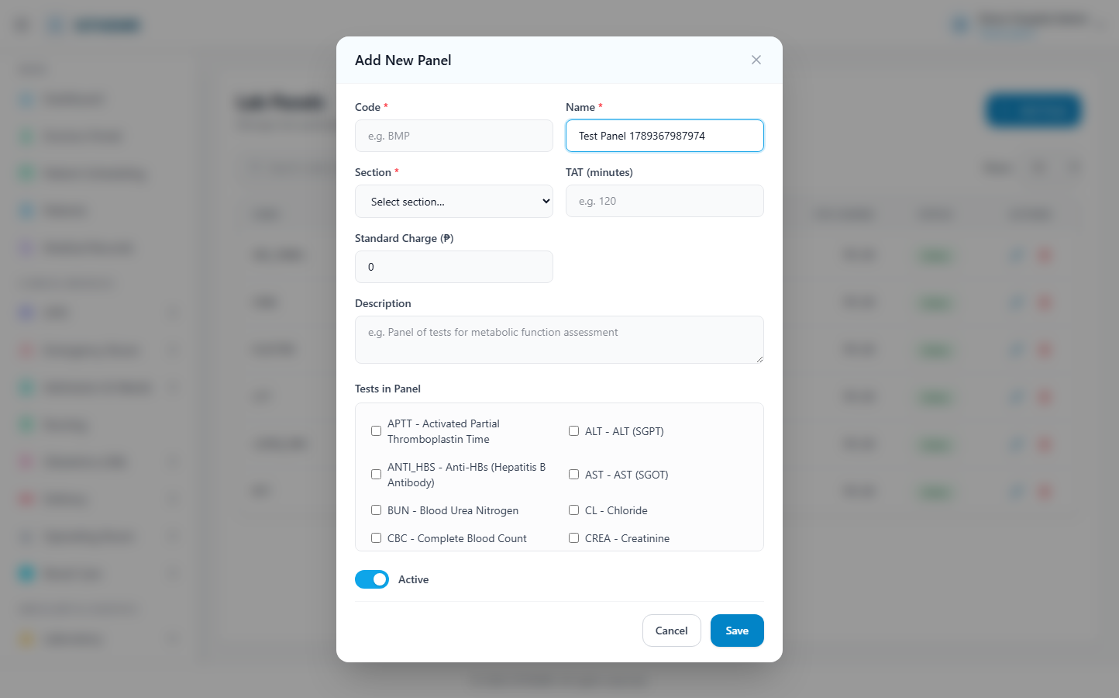
(183 KB)
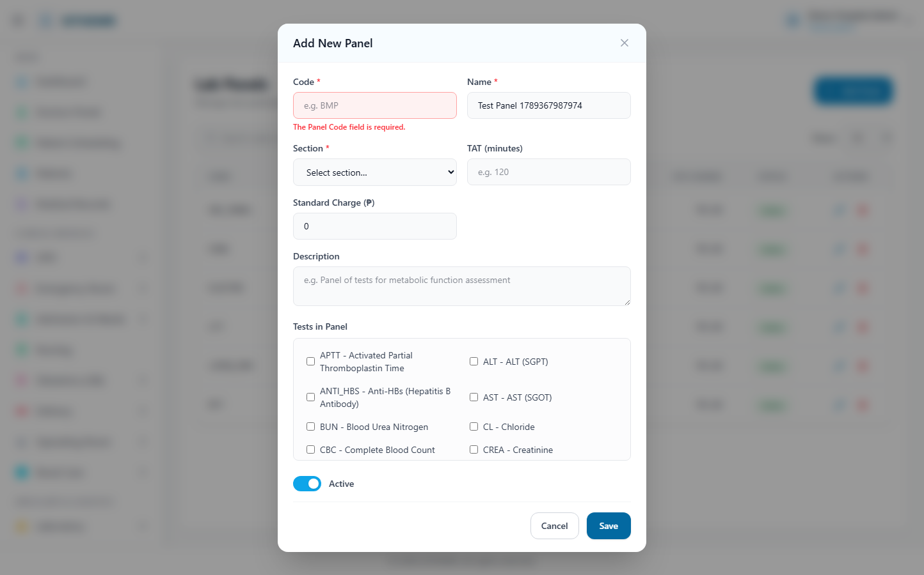
(185 KB)
Reference Ranges
Route: /lab/reference-ranges | Type: crud | Status: PASS
[PASS]
Record created (0 fields filled)
✓ Test record created successfully
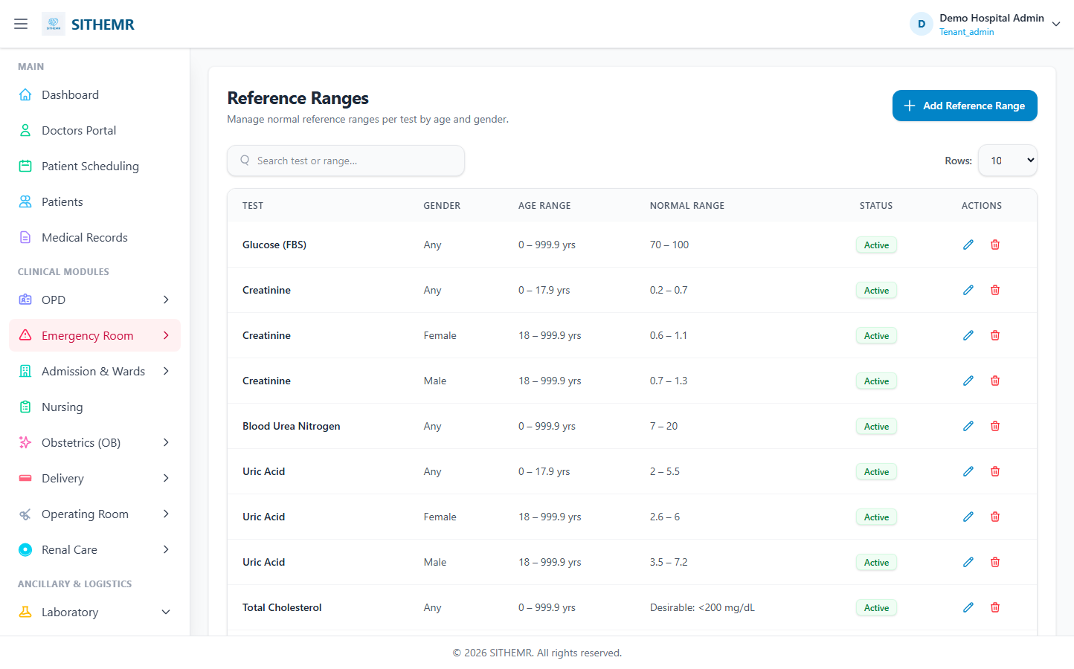
(99 KB)
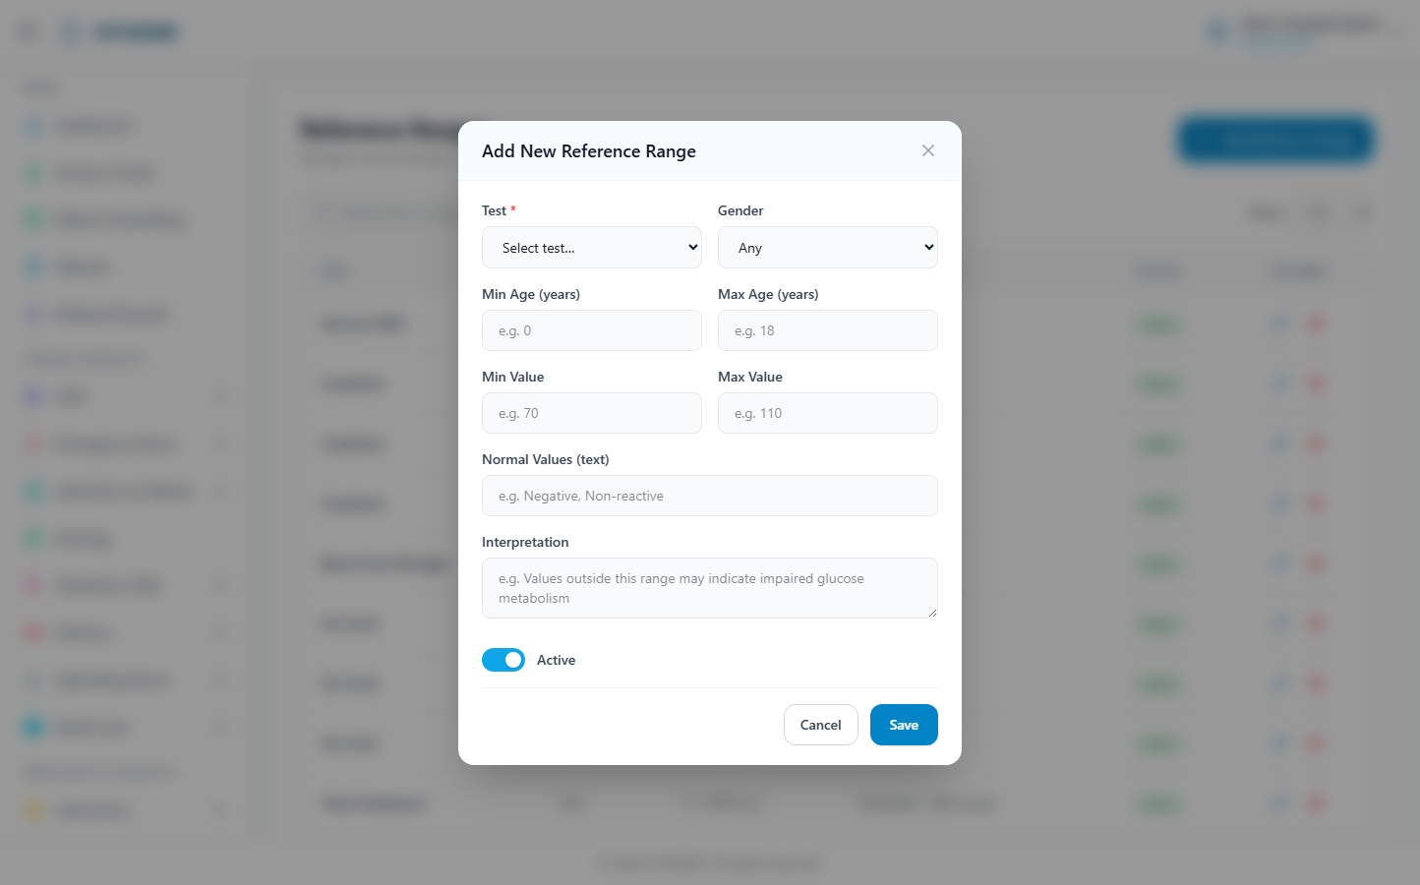
(193 KB)
(193 KB)
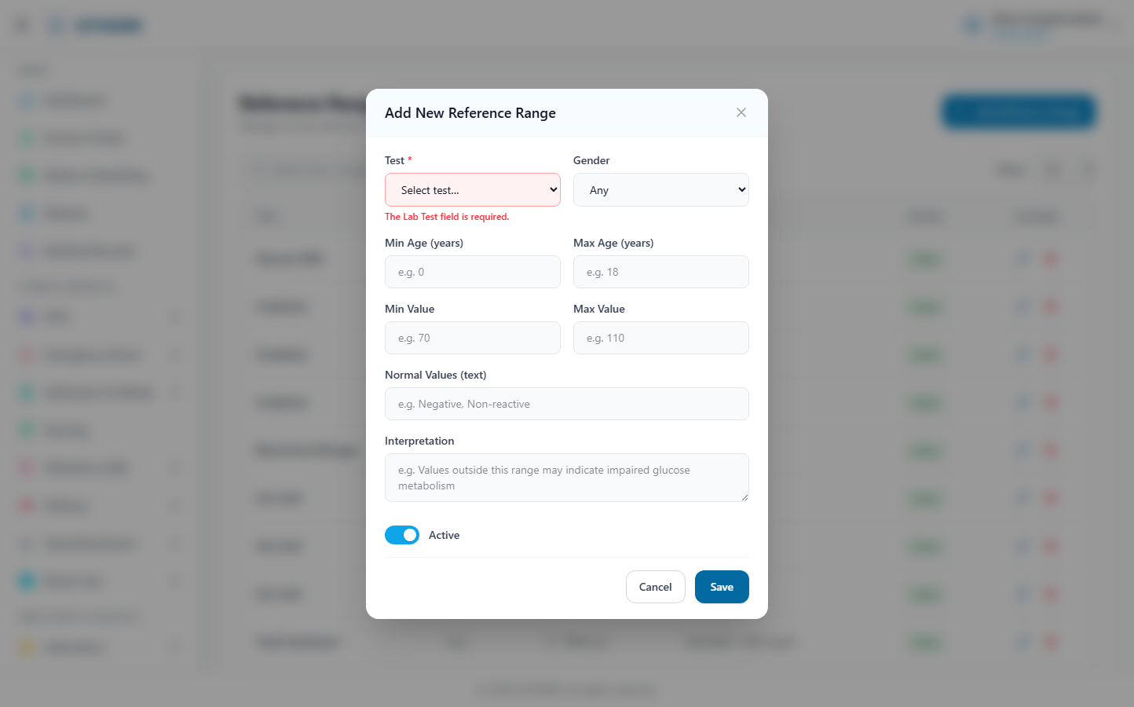
(194 KB)
Lab Results
Route: /lab/results | Type: list-only | Status: PASS
[PASS]
Page loaded — Lab Results Enter, review, and validate laboratory test results. All Pending R
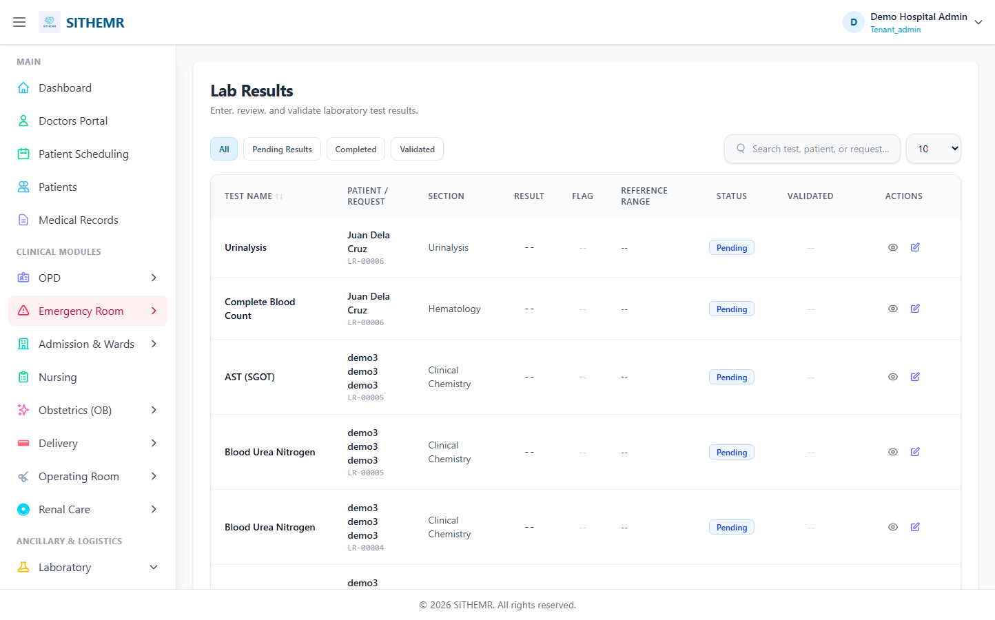
(99 KB)
Lab Dispensing
Route: /lab/dispensing | Type: list-only | Status: PASS
[PASS]
Page loaded — Lab Dispensing Create and manage laboratory test requests from all departments.
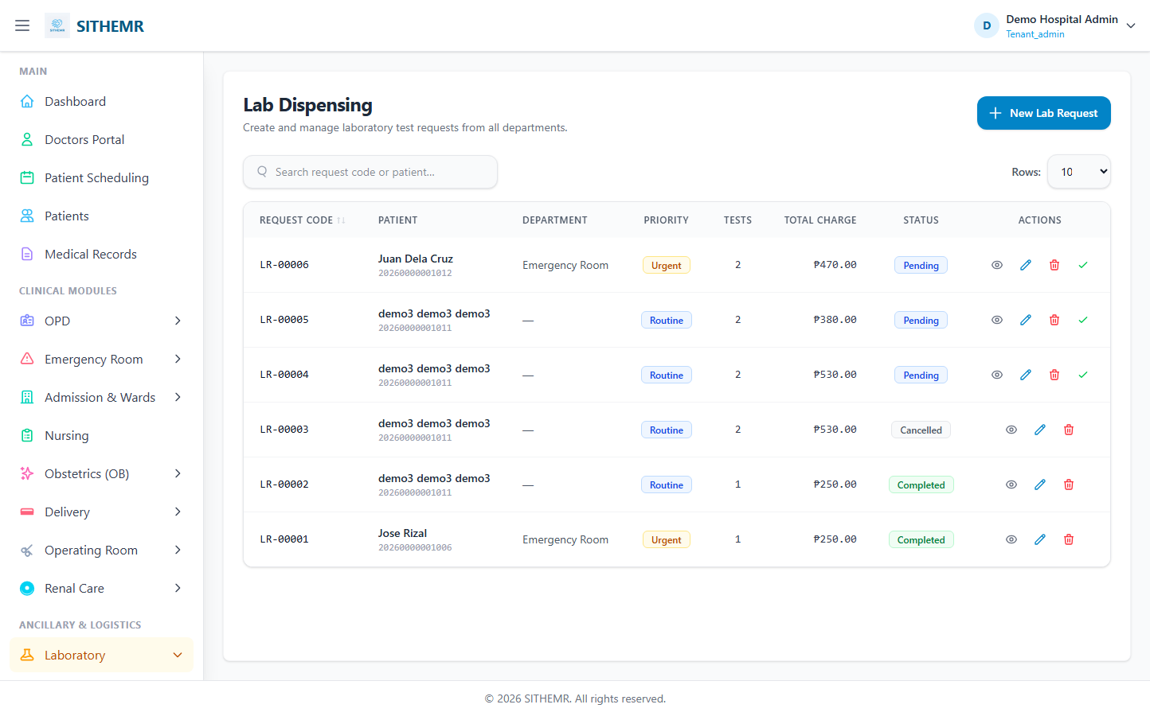
(106 KB)

Radiology
Modalities
Route: /radiology/modalities | Type: crud | Status: PASS
[PASS]
Record created (1 fields filled)
✓ Test record created successfully
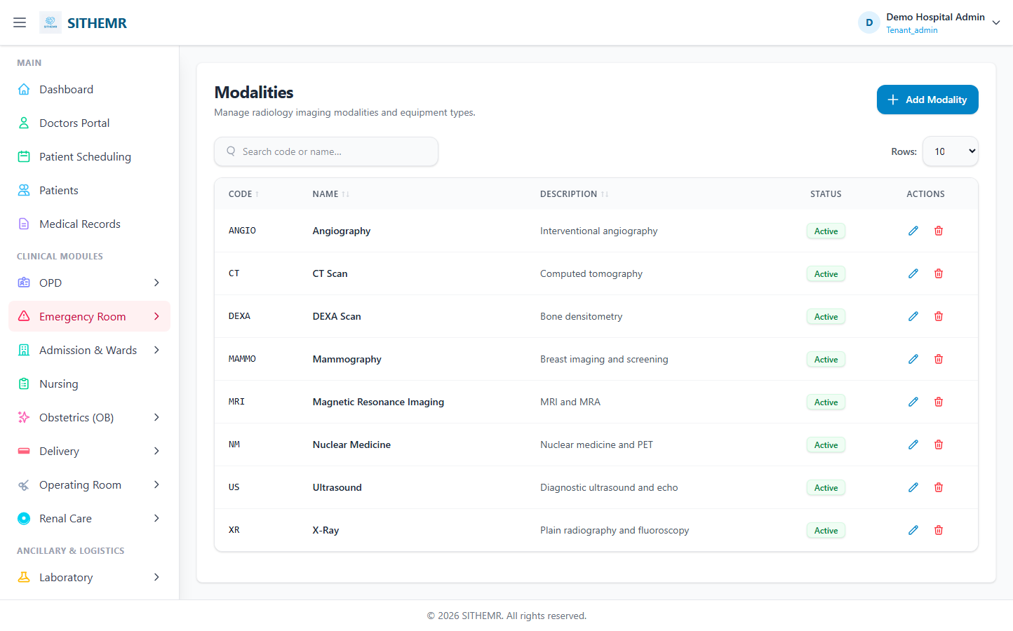
(94 KB)
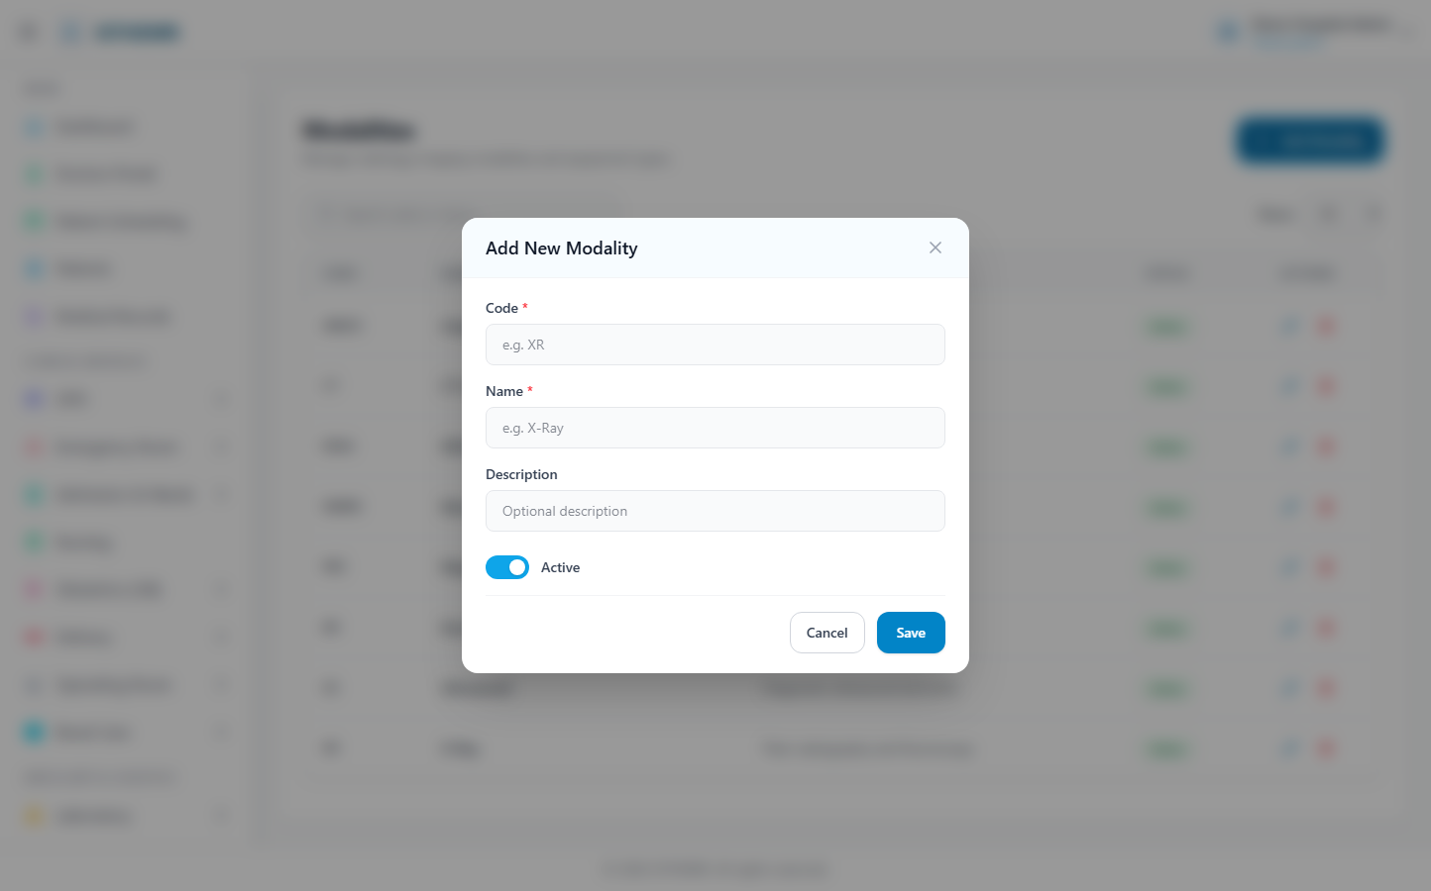
(176 KB)
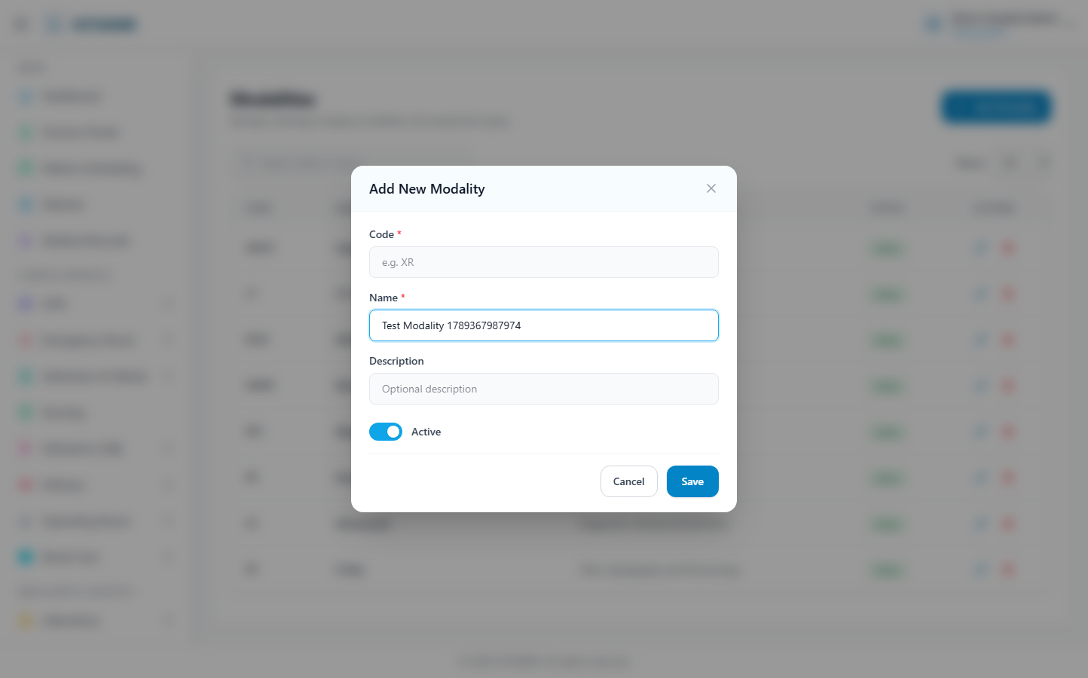
(176 KB)
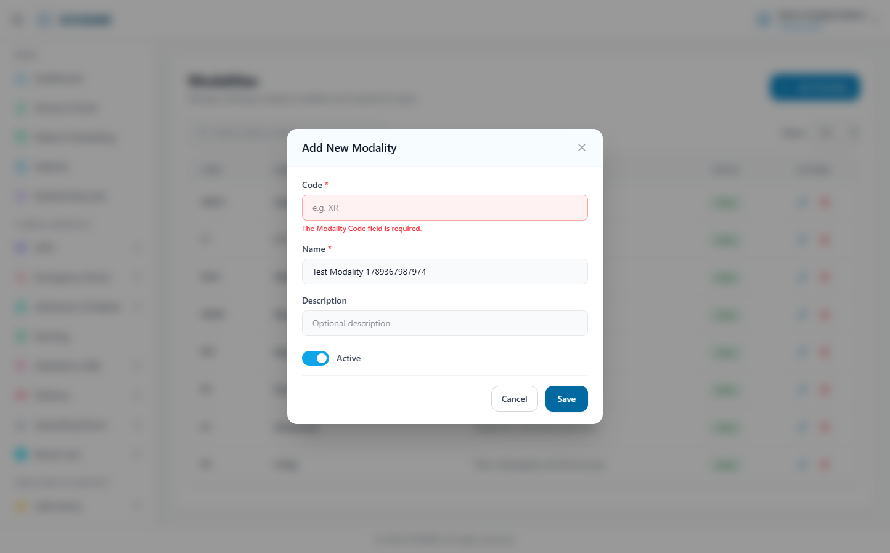
(178 KB)
Body Parts
Route: /radiology/body-parts | Type: crud | Status: PASS
[PASS]
Record created (1 fields filled)
✓ Test record created successfully
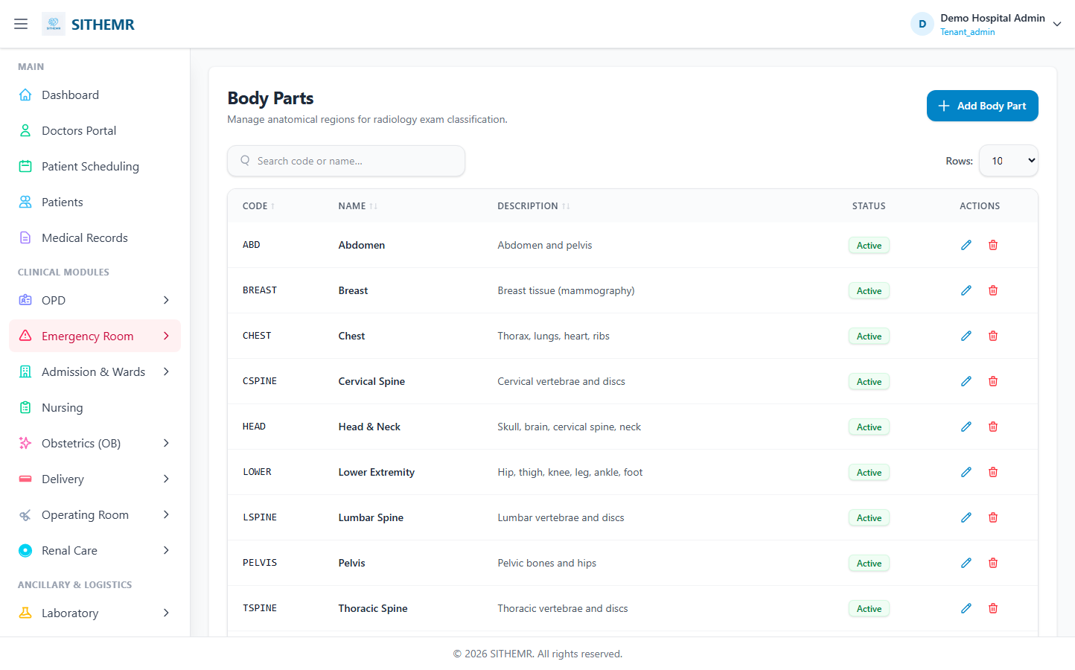
(100 KB)
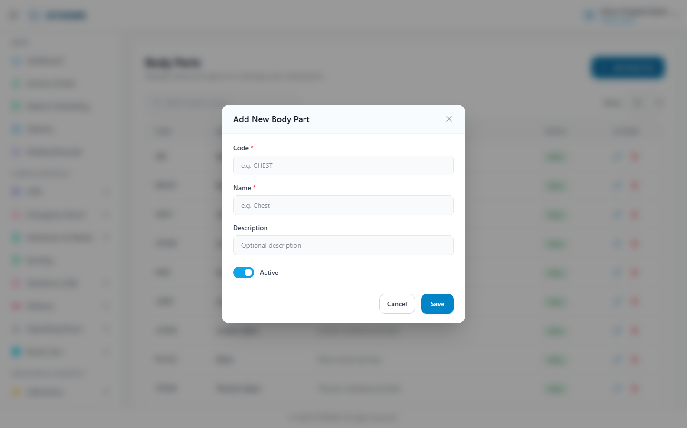
(186 KB)
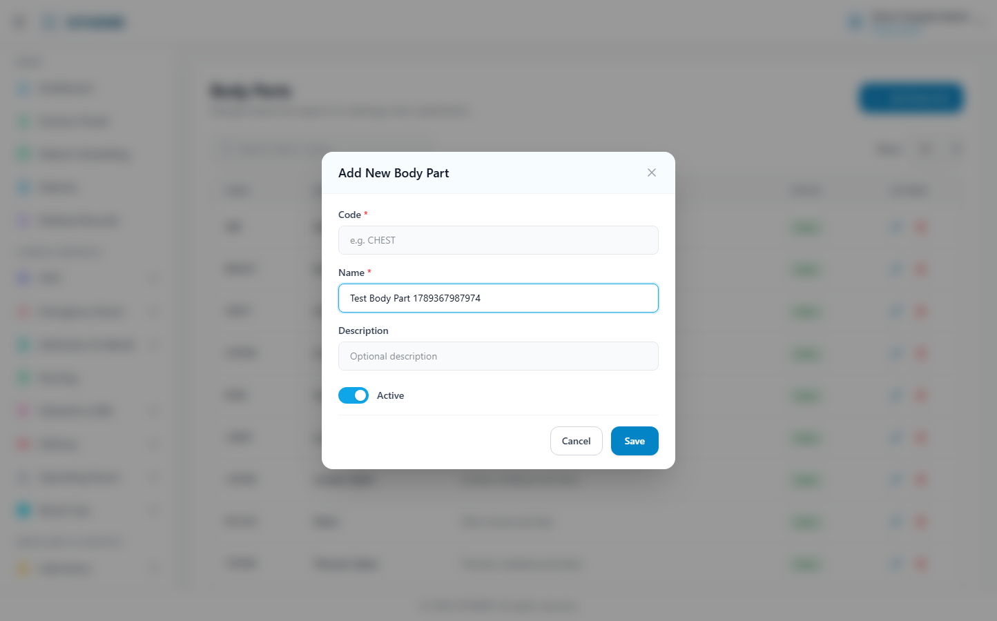
(187 KB)
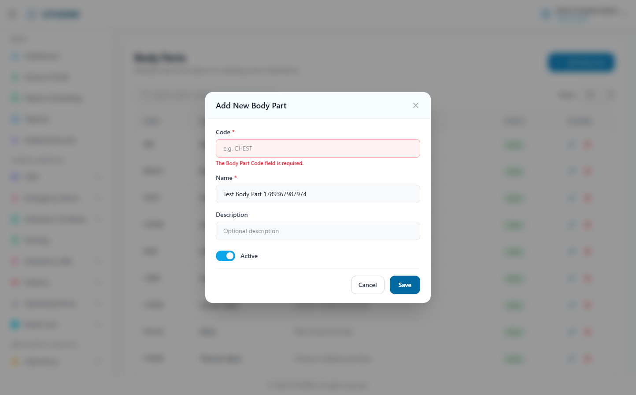
(188 KB)
Exam Types
Route: /radiology/exam-types | Type: crud | Status: PASS
[PASS]
Record created (1 fields filled)
✓ Test record created successfully
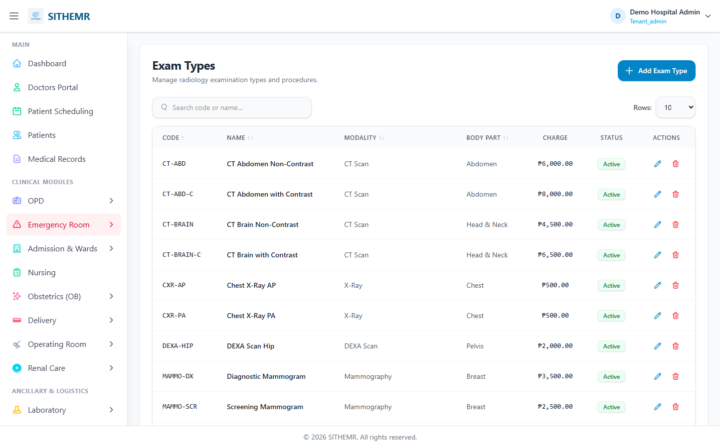
(114 KB)
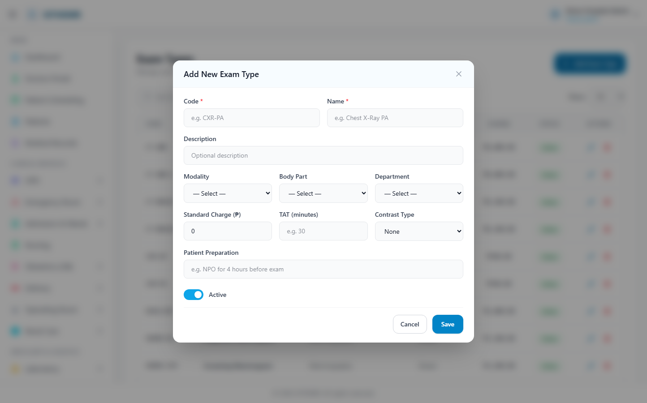
(209 KB)
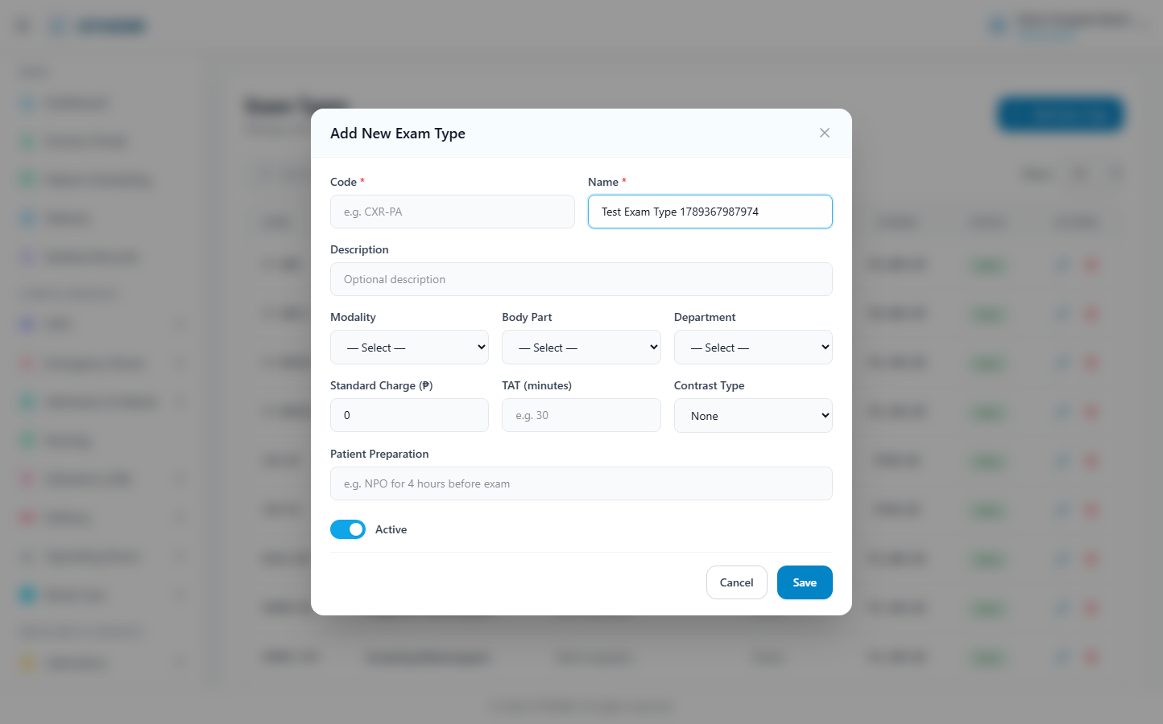
(211 KB)
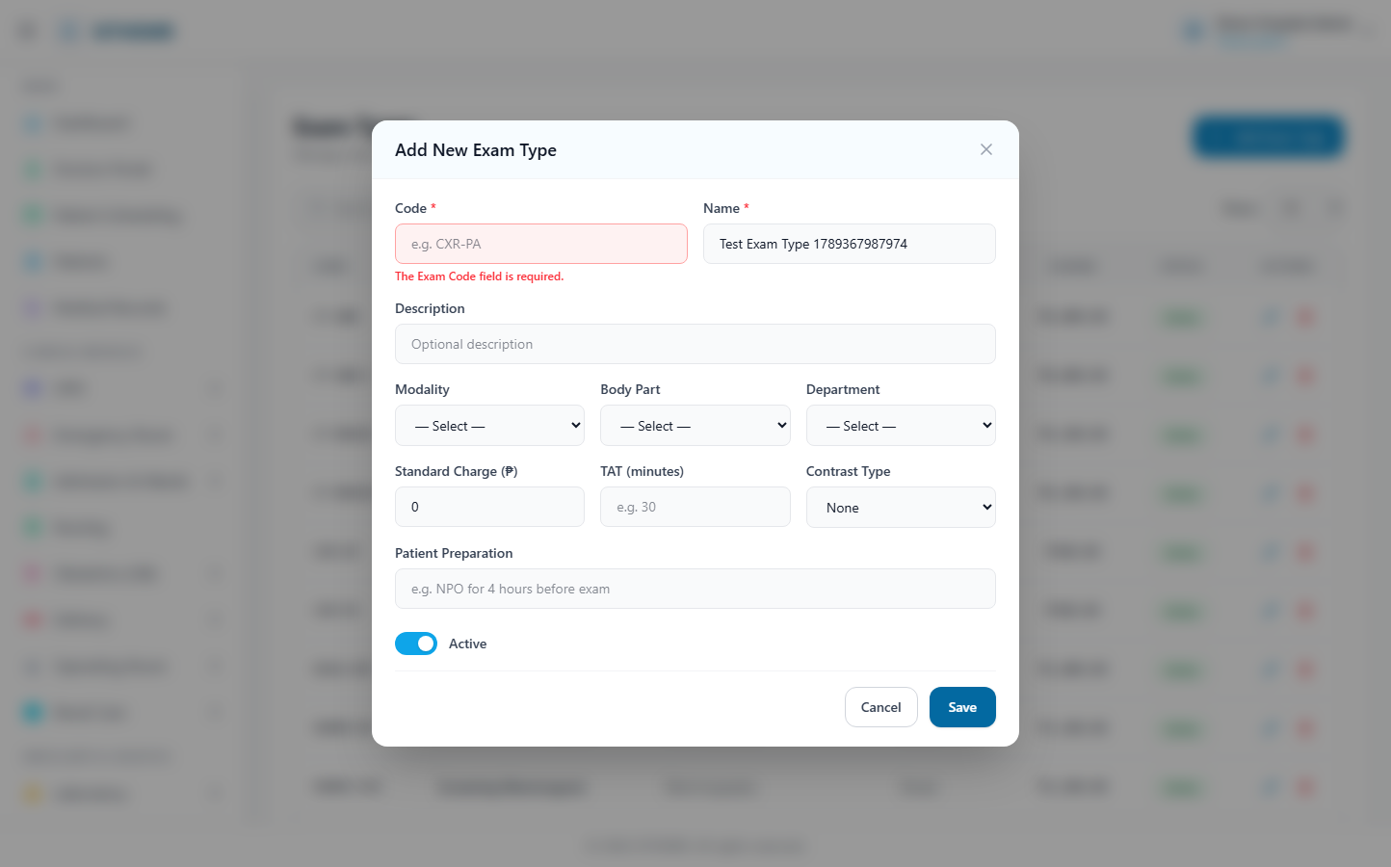
(211 KB)
Radiology Results
Route: /radiology/results | Type: list-only | Status: PASS
[PASS]
Page loaded — Radiology Results Review and manage radiology exam results, readings, and attac
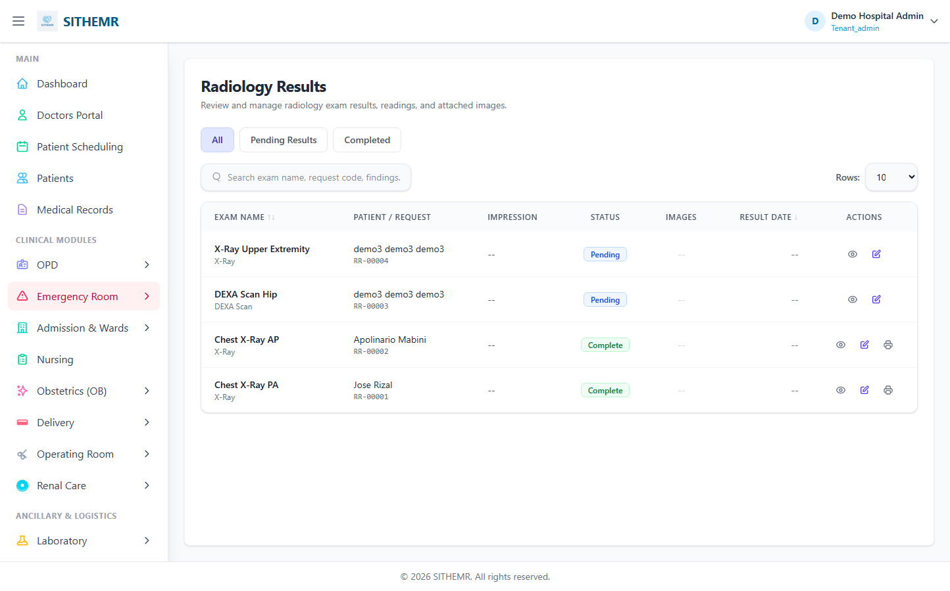
(87 KB)
Radiology Dispensing
Route: /radiology/dispensing | Type: list-only | Status: PASS
[PASS]
Page loaded — Radiology Dispensing Create and manage radiology exam requests from all departm
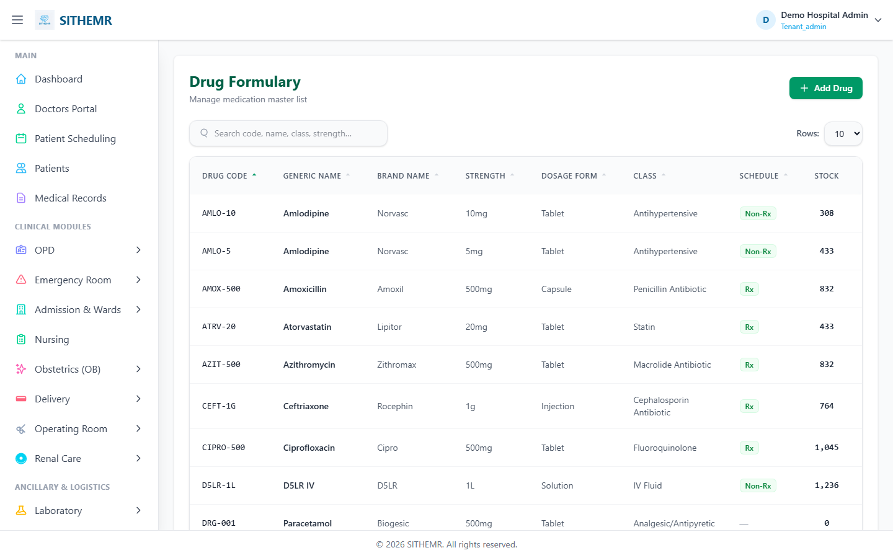
(84 KB)

Pharmacy
Drug Formulary
Route: /pharmacy/drugs | Type: crud | Status: PASS
[PASS]
Record created (0 fields filled)
✓ Test record created successfully
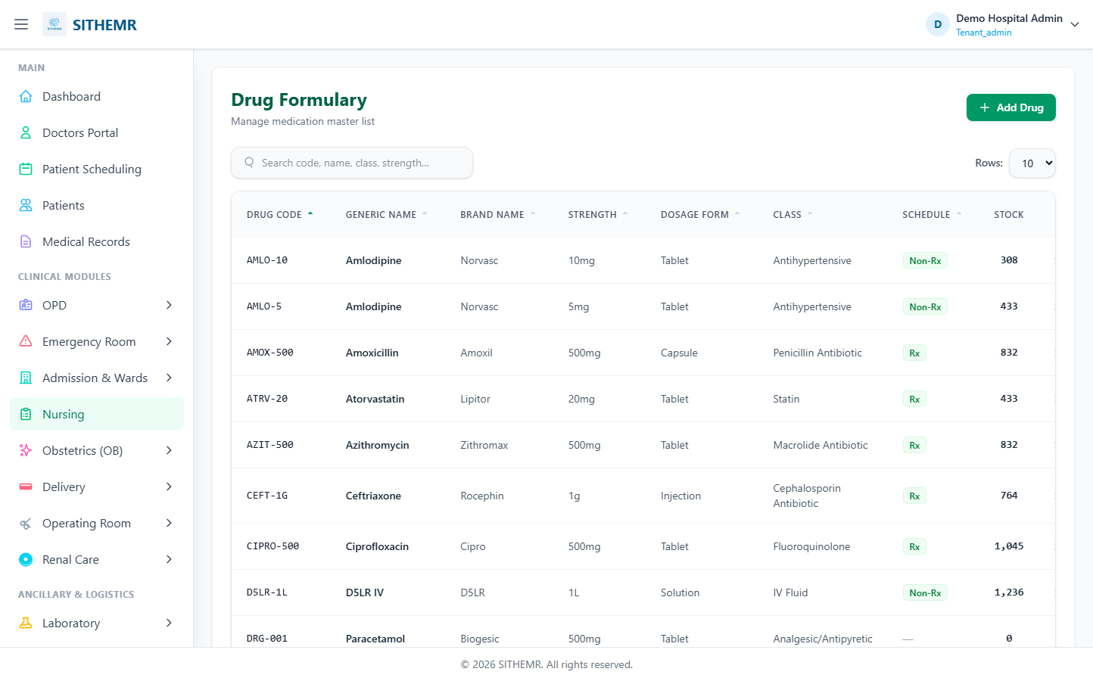
(107 KB)
(91 KB)
(91 KB)
(91 KB)
Drug Batches
Route: /pharmacy/drug-batches | Type: crud | Status: CHECK
[CHECK]
Created but no success toast — verify manually
(129 KB)
(210 KB)
(210 KB)
(209 KB)
Stock Dashboard
Route: /pharmacy/inventory | Type: list-only | Status: PASS
[PASS]
Page loaded — Drug Inventory Dashboard TOTAL DRUGS 33 TOTAL BATCHES 119 STOCK VALUE ₱5,6
(121 KB)
Purchase Orders
Route: /pharmacy/purchase-orders | Type: list-only | Status: PASS
[PASS]
Page loaded — Purchase Order Management Create and manage drug procurement from suppliers. N
(82 KB)
Stock Adjustments
Route: /pharmacy/stock-adjustments | Type: list-only | Status: PASS
[PASS]
Page loaded — Stock Adjustments New Adjustment ADJ. CODE TYPE DRUG BATCH QUANTITY UNIT CO
(102 KB)
Pharmacy Dispensing
Route: /pharmacy/dispensing | Type: list-only | Status: PASS
[PASS]
Page loaded — Pharmacy Dispensing Create and manage medication requests from all departments.
(100 KB)
Patient Med Record
Route: /pharmacy/patient-medication-record | Type: list-only | Status: PASS
[PASS]
Page loaded — Patient Medication Record Search for a Patient Enter a patient name, code, or i
(56 KB)
Pharmacy Reports
Route: /pharmacy/reports | Type: list-only | Status: PASS
[PASS]
Page loaded — Pharmacy Reports Expiry Report Stock Status Consumption Report Drug batches gro
(112 KB)

Billing
Fund Sources
Route: /billing/fund-sources | Type: crud | Status: PASS
[PASS]
Record created (1 fields filled)
✓ Test record created successfully
(96 KB)
(175 KB)
(176 KB)
(178 KB)
Insurance Providers
Route: /billing/insurance-providers | Type: crud | Status: SKIP
[SKIP]
No Create/New/Add button found
(259 KB)
Billing (Invoices)
Route: /billing | Type: list-only | Status: PASS
[PASS]
Page loaded — Command Center with live patient census and financial snapshot
(211 KB)

PhilHealth
E-Claims
Route: /philhealth/claims | Type: list-only | Status: PASS
[PASS]
Page loaded — PhilHealth Claims Manage PhilHealth claims with CF4 clinical data capture for e
(66 KB)
ICD-10 Codes
Route: /philhealth/icd10-codes | Type: crud | Status: PASS
[PASS]
Record created (1 fields filled)
✓ Test record created successfully
(82 KB)
(174 KB)
(174 KB)
(87 KB)
RVS Codes
Route: /philhealth/rvs-codes | Type: crud | Status: PASS
[PASS]
Record created (1 fields filled)
✓ Test record created successfully
(107 KB)
(189 KB)
(190 KB)
(192 KB)
Case Rates
Route: /philhealth/case-rates | Type: crud | Status: PASS
[PASS]
Record created (0 fields filled)
✓ Test record created successfully
(124 KB)
(232 KB)
(232 KB)
(231 KB)
Members
Route: /philhealth/members | Type: list-only | Status: PASS
[PASS]
Page loaded — PhilHealth Member Management Manage PhilHealth member records for claims filing
(102 KB)
HC Professionals
Route: /philhealth/hc-professionals | Type: list-only | Status: PASS
[PASS]
Page loaded — Health Care Professionals Unified registry of doctors, nurses, and other medica
(81 KB)
Claim Batches
Route: /philhealth/batches | Type: list-only | Status: PASS
[PASS]
Page loaded — Claim Batches Group claims into transmittal batches for e-Claims XML submission
(63 KB)
PhilHealth Reports
Route: /philhealth/reports | Type: list-only | Status: PASS
[PASS]
Page loaded — PhilHealth Reports Summary statistics for PhilHealth e-Claims performance. Dat
(131 KB)

Doctors Portal
Doctor Dashboard
Route: /doctors/dashboard | Type: list-only | Status: PASS
[PASS]
Page loaded — Doctors Portal Manage your active patients and clinical workflows. Outpatient
(68 KB)
Doctor Schedule
Route: /doctors/schedule | Type: list-only | Status: PASS
[PASS]
Page loaded — Appointment Schedule Manage patient appointment bookings and your daily schedul
(80 KB)

Obstetrics (OB)
OB Consultations
Route: /ob/consultations | Type: list-only | Status: PASS
[PASS]
Page loaded — OB/GYN Consultations Active Completed New Consultation Rows: 10 25 50 CONSULTA
(67 KB)
OB Visit Types
Route: /ob/visit-types | Type: crud | Status: PASS
[PASS]
Record created (1 fields filled)
✓ Test record created successfully
(87 KB)
(149 KB)
(150 KB)
(152 KB)
Fetal Presentations
Route: /ob/fetal-presentations | Type: crud | Status: PASS
[PASS]
Record created (1 fields filled)
✓ Test record created successfully
(96 KB)
(164 KB)
(166 KB)
(166 KB)
Contraceptive Methods
Route: /ob/contraceptive-methods | Type: crud | Status: PASS
[PASS]
Record created (1 fields filled)
✓ Test record created successfully
(112 KB)
(205 KB)
(206 KB)
(207 KB)

Delivery
Delivery Rooms
Route: /delivery/rooms | Type: crud | Status: PASS
[PASS]
Record created (1 fields filled)
✓ Test record created successfully
(61 KB)
(142 KB)
(143 KB)
(145 KB)
Delivery Types
Route: /delivery/types | Type: crud | Status: PASS
[PASS]
Screenshot captured — page loaded successfully
✓ Test record created successfully
(89 KB)
(157 KB)
(158 KB)
(160 KB)
Delivery Complications
Route: /delivery/complications | Type: crud | Status: PASS
[PASS]
Screenshot captured — page loaded successfully
✓ Test record created successfully
(113 KB)
(204 KB)
(204 KB)
(205 KB)
Delivery Schedule
Route: /delivery/schedule | Type: list-only | Status: PASS
[PASS]
Page loaded — DR Schedule Manage delivery schedules, room assignments, and deliveries. Add S
(71 KB)

Operating Room (OR)
OR Rooms
Route: /or/rooms | Type: crud | Status: PASS
[PASS]
Screenshot captured — page loaded successfully
✓ Test record created successfully
(63 KB)
(143 KB)
(144 KB)
(145 KB)
OR Schedule
Route: /or/schedule | Type: list-only | Status: PASS
[PASS]
Page loaded — OR Schedule Manage surgical schedules, room assignments, and procedures. Add S
(71 KB)

Renal Care
Dialysis Types
Route: /renal-care/dialysis-types | Type: crud | Status: PASS
[PASS]
Screenshot captured — page loaded successfully
✓ Test record created successfully
(104 KB)
(188 KB)
(188 KB)
(189 KB)
Dialysis Sessions
Route: /renal-care/dialysis-sessions | Type: list-only | Status: PASS
[PASS]
Page loaded — Dialysis Sessions Record and manage dialysis treatment sessions. Add Session R
(67 KB)

CSR / Supply Chain
Supply Units
Route: /supply/units | Type: crud | Status: PASS
[PASS]
Screenshot captured — page loaded successfully
✓ Test record created successfully
(82 KB)
(172 KB)
(172 KB)
(173 KB)
Supply Categories
Route: /supply/categories | Type: crud | Status: PASS
[PASS]
Screenshot captured — page loaded successfully
✓ Test record created successfully
(103 KB)
(190 KB)
(190 KB)
(192 KB)
Suppliers
Route: /supply/suppliers | Type: crud | Status: PASS
[PASS]
Screenshot captured — page loaded successfully
✓ Test record created successfully
(84 KB)
(172 KB)
(174 KB)
(175 KB)
Stock Locations
Route: /supply/stock-locations | Type: crud | Status: PASS
[PASS]
Screenshot captured — page loaded successfully
✓ Test record created successfully
(108 KB)
(202 KB)
(203 KB)
(203 KB)
Items
Route: /supply/items | Type: crud | Status: PASS
[PASS]
Screenshot captured — page loaded successfully
✓ Test record created successfully
(114 KB)
(194 KB)
(195 KB)
(195 KB)
Inventory
Route: /supply/inventory | Type: list-only | Status: PASS
[PASS]
Page loaded — Item Batches Manage item inventory batches, lot numbers, and expiry tracking.
(124 KB)
Stock Adjustments
Route: /supply/stock-adjustments | Type: list-only | Status: PASS
[PASS]
Page loaded — Stock Adjustments New Adjustment ADJ. CODE TYPE ITEM BATCH QUANTITY UNIT CO
(58 KB)
Supply Dispensing
Route: /supply/dispensing | Type: list-only | Status: PASS
[PASS]
Page loaded — CSR Dispensing Create and manage supply requests from all departments. New Req
(92 KB)

Procedures
Procedure Categories
Route: /procedures/categories | Type: crud | Status: PASS
[PASS]
Screenshot captured — page loaded successfully
✓ Test record created successfully
(98 KB)
(179 KB)
(180 KB)
(181 KB)
Procedures
Route: /procedures/procedures | Type: list-only | Status: PASS
[PASS]
Page loaded — Procedures Manage medical and surgical procedure catalog. Add Procedure Rows:
(112 KB)
Procedure Dispensing
Route: /procedures/dispensing | Type: list-only | Status: PASS
[PASS]
Page loaded — Procedures Dispensing Create and manage procedure requests from all departments
(83 KB)

Medical Records
Medical Records
Route: /medical-records | Type: list-only | Status: PASS
[PASS]
Page loaded — Medical Records View complete patient encounter history and generate certificat
(72 KB)

YAKAP
YAKAP Dashboard
Route: /yakap/dashboard | Type: list-only | Status: PASS
[PASS]
Page loaded — YAKAP Dashboard Overview of the PhilHealth YAKAP program. Total Empaneled 0
(81 KB)
Empanelments
Route: /yakap/empanelments | Type: list-only | Status: PASS
[PASS]
Page loaded — YAKAP Empanelments Manage patient enrollment in the PhilHealth YAKAP program.
(59 KB)
Screenings
Route: /yakap/screenings | Type: list-only | Status: PASS
[PASS]
Page loaded — YAKAP Screenings Track the 6 YAKAP cancer screenings for empaneled patients. N
(59 KB)
Capitation
Route: /yakap/capitation | Type: list-only | Status: PASS
[PASS]
Page loaded — Capitation Payments Manage YAKAP capitation payment tranches (40% / 60%). New
(61 KB)
FPE Records
Route: /yakap/fpe-records | Type: list-only | Status: PASS
[PASS]
Page loaded — FPE Records First Patient Encounter — YAKAP health risk assessment. New FPE Re
(57 KB)

Konsulta
Konsulta
Route: /konsulta | Type: list-only | Status: PASS
[PASS]
Page loaded — Command Center Live overview of hospital operations and financials. SEPTEMBER
(176 KB)

Public Access
Public Appointment Booking
Route: /book-appointment | Type: nav-only | Status: CHECK
[CHECK]
Page may need verification
(224 KB)

CRUD Test Results — Records Created
Across 61 modules tested with CRUD operations, 54 test records were successfully created. These records used names with timestamps to avoid conflicts.
Module | Route | Record Created | Test Data Fields Filled
Tenant (Hospital) | /masters/company | ✓ YES | 4
Department | /masters/department | ✓ YES | 4
Hospital | /masters/hospital | NO | 4
Country | /masters/country | ✓ YES | 4
Region | /masters/region | ✓ YES | 4
Province/State | /masters/province | ✓ YES | 4
City/Municipality | /masters/city | ✓ YES | 4
Barangay | /masters/barangay | ✓ YES | 4
Religion | /masters/religion | ✓ YES | 4
Gender | /masters/gender | ✓ YES | 4
Civil Status | /masters/civil-status | ✓ YES | 4
Nationality | /masters/nationality | ✓ YES | 4
Occupation | /masters/occupation | ✓ YES | 4
Blood Type | /masters/blood-type | ✓ YES | 4
Relationship | /masters/relationship | ✓ YES | 4
Roles | /admin/roles | ✓ YES | 4
Patient Registration | /patients | SKIP | 1
OPD Clinics | /opd/clinics | ✓ YES | 4
Consultation Types | /opd/consultation-types | ✓ YES | 4
Visit Types | /opd/visit-types | ✓ YES | 4
Services | /opd/services | ✓ YES | 4
Complaints | /opd/complaints | ✓ YES | 4
Referral Sources | /opd/referral-sources | ✓ YES | 4
Acuity Levels | /er/acuity-levels | ✓ YES | 4
Mobility Statuses | /er/mobility-statuses | ✓ YES | 4
ER Zones | /er/zones | NO | 4
ER Beds | /er/beds | NO | 4
Wards | /ward/wards | ✓ YES | 4
Rooms | /ward/rooms | ✓ YES | 4
Room Types | /ward/room-types | ✓ YES | 4
Lab Sections | /lab/sections | ✓ YES | 4
Lab Units | /lab/units | ✓ YES | 4
Specimen Types | /lab/specimen-types | ✓ YES | 4
Instruments | /lab/instruments | NO | 4
Test Catalog | /lab/tests | ✓ YES | 4
Panels | /lab/panels | ✓ YES | 4
Reference Ranges | /lab/reference-ranges | ✓ YES | 4
Modalities | /radiology/modalities | ✓ YES | 4
Body Parts | /radiology/body-parts | ✓ YES | 4
Exam Types | /radiology/exam-types | ✓ YES | 4
Drug Formulary | /pharmacy/drugs | ✓ YES | 4
Drug Batches | /pharmacy/drug-batches | NO | 4
Fund Sources | /billing/fund-sources | ✓ YES | 4
Insurance Providers | /billing/insurance-providers | SKIP | 1
ICD-10 Codes | /philhealth/icd10-codes | ✓ YES | 4
RVS Codes | /philhealth/rvs-codes | ✓ YES | 4
Case Rates | /philhealth/case-rates | ✓ YES | 4
OB Visit Types | /ob/visit-types | ✓ YES | 4
Fetal Presentations | /ob/fetal-presentations | ✓ YES | 4
Contraceptive Methods | /ob/contraceptive-methods | ✓ YES | 4
Delivery Rooms | /delivery/rooms | ✓ YES | 4
Delivery Types | /delivery/types | ✓ YES | 4
Delivery Complications | /delivery/complications | ✓ YES | 4
OR Rooms | /or/rooms | ✓ YES | 4
Dialysis Types | /renal-care/dialysis-types | ✓ YES | 4
Supply Units | /supply/units | ✓ YES | 4
Supply Categories | /supply/categories | ✓ YES | 4
Suppliers | /supply/suppliers | ✓ YES | 4
Stock Locations | /supply/stock-locations | ✓ YES | 4
Items | /supply/items | ✓ YES | 4
Procedure Categories | /procedures/categories | ✓ YES | 4

Issues, Notes & Recommendations

Modules Needing Manual Verification
These modules created records but did not display a visible success confirmation message. The record was likely created successfully — verify in the database or list view.
• Hospital: Created but no success toast — verify manually
(125 KB)
• ER Zones: Created but no success toast — verify manually
(123 KB)
• ER Beds: Created but no success toast — verify manually
(175 KB)
• Instruments: Created but no success toast — verify manually
(131 KB)
• Drug Batches: Created but no success toast — verify manually
(209 KB)
• Public Appointment Booking: Page may need verification

Skipped Modules
These modules did not have a visible Create/New/Add button in the test environment, so CRUD testing was skipped.
• Patient Registration (/patients): No Create/New/Add button found
• Insurance Providers (/billing/insurance-providers): No Create/New/Add button found

General Observations
1. Navigation: All modules are accessible via the left sidebar. Some modules require clicking a parent menu item first to expand the submenu before the target link becomes visible. The test script handled this automatically.
2. Page Titles: The application uses a shared page title ("SITHEMR Dashboard") across all pages. The actual page content is identified by the H1 heading and body text, not the browser tab title.
3. Test Data: All created records use names prefixed with "Test" and a timestamp (Date.now()) to ensure uniqueness and easy identification in the database.
4. Success Indicators: Most modules display a green banner or toast notification ("created successfully") when a record is created. Some modules may use different UI patterns for confirmation.
5. Public Booking: The public appointment booking page (/book-appointment) is accessible without login and was verified as a standalone page.

Appendix: Complete Module Listing
# | Module Name | Route | Test Type | Status | Screenshots
1 | Dashboard | / | nav-only | PASS | dashboard-01-list.png
2 | Tenant (Hospital) | /masters/company | crud | PASS | masters-tenant-01-list.png, masters-tenant-02-form.png, masters-tenant-03-filled.png, masters-tenant-04-after.png
3 | Department | /masters/department | crud | PASS | masters-department-01-list.png, masters-department-02-form.png, masters-department-03-filled.png, masters-department-04-after.png
4 | Users | /masters/users | list-only | PASS | masters-users-01-list.png
5 | Hospital | /masters/hospital | crud | CHECK | masters-hospital-01-list.png, masters-hospital-02-form.png, masters-hospital-03-filled.png, masters-hospital-04-after.png
6 | Permissions | /masters/permissions | list-only | PASS | masters-permissions-01-list.png
7 | Country | /masters/country | crud | PASS | masters-country-01-list.png, masters-country-02-form.png, masters-country-03-filled.png, masters-country-04-after.png
8 | Region | /masters/region | crud | PASS | masters-region-01-list.png, masters-region-02-form.png, masters-region-03-filled.png, masters-region-04-after.png
9 | Province/State | /masters/province | crud | PASS | masters-province-01-list.png, masters-province-02-form.png, masters-province-03-filled.png, masters-province-04-after.png
10 | City/Municipality | /masters/city | crud | PASS | masters-city-01-list.png, masters-city-02-form.png, masters-city-03-filled.png, masters-city-04-after.png
11 | Barangay | /masters/barangay | crud | PASS | masters-barangay-01-list.png, masters-barangay-02-form.png, masters-barangay-03-filled.png, masters-barangay-04-after.png
12 | Religion | /masters/religion | crud | PASS | masters-religion-01-list.png, masters-religion-02-form.png, masters-religion-03-filled.png, masters-religion-04-after.png
13 | Gender | /masters/gender | crud | PASS | masters-gender-01-list.png, masters-gender-02-form.png, masters-gender-03-filled.png, masters-gender-04-after.png
14 | Civil Status | /masters/civil-status | crud | PASS | masters-civil-status-01-list.png, masters-civil-status-02-form.png, masters-civil-status-03-filled.png, masters-civil-status-04-after.png
15 | Nationality | /masters/nationality | crud | PASS | masters-nationality-01-list.png, masters-nationality-02-form.png, masters-nationality-03-filled.png, masters-nationality-04-after.png
16 | Occupation | /masters/occupation | crud | PASS | masters-occupation-01-list.png, masters-occupation-02-form.png, masters-occupation-03-filled.png, masters-occupation-04-after.png
17 | Blood Type | /masters/blood-type | crud | PASS | masters-blood-type-01-list.png, masters-blood-type-02-form.png, masters-blood-type-03-filled.png, masters-blood-type-04-after.png
18 | Relationship | /masters/relationship | crud | PASS | masters-relationship-01-list.png, masters-relationship-02-form.png, masters-relationship-03-filled.png, masters-relationship-04-after.png
19 | Roles | /admin/roles | crud | PASS | admin-roles-01-list.png, admin-roles-02-form.png, admin-roles-03-filled.png, admin-roles-04-after.png
20 | Role Permissions | /admin/role-permissions | list-only | PASS | admin-role-perms-01-list.png
21 | Audit Trail | /admin/audit-log | list-only | PASS | admin-audit-log-01-list.png
22 | Patient Registration | /patients | crud | SKIP | patients-01-list.png
23 | OPD Consultations | /opd/consultations | list-only | PASS | opd-consultations-01-list.png
24 | OPD Clinics | /opd/clinics | crud | PASS | opd-clinics-01-list.png, opd-clinics-02-form.png, opd-clinics-03-filled.png, opd-clinics-04-after.png
25 | Consultation Types | /opd/consultation-types | crud | PASS | opd-consultation-types-01-list.png, opd-consultation-types-02-form.png, opd-consultation-types-03-filled.png, opd-consultation-types-04-after.png
26 | Visit Types | /opd/visit-types | crud | PASS | opd-visit-types-01-list.png, opd-visit-types-02-form.png, opd-visit-types-03-filled.png, opd-visit-types-04-after.png
27 | Services | /opd/services | crud | PASS | opd-services-01-list.png, opd-services-02-form.png, opd-services-03-filled.png, opd-services-04-after.png
28 | Complaints | /opd/complaints | crud | PASS | opd-complaints-01-list.png, opd-complaints-02-form.png, opd-complaints-03-filled.png, opd-complaints-04-after.png
29 | Referral Sources | /opd/referral-sources | crud | PASS | opd-referral-sources-01-list.png, opd-referral-sources-02-form.png, opd-referral-sources-03-filled.png, opd-referral-sources-04-after.png
30 | Triage Records | /er/triage | list-only | PASS | er-triage-01-list.png
31 | ER Area/Admissions | /er/area | list-only | PASS | er-area-01-list.png
32 | Acuity Levels | /er/acuity-levels | crud | PASS | er-acuity-levels-01-list.png, er-acuity-levels-02-form.png, er-acuity-levels-03-filled.png, er-acuity-levels-04-after.png
33 | Mobility Statuses | /er/mobility-statuses | crud | PASS | er-mobility-statuses-01-list.png, er-mobility-statuses-02-form.png, er-mobility-statuses-03-filled.png, er-mobility-statuses-04-after.png
34 | ER Zones | /er/zones | crud | CHECK | er-zones-01-list.png, er-zones-02-form.png, er-zones-03-filled.png, er-zones-04-after.png
35 | ER Beds | /er/beds | crud | CHECK | er-beds-01-list.png, er-beds-02-form.png, er-beds-03-filled.png, er-beds-04-after.png
36 | Admissions | /admission | list-only | PASS | admission-01-list.png
37 | Wards | /ward/wards | crud | PASS | ward-wards-01-list.png, ward-wards-02-form.png, ward-wards-03-filled.png, ward-wards-04-after.png
38 | Rooms | /ward/rooms | crud | PASS | ward-rooms-01-list.png, ward-rooms-02-form.png, ward-rooms-03-filled.png, ward-rooms-04-after.png
39 | Room Types | /ward/room-types | crud | PASS | ward-room-types-01-list.png, ward-room-types-02-form.png, ward-room-types-03-filled.png, ward-room-types-04-after.png
40 | ICU Wards | /icu/wards | list-only | PASS | icu-wards-01-list.png
41 | ICU Beds | /icu/beds | list-only | PASS | icu-beds-01-list.png
42 | Hospital Transfers | /transfers | list-only | PASS | transfer-01-list.png
43 | Nursing | /nursing | list-only | PASS | nursing-01-list.png
44 | Lab Sections | /lab/sections | crud | PASS | lab-sections-01-list.png, lab-sections-02-form.png, lab-sections-03-filled.png, lab-sections-04-after.png
45 | Lab Units | /lab/units | crud | PASS | lab-units-01-list.png, lab-units-02-form.png, lab-units-03-filled.png, lab-units-04-after.png
46 | Specimen Types | /lab/specimen-types | crud | PASS | lab-specimen-types-01-list.png, lab-specimen-types-02-form.png, lab-specimen-types-03-filled.png, lab-specimen-types-04-after.png
47 | Instruments | /lab/instruments | crud | CHECK | lab-instruments-01-list.png, lab-instruments-02-form.png, lab-instruments-03-filled.png, lab-instruments-04-after.png
48 | Test Catalog | /lab/tests | crud | PASS | lab-tests-01-list.png, lab-tests-02-form.png, lab-tests-03-filled.png, lab-tests-04-after.png
49 | Panels | /lab/panels | crud | PASS | lab-panels-01-list.png, lab-panels-02-form.png, lab-panels-03-filled.png, lab-panels-04-after.png
50 | Reference Ranges | /lab/reference-ranges | crud | PASS | lab-reference-ranges-01-list.png, lab-reference-ranges-02-form.png, lab-reference-ranges-03-filled.png, lab-reference-ranges-04-after.png
51 | Lab Results | /lab/results | list-only | PASS | lab-results-01-list.png
52 | Lab Dispensing | /lab/dispensing | list-only | PASS | lab-dispensing-01-list.png
53 | Modalities | /radiology/modalities | crud | PASS | radiology-modalities-01-list.png, radiology-modalities-02-form.png, radiology-modalities-03-filled.png, radiology-modalities-04-after.png
54 | Body Parts | /radiology/body-parts | crud | PASS | radiology-body-parts-01-list.png, radiology-body-parts-02-form.png, radiology-body-parts-03-filled.png, radiology-body-parts-04-after.png
55 | Exam Types | /radiology/exam-types | crud | PASS | radiology-exam-types-01-list.png, radiology-exam-types-02-form.png, radiology-exam-types-03-filled.png, radiology-exam-types-04-after.png
56 | Radiology Results | /radiology/results | list-only | PASS | radiology-results-01-list.png
57 | Radiology Dispensing | /radiology/dispensing | list-only | PASS | radiology-dispensing-01-list.png
58 | Drug Formulary | /pharmacy/drugs | crud | PASS | pharmacy-drugs-01-list.png, pharmacy-drugs-02-form.png, pharmacy-drugs-03-filled.png, pharmacy-drugs-04-after.png
59 | Drug Batches | /pharmacy/drug-batches | crud | CHECK | pharmacy-drug-batches-01-list.png, pharmacy-drug-batches-02-form.png, pharmacy-drug-batches-03-filled.png, pharmacy-drug-batches-04-after.png
60 | Stock Dashboard | /pharmacy/inventory | list-only | PASS | pharmacy-inventory-01-list.png
61 | Purchase Orders | /pharmacy/purchase-orders | list-only | PASS | pharmacy-purchase-orders-01-list.png
62 | Stock Adjustments | /pharmacy/stock-adjustments | list-only | PASS | pharmacy-stock-adjustments-01-list.png
63 | Pharmacy Dispensing | /pharmacy/dispensing | list-only | PASS | pharmacy-dispensing-01-list.png
64 | Patient Med Record | /pharmacy/patient-medication-record | list-only | PASS | pharmacy-patient-record-01-list.png
65 | Pharmacy Reports | /pharmacy/reports | list-only | PASS | pharmacy-reports-01-list.png
66 | Fund Sources | /billing/fund-sources | crud | PASS | billing-fund-sources-01-list.png, billing-fund-sources-02-form.png, billing-fund-sources-03-filled.png, billing-fund-sources-04-after.png
67 | Insurance Providers | /billing/insurance-providers | crud | SKIP | billing-insurance-providers-01-list.png
68 | E-Claims | /philhealth/claims | list-only | PASS | philhealth-claims-01-list.png
69 | ICD-10 Codes | /philhealth/icd10-codes | crud | PASS | philhealth-icd10-01-list.png, philhealth-icd10-02-form.png, philhealth-icd10-03-filled.png, philhealth-icd10-04-after.png
70 | RVS Codes | /philhealth/rvs-codes | crud | PASS | philhealth-rvs-01-list.png, philhealth-rvs-02-form.png, philhealth-rvs-03-filled.png, philhealth-rvs-04-after.png
71 | Case Rates | /philhealth/case-rates | crud | PASS | philhealth-case-rates-01-list.png, philhealth-case-rates-02-form.png, philhealth-case-rates-03-filled.png, philhealth-case-rates-04-after.png
72 | Members | /philhealth/members | list-only | PASS | philhealth-members-01-list.png
73 | HC Professionals | /philhealth/hc-professionals | list-only | PASS | philhealth-hc-professionals-01-list.png
74 | Claim Batches | /philhealth/batches | list-only | PASS | philhealth-batches-01-list.png
75 | PhilHealth Reports | /philhealth/reports | list-only | PASS | philhealth-reports-01-list.png
76 | Doctor Dashboard | /doctors/dashboard | list-only | PASS | doctors-dashboard-01-list.png
77 | Doctor Schedule | /doctors/schedule | list-only | PASS | doctors-schedule-01-list.png
78 | OB Consultations | /ob/consultations | list-only | PASS | ob-consultations-01-list.png
79 | OB Visit Types | /ob/visit-types | crud | PASS | ob-visit-types-01-list.png, ob-visit-types-02-form.png, ob-visit-types-03-filled.png, ob-visit-types-04-after.png
80 | Fetal Presentations | /ob/fetal-presentations | crud | PASS | ob-fetal-presentations-01-list.png, ob-fetal-presentations-02-form.png, ob-fetal-presentations-03-filled.png, ob-fetal-presentations-04-after.png
81 | Contraceptive Methods | /ob/contraceptive-methods | crud | PASS | ob-contraceptive-methods-01-list.png, ob-contraceptive-methods-02-form.png, ob-contraceptive-methods-03-filled.png, ob-contraceptive-methods-04-after.png
82 | Delivery Rooms | /delivery/rooms | crud | PASS | delivery-rooms-01-list.png, delivery-rooms-02-form.png, delivery-rooms-03-filled.png, delivery-rooms-04-after.png
83 | Delivery Types | /delivery/types | crud | PASS | delivery-types-01-list.png, delivery-types-02-form.png, delivery-types-03-filled.png, delivery-types-04-after.png
84 | Delivery Complications | /delivery/complications | crud | PASS | delivery-complications-01-list.png, delivery-complications-02-form.png, delivery-complications-03-filled.png, delivery-complications-04-after.png
85 | OR Rooms | /or/rooms | crud | PASS | or-rooms-01-list.png, or-rooms-02-form.png, or-rooms-03-filled.png, or-rooms-04-after.png
86 | Dialysis Types | /renal-care/dialysis-types | crud | PASS | renal-dialysis-types-01-list.png, renal-dialysis-types-02-form.png, renal-dialysis-types-03-filled.png, renal-dialysis-types-04-after.png
87 | Supply Units | /supply/units | crud | PASS | supply-units-01-list.png, supply-units-02-form.png, supply-units-03-filled.png, supply-units-04-after.png
88 | Supply Categories | /supply/categories | crud | PASS | supply-categories-01-list.png, supply-categories-02-form.png, supply-categories-03-filled.png, supply-categories-04-after.png
89 | Suppliers | /supply/suppliers | crud | PASS | supply-suppliers-01-list.png, supply-suppliers-02-form.png, supply-suppliers-03-filled.png, supply-suppliers-04-after.png
90 | Stock Locations | /supply/stock-locations | crud | PASS | supply-stock-locations-01-list.png, supply-stock-locations-02-form.png, supply-stock-locations-03-filled.png, supply-stock-locations-04-after.png
91 | Items | /supply/items | crud | PASS | supply-items-01-list.png, supply-items-02-form.png, supply-items-03-filled.png, supply-items-04-after.png
92 | Procedure Categories | /procedures/categories | crud | PASS | procedure-categories-01-list.png, procedure-categories-02-form.png, procedure-categories-03-filled.png, procedure-categories-04-after.png
93 | Billing (Invoices) | /billing | list-only | PASS | billing-01-list.png
94 | Delivery Schedule | /delivery/schedule | list-only | PASS | delivery-schedule-01-list.png
95 | OR Schedule | /or/schedule | list-only | PASS | or-schedule-01-list.png
96 | Dialysis Sessions | /renal-care/dialysis-sessions | list-only | PASS | renal-dialysis-sessions-01-list.png
97 | Inventory | /supply/inventory | list-only | PASS | supply-inventory-01-list.png
98 | Stock Adjustments | /supply/stock-adjustments | list-only | PASS | supply-stock-adjustments-01-list.png
99 | Supply Dispensing | /supply/dispensing | list-only | PASS | supply-dispensing-01-list.png
100 | Procedures | /procedures/procedures | list-only | PASS | procedure-procedures-01-list.png
101 | Procedure Dispensing | /procedures/dispensing | list-only | PASS | procedure-dispensing-01-list.png
102 | Medical Records | /medical-records | list-only | PASS | medical-records-01-list.png
103 | YAKAP Dashboard | /yakap/dashboard | list-only | PASS | yakap-dashboard-01-list.png
104 | Empanelments | /yakap/empanelments | list-only | PASS | yakap-empanelments-01-list.png
105 | Screenings | /yakap/screenings | list-only | PASS | yakap-screenings-01-list.png
106 | Capitation | /yakap/capitation | list-only | PASS | yakap-capitation-01-list.png
107 | FPE Records | /yakap/fpe-records | list-only | PASS | yakap-fpe-01-list.png
108 | Konsulta | /konsulta | list-only | PASS | konsulta-01-list.png
109 | Public Appointment Booking | /book-appointment | nav-only | CHECK | public-booking-01-list.png

