
APPLICATION OF NEAR-FIELD COMMUNICATION (NFC) INTO STUDENT ID CARDS AT TALIBON POLYTECHNIC COLLEGE

USER MANUAL

JAMES BARRY C. ROSE
GENVER JON JAY C. ESCARTIN
BRINT ACE P. CRESCENCIO
Introduction
The NFC-Based Student Attendance System is designed to streamline attendance tracking at Talibon Polytechnic College. Using NFC technology, students tap their cards on an NFC reader for attendance logging. The system is built using PHP with a custom MVC framework, and the database includes student, admin, log, and program data.

Requirements
- ACR122U NFC Reader.
- UIDtoKeyboard Software
- NFC cards assigned to students.
- XAMPP installed with Apache and MySQL services running.
- Browser (e.g., Google Chrome).

STEP 1 – NFC Reader Setup
Before using the system, ensure the NFC reader is properly connected and configured. You may use the UIDtoKeyboard software (shown in the image below) to monitor the NFC card reading process.
ensure the correct NFC reader is selected
set the appropriate reading mode option (e.g., Mode 1 for 4-Byte UID).
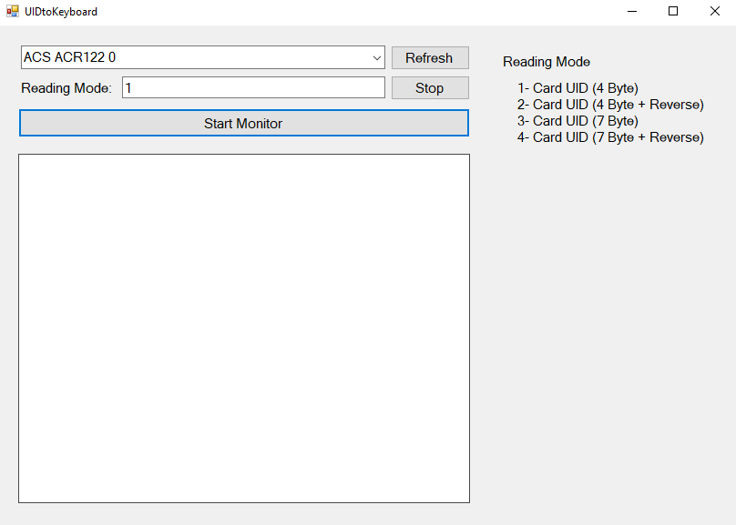

Start Monitor" to begin monitoring the card reads.
Step 2 – Main Dashboard
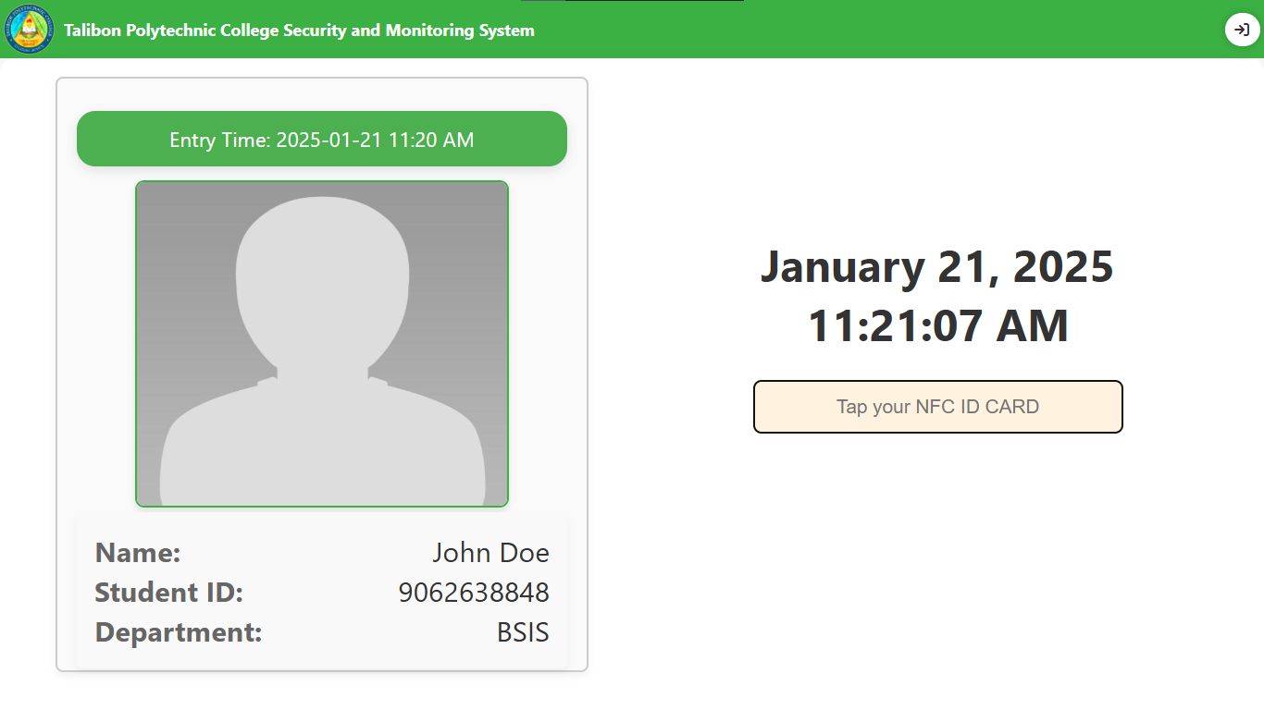
Main Dashboard is the first screen users will see upon accessing the system. It provides access to various functionalities, including NFC ID card scanning for attendance and navigation to other modules.
The system automatically records student attendance with the current time when they successfully tap their ID cards.
"Tap your NFC ID CARD" button prompts students to tap their NFC ID cards.
Directs to the Login Module

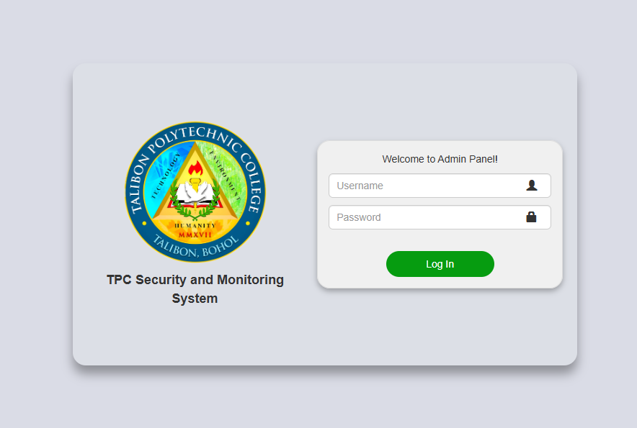

STEP 3 – LOGIN
The login is the gateway for administrators to access the system. It ensures that only authorized personnel can manage the system.

Submits the entered credentials for verification.
Administrator enter their credentials to access the dashboard.

STEP 4 – ADMIN PANEL
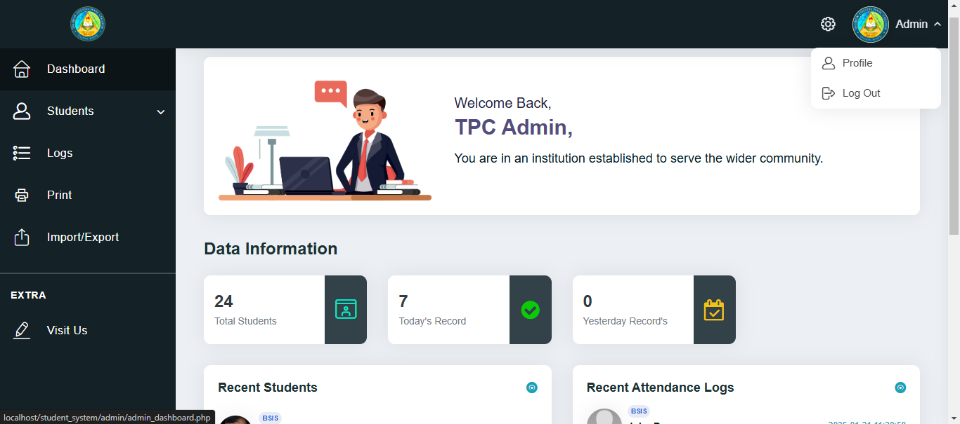
The Admin Panel provides an overview of the system's operations, including managing students, attendance logs, and system settings.
After logout, the system redirects the admin to the main dashboard page.
Navigate to the Admin Management section
Directs to the logs section to review all attendance activities.
Directs to the manage student records.
Customize the layout, themes, and other visual aspects.

STEP 5 – ADD STUDENT
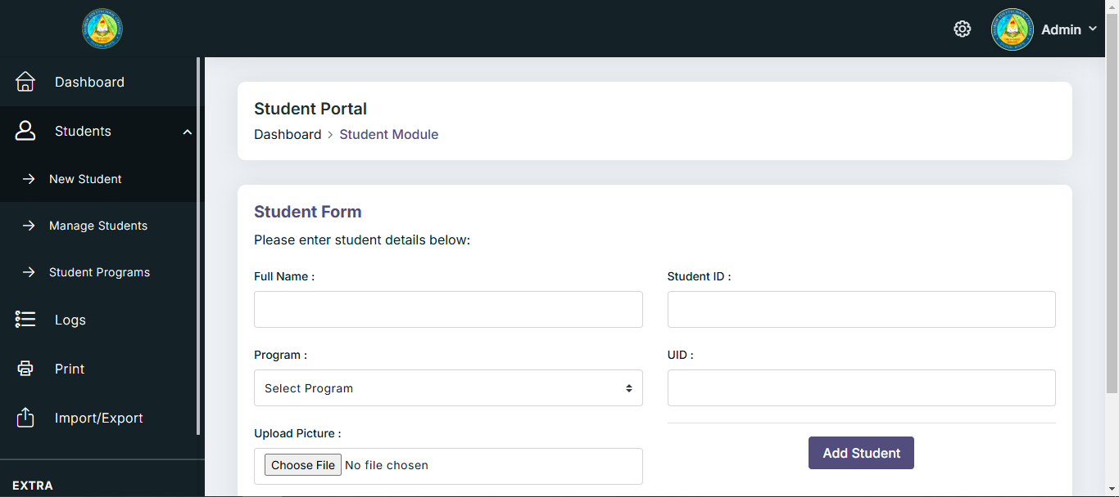
Allows admin to input student information, including student ID, name, program, and NFC UID.
Fill in all necessary fields: name, student ID, program, student picture before adding NFC UID.

The system will detect the NFC UID when tap and automatically enter or add student details.

Choose file at “C:\xampp\htdocs\ student_system\admin\admin\uploads.”

STEP 6 – MANAGE STUDENT
This module allows administrators to view, update, and delete student details.
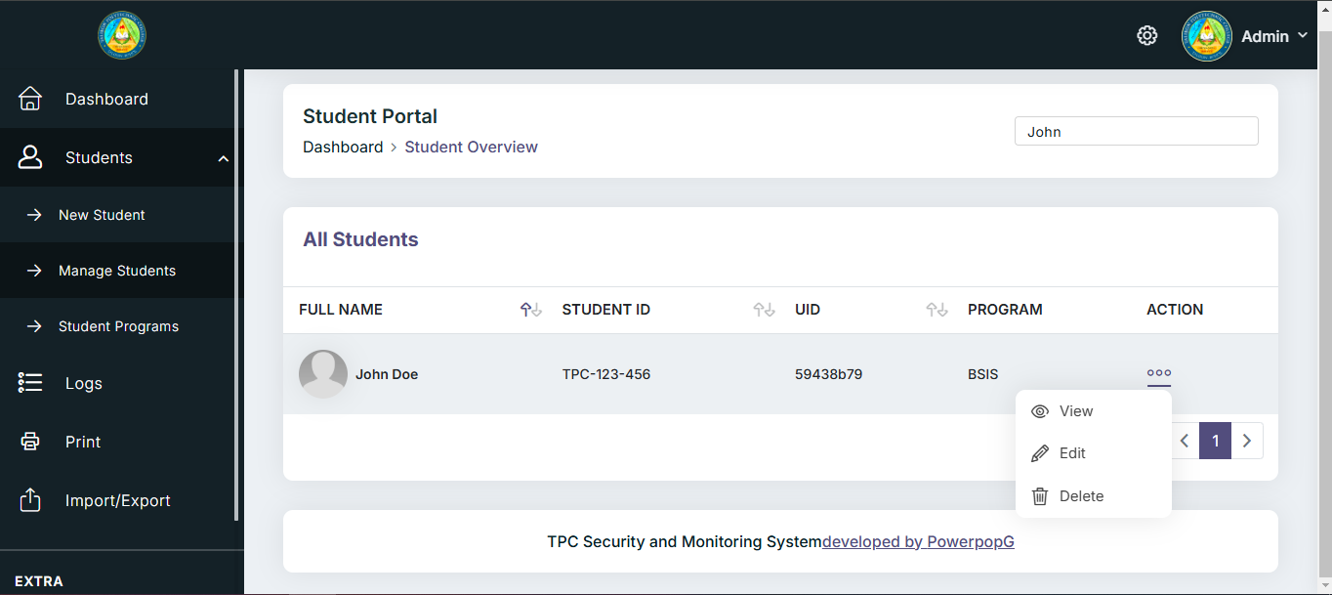
Admin can search by student ID, name

Admin can print and view each student's attendance profile individually.

Admin can edit inactive students (if needed).

Admin can Delete inactive students (optional).

STEP 7 – PROGRAM MANAGEMENT
This allows the admin to manage various academic programs offered at Talibon Polytechnic College.
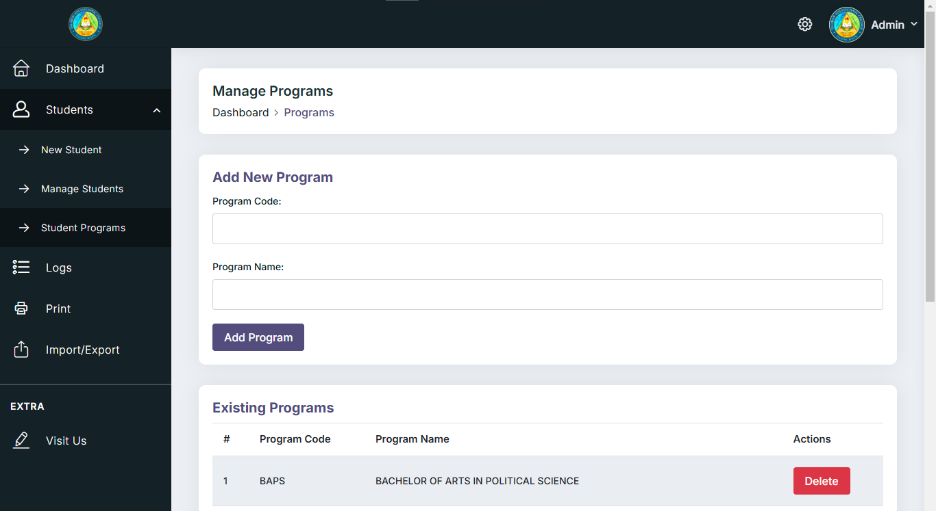
Admin can delete existing programs.
Admin can add new programs with a unique program code and name.

STEP 8 – ATTENDANCE LOGS
This displays all student attendance logs, showing the exact date and time of entry.
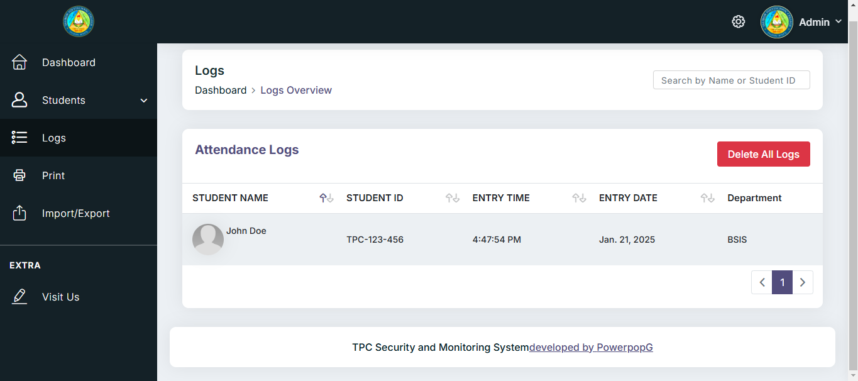
Admin can search by student ID, name.
Admin can also delete all logs anytime.

STEP 8 – PRINT
This enables administrators to print student attendance records or reports.
A button that generates a printable format of the current page or report.
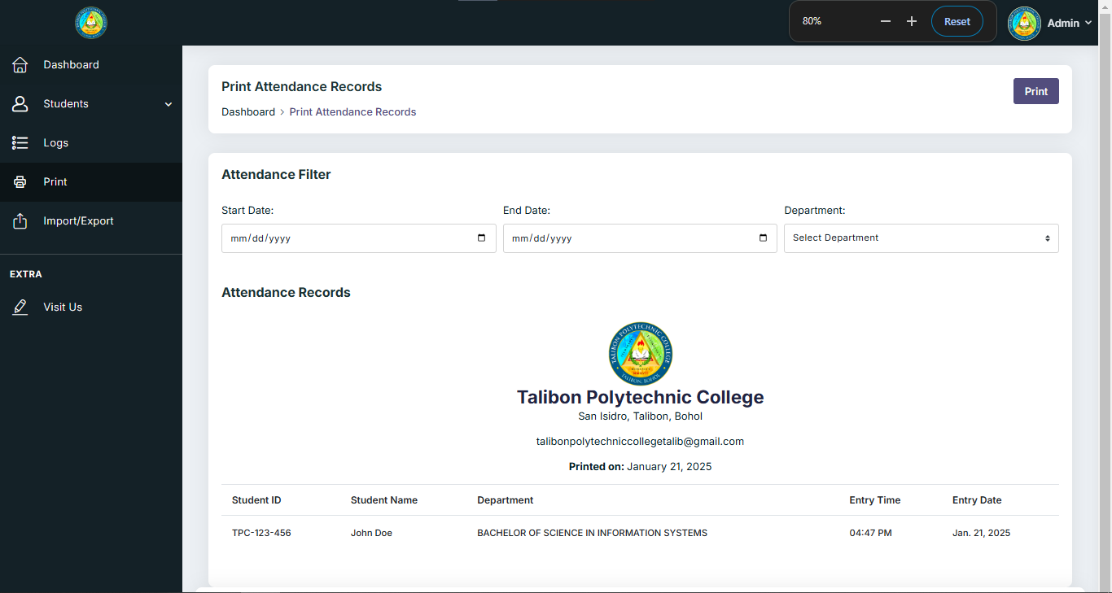
It can select start date and end date.
It can select a department you wish to print.

STEP 8 – IMPORT
The Import allows administrators to upload bulk student data into the system.
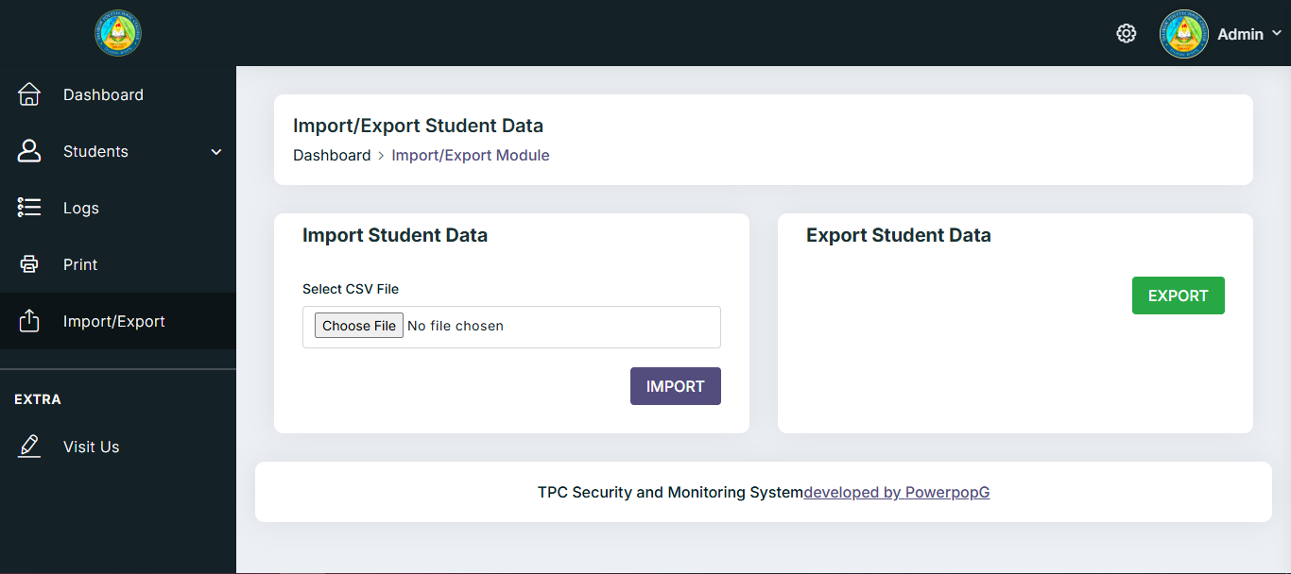
Admin can also export CSV file containing student data.
Once the file is successfully imported, the students will be added to the database.

Choose a CSV file containing student data at “C:\xampp\ htdocs\student_system\asset\student_csv”

