WEEK-3
1# Consider a car dealership that sells both new and used cars, and it operates a service facility. The data requirements are summarized as follows:
- salesperson may sell many cars, but each car is sold by only one salesperson.

- A customer may buy many cars, but each car is bought by only one customer.

- A salesperson writes a single invoice for each car he or she sells.

- A customer gets an invoice for each car he or she buys.

- A customer may come in just to have his or her car serviced, that is, a customer need not buy a car to be classified as a customer.

- When a customer takes one or more cars in for repair or service, one service ticket is written for each car.

- The car dealership maintains a service history for each of the cars serviced. The service records are referenced by the cars serial number.

- A car brought in for service can be worked on by many mechanics, and each mechanic may work on many cars.

- A car that is serviced may or may not need parts (e.g, adjusting a carburettor or cleaning a fuel injector nozzle does not require providing new parts).

Design ER diagram, schema diagram and construct database for the above. Give logical reasoning for the database design.


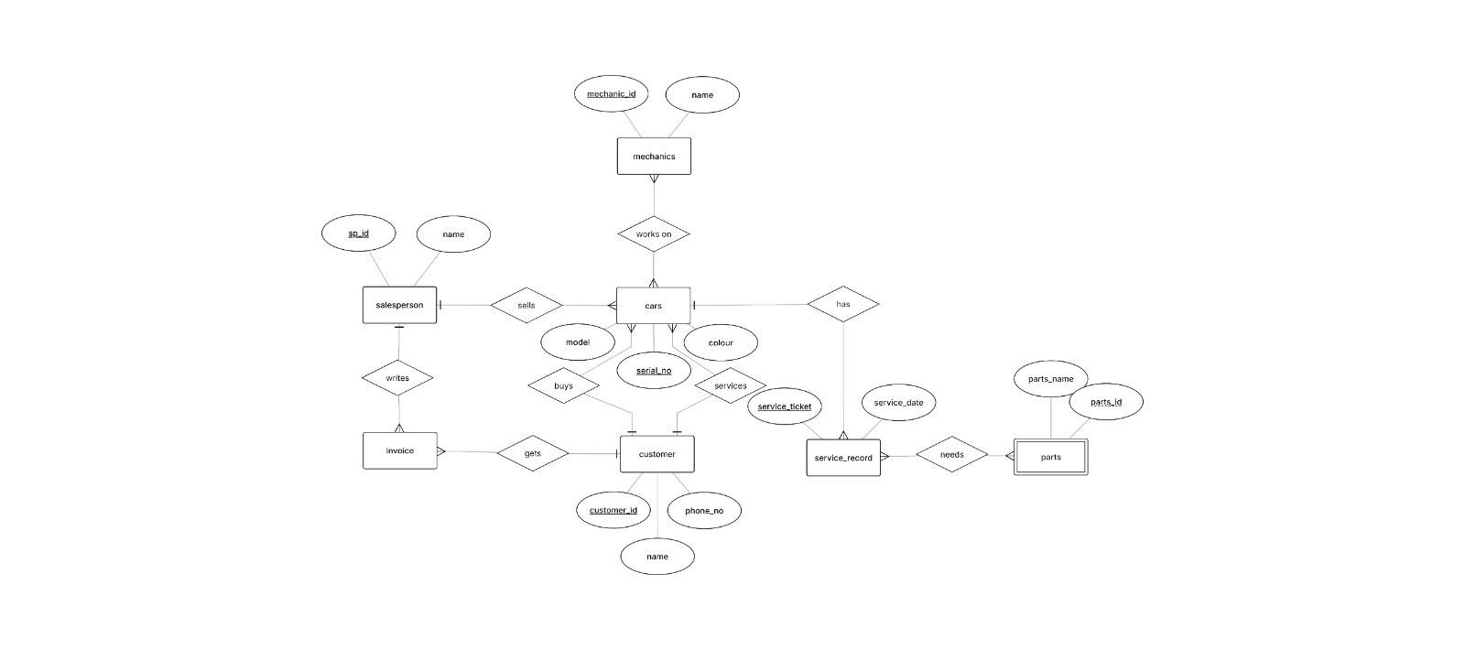
ER Diagram:


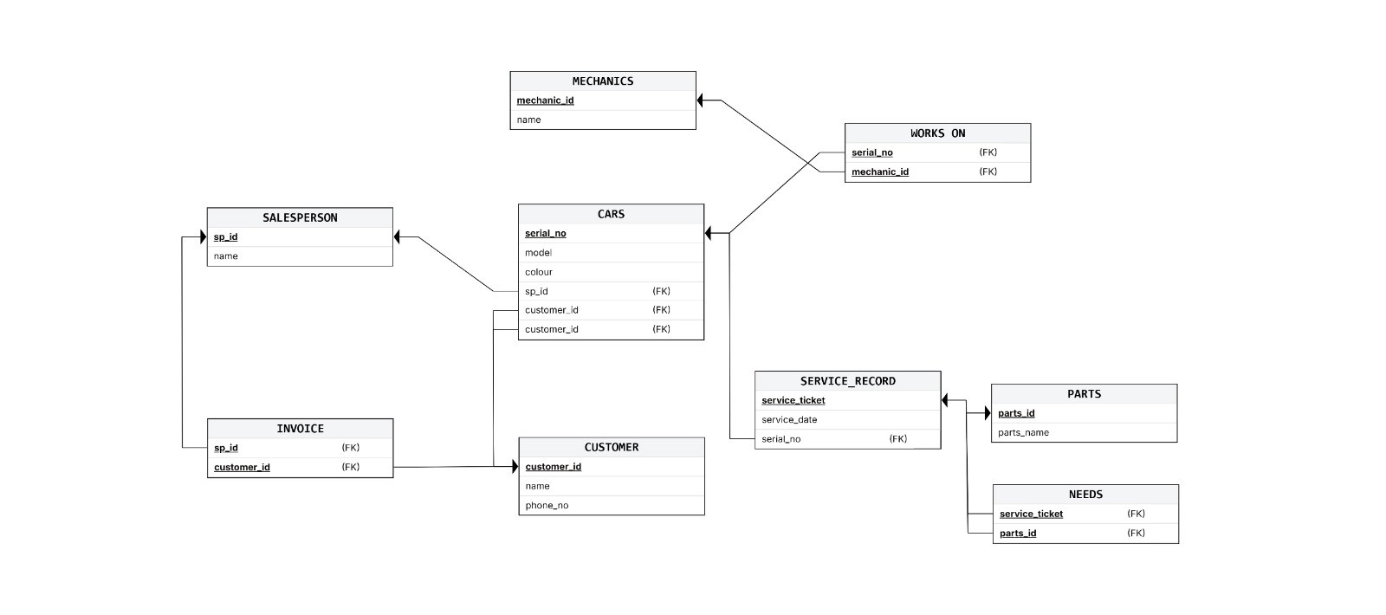
Schema Diagram:

Schema:
create database CarDealershipDB;use CarDealershipDB;
create table salesperson ( salesperson_id int PRIMARY KEY, name varchar(50),
phone varchar(15)
);

create table car (
car_id int PRIMARY KEY, model varchar(50), price decimal(10,2),
salesperson_id int NOT NULL,

FOREIGN KEY (salesperson_id) REFERENCES salesperson (salesperson_id)
);
ALTER table car
ADD customer_id INT NOT NULL,
ADD FOREIGN KEY (customer_id) references customer(customer_id);

create table customer( customer_id int PRIMARY KEY, name varchar(50),
phone varchar(15), address varchar(200)
);

create table invoice(
car_id int UNIQUE NOT NULL, salesperson_id INT NOT NULL,
invoice_id INT PRIMARY KEY, invoice_date DATE, total_amount DECIMAL(10,2),
FOREIGN KEY (car_id) REFERENCES car(car_id),
FOREIGN KEY (salesperson_id) REFERENCES salesperson(salesperson_id)
);

create table serviceTicket ( ticket_id int PRIMARY KEY, car_id INT NOT NULL, service_date DATE, description VARCHAR(255),
foreign key (car_id) references car(car_id)
);

create table mechanic ( mechanic_id INT PRIMARY KEY, name VARCHAR(50),
phone VARCHAR(15)
);

CREATE TABLE service_mechanic( ticket_id INT,
mechanic_id INT,
PRIMARY KEY (ticket_id, mechanic_id),
FOREIGN KEY (ticket_id) REFERENCES serviceTicket(ticket_id), FOREIGN KEY (mechanic_id) REFERENCES mechanic(mechanic_id)
);

CREATE TABLE part (
part_id INT PRIMARY KEY, part_name VARCHAR(50),
price DECIMAL(10,2)
);

CREATE TABLE service_part ( ticket_id INT,
part_id INT, quantity INT,
PRIMARY KEY (ticket_id, part_id),
FOREIGN KEY (ticket_id) REFERENCES serviceTicket(ticket_id), FOREIGN KEY (part_id) REFERENCES part(part_id)

ASNA MIRZA
24CABSA554

