WEEK – 10
1# A Mobile Phone Service Center wants to maintain a database to manage information about customers, mobile phones, and service requests. Currently, records are maintained manually, which causes data inconsistency and difficulty in retrieval. You are required to design and implement a database system for the service center.
a) Create the following tables based on the given scenario:
1. Customer
- Customer_ID
- Customer_Name
- Mobile_No
- Address
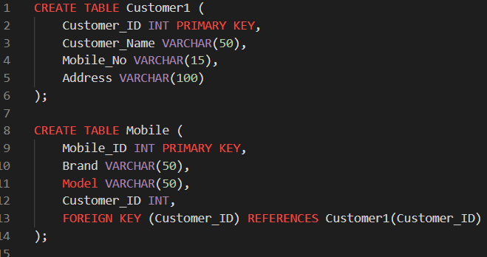
2. Mobile
- Mobile_ID
- Brand
- Model
- Customer_ID

3. Service_Request
- Service_ID
- Mobile_ID
- Problem_Description
- Service_Date
- Service_Cost
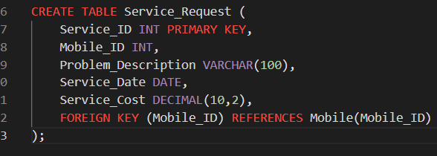
(Choose appropriate data types and define primary keys and foreign keys where required.)

b) Insert at least five records into each table using SQL INSERT statements.
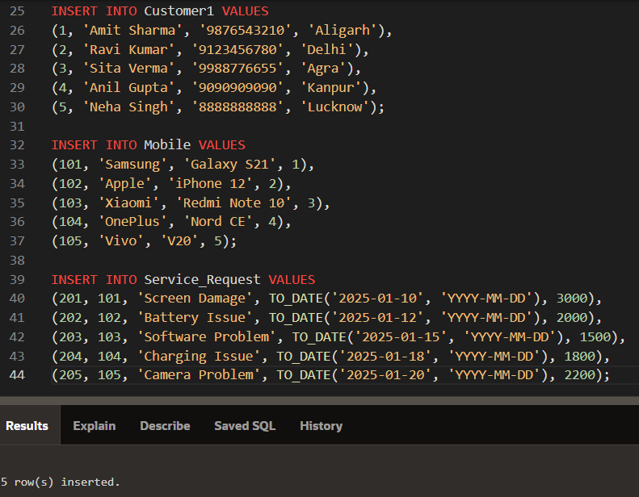

c) Display all customer details.
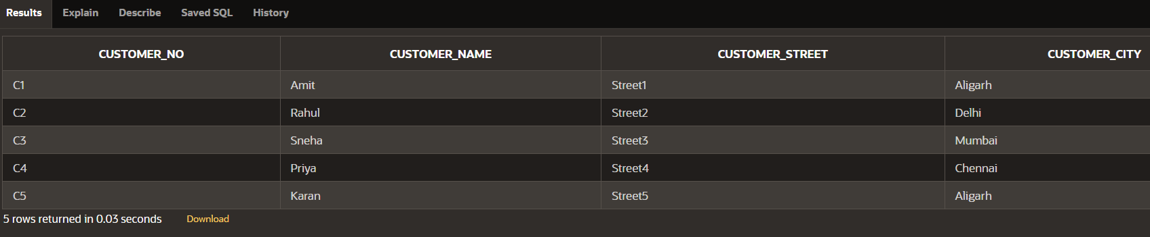
d) Display all mobile phones serviced in the service center.
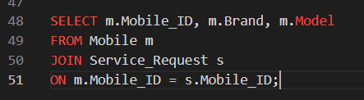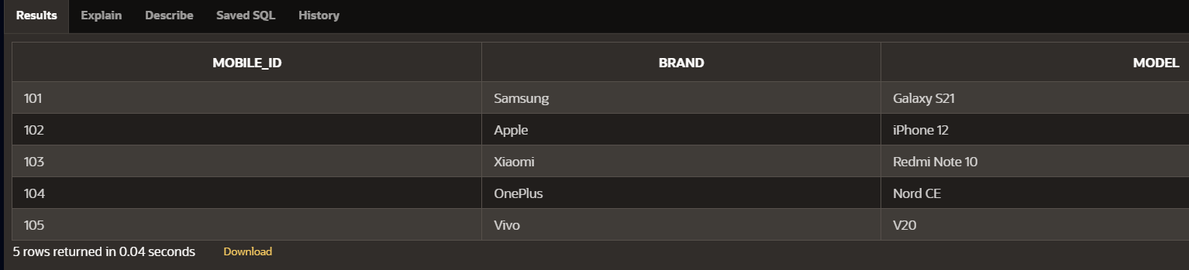

e) Display customer names along with their mobile phone details.
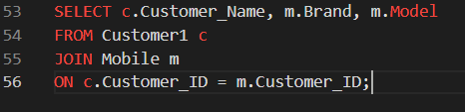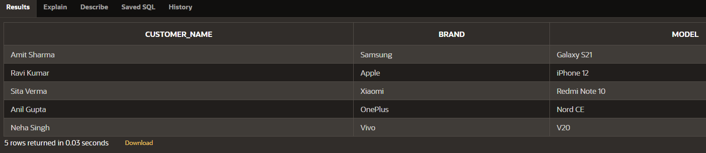
f) Display service details for a particular mobile phone.
