WEEK-7
1# Consider the insurance database given below. The primary keys are made bold and the data types are specified.
PERSON (driver_id:string , name:string , address:string )
CAR(regno:string , model:string , year:int )
ACCIDENT(report_number:int , accd_date:date , location:string )
OWNS(driver_id:string , regno:string )
PARTICIPATED(driver_id:string , regno:string , report_number:int , damage_amount:int).
a) Create the above tables by properly specifying the primary keys and foreign keys.
b) Enter at least five tuples for each relation.
c) Update the damage amount for the car with specific regno in the accident with report number 12 to 25000.
d) Add a new accident to the database.
e) Find the total number of people who owned cars that were involved in accidents in the year 2008 to 2020.
f) Find the number of accidents in which cars belonging to a each model were involved.
a)
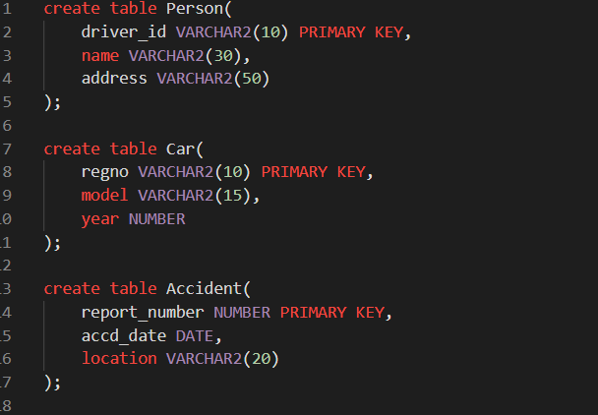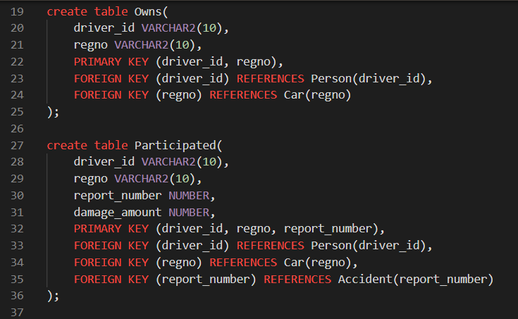
b)
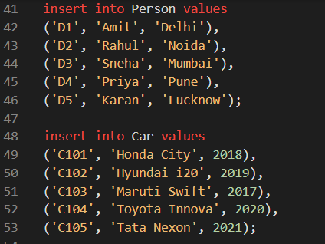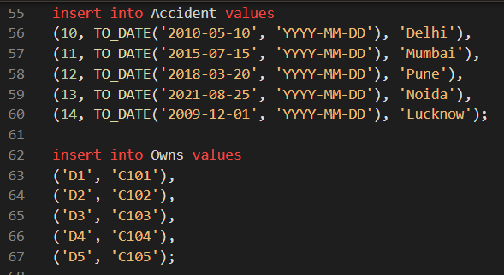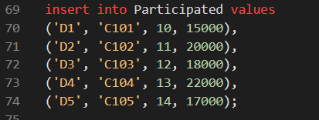

c)
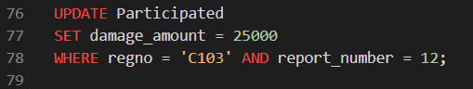

d)

e)
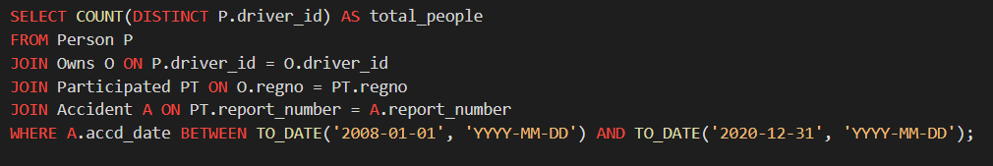
f)
