WEEK-5

1# Write the SQL queries for the following based on previous week’s tables:
(I) Make a reserve copy of all the tables
(II) Exercise on retrieving records from a table

(a) – Find out the names and cities of all the clients
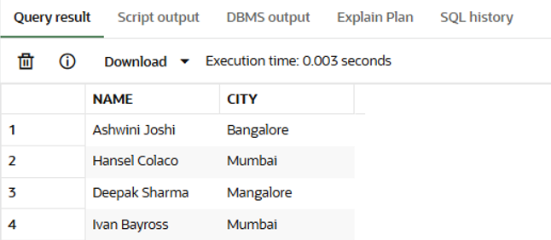
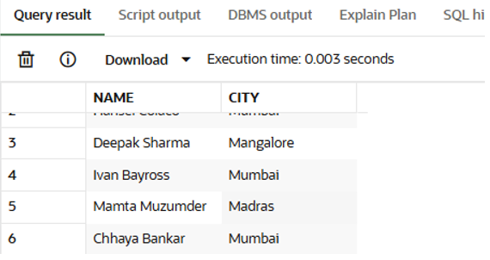
(b) Retrieve the entire contents of the Client_Master table.
(c) Retrieve the list of names, city and the state of all the clients who balance due is 0.
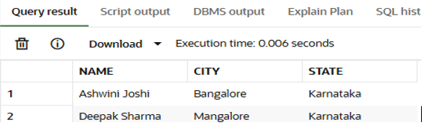
(III) Exercise on updating records in a table
(a) – Change the city of ClientNo C00005 to “Bangalore”
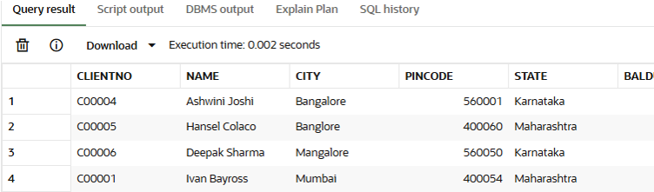
(b) – Change the BalDue of ClientNo C00001 to Rs. 1000
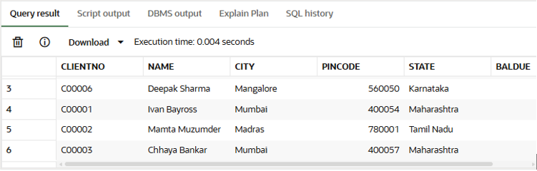
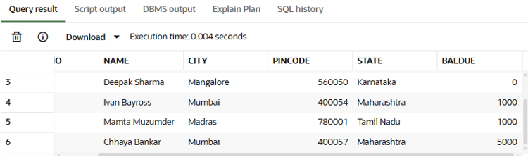
(c) – Change the cost price of Trousers to Rs. 950.00
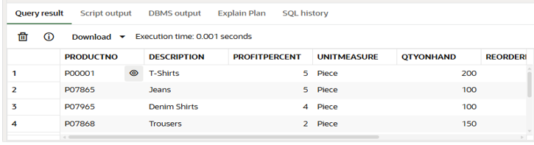
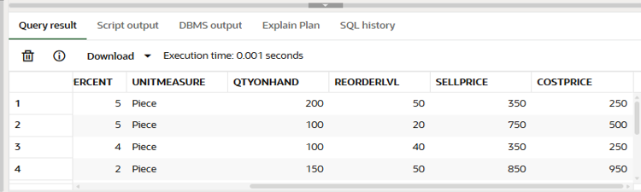
(IV) Exercise on deleting records in a table
(a) – Delete all salesman from the Salesman_Master whose salaries are equal to Rs. 3500
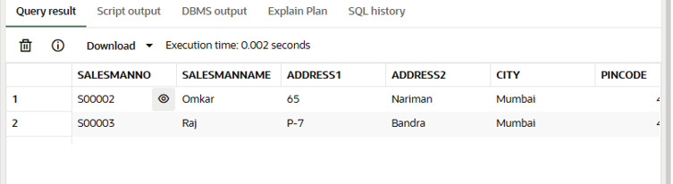
(b) – Delete all products from the Product_Master where the quantity on hand is equal to Rs. 100
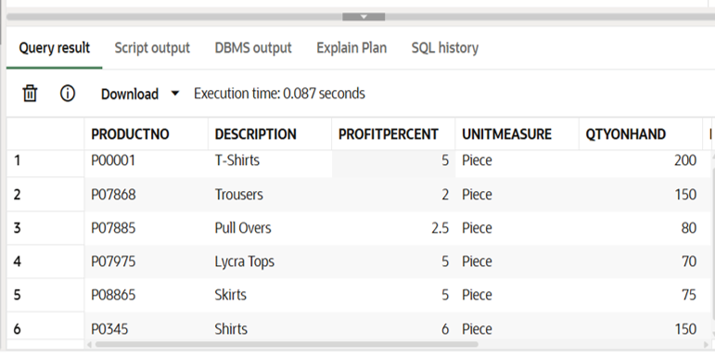
(c) – Delete from Client_Master where the column state holds the value Tamil Nadu
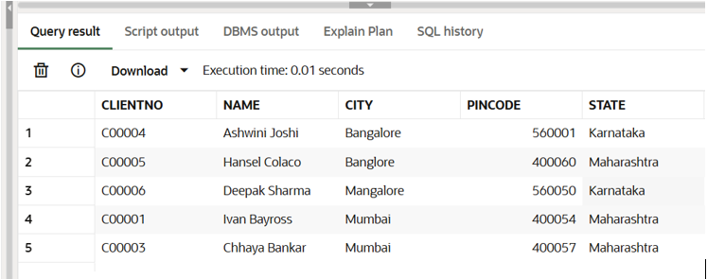
(V) Exercise on altering the table structure
(a) – Add a column called Telephone of data type number and size=10 to the Client_Master table
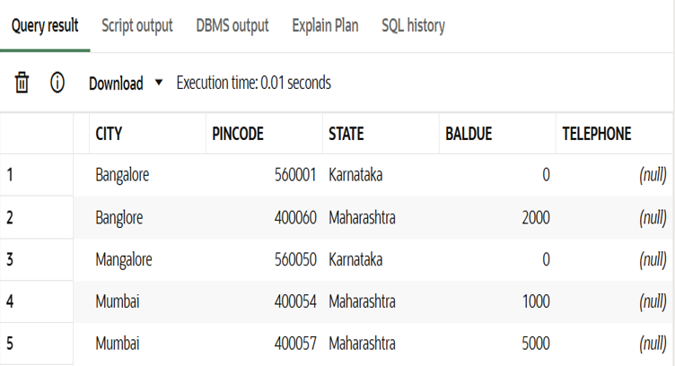
(b) – Change the size of SellPrice column in product_Master to 10,2
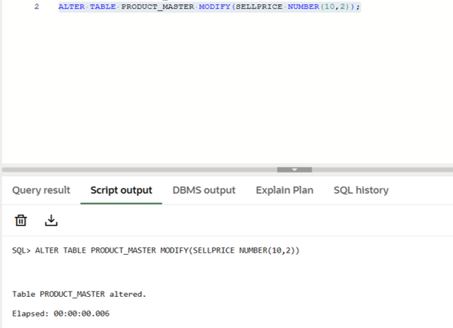
(VI) Exercise on deleting the table structure along with the data
(a) – Destroy the table Client_Master along with its data
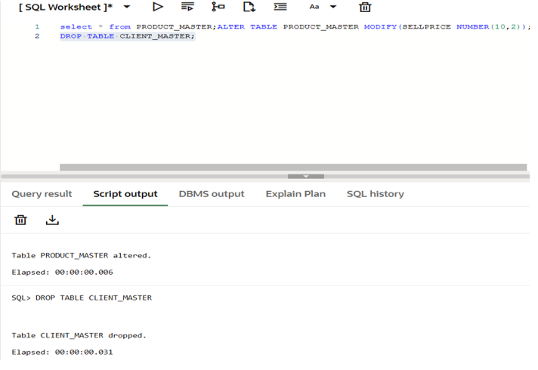
(VII) Exercise on renaming the table
(a) – Change the name of the Salesman_Master table to sman_mast
