WEEK-6

1# A city hospital wants to digitize its patient registration and appointment system. Currently, patient details and doctor schedules are recorded manually, causing delays and errors. You are assigned to design and create a database system to manage patients, doctors, and appointments.

Create the database Hospital_DB
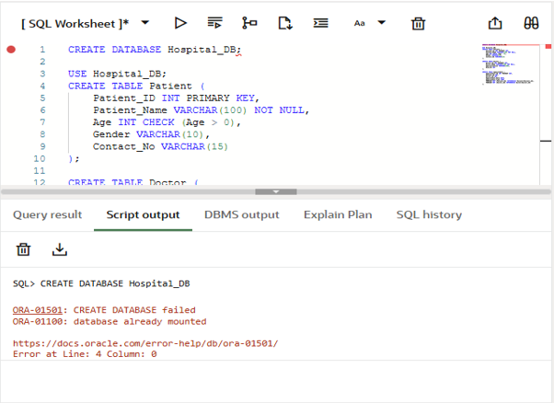

Create all tables with proper data types
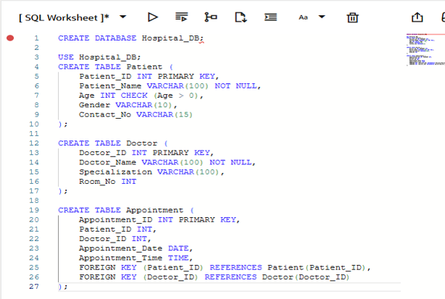
Insert minimum 5 records into each table
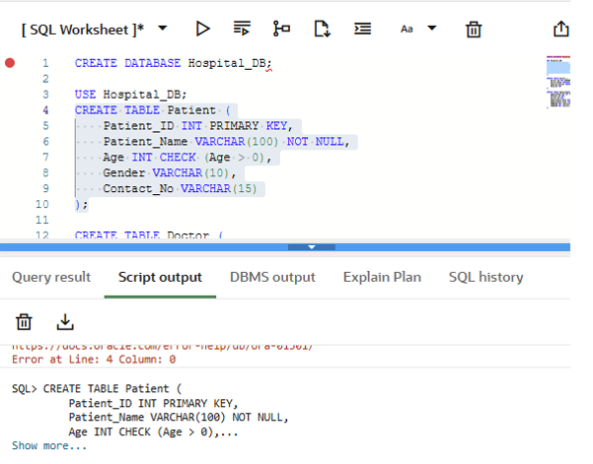
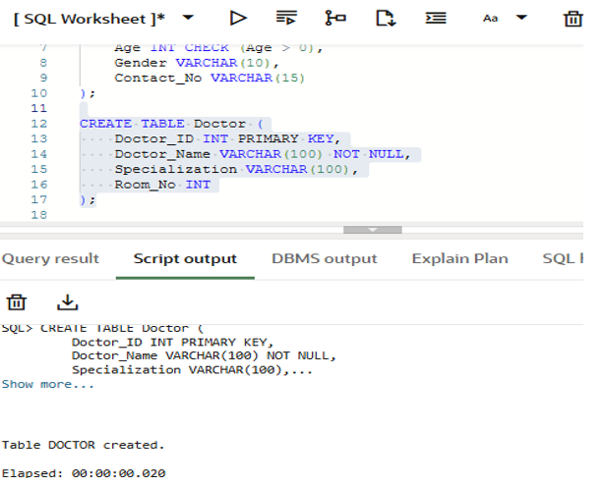
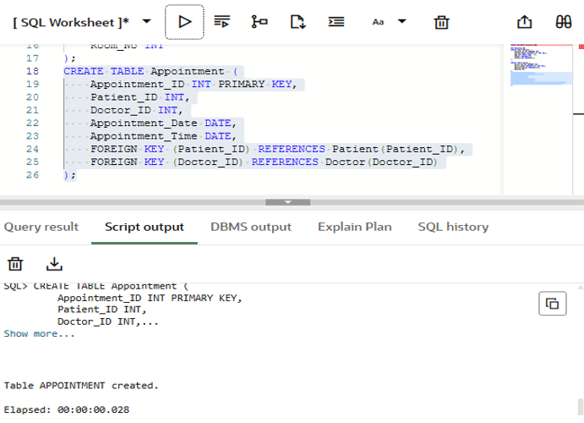

Display: • All patients • All doctors • Appointments of a specific patient
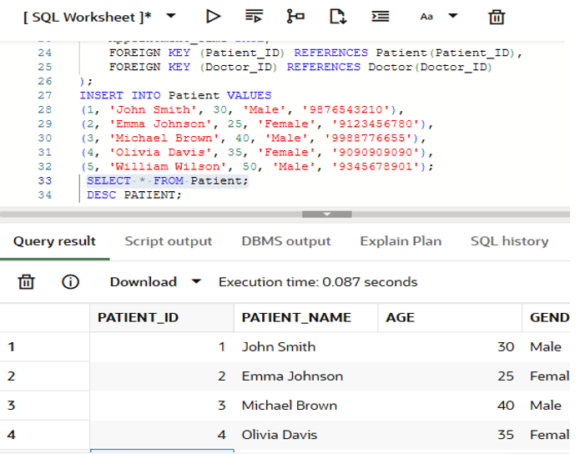
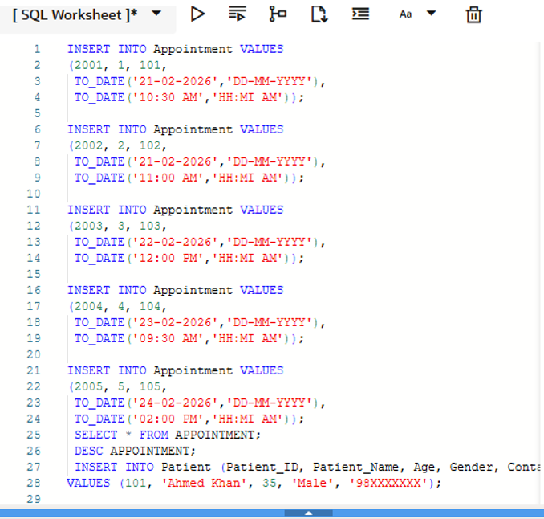
The database consists of the following tables: • Patient ( Patient_ID, Patient_Name, Age, Gender, Contact_No ) • Doctor ( Doctor_ID, Doctor_Name, Specialization, Room_No ) • Appointment ( Appointment_ID, Patient_ID, Doctor_ID, Appointment_Date, Appointment_Time )
Test Case 2: Add a New Patient Record Input: Patient_ID =101, Patient_Name =Ahmed Khan, Age =35, Gender =Male, Contact_No =98XXXXXXXX. Output: Patient record is inserted successfully into the Patient table.
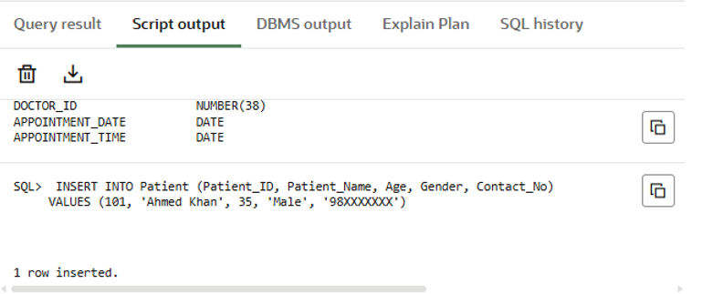
Test Case 3: Add a New Doctor Record Input: Doctor_ID =201, Doctor_Name =Dr. Sharma, Specialization =Cardiology, Room_No =12. Output: Doctor record inserted successfully into the Doctor table.
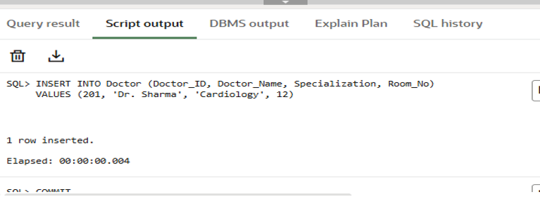

Test Case 4: Add an Appointment Record Input: Appointment_ID =301, Patient_ID =101, Doctor_ID =201, Appointment_Date =15-10-2025, Appointment_Time =10:30 AM. Output: Appointment record is inserted successfully into the Appointment table.
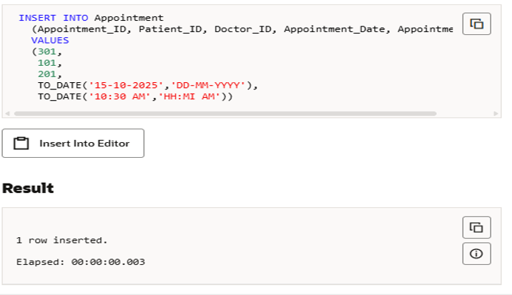
Test Case 5: Insert Multiple Patients Input: Five valid patient records are inserted into the Patient table. Output: All patient records are inserted successfully.
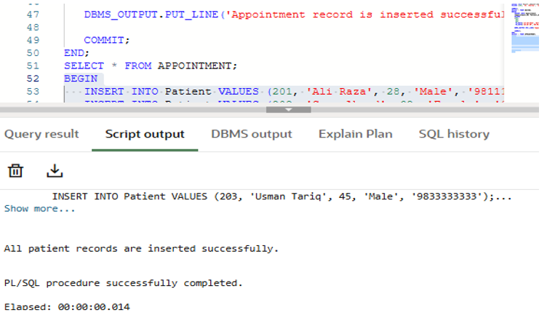
Test Case 6: Insert Multiple Doctors Input: Five valid doctor records are inserted into the Doctor table. Output: All doctor records are inserted successfully.
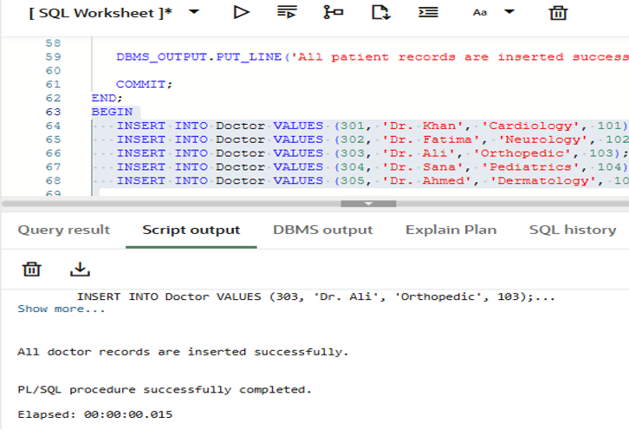
Test Case 7: Insert Multiple Appointments Input: Five valid appointment records are inserted with correct Patient_ID and Doctor_ID references. Output: All appointment records are inserted successfully.
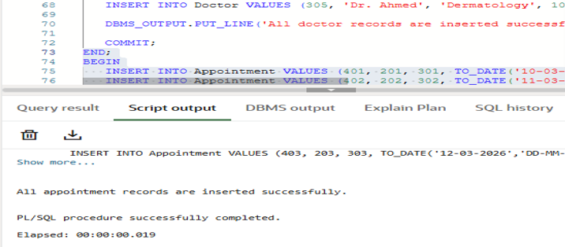

Test Case 8:Display All Patients Input: Request to display all records from the Patient table. Output: Details of all registered patients are displayed successfully.
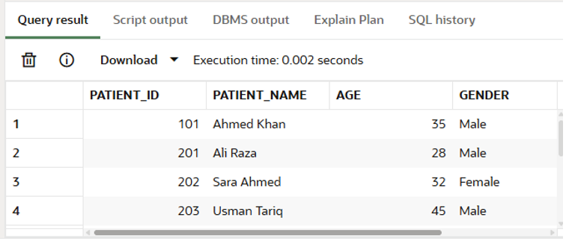
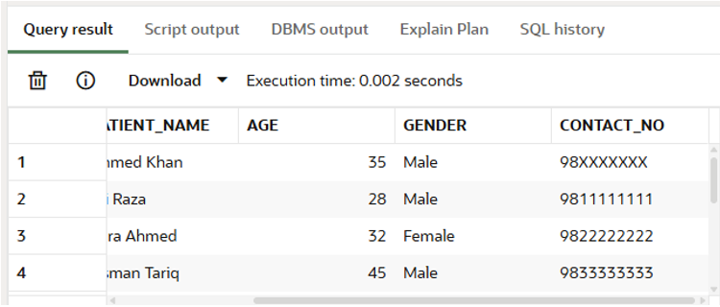
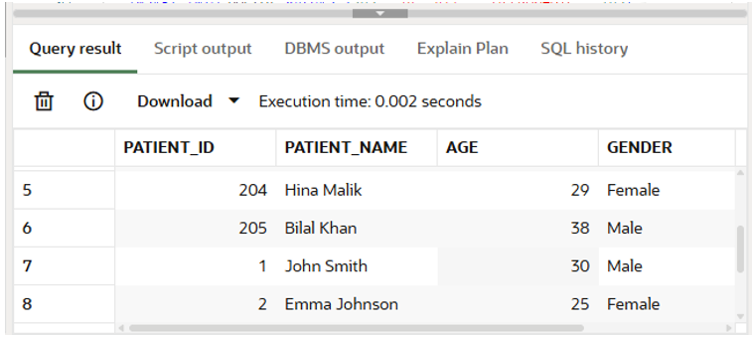
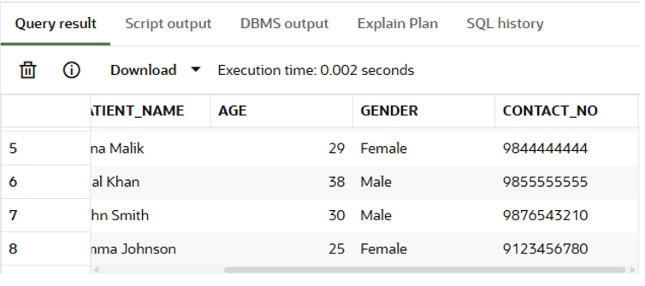
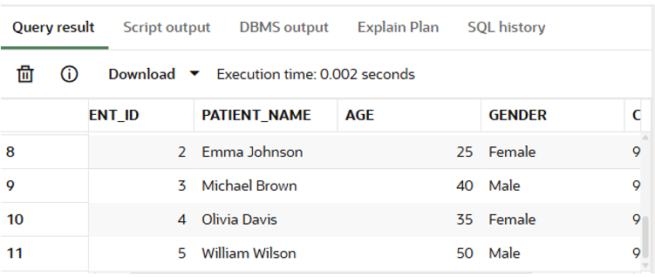
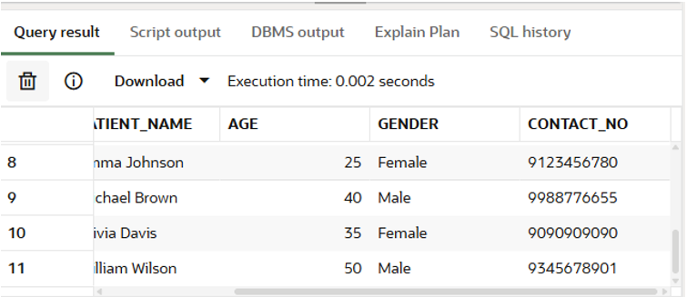

Test Case 9:Display All Doctors Input: Request to display all records from the Doctor table. Output: Details of all doctors are displayed successfully.
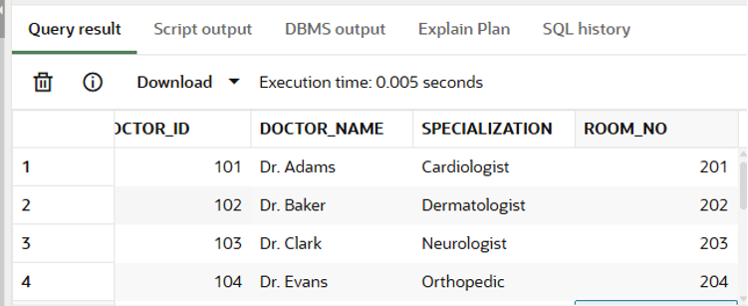
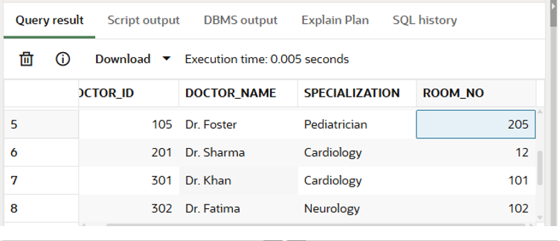
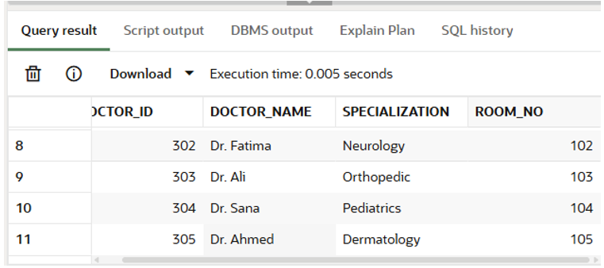
Test Case 10:Display Appointments of a Specific Patient Input: Patient_ID = 101 Output: All appointment details related to the specified patient are displayed successfully.
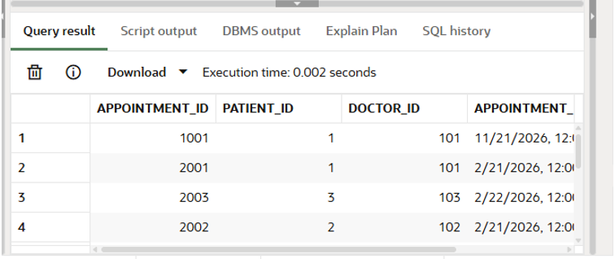
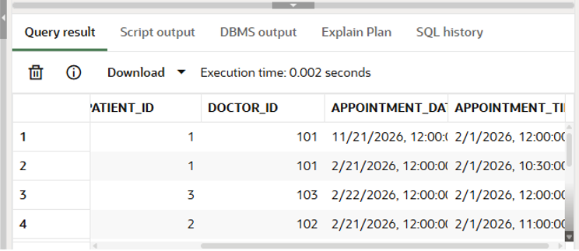
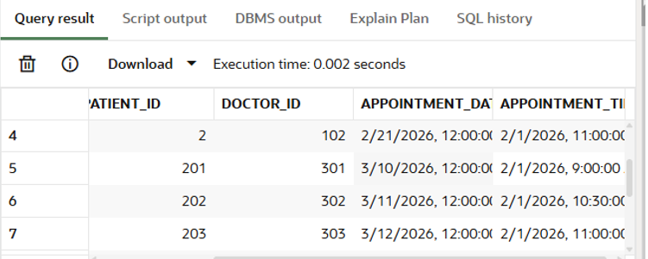
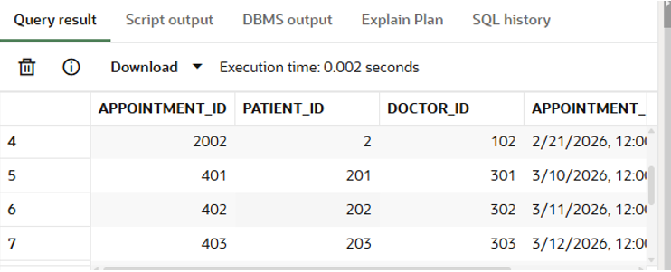
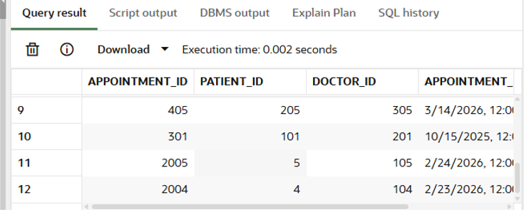
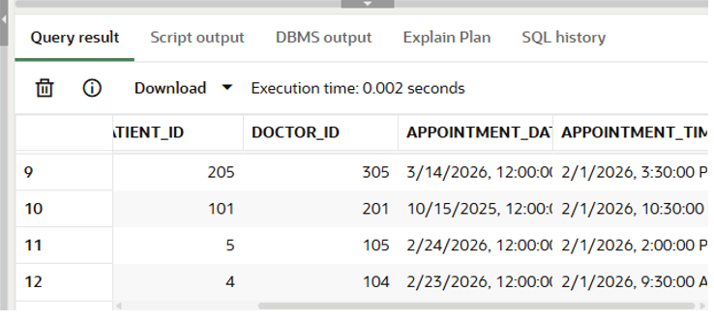

Test Case 11:Appointment with Invalid Patient_ID Input: Appointment inserted with Patient_ID that does not exist in Patient table. Output: Insertion is rejected due to foreign key constraint violation.
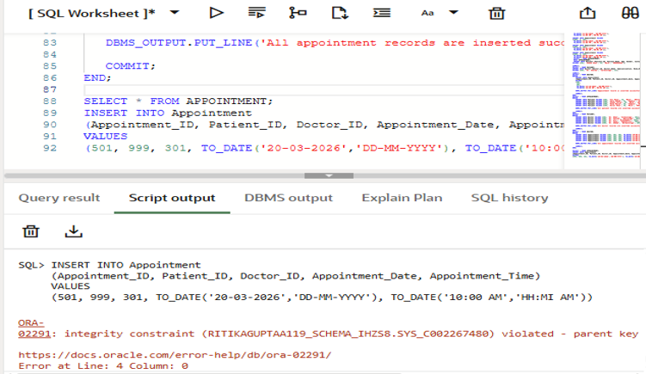

2# In the previous experiment, you designed and created a Hospital Management Database named Hospital_DB using previous tables, write SQL queries to perform the following operations:

- Display all records from the Patient table.
- Display the names and specializations of all doctors.

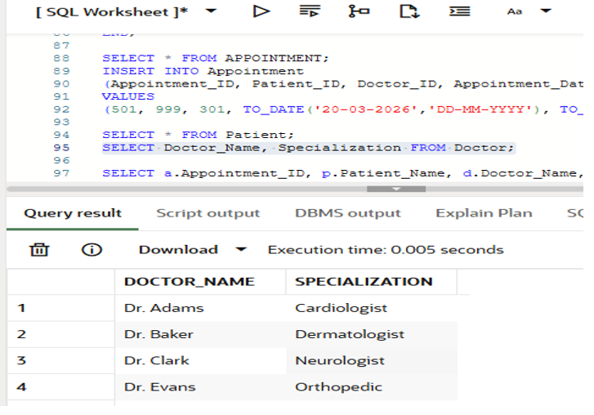
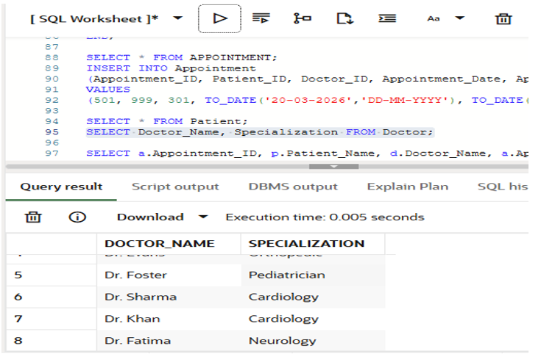

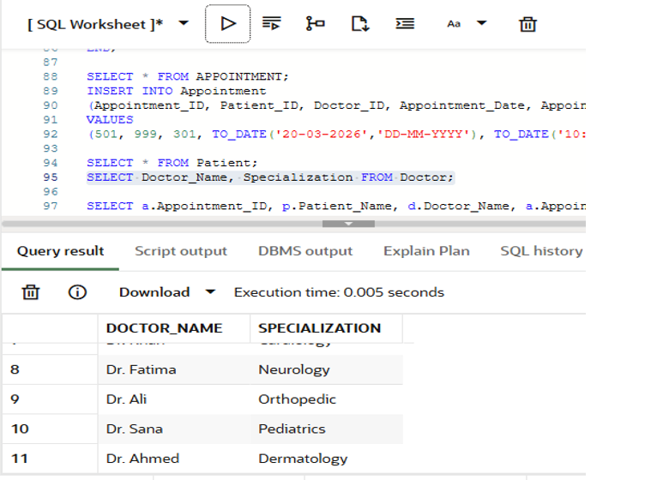
- Retrieve all appointment details of a particular patient using Patient_ID.
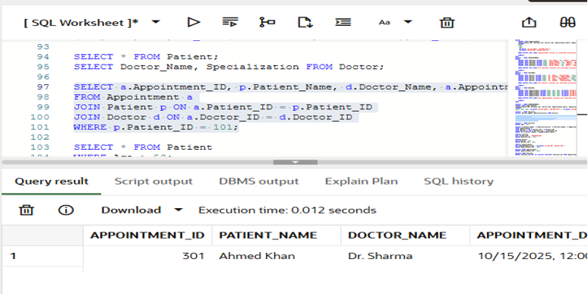
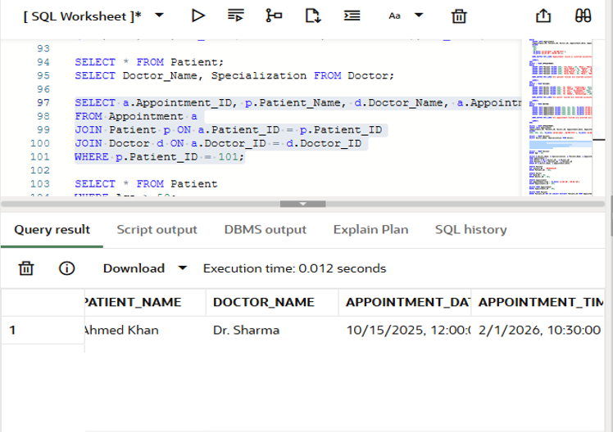
- Display the list of patients whose age is greater than 50 years.
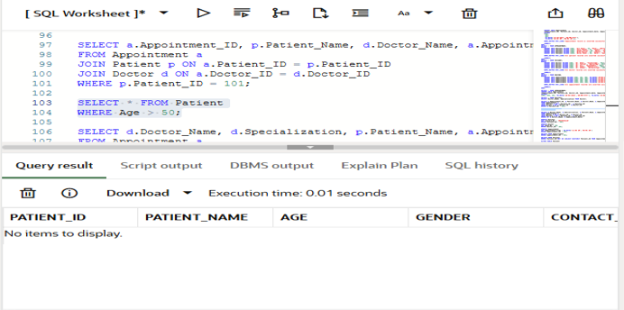

- Display doctor-wise appointment details.
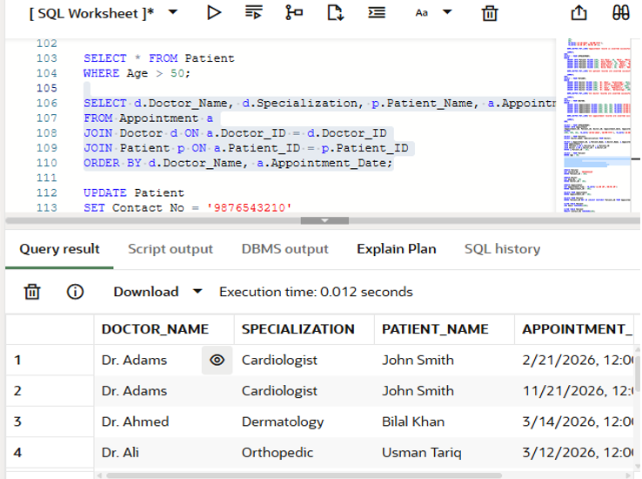
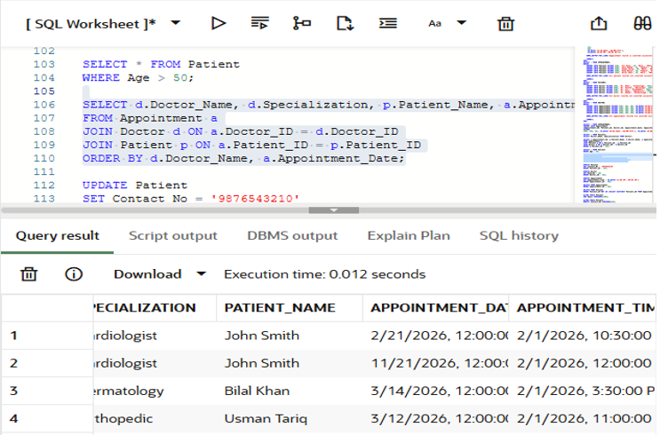
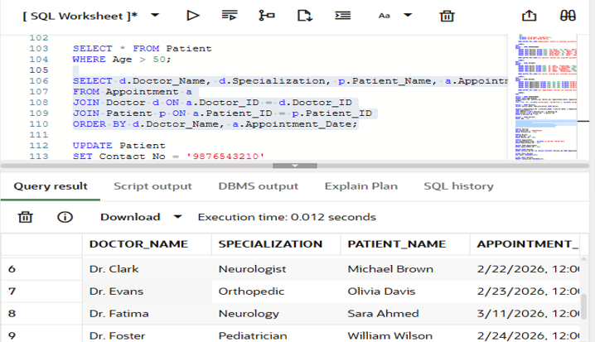
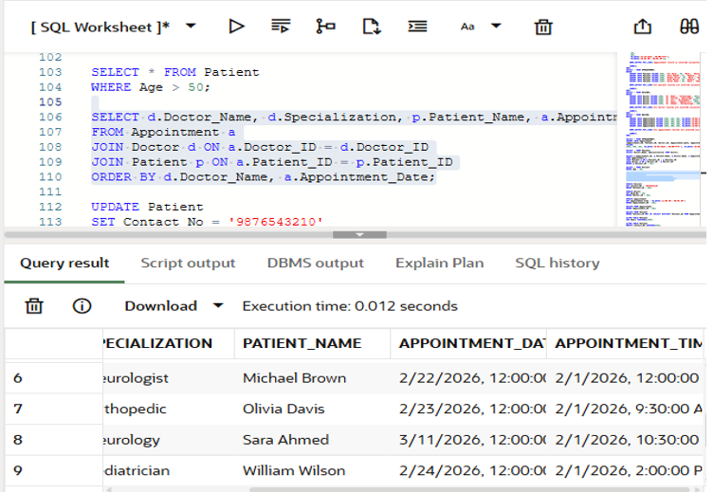

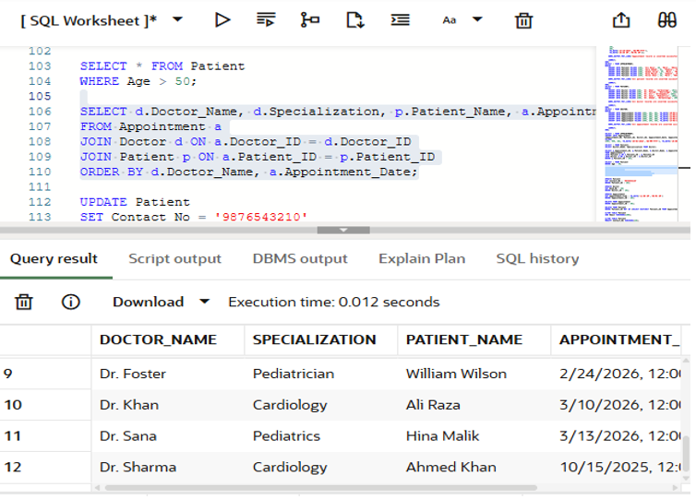
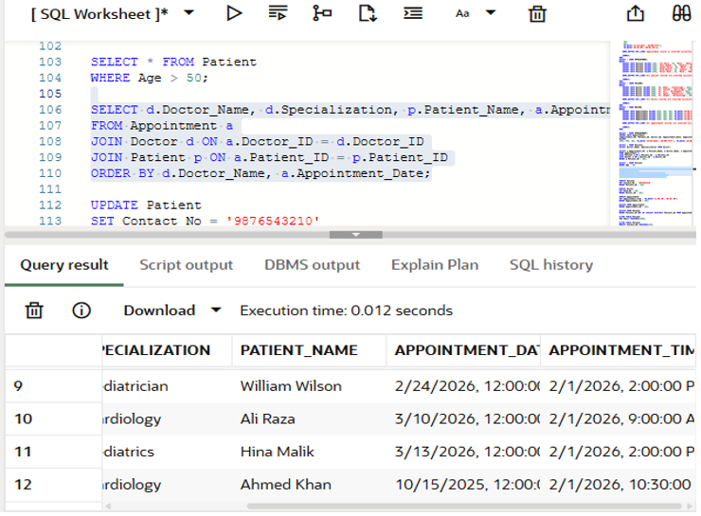
- update the contact number of a patient.
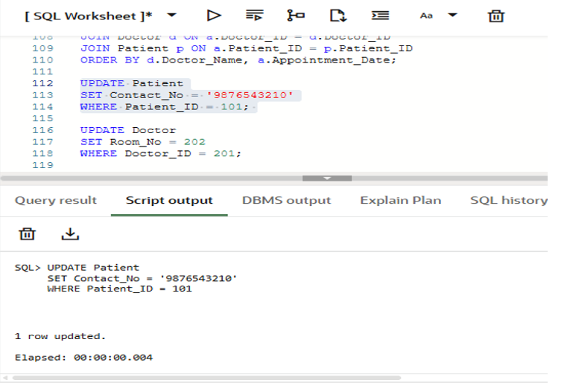
- Change the room number of a doctor.
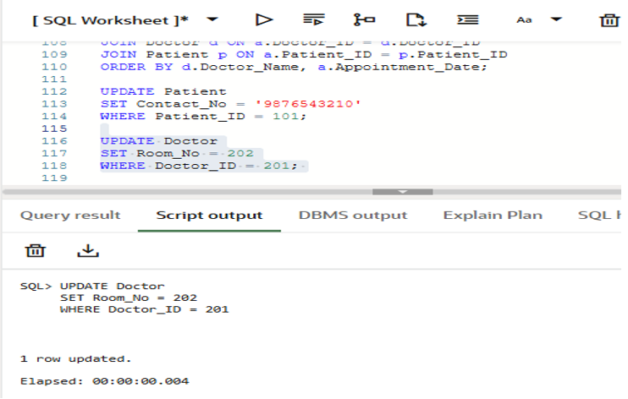
- Update the appointment time for a given appointment.
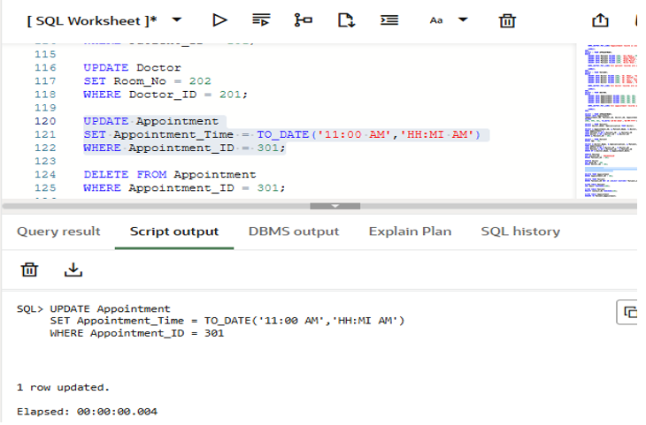
- Delete an appointment record using Appointment_ID.
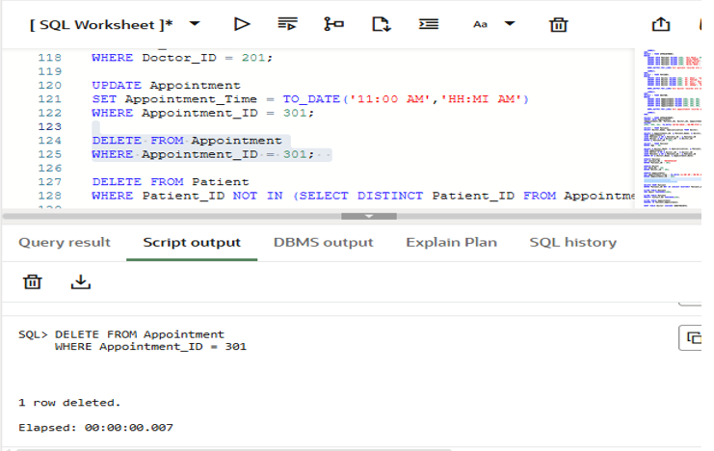
- Delete a patient record who has no appointment.
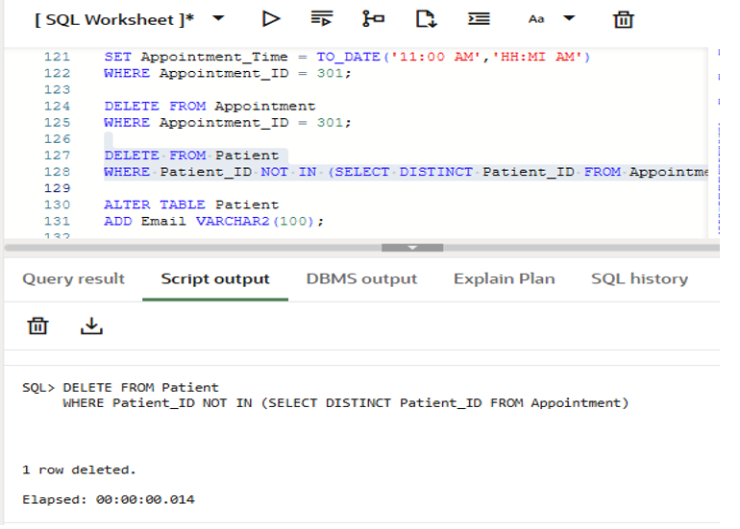
- Add a new column Email to the Patient table.
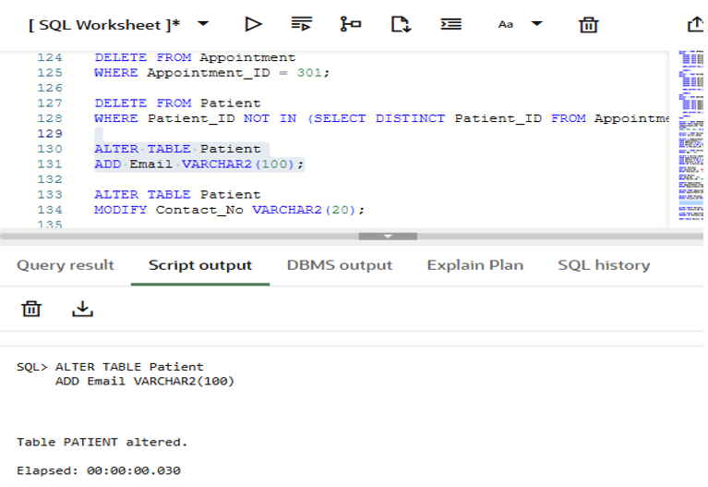
- Modify the data type of the Contact_No column.
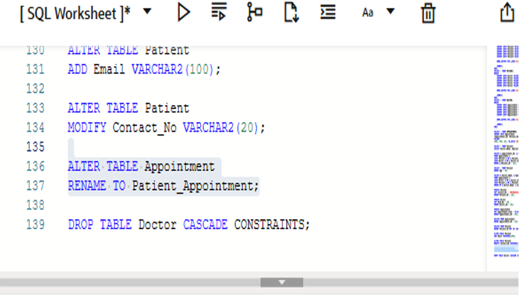
- Rename the Appointment table to Patient_Appointment.
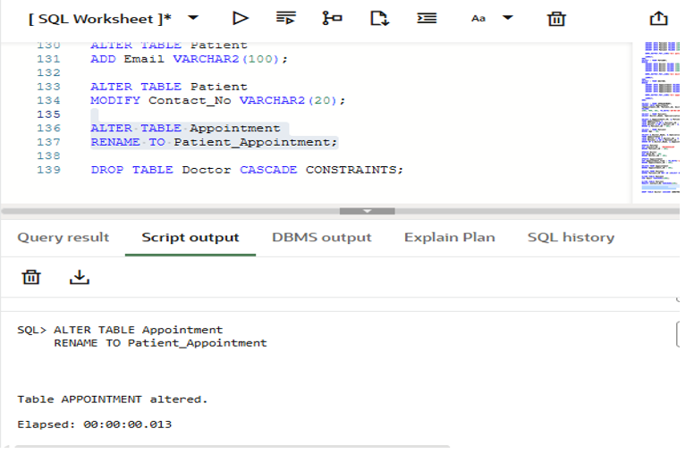

- Delete the Doctor table.
