WEEK – 9
1# A database is to be designed for sales information system. A product can be described with a unique product number, product name, selling price, manufacturer name. The product can sale to a particular client and each client have its own unique client ID, client name, client addresses, city, pin code and total balance to be required to paid. Each client orders to buy product from the salesman. In the order, it has unique sales order number, sales order date, client number and salesman number. Each salesman has the salesman number (unique), name, addresses, city, pin code, salary of the sales man.
- Create ER Diagram and Schema diagram for the above system.
* attached at end

- Create the above tables and mention primary keys and the foreign keys
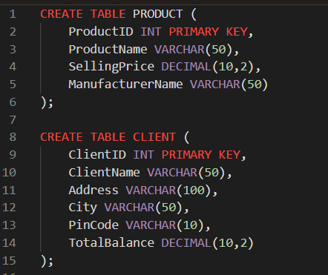
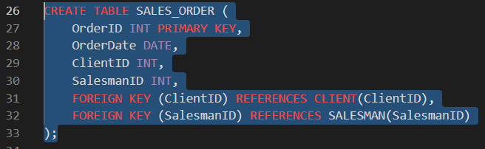
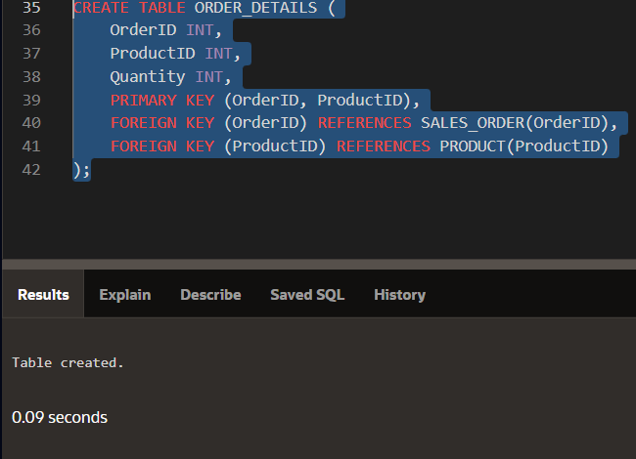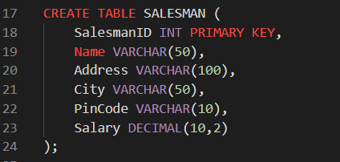

- Insert at least five relevant records in each of the created relations.
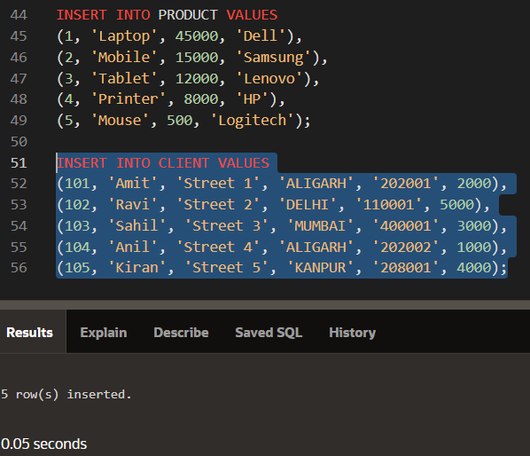
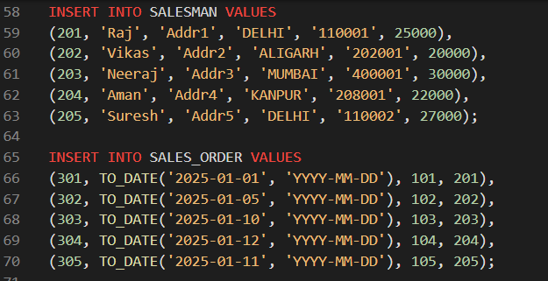
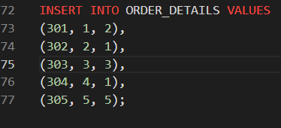
- d) Write following SQL queries based on created Database:

- Retrieve names and cities of all the clients.
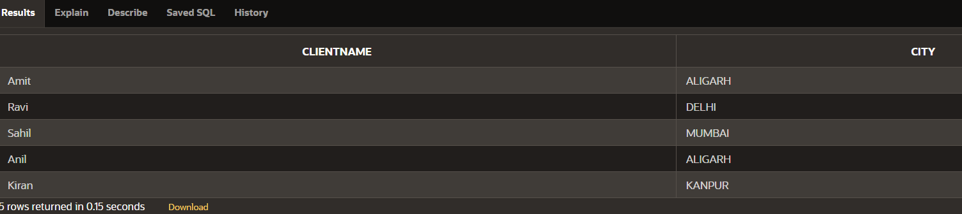
- Retrieve the available products.
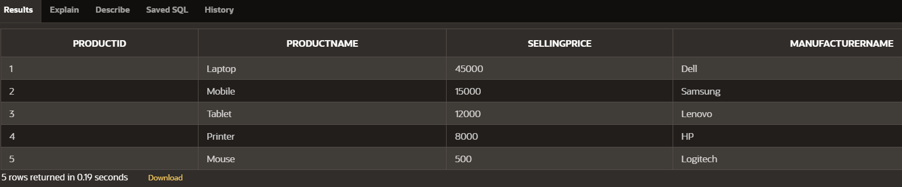
- Find the names of all clients having “a‟ as the second letter in their names.
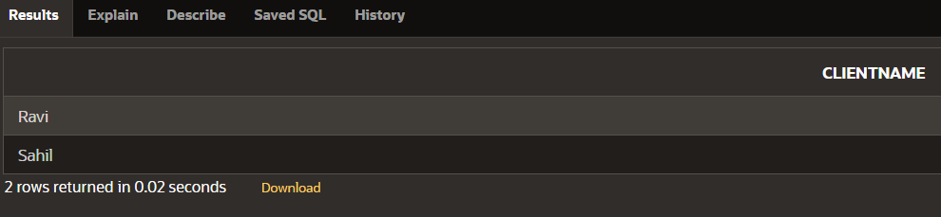
- List of all the clients who are located in ALIGARH.
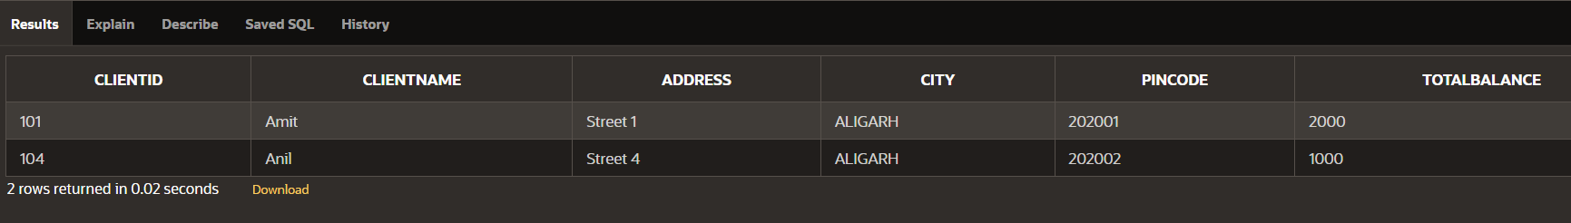
- Find the products whose selling price is less than or equal to 5000.
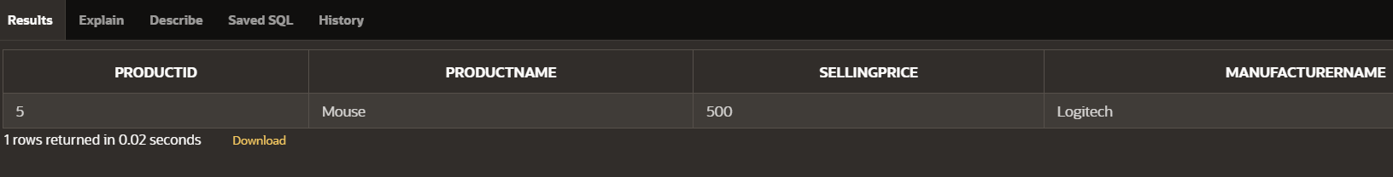

- List the products in sorted order of their selling price
