WEEK-12
1# Write a PL/SQL stored procedure to display “Hello World”.
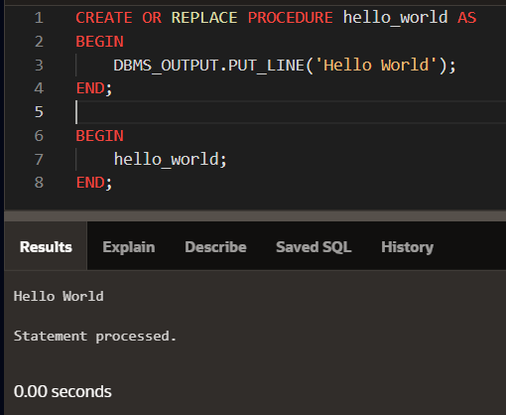
2# Write a PL/SQL stored procedure to calculate the sum of digits at even place of a number entered through users.
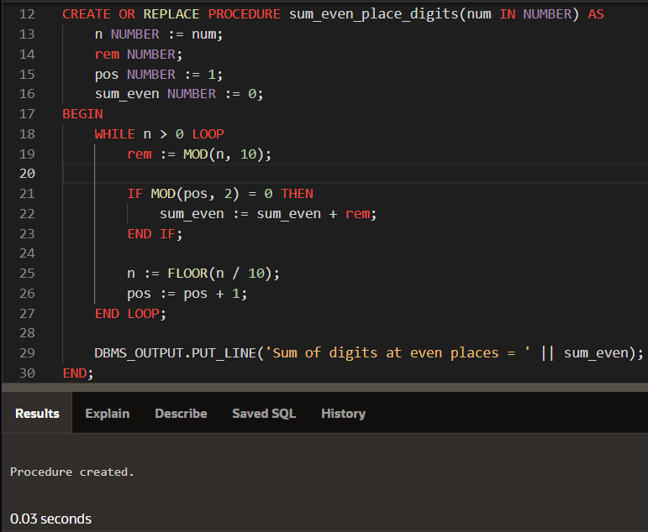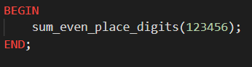
3# Write a PL/SQL stored procedure to count prime and composite numbers entered by the user.
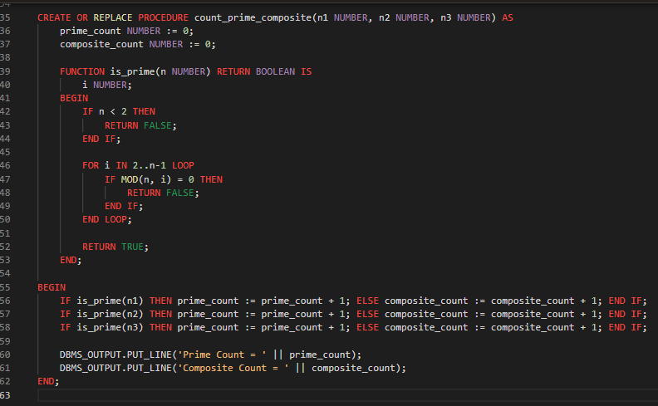
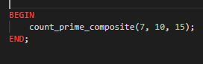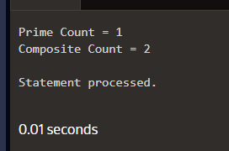

4# Write a PL-SQL function to compare three numbers entered through users and display them in ascending and descending orders.
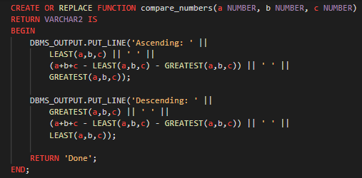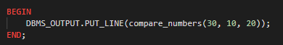
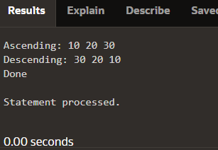

5# Write a PL/SQL function that performs simple arithmetic like Addition, Subtraction, Multiplication & Division of input numbers
