WEEK-1

1# Write a report of steps for installation of My SQL.
MySQL is one of the most popular open-source relational database management systems. This report outlines the standardized steps for installing the MySQL Community Server on a Windows environment, following the structure of an Oracle XE installation.

Step 1: Before installing MySQL on Windows, you will need to dowload it. Go to http://dev.mysql.com/downloads/ and select DOWNLOAD under MySQL Community Server (GPL)
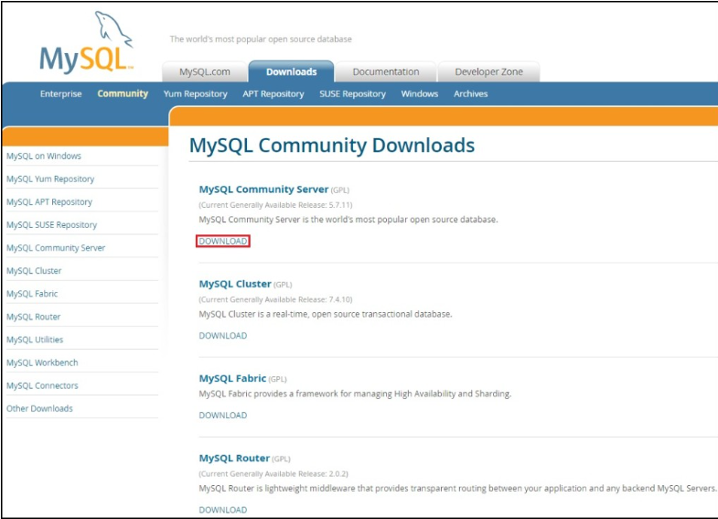
Step 2: Choose Windows as the platform and download the installer:
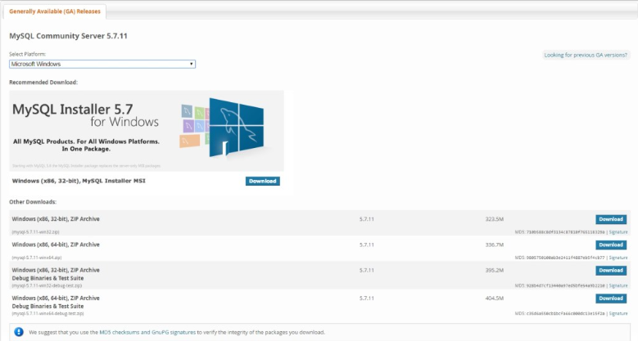
Step 3: If prompted for the login, log in with your account or create a new one. After the download finishes, start the installer. Accept the license agreement and click Next:
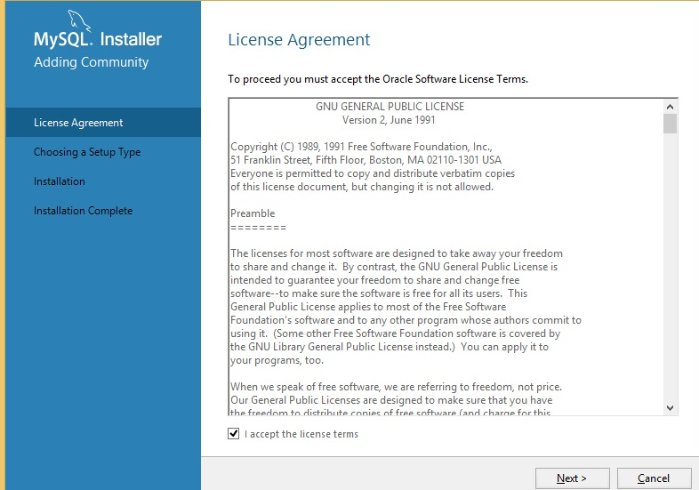
Step 4: Choose the setup type and click Next:
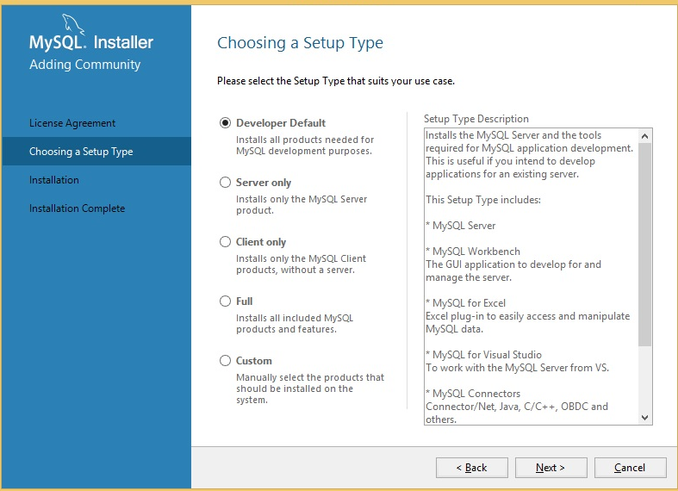

Step 5: Click Execute to install the components:
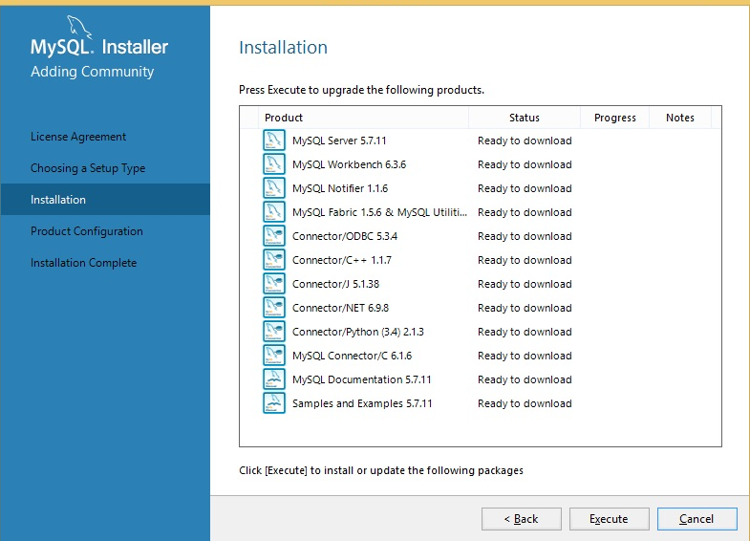
Step 6: Next, the wizard will guide you through the product configuration:
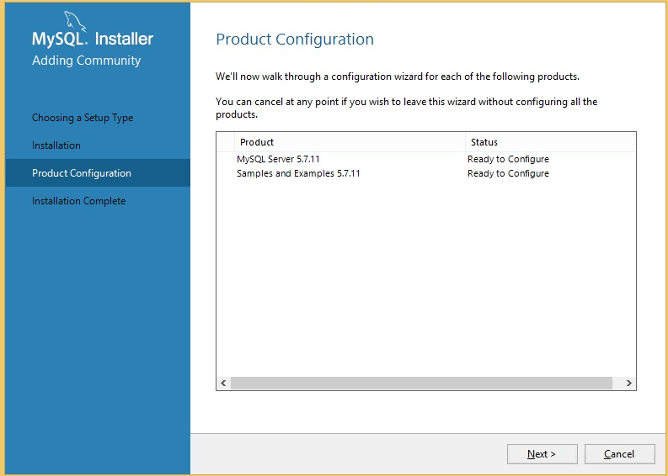

Step 7: Choose your network settings of leave the defaults:
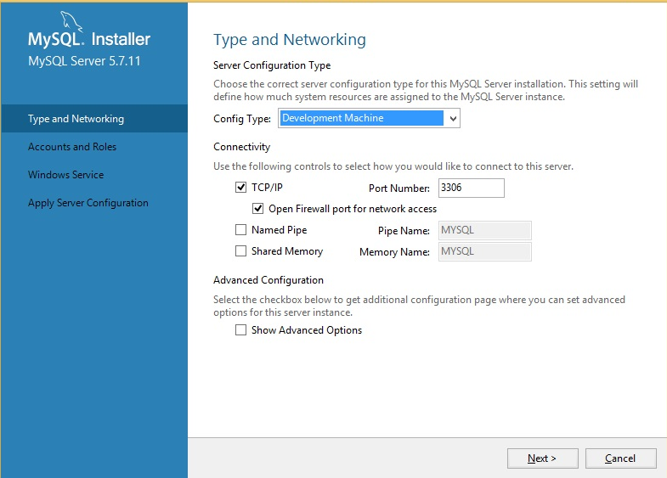
Step 8: Next, you will be prompted to choose the root password:
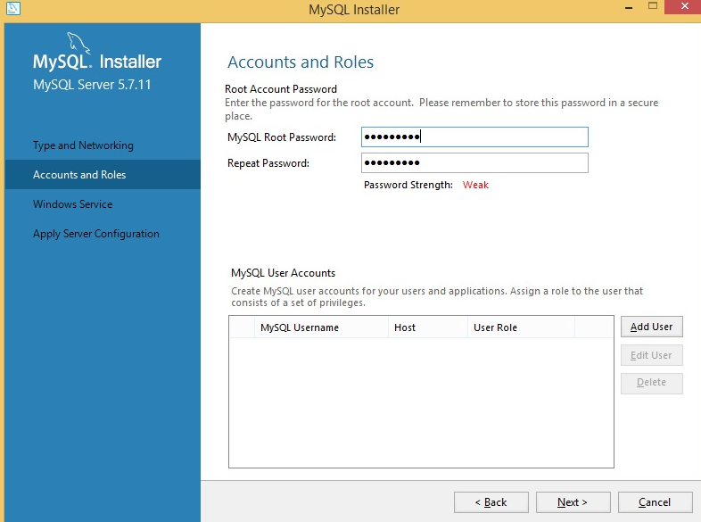

Step 9 : Next, choose the name for the MySQL Windows service
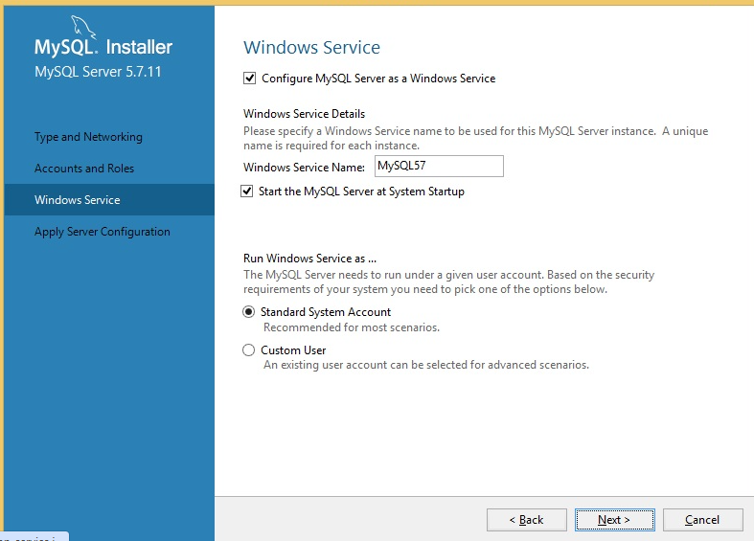
Step 10 : Click Execute to apply the changes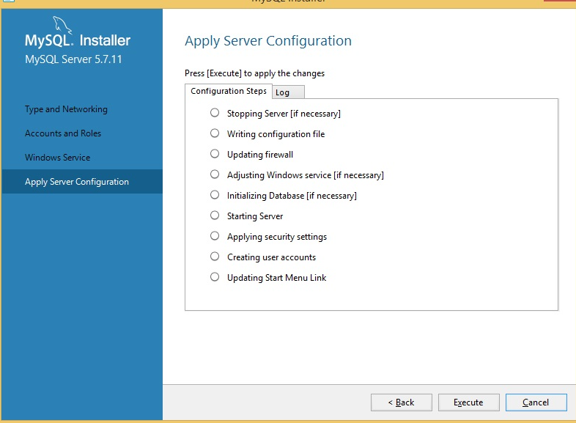
And that’s it! MySQL should be installed.

