WEEK 3
#1 Burst Time Average: Input burst times for n processes and calculate total and average burst time.
#include <stdio.h>
int main() {
int n;
float temp, sum=0, average;
printf("Enter number of processes: ");
if(scanf("%d",&n)!=1 || n < 0) {
printf("Invalid number of processes.");
return 1;
}
printf("Enter Burst time for the processes:\n");
for(int i=1; i<=n; i++) {
if(scanf("%f",&temp)!=1 || temp < 0) {
printf("Invalid Burst time!");
return 1;
}
sum+=temp;
}
average = sum/n;
printf("Sum of burst time: %.2f\n",sum);
printf("Average of burst time: %.2f\n",average);
return 0;
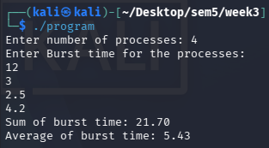
}

#2 Shortest Process Finder: Find and display the process with the shortest burst time.
#include <stdio.h>
int main() {
int n, shortest=0;
float a[n];
printf("Enter number of processes: ");
if(scanf("%d",&n)!=1 || n < 0) {
printf("Invalid number of processes.");
return 1;
}
printf("Enter Burst time for the processes:\n");
for(int i=0; i<n; i++) {
if(scanf("%f",&a[i])!=1 || a[i] < 0) {
printf("Invalid Burst time!");
return 1;
}
if(a[i]<a[shortest]) shortest = i;
}
printf("Shortest Burst time: %.2f\n", a[shortest]);
return 0;
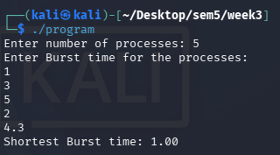
}

#3 Sort by Arrival Time: Sort processes based on arrival times in ascending order.
#include <stdio.h>
struct process {
int id;
float arrival;
};
int main() {
int n, i, j;
struct process p[100], temp;
printf("Enter number of processes: ");
if(scanf("%d",&n)!=1 || n < 0) {
printf("Invalid number of processes.");
return 1;
}
printf("Enter arrival time for the processes:\n");
for(i=0; i<n; i++) {
p[i].id = i+1;
printf("P%d: ",p[i].id);
if(scanf("%f", &p[i].arrival)!=1 || p[i].arrival < 0) {
printf("Invalid arrival time!");
return 1;
}
}
for(i=0; i< n-1; i++) {
for(int j=0; j<n-i-1; j++){
if(p[j].arrival>p[j+1].arrival) {
temp=p[j];
p[j]=p[j+1];
p[j+1]=temp;
}
}
}
printf("Processes in ascending order of arrival time:\n");
for(i=0; i<n; i++) {
printf("P%d : %.2f \n",p[i].id,p[i].arrival);
}
return 0;
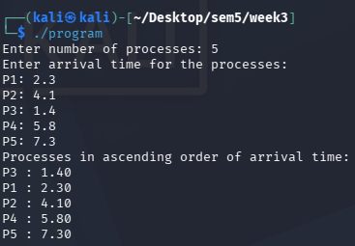
}

#4 Ready Queue Simulation: Input process names and store them in a ready queue.
#include <stdio.h>
int main()
{
int n, i;
char queue[100][20];
printf("Enter number of processes: ");
scanf("%d", &n);
printf("Enter process names:\n");
for (i = 0; i < n; i++)
{
printf("Process %d: ", i + 1);
scanf("%19s", queue[i]);
}
printf("\nReady Queue:\n");
for (i = 0; i < n; i++)
printf("%d. %s\n", i + 1, queue[i]);
return 0;



