WEEK 2
#1 CPU Utilization: Calculate CPU utilization given busy_time and idle_time.
#include <stdio.h>
int main() {
float busy_time, idle_time, utilization;
printf("Enter busy time: ");
if(scanf("%f", &busy_time)!=1 || busy_time<0) {
printf("Invalid busy time!\n");
return 1;
}
printf("Enter idle time: ");
if(scanf("%f", &idle_time)!=1 || idle_time<0) {
printf("Invalid idle time!\n");
return 1;
}
double total_time = busy_time + idle_time;
if(total_time==0) {
printf("CPU Utilization is undefined because total time is zero.\n");
return 1;
}
utilization = (busy_time / total_time) * 100;
printf("CPU Utilization = %.2f%%\n", utilization);
return 0;
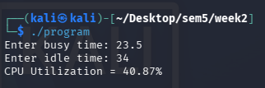
}

#2 Priority Selection: Input priorities of 5 processes (1=High, 2=Medium, 3=Low) and print which process runs first.
#include <stdio.h>
int main() {
int priority[5];
int i, highest = 0;

for (i = 0; i < 5; i++) {
printf("Enter priority of Process %d (1=High, 2=Medium, 3=Low): ",
i + 1);
scanf("%d", &priority[i]);
}
if(priority[i]!=1 || priority[i]!=2 || priority[i]!=3) {
printf("Invalid priority! Please enter 1=High, 2=Medium or 3=Low.\n");
return 1;
}
for (i = 1; i < 5; i++) {
if (priority[i] < priority[highest])
highest = i;
}
printf("\nProcess %d will run first.\n", highest + 1);
printf("Priority = %d\n", priority[highest]);
return 0;
}
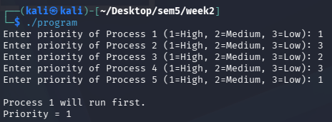
#3 Throughput Calculation: Given n processes and total time, calculate throughput (processes/time).
#include <stdio.h>
int main() {
int processes;
float total_time, throughput;
printf("Enter number of processes: ");
if(scanf("%d", &processes)!=1 || processes<0) {
printf("Invalid number of processes.\n");
return 1;
}
printf("Enter total time: ");
if(scanf("%f", &total_time)!=1 || total_time<=0) {
printf("Invalid total time.\n");
return 1;
}

throughput = processes / total_time;
printf("Throughput = %.2f processes/unit time\n", throughput);
return 0;
}
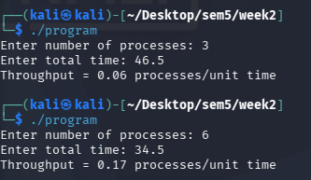
#4 Ready Queue Order: Take process names as input and display them in the order they will execute (manual ready queue).
#include <stdio.h>
int main() {
int n, i;
char process[50][20];
printf("Enter number of processes: ");
scanf("%d", &n);
for (i = 0; i < n; i++) {
printf("Enter process %d name: ", i + 1);
scanf("%19s", process[i]);
}
printf("\nReady Queue / Execution Order:\n");
for (i = 0; i < n; i++) {
printf("%s", process[i]);
if (i < n - 1)
printf(" -> ");
}
printf("\n");
return 0;



