WEEK 1
#1 CPU Time Conversion: Convert CPU burst time (seconds) into HH:MM:SS.
#include <stdio.h>
int main(){
int total_seconds, hours, minutes, seconds;
printf("Enter CPU burst time in seconds: ");

if(scanf("%d",&total_seconds)!=1 || total_seconds<0) {
printf("Invalid Time.\n");
return 1;
}
hours = total_seconds/3600;
minutes = (total_seconds%3600)/60;
seconds = total_seconds%60;
printf("Total time in HH:MM:SS is %02d:%02d:%02d\n", hours,minutes,seconds);
return 0;
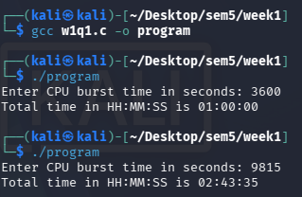
}

#2 Process Type Identification: Input a process ID and print 'System Process' if PID is even, else ‘User Process’.
#include <stdio.h>
int main() {
int pid;
printf("Enter PID: ");
if(scanf("%d",&pid)!=1 || pid<0) {
printf("Invalid PID.\n");
}
else {
if(pid%2==0) printf("System Process\n");
else printf("User Process\n");
}
return 0;
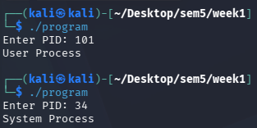
}

#3 Context Switch Overhead: Given total processes and context switch time, calculate total overhead.
#include <stdio.h>
int main() {
int total_processes;
float context_switch_time, total_overhead;
printf("Enter total processes: ");
scanf("%d",&total_processes);

printf("Enter context switch time (in ms): ");
scanf("%f",&context_switch_time);

if(total_processes>1) {
total_overhead = (total_processes-1) * context_switch_time;
printf("Total Overhead : %.2f\n",total_overhead);
}
else if(total_processes==1) {
printf("Total Overhead : 0.0 ms\n");
}
else printf("Invalid number of processes.\n");
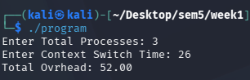
}

#4 Resource Distribution: Given total printers and users, calculate how many printers each user can get equally.

#include <stdio.h>
int main() {
int printers, users;
printf("Enter number of printers: ");
if(scanf("%d",&printers)!=1 || printers<0) {
printf("Invalid number of printers.\n");
return 1;
}
printf("Enter number of users: ");
if(scanf("%d",&users)!=1 || users<0) {
printf("Invalid number of users.\n");
return 1;
}
if(printers<users) {
printf("User per printer: %d\n", users/printers);
printf("Remaining users: %d\n", users%printers);
printf("Remaining users can use any printer.\n");
}
else {
printf("Printer per user: %d\n", printers/users);
printf("Remaining Printers: %d\n", printers%users);
}
return 0;
}
