WEEK 4
#1 Define Process Structure: Create a structure Process with pid, arrival_time, burst_time.
#include <stdio.h>
struct Process {
int pid;
double arrival_time;
double burst_time;
};
int main() {
struct Process p1;
printf("Enter Process ID :");
if(scanf("%d",&p1.pid)!=1||p1.pid<=0){
printf("Invalid Input!!");
return 1;
}
printf("Enter Arrival Time :");
if(scanf("%lf",&p1.arrival_time)!=1||p1.arrival_time<=0){
printf("Invalid Input!!");
return 1;
}
printf("Enter Burst_time :");
if(scanf("%lf",&p1.burst_time)!=1||p1.burst_time<=0){
printf("Invalid Input!!");
return 1;
}
printf("Process ID: %d\n", p1.pid);
printf("Arrival Time: %.2lf\n", p1.arrival_time);
printf("Burst Time: %.2lf\n", p1.burst_time);
return 0;
}
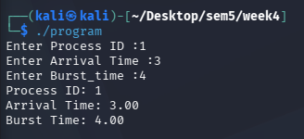
#2 Input & Display Processes: Write functions to input and display processes.
#include <stdio.h>
#define MAX 100
struct Process {
int pid;
double arrival_time;
double burst_time;
};
void inputProcesses(struct Process proc[], int n) {
for (int i = 0; i < n; i++) {
proc[i].pid = i + 1;
printf("Enter Arrival Time for Process %d: ", proc[i].pid);
scanf("%lf", &proc[i].arrival_time);
printf("Enter Burst Time for Process %d: ", proc[i].pid);
scanf("%lf", &proc[i].burst_time);
}
}
void displayProcesses(struct Process proc[], int n) {
printf("\nPID\tArrival Time\tBurst Time\n");
for (int i = 0; i < n; i++) {
printf("%d\t%.2lf\t\t%.2lf\n", proc[i].pid, proc[i].arrival_time, proc[i].burst_time);
}
}
int main() {
int n;
struct Process proc[MAX];
printf("Enter number of processes: ");
scanf("%d", &n);
inputProcesses(proc, n);
displayProcesses(proc, n);
return 0;
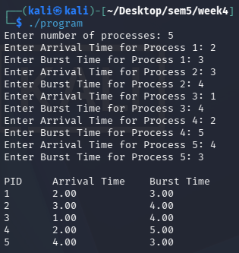
}
#3 Completion Time Calculation: Calculate completion_time = arrival_time + burst_time for each process.
#include <stdio.h
#define MAX 100
// 1. Define Process Structure
struct Process {
int pid;
double arrival_time;
double burst_time;
double completion_time;
};
void calculateCompletionTime(struct Process proc[], int n) {
for (int i = 0; i < n; i++) {
proc[i].completion_time = proc[i].arrival_time + proc[i].burst_time;
}
}
void inputProcesses(struct Process proc[], int n) {
for (int i = 0; i < n; i++) {
proc[i].pid = i + 1;
printf("\n--- Process %d ---\n", proc[i].pid);
printf("Enter Arrival Time: ");
scanf("%lf", &proc[i].arrival_time);
printf("Enter Burst Time: ");
scanf("%lf", &proc[i].burst_time);
}
}
void displayProcesses(struct Process proc[], int n) {
printf("\n----------------------------------------------------\n");
printf("PID\tArrival Time\tBurst Time\tCompletion Time\n");
printf("----------------------------------------------------\n");
for (int i = 0; i < n; i++) {
printf("%d\t%.2lf\t\t%.2lf\t\t%.2lf\n",
proc[i].pid,
proc[i].arrival_time,
proc[i].burst_time,
proc[i].completion_time);
}
printf("----------------------------------------------------\n");
}
int main() {
int n;
struct Process proc[MAX];
printf("Enter number of processes: ");
scanf("%d", &n);
inputProcesses(proc, n);
calculateCompletionTime(proc, n);
displayProcesses(proc, n);
return 0;
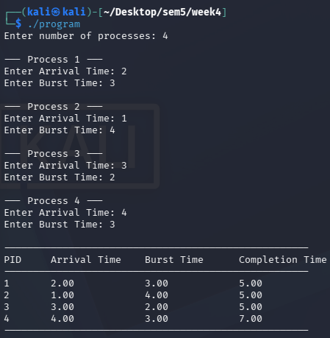
}

#4 Next Process Selection (SJN): Find the process with the shortest burst time from the ready queue.
#include <stdio.h>
struct Process{
int pid;
double arrival_time;
double burst_time;
};
int main(void) {
int n;
printf("Enter number of processes: ");
scanf("%d",&n);
struct Process processes[n];

for (int i = 0; i < n; i++) {
printf("\nEnter details for Process %d\n", i + 1);
printf("PID: ");
scanf("%d",&processes[i].pid);
printf("Arrival Time: ");
scanf("%lf",&processes[i].arrival_time);
printf("Burst Time: ");
scanf("%lf",&processes[i].burst_time);
}
int shortest = 0;
for (int i = 1; i < n; i++) {
if (processes[i].burst_time < processes[shortest].burst_time) {
shortest = i;
}
}
printf("\nShortest Job Next:\n")
printf("PID: %d\n", processes[shortest].pid);
printf("Arrival Time: %.2lf\n", processes[shortest].arrival_time);
printf("Burst Time: %.2lf\n", processes[shortest].burst_time);
return 0;



