**Group 6**

Members: Ayush Chakraborty, Saurav Sathish Nair, Gauthami A

**ML model: Phone price prediction system**

**Problem Statement:**

The task involves predicting the price range of phones using classification based on their specifications. Key features such as dual SIM support, network type, battery power, RAM, storage, and camera quality are used as input variables. By training a machine learning model on a dataset containing these features and corresponding price categories, the model learns to classify new phones into predefined price ranges (e.g., low, medium, high). This process includes data preparation, model selection, training, evaluation, and deployment, enabling quick estimation of a phone's market value based on its specifications.

**Azure AI : Automated ML**

**1)** Where we decide the type of testing (classification) and choose the target column.

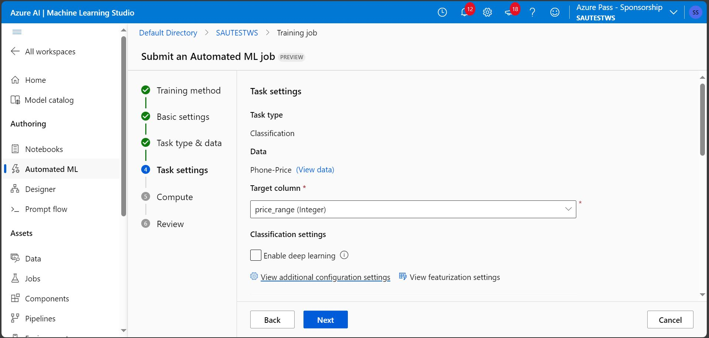

**2)** Primary metric selection involves choosing a key performance indicator to evaluate and explain the best model. This metric helps identify which model performs optimally based on specific criteria, such as accuracy, precision, recall, or F1 score, depending on the problem's requirements.

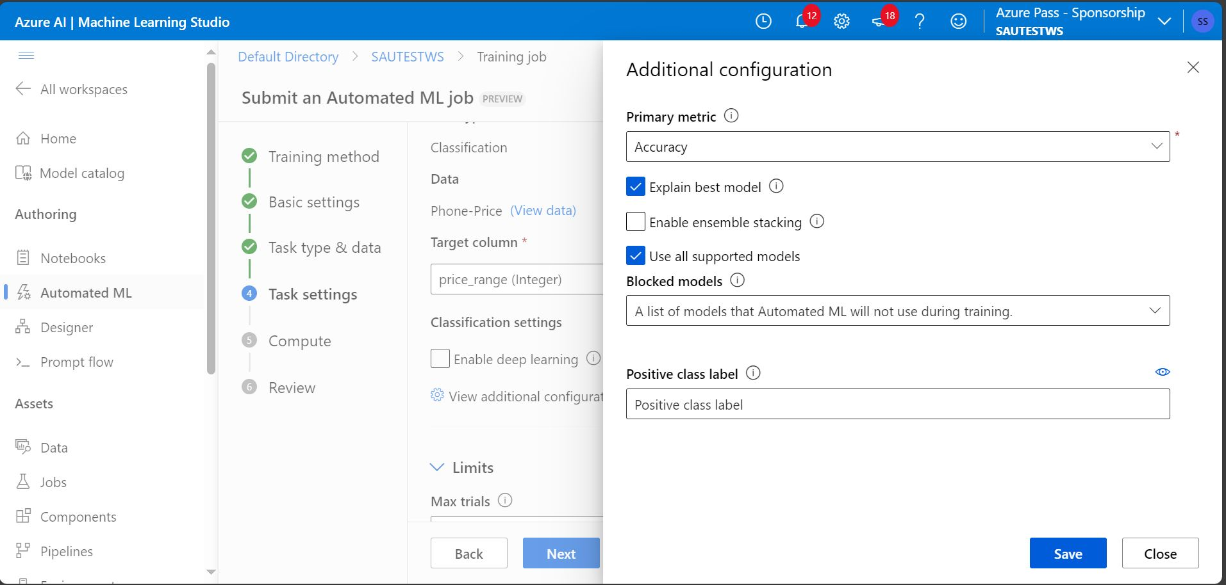

3) Set limits for trials, define a metric score threshold, and specify an experiment timeout.

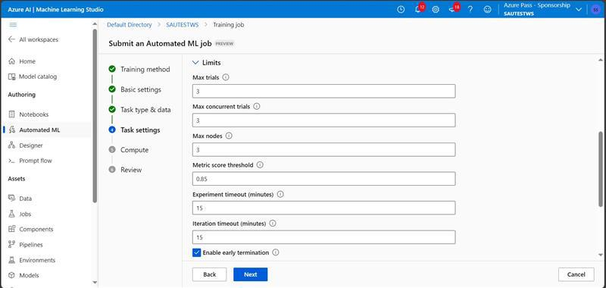

4) Training-Testing split

5) The Best Model Summary provides an overview of the algorithm name, accuracy, Sampling etc

6)

7) Metrics Details accuracy= TP+TN/FP+FN+TP+TN, where

TP=true positive

TN= True negative

FP= False Positives

FN= False Negative

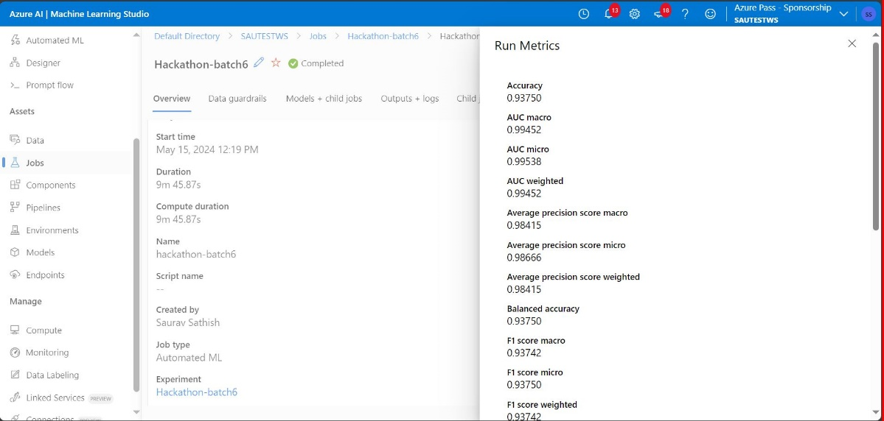

8)

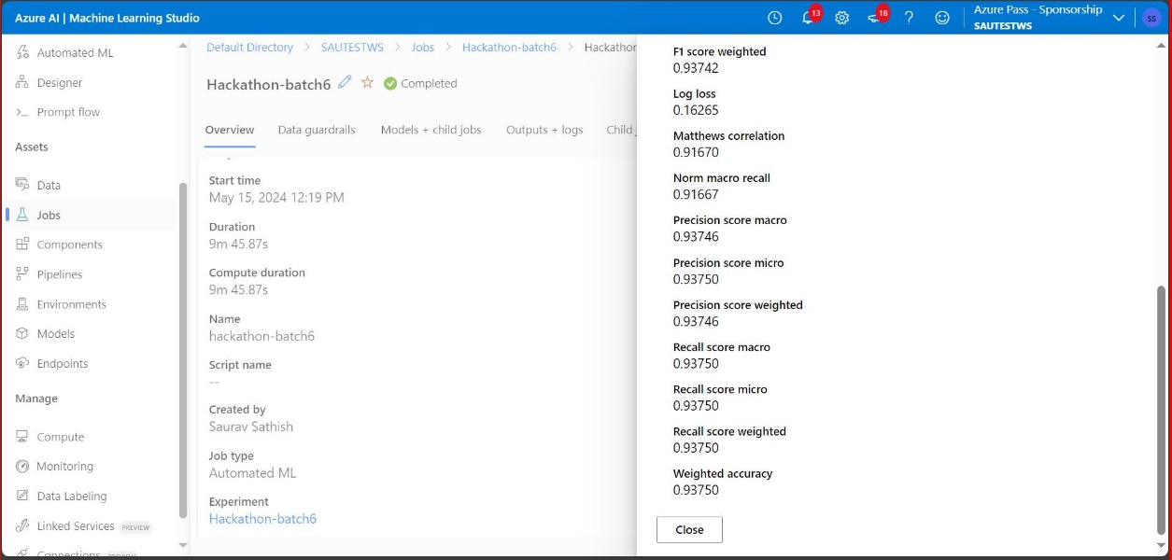

9) Blocked Models

10)The model was deployed using web services.

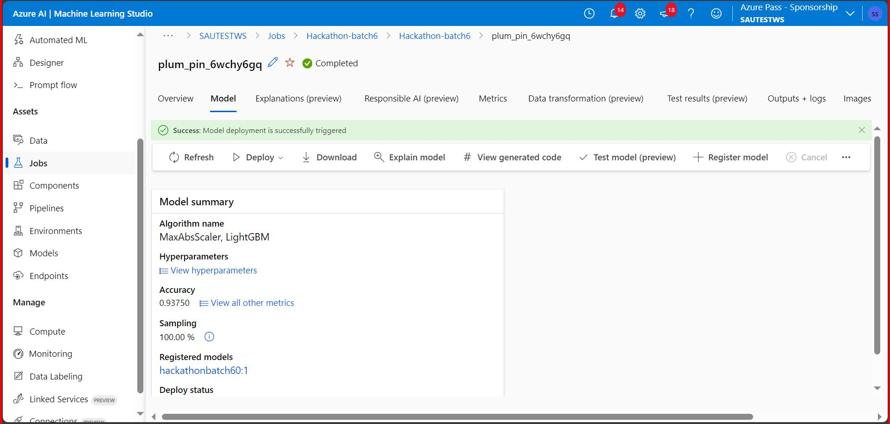

11) Result: 3

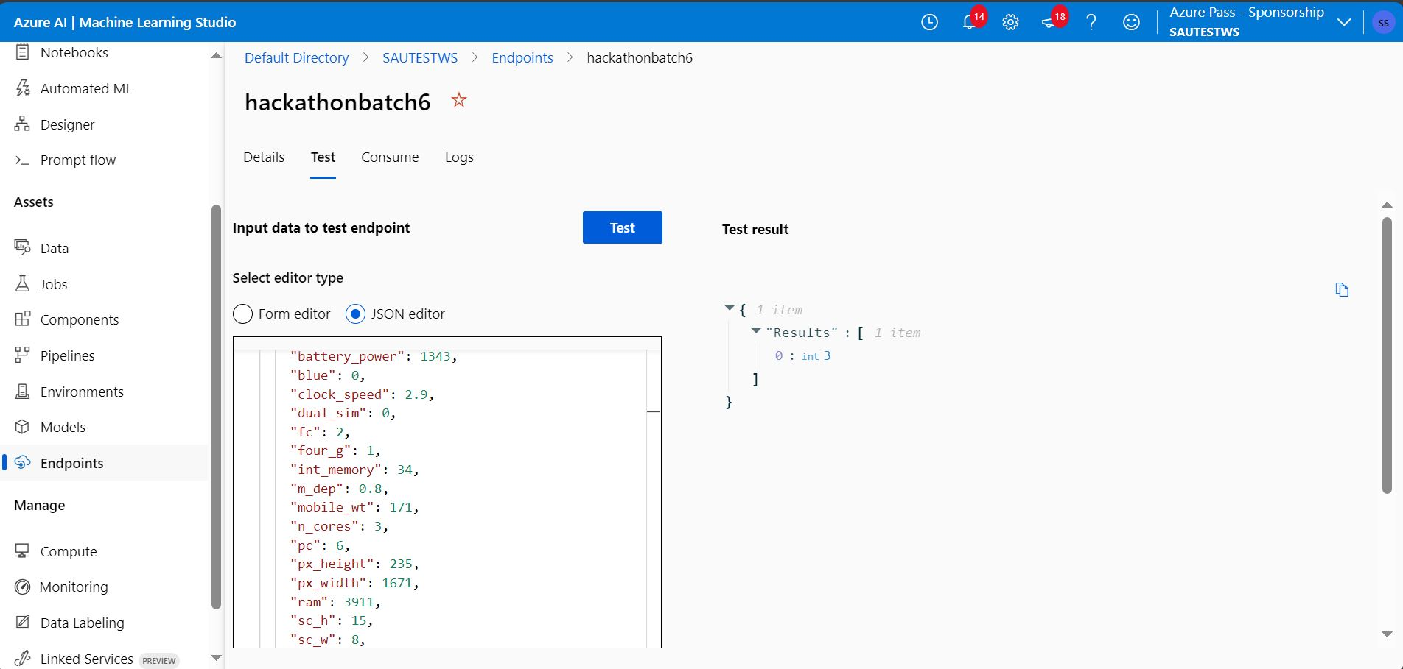

**VS Code:**

**1). Dataset**

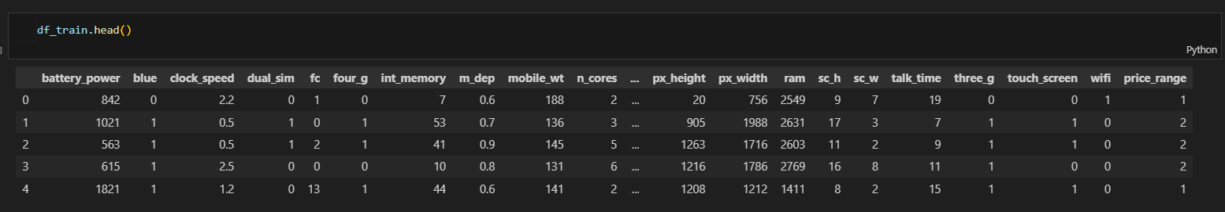

These are the models that has been used to train and test the model using the dataset.

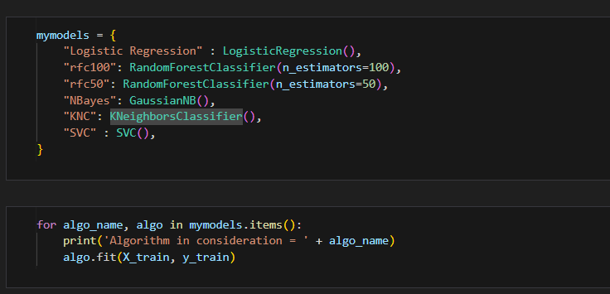

These are the classification report for all the model that has been used for model training.

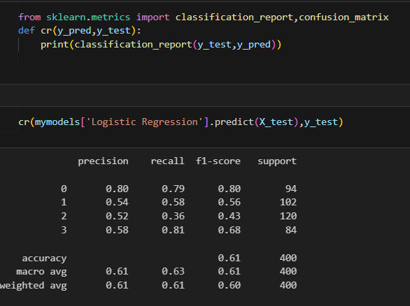

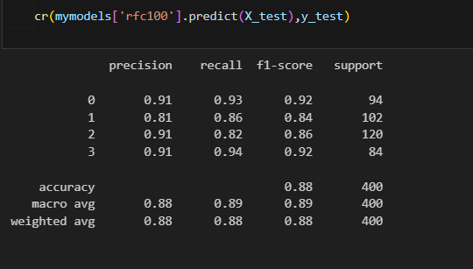

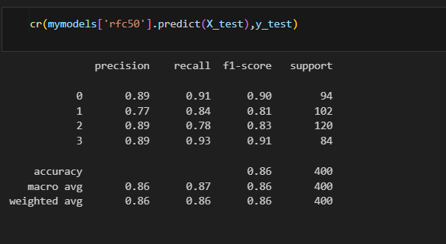

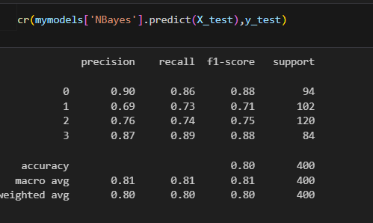

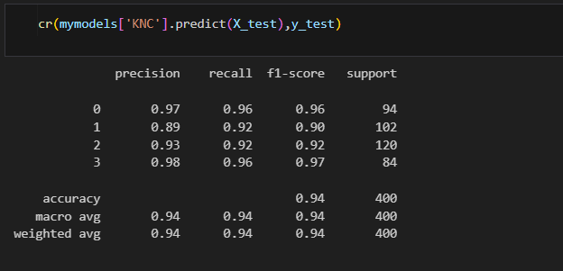

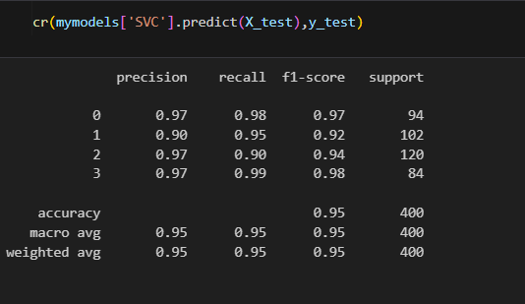

Conclusion: Upon comparison the best result for all the metrics is given by Support Vector Machine.

This is the confusion matrix given by the model.

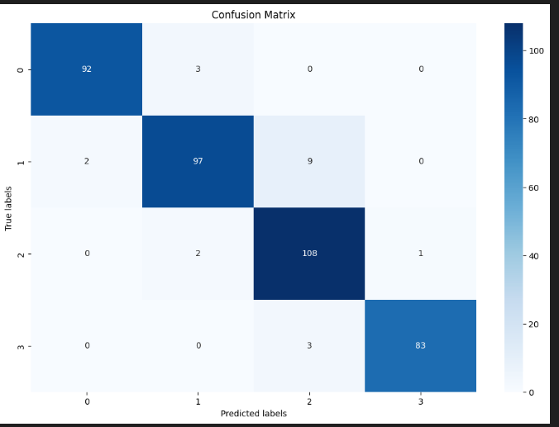

**Summary:**

We have also populated the price range for the testing data set given by the model.

**Challenge 2 :** Computer Vision

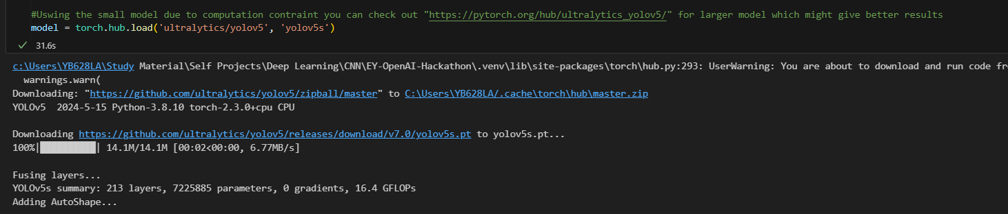

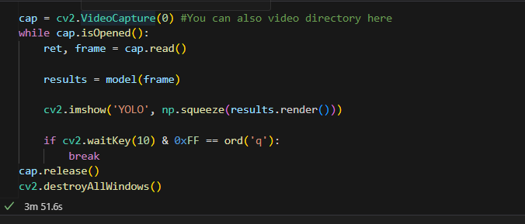

We have used YOLO V5 by ultraletics, which uses the classes to identify the objects in an image provided by coco classes. This code can take a video and classify objects in the video even though the objects are overlapping each other , which is the biggest advantage of YOLO algorithm over any other algorithm.

**Output:**

