Test doc 1
Some text
new line
New para
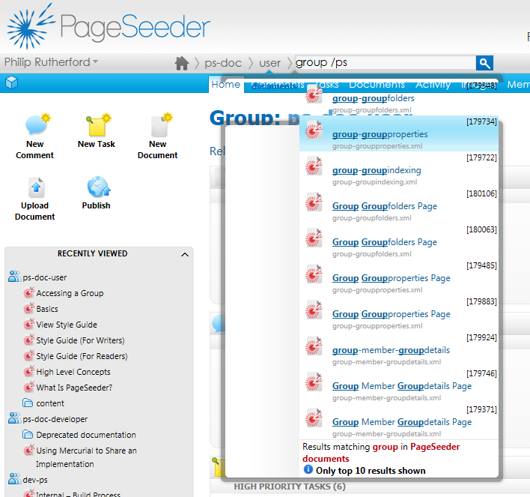
Another heading 2 2
Another heading 2 2
Heading 3 2
Test 4 2

Another heading 2
- List 1
  - List 2
- List 3
- List 4

Another heading 2
With a table
new line
New para
Header | a | b | c | d
1 | 2 | 3 | 4 | 5
11
111
1111 |  |  |  | 5555

Heading 3

Test 4
            - para

