Test doc 1

Some text  
new line

New para

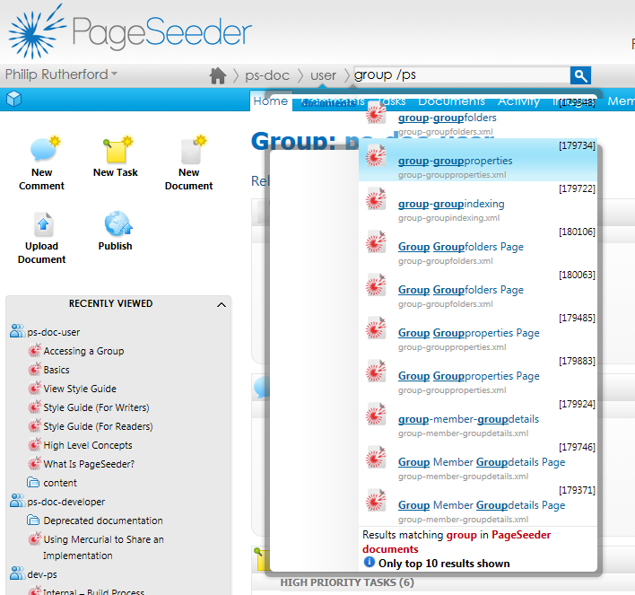

Another heading 2

1. List 1
   1. List 2
2. List 3
3. List 4

Another heading 2

With a table  
new line

New para

| Header | a | b | c | d |
| --- | --- | --- | --- | --- |
| 1 | 2 | 3 | 4 | 5 |
| 11 |  |  |  |  |
| 111 |  |  |  |  |
| 1111 |  |  |  | 5555 |

Heading 3

Test 4

para