# Test bookmarks 1

Test [link5](https://pageseeder.com/test#test5) and [link25](https://pageseeder.com/test#test5) with fragment.

Some text

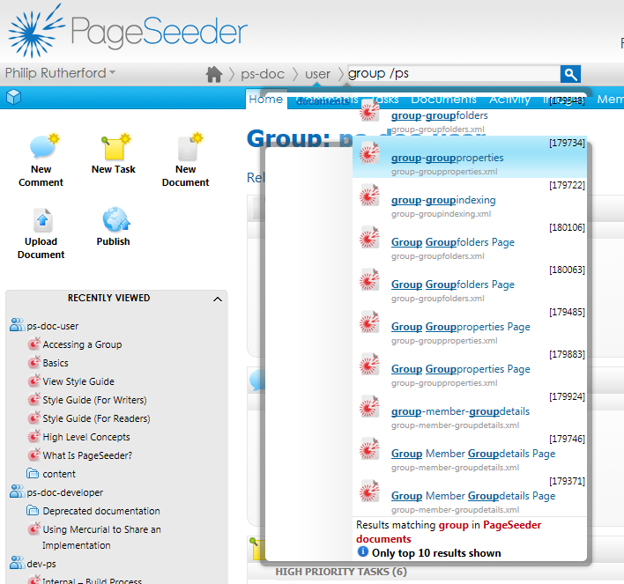

## My heading 2A-

1. List 1
   1. List 2
2. List 3
3. List 4

Another para 2A1

### My heading 3AA

Another para 2A2

Another para 2A3

1. List 2A4

## My heading 2B

With a table

|  |  |  |  |  |
| --- | --- | --- | --- | --- |
| Header | a | b | c | d |
| 1 | 2 | 3 | 4 | 5 |
| 11 |  |  |  |  |
| 111 |  |  |  |  |
| 1111 |  |  |  | 5555 |

## My heading 2C

Some text

Reference to 0

Link to top

Link to heading 2B

### My heading 3CA

Link to 2A

Link to 2A1

Link to 2A2

Link to 2A3

Link to 2A4

Link to heading 2C

Link to heading 3CA