Test Case 7

Basic Word document without configuration.

Test of images.

Image with caption:

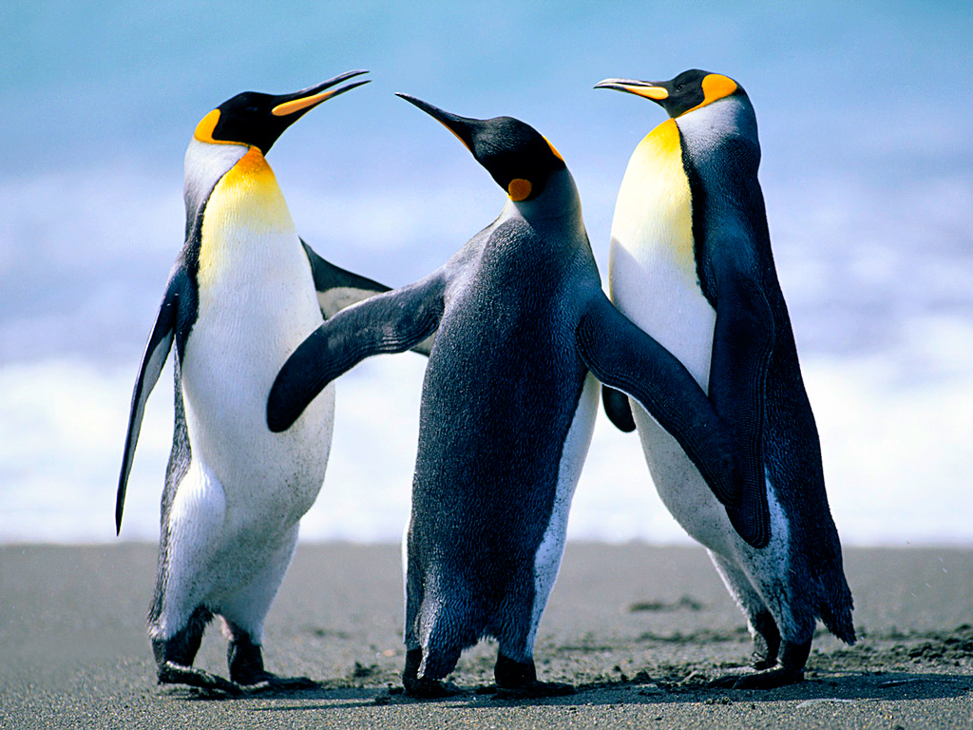

Figure Caption

Image without caption:

