OBJECTIVES

General
The study’s primary objective is to develop a low-cost, threshold-based adaptive failover routing system for a messaging system that integrates a MANET of local IoT/mobile devices with a wifi router to simulate a LEO-satellite path to maintain emergency communications during terrestrial wireless infrastructure failure.

Specific
This section lists the specific objectives to be achieved through the design and development of the project

Hardware
This section lists the specific objectives to be achieved through the design and development of hardware components for the project.
- MANET Node
  - Objective: Design a low-cost MANET node capable of establishing peer-to-peer messaging wireless connectivity for emergency communication.
  - Hardware Parameters:
 ESP32
SX1278 LoRa Module Ra-02 433MHZ
  - Expected Outcome: Each node can autonomously connect to neighbouring nodes to form a MANET with minimal setup.
- Gateway Device
  - Objective: Develop a gateway capable of bridging MANET networks and a wifi router simulating a LEO-satellite backhaul for adaptive failover.
  - Hardware Parameters:
SBC: Raspberry Pi 3b
Communication Interfaces:
Terrestrial: Wi-Fi or Ethernet for MANET integration Simulated Satellite: Wifi Router to simulate LEO satellite terminal

  - Expected Outcome: Gateway autonomously switches between terrestrial MANET and simulated satellite backhaul depending on link quality.

- Integrated Sensor and Monitoring Module
  - Objective: Provide real-time metrics for intelligent routing decisions.
  - Hardware Parameters / Metrics:
RSSI: Measured in dBm, threshold configurable (e.g., –78 dBm) SNR: Measured in dB
Hop Count: Number of nodes traversed per route Battery Level: Measured in percentage (%)
Gateway & Satellite Status: Online/offline detection
  - Expected Outcome: System continuously monitors network quality, allowing software to make autonomous routing and failover decisions.

Software
To develop:

- Adaptive Routing and Decision Logic
  - Implement a lightweight routing protocol, specifically AODV (Ad hoc On-Demand Distance Vector) with metric weighting based on RSSI, SNR, hop count, and battery level, to determine optimal routes for emergency communication.
  - Integrate automatic failover logic that triggers satellite backhaul routing when terrestrial MANET link quality drops below predefined thresholds (e.g., RSSI < – 78 dBm for 10 seconds).
  - Ensure delay-tolerant behaviour by buffering messages during satellite latency, mitigating packet loss, and preserving message order.
- Reliable Messaging Protocol
  - Develop a messaging protocol that guarantees high packet delivery reliability
(≥90%) under both normal MANET operation and during satellite failover.

  - Include mechanisms to handle high-latency satellite links (expected 500–700 ms), ensuring messages are queued and retransmitted as necessary without human intervention.
- Intelligent Link Monitoring and Decision Support
  - Continuously monitor real-time link metrics such as RSSI, SNR, hop count, battery levels, gateway proximity, and satellite link status.
  - Make autonomous routing decisions based on these metrics, ensuring minimal communication disruption during network degradation or outages.

VALIDATION

TEST CAMPAIGN | SETUP | PROCEDURE | MEASURED PARAMETERS | ACCEPTANCE CRITERIA
Baseline Operation (Normal Terrestrial Connectivity) | MANET nodes using LoRa/ESP32 modules powered by Li-ion batteries (≥70%). Gateway connected to terrestrial network via Wi-Fi/Ethernet while wifi router to LEO satellite link remains in standby. Nodes placed with stable inter-node signal strength (RSSI ≥ -78 dBm but not beyond -120 dBm). | 1. Power on MANET nodes and gateway.  2. Allow nodes to auto-discover and form MANET.  3. Transmit periodic text packets between nodes.  4. Monitor link status of all nodes after activation. | RSSI, SNR, hop count, packet delivery rate, end-to-end latency. | Packet delivery rate ≥95%. Satellite backhaul remains inactive throughout the test. MANET must form autonomously within 30 seconds of startup.
Network Degradation Detection | Same configuration as baseline test. Signal degradation introduced by increasing node distance (150–200 ft) or using RF attenuation to reduce signal strength. | 1. Gradually degrade signal quality between nodes.  2. Continue until RSSI falls below -78 dBm for 10 seconds.  3. Observe system logs and routing behavior. | RSSI trends over time, degradation detection time, routing path changes. | RSSI must drop below -78 dBm to simulate degradation. Total loss of terrestrial/cellular signal acts as the failover trigger.
Failover Activation to Satellite Backhaul | MANET operational while gateway is connected to a wifi router simulating a LEO satellite terminal. Terrestrial connection intentionally disabled or degraded to force failover activation. | 1. Nodes detect terrestrial connectivity failure and enter emergency mode.  2. Node closest to satellite gateway acts as relay node.  3. Establish wifi router-MANET link configuration. | Failover trigger time node disconnection status gateway backhaul status. | All 6/6 MANET nodes must detect disconnection before the wifi router that simulates of the LEO satellite backhaul activates. Failover trigger time set to 10 seconds.
Sustained Emergency Operation | Full system deployed with battery-powered nodes and operational gateway. Controlled degradation events introduced to simulate emergencies. | System runs continuously for 24 hours, transitioning between normal operation, degraded MANET state, and satellite failover. Logs collected for system health and routing performance. | System uptime, battery levels, routing stability, metric monitoring continuity. | System must maintain ≥80% uptime over 24 hours. Adaptive routing must remain operational with no crashes, deadlocks, or unrecoverable failures.
Recovery and Reversion to Router Network | System initially operating in wifi routing mode. Router connectivity restored with RSSI ≥ -78 dBm. | 1. Restore wifi connectivity.  2. Maintain RSSI above threshold for 10 seconds.  3. Observe routing transition back to wifi network. | Recovery detection time, route switching time, packet loss during recovery. | System must automatically revert to wifi routing, deactivate wifi backhaul, and complete switching within 5 seconds with no message loss.

Diagram

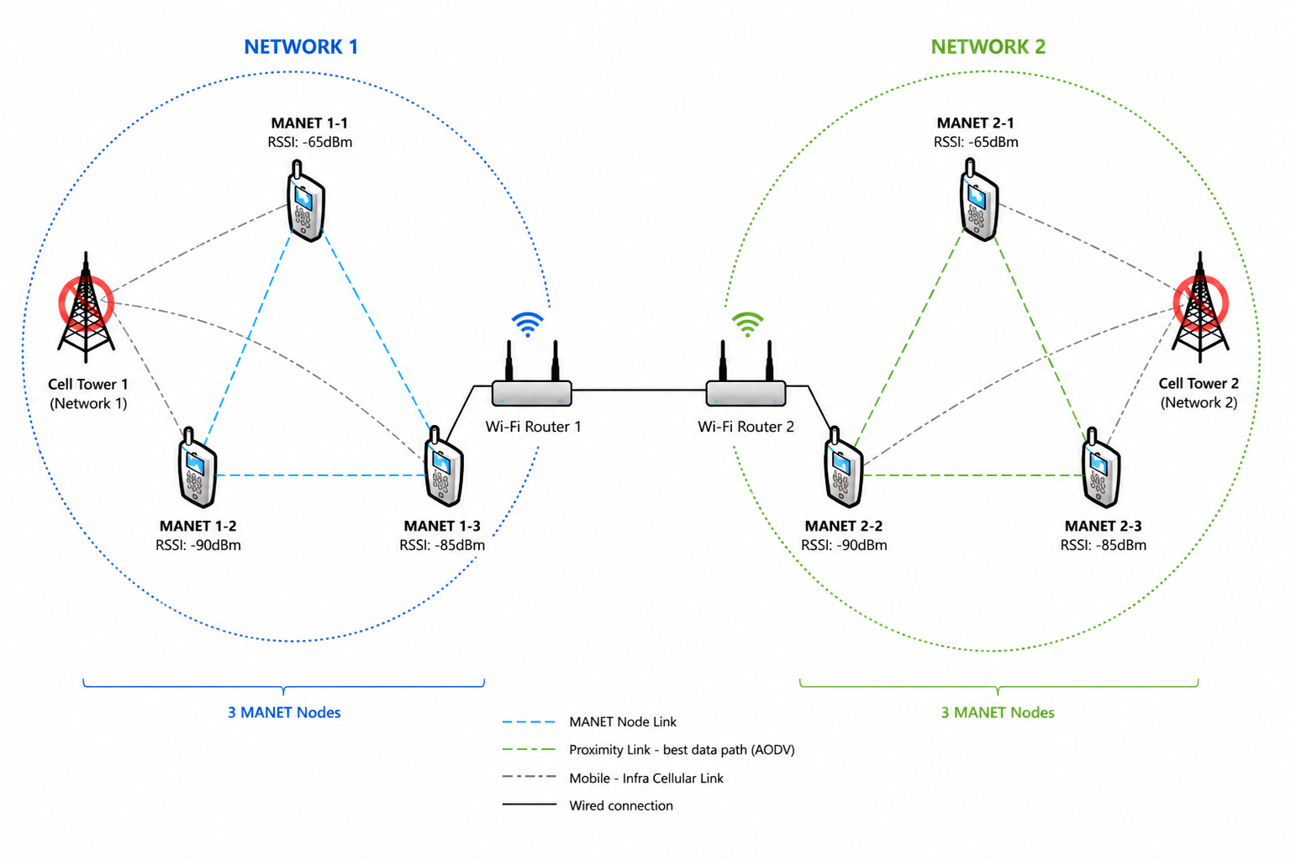

SCOPE AND DELIMITATION
This study aims to focus on the following:

- Development of a prototype user terminal capable of forming peer-to-peer MANET links and automatically switching to a wifi router simulating a LEO satellite–based backhaul during link degradation or outage conditions.
- Implementation of link-quality monitoring and adaptive routing mechanisms using parameters such as RSSI, SNR, hop count, node battery level, gateway or satellite availability, and satellite link status to determine when failover should occur.
- Performance evaluation such as RSSI, SNR, latency, connectivity stability, packet-delivery success rate, failover switching time, and overall system uptime.
- Design of dual-interface communication hardware consisting of a MANET-enabled node using commodity wireless components and a Rpi 3B gateway module capable of connecting to a wifi router simulating a LEO satellite terminal during failover operation.
- Development of lightweight control logic and firmware that autonomously detects terrestrial link failure and initiates satellite failover without requiring human intervention.

