PUP MANET Emergency Messaging System
System Architecture Document
Version 1.0-working-base | June 19, 2026

1. System Overview
The PUP MANET (Mobile Ad-Hoc Network) is an infrastructure-independent emergency messaging system built for disaster response scenarios. Android phones connect to local ESP32 nodes via Bluetooth SPP. ESP32 nodes form a mesh network using LoRa SX1278 transceivers. Two Raspberry Pi gateways bridge geographically separated meshes over Tailscale VPN, enabling cross-mesh communication.
Target users: First responders, firefighters, incident commanders, and support personnel operating in zones where cellular infrastructure is destroyed, congested, or unavailable.

2. System Topology
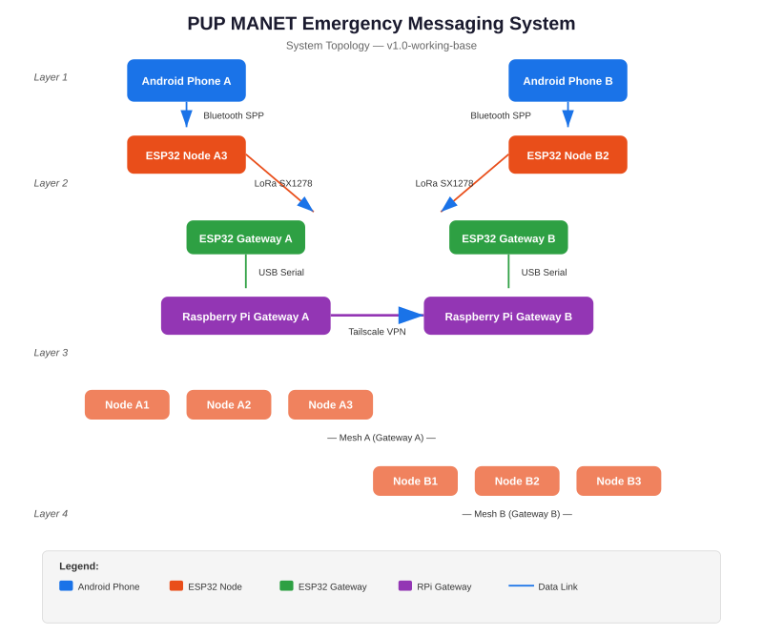

3. End-to-End Data Flow
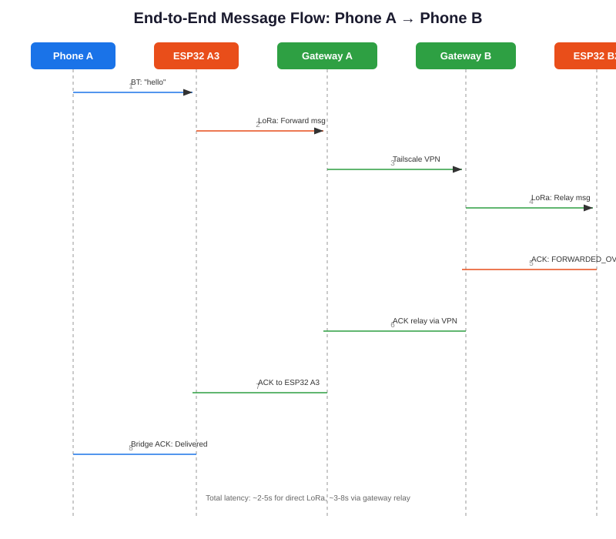

Message flow from Phone A to Phone B traverses four network strata: Bluetooth SPP (phone-to-ESP32), LoRa mesh (node-to-gateway), USB Serial (ESP32-to-RPi), and Tailscale VPN (gateway-to-gateway). Each segment adds 1-2 seconds of latency.

4. Component Breakdown

4.1 Android Application
Single-file Jetpack Compose architecture (MainActivity.kt, 5,435 lines). Five tabs: Chat (messaging with BT-filtered destination chips), Nodes (live node discovery and refresh), Route (path visualization), Bluetooth (connection management with PUP-MANET device filtering), and Logs (packet log + event log).
Key features: ACK delivery tracking with 25-second timeout, chatDestinations filter showing only BT-paired nodes, Broadcast mode for all-node messaging, NODE_LIST parser with BT flag extraction.

4.2 ESP32 Firmware
C++ firmware (main.cpp, 2,903 lines) for ESP32 + SX1278 LoRa modules. Two build configurations: node builds (LoRa + Bluetooth SPP) and gateway builds (LoRa only, USB serial bridge).
Key functions: HELLO broadcast every 10 seconds with Bluetooth client status, NODE_LIST response (semicolon-delimited format with BT flag), learnNodeFromHelloPacket with gatewayId extraction, processIncomingLoRaRelayPacket for cross-gateway relay, node table with 32-entry capacity and 60-second expiry.

4.3 Raspberry Pi Gateway
Python 3 service (gateway_service.py, 990 lines) bridging ESP32 USB serial to Tailscale VPN TCP tunnel. Gateway A runs in SERVER mode (listens on port 5050), Gateway B runs in CLIENT mode (connects to Gateway A).
Features: dual-tier buffer (ESP32 serial + network socket), store-and-forward queue with deduplication, health event parser, route state machine with failover, automatic reconnection on disconnect.

5. Protocol Specification
Packet Type | Format | Direction | Purpose
HELLO | BT1|HELLO-nodeId-timestamp|source|BROADCAST|{"gatewayId":"A","bluetooth":"true"}|... | LoRa Broadcast | Node presence + BT status
MESSAGE | BT1|MSG-packetId|source|destination|payload|ttl|hopCount|hopPath|relayPath | LoRa | User message delivery
NODE_LIST | type=NODE_LIST;localNode=XX;gateway=X;count=N;nodeId,gateway,STATUS,BT;... | BT from ESP32 | Node table export to phone
ACK | BT1|ACK-ackId|gateway|source|ackFor|FORWARDED_OVER_LORA|... | BT + LoRa | Delivery confirmation

6. ACK Delivery Pipeline
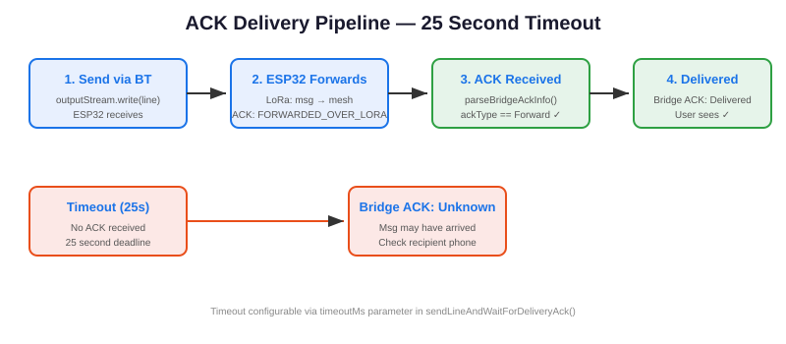

The ACK pipeline uses a 25-second timeout. When a message is sent: the ESP32 forwards it via LoRa and returns a FORWARDED_OVER_LORA ACK via Bluetooth. The app maps this to "Bridge ACK: Delivered" status. If no ACK arrives within 25 seconds, the message shows "Bridge ACK: Unknown" but may still have been delivered.

7. Node Discovery & Routing
Node Discovery: ESP32 broadcasts HELLO every 10 seconds with Bluetooth status. Receiving nodes learn from HELLO packets and store entries in the node table (max 32 entries, 60-second expiry). The Android phone requests NODE_LIST via Bluetooth and parses the semicolon-delimited response.
Message Routing: Messages follow the path Phone→ESP32→LoRa→Gateway→VPN→Gateway→LoRa→ESP32→Phone. Direct LoRa paths are preferred when available. The gateway store-and-forward mechanism buffers messages during network disruption and replays them on reconnection.

8. Bluetooth Status Propagation
Each ESP32 checks its Bluetooth client status every loop iteration. The HELLO broadcast includes a "bluetooth" field ("true" or "false" as a quoted string). The chatDestinations filter in the Android app shows only nodes with bluetoothConnected=true in the NODE_LIST response.

9. Deployment
Parameter | Value
Network devices | 8 (6 nodes + 2 gateways)
Max nodes | 50 (theoretical LoRa mesh limit)
Bluetooth range | ~10 meters
LoRa range | 100m-5km (line-of-sight dependent)
Max hop count | 8
ACK timeout | 25 seconds
HELLO interval | 10 seconds
Battery life | 18-45 hours (2.6Ah 18650, 80mA active)
Tailscale VPN IPs | Gateway A: 100.123.79.41, Gateway B: 100.79.214.18

10. Validation Status
Test Campaign | Result | Date
240 unit tests | PASS (240/240) | 2026-06-17
Failover test campaign | PASS (26/26) | 2026-06-17
Cross-mesh routing | PASS (A↔B) | 2026-06-19
ACK: Delivered rate | >90% on both phones | 2026-06-19
8-node discovery | PASS | 2026-06-19
Bluetooth status propagation | PASS (BT flag in NODE_LIST) | 2026-06-19

