PUP MANET — Code Reference
Version 1.0-working-base | June 19, 2026

1. System Overview
Component | Language | Lines | Platform
Android App | Kotlin (Jetpack Compose) | ~5,435 | Android 12+
ESP32 Firmware | C++ (Arduino/ESP-IDF) | ~2,903 | ESP32 + SX1278
RPi Gateway | Python 3 | ~990 | Raspberry Pi 3B

2. Android App Architecture
File: android-chat-app/app/src/main/java/ph/edu/pup/manetmessenger/MainActivity.kt (5,435 lines). Single-file Compose architecture with five tabs.

2.1 Key Data Structures
DiscoveredNode(nodeId, gatewayId, online, bluetoothConnected) — represents a MANET node. ChatMessage(id, text, sourceNode, targetNode, status, path, deliveryProgress) — represents a sent/received message.

2.2 ACK Pipeline
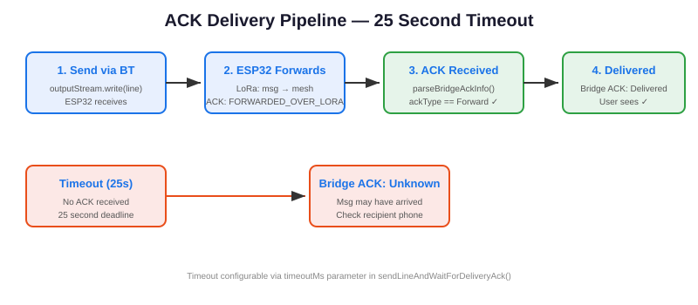

sendLineAndWaitForDeliveryAck() sends a message via Bluetooth and waits up to 25 seconds for the ACK. The ESP32 forwards the message via LoRa and returns a FORWARDED_OVER_LORA ACK. BridgeAckKind.Forward is accepted alongside Delivery as valid delivery confirmation.

2.3 Chat Destination Filter
chatDestinations() filters selectableLiveDestinations() to show only nodes with bluetoothConnected=true. normalizedDiscoveredNodes() uses associateBy { it.nodeId } to keep the latest entry for each node (BT flags may arrive in later NODE_LIST responses).

3. ESP32 Firmware Architecture
File: esp32-node-platformio/src/main.cpp (2,903 lines)
Target | Gateway | Features
nodeA1_lora through nodeB3_lora | A or B | LoRa + Bluetooth SPP
gatewayA_lora / gatewayB_lora | A or B | LoRa only (USB serial bridge)

Key protocol: BT1 packet format (pipe-delimited). HELLO payload includes bluetooth status as quoted string. NODE_LIST is semicolon-delimited with BT suffix. parseStrictGatewayIdPayload() accepts extra JSON fields for forward compatibility.

4. Gateway Service Architecture
File: rpi-gateway/gateway_service.py (990 lines). Dual-thread: SerialThread reads ESP32 via [GW_JSON] protocol, NetworkThread handles Tailscale VPN TCP. Message router relays between serial and network. Store-and-forward queue with deduplication and replay on reconnect.

5. Test Suite
Test File | Coverage
test_store_forward_queue.py | Enqueue, dedup, replay order
test_replay_engine.py | Replay scheduling, retry, backoff
test_route_state_machine.py | State transitions, failover, recovery
test_step048*.py | Gateway integration, relay, ACK, peer detection, reconnect

Run: python3 -m unittest discover -s tests -p "test_*.py" — 240 tests, all PASS.

