PUP MANET — User Manual
GUI Reference & Operations Guide
Version 1.0-working-base | June 19, 2026

1. Application Overview
The PUP MANET app has five tabs accessible from the bottom navigation bar: Chat, Nodes, Route, Bluetooth, and Logs. Each tab serves a distinct function in the emergency messaging workflow.
The app requires Bluetooth permissions (BLUETOOTH_SCAN, BLUETOOTH_CONNECT, BLUETOOTH_ADMIN) granted on first launch. ESP32 nodes must be paired in Android Settings before they appear in the app.

2. Chat Tab — Sending and Receiving Messages
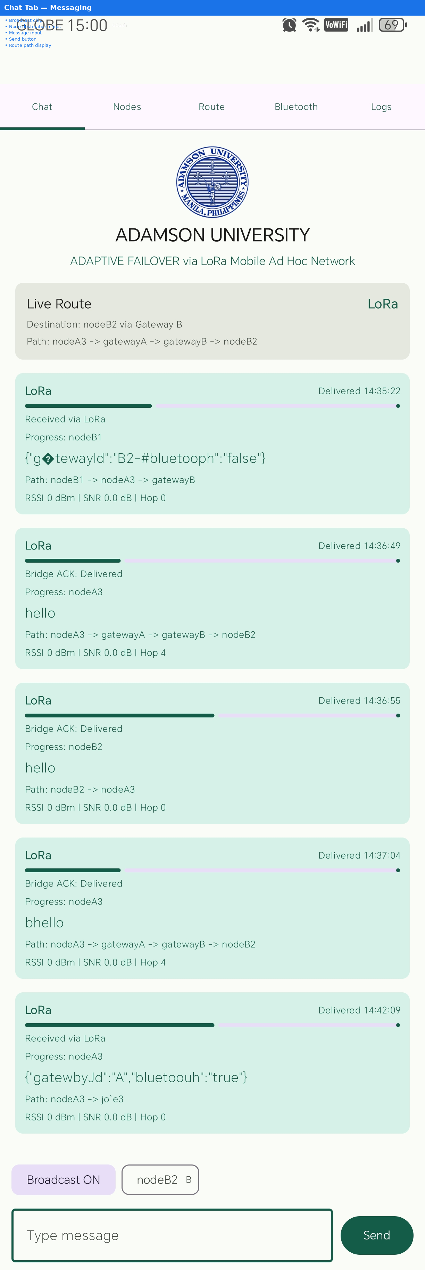
Figure 1: Chat Tab with destination chips, message history, and input area
The Chat tab is the primary interface for sending and receiving emergency text messages over the MANET network.

2.1 GUI Elements
• Broadcast Chip — Sends message to ALL nodes in the network simultaneously. When active, displays "Broadcast ON" with purple highlight.
• Node Destination Chips — One chip per phone-paired node (e.g., "nodeB2 B"). Shows the node ID and its mesh gateway identifier (A or B). Only nodes with a confirmed Bluetooth phone connection appear.
• Message Area — Displays sent and received messages with timestamp, delivery status, route path, and RSSI/SNR signal metrics.
• Send Button — Transmits the typed message to the selected destination or as a broadcast.

2.2 How to Send a Message
1. Select a destination: Tap a node chip (e.g., "nodeB2 B") to highlight it in purple. Alternatively, tap Broadcast to send to all nodes.
2. Type your message in the text field at the bottom.
3. Tap Send. The destination label at the top shows the route path (e.g., "Destination: nodeB2 via Gateway B").
4. Wait for delivery confirmation. The message status updates to "LoRa Delivered" then "Bridge ACK: Delivered" if the recipient confirms receipt.

2.3 Message Statuses
• Bridge ACK: Delivered — Message received and confirmed by the destination device. Green indicator.
• Received via LoRa — Message arrived via the LoRa mesh network.
• Bridge ACK: Unknown — ACK not received within 25 seconds. Message may still have been delivered — check the recipient phone.

3. Nodes Tab — Network Discovery
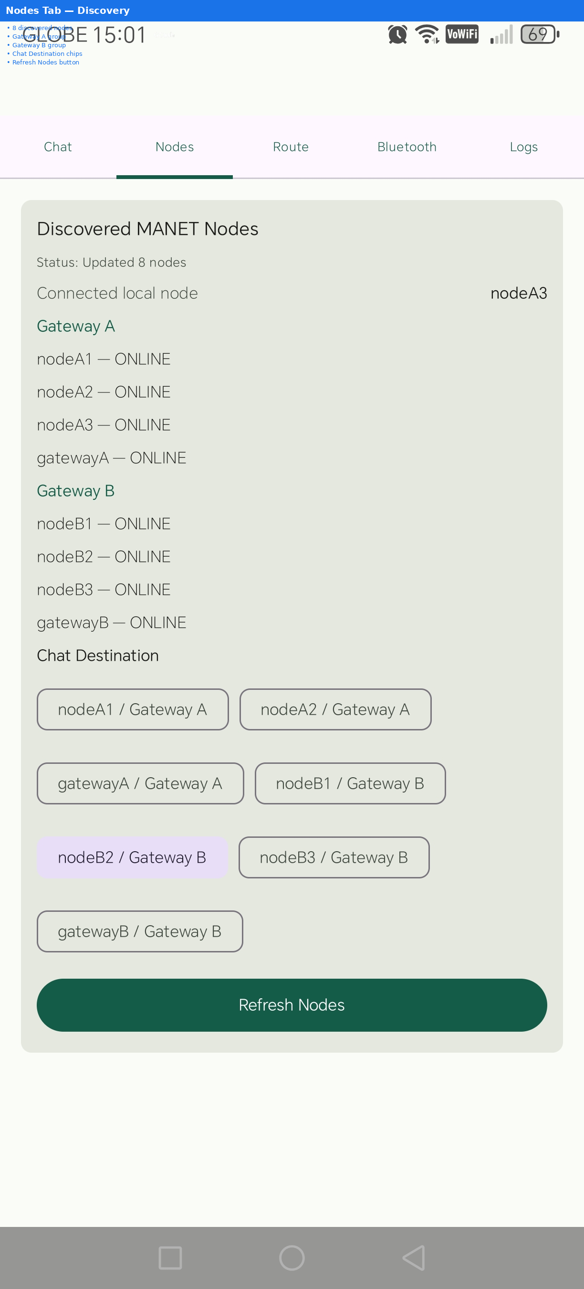
Figure 2: Nodes Tab showing all 8 discovered nodes grouped by mesh gateway
The Nodes tab displays all discovered MANET nodes in real time. Nodes are organized by mesh gateway (A or B).
• Discovered Nodes — Each node shows its ID, gateway, and ONLINE/OFFLINE status.
• Chat Destination Section — Below the node list, shows quick-access chips for available message destinations.
• Refresh Nodes — Tap to request a fresh NODE_LIST from the connected ESP32. Wait 30 seconds after power-on for HELLO broadcasts to propagate before refreshing.
• Connected Local Node — Shows which ESP32 your phone is connected to.

4. Route Tab — Packet Routing
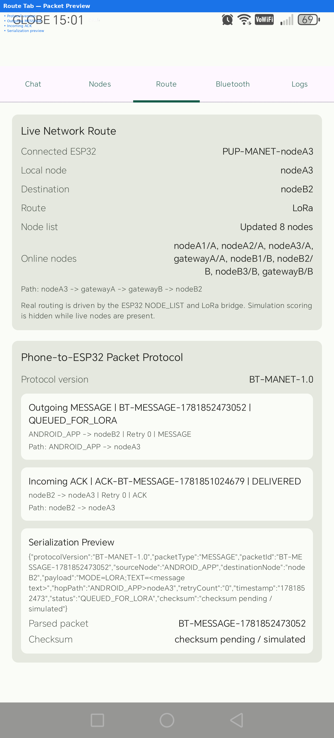
Figure 3: Route Tab showing live packet routing preview
The Route tab shows the current message routing path and serialization preview. It displays the protocol version, outgoing message structure, incoming ACK format, and the hop-by-hop path from source to destination.

5. Bluetooth Tab — Connection Management
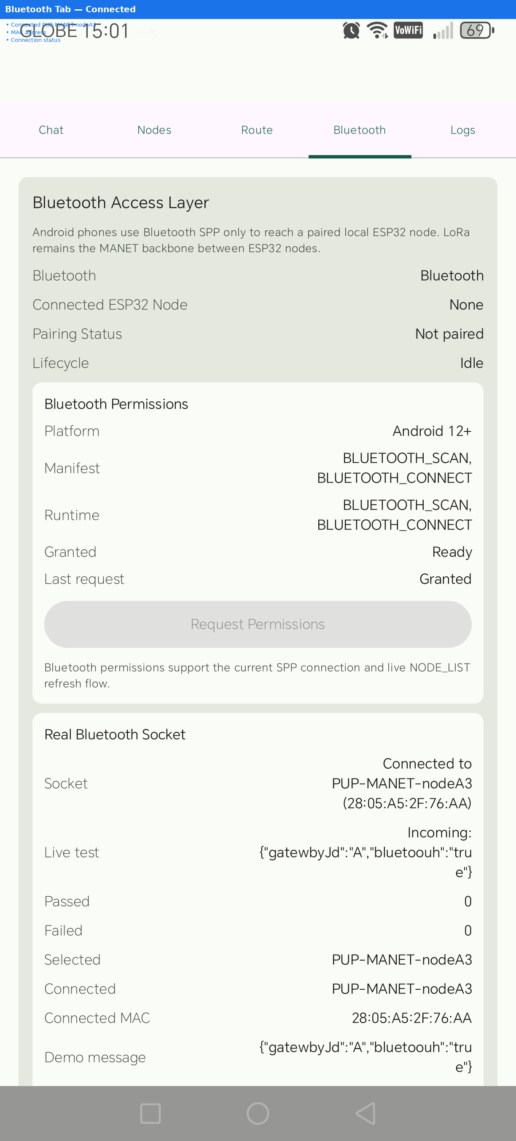
Figure 4: Bluetooth Tab showing active connection to PUP-MANET-nodeA3
The Bluetooth tab manages the connection between the Android phone and the ESP32 node via Bluetooth SPP.

5.1 Connection Flow
1. Open the Bluetooth tab.
2. Load Paired — Scans for paired PUP-MANET devices.
3. Connect ESP32 — Establishes Bluetooth SPP connection to the selected node. Status changes to "Connected."
4. Close Socket — Disconnects from the ESP32.
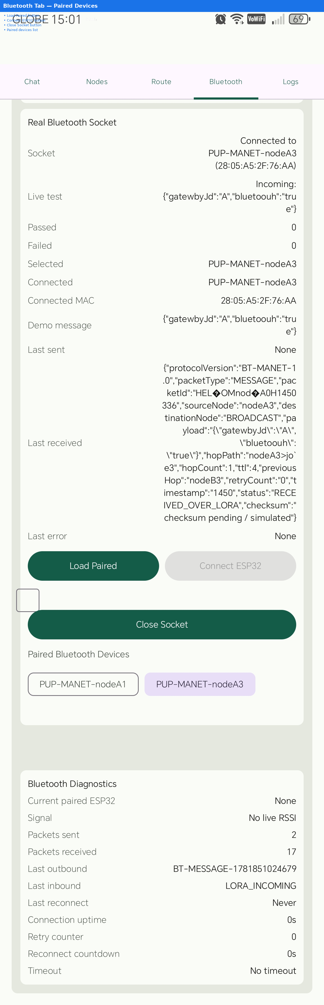
Figure 5: Bluetooth Tab showing paired devices list and connection controls

5.2 Paired Devices
The "Paired Bluetooth Devices" section shows only PUP-MANET-* devices. Non-system Bluetooth devices (headphones, speakers, etc.) are filtered out. If no PUP-MANET nodes are paired, a message instructs the user to pair in Android Settings first.

5.3 Bluetooth Diagnostics
The Bluetooth Diagnostics section shows connection statistics: connected device name, MAC address, last sent/received timestamps, and error count. Useful for troubleshooting connection issues.

6. Logs Tab — System Diagnostics
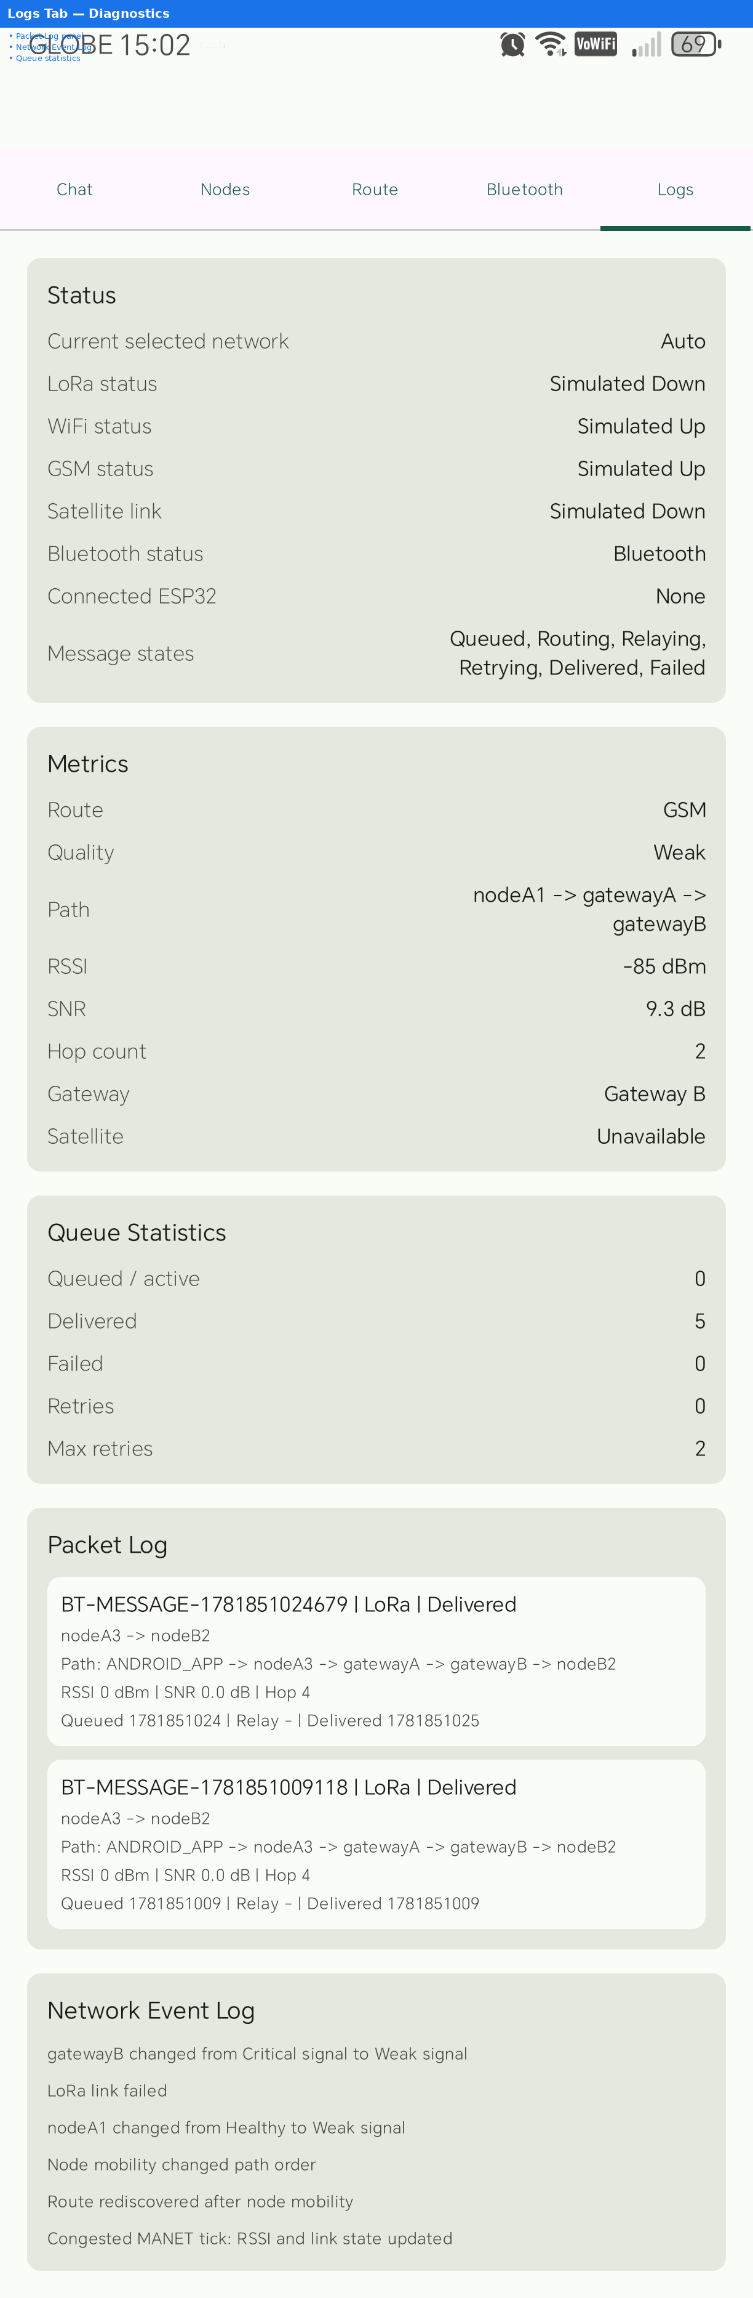
Figure 6: Logs Tab showing Packet Log and Network Event Log
The Logs tab provides diagnostic information for troubleshooting and verification.
• Packet Log — Shows recent Bluetooth protocol packets sent and received, including timestamps and packet types (HELLO, MESSAGE, ACK).
• Network Event Log — Shows system events: connections, disconnections, node discoveries, errors, and state transitions.

7. Troubleshooting
Problem | Solution
No nodes discovered | Wait 30s after power-on, then tap Refresh Nodes
No chat chips visible | Ensure phone is paired AND connected via Bluetooth tab, then Refresh Nodes
ACK: Unknown on all messages | Check gateway VPN is up: ss -tnp | grep 5050
Cannot connect to ESP32 | Unpair and re-pair in Android Settings → Bluetooth
Messages not delivered | Power cycle all nodes + gateways, wait 60s, refresh
App shows "No nodes detected" | Connect to ESP32 first in Bluetooth tab, then switch to Chat

