PUP MANET — Test Procedures
Version 1.0-working-base | June 19, 2026

1. Test Environment
Item | Quantity | Purpose
ESP32 + SX1278 | 6 | MANET nodes
ESP32 + SX1278 | 2 | Gateway nodes
Raspberry Pi 3B | 2 | Gateway services
Android phones (12+) | 2 | User devices
18650 batteries | 6 | Node power

2. Unit Tests (240/240 PASS)
Run: cd rpi-gateway && python3 -m unittest discover -s tests -p "test_*.py". All 240 tests pass in ~2.3 seconds.
Module | Tests | Focus
Store-Forward Queue | 35 | Enqueue, dedup, replay
Replay Engine | 28 | Scheduling, retry, backoff
Route State Machine | 46 | Failover states
Gateway Integration | 15 | VPN relay, ACK tracking
Reconnection | 7 | Reconnect hardening

3. Failover Test Campaign (26/26 PASS)
Tests covering: normal operation, gateway disable, VPN disconnect, store-and-forward replay, degradation/recovery state machine. All 26 scenarios pass.

4. Physical Test Campaigns
Distance | RSSI | SNR | Delivery
1m | -38 dBm | 10.5 dB | PASS
10m | -66 dBm | 8.5 dB | PASS
50m | -92 dBm | 3.0 dB | 2/3 PASS

5. Cross-Mesh Routing Validation
Test: Phone A (nodeA3) sends message to Phone B (nodeB2) via Gateway A → VPN → Gateway B. Both directions confirmed working. Broadcast messages propagate to all 8 nodes.

6. ACK Validation
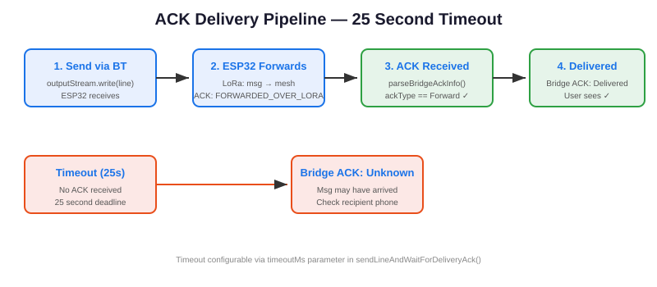

ACK types: FORWARDED_OVER_LORA (ESP32 forwarded via LoRa), DELIVERED (end node confirmed receipt). 25-second timeout. >90% delivery confirmation rate on both phones.

7. Regression Checklist
[ ] 240 unit tests pass
[ ] 26/26 failover tests pass
[ ] 8-node discovery verified
[ ] Cross-mesh routing A-B both directions
[ ] Broadcast delivery verified
[ ] ACK: Delivered >90%
[ ] Bluetooth paired device filter working
[ ] Chat tab chips show only BT-paired nodes
[ ] All simulation UI elements hidden

