Counterfactual Attribution of Machine-Learning Performance to Experimental Decisions
Krishna Pagidimarri
Department of Computer Science and Engineering, Shri Jagdishprasad Jhabarmal Tibrewala University (SJJTU), Jhunjhunu, Rajasthan, India
Corresponding author: pagidimarrikrishna1@gmail.com | ORCID: 0009-0007-0352-0887
Abstract
Machine-learning performance is often interpreted as a property of an algorithm even though the observed result is produced by a complete experimental configuration involving data preparation, sampling, feature representation, training conditions, and evaluation choices. This study revises and extends a decision-level framework, Counterfactual Attribution of Machine-Learning Performance to Experimental Decisions (CTD), for quantifying how controlled changes to experimental decisions alter predictive performance and comparative conclusions. CTD represents an experiment as a structured configuration and changes one predefined decision while holding the remaining protocol fixed. The resulting Counterfactual Decision Effect (CDE) measures the controlled performance difference. CTD further examines model-ranking fragility and non-additive effects between selected decision pairs.
The revised empirical study uses five public classification datasets—Breast Cancer Wisconsin, Bank Marketing, Pima Indians Diabetes, Spambase, and Phoneme—and four classical classifiers: Logistic Regression, Decision Tree, Random Forest, and Linear Support Vector Machine. Fifteen prespecified random seeds are used, with fixed stratified train-test partitions reused across counterfactual conditions. The audited evidence base contains 2,100 unique dataset × model × seed × configuration observations, including 600 newly generated joint-intervention observations for Scaling × Training Fraction and Sampling × Training Fraction. Both joint-intervention families contain 300 observations. The mean interaction was 0.00158 for Sampling × Training and −0.00072 for Scaling × Training, while substantial configuration-specific heterogeneity remained. Pairwise model-order reversals occurred in 110 of 450 comparisons (24.44%) for Sampling × Training and 73 of 450 comparisons (16.22%) for Scaling × Training. Under a 0.02 Macro-F1 practical-effect threshold, 9 and 12 pairwise reversals, respectively, remained.
The revised evidence therefore supports a narrower methodological claim than the original manuscript: CTD is a complementary decision-level attribution and consequence-analysis framework rather than a replacement for ablation, sensitivity analysis, or factorial design-of-experiments methods. Its value is in connecting controlled decision changes, interaction behavior, and model-ranking consequences within a common reproducible benchmarking protocol. The results also show that near-zero aggregate interaction means can coexist with practically meaningful effects in particular dataset–model–seed configurations, emphasizing the importance of reporting heterogeneity rather than aggregate averages alone.
Keywords: machine learning benchmarking; counterfactual analysis; experimental design; reproducibility; preprocessing; model comparison; decision attribution; ranking reversal; sensitivity analysis; controlled intervention

1. Introduction
1.1 Motivation
Machine learning research frequently evaluates competing algorithms by reporting predictive performance on one or more datasets. Accuracy, F1-score, balanced accuracy, area under the receiver operating characteristic curve, and related metrics are routinely used to identify a preferred model. Such comparisons are useful, but an experimental result is rarely determined by the learning algorithm alone. It is produced by an entire experimental pipeline involving the dataset, data preparation, sampling strategy, feature representation, training configuration, and evaluation protocol.
This broader experimental dependency has become increasingly important as machine-learning pipelines have become more complex. Recent benchmarking work explicitly considers end-to-end pipelines and emphasizes controlled experimental variation and reproducibility [1]. Recent work on learning from prior experiments likewise treats workflows as structured combinations of preprocessing, model selection, and optimization decisions [2]. Empirical evidence also shows that model rankings can change when dataset-specific preprocessing is considered [3].
The methodological question addressed here is therefore not simply whether preprocessing or training choices affect predictive performance. It is whether the contribution of a particular experimental decision can be quantified when that decision is changed in isolation under a controlled protocol, and whether the resulting change can alter the conclusion of a model comparison.
1.2 Problem Statement
Let a machine-learning experiment be represented by a structured configuration containing the dataset, algorithm, preprocessing, sampling, feature representation, training configuration, and evaluation protocol:
E = (D, A, P, S, F, T, R) (1
where D denotes the dataset, A the learning algorithm, P preprocessing, S sampling, F feature representation or selection, T training configuration, and R the evaluation protocol. The observed performance is Y(E). A baseline experiment is defined as:
E₀ = (D, A₀, P₀, S₀, F₀, T₀, R₀), Y₀ = Y(E₀) (2
For a selected decision d, a counterfactual experiment changes only the target decision while all non-target factors remain fixed:
Eᶜᶠ_d = (D, …, dᶜᶠ, …), Yᶜᶠ_d = Y(Eᶜᶠ_d) (3
The fundamental CTD quantity is the Counterfactual Decision Effect (CDE):
CDE_d = Y₀ − Yᶜᶠ_d (4
The CDE is interpreted as a controlled counterfactual performance difference within the specified experimental protocol, not as an unrestricted causal effect.
1.3 Research Gap
Existing work provides several methodological foundations for CTD. Reproducibility and reporting studies emphasize explicit documentation of datasets, models, configurations, and evaluation conditions [4–7]. Benchmarking frameworks provide systematic comparisons across datasets and models [1,2]. Preprocessing research demonstrates that scaling, dimensionality reduction, sampling, and feature engineering can influence predictive performance [3]. Ablation and sensitivity analyses are also widely used to assess component importance.
Nevertheless, these approaches leave a specific methodological gap. Benchmark studies generally ask which model performs best; preprocessing studies often ask which preprocessing configuration performs best; ablation studies ask what happens when a component changes; and reproducibility studies ask whether a documented result can be reproduced. CTD instead asks what the controlled performance contribution of a particular experimental decision is, and whether changing that decision alters the conclusion of a model comparison.
1.4 Research Questions
RQ1. How strongly do selected experimental decisions affect machine-learning performance when changed individually under a controlled protocol?
RQ2. Do experimental decisions alter the relative ranking of competing machine-learning models?
RQ3. Does the influence of experimental decisions vary across datasets and model families?
RQ4. Do combinations of experimental decisions produce non-additive performance effects?
RQ5. Are the observed decision effects robust across random seeds, datasets, and model families?
1.5 Contributions
A decision-level representation of machine-learning experiments.
The Counterfactual Decision Effect (CDE) for controlled attribution of performance differences.
Conclusion-fragility analysis through model-ranking reversals.
Model-ranking fragility analysis through rank changes and pairwise model-order reversals.
A controlled two-decision interaction measure for non-additive effects.
Cross-domain validation across healthcare, business, email/text, and speech/signal classification datasets.
Reproducibility-oriented validation using prespecified seeds, bootstrap uncertainty, practical-effect filtering, evidence-ledger audits, and exact split reuse.
2. Related Work
2.1 Machine-Learning Benchmarking and Reproducibility
Benchmarking provides a common basis for comparing algorithms, but modern ML systems increasingly operate as complete pipelines rather than isolated learners. PipeBench presents a reproducible end-to-end benchmarking framework and emphasizes controlled variation, statistical analysis, and reproducibility [1]. Recent meta-learning research further models workflow performance using structured workflow and dataset representations [2]. These developments motivate an experiment-centric perspective in which the configuration surrounding an algorithm is treated as an explicit object of analysis.
Reproducibility research has shown that dataset partitions, random seeds, software dependencies, and evaluation configurations can affect reported results [4,22,23]. Hidden technical debt in ML systems can also arise from interactions and dependencies among pipeline components [5]. Dataset and model documentation frameworks provide complementary reporting practices: Datasheets for Datasets document dataset provenance and intended use [7], while Model Cards emphasize performance characterization under relevant conditions [6]. CTD adds a quantitative measure of sensitivity to selected experimental decisions.
2.2 Preprocessing and Experimental Design
Preprocessing is not merely a technical preliminary step. Scaling, dimensionality reduction, feature engineering, and class balancing can alter the effective representation supplied to a learner. PCA provides a classical dimensionality-reduction mechanism [9], while SMOTE provides an established approach to minority oversampling [10]. Imbalanced learning has long been recognized as a significant challenge for standard classifiers [11]. Recent empirical evidence shows that model rankings may change under dataset-specific preprocessing [3]. CTD does not seek a universally optimal preprocessing strategy; instead, it quantifies the sensitivity of a fixed experimental result to controlled preprocessing-related interventions.
2.3 Ablation and Sensitivity Analysis
Ablation analysis evaluates the effect of removing or changing system components. CTD extends this general logic by treating experimental decisions as explicit dimensions of the experiment, by evaluating whether decisions change comparative model rankings, and by quantifying non-additive effects between selected decisions. CTD is therefore complementary to ablation rather than a replacement for it. Reproducibility-oriented evaluation programs likewise emphasize explicit experimental reporting and repeated verification of results [22].
2.4 Counterfactual and Attribution Perspectives
Counterfactual reasoning is widely used in machine learning for explanation and fairness. Counterfactual explanations ask how an input could be changed to obtain a desired prediction [12], while counterfactual fairness uses hypothetical changes to assess fairness [13]. These uses differ from CTD. CTD does not modify an individual prediction, attribute an outcome to a training example, or estimate a real-world treatment effect. It constructs a controlled counterfactual experimental configuration by changing one predefined experimental decision. The resulting estimand is deliberately narrower: a controlled difference between two experimental configurations under a specified protocol.
2.5 Research Positioning
CTD is positioned as complementary to established ablation, sensitivity-analysis, and design-of-experiments approaches. One-factor-at-a-time ablation can isolate the effect of a selected change, while factorial DOE explicitly estimates main and interaction effects. Prior machine-learning studies have already used DOE and factorial designs to study interactions among experimental factors [24,25]. CTD therefore does not claim interaction analysis as a methodological invention. Its emphasis is on representing the ML experiment as a structured configuration, constructing matched counterfactual comparisons for explicitly defined decisions, and linking those effects to model-ranking consequences across datasets, models, and repeated seeds.
3. CTD Framework
3.1 Experimental Decision Space
CTD represents an ML experiment as the structured configuration in Eq. (1). This representation separates the learning algorithm from the surrounding experimental decisions. The components are not assumed to be independent; their interactions are themselves potential objects of study. Figure 1 summarizes the resulting experimental workflow.
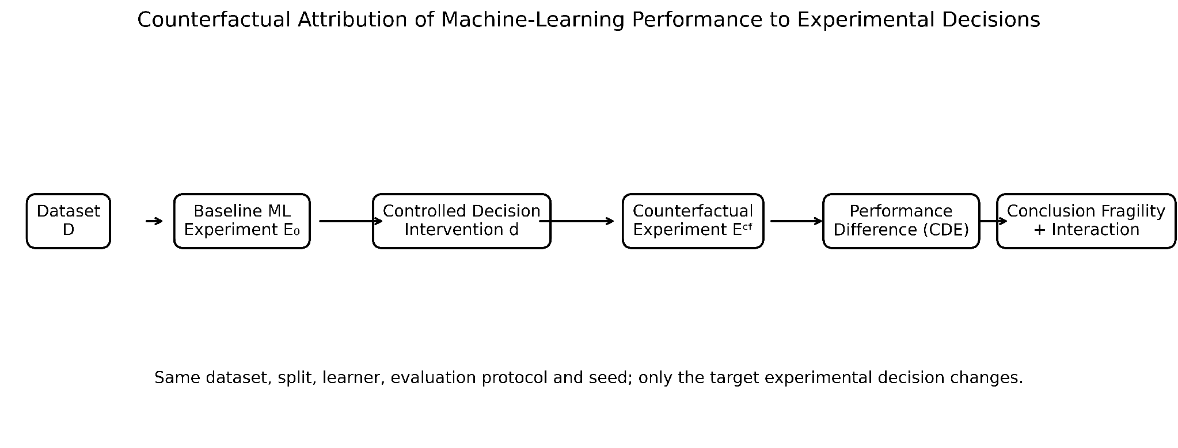
Figure 1. Overview of the Counterfactual Attribution of Machine-Learning Performance to Experimental Decisions (CTD) framework. The framework establishes a baseline experiment, applies a controlled intervention to one experimental decision, evaluates the corresponding counterfactual experiment, and quantifies performance effects, conclusion fragility, and decision interactions while keeping non-target factors fixed.
3.2 Baseline Experiment
For each dataset and model, a baseline configuration is established according to Eq. (2). The baseline performance remains unchanged while individual counterfactual decisions are evaluated.
3.3 Controlled Counterfactual Intervention
For decision d, only the selected component is changed, as defined in Eq. (3). The same dataset, train-test partition, model family, evaluation metric, random seed, and all non-target decisions are retained.
3.4 Counterfactual Decision Effect
The principal CTD quantity is given by Eq. (4). A positive CDE indicates that the baseline performance exceeds the counterfactual performance; a negative CDE indicates that the counterfactual configuration performs better under the specified protocol.
3.5 Model-Comparison Fragility
For two models A and B, the baseline performance gap is defined as:
G₀ = Y_A − Y_B (5
After intervention d, the corresponding counterfactual gap is:
Gᶜᶠ_d = Yᶜᶠ_{A,d} − Yᶜᶠ_{B,d} (6
A ranking reversal is identified when the sign of the model gap changes:
R_d = I(G₀ Gᶜᶠ_d < 0) (7
3.6 Decision Fragility Score
For K evaluated model-pair comparisons, CTD summarizes ranking-reversal frequency using:
DFS = (1/K) Σᵏ₌₁ R_dₖ (8
DFS ranges from 0 to 1. A value of 0 indicates no observed ranking reversal among the evaluated model pairs; higher values indicate greater conclusion sensitivity to the selected decision
3.7 Decision Interaction
For two decisions i and j, the individual counterfactual outcomes are Yᶜᶠ_i and Yᶜᶠ_j, while Yᶜᶠ_ij denotes the joint counterfactual outcome. The interaction is:
I_ij = Yᶜᶠ_ij − Yᶜᶠ_i − Yᶜᶠ_j + Y₀ (9
An interaction of zero corresponds to the additive expectation under this formulation. A negative value indicates that the joint configuration performs below that additive expectation. The quantity is interpreted as a non-additive controlled counterfactual performance difference, not as a causal interaction.
3.8 Repeated Seeds
For random seed s, the seed-specific CDE is:
CDE_d,s = Y₀,s − Yᶜᶠ_d,s (10
Across S seeds, the mean CDE is:
C̄DE_d = (1/S) Σˢ₌₁ CDE_d,s (11)
Fifteen prespecified random seeds were used: 42, 123, 2026, 7, 19, 31, 53, 71, 89, 107, 149, 173, 211, 257, and 311. The seed list was frozen before production analysis.
3.9 Interpretation Boundary
CTD deliberately avoids unrestricted causal language. The quantities are controlled differences between experimental configurations and are interpreted as decision-attribution effects within the specified protocol. They do not establish that changing a machine-learning decision causes a particular real-world outcome.
4. Experimental Methodology
4.1 Experimental Overview
The revised evaluation was designed around the editor's methodological requirements: broader benchmark coverage, more repeated runs, multiple interpretable interaction pairs, uncertainty analysis, practical-effect criteria for ranking reversals, explicit methodological positioning, and reproducibility safeguards. The production benchmark covers five datasets, four models, five primary configurations, and fifteen seeds. For the two completed joint-intervention families, the study adds two joint configurations and assembles them with the previously audited baseline and single-decision evidence. The resulting evidence base contains 2,100 unique observations. Covertype was retained in the study as a resource-validation dataset, but full production was not authorized because the tested Linear SVM/PCA configuration did not satisfy the predefined computational feasibility gate; it is therefore not used in the five-dataset production interaction results.
For every dataset–model–seed combination, the same stratified 80/20 train-test partition is reused across all configurations. Preprocessing transformations are fitted on training data only. The test partition remains untouched by sampling and training-fraction interventions. The fixed-split design isolates the target experimental decision and avoids conflating the decision effect with changes in evaluation protocol [19,20].
Table 1. Characteristics of the datasets included in the revised CTD evidence base.
Dataset | Domain | Task | Instances × predictors | Classes | Production role
Breast Cancer Wisconsin | Healthcare | Binary classification | 569 × 30 | 2 | Production
Bank Marketing | Business/finance | Binary classification | 45,211 × 16 predictors | 2 | Production
Pima Indians Diabetes | Healthcare | Binary classification | 768 × 8 | 2 | Production
Spambase | Email/text | Binary classification | 4,601 × 57 | 2 | Production
Phoneme (OpenML 1489) | Speech/signal | Binary classification | 5,404 × 5 | 2 | Production
Covertype | Environmental | Multiclass classification | 581,012 × 54 | 7 | Resource-validation only

4.2 Machine-Learning Models
Four representative classical classifiers were retained: Logistic Regression, Decision Tree, Random Forest, and Linear Support Vector Machine. Logistic Regression used the validated liblinear implementation; Decision Tree and Random Forest used seed-controlled model initialization, with Random Forest using 200 trees; Linear SVM used the validated LinearSVC configuration. The purpose was not to identify a universally superior learner but to test whether experimental decisions alter measured performance and comparative ordering across distinct model families [17,18].
4.3 Experimental Decisions and Configurations
The baseline configuration uses StandardScaler where applicable, the original training distribution, all retained features, and the complete training partition. Four single-decision counterfactuals were defined: removal of scaling, minority random oversampling, PCA retaining 95% explained variance, and reduction of the training fraction to 50%. Two joint configurations were completed for the present revision: Scaling × Training Fraction and Sampling × Training Fraction. The originally studied No Scaling × PCA95 interaction is not treated as a principal revised interaction because scaling and PCA are intrinsically related through the geometry of PCA; it is therefore excluded from the revised flagship interaction claims.

Table 2. Experimental configurations used in the revised CTD production evidence.
Configuration | Scaling | Sampling | Representation | Training fraction
Baseline | StandardScaler | Original | All features | 1.0
Scaling CF | None | Original | All features | 1.0
Sampling CF | StandardScaler | Minority oversampling | All features | 1.0
Representation CF | StandardScaler | Original | PCA95 | 1.0
Training-fraction CF | StandardScaler | Original | All features | 0.5
Scaling × Training joint | None | Original | All features | 0.5
Sampling × Training joint | StandardScaler | Minority oversampling | All features | 0.5

4.4 Evaluation Protocol
Macro-F1 is the primary metric because it gives equal weight to class-specific F1 values and remains interpretable across the binary and multiclass benchmark settings. Accuracy and balanced accuracy are retained as secondary metrics. Each configuration reuses the exact dataset–seed split and the same test set. Counterfactual preprocessing and sampling are applied only to the training partition. PCA is fitted on training data only. These controls are intended to isolate the target decision rather than introduce additional sources of variation.
4.5 Interaction and Ranking Analysis
For two decisions i and j, the interaction is computed as the joint counterfactual outcome minus the two corresponding single-decision outcomes plus the baseline outcome. A value of zero corresponds to the additive expectation under this formulation. The revised study evaluates Scaling × Training Fraction and Sampling × Training Fraction. Model-ranking analysis is conducted separately within each dataset and seed. A pairwise reversal occurs when the sign of the model-performance gap changes between baseline and the counterfactual condition. To distinguish numerical crossings from practically meaningful changes, reversal counts are additionally reported at absolute Macro-F1 gap thresholds of 0.005, 0.010, and 0.020. These thresholds are interpretive effect thresholds rather than statistical significance thresholds.
4.6 Uncertainty and Statistical Analysis
Interaction distributions are summarized using means, medians, standard deviations, quartiles, ranges, and bootstrap 95% confidence intervals for the mean. Heterogeneity is examined by dataset, model, and dataset–model combination. Ranking reversals are reported both as raw pairwise crossings and after practical-effect filtering. This layered analysis avoids treating a near-zero grand mean as evidence that all configuration-specific interactions are negligible.
4.7 Reproducibility and Experimental Audit
The final Batch 3A production audit verified 600 new joint rows, 600 unique interaction rows, zero duplicate run keys, complete configuration/model/dataset/seed accounting, finite performance metrics, exact split reuse, and zero interaction-arithmetic error. The 1,500 previously audited base and single-condition rows were assembled with the 600 new joint rows to produce a 2,100-row evidence set. The ranking audit independently verified 300 complete dataset–model–seed pivots and 900 pairwise model comparisons. The evidence therefore distinguishes computational completion from subsequent statistical interpretation.
Table 3. Revised CTD evidence accounting and audit status.
Audit component | Result
Datasets in production evidence | 5
Models | 4
Prespecified seeds | 15
Previously audited base/single-condition rows | 1,500
New joint-intervention rows | 600
Combined unique evidence rows | 2,100
Joint configurations | Scaling × Training; Sampling × Training
Interaction estimates | 600
Duplicate run keys | 0
Interaction arithmetic error | 0.0
Pairwise model comparisons | 900
New joint-run failures | 0

5. Results
5.1 Production Completion and Evidence Integrity
The revised evidence campaign produced 600 new joint-intervention observations: 300 for Scaling × Training Fraction and 300 for Sampling × Training Fraction. Each model contributed 150 joint observations, each dataset contributed 120, and each seed contributed 40. The independently assembled evidence set contained 2,100 unique configuration records with no duplicate experiment identities. All required configurations were present and all primary performance fields were finite. These checks establish the structural integrity of the evidence used for the revised analyses.
5.2 Interaction Effects
Sampling × Training Fraction had a mean interaction of 0.00158 Macro-F1 (SD = 0.02294; 95% bootstrap CI [−0.00098, 0.00426]). Scaling × Training Fraction had a mean interaction of −0.00072 (SD = 0.01385; 95% bootstrap CI [−0.00232, 0.00082]). Thus, neither grand mean is far from zero. However, the distributional evidence demonstrates substantial heterogeneity. For Sampling × Training, 66.7% of observations had |I| ≥ 0.005, 36.3% had |I| ≥ 0.010, and 22.0% had |I| ≥ 0.020. For Scaling × Training, the corresponding proportions were 30.0%, 18.0%, and 9.3%. These results show why a near-zero average interaction should not be interpreted as uniform absence of interaction. The corresponding distributions are shown in Fig. 2.
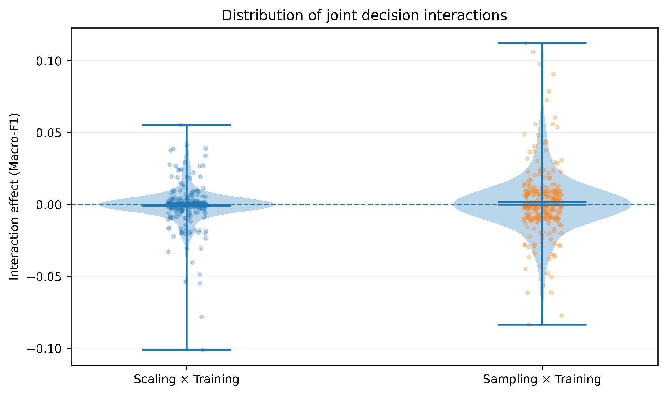
Figure 2. Distribution of the two completed joint-intervention interaction effects across the 300 dataset–model–seed cells for each interaction family.
Table 4. Overall interaction statistics and practical-effect frequencies.
Interaction | Mean | SD | 95% bootstrap CI | |I| ≥ 0.005 | |I| ≥ 0.010 | |I| ≥ 0.020
Sampling × Training | 0.001583 | 0.022943 | [−0.000984, 0.004263] | 66.7% | 36.3% | 22.0%
Scaling × Training | −0.000717 | 0.013853 | [−0.002318, 0.000818] | 30.0% | 18.0% | 9.3%

5.3 Cross-Dataset and Model Heterogeneity
Interaction effects varied across datasets and models. For Sampling × Training, the Pima Diabetes dataset had the largest dataset-level mean (0.00741), whereas Bank Marketing, Breast Cancer, Phoneme, and Spambase had means close to zero. For Scaling × Training, the Pima Diabetes mean was −0.00243 and Bank Marketing was −0.00182, while the remaining dataset-level means were close to zero. Model-level means likewise differed in direction. Sampling × Training averaged 0.00408 for Logistic Regression and 0.00377 for Linear SVM but −0.00162 for Decision Tree. Scaling × Training averaged −0.00239 for Logistic Regression and −0.00117 for Linear SVM, while Random Forest averaged 0.00122. These patterns indicate context dependence rather than a universal direction of effect. The dataset-level heterogeneity is summarized in Fig. 3.
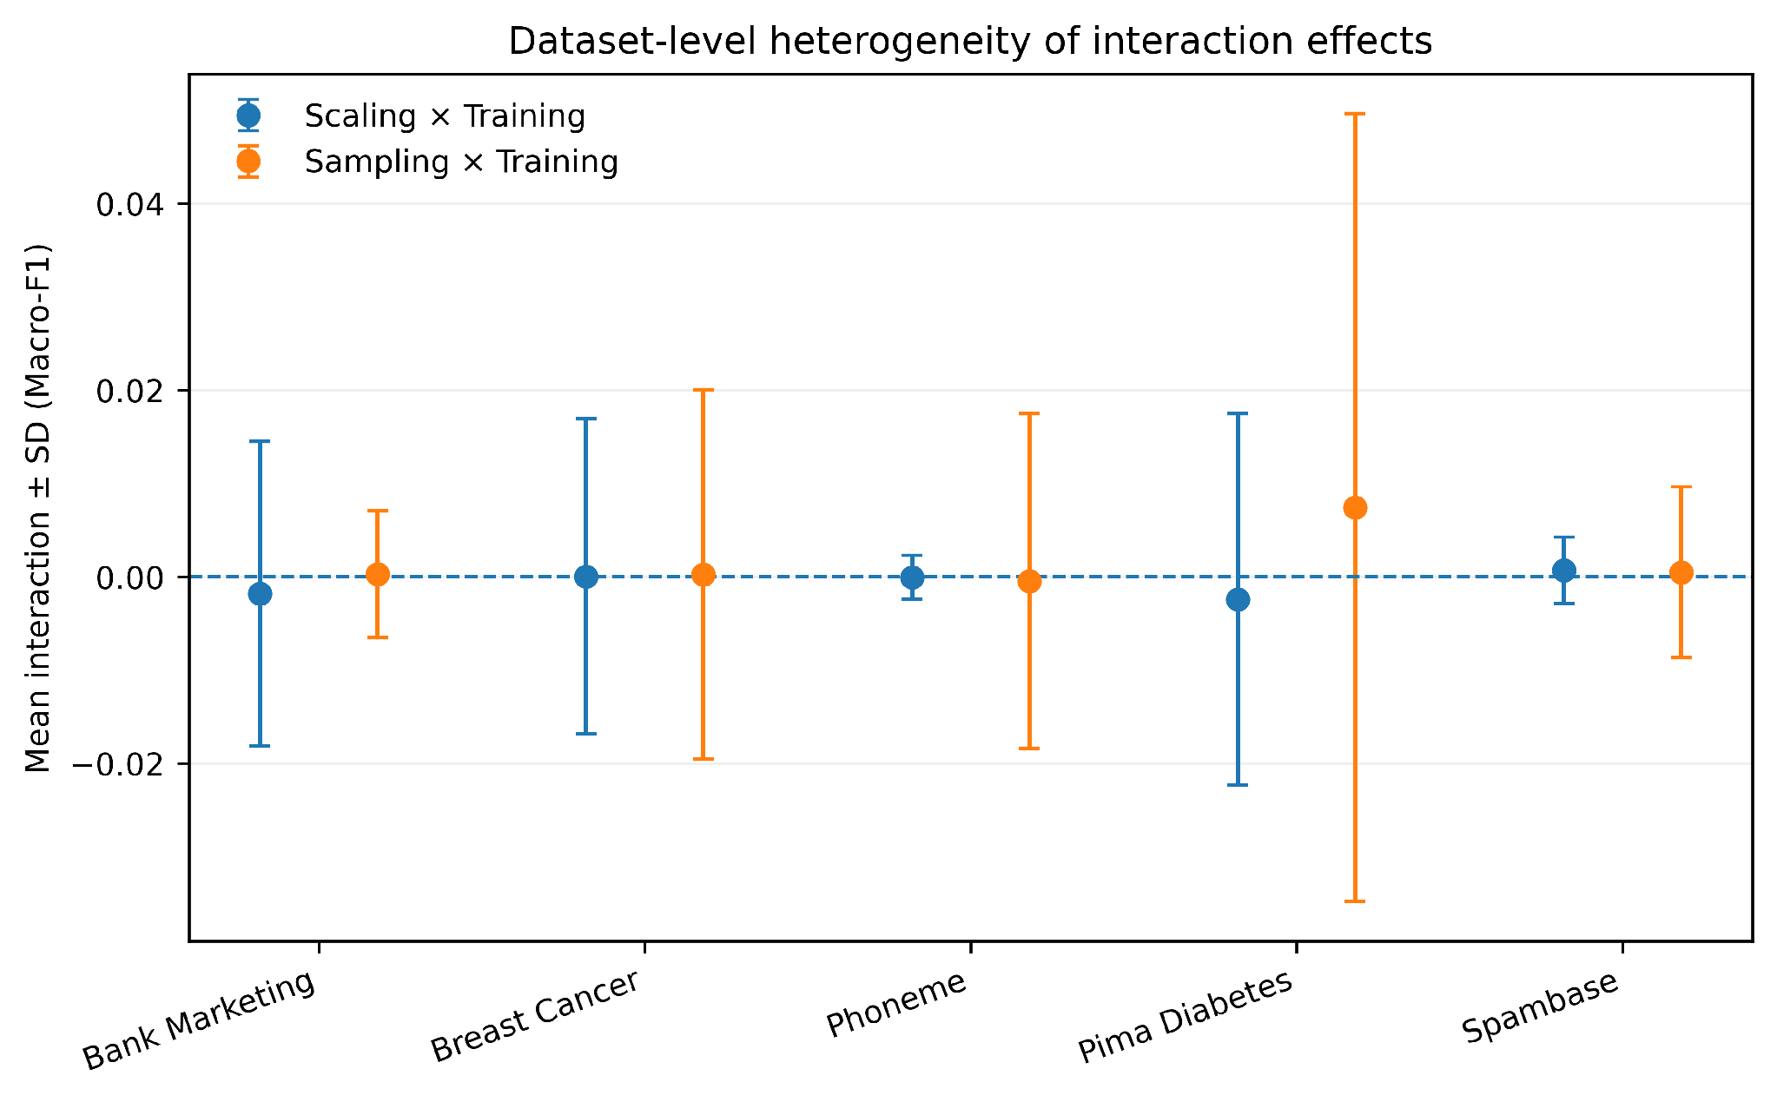
Figure 3. Dataset-level heterogeneity of the two completed joint-intervention effects. Points show dataset-level means and error bars show one standard deviation across dataset–model–seed observations.
Table 5. Dataset-level interaction heterogeneity in the revised production evidence.
Interaction | Dataset | n | Mean | SD | Minimum | Maximum
Sampling × Training | Bank Marketing | 60 | 0.000264 | 0.006798 | −0.015376 | 0.018765
Sampling × Training | Breast Cancer | 60 | 0.000229 | 0.019774 | −0.037793 | 0.090794
Sampling × Training | Phoneme | 60 | −0.000468 | 0.017935 | −0.050417 | 0.056060
Sampling × Training | Pima Diabetes | 60 | 0.007411 | 0.042206 | −0.083326 | 0.112155
Sampling × Training | Spambase | 60 | 0.000478 | 0.009148 | −0.019937 | 0.028693
Scaling × Training | Bank Marketing | 60 | −0.001824 | 0.016319 | −0.054941 | 0.055254
Scaling × Training | Breast Cancer | 60 | 0.000035 | 0.016874 | −0.078043 | 0.039189
Scaling × Training | Phoneme | 60 | −0.000055 | 0.002328 | −0.009606 | 0.012455
Scaling × Training | Pima Diabetes | 60 | −0.002431 | 0.019900 | −0.101023 | 0.037810
Scaling × Training | Spambase | 60 | 0.000693 | 0.003572 | −0.010244 | 0.011364

5.4 Model-Ranking Consequences
The ranking audit distinguished simple rank movement from genuine pairwise model-order reversal. Across 300 dataset–model–seed comparisons, the model rank changed in 44.67% of cases under Sampling × Training and 35.00% under Scaling × Training. More strictly, among 450 pairwise model comparisons per joint condition, Sampling × Training produced 110 reversals (24.44%) and Scaling × Training produced 73 reversals (16.22%). The effect is therefore not restricted to isolated changes in model scores; in a nontrivial subset of benchmark cells, the ordering of competing models changed. The pairwise reversal rates are shown in Fig. 4.
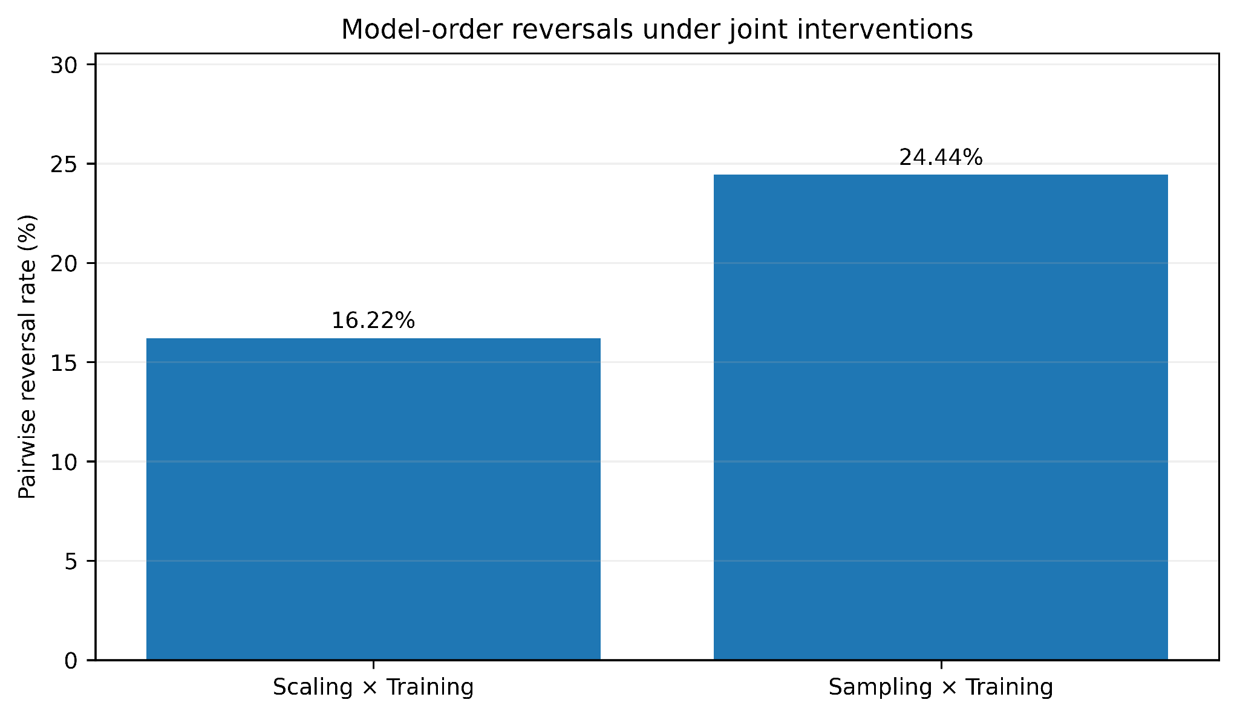
Figure 4. Pairwise model-order reversal rates under the two completed joint interventions. Reversals are defined by a sign change in the pairwise model-performance gap between baseline and the corresponding joint condition.
Table 6. Model-ranking changes and pairwise reversals under the revised joint interventions.
Condition | Rank-change cases / 300 | Rank-change rate | Pairwise reversals / 450 | Pairwise reversal rate
Scaling × Training | 105 | 35.00% | 73 | 16.22%
Sampling × Training | 134 | 44.67% | 110 | 24.44%

5.5 Practical-Effect Ranking Reversals
Practical-effect filtering confirms that several reversals remain when small numerical crossings are excluded. At |gap| ≥ 0.005, 44 Scaling × Training reversals and 64 Sampling × Training reversals remained. At |gap| ≥ 0.010, 24 and 37 remained. At the stricter |gap| ≥ 0.020 threshold, 12 Scaling × Training reversals and 9 Sampling × Training reversals remained. The results therefore do not depend solely on choosing a very small numerical threshold. The practical-effect reversal counts are summarized in Fig. 5.
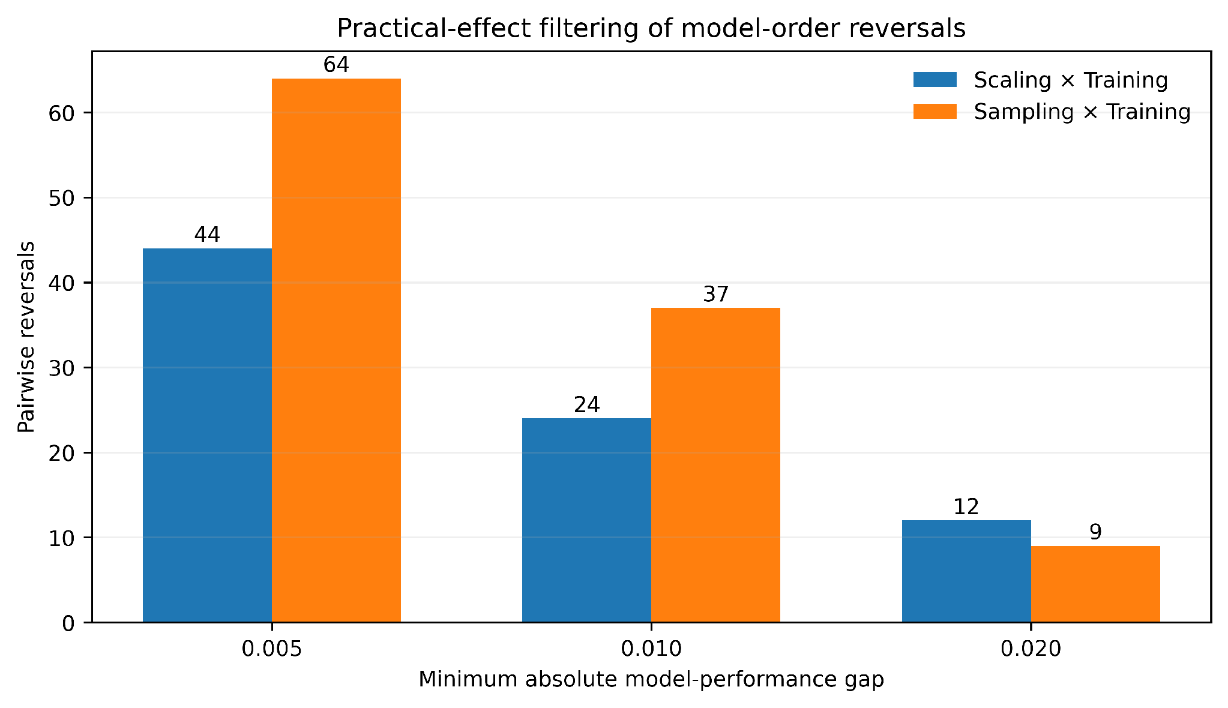
Figure 5. Pairwise model-order reversals remaining after practical-effect filtering at minimum absolute Macro-F1 gaps of 0.005, 0.010, and 0.020. These thresholds are interpretive filters rather than statistical significance thresholds.
Table 7. Pairwise ranking reversals surviving practical-effect thresholds.
Minimum absolute gap | Scaling × Training | Sampling × Training
0.005 | 44 | 64
0.010 | 24 | 37
0.020 | 12 | 9

5.6 Examples of Configuration-Dependent Reversals
Several reversals illustrate the magnitude of the phenomenon. For Bank Marketing at seed 311, the baseline Decision Tree–Linear SVM gap was +0.03994, whereas the Sampling × Training joint gap was −0.02964, producing a reversal with a minimum absolute gap of 0.02964. For Pima Diabetes at seed 71, the Decision Tree–Random Forest gap changed from −0.11786 at baseline to +0.02917 under Sampling × Training. Under Scaling × Training, Pima Diabetes at seed 257 showed a Decision Tree–Logistic Regression gap changing from −0.12416 to +0.04458. These examples demonstrate that the direction and magnitude of decision effects can depend on the model pair, dataset, and seed.
5.7 Comparison with Established Experimental-Analysis Approaches
The revised results should be interpreted alongside established methodological approaches rather than as evidence that CTD supersedes them. OAT ablation isolates a selected change; sensitivity analysis quantifies response dependence on factors; factorial DOE provides a formal framework for estimating main and interaction effects; and ranking-stability analysis focuses on persistence of model ordering. CTD combines controlled decision-level counterfactuals with explicit ranking consequences and selected two-decision interactions. This positioning is consistent with prior work applying DOE to machine-learning experimentation and showing that factor interactions can affect predictive performance [24,25].
Table 8. Methodological positioning of CTD relative to established approaches.
Approach | Primary analytical question | Decision effect | Interaction | Ranking consequence | Role relative to CTD
OAT ablation | What changes when one component is changed? | Yes | Usually limited | Not central | Complementary
Sensitivity analysis | Which factors affect response variability? | Yes | Depending on design | Not central | Complementary
Factorial DOE | What are the main and interaction effects? | Yes | Yes | Possible | Methodological foundation
Ranking stability | Does model ordering persist? | Indirect | Not required | Yes | Complementary consequence analysis
CTD | What decision-level change occurs and does it alter comparative conclusions? | Explicit | Selected pairs | Explicit | Integrative framework

6. Discussion
6.1 Experimental Decisions as Sources of Benchmark Variation
The revised evidence supports the central premise of CTD in a deliberately bounded form: a reported ML benchmark result should be interpreted together with the experimental configuration that produced it. The evidence does not imply that algorithms are unimportant. Rather, it shows that surrounding decisions can alter measured performance and, in some cases, alter the ordering of models. The effect is heterogeneous across datasets, models, and seeds, so the appropriate conclusion is not that a particular decision is universally beneficial or harmful.
6.2 Interaction Effects and Hidden Heterogeneity
The interaction results illustrate an important distinction between an aggregate effect and a configuration-specific effect. The grand means of both completed interaction families are close to zero, yet substantial fractions of observations exceed practical-effect thresholds. This pattern means that averaging over heterogeneous configurations can conceal meaningful local behavior. CTD makes that heterogeneity visible by retaining the matched dataset–model–seed unit and by evaluating the joint intervention against its corresponding single-decision counterfactuals.
6.3 Model-Ranking Fragility
The ranking results provide a consequence-oriented view of experimental sensitivity. A small average performance change may have little practical importance if model ordering is unchanged; conversely, a decision can be important for benchmarking if it causes a model-order reversal. The revised analysis therefore reports both score changes and pairwise reversals, with practical-effect filtering to distinguish substantial crossings from very small numerical changes.
6.4 Relation to Ablation, Sensitivity Analysis, and DOE
CTD should be understood as complementary to established experimental-analysis methods. Factorial DOE can estimate main and interaction effects and is therefore capable of addressing interaction questions that arise in CTD [24,25]. CTD's emphasis is different: it begins with a structured representation of the ML experiment, defines a matched counterfactual for a named experimental decision, and follows the resulting performance change into model-comparison consequences. This makes CTD useful as an attribution-and-reporting protocol within ML benchmarking, while DOE remains the more general statistical design framework for multifactor experimentation.
6.5 Reproducible Benchmarking Implications
Reproducibility guidance emphasizes documenting datasets, models, configurations, partitions, and evaluation procedures [4–7,22,23]. The revised CTD workflow extends that documentation into an evidence ledger in which each result is tied to a dataset, model, seed, configuration, split identity, metric, and execution status. Such an evidence structure supports independent auditing and makes it possible to separate computational completion from statistical interpretation.
6.6 Practical Implications
For comparative ML studies, the results suggest that reporting a single model ranking without documenting the surrounding experimental configuration can omit an important source of uncertainty. A stronger benchmark report can state the baseline configuration, quantify selected decision effects, report model-order stability, and identify selected interactions. The purpose is not to prescribe a universally preferred preprocessing or training strategy, but to make the conditions under which a benchmark conclusion holds more explicit.
6.7 Scope of the Contribution
The revised contribution is therefore methodological and empirical rather than algorithmic. CTD provides a structured way to connect decision-level counterfactual attribution, selected interaction analysis, and ranking consequences within a reproducible ML benchmarking protocol. The present evidence demonstrates these properties across five production datasets and four classical models; it does not establish universal behavior across all datasets, algorithms, or validation protocols.
7. Threats to Validity and Limitations
• Dataset scope: the production interaction evidence covers five public datasets spanning several application types, but this sample cannot represent all machine-learning domains. Covertype was subjected to resource validation but was not included in the full production interaction analysis because the tested Linear SVM/PCA implementation did not satisfy the predefined computational feasibility gate.
• Model scope: four classical classifiers were used. Deep neural networks, gradient-boosting systems, probabilistic models, and foundation models were not included.
• Decision scope: the revised study evaluates scaling, sampling, representation, and training fraction, with two completed joint-intervention families. Other decisions—including hyperparameters, feature engineering, split strategy, cross-validation design, loss functions, calibration, and decision thresholds—may exhibit additional effects.
• Interaction scope: the revised production evidence evaluates Scaling × Training Fraction and Sampling × Training Fraction. The study does not constitute a complete factorial analysis of every possible decision pair.
• Counterfactual interpretation: CDE and interaction values are controlled differences between experimental configurations under a specified protocol. They are not unrestricted causal effects in the real-world sense.
• Threshold interpretation: the 0.005, 0.010, and 0.020 thresholds are practical-effect filters for interpreting ranking reversals, not statistical significance thresholds. Different application contexts may justify different practical thresholds.
• Fixed evaluation protocol: fixed stratified splits and matched test sets are necessary for isolating target decisions, but the resulting conclusions may differ under alternative validation schemes.
• Generalization of ranking reversals: observed reversal frequencies describe the present benchmark and should not be interpreted as population probabilities for arbitrary ML studies.
8. Conclusion
This revised study examined Counterfactual Attribution of Machine-Learning Performance to Experimental Decisions (CTD) as a decision-level framework for understanding how controlled experimental choices affect machine-learning benchmarking results. The framework represents the experiment as a structured configuration and compares matched baseline and counterfactual conditions while retaining the same dataset, split, model, evaluation protocol, and seed.
The expanded audited evidence comprises 2,100 unique observations from five production datasets, four classical classifiers, and fifteen prespecified seeds. Two completed joint-intervention families yielded 600 interaction estimates. Although the mean interactions were close to zero, configuration-specific effects were heterogeneous: 36.3% of Sampling × Training observations and 18.0% of Scaling × Training observations exceeded an absolute interaction magnitude of 0.010. Pairwise model-order reversals occurred in 24.44% of comparisons for Sampling × Training and 16.22% for Scaling × Training, with substantial reversals remaining under a 0.020 practical-effect threshold.
The principal methodological conclusion is deliberately bounded. CTD does not replace ablation, sensitivity analysis, or factorial DOE, and it does not establish universal causal effects of experimental decisions. Instead, it provides an integrative counterfactual benchmarking protocol that connects decision-level performance attribution with selected interaction effects and model-ranking consequences. The evidence suggests that ML benchmark conclusions can depend materially on the surrounding experimental configuration and that aggregate effects can conceal heterogeneous configuration-specific behavior. Future work should extend the framework to additional model families, alternative validation protocols, broader decision spaces, and formally designed multifactor experiments where computationally feasible.
Declarations
Funding
The author received no financial support for the research, authorship, or publication of this article.
Competing Interests
The author declares that there are no competing interests, financial or non-financial, that could have influenced the work reported in this manuscript.
Author Contributions
Krishna Pagidimarri: Conceptualization, methodology, software, data curation, formal analysis, investigation, visualization, validation, writing—original draft, writing—review and editing, and project administration.
Data Availability
The study uses publicly available benchmark datasets. The revised production evidence covers Breast Cancer Wisconsin, Bank Marketing, Pima Indians Diabetes, Spambase, and Phoneme; Covertype was used for resource-validation diagnostics. Dataset identities, preprocessing specifications, split protocols, seeds, and experimental manifests are documented in the reproducibility package. Processed experimental ledgers and audit records can be made available for verification subject to repository and journal requirements.
Code Availability
The experimental procedures were implemented using Python-based machine-learning and statistical computing tools. The revision reproducibility package contains the experimental manifests, validation and production scripts, audit procedures, and evidence-ledger specifications. A public repository link should be inserted before final submission if required by the journal.
Ethics Approval
This study used publicly available benchmark datasets and did not involve human-subject experimentation, clinical intervention, animal experimentation, or collection of personally identifiable information. Ethical approval was therefore not required.
Consent to Participate
Not applicable.
Consent for Publication
Not applicable.
Generative AI / AI-Assisted Writing Declaration
During manuscript preparation, generative artificial-intelligence tools were used as language and editorial assistance for drafting, restructuring, proofreading, and improving manuscript clarity. The author retained responsibility for the scientific content, experimental decisions, analysis, interpretation, and final manuscript.
Acknowledgements
The author has no specific acknowledgements to declare.
References
[1] S. Agal and R. Katariya, “PipeBench: a benchmarking framework for end-to-end machine learning pipelines,” Scientific Reports, vol. 16, art. 24438, 2026, doi: 10.1038/s41598-026-53722-x.
[2] R. Neruda, J. C. Figueroa-García, and C. A. Franco Franco, “Learning from Prior Experiments: Meta-learning Models of Workflow Performance,” SN Computer Science, vol. 7, art. 710, 2026, doi: 10.1007/s42979-026-05295-9.
[3] A. Tschalzev, S. Marton, S. Lüdtke, C. Bartelt, and H. Stuckenschmidt, “A Data-Centric Perspective on Evaluating Machine Learning Models for Tabular Data,” in Advances in Neural Information Processing Systems, 2024.
[4] I. Shulepov, “Mutation Testing for Reproducibility Safeguards in Machine Learning Research Software: An Empirical Study,” arXiv preprint arXiv:2608.27100, 2026.
[5] D. Sculley, G. Holt, D. Golovin, E. Davydov, T. Phillips, D. Ebner, V. Chaudhary, M. Young, J.-F. Crespo, and D. Dennison, “Hidden Technical Debt in Machine Learning Systems,” in Advances in Neural Information Processing Systems, 2015.
[6] M. Mitchell, S. Wu, A. Zaldivar, P. Barnes, L. Vasserman, B. Hutchinson, E. Spitzer, I. D. Raji, and T. Gebru, “Model Cards for Model Reporting,” in Proceedings of the Conference on Fairness, Accountability, and Transparency, 2019.
[7] T. Gebru, J. Morgenstern, B. Vecchione, J. W. Vaughan, J. Wallach, H. Daumé III, and K. Crawford, “Datasheets for Datasets,” Communications of the ACM, vol. 64, no. 12, pp. 86–92, 2021, doi: 10.1145/3458723.
[8] J. Demšar, “Statistical Comparisons of Classifiers over Multiple Data Sets,” Journal of Machine Learning Research, vol. 7, pp. 1–30, 2006.
[9] I. T. Jolliffe, Principal Component Analysis, 2nd ed. New York, NY, USA: Springer, 2002, doi: 10.1007/b98835.
[10] N. V. Chawla, K. W. Bowyer, L. O. Hall, and W. P. Kegelmeyer, “SMOTE: Synthetic Minority Over-sampling Technique,” Journal of Artificial Intelligence Research, vol. 16, pp. 321–357, 2002, doi: 10.1613/jair.953.
[11] H. He and E. A. Garcia, “Learning from Imbalanced Data,” IEEE Transactions on Knowledge and Data Engineering, vol. 21, no. 9, pp. 1263–1284, 2009, doi: 10.1109/TKDE.2008.239.
[12] S. Wachter, B. Mittelstadt, and C. Russell, “Counterfactual Explanations Without Opening the Black Box: Automated Decisions and the GDPR,” Harvard Journal of Law & Technology, vol. 31, no. 2, pp. 841–887, 2018.
[13] N. Kusner, J. Loftus, C. Russell, and R. Silva, “Counterfactual Fairness,” in Advances in Neural Information Processing Systems, vol. 30, 2017.
[14] W. Wolberg, “Breast Cancer Wisconsin (Original) [Dataset],” UCI Machine Learning Repository, doi: 10.24432/C5HP4Z.
[15] S. Moro, P. Cortez, and P. Rita, “A Data-Driven Approach to Predict the Success of Bank Telemarketing,” Decision Support Systems, vol. 62, pp. 22–31, 2014, doi: 10.1016/j.dss.2014.03.001.
[16] J. Blackard, “Covertype [Dataset],” UCI Machine Learning Repository, doi: 10.24432/C50K5N.
[17] L. Breiman, “Random Forests,” Machine Learning, vol. 45, pp. 5–32, 2001, doi: 10.1023/A:1010933404324.
[18] C. Cortes and V. Vapnik, “Support-vector networks,” Machine Learning, vol. 20, pp. 273–297, 1995, doi: 10.1007/BF00994018.
[19] R. Kohavi, “A Study of Cross-Validation and Bootstrap for Accuracy Estimation and Model Selection,” in Proceedings of the 14th International Joint Conference on Artificial Intelligence (IJCAI), 1995, pp. 1137–1145.
[20] S. Varma and R. Simon, “Bias in error estimation when using cross-validation for model selection,” BMC Bioinformatics, vol. 7, art. 91, 2006, doi: 10.1186/1471-2105-7-91.
[21] T. G. Dietterich, “Approximate Statistical Tests for Comparing Supervised Classification Learning Algorithms,” Neural Computation, vol. 10, no. 7, pp. 1895–1923, 1998, doi: 10.1162/089976698300017197.
[22] J. Pineau, P. Vincent-Lamarre, K. Sinha, V. Larivière, A. Beygelzimer, F. d’Alché-Buc, E. Fox, and H. Larochelle, “Improving Reproducibility in Machine Learning Research (A Report from the NeurIPS 2019 Reproducibility Program),” Journal of Machine Learning Research, vol. 22, no. 164, pp. 1–20, 2021.
[23] S. Kapoor and A. Narayanan, “Leakage and the reproducibility crisis in machine-learning-based science,” Patterns, vol. 4, no. 9, art. 100804, 2023, doi: 10.1016/j.patter.2023.100804.
[24] G. A. Lujan-Moreno, P. R. Howard, O. G. Rojas, and D. C. Montgomery, “Design of experiments and response surface methodology to tune machine learning hyperparameters, with a random forest case-study,” Expert Systems with Applications, vol. 109, pp. 195–205, 2018, doi: 10.1016/j.eswa.2018.05.024.
[25] R. Fontana, A. Molena, L. Pegoraro, et al., “Design of experiments and machine learning with application to industrial experiments,” Statistical Papers, vol. 64, pp. 1251–1274, 2023, doi: 10.1007/s00362-023-01437-w.

