**ANGULAR:**

Angular is the most popular JavaScript framework and platform for developing client-side mobile and desktop web apps or single page applications (SPAs).

**How to install angular8?**

Before to setup environment for Angular development using the Angular CLI tool, we must have installed Node.js on the system and npm package manager.

* Now we have to install typescript , for that open node.js command prompt and run the following command

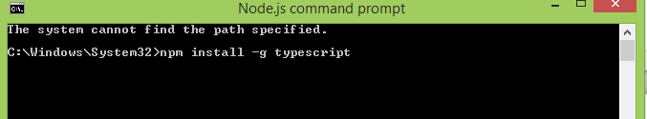

* After running the above command the following window will appear.

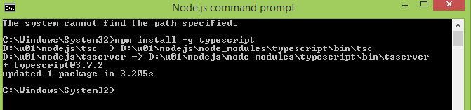

* Type script was successfully installed.
* Now we have install angular CLI (command line interface) , for that type below command in node.js command prompt.

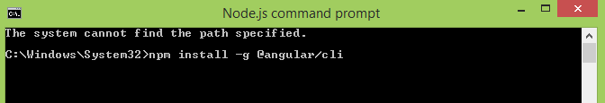

* After running above command the following window will appear.

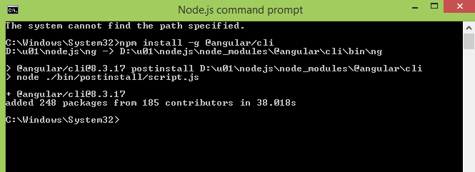

* Now we have to check whether angular is properly installed or not. For that run the below command .

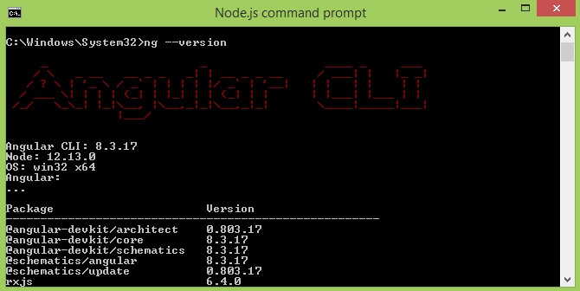

**How to create an angular project?**

* To create an angular project run the following command in command prompt.

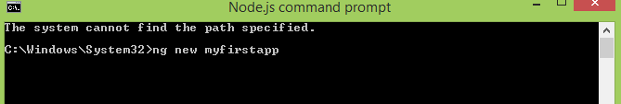

Here myfirstapp is a filename of newly created project.

* Now it will ask you to add angular routing to your project or not

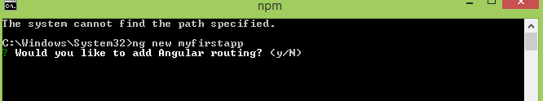

* Type y to select routing
* After that it will ask you to which type of style sheet would you like

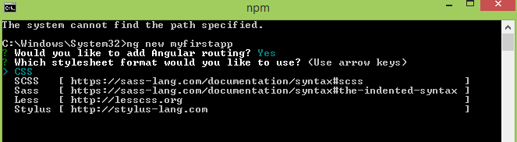

* Select css and press enter.
* Now observe the new project files are created.

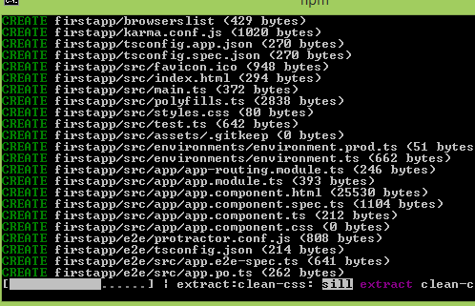

**How to run a angular project?**

* To run an angular project type the following command and run.

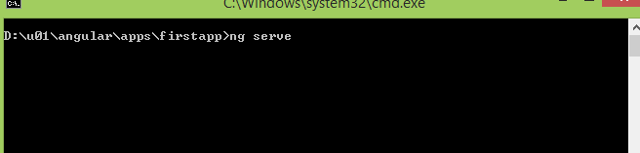

* Now observe what will happen. success fully compiled

