Apache tomcat

Open source java web server.

container of servlets and jsp

**Implementation** of java servlets, java server pages, java expression language, and java web socket technologies.

Specification of java servlets, java server pages, java expression language, and java web socket technologies are developed by under the Java Community Process (JCP).

Tomcat version 9.0 is implantation of servlet 4.0 and jsp 2.3 specifications from the JCP

It includes many features by using this we can easily develop and deploy the web applications and web services

Examples of java web servers:

Glass fish Oracle open source

Jboss Jboss community open source

Websphere IBM not an open source

Weblogic Oracle not an open source

Tomcat Apache open source

Etc…..

Tomcat Server Download

Download from the <https://tomcat.apache.org/download-90.cgi> link

There are three variants

32-bit windows zip

64-bit windows zip

32/64-bit windows service installer

Difference between installer and zip folder download?

//to do wright

Introduction// to do

Tomcat server 9.0.22 installation

Prerequisites

JAVA 1.8 or later

How to start tomcat server from command prompt ?

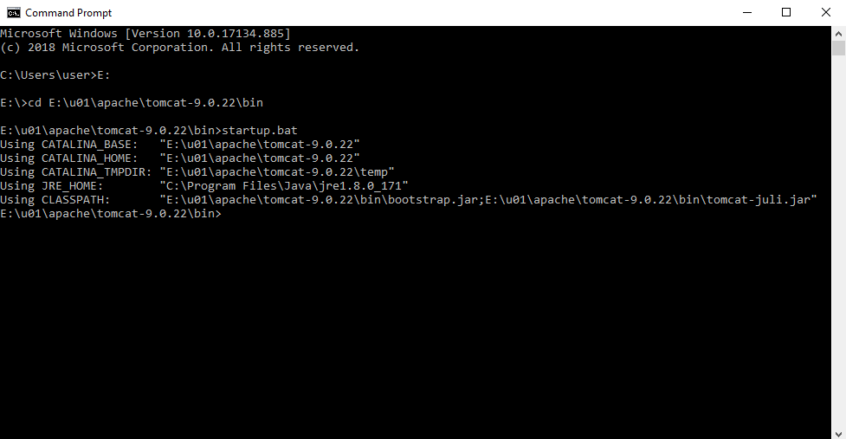

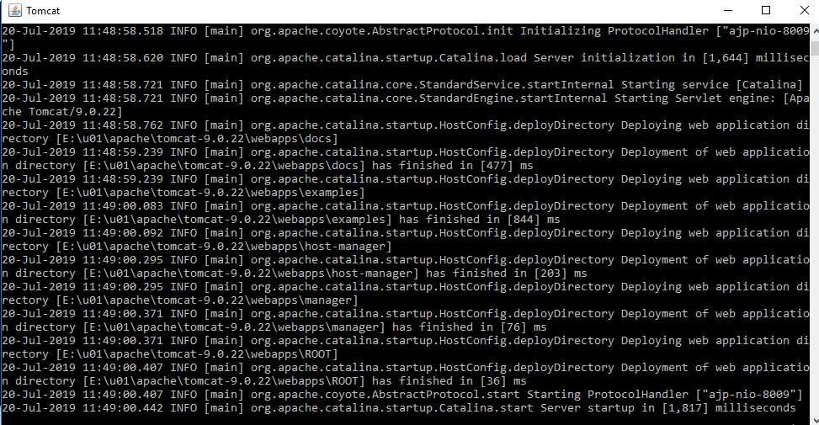

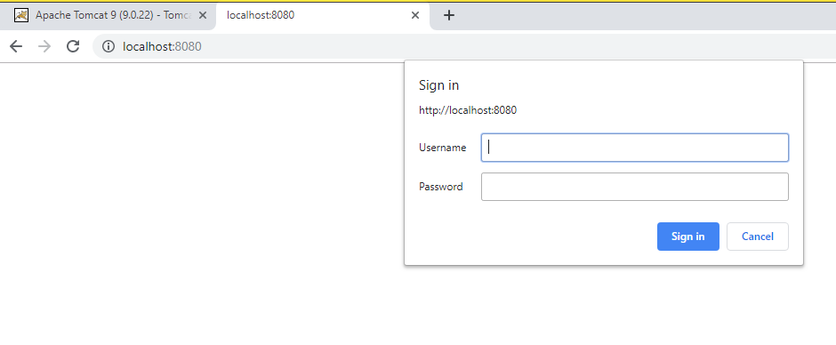

How to create user name and password for a tomcat to login?

What is the difference between CATALINA_BASE and CATALINA_HOME?