**Ajax introduction**:

AJAX: **A**synchronous **J**avaScript **A**nd **X**ml.

Ajax allows you to send and receive the data without reloading webpage. It is a group of related technologies (HTML, CSS, XML and DOM) used to display data asynchronously. The real web applications of AJAX running in the market are Gmail, Face book, twitter and YouTube etc…

AJAX allows you to send only important information to the server not the entire page. So only valuable data from the client side is routed to the server side. It makes your application interactive and faster.

**Difference between synchronous and asynchronous**:

|  |  |
| --- | --- |
| Synchronous | Asynchronous |
| It waits the each operation to complete, after that it only executes the next operation. | Asynchronous is no need to complete the each operation it works parallely. |

**Ajax technologies:**

* DOM (document object model).

It is used for dynamic display and iteration with data.

* HTML (hypertext markup language) and CSS (Cascading style sheets).

These technologies used for display content and style. It is mainly used for presentation.

* XML (extensible markup language) or JSON (JavaScript object notation).

For carrying data to and from server. Json is like XML but it is short and faster than xml.

* XMLHttpRequest.

For asynchronous communication between client and server.

* JAVASCRIPT.

For using JavaScript is mainly client-side validation.

**XMLHttpRequest**:

An object of XMLHttpRequest is used for asynchronous communication between client and server. It performs following properties:

1. Send data from the client in the background.
2. Receive the data from the server.
3. Updates the WebPages without reloading it.

**Properties**:

1. onReadyStateChange.
2. ReadyState.
3. ResponceText.
4. ResponseXML.

**HOW AJAX WORKS**:

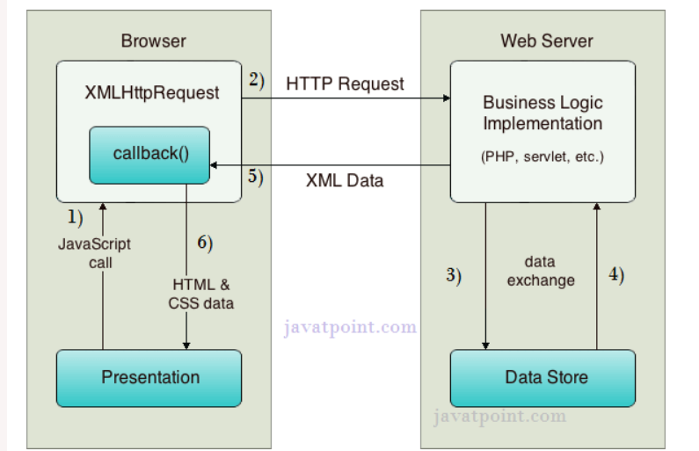

References:

1. <https://www.javatpoint.com/ajax-tutorial>.
2. <https://www.w3schools.com/js/js_ajax_intro.asp>.