Double click on jdk

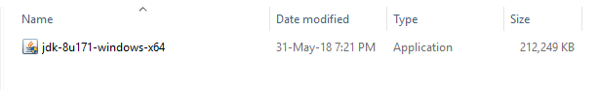

Then it will open the window like

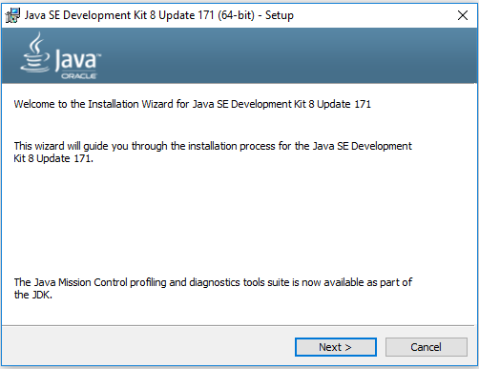

Click next button

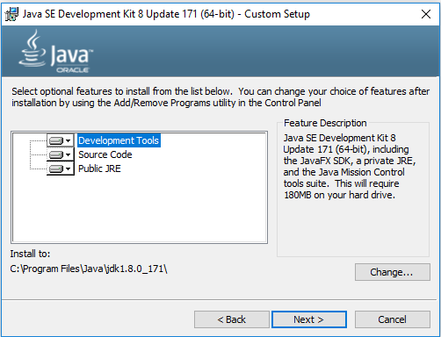

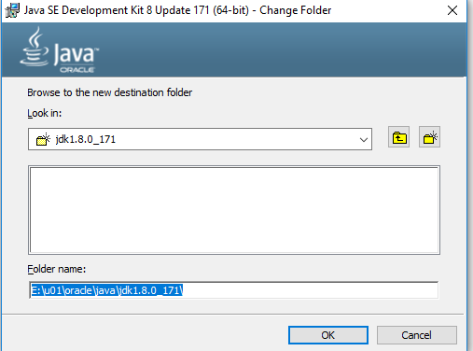

Click ok and Click next

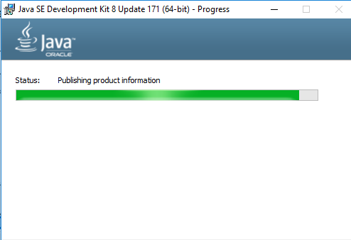

Wait for sometime it will open new window for jre installation, like below

Click on next

Click on change button to change the jre installation location as like below, then click next.

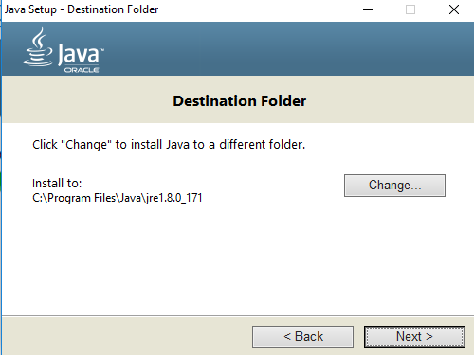

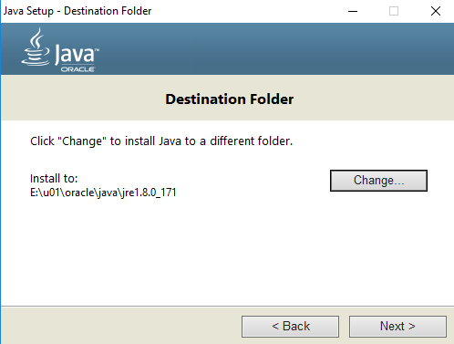

It will start jre installation process

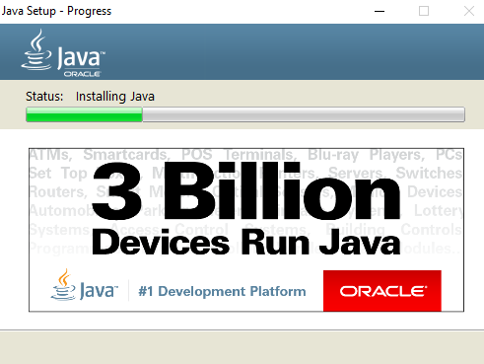

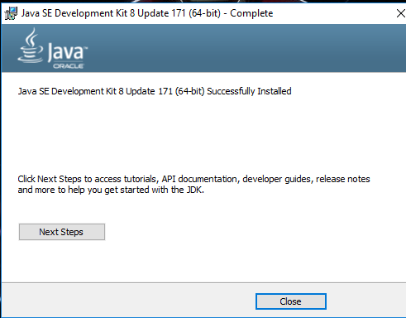

java installation completed.

How to set the java path

Copy the path upto bin folder

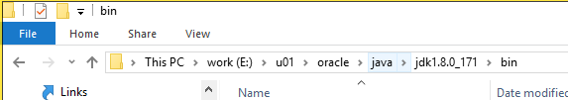

Goto the advances system settings

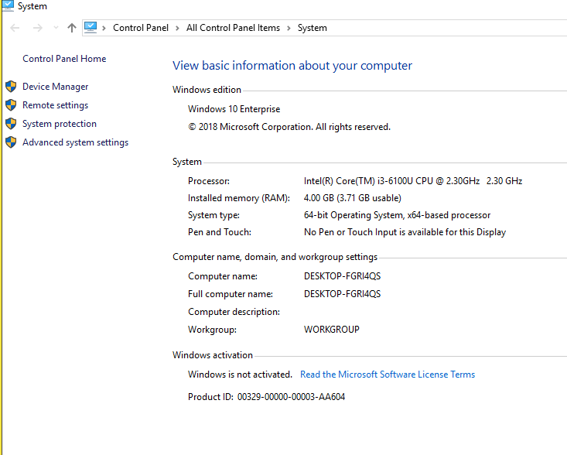

Click on advance system settings link

Click on environment variables

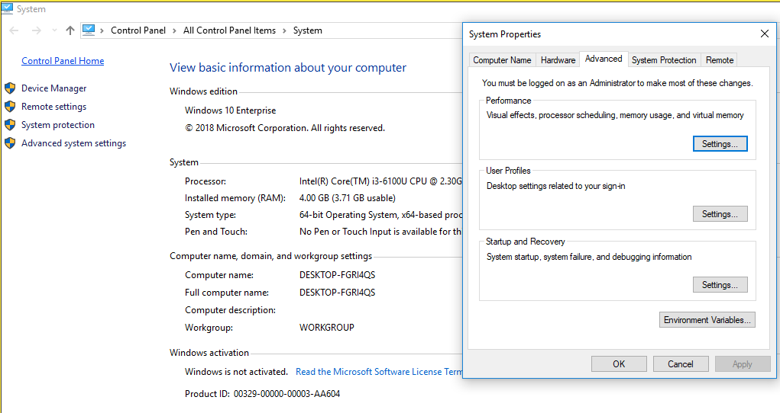

It will opens the user environment variable and system variables.

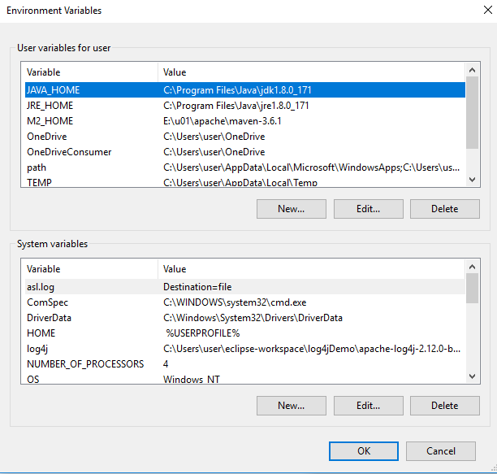

Update the JAVA _ HOME like below and then click on ok button.

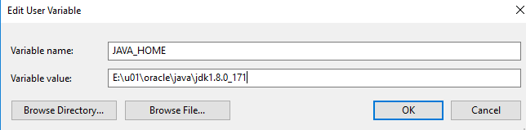

Create a JRE_HOME in the user variable section and provide the value like below.

Then click on a ok button.

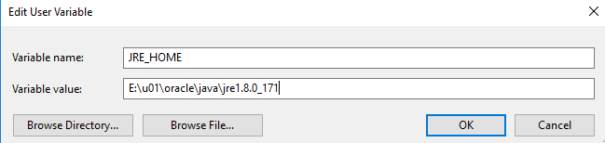

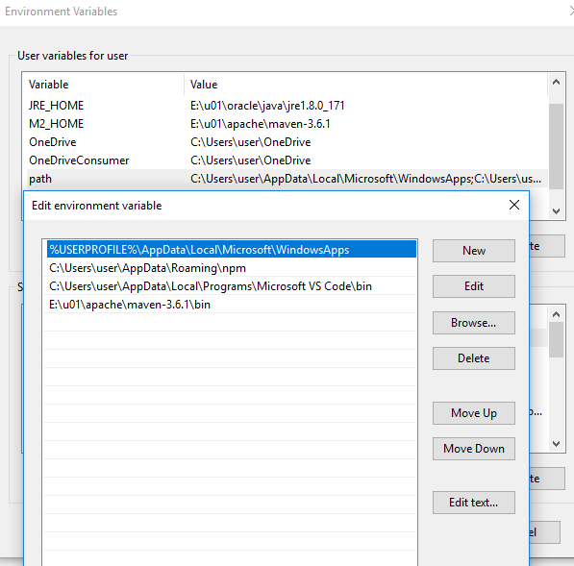

Click on new button and add the jdk path upto bin folder.

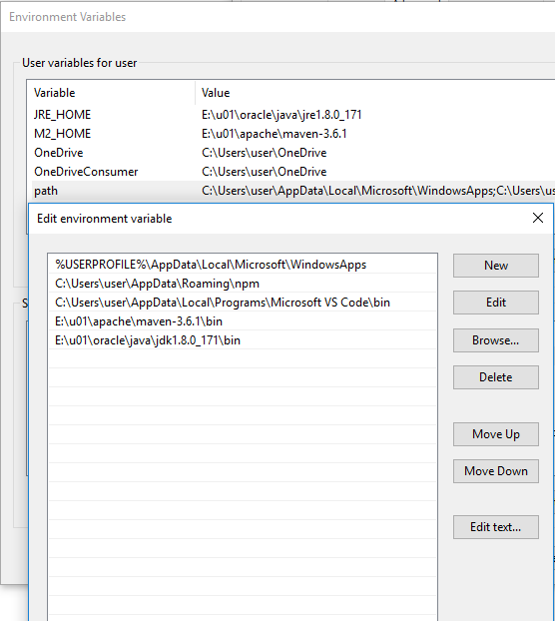

Click on ok ok buttons and close the advanced system settings.

------------

Check the java version

Open the command prompt and type the java –version.

It will show the installed java version like below.

