How to integrate log4j with maven project in eclipse:--

First create a new Maven project in Eclipse,and enter location for that maven project.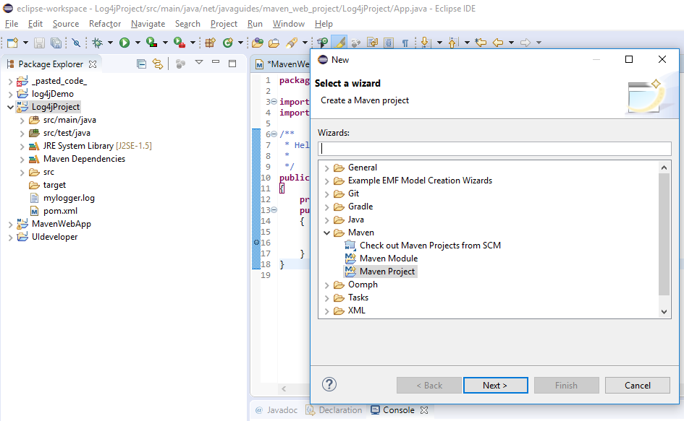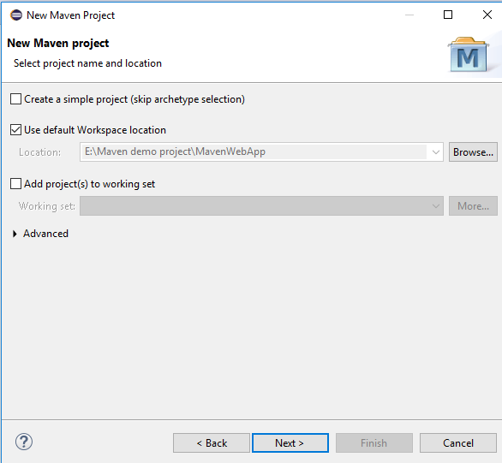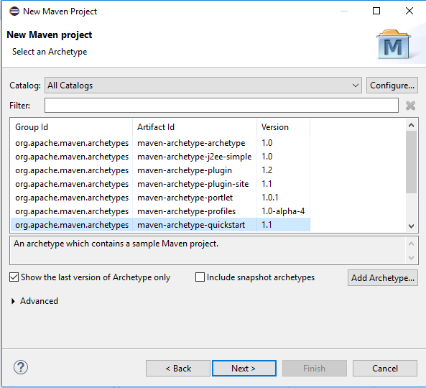

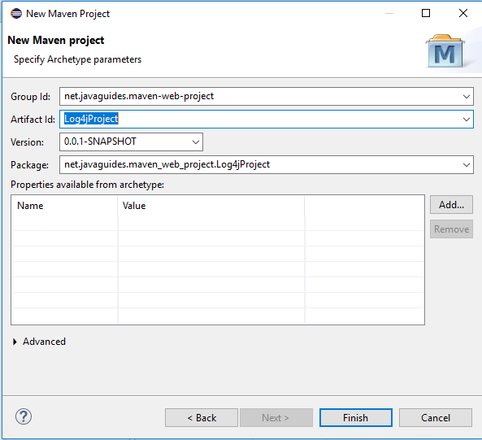

Go to source folder in that main folder create a new Resource folder.

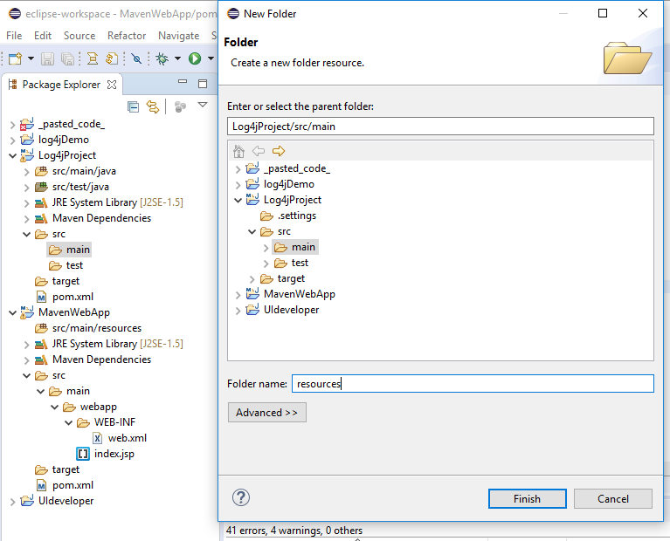

In Resources folder create a log4j2.properties file.

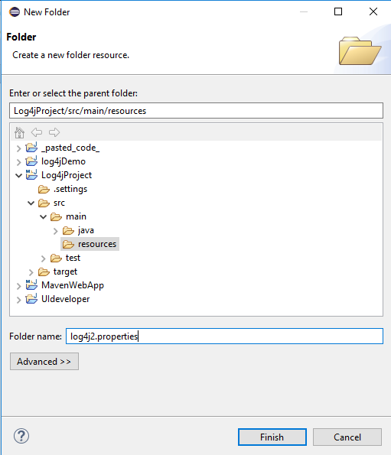

Go to log4j2.properties and give the properties, That properties are available in browser you can google it.

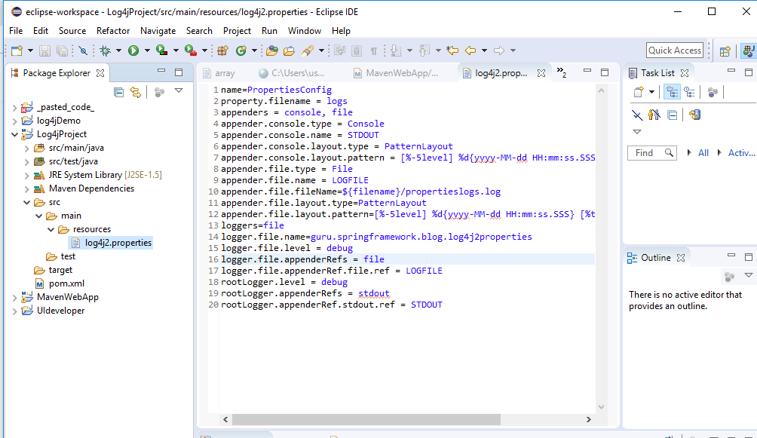

You can change the appender.file.filename=mylogger.log, As your wish.

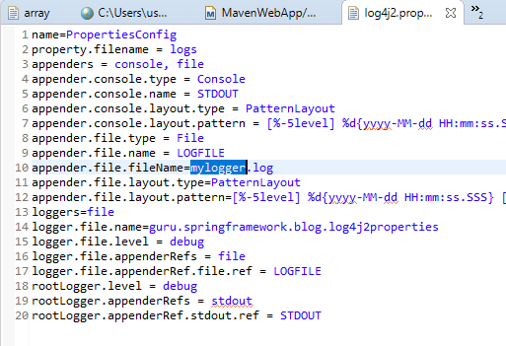

After changing appender file name, we have to change again package name,here.

logger.file.name=net.javaguide.maven_web_project.Log4jProject

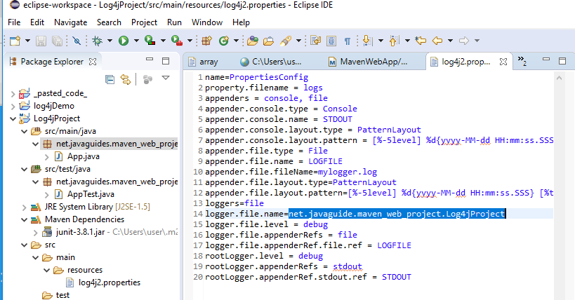

***We have to add the Log4j dependencies in maven pom.xml.

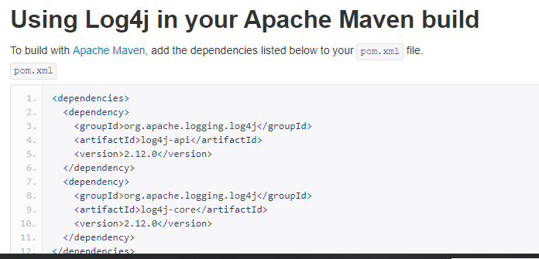

We have added log4j2 dependencies in pom.xml file.

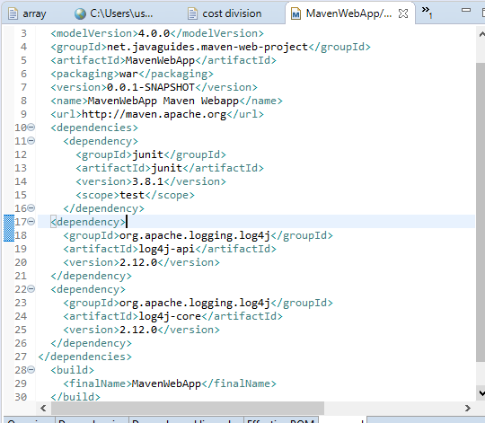

Do a small coding to test that logger is working or not?

Coming that( App.java ),here we create that object of logger and write the statement

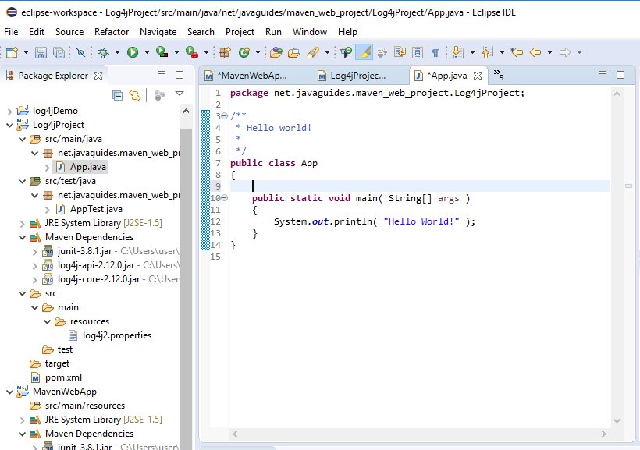

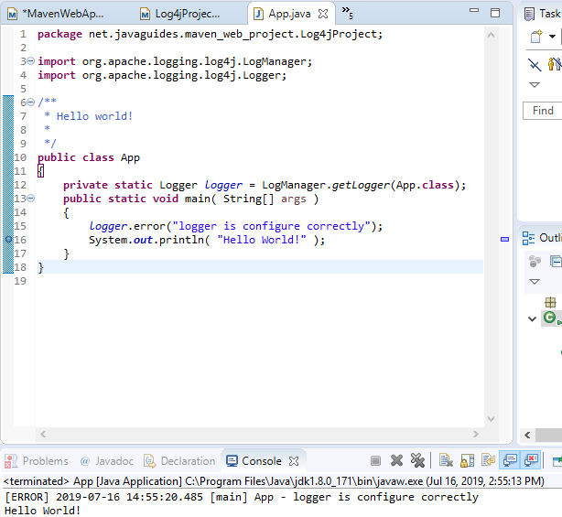

After enter the code App.java file run the program in server, then Here logger statement is printed, now we have to check logger file is generated or not.

Go to project and right click then refresh .

Here we got successfully configured, And we got mylogger.log file is Created.

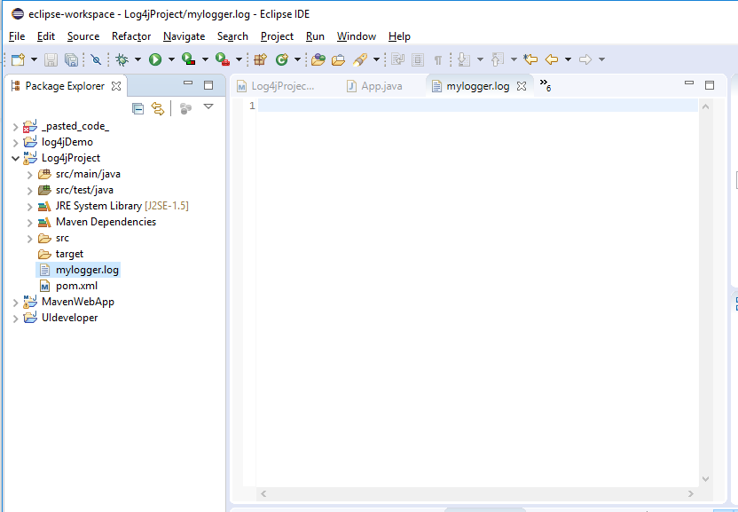

How to integrate log4j audit with maven project in eclipse:--