*Paul Glenn*

*CHEM 220B*

*PS #6*

1(i)

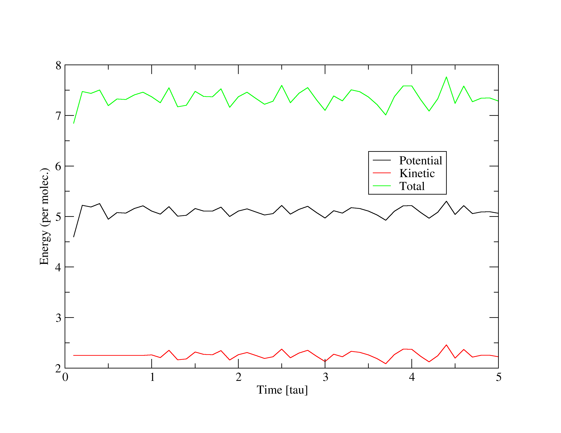

(ii)

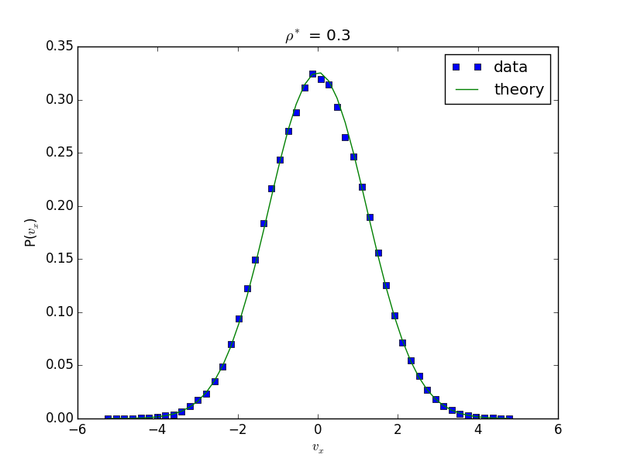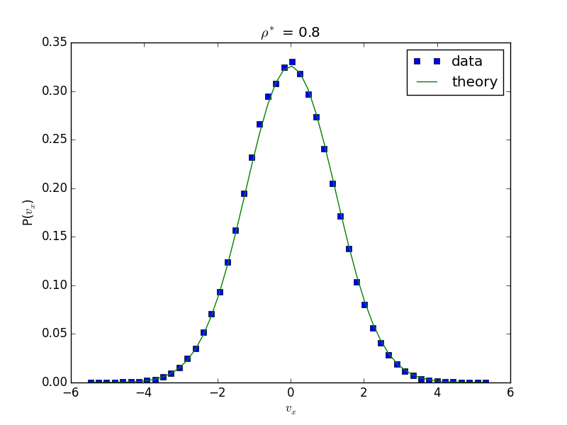

(iii)

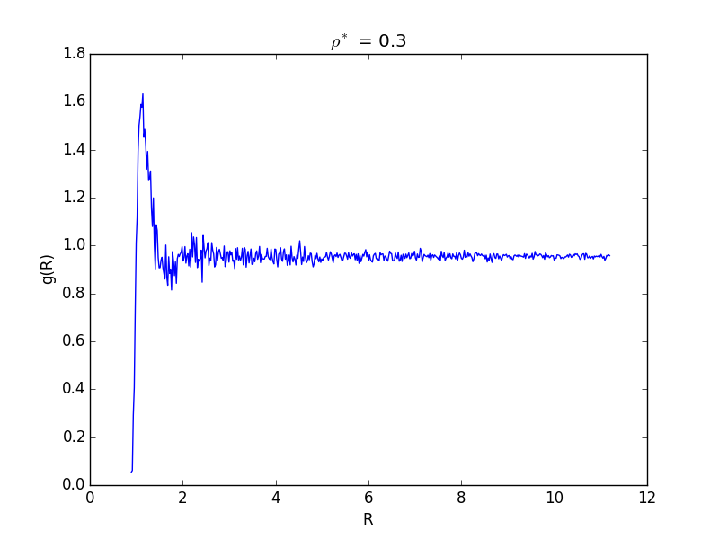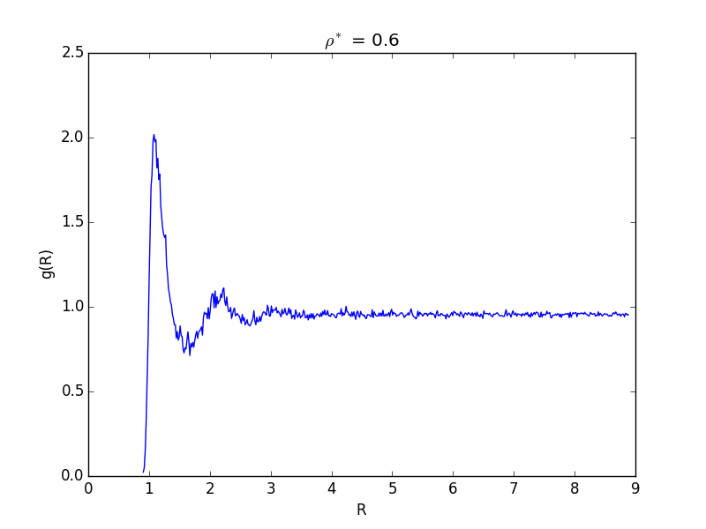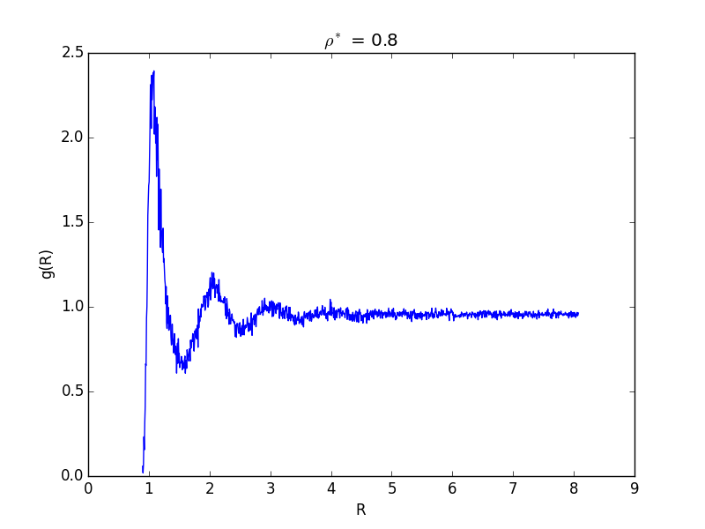

The radial distribution functions for hard spheres are zero for distances less than a particle diameter: here it is not quite so. They both do drop off severely, however. The other qualitative aspects are identical.

At higher temperatures, one would expect the peaks to be less pronounced, as they should approach the low density case. This is because the energetics start to matter less at higher temperatures. The tail for distances less than a particle diameter could also become larger for the same reason, since the energetic penalty is finite.

(iv) Mean square deviation

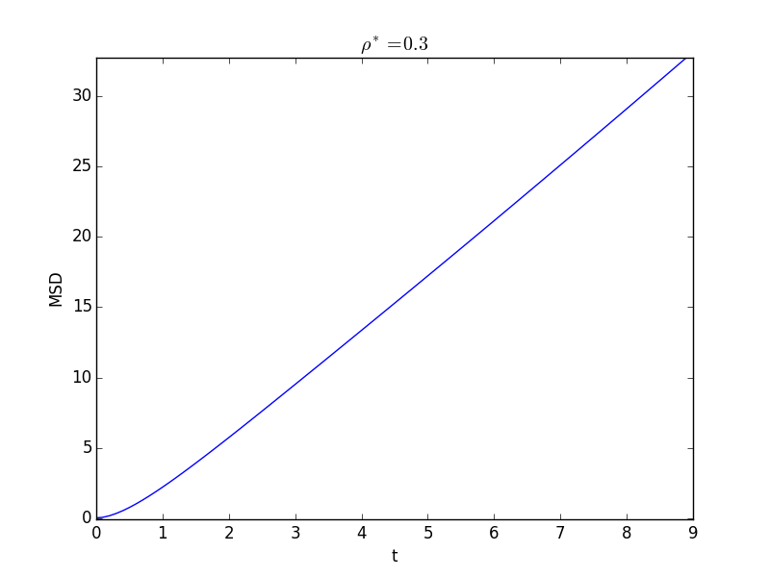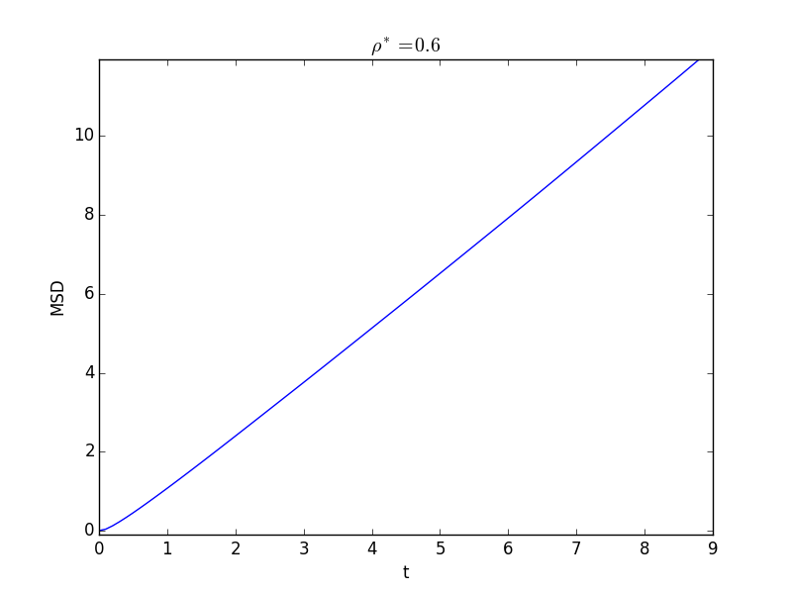x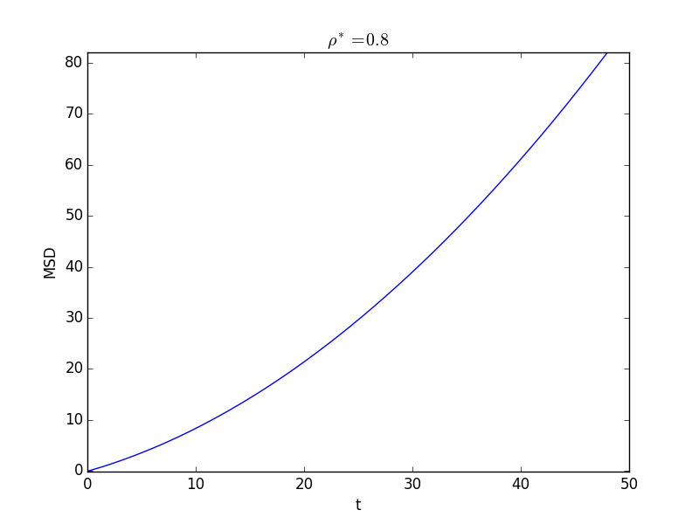

(v) VCF

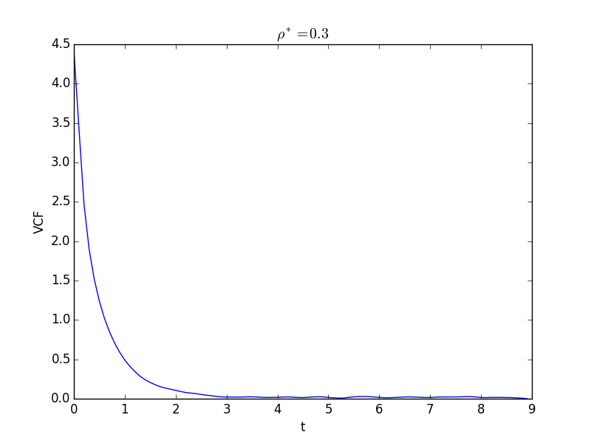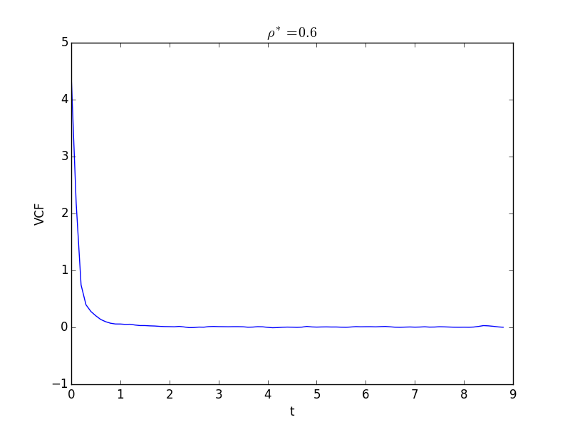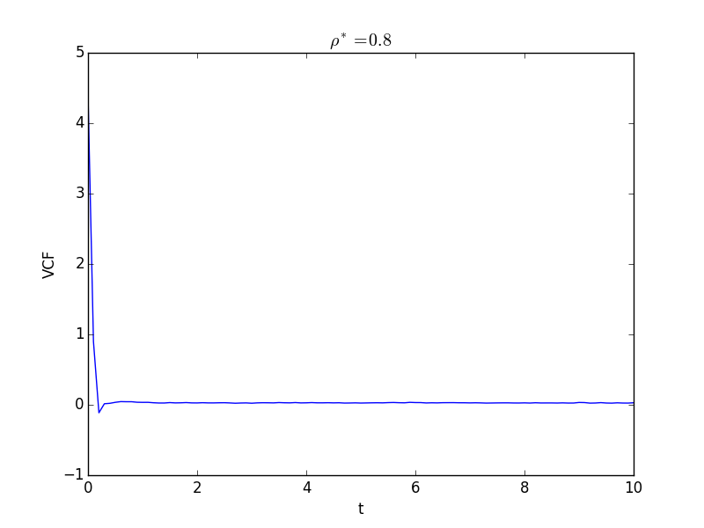

(vi) Diffusion coefficients

|  |  |  |
| --- | --- | --- |
| Density | D(MSD) | D(VCF) |
| 0.3 | $$0.67±0.04$$ | 0.68 $±$ 0.04 |
| 0.6 | $$0.24±0.0$$ | $$0.24±0.0$$ |
| 0.8 | $$0.14±0.0$$ | $$0.14±0.0$$ |