Assignment - Classification with Logistic Regression

## Prince Agyabeng

Loading the Library

library(tidyverse)

## -- Attaching packages ------------------------------------------ tidyverse 1.3.0 --

## v ggplot2 3.2.1 v purrr 0.3.3  
## v tibble 2.1.3 v dplyr 0.8.3  
## v tidyr 1.0.0 v stringr 1.4.0  
## v readr 1.3.1 v forcats 0.4.0

## -- Conflicts --------------------------------------------- tidyverse_conflicts() --  
## x dplyr::filter() masks stats::filter()  
## x dplyr::lag() masks stats::lag()

library(MASS)

##   
## Attaching package: 'MASS'

## The following object is masked from 'package:dplyr':  
##   
## select

library(ROCR)

## Loading required package: gplots

##   
## Attaching package: 'gplots'

## The following object is masked from 'package:stats':  
##   
## lowess

library(caret)

## Loading required package: lattice

##   
## Attaching package: 'caret'

## The following object is masked from 'package:purrr':  
##   
## lift

library(e1071)

Loading the data

parole <- read_csv("parole.csv")

## Parsed with column specification:  
## cols(  
## male = col_double(),  
## race = col_double(),  
## age = col_double(),  
## state = col_double(),  
## time.served = col_double(),  
## max.sentence = col_double(),  
## multiple.offenses = col_double(),  
## crime = col_double(),  
## violator = col_double()  
## )

str(parole)

## Classes 'spec_tbl_df', 'tbl_df', 'tbl' and 'data.frame': 675 obs. of 9 variables:  
## $ male : num 1 0 1 1 1 1 1 0 0 1 ...  
## $ race : num 1 1 2 1 2 2 1 1 1 2 ...  
## $ age : num 33.2 39.7 29.5 22.4 21.6 46.7 31 24.6 32.6 29.1 ...  
## $ state : num 1 1 1 1 1 1 1 1 1 1 ...  
## $ time.served : num 5.5 5.4 5.6 5.7 5.4 6 6 4.8 4.5 4.7 ...  
## $ max.sentence : num 18 12 12 18 12 18 18 12 13 12 ...  
## $ multiple.offenses: num 0 0 0 0 0 0 0 0 0 0 ...  
## $ crime : num 4 3 3 1 1 4 3 1 3 2 ...  
## $ violator : num 0 0 0 0 0 0 0 0 0 0 ...  
## - attr(*, "spec")=  
## .. cols(  
## .. male = col_double(),  
## .. race = col_double(),  
## .. age = col_double(),  
## .. state = col_double(),  
## .. time.served = col_double(),  
## .. max.sentence = col_double(),  
## .. multiple.offenses = col_double(),  
## .. crime = col_double(),  
## .. violator = col_double()  
## .. )

Transforming the data sets

parole = parole %>% mutate(male = as_factor(as.character(male))) %>%  
mutate(male = fct_recode(male,  
"male" = "1",  
"female" = "0"))  
  
parole = parole %>% mutate(race = as_factor(as.character(race))) %>%  
mutate(race = fct_recode(race,  
"White" = "1",  
"Other" = "2"))  
  
parole = parole %>% mutate(state = as_factor(as.character(state))) %>%  
mutate(state = fct_recode(state,  
"Kentucky" = "2",  
"Louisiana" = "3",  
"Virginia" = "4",  
"any other state" = "1"))  
  
parole = parole %>% mutate(multiple.offenses = as_factor(as.character(multiple.offenses))) %>%  
mutate(multiple.offenses = fct_recode(multiple.offenses,  
"multiple.offenses" = "1",  
"Otherwise" = "0"))  
  
parole = parole %>% mutate(crime = as_factor(as.character(crime))) %>%  
mutate(crime = fct_recode(crime,  
"larceny" = "2",  
"drug-related crime" = "3",  
"drug-related crime" = "4",  
"any other crime" = "1"))  
  
parole = parole %>% mutate(violator = as_factor(as.character(violator))) %>%  
mutate(violator = fct_recode(violator,  
"violated the parole" = "1",  
"completed the parole without violation" = "0"))  
str(parole)

## Classes 'spec_tbl_df', 'tbl_df', 'tbl' and 'data.frame': 675 obs. of 9 variables:  
## $ male : Factor w/ 2 levels "male","female": 1 2 1 1 1 1 1 2 2 1 ...  
## $ race : Factor w/ 2 levels "White","Other": 1 1 2 1 2 2 1 1 1 2 ...  
## $ age : num 33.2 39.7 29.5 22.4 21.6 46.7 31 24.6 32.6 29.1 ...  
## $ state : Factor w/ 4 levels "any other state",..: 1 1 1 1 1 1 1 1 1 1 ...  
## $ time.served : num 5.5 5.4 5.6 5.7 5.4 6 6 4.8 4.5 4.7 ...  
## $ max.sentence : num 18 12 12 18 12 18 18 12 13 12 ...  
## $ multiple.offenses: Factor w/ 2 levels "Otherwise","multiple.offenses": 1 1 1 1 1 1 1 1 1 1 ...  
## $ crime : Factor w/ 3 levels "drug-related crime",..: 1 1 1 2 2 1 1 2 1 3 ...  
## $ violator : Factor w/ 2 levels "completed the parole without violation",..: 1 1 1 1 1 1 1 1 1 1 ...

Task 1 - Training the Data

set.seed(12345)  
train.rows = createDataPartition(y = parole$violator, p=0.7, list = FALSE)  
train = parole[train.rows,]   
test = parole[-train.rows,]

Task 2 - Data visualization

ggplot(train, aes(x=male, fill = violator)) + geom_bar() + theme_bw()

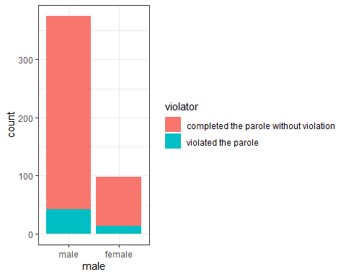

There’s seems to be relationship between male and violator. It indicates that male are more likely to violates their parole.

ggplot(train, aes(x=state, fill = violator)) + geom_bar() + theme_bw()

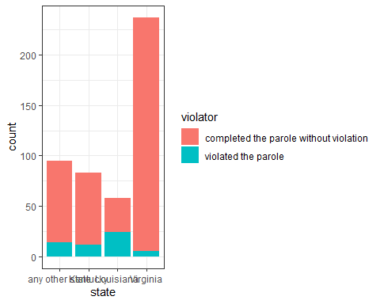

State has a strong relationship with violator and hence state will be choosen to predict violator

ggplot(train, aes(x=violator, y= age)) + geom_boxplot() + theme_bw()

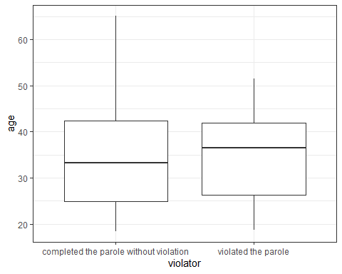

There’s also no relationship between age and violator

ggplot(train, aes(x=crime, fill = violator)) + geom_bar() + theme_bw()

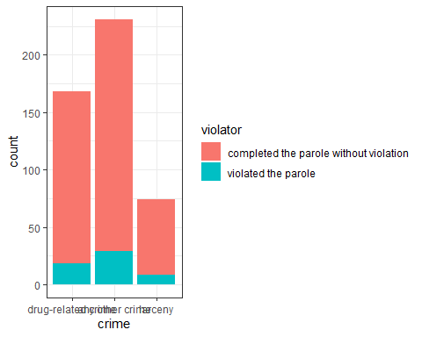

There’s seemsto be a relationship between crime and violator

ggplot(train, aes(x=multiple.offenses, fill = violator)) + geom_bar() + theme_bw()

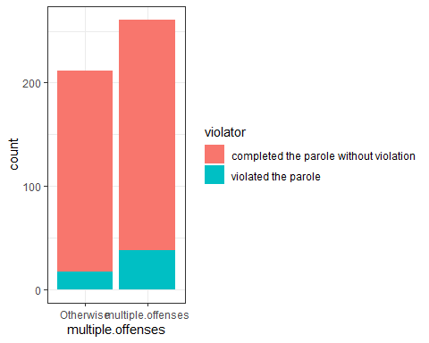

It seems people with multiple offenses tend to violate the parole.

ggplot(train, aes(x=race, fill = violator)) + geom_bar() + theme_bw()

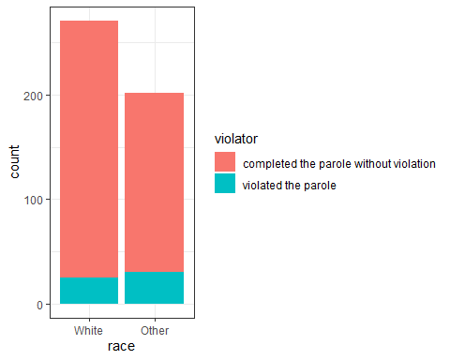

From the graph, race doesn’t predict the violator variable. state has strong predictive relationship with violator as indicated in the graph above.

Task 3 - building a model

Model1 = glm(violator ~ state , train, family = "binomial")  
summary(Model1)

##   
## Call:  
## glm(formula = violator ~ state, family = "binomial", data = train)  
##   
## Deviance Residuals:   
## Min 1Q Median 3Q Max   
## -1.0335 -0.5589 -0.2065 -0.2065 2.7780   
##   
## Coefficients:  
## Estimate Std. Error z value Pr(>|z|)   
## (Intercept) -1.75539 0.28944 -6.065 1.32e-09 ***  
## stateKentucky -0.02238 0.42567 -0.053 0.958067   
## stateLouisiana 1.40709 0.39351 3.576 0.000349 ***  
## stateVirginia -2.08191 0.53672 -3.879 0.000105 ***  
## ---  
## Signif. codes: 0 '***' 0.001 '**' 0.01 '*' 0.05 '.' 0.1 ' ' 1  
##   
## (Dispersion parameter for binomial family taken to be 1)  
##   
## Null deviance: 340.04 on 472 degrees of freedom  
## Residual deviance: 275.18 on 469 degrees of freedom  
## AIC: 283.18  
##   
## Number of Fisher Scoring iterations: 6

From the graph, Louisiana and Virginia state are signigicant in prediciting violator variables. The model is good as the AIC is smaller.

Task 4 - using stepwise method

all_variable = glm(violator ~., train, family = "binomial")   
summary(all_variable)

##   
## Call:  
## glm(formula = violator ~ ., family = "binomial", data = train)  
##   
## Deviance Residuals:   
## Min 1Q Median 3Q Max   
## -1.6201 -0.3978 -0.2639 -0.1338 2.9653   
##   
## Coefficients:  
## Estimate Std. Error z value Pr(>|z|)   
## (Intercept) -3.358812 1.181944 -2.842 0.00449 **   
## malefemale 0.159699 0.410679 0.389 0.69737   
## raceOther 1.163370 0.401162 2.900 0.00373 **   
## age 0.003205 0.016620 0.193 0.84707   
## stateKentucky 0.189102 0.485207 0.390 0.69673   
## stateLouisiana 0.247086 0.555933 0.444 0.65672   
## stateVirginia -3.827016 0.666254 -5.744 9.24e-09 ***  
## time.served -0.106924 0.118860 -0.900 0.36835   
## max.sentence 0.066590 0.053945 1.234 0.21705   
## multiple.offensesmultiple.offenses 1.737180 0.396432 4.382 1.18e-05 ***  
## crimeany other crime 0.337331 0.377971 0.892 0.37214   
## crimelarceny 0.732766 0.552556 1.326 0.18479   
## ---  
## Signif. codes: 0 '***' 0.001 '**' 0.01 '*' 0.05 '.' 0.1 ' ' 1  
##   
## (Dispersion parameter for binomial family taken to be 1)  
##   
## Null deviance: 340.04 on 472 degrees of freedom  
## Residual deviance: 242.60 on 461 degrees of freedom  
## AIC: 266.6  
##   
## Number of Fisher Scoring iterations: 6

empty_variable = glm(violator~1, train, family = "binomial")   
summary(empty_variable)

##   
## Call:  
## glm(formula = violator ~ 1, family = "binomial", data = train)  
##   
## Deviance Residuals:   
## Min 1Q Median 3Q Max   
## -0.4972 -0.4972 -0.4972 -0.4972 2.0745   
##   
## Coefficients:  
## Estimate Std. Error z value Pr(>|z|)   
## (Intercept) -2.0281 0.1434 -14.14 <2e-16 ***  
## ---  
## Signif. codes: 0 '***' 0.001 '**' 0.01 '*' 0.05 '.' 0.1 ' ' 1  
##   
## (Dispersion parameter for binomial family taken to be 1)  
##   
## Null deviance: 340.04 on 472 degrees of freedom  
## Residual deviance: 340.04 on 472 degrees of freedom  
## AIC: 342.04  
##   
## Number of Fisher Scoring iterations: 4

Using Backward stepwise

backmodel = stepAIC(all_variable, direction = "backward", trace = TRUE)

## Start: AIC=266.6  
## violator ~ male + race + age + state + time.served + max.sentence +   
## multiple.offenses + crime  
##   
## Df Deviance AIC  
## - crime 2 244.47 264.47  
## - age 1 242.64 264.64  
## - male 1 242.75 264.75  
## - time.served 1 243.41 265.41  
## - max.sentence 1 244.16 266.16  
## <none> 242.60 266.60  
## - race 1 251.20 273.20  
## - multiple.offenses 1 263.06 285.06  
## - state 3 321.52 339.52  
##   
## Step: AIC=264.47  
## violator ~ male + race + age + state + time.served + max.sentence +   
## multiple.offenses  
##   
## Df Deviance AIC  
## - age 1 244.48 262.48  
## - male 1 244.85 262.85  
## - time.served 1 245.04 263.04  
## - max.sentence 1 246.00 264.00  
## <none> 244.47 264.47  
## - race 1 252.62 270.62  
## - multiple.offenses 1 265.46 283.46  
## - state 3 321.69 335.69  
##   
## Step: AIC=262.48  
## violator ~ male + race + state + time.served + max.sentence +   
## multiple.offenses  
##   
## Df Deviance AIC  
## - male 1 244.86 260.86  
## - time.served 1 245.04 261.04  
## - max.sentence 1 246.01 262.01  
## <none> 244.48 262.48  
## - race 1 252.65 268.65  
## - multiple.offenses 1 265.52 281.52  
## - state 3 322.14 334.14  
##   
## Step: AIC=260.86  
## violator ~ race + state + time.served + max.sentence + multiple.offenses  
##   
## Df Deviance AIC  
## - time.served 1 245.31 259.31  
## - max.sentence 1 246.33 260.33  
## <none> 244.86 260.86  
## - race 1 252.80 266.80  
## - multiple.offenses 1 265.93 279.93  
## - state 3 322.54 332.54  
##   
## Step: AIC=259.31  
## violator ~ race + state + max.sentence + multiple.offenses  
##   
## Df Deviance AIC  
## - max.sentence 1 246.98 258.98  
## <none> 245.31 259.31  
## - race 1 253.11 265.11  
## - multiple.offenses 1 266.89 278.89  
## - state 3 323.88 331.88  
##   
## Step: AIC=258.98  
## violator ~ race + state + multiple.offenses  
##   
## Df Deviance AIC  
## <none> 246.98 258.98  
## - race 1 254.96 264.96  
## - multiple.offenses 1 267.66 277.66  
## - state 3 332.93 338.93

summary(backmodel)

##   
## Call:  
## glm(formula = violator ~ race + state + multiple.offenses, family = "binomial",   
## data = train)  
##   
## Deviance Residuals:   
## Min 1Q Median 3Q Max   
## -1.3609 -0.4094 -0.2705 -0.1575 2.9653   
##   
## Coefficients:  
## Estimate Std. Error z value Pr(>|z|)   
## (Intercept) -2.51087 0.36354 -6.907 4.96e-12 ***  
## raceOther 1.09382 0.38974 2.807 0.00501 **   
## stateKentucky 0.07372 0.46051 0.160 0.87282   
## stateLouisiana 0.10381 0.50018 0.208 0.83559   
## stateVirginia -3.60795 0.63788 -5.656 1.55e-08 ***  
## multiple.offensesmultiple.offenses 1.73482 0.39421 4.401 1.08e-05 ***  
## ---  
## Signif. codes: 0 '***' 0.001 '**' 0.01 '*' 0.05 '.' 0.1 ' ' 1  
##   
## (Dispersion parameter for binomial family taken to be 1)  
##   
## Null deviance: 340.04 on 472 degrees of freedom  
## Residual deviance: 246.98 on 467 degrees of freedom  
## AIC: 258.98  
##   
## Number of Fisher Scoring iterations: 6

from the graph, the model, violator ~ race + state + multiple.offenses gives the best prediction with AIC as 260.59 using the backward stepwise method

Forward stepwise approach

forwardmodel = stepAIC(empty_variable, direction = "forward", scope=list(upper=all_variable,lower=empty_variable), trace = TRUE)

## Start: AIC=342.04  
## violator ~ 1  
##   
## Df Deviance AIC  
## + state 3 275.18 283.18  
## + max.sentence 1 331.01 335.01  
## + multiple.offenses 1 335.02 339.02  
## + race 1 336.51 340.51  
## + time.served 1 336.61 340.61  
## <none> 340.04 342.04  
## + male 1 339.72 343.72  
## + age 1 339.95 343.95  
## + crime 2 339.66 345.66  
##   
## Step: AIC=283.18  
## violator ~ state  
##   
## Df Deviance AIC  
## + multiple.offenses 1 254.96 264.96  
## + race 1 267.66 277.66  
## <none> 275.18 283.18  
## + max.sentence 1 274.27 284.27  
## + time.served 1 274.44 284.44  
## + age 1 275.11 285.11  
## + male 1 275.13 285.13  
## + crime 2 273.21 285.21  
##   
## Step: AIC=264.96  
## violator ~ state + multiple.offenses  
##   
## Df Deviance AIC  
## + race 1 246.98 258.98  
## <none> 254.96 264.96  
## + max.sentence 1 253.11 265.11  
## + time.served 1 254.47 266.47  
## + male 1 254.91 266.91  
## + age 1 254.94 266.94  
## + crime 2 253.73 267.73  
##   
## Step: AIC=258.98  
## violator ~ state + multiple.offenses + race  
##   
## Df Deviance AIC  
## <none> 246.98 258.98  
## + max.sentence 1 245.31 259.31  
## + time.served 1 246.33 260.33  
## + male 1 246.78 260.78  
## + age 1 246.98 260.98  
## + crime 2 245.29 261.29

summary(forwardmodel)

##   
## Call:  
## glm(formula = violator ~ state + multiple.offenses + race, family = "binomial",   
## data = train)  
##   
## Deviance Residuals:   
## Min 1Q Median 3Q Max   
## -1.3609 -0.4094 -0.2705 -0.1575 2.9653   
##   
## Coefficients:  
## Estimate Std. Error z value Pr(>|z|)   
## (Intercept) -2.51087 0.36354 -6.907 4.96e-12 ***  
## stateKentucky 0.07372 0.46051 0.160 0.87282   
## stateLouisiana 0.10381 0.50018 0.208 0.83559   
## stateVirginia -3.60795 0.63788 -5.656 1.55e-08 ***  
## multiple.offensesmultiple.offenses 1.73482 0.39421 4.401 1.08e-05 ***  
## raceOther 1.09382 0.38974 2.807 0.00501 **   
## ---  
## Signif. codes: 0 '***' 0.001 '**' 0.01 '*' 0.05 '.' 0.1 ' ' 1  
##   
## (Dispersion parameter for binomial family taken to be 1)  
##   
## Null deviance: 340.04 on 472 degrees of freedom  
## Residual deviance: 246.98 on 467 degrees of freedom  
## AIC: 258.98  
##   
## Number of Fisher Scoring iterations: 6

Forward stepwise approach also produces the same results with violator ~ state + multiple.offenses + race.

Task 5 - using race, state and mulitple offenses

Model2 = glm(violator ~ state + race + multiple.offenses, train, family = "binomial")  
summary(Model2)

##   
## Call:  
## glm(formula = violator ~ state + race + multiple.offenses, family = "binomial",   
## data = train)  
##   
## Deviance Residuals:   
## Min 1Q Median 3Q Max   
## -1.3609 -0.4094 -0.2705 -0.1575 2.9653   
##   
## Coefficients:  
## Estimate Std. Error z value Pr(>|z|)   
## (Intercept) -2.51087 0.36354 -6.907 4.96e-12 ***  
## stateKentucky 0.07372 0.46051 0.160 0.87282   
## stateLouisiana 0.10381 0.50018 0.208 0.83559   
## stateVirginia -3.60795 0.63788 -5.656 1.55e-08 ***  
## raceOther 1.09382 0.38974 2.807 0.00501 **   
## multiple.offensesmultiple.offenses 1.73482 0.39421 4.401 1.08e-05 ***  
## ---  
## Signif. codes: 0 '***' 0.001 '**' 0.01 '*' 0.05 '.' 0.1 ' ' 1  
##   
## (Dispersion parameter for binomial family taken to be 1)  
##   
## Null deviance: 340.04 on 472 degrees of freedom  
## Residual deviance: 246.98 on 467 degrees of freedom  
## AIC: 258.98  
##   
## Number of Fisher Scoring iterations: 6

The model above gives the best prediction of violator as Louisiana, virginia state and race other are signifant variables in predicting the violator.

Task 6 - Predictions

#newdata2 = data.frame(state = "Louisiana", race = "1", multiple.offenses)  
#predict(forwardmodel, newdata2, type="response")

Task 7 - Prediction

predictions = predict(Model2, type="response")   
head(predictions)

## 1 2 3 4 5 6   
## 0.07509978 0.19512504 0.19512504 0.07509978 0.07509978 0.19512504

Threshold selection

ROCRpred = prediction(predictions, train$violator)   
ROCRperf = performance(ROCRpred, "tpr", "fpr")  
plot(ROCRperf, colorize=TRUE, print.cutoffs.at=seq(0,1,by=0.1), text.adj=c(-0.2,1.7))

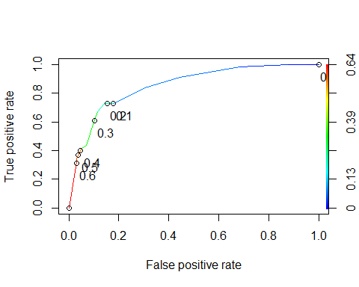

The Performance

as.numeric(performance(ROCRpred, "auc")@y.values)

## [1] 0.8524576

The performanc of the model is good from the above calculation.

Task 8

t1 = table(train$violator,predictions > 0.8513049)  
t1

##   
## FALSE  
## completed the parole without violation 418  
## violated the parole 55

```