BILL OF LADING
Shipper  $(company1.1)  $(company1.2)  $(address1)** |  |  |  |  |  |  |  |  |  |  |  |  |  |  | B/L NO.  $(bill_id)
 |  |  |  |  |  |  |  | 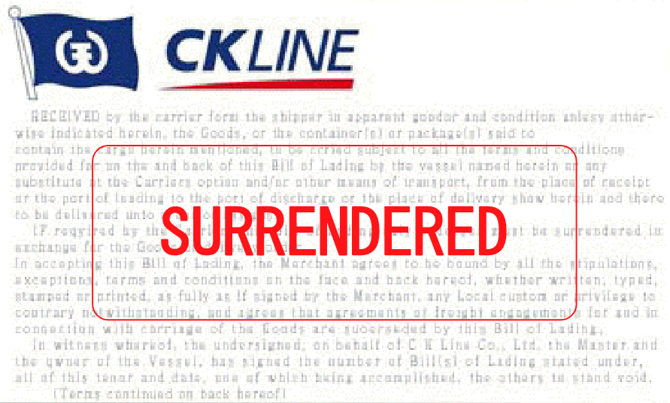
Consignee
$(code1) #$(code2) #$(code3) #$(company2) #$(address2) ***
Notify Party
$(code1) #$(code2) #$(code3) #$(company2) #$(address2) ***
Pre-carriage by |  |  | Place of Receipt  $(place_of_receipt)
Ocean Vessel  $(ocean_vessel) |  |  | Voyage No.  $(voyage_no) |  |  |  |  | Flag  $(flag) |  | Place of Delivery  $(place_of_delivery)
Port of Loading  $(port_of_loading) |  |  | Port of Discharge  $(port_of_discharge) |  |  |  |  | For transhipment to/Final Destination
Container No.& Seal No.  Marks and Numbers |  |  |  | No.& Kind of Pkgs/Cntrs |  |  | Description of Goods |  |  |  |  |  | Gross Weight |  |  |  | Measurement
$(con_no1) $(con_num1)$(con_mark1)  $(con_no2) $(con_num2)$(con_mark2)  $(con_no3) $(con_num3)$(con_mark3)  $(con_no4) $(con_num4)$(con_mark4)  $(con_no5) $(con_num5)$(con_mark5) |  |  |  |  | $(con_no1) X $(con_quantity)  $(bale_quantity) BALES |  | SHIPPER'S LOAD, COUNT AND SEAL SAID TO CONTAIN:  WASTE PAPER (POST  CONSUMER RECLAIMED MATERIAL)NO.11  #108 BALES  #HS CODE: 47071000  #225 CBM  #5 X 40' CONTAINERS  #118.680 MT  #118680 KG  #FREIGHT PREPAID  #DTHC PREPAID |  |  |  |  |  |  | (KGS)  $(gross_weight) |  |  |  | (CBM)  $(measurement)
**$(country1)
TEL: $(tel1)
FAX: $(fax1)
CONTACT:$(name_contact1)
$(ein_tax1)
***$(country2)
#TEL:$(tel2)
#FAX:$(fax2)
#CONTACT:$(name_contact2)
#$(gmail2)
Total number of  packages or units (in words) | "FREIGHT PREPAID" (CY/CY)  SAY : $(text_con_quantity) ($(con_quantity)) CONTAINERS ONLY.
Freight & Charges |  | Revenue Tons |  |  |  |  | Rate |  | Per |  |  | Prepaid |  |  |  | Collect
AS ARRANGED

Freight Prepaid at  $(freight_prepaid_at) |  |  |  |  |  | Freight Payable at |  |  |  |  | Place of Issue  $(place_of_issue)
Total Prepaid in |  |  |  |  |  | No. of Original B/L  ZERO (0) |  |  |  |  | Date of Issue  $(date)
Laden on board the Vessel  Date $(date)  By ___________________________________________________ |  |  |  |  |  |  |  | C K LINE CO. , LTD.  (CHUN KYUNG SHIPPING CO,.LTD.)  By _ "AS_CARRIER" ______________

