$(contract_no) (KR&TW)
 | $(seller_company)
 | 銷售合同  Sales Contract | 正本Original

賣方 | 香港中南貿易有限公司 |  | 合同號碼
Seller: | $(seller_company)  $(seller_address) |  | Contract No.:  日期  Date: | $(contract_no)  $(contract_date)
买方 Buyer: |  | $(buyer_company) | P/O:

1.) | 商品名稱 Commodity: | Waste taper: | (POST CONSUMER RECLAIMED MATERIAL)
 |  | NO.11 | 350 MT AT USD 143.00/MT | CFR Cat Lai or Cai Mep (DTHC Prepaid)
 |  | NO.12 | 1000 MT AT USD 143.00/MT | CFR Cat Lai or Cai Mep (DTHC Prepaid)
 |  | NO.11 | 2000 MT AT USD 155.00/MT | CFR Cat Lai or Cai Mep (DTHC Prepaid)
2.) | 規格/唱質說明 Specifications: | $(specifications)
3.) | 数量 Quantity: | $(quantity)
4.) | 单价 Unit Price: | $(unit_price)
5.) | 忌值 Total Value: | $(total_value)
6.) | 包装 Packing: | Standard Export Packing, Shipped in Containers
7.) | 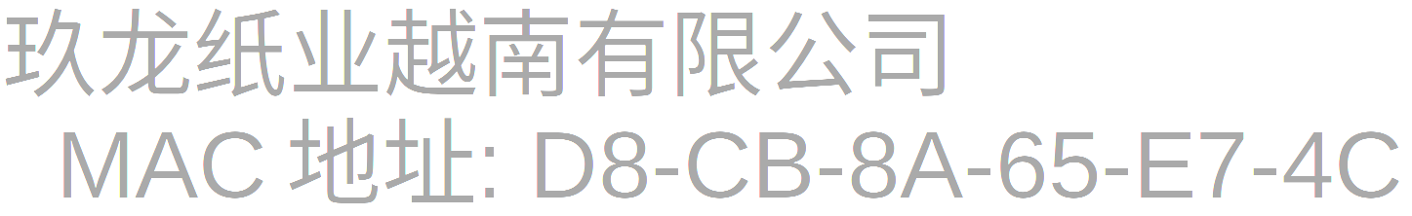  生產國家及制造廣商
Country of Origin & Manufacturer: |  | USA Or Canada Or Europe Or Korea Or Japan Or Japan Or Taiwan, China Or Singapore Or Russia
8.) | 付款条件 Terms of Payment: | T/T in advance
9.) | 保险 Insurance: | To be covered by Buyer
10.) | 装运时间 Time of Shipment: | $(time_of_shipment)
11.) | 裝運口岸 Port of Loading: | Any Port In USA Or Canada Or Europe Or Korea Or Japan Or Taiwan, China Or Singapore Or Russia
12.) | 目的口岸 Port of Destination: | Cat Lai or Cai Mep or Hochiminh Viet or Binh Duong, Vietnam
13.) | 裝運標志 Shipping Marks: | N/M
14.) | 其他條款 Remarks:

严格禁止将生活垃圾与"控制危險鹿物越境點移及其目置巴準球公約"禁止的危险废物和其他废物混合。
进口废物必须符合越南环境保护控制标准的要求。
对于所有索赔，买方必须提供反映质量的全套照片，清楚地显示相关集装箱号和货物的发出情况，并在装运之日起 60 天内将这些照片发送至 总部。 买家必须提供附有集装箱号的重量票，以证明集装箱存在短重问题。 卖方保留拒绝所有逾期索赔的权利。 如有质量问题，买家和卖家将根据照片或重量票等信息协商解决。
Mixing of domestic waste and hazardous and other wastes prohibited by the Basel Convention on the Control of Transboundary Movements of Hazardous Wastes and their Disposal in Commodity is strictly prohibited.
Imported waste must meet the requirements of Vietnam's environmental protection control standards.
For all claims, Buyer must provide a full set of photos that reflect the quality, clearly showing the relevant container number and the issue of thee goods, and send these to the headquarters of America Chung Nam LLC within 60 days after the date of shipment. Buyer must provide a weight ticket with the container number to prove that the container has a short-weight issue. Seller reserves the right to reject all late claims. Any quality issues will be resolved by negotiation between Buyer and Seller based on information such as photos or weight tickets.
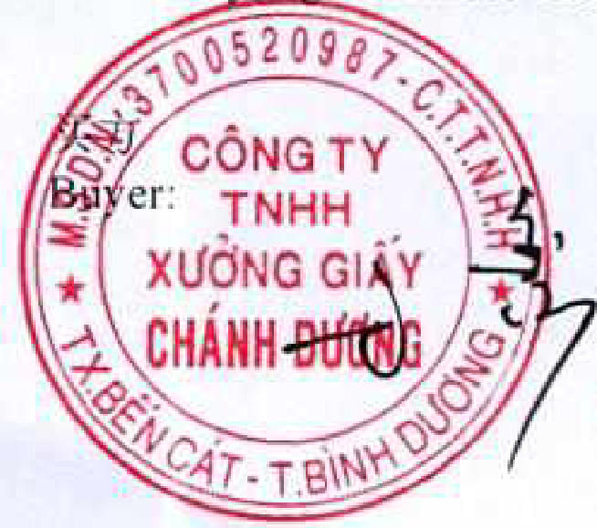 |  | 卖方  Seller: | 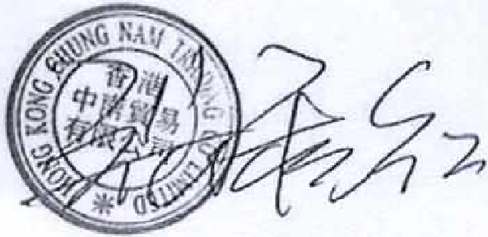
 | TỔNG GIÁM ĐỐC  LI XIN | 卖方  Seller:

