
BENEFITS ASSISTANT
Journey, Configuration &
Workflow Blueprint
Current-state product/UX reference and proposed corporate configuration model
Repository baseline Verified against the EB+Claims workspace as of 10 August 2026. Existing behavior, conceptual future configuration, and identified gaps are explicitly labelled.
Artifact | Value
Audience | Product, UX, engineering, operations, HR and corporate administrators
Orientation | US Letter portrait only; 1-inch margins
Status | Implementation blueprint — no application code or APIs changed
Version | 1.0 | 10 August 2026

Pine green • Mint • Cream • Editable Word workflows

Contents
Select a section to jump to it. Flowcharts are native Word drawing objects and remain editable.
1. Executive summary & scope
2. Master assistant journey
3. Quick-chat and guided workflows
4. Use-case coverage matrices
5. Corporate configuration specification
6. Canonical claim lifecycle
7. Corporate profiles & validation examples
8. Current-state gaps & improvement backlog
9. Conceptual interfaces & implementation notes
10. Verification checklist

Legend
Visual | Meaning
Mint | Success, approved state, or validated outcome
Cream | Employee or assistant action
Amber diamond | Decision or configurable gate
Soft red | Blocked, rejected, or recovery path
Blue | Downstream screen or operational handoff
[CURRENT] | Behavior verified in repository code or deterministic demo
[PROPOSED] | Recommended configuration/lifecycle behavior not yet implemented
[GAP] | Observed difference between intended capability and reachable behavior

1. Executive summary & scope
The Benefits Assistant combines five visible quick chats with additional guided workflows, free-text routing, local persistence, and downstream screen handoffs. Its strongest current behavior is the deterministic, structured benefit-claim demo: the assistant turns a selected bill scenario into editable details, policy checks, warnings and a submission receipt. Vehicle and driver registration are also guided, structured journeys.
Blueprint decision Use the repository as the source of truth for current journeys. Treat corporate configuration, automated reimbursement, and the canonical reimbursement lifecycle as a proposed product contract until backed by services and persisted state.

Scope
- Five visible quick chats: Upload bill, Claim history, Meals merchant, View dashboard and View policy.
- Guided and free-text routes: Track/edit claim, Vehicle Registration, Driver Salary, grounded policy/app-data answers, fallback, persistence and privacy.
- Seven benefit categories, twelve bill scenarios, two driving-licence outcomes, policy questions, claim filters, merchant paths, persona differences, error states and handoffs.
- Corporate configurability only for Bill Upload, Driver Salary and Vehicle Registration.
- User-facing claim lifecycle from upload through reimbursement, including recovery and payment-failure states.

Out of scope
This artifact does not change TypeScript, APIs, database schemas, corporate policy, payment rails, HR queues or production OCR/verification services. Interface names in section 9 are conceptual contracts for future implementation.

Repository evidence
Evidence area | Verified source / observation
Quick chats | features/chat/constants.ts defines the five visible actions.
Routing and guided flows | features/chat/useChat.ts handles quick actions, free text, registration, claim edit, grounding and persistence.
Bill scenarios | features/chat/demoUploadScenarios.ts defines 12 deterministic scenarios.
Benefits & policies | Claim, policy, dashboard and history constants provide the seven categories, balances, status views and policy copy.
Screenshots | Six deterministic local demo journeys captured from http://127.0.0.1:3000 on 10 August 2026.

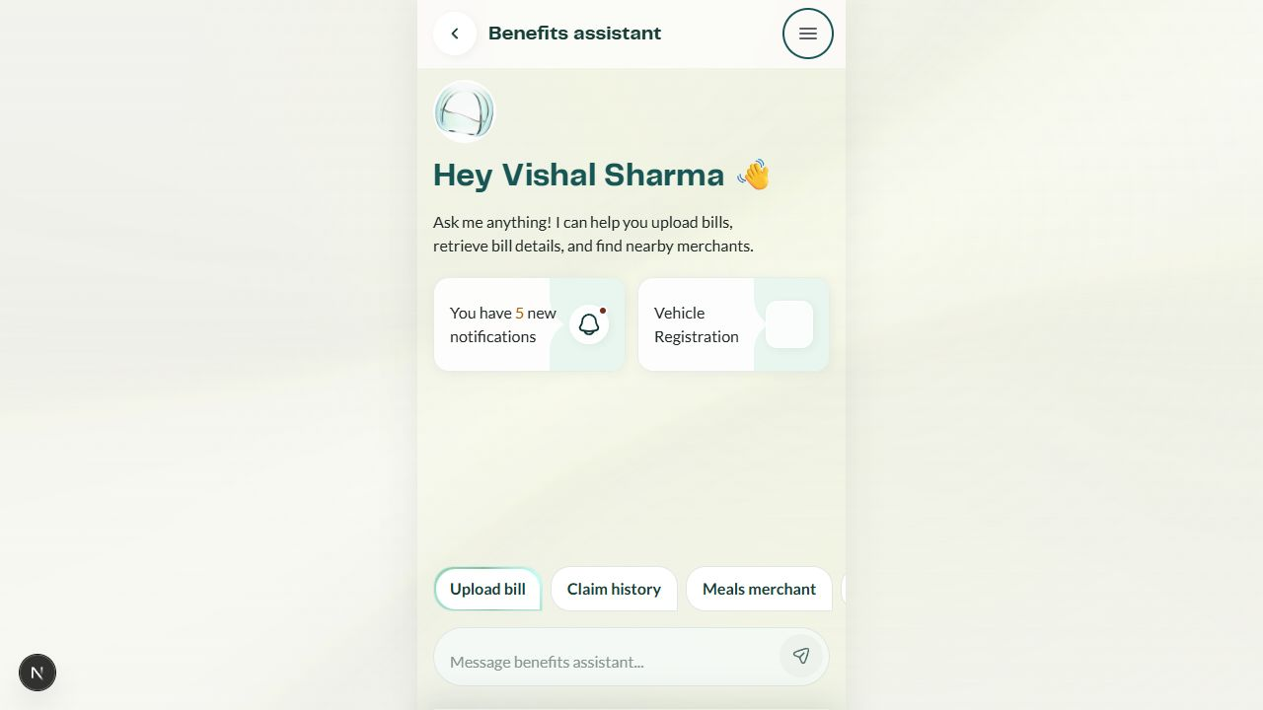
Figure 1 — Assistant entry and visible quick chats

2. Master assistant journey
The master journey separates reachable current behavior from proposed operational processing. Every route ends in a structured assistant outcome, a downstream screen, an employee recovery action, or a safe fallback.
quick
quick/text
quick/text
guided
quick
unknown
session
submit
service handoff
Employee opens Benefits Assistant
Choose quick chat or enter free text
Upload bill → precheck → submit
History / dashboard / track / edit
Policy or app-data answer
Vehicle / driver registration
Meals merchant search
Clarify, ground, or fallback
Persist pending intent / clear chat
Downstream app / HR handoff
[CURRENT] Structured receipt or screen handoff
[PROPOSED] Verification → approval → reimbursement
Master editable flow — current application reach ends at structured outcomes and handoffs; the reimbursement lifecycle is a proposed cross-service contract.

Routing rules
Entry | Resolution | Fallback / handoff
Visible quick chat | Deterministic handler and structured card | Action-specific recovery or downstream screen
Recognized free text | Intent handler for claim, policy, merchant, vehicle or driver | Pending intent requests missing detail
Grounded policy/app-data question | Repository-backed answer; model may rewrite with grounding | Deterministic fallback if model unavailable
Unknown / ambiguous message | Ask a clarifying question or present available actions | Preserve draft until user clears conversation

3. Quick-chat and guided workflows
Each chart summarizes the reachable current branch structure and marks proposed configuration gates where applicable. Detailed scenarios and exceptions follow in the coverage matrices.

3.1 Upload bill
[CURRENT] All three source options open the deterministic scenario picker. [PROPOSED] Production sources should feed OCR/extraction and corporate-configured verification gates.
demo
production
future
yes
no
retry
current
proposed
Select Upload bill
Choose camera / PDF / gallery
[CURRENT] Choose 1 of 12 demo scenarios
[GAP] Live file/OCR path not wired to UI
[PROPOSED] Extract fields + confidence
Editable details + policy precheck
Blocked issue or warning?
Correct / replace / acknowledge
Submit claim
[PROPOSED] Configured verification route
[CURRENT] Claim receipt
Editable workflow — each node and connector is a native Word drawing object.
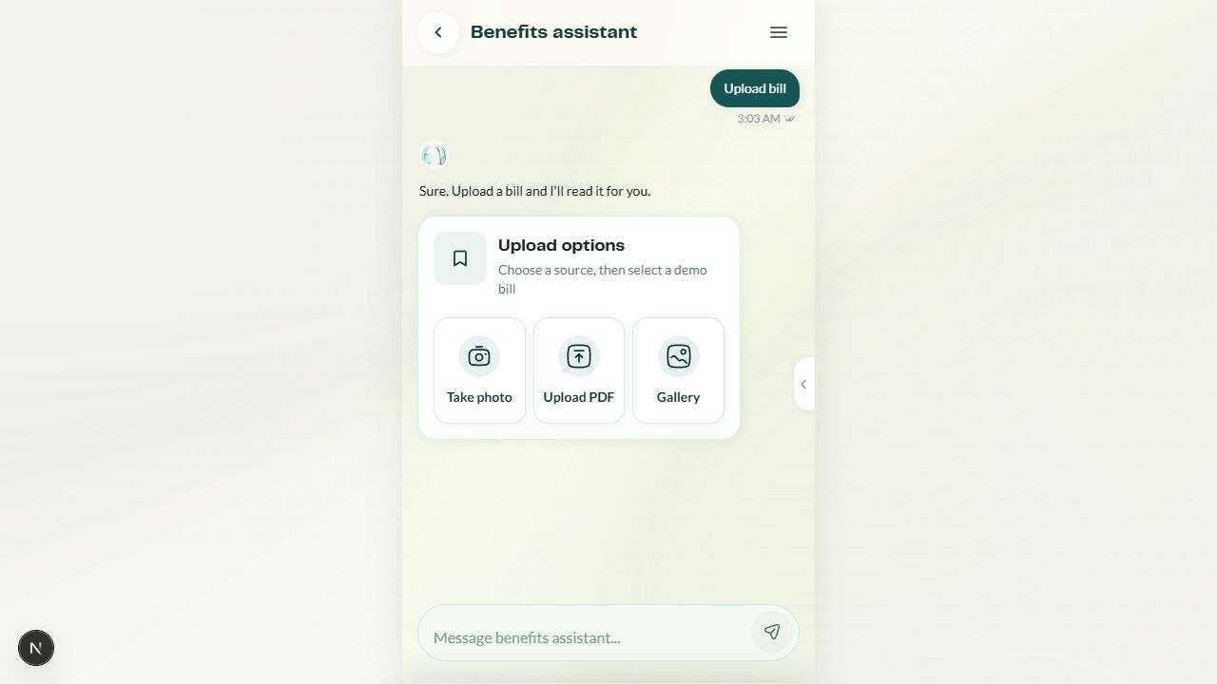
Figure 2 — Bill upload source selection
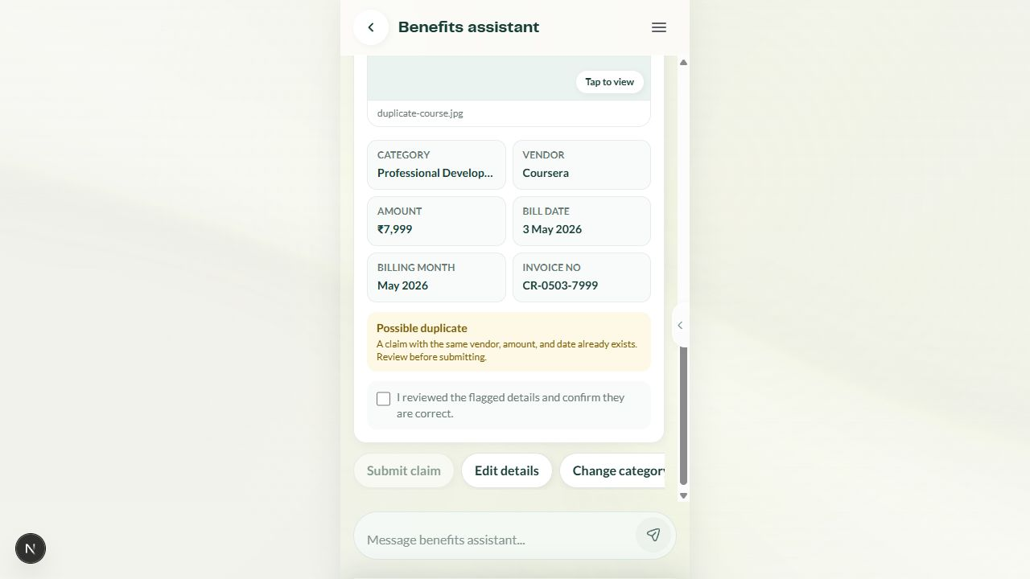
Figure 3 — Duplicate warning and acknowledgement gate

3.2 Claim history
[CURRENT] Presents claim history and benefit/status filters, with cards that can hand off to claim detail.
0
1+
view
track/edit
retry
Select Claim history
Load repository-backed claim history
Choose benefit / status filter
No results → clear/change filter
Matching claim cards
Open claim detail screen
Track or edit eligible claim
Editable workflow — each node and connector is a native Word drawing object.

3.3 Meals merchant
[CURRENT] The visible quick chat is fixed to Meals. It supports merchant-name lookup and a nearby-search branch; results communicate allowed/not allowed status.
name
nearby
yes
no
none
retry
Select Meals merchant
Search by name or nearby?
Enter merchant name
Allow location / nearby search
Resolve merchant eligibility
Allowed → show benefit
Not allowed → explain
No result → refine query
Editable workflow — each node and connector is a native Word drawing object.
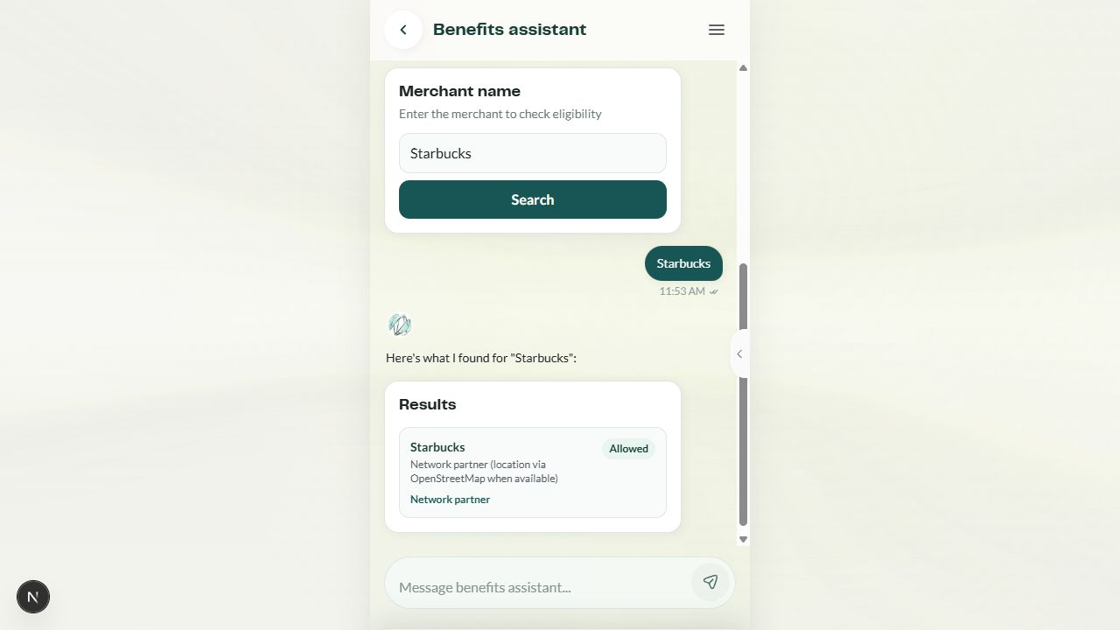
Figure 4 — Structured merchant eligibility result

3.4 View dashboard
[CURRENT] Provides a structured summary and hands off to the Claims Dashboard screen for deeper analysis.
no
yes
Select View dashboard
Show balances / claim summary
Need full dashboard?
Continue in assistant
Open Claims Dashboard
Use dashboard filters/details
Editable workflow — each node and connector is a native Word drawing object.

3.5 View policy
[CURRENT] Lets the user choose a benefit and asks/answers policy questions using grounded repository content, with deterministic fallback when model output is unavailable.
optional
direct
ready
timeout/error
more
more
Select View policy
Choose 1 of 7 benefits
Load grounded policy/app data
Optional on-device rewrite
Structured answer + source context
Deterministic grounded fallback
Open Policy details if needed
Editable workflow — each node and connector is a native Word drawing object.

3.6 Track and edit claim
[CURRENT] Track uses a canned claim response and edit collects claim/date intent before showing editable details. [GAP] Track does not yet bind to the user-entered claim identifier.
track
edit
missing
answer
complete
yes
no
open
Free text or history action
Track or edit?
[CURRENT] Canned CLM-43872 status
Collect claim ID / date
Missing detail → pending intent
Show structured claim details
Editable in current status?
Save change / resubmit
Read-only status explanation
Open claim details
Editable workflow — each node and connector is a native Word drawing object.

3.7 Vehicle registration
[CURRENT] A guided vehicle lookup, ownership confirmation, review/declaration and HR submission. [PROPOSED] Corporate settings govern eligibility, change limits, documents and verification.
no
yes
retry
proposed
current
pass
fail
declare
next
Start Vehicle Registration
Enter registration number
Vehicle found and eligible?
Correct number / unsupported
Self owned or company leased
[PROPOSED] Config + document gates
Review details + declaration
Submit to HR
Registration receipt
Driver Salary enabled?
Editable workflow — each node and connector is a native Word drawing object.
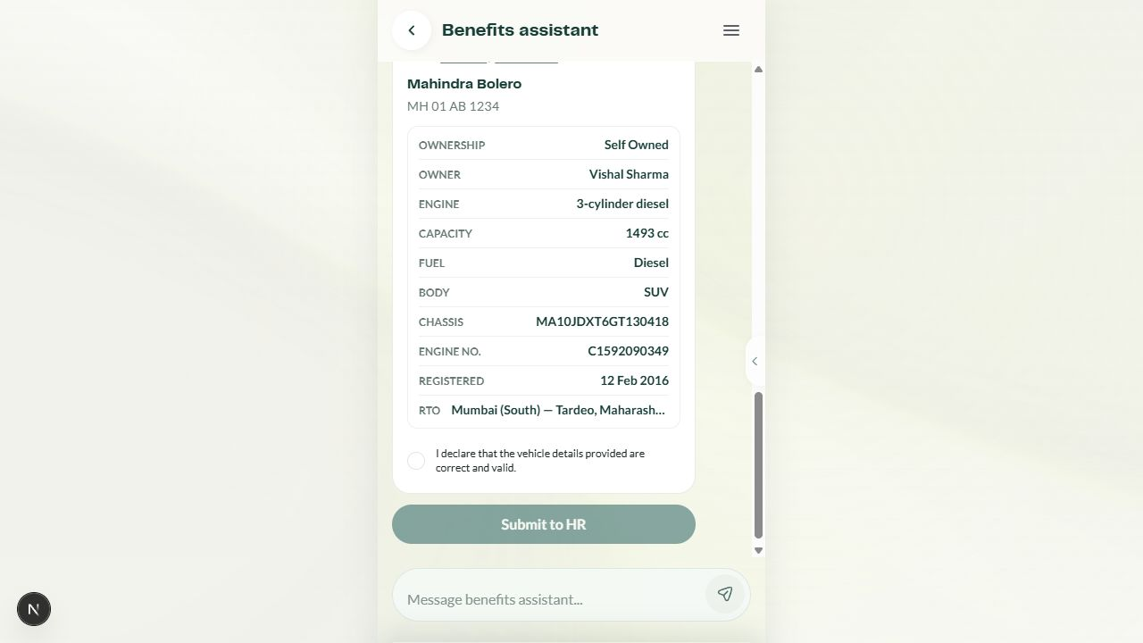
Figure 5 — Vehicle registration review and HR handoff

3.8 Driver registration and Driver Salary
[CURRENT] Begins after vehicle submission or direct intent, captures driver name, chooses a DL outcome, confirms licence data and continues to salary details. [PROPOSED] Corporate settings govern prerequisites, limits, proof and processing.
yes/not approved
no/pass
after approval
yes
no
fail
pass
retry
Start Driver Salary
Approved vehicle required?
Register / approve vehicle first
Enter driver full name
Upload licence / choose demo
DL number found?
Confirm extracted DL
Enter DL manually
Enter salary / effective date / proof
Corporate checks pass?
Correction or manual review
Submit / activate benefit
Editable workflow — each node and connector is a native Word drawing object.
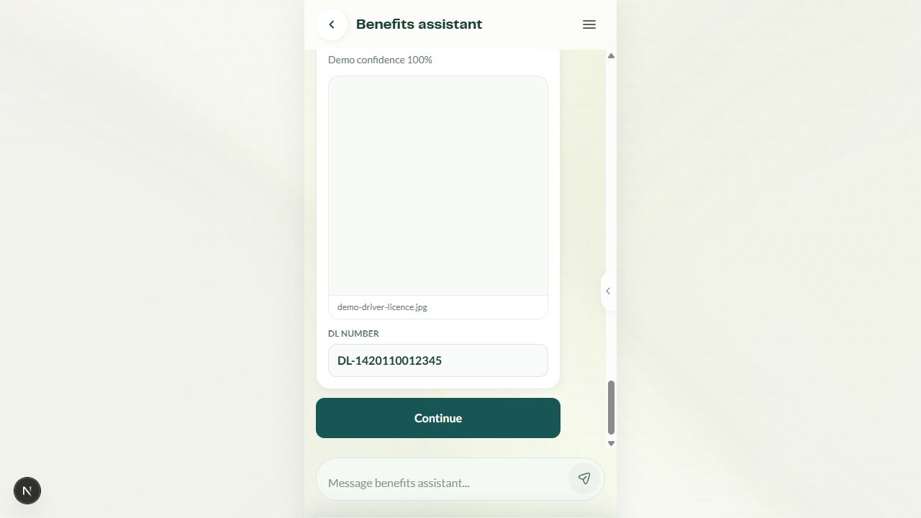
Figure 6 — Driver Salary DL extraction outcome

3.9 Grounded policy/app-data routing and fallback
[CURRENT] Recognized questions use repository-backed facts. Optional model generation may refine phrasing; deterministic answers remain the safe fallback.
policy/data
action
unknown
yes
no
screen
optional
optional
clarify
Employee asks free-text question
Policy, app data, action, or unknown?
Retrieve grounded facts
Dispatch deterministic action
Clarify / show capabilities
Model available and grounded?
Structured grounded answer
Deterministic fallback answer
Open relevant screen
Editable workflow — each node and connector is a native Word drawing object.

3.10 Chat persistence, pending intents, privacy and clearing
[CURRENT] Chat and structured claim details are stored in the browser; pending intents keep incomplete journeys resumable. Clearing removes browser-saved conversation data, while original files/raw OCR are not retained by this demo.
no
yes
answer
later
cancel
confirm
Message or structured action
Enough information to complete intent?
Save pending intent + ask follow-up
Resolve intent + save messages
Reload browser conversation
Start new chat / clear?
Keep draft and continue
Clear messages + structured details
Original files/raw OCR not stored
Editable workflow — each node and connector is a native Word drawing object.

4. Use-case coverage matrices

4.1 Seven benefits
Benefit | Bill / policy coverage | Assistant behavior | Key exception
Meal | Meal receipt; merchant eligibility | Precheck, merchant search, policy answer | Missing amount/date; merchant not eligible
Fuel & Maintenance | Fuel receipt; vehicle dependency | Precheck and policy routing | Allowance overrun; vehicle not registered
Internet | Broadband invoice | Structured extraction and precheck | Unsupported proof or period
Mobile | Postpaid mobile invoice | Structured extraction and precheck | Line/employee mismatch
Gift | Gift purchase | Structured extraction and precheck | Category or merchant restriction
Books & Periodicals | Professional book invoice | Structured extraction and precheck | Non-professional item
Professional Development | Role-related course invoice | Structured extraction and precheck | HR review / category ambiguity

4.2 Twelve bill scenarios
Scenario | Expected precheck | Employee branch | Current outcome
Meal Bill | All standard checks pass | Review → submit | Receipt
Meal Bill — missing data | Amount/date incomplete | Edit missing fields | Returns to precheck
Fuel Bill | Policy/category match | Review → submit | Receipt
Fuel Bill — exceeding balance | Amount > available allowance | Correct or stop | Submission blocked
Internet Bill | Required invoice fields | Review → submit | Receipt
Mobile Postpaid Bill | Required invoice fields | Review → submit | Receipt
Gift Bill | Category/amount checks | Review → submit | Receipt
Books & Periodicals | Professional category match | Review → submit | Receipt
Professional Development | Role-related category | Review / HR path | Receipt or review
Duplicate Bill | Duplicate warning | Acknowledge warning | Submit enabled after acknowledgement
Late Bill | Submission-window warning/block | Acknowledge or stop per rule | Configured/current scenario result
Other / HR Review | No direct category match | Accept HR review | Manual-review route

4.3 DL outcomes, policy questions and claims
Area | Covered variants | Resolution
Driving licence | DL found; DL data not found | Confirm extracted number or enter manually; continue to salary details.
Policy questions | Eligibility, allowance, deadline, proof, category and process questions across benefits | Grounded app/policy content; optional model rewrite; deterministic fallback.
Claim filters | Benefit/category and status views | Filter history; empty state returns to filter; card opens detail.
Claim tracking | Track status and open details | Current response is canned; proposed route binds actual claim ID.
Claim editing | Claim ID/date collection and editable details | Pending intent collects missing identifiers; save/resubmit only when eligible.
Merchant search | By name; nearby; allowed/not allowed/no result | Structured eligibility answer and query refinement.

4.4 Personas, errors and handoffs
Dimension | Current variants | Product implication
Persona | Persona system changes user context; vehicle lookup displays a hard-coded Vishal Sharma owner. | Remove hard-coded name and bind all identity copy to the active persona.
Upload errors | Missing data, allowance overrun, duplicate, late, other/HR review. | Keep every error actionable; distinguish warning acknowledgement from hard block.
DL errors | No extracted number. | Manual entry must preserve the uploaded preview and prior driver name.
Model errors | On-device preparation may stall or be unavailable. | Time-bound model use and always surface grounded fallback content.
Persistence | Browser-saved messages, structured details, pending intents. | Define expiry, version migration and privacy notices for production.
Handoffs | Claims Dashboard, policy details, claim details, vehicle details, HR queue. | Carry employee/claim context and return path across screens.

5. Corporate configuration specification
Status: PROPOSED These capabilities are a future configuration contract. The current repository demonstrates local guided flows and prechecks; it does not implement a corporate configuration service or automated payout orchestration.

5.1 Resolution model
At runtime, each setting resolves from the most specific eligible source. Missing benefit overrides inherit the corporate default; missing corporate defaults inherit the platform default. A configuration is publishable only after schema validation, dependency validation, sample-journey simulation and an effective-date check.
Layer | Example | Governance
Benefit-specific override | Fuel bills: max auto reimbursement ₹8,000 | Corporate admin; requires reason and effective date
Corporate default | All benefits: confidence-routed at 90% | Corporate admin; versioned and approved
Platform default | Manual review; auto reimbursement off | Platform operator; safest fallback

5.2 Composite automation guardrail
Confidence alone never authorizes reimbursement. Automatic approval/reimbursement is allowed only when every configured guardrail passes:
- Confidence meets the configured threshold.
- Required fields and acceptable proof are present.
- Benefit/category match succeeds.
- Amount is within allowance and the auto-processing cap.
- Deadline, duplicate, merchant, employee eligibility and fraud/risk checks pass.
- No unresolved warning or required employee acknowledgement remains.
Failure behavior Any failed gate routes to correction, replacement upload, manual review or rejection according to corporate configuration. A failed payment gate never removes an already recorded approval.

5.3 Bill Upload configuration
Precedence: Benefit-specific override → Corporate default → Platform default. Every evaluated claim/registration records the resolved value, source level, configuration version, timestamp and actor/service.
Field | Purpose / type | Allowed / default | Validation / dependencies | User behavior / audit
processing_mode | Select review strategy; enum | manual_only | confidence_routed | straight_through; default confidence_routed | straight_through requires automation service; benefit override allowed | Sets routing; log resolved value and actor
auto_verification_threshold | Minimum OCR/verification confidence; integer % | 0–100; recommended 90 | Must exceed manual band ceiling | At/above may auto-verify; audit score/model/version
manual_review_band | Confidence range for review; integer range | Recommended 60–89 | No overlap with auto threshold | Routes to reviewer; audit band and reason
low_confidence_behavior | Below-band action; enum | manual_entry | replacement_upload | reject; default manual_entry | Reject only if policy permits | Shows recovery or terminal copy; audit selection
automatic_reimbursement_enabled | Permit straight-through payout; boolean | true | false; default false | Requires processing mode, payout rail and all guardrails | Schedules reimbursement only after composite pass; audit gate results
max_auto_reimbursement_amount | Per-claim automation cap; currency | ≥0; default ₹5,000 example | Ignored if auto reimbursement off | Higher amounts route manual; audit amount/currency
allowed_sources | Accepted upload channels; set | camera | pdf | gallery; default all | At least one source | Hides/disables disallowed sources; audit config change

5.3 Bill Upload configuration — continued 2
Field | Purpose / type | Allowed / default | Validation / dependencies | User behavior / audit
allowed_file_formats | Accepted MIME/extensions; set | jpg, jpeg, png, pdf; default all | Must match source capabilities | Rejects unsupported file before processing; audit file metadata
allowed_proof_types | Evidence kinds; set | receipt | tax_invoice | bank_proof | other | At least one per benefit | Guides upload copy and proof checks; audit proof classification
required_fields | Fields needed to submit; set | merchant, date, amount, category, proof + corporate additions | Field must exist in schema | Missing fields produce Needs attention; audit missing list
allowed_categories_merchants | Eligibility lists/rules; set | benefit categories, allow/deny merchant lists | Deny takes precedence; versioned | Mismatch blocks/reviews; audit rule/version
submission_window_days | Days after bill date; integer | 0–365; default 30 example | Late policy required | Marks late claims; audit bill/submission dates
reimbursement_frequency | Claim cadence; enum/count | per_bill | weekly | monthly | n_per_period | Must align to benefit policy | Controls eligibility and user explanation; audit counter/reset
duplicate_policy | Duplicate response; enum | block | warn_acknowledge | manual_review; default warn_acknowledge | Duplicate matcher must be enabled | Blocks, warns or routes review; audit match evidence

5.3 Bill Upload configuration — continued 3
Field | Purpose / type | Allowed / default | Validation / dependencies | User behavior / audit
allowance_overrun_policy | Over-limit behavior; enum | block | cap_to_balance | manual_review | Cap needs employee consent | Shows remaining allowance and next action; audit overrun
late_submission_policy | Late response; enum | block | warn_acknowledge | manual_review | Uses submission window | Controls Expired vs review path; audit deadline rule
manual_approver_levels | Approval chain; array | 1–5 levels; default 1 | Role IDs valid and ordered | Shows owner/SLA; audit each decision
escalation_rules_sla | Review deadlines/escalation; duration + rules | hours/days; default 2 business days | Calendar/holiday policy required | Notifies and escalates overdue work; audit timers
payout_cadence | Approved-payment schedule; enum | immediate | daily | weekly | payroll_cycle | Payout rail required | Sets Reimbursement scheduled date; audit batch ID
notification_policy | Events/channels; object | in_app | email | SMS per state | Respect consent and quiet hours | Sends state and action notices; audit delivery
risk_fraud_rules | Risk gate; ruleset reference | corporate/platform ruleset ID | Must return pass/review/block | Failed gate prevents automation; audit signals/version

5.4 Driver Salary configuration
Precedence: Benefit-specific override → Corporate default → Platform default. Every evaluated claim/registration records the resolved value, source level, configuration version, timestamp and actor/service.
Field | Purpose / type | Allowed / default | Validation / dependencies | User behavior / audit
enabled_employee_groups | Feature + eligibility; boolean/set | enabled + group IDs; default disabled | Groups must exist | Shows/hides journey; audit resolved eligibility
approved_vehicle_prerequisite | Require approved vehicle; boolean | true | false; recommended true | Vehicle module must be enabled | Blocks with vehicle CTA until approved; audit vehicle ID
max_active_drivers | Concurrent driver limit; integer | 1–10; default 1 | ≥1 when enabled | Blocks or offers replacement; audit active count
driver_change_limit | Replacement/change count; integer | 0–12 per period; default 1 | Reset period required | Shows remaining changes; audit counter
driver_change_reset_period | Counter window; enum | financial_year | calendar_year | rolling_12_months | Required with limit | Resets change allowance; audit boundary
required_driver_details | Mandatory profile fields; set | name, mobile, address, relationship + additions | Fields must be supported | Missing fields → Needs attention; audit field set
required_dl_documents | Licence proof requirements; set | front, back, single PDF, expiry | At least one DL proof | Guides upload; audit document hashes/metadata

5.4 Driver Salary configuration — continued 2
Field | Purpose / type | Allowed / default | Validation / dependencies | User behavior / audit
payment_proof_requirements | Salary evidence; set | receipt | bank_transfer | signed_acknowledgement | At least one if claims enabled | Controls monthly claim completeness; audit proof
dl_confidence_threshold | Auto-verification threshold; integer % | 0–100; recommended 90 | Manual fallback required below threshold | Auto-confirms or routes manual; audit score/model
dl_low_confidence_fallback | Below-threshold behavior; enum | manual_entry | manual_review | replacement_upload | Manual review role required if selected | Preserves progress and requests action; audit reason
monthly_salary_cap | Eligible monthly maximum; currency | >0; corporate default | Must match benefit allowance | Blocks/caps/reviews excess by policy; audit amount
claim_frequency | Salary claim cadence; enum | monthly | payroll_cycle | n_per_period | Cutoff required | Controls available claim periods; audit period
effective_date_rules | Start-date policy; rules | approval_date | next_month | chosen_date | Cannot predate employee eligibility | Explains when benefit starts; audit date resolution
retroactive_period_days | Backdated eligibility; integer | 0–365; default 0 | Requires proof and corporate permission | Allows/blocks past periods; audit dates

5.4 Driver Salary configuration — continued 3
Field | Purpose / type | Allowed / default | Validation / dependencies | User behavior / audit
manual_approval_levels | Approval chain; array | 0–5; default 1 | 0 only with auto mode | Routes registration/claims; audit decisions
payroll_cutoff_sla | Cutoff + review SLA; schedule | day/time/calendar; example 25th | Timezone and holidays required | Shows next payout window; audit cutoff
processing_mode | DL/claim processing; enum | manual_only | confidence_routed | auto_verify | Auto requires verification service | Controls verification route; audit resolved mode
notification_policy | Events/channels; object | in_app | email | SMS | Consent/quiet hours | Notifies activation, info request, claim result; audit delivery
deactivation_replacement | Exit/replacement behavior; rules | immediate | period_end; resubmit yes/no | Open claims must be handled | Preserves history and explains next eligibility; audit reason

5.5 Vehicle Registration configuration
Precedence: Benefit-specific override → Corporate default → Platform default. Every evaluated claim/registration records the resolved value, source level, configuration version, timestamp and actor/service.
Field | Purpose / type | Allowed / default | Validation / dependencies | User behavior / audit
enabled | Feature availability; boolean | true | false; default true example | Corporate scope required | Shows/hides registration; audit change
max_active_vehicles | Concurrent vehicles; integer | 1–10; default 1 | ≥1 when enabled | Blocks or offers replacement; audit count
vehicle_change_allowance | Changes per period; integer | 1–12; recommended profile-specific | Reset period required | Shows remaining changes and blocks at limit; audit counter
change_reset_period | Allowance window; enum | financial_year | calendar_year | rolling_12_months | Required with allowance | Resets counter; audit boundary
cooling_off_days | Minimum time between changes; integer | 0–365; default 0 | Cannot exceed reset period | Shows next eligible date; audit last change
permitted_ownership_types | Allowed ownership; set | self_owned | company_leased | family_owned | At least one | Hides/disallows ownership choices; audit resolved rule
permitted_vehicle_classes | Eligible classes; set | car | two_wheeler | commercial + corporate taxonomy | Taxonomy versioned | Blocks/reviews ineligible class; audit class

5.5 Vehicle Registration configuration — continued 2
Field | Purpose / type | Allowed / default | Validation / dependencies | User behavior / audit
permitted_fuel_types | Eligible fuels; set | petrol | diesel | CNG | electric | hybrid | At least one | Controls benefit/policy eligibility; audit fuel
registration_relationships | Name relationship rules; set | employee | spouse | parent | company | Proof map required | Requests relationship proof; audit identity match
required_documents | Registration proofs; set | RC | insurance | lease_proof | PUC | Conditional by ownership/fuel/class | Missing proof → correction; audit metadata
verification_method | Document/lookup route; enum | automatic | confidence_routed | manual; default confidence_routed | Auto service required | Sets verification state and owner; audit response
verification_threshold | Confidence threshold; integer % | 0–100; recommended 90 | Used only for confidence routing | Routes auto/manual; audit score/model
hr_approval_required | Require HR decision; boolean | true | false; default true | False needs auto-verification | Shows HR handoff or direct approval; audit decision
approval_sla | Registration review SLA; duration | business hours/days; default 2 days | Calendar required | Shows expected completion; audit timer

5.5 Vehicle Registration configuration — continued 3
Field | Purpose / type | Allowed / default | Validation / dependencies | User behavior / audit
effective_date_rule | Activation date; enum | submission | approval | next_period | Must align to payroll/benefit | Controls when vehicle-dependent benefits unlock; audit date
replacement_reason_required | Require reason on change; boolean | true | false; recommended true | Applies after first registration | Collects reason before replacement; audit text/code
driver_salary_requires_approval | Gate Driver Salary; boolean | true | false; recommended true | Driver Salary feature enabled | Shows Driver Salary only after approval; audit vehicle link
deactivation_rejection_correction | Recovery rules; object | deactivate timing, correction window, resubmit/appeal flags | Must define effect on dependent claims | Provides next valid action; audit state/reason

6. Canonical claim lifecycle
Status: PROPOSED user-facing contract This normalized lifecycle should sit above internal service states. The current repository uses overlapping labels including Submitted, Policy checked, Under review, Needs info, Approved, Rejected, Revoked and Reimbursed; one quick explanation also uses Paid.
pass
paid
extract
more proof
fail
payment
retry
correct
resubmit
deadline
cancel
Uploaded
Processing
Details ready
Ready to submit
Submitted
Under review / automated verification
Approved
Reimbursement scheduled
Reimbursed
Needs attention
Needs information
Rejected
Reimbursement delayed / failed
Expired
Cancelled / Revoked
Canonical lifecycle with actionable recovery loops. Internal technical states may be more granular but must map to exactly one user-facing state.

6.1 State specification
State | Meaning / entry | Employee / owner | Notification / next states | Class / config impact
Uploaded | File accepted  Entry: Source passes file checks | Action: Wait/remove  Owner: System | Notify: In-app  Next: Processing, Cancelled | Transient  Config: Source/format limits
Processing | Extracting/checking  Entry: Processing starts | Action: Wait  Owner: System | Notify: Progress/error  Next: Details ready, Needs attention | Transient  Config: Mode, confidence bands
Details ready | Fields available to review  Entry: Extraction/manual entry complete | Action: Edit  Owner: Employee | Notify: In-app  Next: Ready to submit, Needs attention | Actionable  Config: Required fields/proof
Ready to submit | All pre-submit checks evaluated  Entry: Required data present | Action: Acknowledge/submit  Owner: Employee | Notify: Warnings  Next: Submitted, Expired, Cancelled | Actionable  Config: Duplicate/late/overrun rules
Submitted | Claim recorded  Entry: Employee submits | Action: View/cancel if allowed  Owner: System | Notify: Receipt  Next: Under review/automated verification, Cancelled | Transient  Config: Cancellation window

6.1 State specification — continued 2
State | Meaning / entry | Employee / owner | Notification / next states | Class / config impact
Under review / automated verification | Decision in progress  Entry: Routing selects reviewer/automation | Action: Wait/respond  Owner: Reviewer/system | Notify: SLA updates  Next: Approved, Needs information, Rejected | Transient  Config: Processing mode, thresholds, approvers
Approved | Claim accepted  Entry: All decision gates pass | Action: View  Owner: Approver/system | Notify: Approval notice  Next: Reimbursement scheduled | Transient  Config: Approval/payout rules
Reimbursement scheduled | Payment queued  Entry: Payout batch/date assigned | Action: View schedule  Owner: Payments | Notify: Schedule notice  Next: Reimbursed, Reimbursement delayed/failed | Transient  Config: Payout cadence
Reimbursed | Payment completed  Entry: Payment confirmation received | Action: View reference  Owner: Payments | Notify: Receipt  Next: None | Terminal  Config: Notification/reference policy
Needs attention | Missing/unreadable/low-confidence data  Entry: Pre-submit check fails | Action: Edit/replace  Owner: Employee | Notify: Action request  Next: Processing, Details ready, Cancelled | Actionable  Config: Low-confidence behavior

6.1 State specification — continued 3
State | Meaning / entry | Employee / owner | Notification / next states | Class / config impact
Needs information | Reviewer requests proof  Entry: Review cannot decide | Action: Upload/respond/resubmit  Owner: Employee | Notify: Request + due date  Next: Ready to submit, Rejected, Expired | Actionable  Config: Info deadline/resubmit rules
Rejected | Claim not eligible  Entry: Decision gate fails | Action: Appeal/resubmit if allowed  Owner: Approver/system | Notify: Reason notice  Next: Terminal or Ready to submit | Terminal/actionable  Config: Appeal/resubmission policy
Cancelled / Revoked | Eligible claim terminated  Entry: Employee/admin action | Action: View reason  Owner: Employee/admin | Notify: Cancellation notice  Next: None | Terminal  Config: Cancellation/revocation rules
Reimbursement delayed / failed | Approval retained; payment needs retry  Entry: Payment rail failure | Action: Update details if asked  Owner: Payments | Notify: Delay + retry  Next: Reimbursement scheduled, Reimbursed | Actionable/transient  Config: Retry/escalation rules
Expired | Submission/action window closed  Entry: Deadline passes | Action: Appeal if allowed  Owner: System | Notify: Expiry notice  Next: Terminal or Ready to submit | Terminal/actionable  Config: Late/appeal policy

6.2 Lifecycle examples
Example | User-facing path | Configuration condition
High-confidence straight-through | Uploaded → Processing → Details ready → Ready to submit → Submitted → Automated verification → Approved → Reimbursement scheduled → Reimbursed | Confidence and every composite guardrail pass; automation enabled and amount under cap.
Confidence-routed manual review | Uploaded → Processing → Details ready → Ready to submit → Submitted → Under review → Approved → Reimbursement scheduled → Reimbursed | Confidence falls in review band or corporate mode requires review.
Missing information + resubmission | Uploaded → Processing → Needs attention → Details ready → Ready to submit → Submitted → Needs information → Ready to submit → Under review → Approved | Employee corrects extraction and later supplies reviewer-requested proof.
Duplicate or late claim | Ready to submit → warning acknowledgement → Submitted / Under review, or → Expired / Rejected | Transition is selected by duplicate and late policies; acknowledgement must be persisted.
Payment failure + retry | Approved → Reimbursement scheduled → Reimbursement delayed/failed → Reimbursement scheduled → Reimbursed | Approval is preserved; payment owner retries and notifies the employee.

7. Corporate profiles & validation examples
Illustrative profiles show how identical journeys change after configuration resolution. Values are examples, not policy recommendations.
Setting | Conservative | Balanced | High Automation
Bill processing | manual_only | confidence_routed | straight_through
Auto threshold | N/A | 90% | 95%
Manual band | All claims | 60–89% | 75–94%
Auto reimbursement | Off | On ≤ ₹5,000 after all gates | On ≤ ₹25,000 after all gates
Duplicate / late | Manual review / block | Warn + acknowledge / manual review | Rules engine; block or review
Vehicle changes | 1 / financial year | 4 / financial year | 12 / rolling 12 months
Vehicle verification | Manual + HR | Confidence-routed + HR | Automatic; exception-only HR
Active drivers / changes | 1 / 1 per year | 1 / 2 per year | 2 / 12 rolling months
DL verification | Manual | ≥90% auto; else manual | ≥95% auto; else manual
Driver Salary activation | After vehicle + HR approval | After vehicle approval | After automatic vehicle approval

7.1 Validated journey samples
Sample | Resolved profile | Expected result | Validation assertion
Meal bill; 96%; ₹1,200; all gates pass | Conservative | Manual review | manual_only overrides confidence
Meal bill; 96%; ₹1,200; all gates pass | Balanced | Auto verify + reimburse | Below cap; all composite gates true
Fuel bill; 96%; ₹6,500; all gates pass | Balanced with fuel cap ₹8,000 | Auto verify + reimburse | Benefit override wins over ₹5,000 corporate cap
Duplicate bill; 99%; ₹500 | High Automation | Block/review per duplicate rule | Confidence cannot bypass duplicate gate
Vehicle change #2 in same FY | Conservative | Blocked; next eligible period shown | Limit 1 reached
Vehicle change #12 rolling year | High Automation | Allowed if cooling-off passes | Counter ≤12 and time gate passes
DL confidence 72% | Balanced | Manual verification / manual entry | Below 90% threshold
Driver salary above monthly cap | All | Block/cap/review by overrun rule | No straight-through beyond cap
Approved claim; payout rail fails | All | Reimbursement delayed/failed → retry | Approval remains immutable

7.2 Publish-time validation
- Validate field type, allowed values, ranges, references and conditional dependencies.
- Resolve sample employees and benefits through all three precedence levels.
- Simulate at least one pass, correction, manual-review, rejection and payment-failure journey.
- Reject overlapping confidence bands, missing fallback owners, impossible state transitions and unbounded auto caps.
- Require effective date, change reason, approver identity and immutable configuration version.

8. Current-state gaps & improvement backlog
P0 assessment No verified P0 issue was found in the repository snapshot. P0 remains reserved for data loss, privacy/security exposure, or incorrect money movement. The gaps below are P1/P2 product reliability and consistency issues.

8.1 Prioritized backlog
Pri / ID | Gap | Evidence | Recommended change | Acceptance signal
P1  G-01 | Live upload path unreachable | Camera, PDF and Gallery all open demo scenarios although OCR helpers exist. | Wire file inputs to extraction; retain demo path behind explicit demo mode. | Upload e2e for every allowed source and format.
P1  G-02 | Track claim is canned | Track response uses CLM-43872 rather than entered claim ID/date. | Bind track intent to repository/service lookup and preserve identifier. | Two claims return distinct correct states.
P1  G-03 | Vehicle owner hard-coded | Lookup summary displays Vishal Sharma even with persona context. | Resolve owner from active persona/vehicle response. | Persona matrix has no leaked identity.
P1  G-04 | Merchant scope inconsistency | Visible action is Meals merchant; dormant UI/docs suggest broader merchant types. | Either constrain docs/components to Meals or expose benefit selection. | All visible entry points agree on scope.

8.1 Prioritized backlog — continued
Pri / ID | Gap | Evidence | Recommended change | Acceptance signal
P1  G-05 | Lifecycle not persisted end-to-end | Current demo reaches receipt/HR handoff, not verification-to-payment state transitions. | Implement canonical state mapping and event-backed history. | All lifecycle examples replay from events.
P2  G-06 | Model preparation can stall | Policy demo remained in preparation during deterministic capture. | Time-box model generation; display grounded answer first/fallback. | Answer visible within defined latency budget.
P2  G-07 | Capability docs exceed reachable UI | Some described actions/components are not visible or connected. | Generate capability copy from feature flags/routes. | Documentation contract test passes.
P2  G-08 | Status vocabulary overlaps | Paid vs Reimbursed and Pending vs Under review appear across surfaces. | Adopt canonical user-facing state mapping and copy tokens. | Snapshot audit finds one label per state.

8.2 Sequencing
Wave | Objective | Items
Foundation | Make current journeys trustworthy and identity-safe | G-01, G-02, G-03
State contract | Persist canonical lifecycle and normalize copy | G-05, G-08
Experience consistency | Align merchant scope, capabilities and fallback latency | G-04, G-06, G-07
Configuration rollout | Introduce versioned config resolver, admin validation and simulations | Section 5 contracts

9. Conceptual interfaces & implementation notes
Conceptual only These names describe future boundaries; no application APIs or TypeScript files were changed.
Interface | Minimum conceptual responsibility
CorporateBenefitsConfig | corporateId, version, effectiveFrom, platformDefaultsRef, benefitOverrides, billUpload, driverSalary, vehicleRegistration, notificationPolicy, auditMetadata
BillUploadConfig | processingMode, confidence thresholds, source/proof rules, eligibility/duplicate/deadline rules, approval/SLA, payout/notifications
DriverSalaryConfig | eligibility, vehicle prerequisite, driver limits, DL verification, salary/proof rules, dates, approvals, lifecycle behavior
VehicleRegistrationConfig | eligibility, active/change limits, period/cooling-off, ownership/class/fuel/doc rules, verification, HR/effective-date/dependency behavior
ClaimLifecycleState | canonicalCode, displayLabel, explanation, classification, owner, allowedEmployeeActions, nextStates, notificationTemplate, internalStateMappings

9.1 Runtime evaluation
- Resolve configuration using benefit override → corporate default → platform default.
- Create an immutable evaluation snapshot on upload/registration; later configuration changes do not silently rewrite an in-flight decision.
- Evaluate composite gates and emit human-readable reason codes for every non-happy-path transition.
- Map internal service events to one canonical user-facing state and retain the full transition history.
- Carry correlation IDs across assistant, HR/reviewer queue, dashboard and payment rail.
- Keep automation explainable: confidence, model/rules version, fields/proofs, allowance, duplicate/deadline, risk and acknowledgements.

9.2 Accessibility and content rules
Rule | Specification
Status | Never rely on color alone; pair state with label, reason and next action.
Errors | Place correction guidance next to the field and preserve previously valid data.
Progress | Name the current activity and expected wait; offer fallback when model/service exceeds latency budget.
Documents | Announce accepted formats, size limits, proof needs and privacy before upload.
Notifications | Use consistent state labels and deep-link to the exact action or detail view.
Charts | All workflow text is editable; color categories are also named in the legend and node text.

10. Verification checklist
This blueprint is considered implementation-ready only when the product and artifact checks below pass.
Check | Pass criterion
Quick-chat coverage | All five visible quick chats and five additional guided/system workflows have editable charts.
Scenario coverage | Seven benefits, 12 bill scenarios, two DL outcomes, policy/data routes, filters, merchant variants, personas, errors and handoffs are mapped.
Configuration completeness | Each Bill Upload, Driver Salary and Vehicle Registration field includes type, values/default, validation/dependencies, behavior and audit.
Profile validation | Conservative, Balanced and High Automation examples resolve through precedence and composite gates.
Lifecycle integrity | Every state has an entry, owner, action, notification, valid next state, classification and configuration impact.
Recovery loops | Needs attention and Needs information return to actionable editing/resubmission; payment failure returns to scheduled/reimbursed without losing approval.
Editable drawings | Workflow nodes and connectors are native Word VML drawing objects, not flattened images.
Accessibility | Document title, semantic headings, linked contents, table headers, captions and image alt text are present.
Layout | Letter portrait only, 1-inch margins, no clipped tables/charts/screenshots, clean headers/footers and page breaks.
Current vs proposed | Every future configuration/automation element is labelled PROPOSED and verified behavior is labelled CURRENT.

10.1 Decision log
Decision | Rationale
Portrait only | Meets delivery constraint; large workflows split into dedicated pages.
User-facing canonical lifecycle | Keeps employee copy stable while allowing richer internal service states.
Composite auto-reimbursement gate | Prevents confidence score from bypassing eligibility, allowance, duplicate, deadline, proof or risk controls.
Configuration scoped to three areas | Matches requested corporate variability: bill upload, driver salary and vehicle registration.
Repository truth over capability copy | Observed reachable behavior is labelled CURRENT; unimplemented capability remains PROPOSED/GAP.

End state The blueprint is ready for product review, configuration-schema design, lifecycle event modeling and phased engineering delivery.

