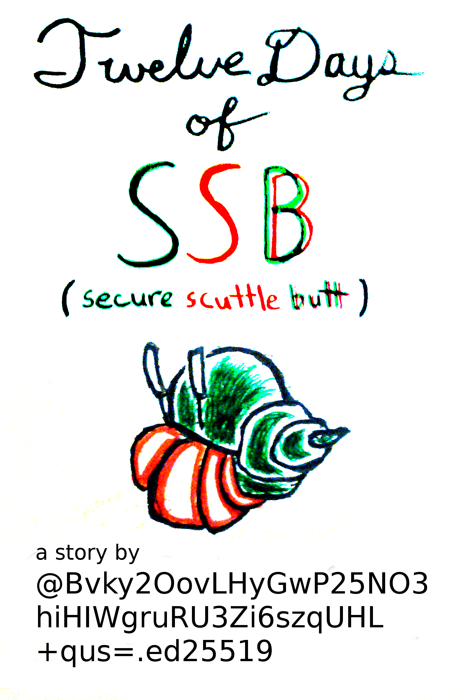

As I prepared to leave the Bay Area and head home for the holidays, I was confronted with the ultimate packing problem: Which is more likely to be refused by TSA? One jelly jar of beard oil, two disaster.radio prototypes, three People’s Open nodes, or a patchwork in a merkle tree?

For background on the devices and projects mentioned in this story, visit the following links:

ssbc.nz
disaster.radio
peoplesopen.net

or

Just install SSB. Patchwork is a good place to start.
github.com/ssbc/patchwork/releases

this story is based on reality, some identities have been altered

I doubted they would inspect my laptop. Much less sort out how to start sbot, so I felt safe taking my SSB key containing computer with me. It’s my main machine and I would have felt lost with out it, this was a non-choice. The mesh nodes, well, they look harmless enough disguised as home routers, though they hide a dirty ad-hoc enabling secret thanks to peoplesopen.net and their crackpot team of hackers, SudoMesh. Anyway, I could pass the nodes off as presents for my family, which they indeed are. Things get a little shadier with the disaster.radio prototypes. Yes, they are just ESP8266s and LoRa transceivers on a custom printed PCB, but try explaining that to the TSA agent that asks to lift your arms in the spinny magnetic thing (remember when people were outraged about those, now I can’t even remember it's name). As soon as you mention 900MHz, their mind will conjure up all sorts scary realities where I'm shooting off malicious packets from 30 thousand feet in the air (hmm... I wonder how far a LoRa packet would travel from an airpl...no no resist the temptation). Ultimately, I decided to bring the prototypes and hoped I wouldn’t have to explain them to anyone.
As for the beard oil, perhaps the most inert of all four items, I didn’t even consider trying. No point, they’d pull my bag to the side in heartbeat. The TSA agent from the X-ray scanner would search through my bag like it contained the fountain of youth (close, that beard oil is pretty magical). At length, X-ray eyes, lets call them Jamie, would pull out a little jelly jar filled with a mysterious, white, oily gloop. Perplexed, Jamie would call over the agent from the spinny magnetic thing for a second opinion. Spinny magnetic, lets call them Kris, with an equally perplexed look on their face would hazard a guess, “What ya got there X-ray eyes, vaseline?” (interestingly, Jamie and Kris refer to each other by the same nicks that I gave them in my hypothetical situation). To which Jamie would respond, “I don’t think so Spinny Magnetic...” poking at the mystery substance with a blue-gloved hand, “...maybe it’s glycerin!” Immediately, Jamie and Kris would glance at one another and then throw me a sideways glare. I’d have to explain "NO! NO! it's one part beeswax, four parts coconut oil, one part jojoba oil, I got the recipe from @microgorilla on SSB". Realizing, I had slightly over-explained, I’d backtrack with an obvious lie, “it’s...it’s a present...for...my mother.” Jamie sees right through my lie, “sounds suspect, eh Spinny Magnetic?” Kris, ignoring Jamie’s observation, asks me, “What was that you said about SSB?” followed by Jamie, “And who's this Micro Gorilla, frankly he sounds made up." “It’s just face lotion!” I implore, embarrassed to tell them its true purpose. Kris, walking circles around me, grabs at the walkie-talkie clipped to their vest, holds a button, and speaks into it. “Niner niner, we got a bogey in the merklewood forest, we’re gonna need take him back for further questioning.”

In a dimly lit back room (you know, that one that is in every airport, police station, post office, govt. building, mall, or pretty much any place with cops or similar authority figures), I sit for what seems an interminable period of time. Relieved of my baggage, I don’t even have my copy of James Gleick’s Chaos to pass the time. Talking to myself, “God, they could have at least left me a brochu...”
The door swings open and interrupts my train of thought. Kris walks in with a new cronie, who is, for some reason, a wearing a pilot’s uniform. This piloty fellow, lets call her Jones, speaks to me, “So Kris here,” what do you know, I got spinning magnetic’s name right, “tells me you were carrying a suspicious substance. What do you think you’re trying to pull? You think you can just cavort on to my plane! HUH!” Kris interjects, “Easy Pilot Jones”, wow, two for two! now I’m wondering what X-ray eyes real name was, “I’m sure ole Paid For By here didn’t mean any harm.” That’s odd, how does Kris know my nick? Jones retorts, “But, Kris, that’s not all we found in his bags.” Oh no. My mind races through the contents of my baggage, what else was in there? Could it be my Arabic t-shirt? No, maybe they found the worn copy of Chaos (signed “For Dad\n July ‘89\n Love Tina”)? Hmmm...then I remember. I packed the disaster.radios! As that thought crosses my mind, Pilot Jones reaches into her vest pockets, pulls out two disaster.radios and slams them on the table. I cringe, concerned for the delicate solder joints that I painstakingly repaired just few nights prior. “You wanna tell me what these little devices are...? No! Don’t tell me I wanna guess...” Jones almost licking her lips, seems genuinely thrilled by the opportunity to prove her technical competence. “Are they the prototypes for a disaster-resilient communications network powered by the sun!” Weird, how’d she know that? “yea...yeah,” I stutter, “that’s exactly what they are, how’d you kn...” I dawns on me. My computer. Covered with RESIST stickers! They have everything on me, they could be pushing to all my repos, they could change my .vimrc file, worst of all, they have my SSB keys! Worse than that, it was in hibernation. If only I had listened when @jewel warned of me of the dangers of hibernating my computer. I was in the middle of writing this post when I left the airport diner to go through TSA. I didn’t want to lose my place. Instinctively, I hibernated my computer. I’m exposed.
Sliding on a pair of blue gloves, Kris pulls my computer out of a grey plastic bin (one of those ones you put your stuff in for X-ray eyes to look at). They carefully open the laptop and begin reading, “Twelve Days of SSB, eh, so I guess you weren’t lying.” Luckily, I was writing this post in emacs org-mode and, clearly, they didn’t know how to unfold headings, so they could only read the first line. Maybe they wouldn’t know how to switch to other workspaces either; I was working on #ssb-cljient in the second desktop. Kris, continuing the interrogation, “S-S-B cly-gent? You some sort of hacker, eh? Trying to learn a functional programming language, how cute.” Pilot Jones continues, “No, this one’s different. He’s a hacker all right, but isn’t so concerned with learning. No no, he’s a hacker that wants to teach other hackers how to build their own internet!” Obviously, she’d just read the Build Your Own Internet sticker on my computer...no wait. “Just look at these mesh nodes that were in his bag. You trying to circumvent traditional internet infrastructure?” I’m frozen, speechless. “Now, we can’t have that can we, Pilot Jones?” says Kris, a smirk growing on their face. “No, certainly not. Chairman Pai wouldn’t allow it.” “Indeed. He’d be terribly disappointed if we let this one get away” They give a slight cackle and I attempt to speak, “What...what are you...going to do?” “With you...oh nothing. It’s your identity that’s valuable to us.” My keys! The very keys that @cellofane had so effortlessly recovered for me less than a week ago. My secret, my gossip.json! My identity is their’s, the pubs will take them for the real @paidforby_____, my subs will be duped! I have to let someone know somehow. No phone, no signal. My mind screams into the void, label me @paidforbydeath. I feel a thud.

I wake up on the floor, next to a moving walkway. I rub my head, it still rings. As I sit up, I glance around for my bags and pat my pockets, searching for some means of communication. Nothing. From my inside jacket pocket, I pull out my passport. It has a boarding pass tucked inside. It’s not my passport or my boarding pass. The picture in the passport is blank, waiting to be assigned, the name is a hash, "@5673fd8d3ad92d7bffac79158470a07445277f90". The identity on the boarding pass matches, the gate is G42, but the destination is blank. Considering I have nothing else, I follow the boarding pass. Feeling a presence watching me, I realize I have no choice but to go to the gate and get on the plane. The airport is oddly empty, though I see a flight crew walking swiftly down a moving walkaway, headed in the same direction as me.
Arriving at the gate, I show the attendant my faulty documents and inquire as to the destination of the flight. They fail to answer; only handing back the documents and saying, “You’re all set. You’ll board with Zone 5.” Baffled, I ask the attendant if I can borrow a pen. They oblige and I walk to a nearby table. I sit down and begin rewriting this post in the extra pages of my passport, approximating the beginning, and picking up where I left off. Eventually, Zone 5 is called. Though, I can’t seem to remember anyone boarding for the first four zones, I board. Writing fervently as the plane taxis the runway, I perceive time to be in short supply. As the plane lifts off, I finish this paragraph and begin a new piece . Something simple, a variant on a classic, written in the quickest language I know. I begin “12days.js”. A list, left open, for others to interpret. Without a word, I hand the passport to the person sitting next to me. I lay down the pen on the seat back tray table and turn my head away. My view out of the cabin window turns pure white. The plane hits turbulence as it flies into a snowstorm.

12days.js

#!/usr/bin/env node

day = [
{order: "1st", qty: "a", gift: "patchwork in a merkle tree"},
{order: "2nd", qty: "two", gift: "forked feeds"},
{order: "3rd", qty: "three", gift: "hash keys"},
{order: "4th", qty: "four", gift: "log streams"},
{order: "5th", qty: "five", gift: "LOCAL PEERS"},
{order: "6th", qty: "six", gift: "bananas a-tuning"},
{order: "7th", qty: "seven", gift: "cels a-singing"},
{order: "8th", qty: "eight", gift: "mixs a-mixing"},
{order: "9th", qty: "nine", gift: "noffles waffling"},
{order: "10th", qty: "ten", gift: "leezs a-larping"},
{order: "11th", qty: "eleven", gift: "sbots serving"},
{order: "12th", qty: "twelve", gift: "different ssb clients"},
];

console.log("On the %s day of SSB, my true pub gave to me.", day[0].order);
console.log("%s %s\n", day[0].qty, day[0].gift);

for (i = 1; i <= 11; i++){
console.log("On the %s day of SSB, my true pub gave to me", day[i].order);
for(j = i; j >= 1 ; j--){
console.log("%s %s,", day[j].qty, day[j].gift);
}
console.log("and %s %s.\n", day[0].qty, day[0].gift);
}

source code and alternate versions available at:
github.com/paidforby/12-days

cover art and story licensed to

paidforby_____
aka
@Bvky2OovLHyGwP25NO3hiHIWgruRU3Zi6szqUHL+qus=.ed25519

CC-BY-SA 4.0

