GitHub repository link: <https://github.com/paie2993/FormalLanguages>

Structure of the input file for finite automaton:

file = states categorySeparator alphabet categorySeparator transitions categorySeparator initialState categorySeparator finalStates

categorySeparator = newline newline

newline = “\n”

letter = “a”|”b”|”c”|…|”z”|”A”|”B”|”C”|…|”Z”

decimal = “0”|”1”|…|”9”

char = letter | decimal

state = char { char }

symbol = “_”|”+”|”-”| char

statesSequence = state { “ ” state }

transition = “d(” state “, ” symbol “) = { ” statesSequence “ }”

states = state { newline state }

alphabet = symbol { newline symbol }

transitions = transition { newline transition }

initialState = state

finalStates = states

Class diagram:

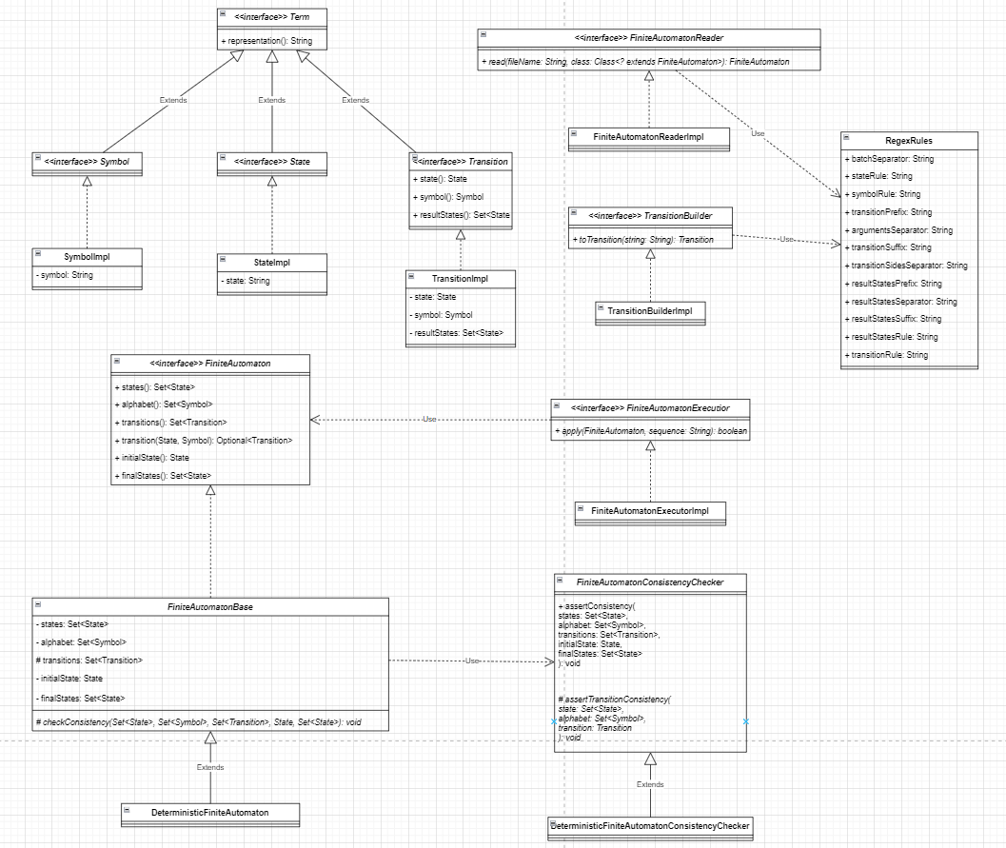

Finite Automata:

1. Integer:

1. Identifier:

