Link to github repository : <https://github.com/paie2993/FormalLanguagesParser> (Andrei Șaramet + Adrian Popescu from 936/1)

Link to reviewed repository: <https://github.com/rad0o/FLCD/tree/main/lab5> (Radu Savin from 936/1)

Symbol hierarchy:

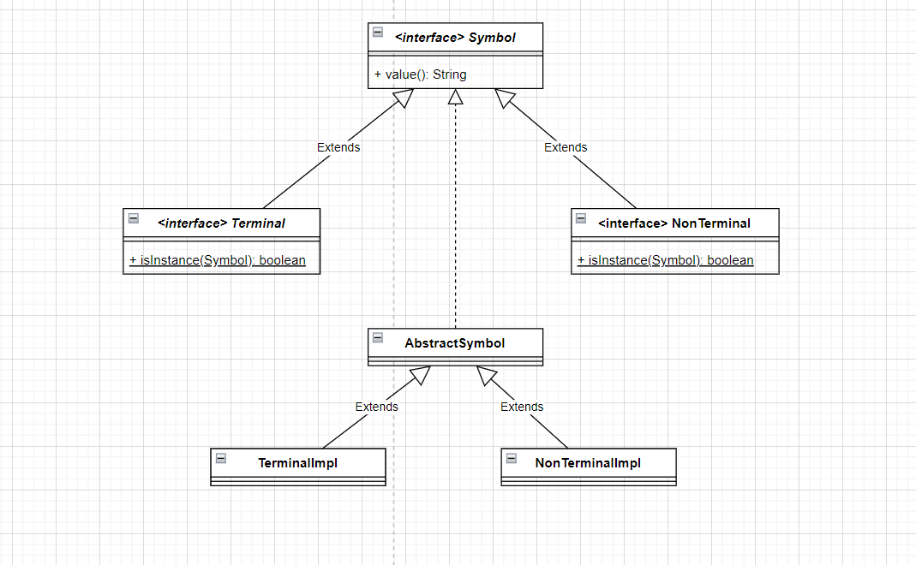

Production hierarchy: 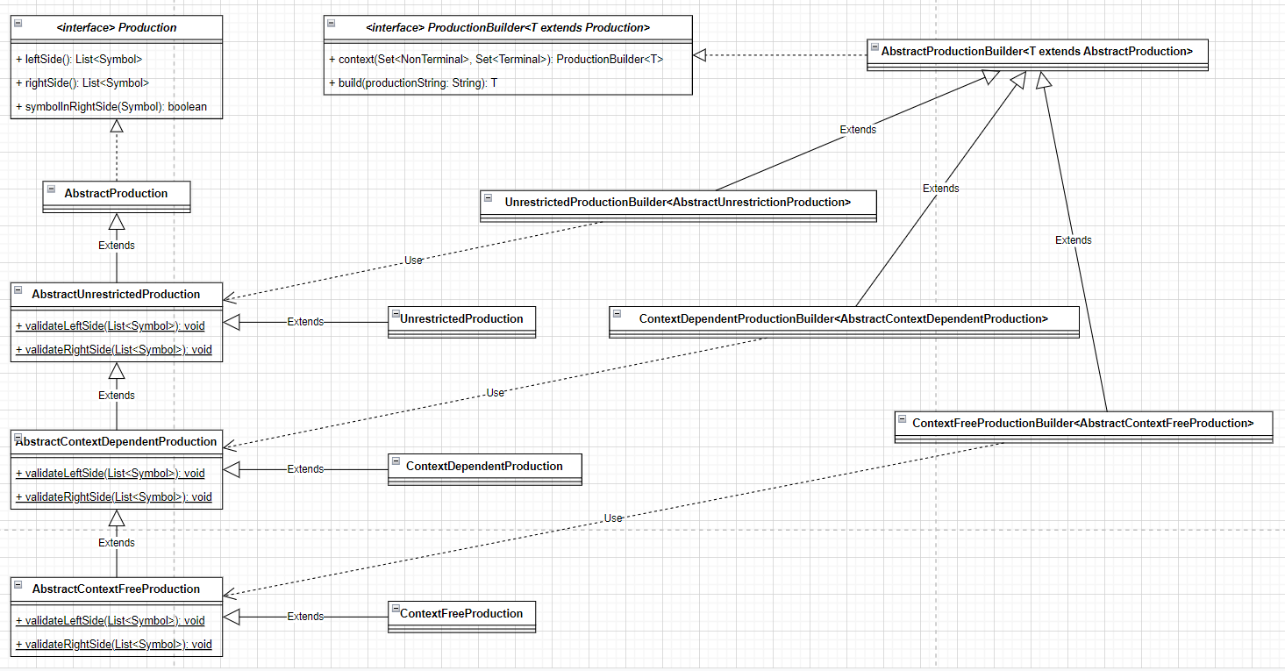

Grammar hierarchy:

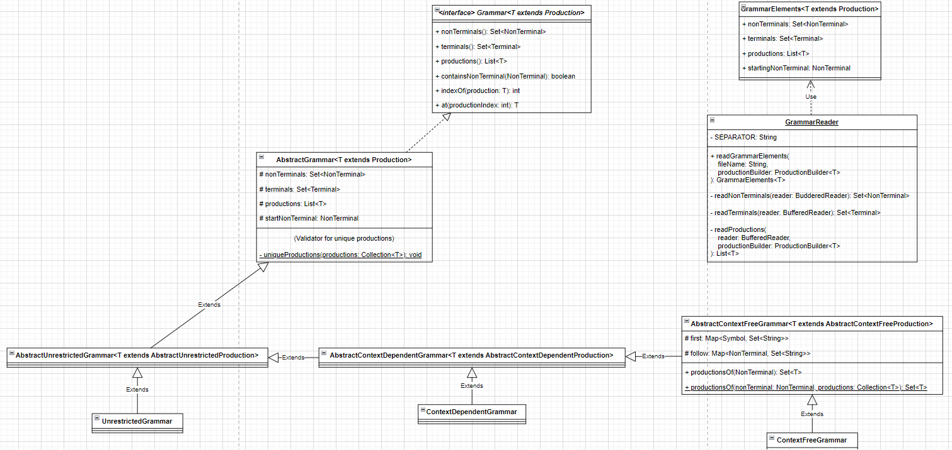

First, follow, concatentate:

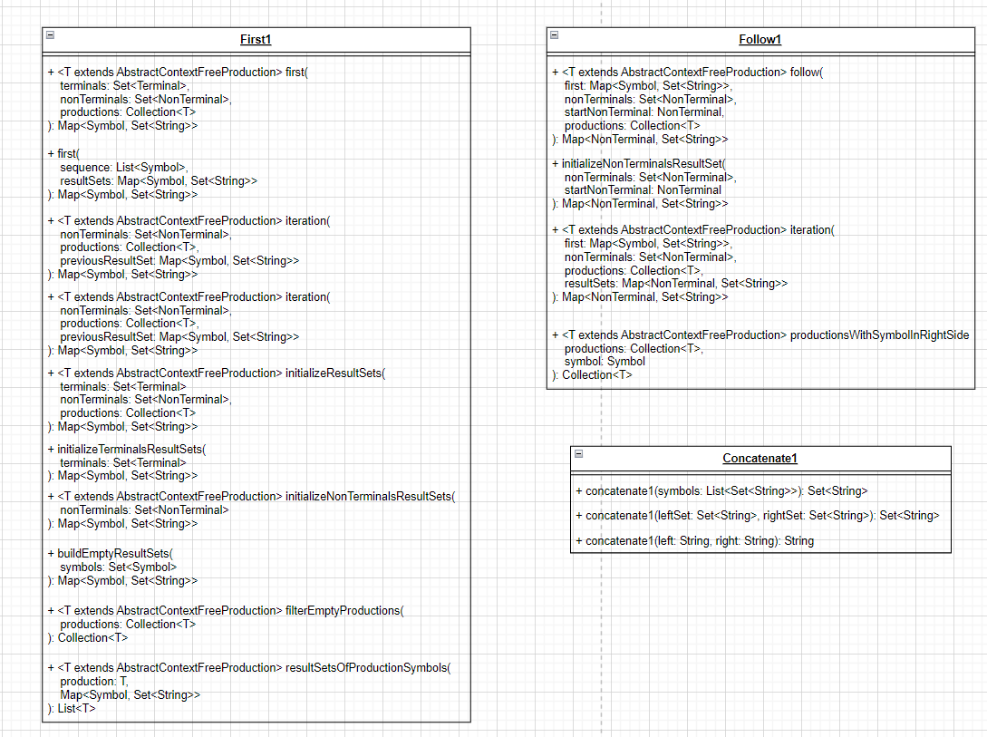

Pare Table:

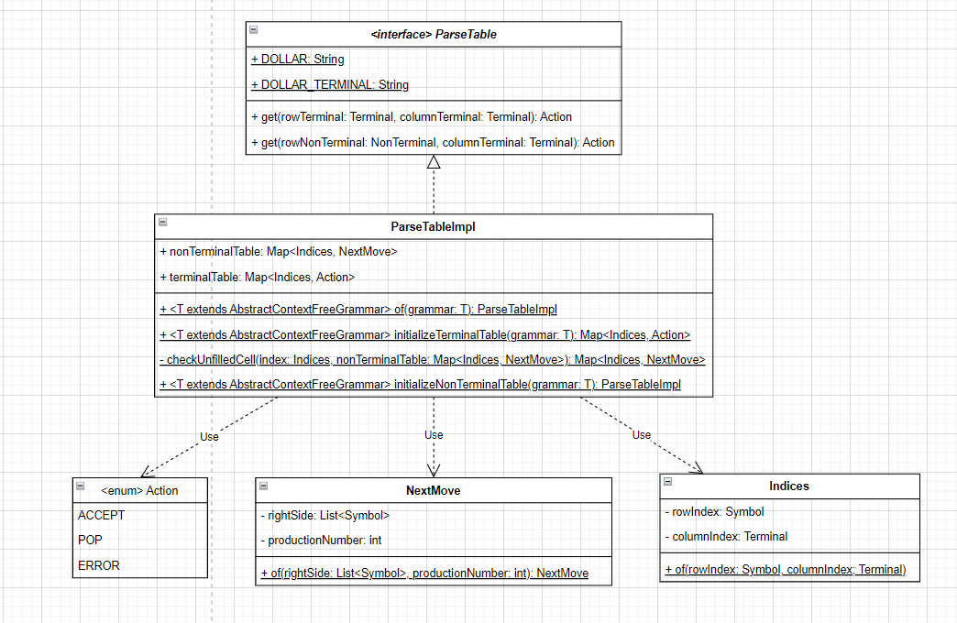

LLI1 Parser:

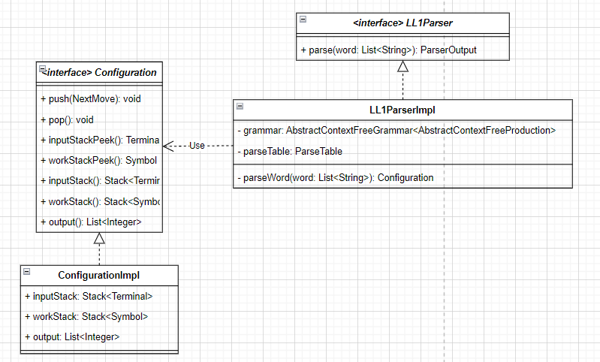

Parser output:

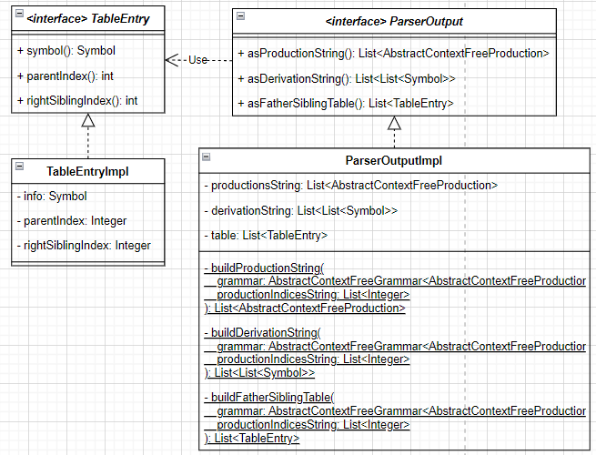

File readers and writers:

