Laboratory Assignment AND Assessment Requirements Specification

Version 1.0

March, 2023

Developed by:

Andrei Șaramet, Radu Constantin Savin, Adrian Popescu

936

Version History

|  |  |  |  |
| --- | --- | --- | --- |
| Version | Description of Change | Author | Date |
| V01 | Initial | Student X  Student Y | 16.03.2020 |
| V02 | Improved | Andrei Șaramet, Radu Constantin Savin, Adrian Popescu | 15.03.2023 |

**Contents**

Laboratory Assignment AND Assessment Requirements Specification 1

Version 1.0 1

March, 2020 1

1 Functional Requirements 3

2 Actors 3

3 Use cases – diagram 3

3.1 Use case number 1 (Description of the use case) 3

4 Analysis 3

4.1 Entities 3

4.2 Relations between entities 3

4.3 Attributes 3

4.4 System events 4

5 Design 4

**Analysis and design Document**

# Functional Requirements

List the functional requirements (FR) of the system.

|  |  |
| --- | --- |
| Section/ Requirement ID | Requirement Definition |
| FR1.0 | CRUD operations for the Student entity |
| FR1.1 | Adding an assignment |
| FR2.0 | Adding a grade for a particular student to an assignment |
| FR3.0 | Extending the deadline for an assignment |
| FR4.0 | When adding a new assignment, as well as modifying the deadline, all students will be notified by email |
| FR5.0 | The NameStudent.txt file (or its content) will be emailed to the student, weekly, with the subject "Feedback laboratory MAP" |
| FR6.0 | The delays will not be considered if the student has motivation. Also, if the teacher did not enter the grades in time, it will be possible to specify the week in which the subject was delivered |
| FR7.0 | Filtering entities based on criteria |
| FR8.0 | Reports: assignment grade for each student, most difficult assignment (smallest average of grades), students who have an average greater than or equal to 4, students who have delivered the assignments on time |

# Actors

Teacher

# Use cases – diagram

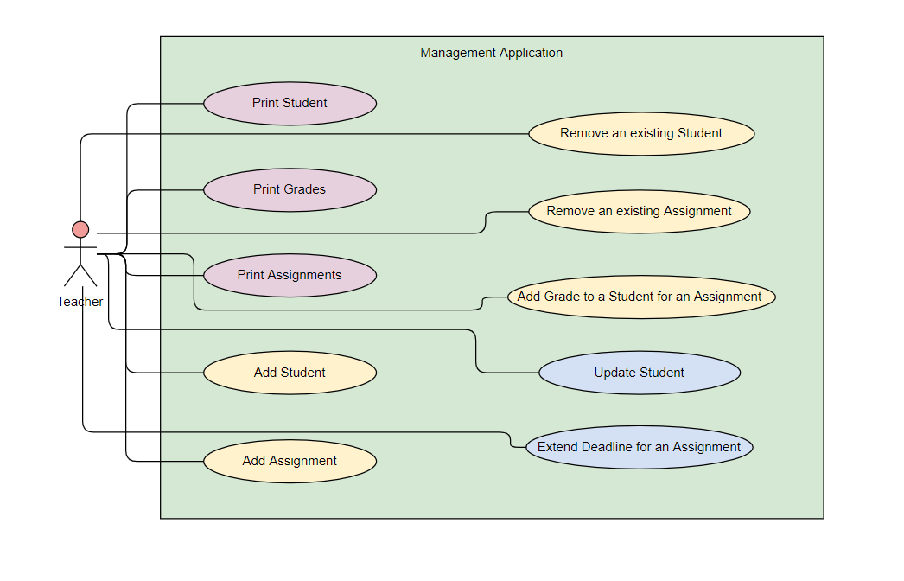

## Use case number 1 (Description of the use case)

Actors: teacher

Description: create a new student

Precondition: - all fields are specified

Postcondition: - a new student was added in the list

|  |  |
| --- | --- |
| Action | System Response |
| 1 Completes the necessary fields for adding |  |
|  | 2 Checks if everything is alright, adds a new element in the list if so |
| 3 - | 3. If the input is invalid, throws an exception |

Exceptions: When the fields aren’t filled.

## 3.2 Use case number 2 (Description of the use case)

Actors: teacher

Description: delete student

Precondition: - valid id belonging to an existing student is specified

Postcondition: - the student with the specified id is removed from the list

|  |  |
| --- | --- |
| Action | System response |
| 1 Give an id as input |  |
|  | 2 Checks if it is a valid id and there is a student with that id and deletes the student |
| 3 - | 3. If the input is invalid, throws an exception |

## 3.3 Use case number 3 (Description of the use case)

Actors: teacher

Description: update student

Precondition: - valid id belonging to an existing student and all other fields for student are specified

Postcondition: - the student with the specified id has the data updated

|  |  |
| --- | --- |
| action | System response |
| 1 Give an id and all other fields for the Student entity as input |  |
|  | 2 Checks if it is a valid id and there is a student with that id, than checks if the rest of the input is valid, and updates the data for that student |
| 3 - | 3. If the input is invalid, throws an exception |

# Analysis

## Entities

Student, Assignment, Grade, Professor, Group

## Relations between entities

One student can have multiple assignments and one assignment can be assigned to many students. It is a many-to-many relationship between the two classes.

Class Grade has as id, a pair consisting of studentId and assignmentId and it is the association class between the Student and Assignment classes.

There is a one-to-many relationship from Group entities to Student entities, and a many-to-one relationship from Student entities to Group entities.

There is a one-to-many relationship from Professor to Student entities.

## Attributes

Student: id, name, group id, email, professor id

Assignment: id, description, deadline, assignation date

Grade: id(studentId, assignmentId), value, deliver date, feedback

Professor: id, professor name

Group: id, number

## System events

After each operation a message is shown to the user either if the command terminated succesfully or with an error message.

# Design

* 1. **Class diagram**

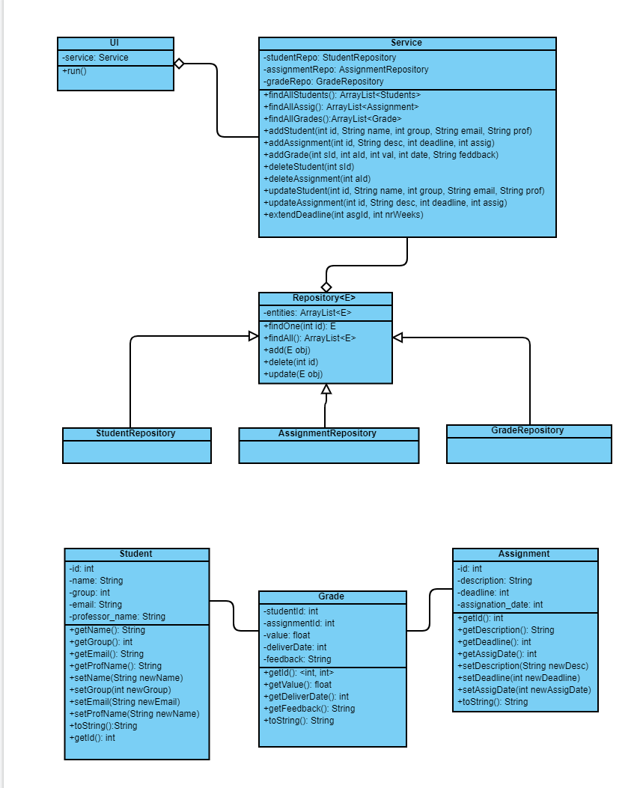

* 1. **Sequence diagrams (for each use case)**
* **Add Student Sequence Diagram**

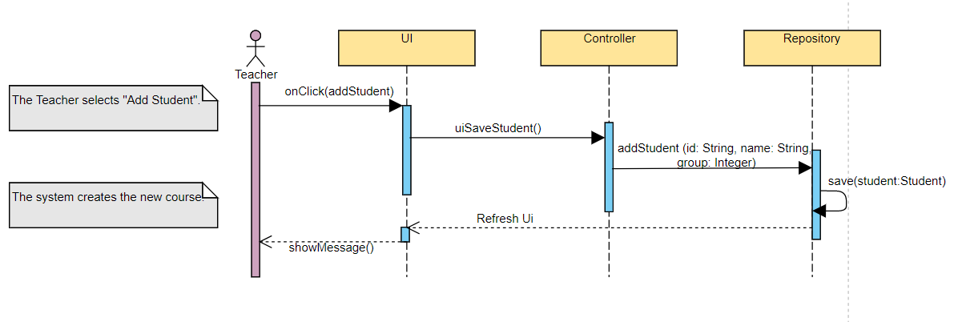

* **Delete Student Sequence Diagram**

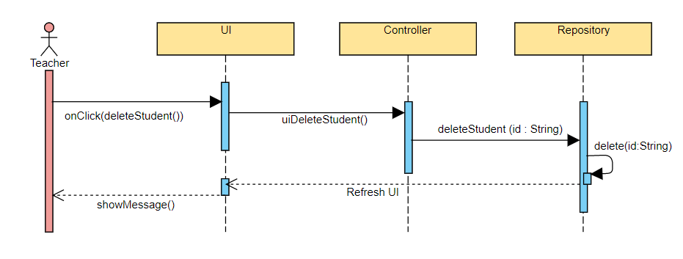

* **Update Student Sequence Diagram**

