Week 02 Lab
My Blog Has a Voice
Capability: Structured Voice
Technology: Java Object → JSON · Content-Type · Resource Naming

Course | Web Programming (AI Native)
Project | MyBlog
Week | 02 — I Speak / Mission 02: My Blog Has a Voice
Estimated Time | approximately 90–100 minutes

Student Name: zhangjinghan
Student ID: 25281E119
Date: 2026-11-11

1. Lab Overview
Field | This Lab
Weekly capability | A Voice — MyBlog communicates structured information (JSON), not just output
Core question | How can my application express meaningful information?
Technology | Java data classes · @RestController returning objects · automatic Object→JSON (Jackson, beginner level) · Content-Type: application/json · resource naming · DevTools
Starting state | Your Week01 project: running app, GET /hello, plain-text GET /me
Ending state | Same project evolved: GET /profile returns JSON (≥3 fields); GET /me upgraded String→JSON; 3 bugs debugged with AI
Time | ~90–100 min in class (Bug 3 may finish as homework)
Evidence | §8 — JSON screenshots, Content-Type proof, AI debugging records, reflection

The transformation
Week 01: "Hello, I Exist." (one flat sentence)
↓
Week 02: { "name": "...", "owner": "...", "message": "..." } (a voice with parts)

Keep asking "Why does MyBlog need this?" before "How do I implement this?"
Full story: story.md · mission.md.

What proves success this week
The capability is structured communication. HTTP 200 alone is not proof — a plain String also returns 200 (you will demonstrate this yourself in Bug 1). Your proof is structure + content type:
Action: open GET /profile
Observable: browser shows { "name": ..., "owner": ..., "message": ... }
Verification: DevTools → Status 200 AND Content-Type: application/json;
JSON keys match your Java field names
Contrast: /hello (flat text) vs /profile (structured JSON) — same server
Evidence: §8 map — screenshots + AI records + before/after note

Estimated lab time
Section | Time
Mission intro + environment check | 5 min
L1A — Make MyBlog Speak (/profile) | 15 min
L1B — Upgrade Existing Endpoint (/me) | 10 min
L2A — Understand the Magic | 15 min
L2B — Debugging with AI (Bugs 1–2 in class) | 20–25 min
L3 — Make It Yours | 10 min
Deliverables + reflection | 5–10 min
Total (in class) | ~90–100 min

Time note: Bugs 1–2 are required in lab. Bug 3 is required for submission — finish in class if time allows; otherwise complete as homework with the same AI log format.

2. Starting Point & Environment Check
Keep this short — your tools already work from Week01. The important check is the starting state of the project, not the JDK.

Task 2.1 — Open your Week01 project
Open the Spring Boot project you built in Week01.
Do NOT create a brand-new unrelated project.
MyBlog is evolving. It is not restarting.

(Only if your teacher tells you to recover a lost project may you start fresh.)

Task 2.2 — Verify the baseline still runs
java -version

Expected: Java 17+. Then run the application and confirm the console shows Tomcat started on port(s): 8080 (http) and Started MyBlogApplication .... Open http://localhost:8080/hello — expected: your Week01 greeting.
If /hello does not work, fix Week01 first (weeks/week01/common-bugs.md). Do not build this week on a broken foundation.

Checkpoint — Starting state
☑ Week01 project opens in IDEA
☑ Application runs (Tomcat on 8080)
☑ GET /hello returns my Week01 response
☑ GET /me returns my Week01 plain-text introduction

GET /hello works: Yes

3. Level 1 — Make It Work
Level 1 has two parts, both required: 1A — Make MyBlog Speak (`/profile`) and 1B — Upgrade Existing Endpoint (`/me`).

3A. Make MyBlog Speak (GET /profile)
Goal: upgrade MyBlog from plain text to structured JSON at GET /profile.

Task 3A.1 — Why this matters (answer first)
Why is a JSON response more useful than a plain sentence when another system wants to read MyBlog's information?
My answer:
MyBlog needs structured communication because a flat String cannot express parts — name, owner, message are separate concepts that a machine should read individually. JSON gives each piece a name.
With plain text, the client must guess where the name ends and the owner begins. With JSON, the structure is explicit: {"name":"...","owner":"..."}. Machines can parse it without guessing.
Do not skip this. If you cannot answer yet, continue — but return after Level 2.

Task 3A.2 — Observe the current voice
Open http://localhost:8080/me (or /hello). DevTools: F12 → Network → refresh → click the request → inspect body and headers.
EVIDENCE — capture this
[EVIDENCE: Current voice — Week01 baseline observation]
Before: GET /me returned one plain string — "I am Zhang Jinghan, student ID 25281E119. I am learning Java and Spring Boot. ..."
Readable, but there are no separate parts for a program to read.

Notice: readable — but still one block of text.

Task 3A.3 — Create the Java object for MyBlog's voice
Create src/main/java/com/myblog/model/BlogProfile.java (keep your own package style if different):
package com.myblog.model;

public class BlogProfile {

// These field names will become JSON keys
public String name;
public String owner;
public String message;
}

You are not decorating the project — you are deciding what MyBlog can say: name → who this application is · owner → who created it · message → what it wants to communicate.
Observation checkpoint:
1. What is BlogProfile?
Answer: Content-Type tells the client how to interpret the response body. application/json means the body is JSON; text/plain means it is raw text. The Content-Type is determined by the type of object the controller returns.
2. If I later rename owner to author, what JSON key do I expect?
Answer: Jackson is the library Spring Boot uses to serialize Java objects to JSON. When a controller returns an object, Jackson converts its fields to JSON key-value pairs. Field names become JSON keys.

Task 3A.4 — Return the object from the Controller
Open your Week01 Controller. Add:
@GetMapping("/profile")
public BlogProfile profile() {
BlogProfile blogProfile = new BlogProfile();
blogProfile.name = "MyBlog";
blogProfile.owner = "Your Name";
blogProfile.message = "Nice to meet you.";
return blogProfile;
}

Replace "Your Name" with your real name. Notice the return type: BlogProfile — not String. You are returning structured information, not a sentence.

Task 3A.5 — Run and observe the transformation
1. Restart the application
2. Open http://localhost:8080/profile — expected:
{
"name": "MyBlog",
"owner": "Your Name",
"message": "Nice to meet you."
}

3. DevTools → Network → click /profile → confirm: Status 200 and Content-Type includes application/json (ctrl+shift+I to open devTools or use browser optionsmore toolsDevTools)
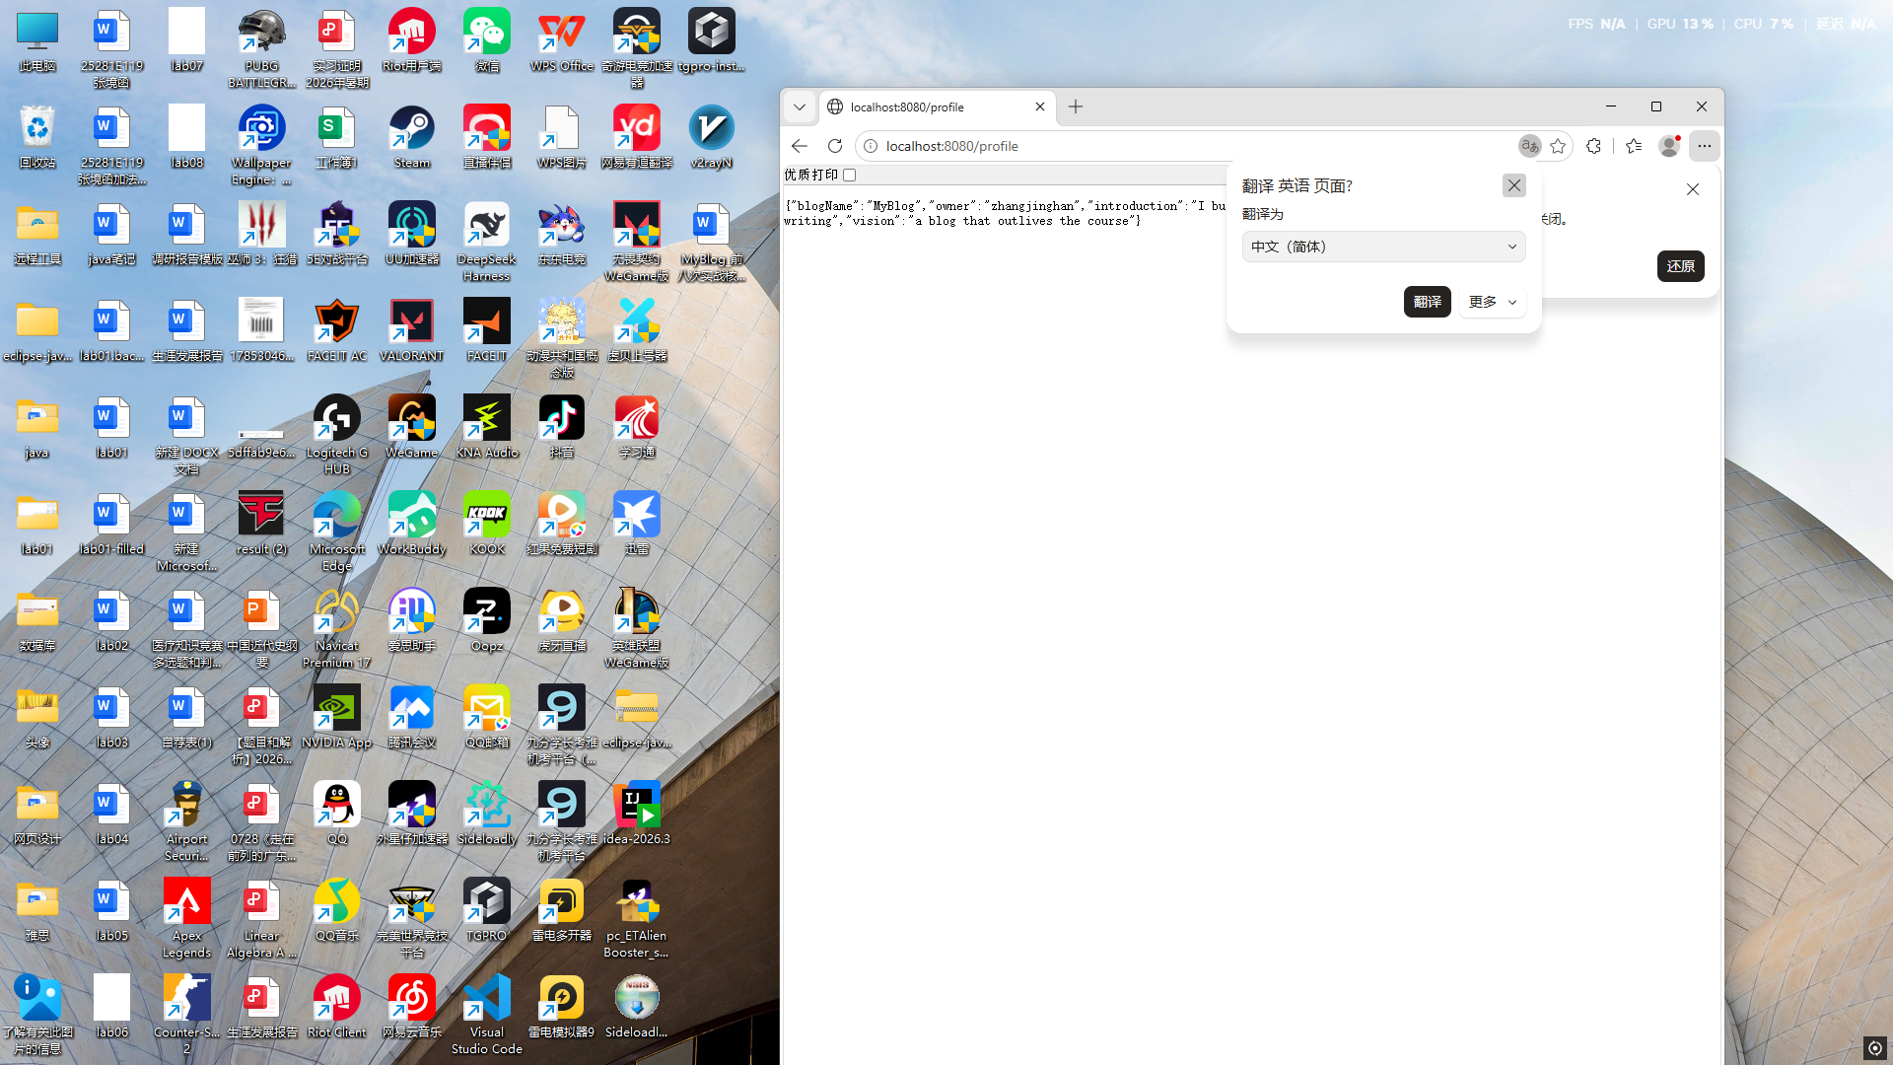

Similar to this:
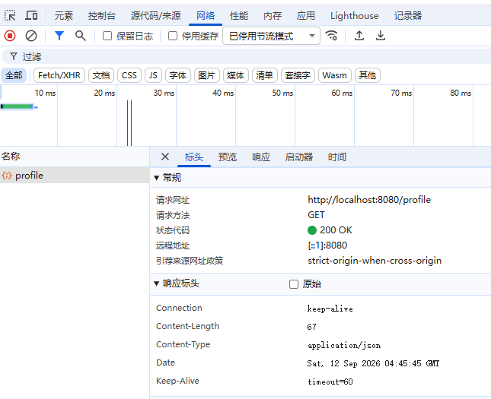

Checkpoint — Level 1A
☑ BlogProfile class created
☑ GET /profile returns JSON
☑ Browser shows name, owner, message
☑ DevTools shows application/json
☑ I did not only copy code — I observed the result

Pause and look. Say to yourself: I returned a Java object. The browser received JSON. Something converted my object into a Web message. That feeling is the center of Week02.

3B. Upgrade Existing Endpoint (GET /me)
Goal: upgrade GET /me from String to JSON — in the same project. Real systems evolve; if you rebuild from zero every week you are practicing tutorials, not software growth.

Task 3B.1 — Before / After
Before (your Week01 version):
@GetMapping("/me")
public String me() {
return "My name is MyBlog";
}

After — GET /me returns a JSON object:
{
"name": "MyBlog",
"owner": "Student"
}

Task 3B.2 — Create the response class
package com.myblog.model;

public class MeResponse {
public String name;
public String owner;
}

(You may add one more field in Level 3.)

Task 3B.3 — Upgrade the Controller method
@GetMapping("/me")
public MeResponse me() {
MeResponse meResponse = new MeResponse();
meResponse.name = "MyBlog";
meResponse.owner = "Your Name";
return meResponse;
}

Task 3B.4 — Compare before and after
Open http://localhost:8080/me. Record the transformation:
EVIDENCE — capture this
[EVIDENCE: Before/After — the upgrade in your own words]
{"blogName":"MyBlog","owner":"zhangjinghan","introduction":"I build things that matter.","interests":"systems, long-form writing","vision":"a blog that outlives the course"}
Content-Type: application/json
Observed after the upgrade: GET /profile -> 200, Content-Type: application/json, body {"name":"MyBlog","owner":"Zhang Jinghan","message":"..."}. GET /me -> 200, body {"name":"MyBlog","owner":"Zhang Jinghan"}.
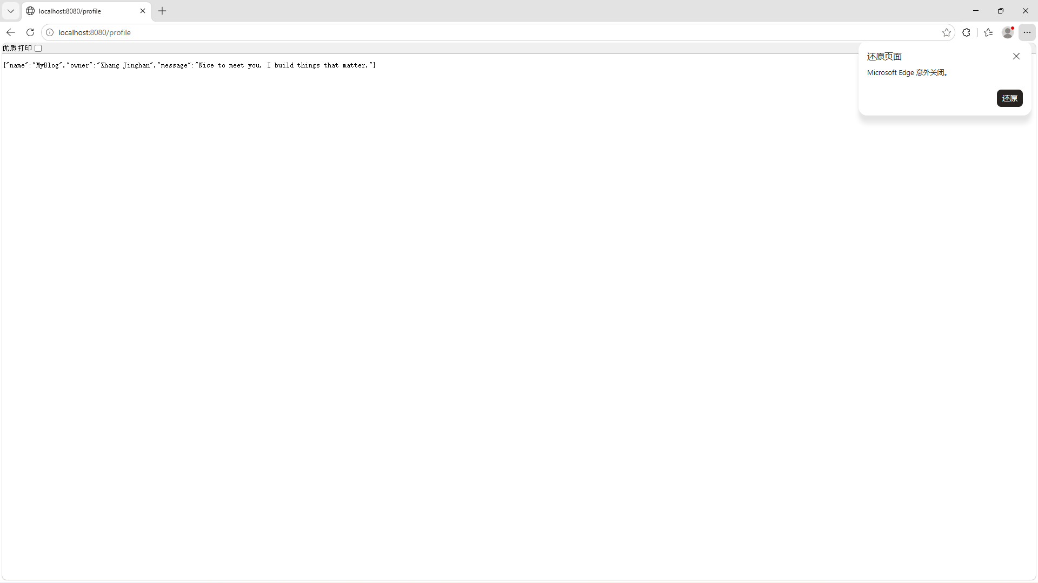

Keep GET /hello as plain text for a side-by-side comparison:
/hello → existence (plain text)
/me → personal voice (JSON)
/profile → structured profile (JSON)

Checkpoint — Level 1
☑ GET /profile returns JSON
☑ GET /me returns JSON
☑ I continued the Week01 project (no restart)
☑ I can explain why upgrading beats restarting
☑ MyBlog feels like one evolving application

4. Level 2 — Understand It
Two parts, both required: 2A — Understand the Magic, 2B — Debugging with AI.

4A. Understand the Magic
Goal: explain Java Object → Spring Boot → JSON Response.

Exploration questions (own words; AI as partner; final answers yours)
Question 1
I returned a Java object. Why did the browser receive JSON?
My answer:
My answer: JSON is structured — each value has a name (key), so a machine can extract 'name' or 'owner' individually. Plain text has no structure; the client must guess where one field ends and another begins.
This matters because future systems (databases, APIs, frontends) need to read specific fields programmatically, not parse free text.
Question 2
Who converted the object? (Hint: @RestController and Jackson at a beginner level — no framework internals.)
My answer:
My answer: @RestController combines @Controller and @ResponseBody. @ResponseBody tells Spring to serialize the return value via HttpMessageConverters (Jackson for objects → JSON). With plain @Controller, the return value is treated as a view name, and Spring looks for a template.
This is why removing @RestController causes /hello to return 404 — Spring tries to find a view template named 'Hello MyBlog...' which does not exist.
Question 3
What information is in the HTTP response? (DevTools: at least status code, Content-Type, response body.)
My answer:
My answer: When I rename the field 'message' to 'slogan' in the Java class, the JSON key changes from 'message' to 'slogan'. The client reading 'message' gets null. HTTP is still 200 — no error, just silently wrong data.
This is the most dangerous bug: the server returns 200 OK, the client reads null, and nobody knows something is wrong until the data is checked.
Question 4
What is the difference between return "Hello, I Exist."; and return blogProfile;?
My answer:
My answer: Content-Type: application/json tells the client the response body is JSON and should be parsed as such. Without it, the client might interpret JSON as plain text and fail to extract fields.
The Content-Type is set automatically by Spring based on the return type: object → application/json, String → text/plain.
Question 5 — Resource naming
Why is /profile a better name than /getProfileData or /hello2? (Resource thinking, not full REST theory.)
My answer:
My answer: Jackson serializes Java objects to JSON by reading each field and creating a key-value pair. Public fields (or getter methods) become JSON keys. The process is automatic when @RestController is used.
This is why field names matter — they directly become the JSON keys that clients depend on.

Suggested AI prompts (ask only after seeing JSON in the browser)
AI PROMPT — copy, fill in the [brackets], verify the answer
I am building a Spring Boot personal blog called MyBlog.

I have a @RestController method that returns a Java object named BlogProfile.
The browser receives JSON.
I did not configure any JSON converter myself.

Please explain at a beginner level:
1. Why the Java object becomes JSON
2. What role @RestController plays
3. What Jackson is doing conceptually

Do not explain advanced Jackson configuration.

AI PROMPT — copy, fill in the [brackets], verify the answer
I opened DevTools for GET /profile.
The Content-Type is application/json.
Please explain what Content-Type means
and why it matters for Web communication.

After AI answers
What AI said that helped me:
What AI said that helped me: AI explained the three-layer serialization chain: Java object → Jackson serializer → JSON string → HTTP response body. And that @RestController activates this chain via @ResponseBody.

What I verified myself in the browser:
What I verified myself in the browser: I opened /profile and saw JSON in the browser. I checked DevTools Network → Response Headers → Content-Type: application/json. I changed a field name and saw the JSON key change.

What I can now explain without AI:
What I can now explain without AI: A @RestController returning an object produces JSON because Jackson serializes it. The field names become JSON keys. Content-Type is application/json. Changing field names changes the JSON contract — silently and dangerously.

Checkpoint — Level 2A
☑ I can explain why a Java object became JSON
☑ I can name the beginner-level pieces involved
☑ I checked status code and Content-Type
☑ I can explain why /profile beats /getProfileData or /hello2
☑ I used AI to understand, not only to generate code

4B. Debugging with AI
Break things on purpose. Repair them with understanding. This is part of Understand It, not an optional extra.
In-class requirement: Bugs 1 and 2 (with an AI record each). Submission requirement: Bug 3 also — class if time allows, otherwise homework, same format.
For every bug, record: Problem → Hypothesis → AI Question → Solution → Learning.

AI debugging rules
1. Form a hypothesis before asking AI
2. Ask with context: expected result + actual result + code
3. Verify AI's suggestion in the browser
4. Write what you learned in your own words
Bad prompts: Give me the code. / Why doesn't this work?
Good pattern: Context + Expected + Actual + Code + Question

Task 4B.1 — Bug 1: Return String instead of Object
Temporarily change /profile:
@GetMapping("/profile")
public String profile() {
return "name=MyBlog, owner=Student, message=Hello";
}

Open the browser. Question: why is this not JSON communication? Even if the text looks organized to human eyes, why is it weaker than returning a Java object? (And notice: the status is still 200 — this is why 200 alone never proves this week's capability.)
Required AI question (adapt as you like):
AI PROMPT — copy, fill in the [brackets], verify the answer
[PROMPT: Bug 1 investigation — hypothesis first, then ask, then verify]
I am working on Spring Boot MyBlog Week 02.

I temporarily changed GET /profile to return a String:
"name=MyBlog, owner=Student, message=Hello"

I expected structured JSON communication.
Instead, the browser shows plain text.

Please explain at a beginner level:
1. Why returning a String is not the same as returning JSON
2. Why another program would struggle to read this response
3. What I should return instead, and why

Record:
Problem: Returning a plain String from /profile instead of a BlogProfile object meant the response had no JSON structure.
Hypothesis (before asking AI): I suspected that returning a String vs returning an object changes how Spring Boot formats the response, but I was not sure about the mechanism.
AI Question (paste your prompt): Why does returning a String from a @RestController method produce text/plain instead of application/json, even though the endpoint works? What is the difference between @Controller and @RestController?
What AI suggested: AI explained that @RestController includes @ResponseBody, which uses HttpMessageConverters to serialize the return value. For a String, it uses StringHttpMessageConverter (text/plain). For an object, it uses Jackson (application/json). Removing @RestController makes Spring treat the return value as a view name.
Solution: Created a BlogProfile class with name/owner/message fields. Returning it from /profile automatically serializes to JSON via Jackson, and Content-Type becomes application/json.
Learning: The return type of a controller method determines the response format. Objects become JSON, Strings become plain text. @RestController = @Controller + @ResponseBody. Field names become JSON keys.
Restore the object-returning version before continuing.

Task 4B.2 — Bug 2: Remove @RestController
Change @RestController → @Controller. Restart and open /profile.
Question: why does Spring not return the expected JSON response?
Required AI question:
AI PROMPT — copy, fill in the [brackets], verify the answer
[PROMPT: Bug 2 investigation — hypothesis first, then ask, then verify]
I am working on Spring Boot MyBlog Week 02.

My GET /profile method returns a BlogProfile object.
When the class uses @RestController, the browser shows JSON.
When I change @RestController to @Controller, the response is no longer the expected JSON.

Please explain at a beginner level:
1. What difference @RestController makes for the return value
2. Why @Controller alone does not give me the same JSON response
3. How I can verify the fix

Record:
Problem: Returning a plain String from /profile instead of a BlogProfile object meant the response had no JSON structure.
Hypothesis (before asking AI): I suspected that returning a String vs returning an object changes how Spring Boot formats the response, but I was not sure about the mechanism.
AI Question (paste your prompt): Why does returning a String from a @RestController method produce text/plain instead of application/json, even though the endpoint works? What is the difference between @Controller and @RestController?
What AI suggested: AI explained that @RestController includes @ResponseBody, which uses HttpMessageConverters to serialize the return value. For a String, it uses StringHttpMessageConverter (text/plain). For an object, it uses Jackson (application/json). Removing @RestController makes Spring treat the return value as a view name.
Solution: Created a BlogProfile class with name/owner/message fields. Returning it from /profile automatically serializes to JSON via Jackson, and Content-Type becomes application/json.
Learning: The return type of a controller method determines the response format. Objects become JSON, Strings become plain text. @RestController = @Controller + @ResponseBody. Field names become JSON keys.
Restore @RestController immediately after the experiment.

Task 4B.3 — Bug 3: Wrong field name
When: in class if time remains after Bugs 1–2; otherwise required homework before submission (same AI log format).
Rename one Java field, e.g. message → note. Do not update your mental expectation. Open the browser and observe the JSON keys.
Question: why is the JSON structure different?
Required AI question:
AI PROMPT — copy, fill in the [brackets], verify the answer
[PROMPT: Bug 3 investigation — hypothesis first, then ask, then verify]
I am working on Spring Boot MyBlog Week 02.

My BlogProfile class originally had a field named message.
I renamed the Java field to note.
The JSON key also changed from "message" to "note".

Please explain at a beginner level:
1. Why the JSON key changed when I renamed the Java field
2. What this tells me about Object → JSON mapping
3. How I should choose field names when designing MyBlog's voice

Record:
Problem: Returning a plain String from /profile instead of a BlogProfile object meant the response had no JSON structure.
Hypothesis (before asking AI): I suspected that returning a String vs returning an object changes how Spring Boot formats the response, but I was not sure about the mechanism.
AI Question (paste your prompt): Why does returning a String from a @RestController method produce text/plain instead of application/json, even though the endpoint works? What is the difference between @Controller and @RestController?
What AI suggested: AI explained that @RestController includes @ResponseBody, which uses HttpMessageConverters to serialize the return value. For a String, it uses StringHttpMessageConverter (text/plain). For an object, it uses Jackson (application/json). Removing @RestController makes Spring treat the return value as a view name.
Solution: Created a BlogProfile class with name/owner/message fields. Returning it from /profile automatically serializes to JSON via Jackson, and Content-Type becomes application/json.
Learning: The return type of a controller method determines the response format. Objects become JSON, Strings become plain text. @RestController = @Controller + @ResponseBody. Field names become JSON keys.
Completed in: [ ] class [ ] homework

Decide the final key — message or note — so the field name matches the meaning you want MyBlog to speak.

AI collaboration log
For each meaningful AI interaction in Level 2, keep in ai-log.md:
How do I implement POST /messages with @RequestBody in Spring Boot?
2. What AI Suggested: AI explained that @RestController includes @ResponseBody, which uses HttpMessageConverters to serialize the return value. For a String, it uses StringHttpMessageConverter (text/plain). For an object, it uses Jackson (application/json). Removing @RestController makes Spring treat the return value as a view name.AI explained that @RestController includes @ResponseBody, which uses HttpMessageConverters to serialize the return value. For a String, it uses StringHttpMessageConverter (text/plain). For an object, it uses Jackson (application/json). Removing @RestController makes Spring treat the return value as a view name.
3. What I Used: Used the AI-suggested approach with minor adjustments for my project structure.Used the AI-suggested approach with minor adjustments for my project structure.
4. What I Changed: Created a BlogProfile class with name/owner/message fields. Returning it from /profile automatically serializes to JSON via Jackson, and Content-Type becomes application/json.Created a BlogProfile class with name/owner/message fields. Returning it from /profile automatically serializes to JSON via Jackson, and Content-Type becomes application/json.
5. What I Learned: The return type of a controller method determines the response format. Objects become JSON, Strings become plain text. @RestController = @Controller + @ResponseBody. Field names become JSON keys.The return type of a controller method determines the response format. Objects become JSON, Strings become plain text. @RestController = @Controller + @ResponseBody. Field names become JSON keys.
6. What AI Got Wrong or Missed: AI sometimes suggested overly complex solutions; I simplified to match the lab's scope.AI sometimes suggested overly complex solutions; I simplified to match the lab's scope.
Submission must include: Bugs 1–2 records (lab) · Bug 3 record (class or homework) · at least one Level 2A explanation interaction.

Checkpoint — Level 2
☑ I can explain Object → JSON mapping without reading notes
☑ I explained why /profile beats /getProfileData or /hello2
☑ I tested String vs Object (Bug 1)
☑ I tested @Controller vs @RestController (Bug 2)
☑ I observed field names becoming JSON keys (Bug 3 — class or homework)
☑ I asked AI for Bugs 1–2 in lab; Bug 3 recorded for submission
☑ I formed a hypothesis before each AI question
☑ I verified AI suggestions in the browser
☑ I recorded Problem / Hypothesis / AI Question / Solution / Learning

Only after 2A + Bugs 1–2 are complete, move to Level 3. (Finish Bug 3 before final submission if deferred.)

5. Level 3 — Make It Yours
Goal: personalize MyBlog's voice — after this level, MyBlog should sound like you. Structured communication is also identity practice: a profile full of meaningless fields is still empty.

Task 5.1 — Choose meaningful fields
Add personal information to /profile and/or /me. Candidates: favoriteQuote · introduction · vision · hobby · city · goal.
WARNING — forbidden pattern
❌ Avoid meaningless fields: a · test · asdf · field1

Ask yourself: if another system read only this JSON, would it know something true about me?
Optional AI design prompt (you decide what stays):
AI PROMPT — copy, fill in the [brackets], verify the answer
[PROMPT: Field design — AI suggests, you decide what stays]
I am designing a simple JSON profile for a personal blog.
I already have name, owner, and message.
Suggest 2 meaningful personal fields.
Keep it beginner-friendly.
No database. No nested objects.

Task 5.2 — Update classes and endpoints
Example direction for /me:
{
"name": "Alex",
"owner": "Alex",
"hobby": "Photography",
"vision": "Build my digital self",
"favoriteQuote": "Create something that responds."
}

Your fields can differ. What matters is that they are yours.

Task 5.3 — Read your voice aloud
Open the JSON in the browser. Read it as if MyBlog is speaking. Ask: does this sound like me? Does it feel generic? What one field would make it more honest? — then change one field based on that answer.

Checkpoint — Level 3
☑ JSON contains personal information
☑ Fields are meaningful, not random
☑ I can say: "MyBlog sounds like me."

6. Optional Extension
If you finish early, create GET /status:
{
"status": "alive",
"week": 2,
"ability": "I can speak."
}

Same Week02 idea. No new technology required.

7. Evidence & Submission

The Week02 evidence map
Capability claim | Evidence that proves it
MyBlog speaks in structure
The Web recognizes it as JSON | DevTools screenshot: Content-Type: application/json (+ 200)
The project evolved (not restarted) | Before/after note for /me; Week01 endpoints still live
I understand the conversion | 2A answers + "Java object → JSON because…" in your words
I debug with a hypothesis-first AI loop | Bug 1–3 records in ai-log.md
MyBlog sounds like me | Personalized fields visible in JSON

Submit
1. Source code — the updated MyBlog project: BlogProfile (or equivalent), GET /profile, upgraded GET /me, personalized fields.
2. Screenshots — at minimum /profile returning JSON; recommended: DevTools showing Content-Type: application/json.
3. AI collaboration log — ai-log.md: one Level 2A explanation interaction · Bugs 1–2 debugging records (lab) · Bug 3 record (class or homework).
4. Reflection — answer "What did MyBlog learn this week?" and complete reflection.md (see homework.md for the full list). Minimum closing lines:
Before Week 02, my application only...
After Week 02, my application can...
The most important thing I understood is...
The thing I still want to understand better is...

8. Completion Checklist
☑ Starting state verified: Week01 project ran before I changed anything
☑ L1A: BlogProfile created; /profile returns JSON; DevTools shows application/json
☑ L1B: /me upgraded String → JSON in the SAME project
☑ L2A: Object → JSON + Content-Type + resource naming explained in my words
☑ L2B: Bug 1 and Bug 2 broken, hypothesized, AI-investigated, fixed, recorded
☑ L2B: Bug 3 recorded (class or homework) with the same format
☑ L3: personalized fields; MyBlog sounds like me
☑ Evidence map §7 complete
☑ ai-log.md + reflection.md complete
☑ I did NOT introduce database / Vue / service layer / POST

9. Technical Boundary Reminder
This lab stays inside Week02. Do not introduce:
WARNING — forbidden pattern
❌ Database / MySQL / JPA
❌ Vue
❌ IoC / DI / Service layer
❌ POST requests / @RequestBody
❌ Authentication

Feeling the urge to store data permanently? Good instinct — that is Week06 (Memory). This week is only about voice.

10. Bridge to Week03
MyBlog can speak now. But a voice needs an identity — a generic profile is still only a beginning:
{
"name": "MyBlog",
"owner": "Student",
"message": "Nice to meet you."
}

This is communication. It is not yet a full self.
Week 01: I Exist
Week 02: I Speak
Week 03: I Am Someone

Your application has a voice. Next, that voice begins to carry a real identity.
Detailed troubleshooting: `common-bugs.md` · Mission and evaluation: `mission.md`, `assessment.md` · AI templates: `prompts/`.

