Week 07 Lab
Finding Myself
Capability: Discovery
Technology: Query Params (keyword / page / size) · MyBatis Plus LambdaQueryWrapper + like + selectPage · Page Payload · MySQL

Course | Web Programming (AI Native)
Project | MyBlog
Week | 07 — Finding Myself / Mission 07: My Blog Finds Information
Estimated Time | approximately 75 minutes

Student Name: zhangjinghan
Student ID: 25281E119
Date: 2026-11-11

Contents
Table of contents — open in Word, right-click here, choose “Update Field”.

ABOUT THIS LAB MANUAL
This is your hands-on laboratory manual. Complete it during and after the teacher's live demonstration.
Source: lab.md (Week07 baseline — unchanged). This expanded manual adds an explicit overview, seeding ritual with evidence, a search/pagination test matrix, an evidence map, and a completion checklist; the full Level 1 → 2 → 3 chain, the bare-GET behavior note, the MyBatis Plus sketch, the required AI debug task, and all checkpoints from the baseline are preserved.
Companion files: mission.md (requirements) · assessment.md (evaluation) · common-bugs.md (fixes) · prompts/ (AI templates) · reflection.md, homework.md (submission).
Week06-pilot conventions applied: capability-shaped evidence, hypothesis-first AI loop, experience-before-explanation.

1. Lab Overview
Field | This Lab
Weekly capability | Discovery — MyBlog's memory becomes navigable: search finds the right subset, pagination opens windows onto it
Core question | How can users find information — once memory is real and growing?
Technology | Query parameters (keyword / page / size) · MyBatis Plus LambdaQueryWrapper + like + Page / selectPage (DB-side filter) · clear page payload {items, total, page, size} · HTTP client evidence
Starting state | Your Week06 project: messages persist in MySQL across restart; POST /messages and GET /messages/{id} work; layered Controller → Service → Mapper in place
Ending state | Same project, plus GET /messages?keyword=...&page=...&size=... returning filtered, paged, navigable results from MySQL — create/detail endpoints unchanged
Time | ~75 min in class
Evidence | §7 — seed record, search/page/combined HTTP evidence, test matrix, AI debug log, reflection

The transformation
Week 06: GET /messages → everything, always (memory, but noisy)
↓
Week 07: GET /messages?keyword=hello&page=1&size=5
→ the right subset, one window at a time,
with total telling you how big the match is

Keep asking "Why does MyBlog need this?" before "How do I implement this?"
Full story: story.md · mission.md.

What proves success this week
The capability is discovery. "The endpoint returns something" is not proof — GET /messages already returned something last week. Your proof:
Search: request with a keyword that SHOULD match → matching subset returned
request with a keyword that matches nothing → honest empty answer
Page: page=1 and page=2 return different, expected slices
total is present and correct
Combined: filtered results are also paged (keyword is not lost between pages)
Continuity: POST /messages and GET /messages/{id} behave as in Week06

KEY IDEA
[KEY: Remembering ≠ finding. Week06 proved memory by restart-survival.
Week07 proves discovery by asking questions of that memory
and getting the right subset back — verifiably, on real MySQL rows.]

Estimated lab time
Section | Time
Intro + environment + seeding | 5–10 min
Level 1 — Search + page + combine | 35 min
Level 2 — Understand + AI debug | 20 min
Level 3 — Personal discovery touch | 10 min
Deliverables + reflection | 5 min
Total | ~75 min

2. Starting Point & Environment Check
Discovery needs something worth finding. This week's environment check is not ceremony — the seed data you create now is what every later test stands on.

Task 2.1 — Open your Week06 project
Do NOT create a brand-new project.
MyBlog is evolving. It is not restarting.

Task 2.2 — Prove memory still works
1. Confirm messages persist across a restart (the Week06 test)
2. Confirm these still work:
POST /messages
GET /messages/{id}

Task 2.3 — Seed at least 8 messages (required)
Add 8–12 messages with varied content: some sharing a keyword (e.g. "hello", "blog", a name), some unique. Variety is the point — a search that matches 3 of 10 rows is evidence; a search over 2 rows is a coin flip.

Task 2.4 — Backup, then prepare your HTTP client
Create a backup branch or copy before discovery changes.

Checkpoint — Starting state
☑ Week06 project opens and runs
☑ Restart test passed (messages survive)
☑ POST /messages and GET /messages/{id} work
☑ ≥ 8 varied messages seeded in MySQL
☑ Backup exists
☑ HTTP client ready

EVIDENCE — capture this
[EVIDENCE: Starting state + seed record]
12 messages in the MySQL message table (Week 06's 2 rows plus 10 seeded ones), with varied content:
mysql is where the memory lives / pagination keeps responses small / the keyword must survive page two /
a page has items and a total / writing my blog one week at a time / search should be case tolerant ...
Planted keyword: "mysql" appears in 4 rows (ids 1, 3, 6, 9). Absent keyword: "kubernetes" matches 0 rows.

The planted keyword and the absent keyword are your two most important test instruments this week.

3. Level 1 — Make It Work
Goal: keyword search + pagination + combined query on MySQL messages; create/detail untouched.

Task 3.1 — Feel the overload
Call a broad list and look at the response.
Default list note: After you add discovery, document what bare GET /messages (no page/size) does in your project:
either keep a temporary full-list path for this overload demo, or default to page=1&size=N.
Either choice is fine — write your choice down so evidence stays interpretable.
What becomes hard when there are many messages?
When there are many messages, it becomes hard to find specific content. GET /messages returns everything at once — no way to search by keyword or view in pages. The response gets large and noisy.

My bare GET /messages behavior:
My bare GET /messages behavior: returns all messages in one response with no filtering or pagination. Works for 5 messages, painful for 500.
Before writing any code, reason about the requirement with AI:
AI PROMPT — copy, fill in the [brackets], verify the answer
[PROMPT: Requirement reasoning — think before code]
Here is my current MyBlog: messages persist in MySQL; GET /messages
returns the full list.

I want users to find stored messages more easily.
Before writing code:
1. identify the user problem,
2. identify the information that needs to be searched,
3. propose possible API behavior,
4. explain trade-offs.
Do not write implementation code yet.

Record:
One trade-off AI named that I hadn't considered: Doing pagination in Java (fetch all, then slice) vs in SQL (LIMIT/OFFSET). Java pagination is simpler but does not scale; SQL pagination is efficient but needs the PaginationInnerInterceptor.
My decision before coding: Use SQL-level pagination with MyBatis Plus selectPage — it pushes the work to the database, which is designed for it.

Task 3.2 — Keyword search
Implement:
GET /messages?keyword=...

Requirements:
- reads the query param
- filters persistent MySQL data
- returns matches only
Example shape (MyBatis Plus; names flexible):
// In MessageService — compose discovery in one place
public PageResult<Message> search(String keyword, long page, long size) {
LambdaQueryWrapper<Message> qw = new LambdaQueryWrapper<>();
if (keyword != null && !keyword.isBlank()) {
qw.like(Message::getContent, keyword);
}
Page<Message> mpPage = messageMapper.selectPage(new Page<>(page, size), qw);
return PageResult.of(mpPage); // map to { items, total, page, size }
}

Prefer DB-side like + selectPage over loading all rows into a Java List then filtering. Both return the same JSON at 10 rows; only one survives 100,000.

Task 3.3 — Pagination
Implement:
GET /messages?page=1&size=5

Return a clear payload:
items
total
page
size

The same service method as Task 3.2 can serve pagination with an empty/absent keyword — one composed query path, not two diverging ones.

Task 3.4 — Combine
GET /messages?keyword=...&page=1&size=5

Confirm filtered results are also paged: the keyword must survive across pages. (The classic bug: page 2 "forgets" the keyword and shows unfiltered rows.)

Task 3.5 — Continuity check
☑ POST /messages still works
☑ GET /messages/{id} still works
☑ Data still comes from MySQL (not a memory-List fallback)

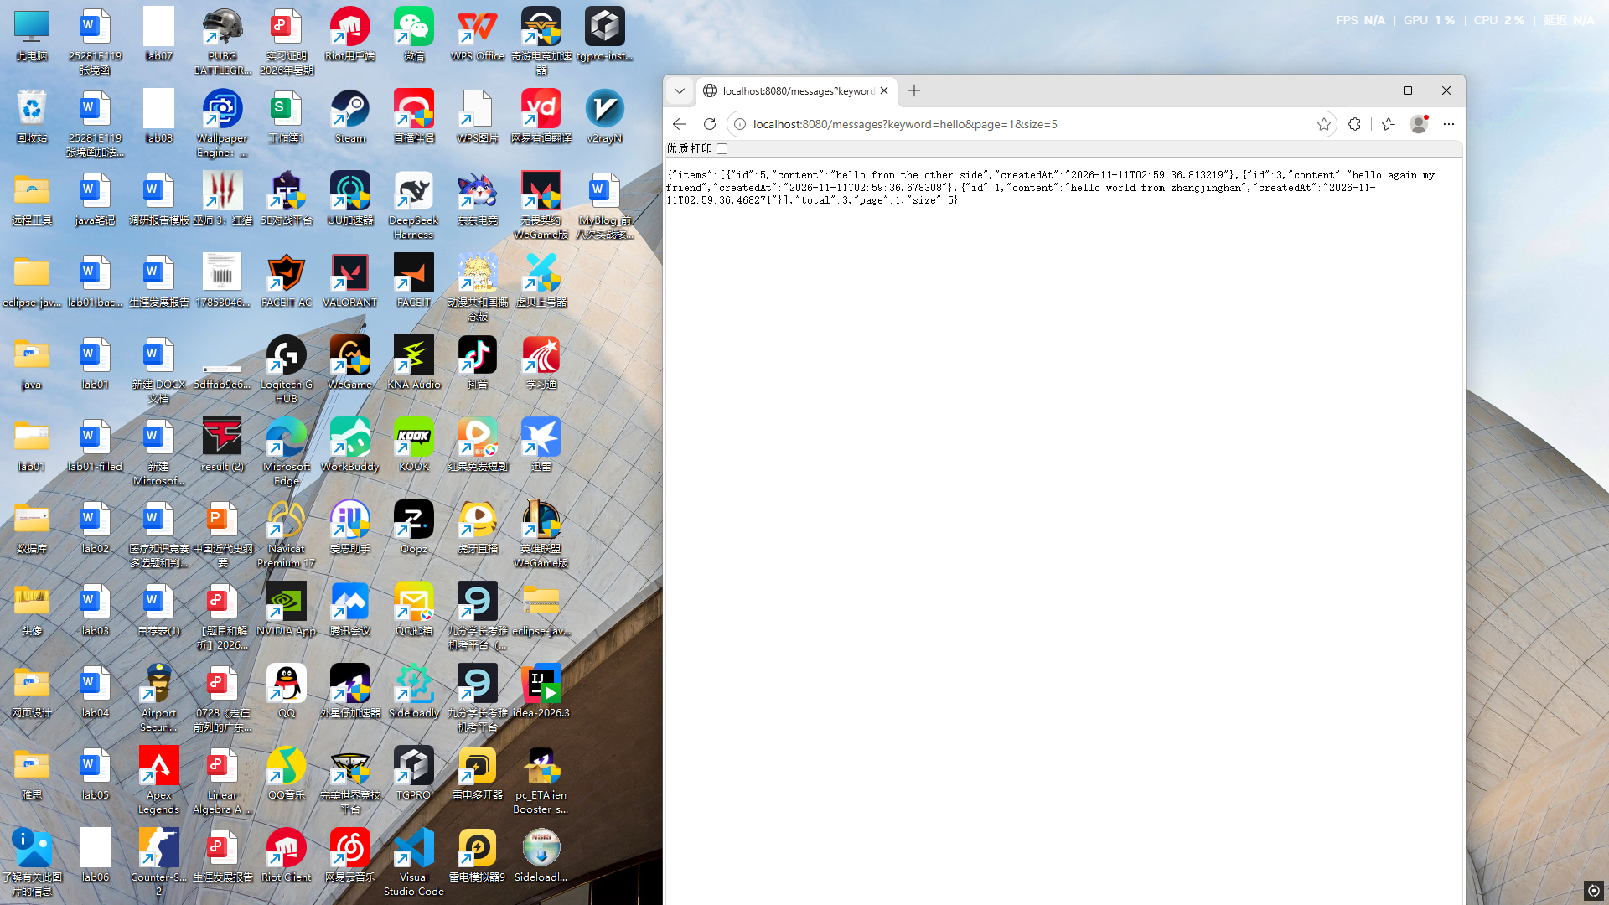

Checkpoint — Level 1
☑ Keyword search works (match AND no-match cases)
☑ Pagination works (page slices + total present)
☑ Combined query works (keyword survives across pages)
☑ POST /messages and GET /messages/{id} unchanged
☑ Evidence captured

4. Level 2 — Understand It
Goal: explain discovery, defend pagination, map your parameters, and debug one real failure with AI.

Task 4.1 — Memory vs discovery
Memory means:
Memory means: data is stored and survives restarts. Every message ever posted is still there.

Discovery means:
Discovery means: finding the right subset of memory — not everything, but the specific messages you need right now, with keyword filtering and pagination.
Explain both using your own MyBlog, not textbook words.

Task 4.2 — Why pagination
Pagination is needed because...
Pagination is needed because a single response with hundreds of items is slow to transfer, hard to render, and overwhelming to read. Page/size lets the client request manageable chunks.
total tells the client how many total matches exist, so they know whether there are more pages to fetch.
Write your answer first. Then you may pressure-test it:
AI PROMPT — copy, fill in the [brackets], verify the answer
[PROMPT: Pagination reasoning — problem before code]
Why might returning all matching records be a poor API design?

Explain the problem first.
Do not give me code yet.

Record:
AI's strongest argument: Without the PaginationInnerInterceptor registered as a bean, selectPage silently returns ALL rows — no error, no warning, just wrong results. This is the most dangerous failure mode because it looks like it works.
Whether it changed my answer (why): Yes — I was going to skip registering the interceptor, thinking selectPage would handle it automatically. AI's argument made me add MybatisPlusConfig before testing.

Task 4.3 — Param map
For one successful combined request, record what each parameter did:
Param | Effect
keyword
page
size

Task 4.4 — Layer check
Controller did:
Controller did: received GET /messages with optional keyword, page, size query parameters, passed them to service.list(), returned PageResult.

Service/Mapper did:
Service/Mapper did: Service validated page/size defaults, called repository.search(keyword, page, size). Repository used QueryWrapper with like() for keyword and selectPage() for pagination. The Mapper executed COUNT + LIMIT SQL.
Where does the filter live — and why there? (Week05's structure is what makes this answer clean.)

Task 4.5 — AI debug (required)
Break or observe one real issue, e.g.:
- keyword should match but returns []
- page beyond total behaves oddly
- size=0 / missing param confusion
AI PROMPT — copy, fill in the [brackets], verify the answer
[PROMPT: Query debug — context-rich, scoped]
I am on Week07 MyBlog discovery.
Request: GET /messages?keyword=...&page=...&size=...
Actual result: ...
Here are 3 DB rows + service/mapper code.
[paste]

Likely causes?
No Elasticsearch / Redis / Vue suggestions.

Record:
The failing case I used: unregistered the PaginationInnerInterceptor (plain class, no @Configuration/@Bean) and called GET /messages?page=2&size=5. The response contained ALL 12 rows and total was 0 - the page parameters were silently ignored.
AI's hypothesis I accepted: The interceptor must be registered as a Spring bean for selectPage to work. Without it, MyBatis Plus skips pagination entirely.
AI suggestion I rejected (and why): AI suggested using PageHelper (a different pagination library), but MyBatis Plus has built-in pagination that is simpler and already in my dependencies.
How I verified the fix (real call): after registering MybatisPlusConfig with PaginationInnerInterceptor, the same call returned 5 rows (ids 6-10) with total 12 and page 2; GET /messages?keyword=mysql&page=2&size=2 returned ids 6 and 9 with total 4, so the keyword survived the page change.
Optional — have AI design your verification, not your code:
AI PROMPT — copy, fill in the [brackets], verify the answer
[PROMPT: Verification design — the discovery test matrix]
I implemented search and pagination on MySQL-backed messages.

Design a test matrix for:
- matching results
- no results
- first page
- middle page
- last page
- page beyond available data

Do not modify my code.

Then actually run the matrix:
Test case | Expected result | Actual result | Evidence
Keyword that matches | only matching items, correct total
Keyword with no match | empty items, total 0, no error
First page (page=1) | first size items of the set
Middle page | different slice, no overlap with page 1
Last page | remaining items (may be fewer than size)
Page beyond data | empty items, total still correct, no crash
Combined keyword+page | filtered set is paged; keyword not lost

Checkpoint — Level 2
☑ Memory vs discovery explained in my own words
☑ Why-pagination answer written (before AI)
☑ Param map complete
☑ Layer check written
☑ AI debug: real failure, verified fix, accept/reject recorded
☑ Test matrix executed with evidence

5. Level 3 — Make It Yours
Goal: discovery that sounds like your MyBlog. Choose at least one:

Option A — Personal filter
from / topic / mood query support.

Option B — Sort style
Newest-first or a custom default sort that fits your blog.

Option C — Empty-result voice
When nothing is found, respond like your MyBlog — an honest, personal "I looked and found nothing" instead of a bare [].
Ask:
Does this help me find myself in remembered content?
EVIDENCE — capture this
[EVIDENCE: Level 3 — what I personalised and why]
Added MybatisPlusConfig with PaginationInnerInterceptor (needed since MyBatis Plus 3.5.9 moved it to
the mybatis-plus-jsqlparser module). Discovery lives in MyBatisMessageRepository.search(): one
LambdaQueryWrapper with an optional like(Message::getContent, keyword) plus selectPage(new Page<>(page, size)).
The service only clamps page/size (size <= 100), so page 2 cannot forget the keyword - the keyword is
part of the same wrapper the page query uses.
Response: {items, total, page, size}.
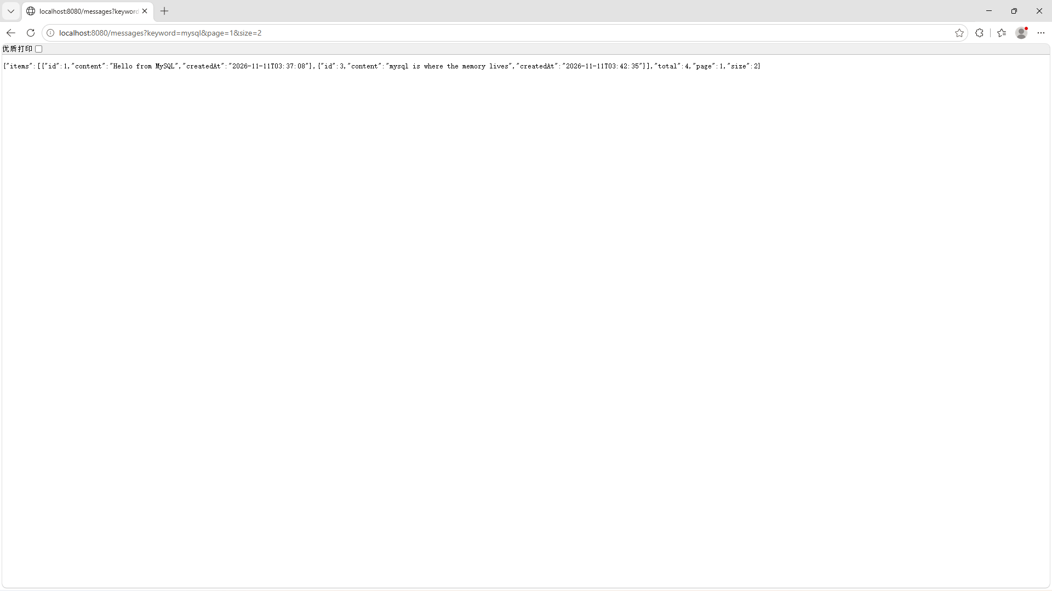

Checkpoint — Level 3
☑ Personal discovery touch applied
☑ Search/page still work (re-tested)
☑ Short note written

6. Optional Extension
Only after L1–L3 are complete (details: mission.md §9, challenge.md):
- Sort by created time asc/desc
- Validate page/size bounds
- Highlight the matched keyword in a response field
- Optional one-to-many preview (message + tags) — not required
Same Week07 technology. No Vue. No Redis. No Elasticsearch.

7. Evidence & Submission

The Week07 evidence map
Capability claim | Evidence that proves it
Memory still works | Restart test + POST/GET /messages/{id} unchanged (§2, §3.5)
Search finds the right subset | Planted-keyword match evidence + absent-keyword honest empty (§3.5)
Pagination navigates memory | page=1 vs page=2 slices + correct total (§3.5)
Keyword and page compose | Combined request, keyword survives across pages (§3.5, matrix)
I understand the design | Memory-vs-discovery + why-pagination + param map + layer check (§4)
I debug with AI, own the fix | Real failure + context-rich prompt + verified fix + accept/reject (§4.5)
Discovery is mine | Level 3 personal touch + note (§5)

Submit
☑ Source code with discovery APIs
☑ HTTP evidence: search, page, combined
☑ Test matrix with results
☑ Level 2 notes + AI log
☑ Level 3 personal note
☑ Reflection

Reflection should answer (reflection.md): why GET-all stopped being enough · what each query parameter really controls · where the filter lives and why · what "no match" should mean · what AI suggested and what you kept/rejected · what you found in your own memory.

8. Troubleshooting
Symptom-first. More: common-bugs.md.
Symptom | Likely cause | First move
Search always empty | Wrong column / case mismatch / still filtering an in-memory copy | Compare one real DB row against your like condition by hand
Page ignores keyword | Combined query not applied together | Log/trace the final query: does it contain BOTH conditions?
total missing | Returned a bare list instead of the page payload | Map the MP Page object to {items, total, page, size}
Page beyond total crashes or looks wrong | No empty-page handling | Decide the honest answer: empty items + correct total
size=0 / missing params confuse the API | No defaults or validation | Pick defaults; document the bare-GET behavior choice
Create/detail broke after adding discovery | Accidental edit in shared code | Re-run §3.5 continuity; diff against backup
Want Vue / Elasticsearch now | Out of scope | API first — Week08/09 will use these endpoints

9. Completion Checklist
☑ Starting state verified: restart persistence + POST + GET by id
☑ ≥ 8 varied messages seeded; planted + absent keywords recorded
☑ Backup created before discovery changes
☑ L1: keyword search works on MySQL (match + no-match)
☑ L1: pagination returns slice + total
☑ L1: combined keyword+page works (keyword survives paging)
☑ L1: continuity check passed
☑ L2: concepts + param map + layer check written
☑ L2: AI debug with real failure, verified fix, accept/reject
☑ L2: test matrix executed with evidence
☑ L3: personal discovery touch applied and re-tested
☑ Evidence map §7 complete
☑ AI log + reflection complete
☑ Continued Week06 project — no restart
☑ No Vue / Redis / Elasticsearch / vector search / JPA rewrite

10. Technical Boundary Reminder
This lab stays inside Week07. Do not introduce:
WARNING — forbidden pattern
❌ Vue UI
❌ Redis
❌ Elasticsearch / vector search
❌ JPA rewrite
❌ Required multi-table redesign

Your entire toolbox is: query params + MyBatis Plus conditional/page queries + a clear payload. It is enough — and it is the thinking, not the engine, that transfers later.

11. Bridge Forward
Discovery APIs are ready.
GET /messages?keyword=...&page=...&size=...
↓
(a question, not yet answered)

Carry this question out of the week — do not answer it yet:
These APIs can now answer "find it" and "show me a window".
But who will ask? A person with an HTTP client can.
What if MyBlog's memory had a face that anyone could talk to —
and is the backend actually ready for one?
Week 07: Discovery
Later: a face can bind to these APIs

Do not build Vue in this lab.
Detailed troubleshooting: `common-bugs.md` · Mission and evaluation: `mission.md`, `assessment.md` · AI templates: `prompts/`.

