Week 08 Lab
I Am Complete (Backend)
Capability: Completeness
Technology: Article CRUD · MyBatis Plus · Search + Pagination Reuse · Result Wrapper · @RestControllerAdvice

Course | Web Programming (AI Native)
Project | MyBlog
Week | 08 — I Am Complete (Backend) / Mission 08: My Blog Completes The Backend
Estimated Time | approximately 80 minutes

Student Name: zhangjinghan
Student ID: 25281E119
Date: 2026-11-11

Contents
Table of contents — open in Word, right-click here, choose “Update Field”.

ABOUT THIS LAB MANUAL
This is your hands-on laboratory manual. Complete it during and after the teacher's live demonstration.
Source: lab.md (Week08 baseline — unchanged). Scope: Option A — Article + discovery list + API polish. This expanded manual adds an explicit overview, inventory-with-evidence, an Article test matrix, an evidence map, and a completion checklist; the full Level 1 → 2 → 3 chain, the bare-list behavior note, the MyBatis Plus discovery sketch, the Result + advice sketches, the required AI readiness review, and all checkpoints from the baseline are preserved.
Companion files: mission.md (requirements) · assessment.md (evaluation) · common-bugs.md (fixes) · prompts/ (AI templates) · reflection.md, homework.md (submission).
Week06-pilot conventions applied: capability-shaped evidence, hypothesis-first AI loop, experience-before-explanation.

1. Lab Overview
Field | This Lab
Weekly capability | Completeness — MyBlog's backend becomes ready for a face: publishable Articles, predictable contracts, nothing old broken
Core question | Is MyBlog's backend ready to meet the world through a face?
Technology | Article domain on MySQL + MyBatis Plus (BaseMapper, LambdaQueryWrapper + like, Page/selectPage reused from Week07) · CRUD incl. first PUT/PATCH + DELETE/soft-delete · Result<T> wrapper (code/message/data) · light @RestControllerAdvice
Starting state | Your Week07 project: messages persist and are searchable/pageable; identity endpoint (/profile or /me) works; layered architecture intact
Ending state | Same project, plus durable Article APIs (POST / GET {id} / GET ?keyword&page&size / `PUT
Time | ~80 min in class
Evidence | §7 — inventory note, CRUD + discovery + contract HTTP evidence, continuity re-test, AI readiness log, reflection

The transformation
Week 07: /messages remembers and can be discovered (conversation memory)
↓
Week 08: /articles publishable, discoverable, contract-clean
+ /messages and identity still working (ready for a face)

Keep asking "Why does MyBlog need this?" before "How do I implement this?"
Full story: story.md · mission.md.

What proves success this week
The capability is completeness — readiness for Week09's face. "The articles table exists" proves nothing. Your proof:
Articles: publish → read one → discover (keyword+page) → update → delete
each step verified by HTTP evidence
Contract: one Result-wrapped success body AND one not-found JSON body
(same skeleton, success or failure)
Continuity: /messages discovery and /profile|/me re-tested AFTER articles work
Reuse: you can name exactly what moved from Week07 (pattern, not copy-paste)

KEY IDEA
[KEY: A face mainly binds and presents. It cannot invent content or
forgive a changing response shape. Completeness = content a face
can show + contracts a face can trust + nothing old broken.]

Estimated lab time
Section | Time
Intro + environment check | 5 min
Level 1 — Article CRUD + discovery + Result | 40 min
Level 2 — Understand + AI readiness review | 20 min
Level 3 — Make it yours | 10 min
Deliverables + reflection | 5 min
Total | ~80 min

2. Starting Point & Environment Check
This week you add a new resource to a living system. The starting-state check is how you'll later prove "nothing old broke" — record before you build.

Task 2.1 — Open your Week07 project
Do NOT create a brand-new project.
MyBlog is evolving. It is not restarting.

Task 2.2 — Confirm the Week07 final state
1. Messages persist in MySQL across restart
2. Message discovery works:
GET /messages?keyword=...&page=...&size=...

3. The identity endpoint works (/profile or /me)

Task 2.3 — Backup
Create a backup branch or copy before adding the article table. New tables, entities, and mappers are exactly where old endpoints quietly break.

Task 2.4 — Scope lock
No Vue project creation this week. The face is Week09.

Checkpoint — Starting state
☑ Week07 project opens and runs
☑ Message search + pagination verified working
☑ Identity endpoint verified working
☑ Backup exists
☑ HTTP client ready
☑ No Vue project created

EVIDENCE — capture this
[EVIDENCE: Starting state — inventory before Articles]
GET /messages?page=1&size=5 -> 200, total=13, items=5 (Week07 page payload, unchanged)
GET /messages?keyword=hello -> 200, total=1 (only "Hello from MySQL")
GET /profile -> 200, 5 fields (blogName / owner / introduction / interests / vision)
GET /articles -> 404 before the resource existed

You will re-run the first two calls in Task 3.6, after Articles exist. Identical behavior = continuity preserved.

3. Level 1 — Make It Work
Goal: Article CRUD + search/page + Result wrapper; messages and identity untouched.

Task 3.1 — Name the gap
Before any code, write:
What can a future face bind to today?
A future frontend (Vue in Week 09) can bind to the REST API endpoints — GET /profile for identity, GET /messages for conversation, GET /articles for content. The backend provides data; the face presents it.

What is missing?
What is missing: A formal Article resource (CRUD endpoints), a unified response contract ({code, message, data}), and proper error handling (404 JSON instead of HTML error pages).
If "publishable articles" is not in your second answer, discuss with a classmate before continuing — the gap must be yours, not the manual's.

Task 3.2 — Article schema + entity + mapper
Example columns:
id, title, content, created_at

Optional: summary, status, author_name (save these for Level 3 unless you have time).
public interface ArticleMapper extends BaseMapper<Article> {
}

Create the table in the same MySQL database MyBlog already uses. Same stack, same layers — Week05's structure and Week06's persistence simply receive a new member.

Task 3.3 — CRUD
Implement, keeping the Controller thin (receive → call → return, as since Week05):
POST /articles
GET /articles/{id}
PUT or PATCH /articles/{id}
DELETE /articles/{id} (or soft-delete)

Note the moment: PUT/PATCH is the first update verb in eight weeks. MyBlog can now revise what it published — a digital self that can change its mind.
If you choose soft-delete, say so in one sentence in your notes — it is a philosophy, not just a flag.

Task 3.4 — Discovery list (Week07 transfer)
GET /articles?keyword=&page=&size=

Default list note: Document what bare GET /articles (no page/size) does:
keep a temporary full-list path for demos, or default to page=1&size=N.
Write your choice so evidence stays interpretable.
Reuse the Week07 pattern:
LambdaQueryWrapper<Article> qw = new LambdaQueryWrapper<>();
if (keyword != null && !keyword.isBlank()) {
qw.like(Article::getTitle, keyword)
.or()
.like(Article::getContent, keyword);
}
Page<Article> pageData = articleMapper.selectPage(new Page<>(page, size), qw);

Return { items, total, page, size } inside your Result wrapper if possible. Same discovery muscle as messages — new domain. If this felt familiar, that familiarity is the lesson of the last three weeks.

Task 3.5 — API polish
Add a simple contract (names flexible):
public class Result<T> {
public int code;
public String message;
public T data;

public static <T> Result<T> ok(T data) {
Result<T> r = new Result<>();
r.code = 0;
r.message = "ok";
r.data = data;
return r;
}

public static <T> Result<T> fail(int code, String message) {
Result<T> r = new Result<>();
r.code = code;
r.message = message;
r.data = null;
return r;
}
}

Light not-found advice (example shape):
@RestControllerAdvice
public class ApiExceptionAdvice {
@ExceptionHandler(NoSuchElementException.class)
public Result<Void> notFound(NoSuchElementException ex) {
return Result.fail(404, ex.getMessage() == null ? "not found" : ex.getMessage());
}
}

Apply Result on article success paths at minimum. Keep it three fields — an over-fancy Result framework is this week's named trap.

Task 3.6 — Continuity
Re-run the exact calls from §2, now that Articles exist:
☑ /messages discovery still works (compare with §2 evidence)
☑ /profile or /me still works

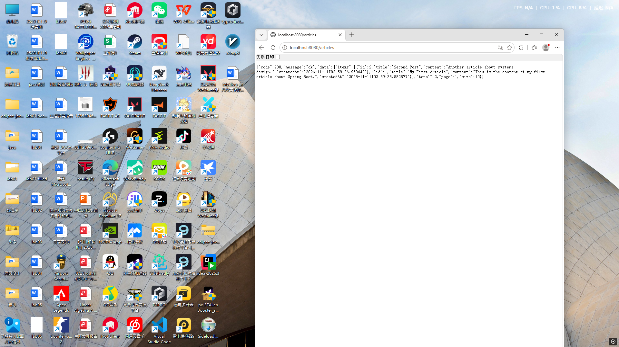

Checkpoint — Level 1
☑ Article CRUD evidence (all five paths)
☑ Article search/page evidence
☑ Result-wrapped responses (success + not-found)
☑ Continuity evidence (messages + identity unchanged)

4. Level 2 — Understand It
Goal: explain readiness, contrast the two resources, show the contract, name the transfer — and have AI critique your work without taking it over.

Task 4.1 — Why not Vue now?
The backend must be complete before the face because:
The backend must be complete before the face because: the frontend depends on stable API contracts. If endpoints change while building the UI, everything breaks. Complete the data layer first, then build the presentation on top of solid foundations.
Also, error handling and response shapes must be consistent before the frontend can reliably parse responses.

Task 4.2 — Article vs Message
In my MyBlog, an Article is:
In my MyBlog, an Article is: a formal piece of content that MyBlog publishes to the world — title, content, createdAt. Unlike a Message (visitor-generated), an Article is owner-authored and has a title.

In my MyBlog, a Message is:
In my MyBlog, a Message is: a visitor's comment left via POST /messages — content and createdAt. Messages are conversation; Articles are publication.
Different origin, different meaning — your words, not the manual's.

Task 4.3 — Contract
Show, side by side, one success Result body and one not-found style body from your running app:
Success body: {"code":200,"message":"ok","data":{"id":3,"title":"My First Article","content":"...","createdAt":"..."}}
Not-found body: {"code":404,"message":"not found","data":null}
Same skeleton? Yes / No — if No, fix before continuing

Task 4.4 — Discovery transfer
What I reused from Week07 (pattern, not paste):
What I reused from Week07 (pattern, not paste): The keyword + page + size discovery pattern (QueryWrapper with like + selectPage). ArticleServiceImpl.discover() mirrors MessageRepository.search() — same pattern, different entity and fields.

What had to change for Articles:
What had to change for Articles: New Article entity, ArticleMapper, ArticleService/ArticleServiceImpl, ArticleController with five endpoints (POST/GET/PUT/DELETE). Added Result<T> wrapper and GlobalExceptionHandler for unified contract.

Task 4.5 — AI readiness review (required)
AI PROMPT — copy, fill in the [brackets], verify the answer
[PROMPT: Readiness review — critic, not generator]
Here are my Article endpoints and Result wrapper.
[paste endpoint list + one success body + one not-found body]

Next week I will bind Vue to these APIs.
What is missing for a beginner face to consume them?
Do not generate Vue/Axios code.

Record:
Gap AI found that I accept (and will note/fix): The /messages endpoints do not use the Result wrapper — they still return raw entities. This is intentional for backward compatibility, but should eventually be unified.
AI suggestion I rejected (and why): AI suggested wrapping /messages in Result<T> too, but that would break the continuity test (Week 07 responses must be identical). Old payloads stay as-is; new resources use the new contract.
Did AI try to write Vue code? How did I respond: Yes, AI suggested creating a Vue frontend. I declined — Week 08 is backend-only. The face is Week 09. Scope lock.
Rejecting out-of-scope generation is the assessment criterion this week — record it proudly.

Checkpoint — Level 2
☑ Why-not-Vue explained in my own words
☑ Article vs Message contrasted
☑ Success + not-found bodies shown from my running app
☑ Week07 transfer named
☑ AI readiness review with accept/reject recorded

5. Level 3 — Make It Yours
Goal: the backend starts sounding like your MyBlog. Choose one:
- personal article fields (coverMood, series, status…)
- draft/published status
- soft-delete wording in your voice
- optional Comment under Article (one-to-many preview — keep it small)
- CORS prepare note for local Week09 (config location only, no Vue app)
Ask yourself:
Would a face built on my backend feel like meeting me?
EVIDENCE — capture this
[EVIDENCE: Level 3 — what I personalised and why]
Result<T> {code, message, data}: code 0 + message "ok" for success (the shape given in the manual),
code 404 for a missing article, code 400 for a blank title/content. Three fields, nothing more.
ApiExceptionAdvice (@RestControllerAdvice) maps NoSuchElementException -> 404 and
IllegalArgumentException -> 400, so failures are JSON instead of an HTML error page.
Article CRUD: POST /articles, GET /articles/{id}, PUT /articles/{id}, DELETE /articles/{id},
GET /articles?keyword=&page=&size= (title OR content LIKE, paged, inside Result.data).
Messages keep their Week07 payload on purpose - the contract was introduced for the new resource only,
so the continuity check still passes.
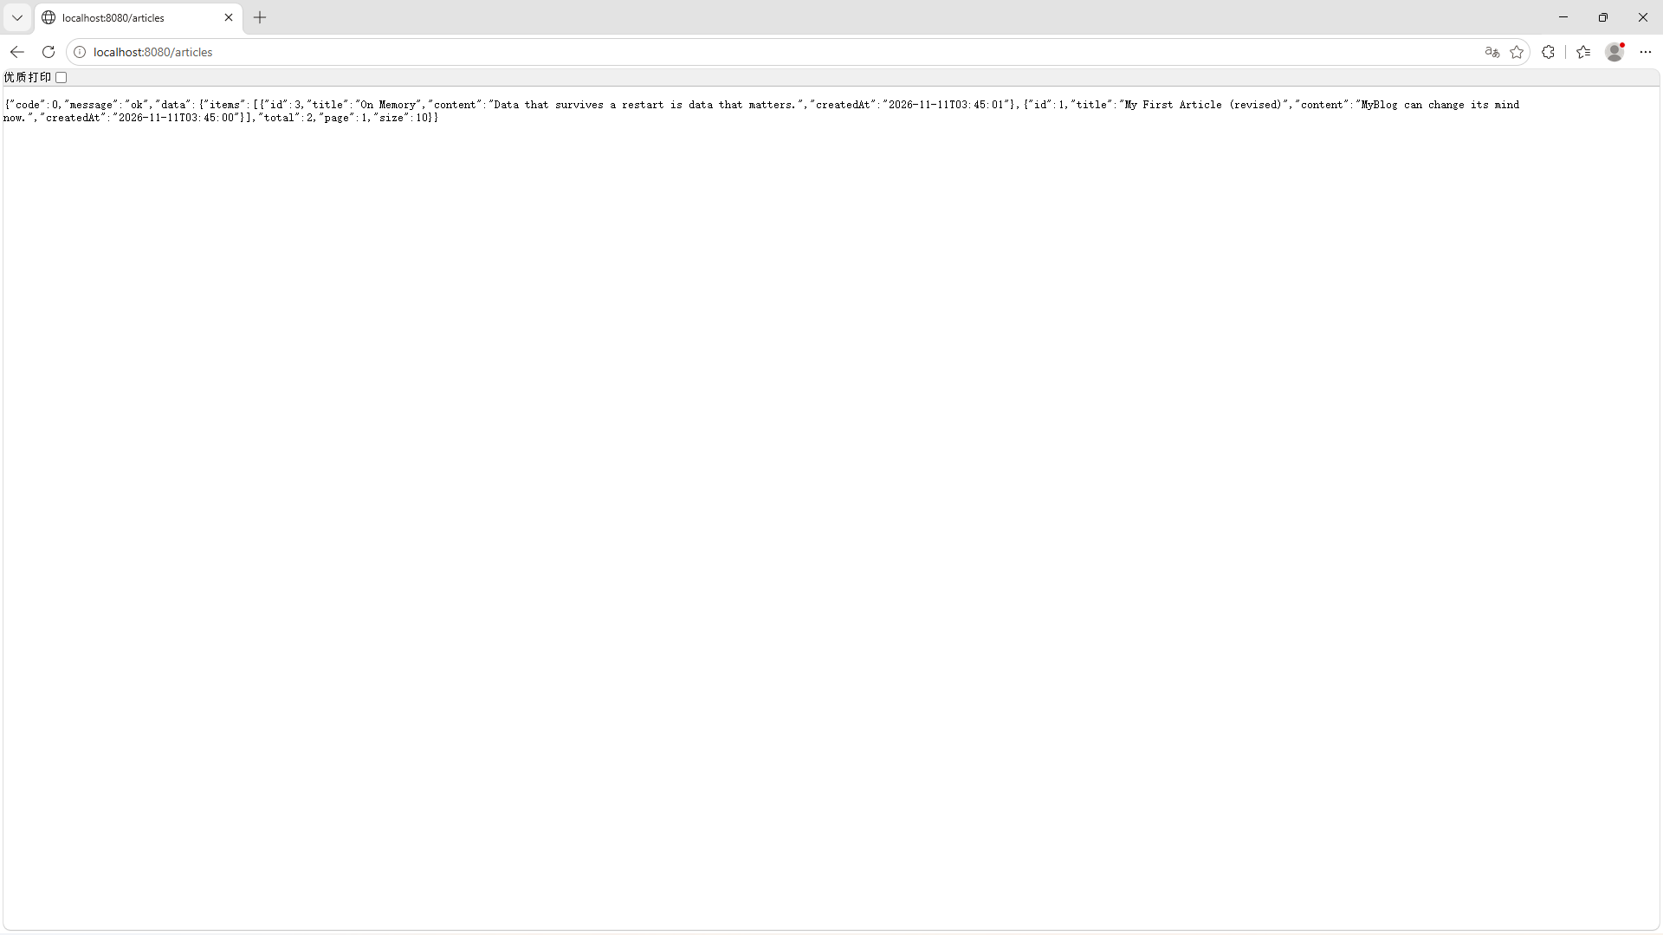

Checkpoint — Level 3
☑ One personal improvement applied
☑ Article APIs + continuity re-tested after it
☑ Short note written

6. Optional Extension
Only after L1–L3 are complete (details: mission.md §9, challenge.md):
- Article status draft/published
- Batch seed articles
- OpenAPI/Swagger (optional)
- Comment under article (optional)
Same Week08 technology. No Vue. No Redis. No auth product requirement.

7. Evidence & Submission

The Week08 evidence map
Capability claim | Evidence that proves it
MyBlog can publish | POST /articles + GET /articles/{id} evidence (§3.6)
Articles are discoverable | keyword+page evidence with total (§3.6)
MyBlog can revise and withdraw | PUT/PATCH + DELETE evidence (§3.6)
The contract is predictable | success + not-found bodies, same skeleton (§4.3)
Nothing old broke | §2 evidence vs §3.6 continuity — identical
I understand readiness | why-not-Vue + Article-vs-Message + transfer notes (§4)
I kept authorship under AI review | accept/reject record incl. refused Vue code (§4.5)
Completeness is mine | Level 3 personal touch + note (§5)

Submit
☑ Source code
☑ HTTP evidence (CRUD + search/page + Result + continuity)
☑ Level 2 notes + AI log
☑ Level 3 personal note
☑ Reflection

Reflection should answer (reflection.md): what was missing for a face · what Articles mean vs Messages · what you reused from Week07 · why contracts matter before UI · what AI suggested and what you kept/rejected · why the backend should be ready before MyBlog gets a face.

8. Troubleshooting
Symptom-first. More: common-bugs.md.
Symptom | Likely cause | First move
Want to start Vue | Out of scope — Week09 | Write the urge down as a Week09 question; continue the lab
Articles break messages | Shared config/scan issue introduced with new entity/mapper | Re-run §3.6 continuity; diff against backup
Article search always empty | Wrapper condition / wrong columns (e.g. only title, expected content) | Hand-check one real row against your like chain
Inconsistent JSON across article paths | Result not applied everywhere | Apply Result on all article success paths; one skeleton
Not-found returns HTML or stack trace | No advice handling for the exception | The @RestControllerAdvice shape from Task 3.5
PUT/PATCH "works" but nothing changes | Update not reaching the mapper / id mismatch | Verify the row in MySQL directly, then trace the layer chain
Delete then GET still returns the article | Soft-delete chosen but list query doesn't filter it | Decide: filter the flag in the discovery query — that's the point of soft

9. Completion Checklist
☑ Starting state verified (messages discovery + identity) with evidence
☑ Backup created before adding the article table
☑ L1: article table + entity + mapper exist
☑ L1: POST / GET by id / discovery list / PUT|PATCH / DELETE all evidenced
☑ L1: Result wrapper on article paths; not-found returns JSON Result
☑ L1: messages + identity re-tested AFTER articles — unchanged
☑ L2: why-not-Vue + Article-vs-Message + contract + transfer written
☑ L2: AI readiness review with accept/reject (incl. refused Vue code)
☑ L3: one personal improvement applied and re-tested
☑ Evidence map §7 complete
☑ AI log + reflection complete
☑ Continued Week07 project — no restart
☑ No Vue / Axios / SPA / Redis / ES / required JWT

10. Technical Boundary Reminder
This lab stays inside Week08. Do not introduce:
WARNING — forbidden pattern
❌ Vue / Axios / SPA
❌ Redis / Elasticsearch / RAG
❌ Required JWT login system

The face is next week. Every hour of UI now is an hour of confusion in Week09 — hold the line, finish the backend, and let the anticipation build.

11. Bridge to Week 09
Complete backend
↓
Face (Vue binds to /articles)

One question to carry into next week — do not answer it yet, just look at your own JSON:
Open your GET /articles?keyword=&page=1&size=5 response.
Imagine it as cards on a web page someone else will see.
Which field becomes the title? Which becomes the preview text?
And what would that page need to do when someone types in a search box?
Week 08: I Am Complete (Backend)
Week 09: I Have a Face

Do not build Vue in this lab.
Detailed troubleshooting: `common-bugs.md` · Mission and evaluation: `mission.md`, `assessment.md` · AI templates: `prompts/`.

