CHATER-4

Hardware Components

**4.1 Arduino Uno Microcontroller**

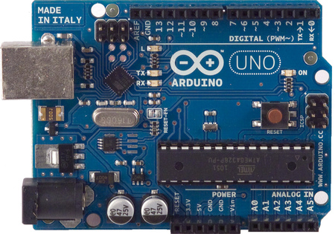

4.1.Arduino Uno

The Arduino Uno is a microcontroller board based on the ATmega328 . It has 14 digital input/output pins (of which 6 can be used as PWM outputs), 6 analog inputs, a 16 MHz crystal oscillator, a USB connection, a power jack, an ICSP header, and a reset button. It contains everything needed to support the microcontroller; simply connect it to a computer with a USB cable or power it with a AC-to-DC adapter or battery to get started. The Uno differs from all preceding boards in that it does not use the FTDI USB-to-serial driver chip. Instead, it features the Atmega8U2 programmed as a USB-to-serial converter.We have used two Arduinos, one on the transmitter side and another on the receiver side.

**4.2 RF Transmitter and Receiver**

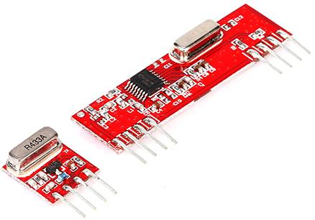

Fig 4.2. RF Module

The RF module operates at Radio Frequency. In this RF system, the digital data is represented as variations in the amplitude of carrier wave. This kind of modulation is known as Amplitude Shift Keying (ASK). This **RF module** comprises of an **RF Transmitter** and an **RF Receiver**. The transmitter/receiver (Tx/Rx) pair operates at a frequency of **434 MHz**. An RF transmitter receives serial data and transmits it wirelessly through RF through its antenna connected at pin4. The transmission occurs at the rate of 1Kbps - 10Kbps.The transmitted data is received by an RF receiver operating at the same frequency as that of the transmitter.

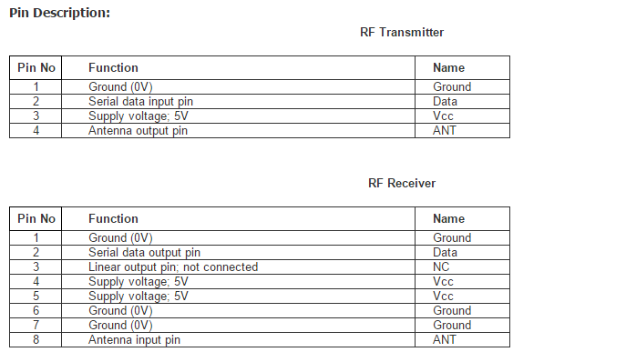

Fig 4.3. RF module pin description

**4.3 Light Emitting Diodes**

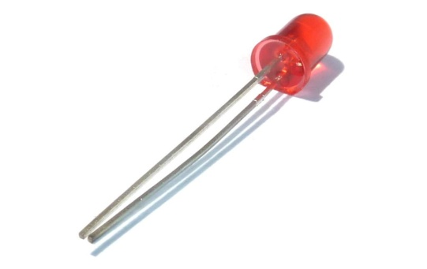

Fig.4.4. LED

LEDs are a particular type of diode that convert electrical energy into light.We have used LEDs of two different colours.The LEDs are connected to the arduino on the receiver side.

**4.4 L293D motor driver IC**

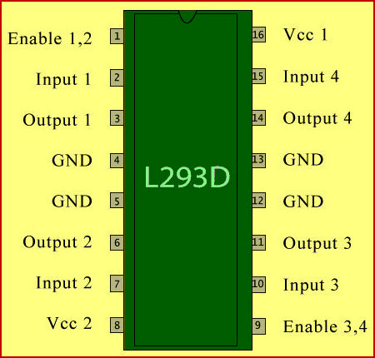

Fig.4.5.L293D IC pin diagram

L293D is a typical Motor driver or Motor Driver IC which allows DC motor to drive on either direction. L293D is a 16-pin IC which can control a set of two DC motors simultaneously in any direction. We have used L293D IC to control two motors used for our application

**4.5 DC Motor**

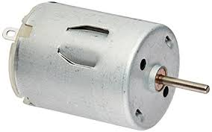

Fig.4.6.DC Motor

A DC motor converts electrical energy into mechanical energy. We use two motors on the receiver side, one to act as a fan and another motor to control the opening and closing of the door.